This chapter presents the analysis of the data collected in accordance with the research objectives outlined in the previous chapter.
The purpose of this chapter is to interpret the data in a meaningful way that addresses research questions, please see Appendix 1 and interview questions Appendix 2.
The analysis process involves organising and describing report results, analysing and interpreting results and summarising, synthesising the data to identify patterns, trends and relationships relating to the research and previous studies.
Consistent themes and repetitive answers indicate answers required through research data.
Both quantitative and qualitative approaches are employed to ensure a comprehensive understanding of the findings.
Quantitative data is analysed using appropriate statistical techniques to describe the characteristics of the sample from a questionnaire in order to identify patterns, connections and variations of occupational variables.
Techniques used summarise the data and test the relationship between stress, job satisfaction, resilience and organisational support.
Qualitative data alternatively, is examined to capture the depth and context of the participants’, experiences and perspectives from interview questions. Exploring subjective experiences of mental health and wellbeing, awareness and perceptions of Organisational support.
Findings of both method analysis were integrated during interpretation to enable and enhance the validity of conclusions, allowing contextual depth and comprehensive understanding of wellbeing within the policing environment.
This approach compliments the data by proving a richer understanding of results, semi structural interview data uncovers officers’ perceptions, experiences of support strategies, organisational culture, effectiveness and recommendations relating to wellbeing.
Giving a voice that may not be fully captured through numerical data alone.
The results, that do not directly relate to the objectives although valuable and informative, can be found in Appendix 3 and 4 to allow a full picture of surrounding, background information.
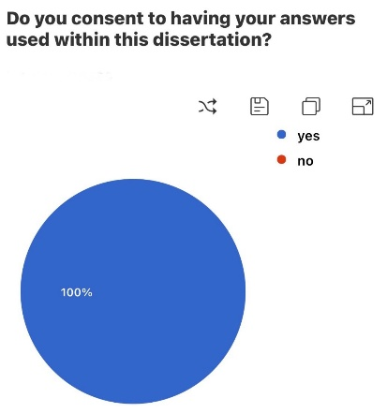

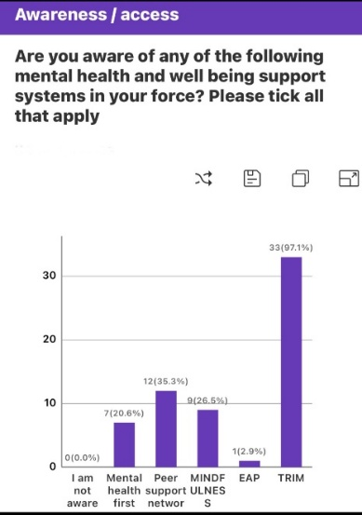
The awareness of TRIM is 97%, this is high showing that trauma support processes are well stablished and understood.
Awareness of peer support networks, mindfulness support and mental health first was moderate and leaves room for improvement.
The employee assistance programme (EAPS) awareness was low suggesting officers do not know about this service, this is concenring as it provides confidential counselling and key to early intervention and stress prevention.
The absence of complete unawareness is encouraging it indicates that wellbeing communication efforts are reaching all staff and officer to some degree reviewed Phythian et al., (2022).

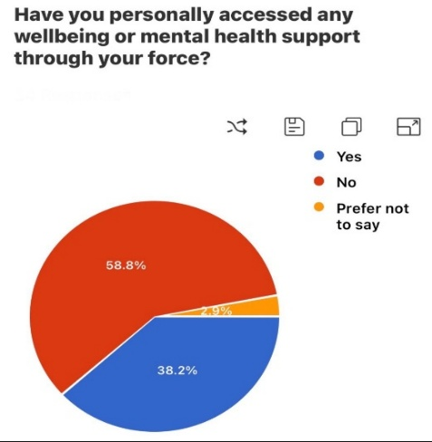
The 58.8% non-engagement rate suggests several possible reasons, lack of awareness of services or services not required, perceived stigma or fear of negative career impact, belief that services may not be effective or confidential enough, there may also be cultural or operational barriers, Phythian et al., (2022).

38% who accessed support is a significant group indicating that support services are being used but not yet normalised.
The ‘prefer not to say’ group though small reinforces that mental health remains a sensitive topic.
This aligns with the findings of MIND, (2022).

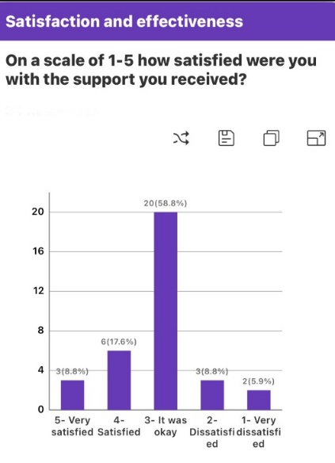
Of the 38% of officers who accessed wellbeing support 58.8% rated it (ok), this suggests even staff who do seek help their experience is not wholey positive.
Postive experience account for 26%, 1 in 4 users had a good experiece.
15% a notable majority were unhappy with the support they received.
The indications are while most staff had an adequate experience, fewer than 1 in 3 were generaly satisfied.

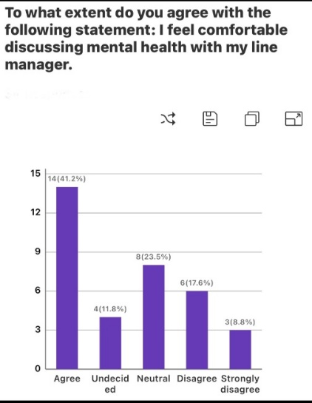
This reflects mixed confidence levels 41% agree, however 49% feel neutral, undecided or disagree, therefore less than half feel safe raising wellbeing issues to supervisors.
A concerning 1 in 4 actively disagree or strongly disagree suggesting a trust or culture gap around mental health within the management structure possibly due to lingering stigma, fear of judgment or lack of trust.
This pattern alongside the lack of wellbeing access and those who did rating it only as ok implies that cultural and relational barriers may play a role in preventing engagement.
This result highlights the critical influence of line managers as gatekeepers to wellbeing culture where their approachability directly affects officer’s willingness to seek help.
There is progress but barriers persist, as reported by Police Federation, (2024) and Newell et al., 2021).
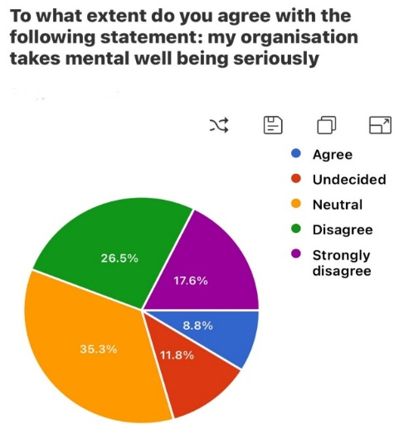
8.8% is a very low confidence level, a combined 43% show a significant perception gap between policy and lived experience. Large neutral and undecided segments indicate widespread uncertainty or inconsistancy.
This reveals serious trust and visibility challenges.
When viewed alongside previous results, these findings illistrate a systemic cultural issue, wellbeing is acknowledge but not fully embraced in daily operations, also examined by Porter and Gavin, (2024).

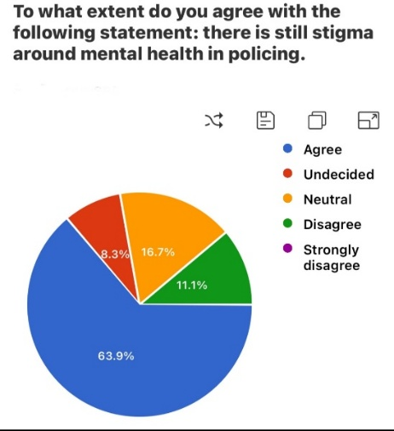
A clear majority agree stigma around mental health within policing with only 12% disagreeing suggesting a broad consensus that it is an issue, reflecting a culture where mental health challenges may still be seen as weakness or career risk. Officers may feel discouraged from seeking help fearing judgement or negative career implications. Consistent with College of Policing 2023.
Previous connections and results together indicate a cultural barrier suggesting policy and practice are not compariable with daily experience.

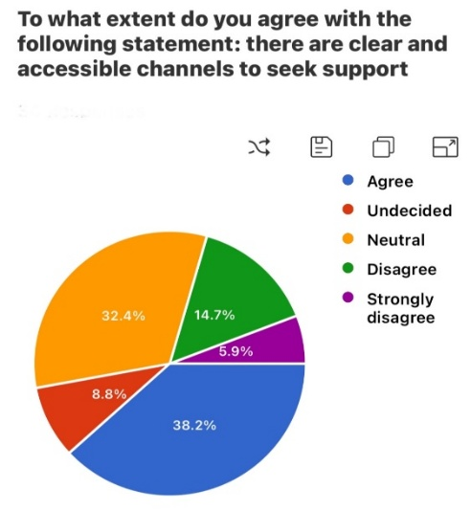

Mixed confidence in wellbeing systems where awareness exists but clarity and consistency are lacking, only 38.2% agree therefore most officers do not perceive clear and straight forward pathways. This could be explained by over complex referral process, poor communication internally about services and lack of visible contacts.
Large neutral / undecided response suggest that many officers are unsure of channels or how to access, highlighting a communication gap, support is there but officers don’t know or don’t trust with lack of clarity in current wellbeing pathways.
Together with previous results, indications are that structural and cultural barriers exist which limits engagement, lack of confidence and how and where to access help, as suggested by Phythian et al., (2022).

From the data response of the interviews 6 major themes emerged which align with the set-out objectives:
- Improved access and investment in support.
- A better tailored and responsive wellbeing service.
- A more compassionate organisational culture.
- Enhanced peer and team-based support.
- Promote preventative health initiatives.
- Action to reduce workloads pressures.
Officers constantly emphasise the need for both practical and cultural improvements to ensure wellbeing is genuinely and embedded across policing. This is consistent with Mental Health Foundation, (2023).
The responses reflect a holistic view of subjective experiences which recognises that psychological health depends not just on access to services but on culture, workload and preventative care, and a whole system approach to wellbeing blending service provision with cultural change as supported by College of Policing, (2021), Lewis, and Muir, (2019) and Foley and Massey, (2020).
Findings of both method analysis were integrated during interpretation to enable to enhance the validity of conclusions.

Appendix 1:
Questionnaire questions
- Do you consent to having your answers used within this dissertation?
- How do you identify?
- What is your current role?
- How many years’ service do you have in policing?
- Are you aware of any of the following mental health and wellbeing support systems in your force? Please tick all that apply
- Have you personally accessed any wellbeing or mental health support through your force?
- On a scale of 1-5 how satisfied were you with the support you received?
- To what extent do you agree with the following statement: I feel comfortable discussing mental health with my line manager.
- To what extent do you agree with the following statement: my organisation takes mental wellbeing seriously.
- To what extent do you agree with the following statement: there is still stigma around mental health in policing.
- To what extent do you agree with the following statement: there are clear and accessible channels to seek support.
- Have you ever taken time off work due to stress, burnout or mental health?

Appendix 2:
Interview questions
Introduction questions-
- Please give me a brief description of your role and policing background
- What does mental wellbeing mean to you in the context of your job?
Experiences of mental health in policing-
- Have you experienced periods of high stress, burnout or trauma during your service?
- What support (if any) was available to you at that time?
Support services and access-
- Are you aware of the wellbeing or mental health services available in your force?
- Have you used any of these services? If yes, which ones and what was your experience?
- What barriers (if any) made it difficult to access support?
Organisational culture-
- How do you feel mental health is viewed within your department or team?
- Is there stigma or fear around speaking up about mental health?
Effectiveness and recommendations-
- In your view, how effective are wellbeing strategies in the police?
- What do you think could be improved?

Appendix 3:
Questionnaire results
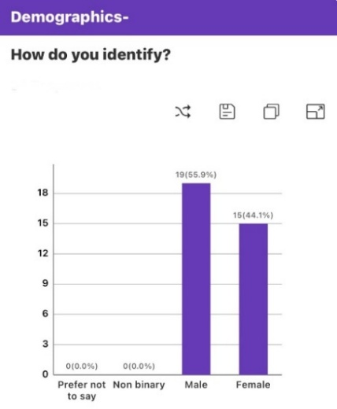
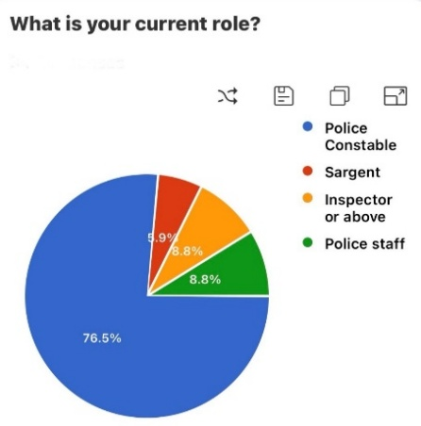
The actual police workforce consists of largely police constables so therefore the response distribution is potentially broadly representative.
The dominant respondent group, 76.5% of respondents in the quantitative data were acting police constables giving this an overwhelming majority.
While sergeants, inspectors and police staff are underrepresented, therefore the results primarily reflect the experience of frontline police constables. Therefore, fewer insights from supervisor ranks and police staff.
It is noted that on a representativeness check.
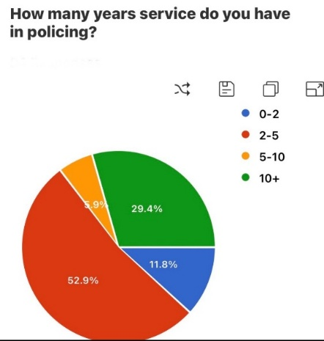
The majority of respondents 52.9% suggests that early career officers were most engaged with the wellbeing questionnaire and the results may reflect on the wellbeing of early career officers.
Relatively few 6% have 5-10 years of service possibly indicating a drop in engagement among mid-career officers or a smaller actual workforce segment in that range.
The 10 years + group gives some balance offering contrast between newer and longer serving officers, continuing sensitivity around this topic.

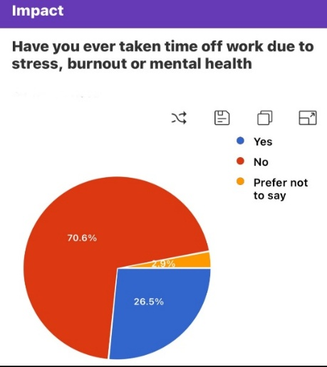
The 70.6% majority who have not taken time off could include officers who are generally well but alternatively those who continue working despite having symptoms of stress possibly due to negative career consequences, stigma or staff shortages. There are potential unmet mental health needs among those struggling while still working.
Over a quarter have taken time off suggesting mental health related absence is a notable issue in the police service.
The 3% who prefer not to say indicates continuing sensitivity around this topic.

Appendix 4:
Interview question results
Open coding table:
- Burnout  - Stress  - Cancelled rest days  - Shift work  - Exposure to trauma  - Difficult job  - Mental health concerns  - Need more officers  - Increase resources  - Staffing issues  - Heavy workloads  - Long hours  - Annual leave restrictions  - Single crewing  - Paperwork  - Lack of support  - Abuse  - TRIM  - Peer support  - Mindfulness | - Increase access to support  - Check ins  - Different people need different support  - Funding for more support  - Six monthly mental health heck with mental health professionals  - Outside agencies  - More caring for each other  - Team debriefs following trauma  - Quicker response to officers in crisis  - Safe areas in police stations for staff  - Promote exercise  - Have recognised days off post trauma i.e. wellbeing days

Themes:
Description:  - Greater access to mental health and wellbeing services including more funding, external options and professional checkups  - Flexible multi-level support that meets varied needs and responds quickly when needed  - A strong desire for leadership and management that genuinely understands stress, burnout and emotional demands of policing  - Many officers’ highlight importance of shared experiences and past incidents. Reflection through debriefs and safe spaces  - Physical health and proactive prevention, are seen as key components of mental resilience  - Heavy workloads, cancelled rest days and strain on resources are key causes of stress that must be relieved | Illustrative responses:  - ‘More access to support’  - ‘Increase funding for support’  - ‘Professional checkups from outside agencies’  - ‘Different levels of support’  - ‘Better response’  - ‘Caring attitudes’  - ‘The understanding of burnout and tress’  - ‘Having compassion and empathy’  - ‘Team briefings after traumatic events’  - ‘Safe, quiet areas for reflection in police stations’  - ‘Promote exercise’  - ‘Wellbeing days’  - ‘Professional check ups’  - ‘Reduce workload’  - ‘Cancelled rest days’  - ‘Shift work / long hours’  - ‘Improved resources’  - ‘Relieve pressures’

Bibliography-
College of Policing (2021). Policing and living well | College of Policing. [online] www.college.police.uk. Available at: https://www.college.police.uk/research/projects/policing-and-living-well. Accessed 24/10/2025.
Foley, J. and Massey, K.L.D. (2020). The ‘cost’ of caring in policing: From burnout to PTSD in police officers in England and Wales. The Police Journal: Theory, Practice and Principles, [online] 94(3), pp.298–315. doi:https://doi.org/10.1177/0032258x20917442. Accessed 24/10/2025.
Lewis, K., And, A. and Muir, R. (2019). POLICE WORKFORCE WELLBEING AND ORGANISATIONAL DEVELOPMENT. [online] Available at: https://www.police-foundation.org.uk/wp-content/uploads/2019/02/organisational_development_report_final.pdf. Accessed 24/10/2025.
Mental Health Foundation (2023). Mental health at work: statistics. [online] www.mentalhealth.org.uk. Available at: https://www.mentalhealth.org.uk/explore-mental-health/statistics/mental-health-work-statistics. Accessed 24/10/2025.
MIND (2022). Supporting someone in the police service. [online] www.mind.org.uk. Available at: https://www.mind.org.uk/news-campaigns/campaigns/blue-light-programme/blue-light-information/supporting-someone-in-the-police-service/. Accessed 24/10/2025.
Newell, C.J., Ricciardelli, R., Czarnuch, S.M. and Martin, K. (2021). Police staff and mental health: barriers and recommendations for improving help-seeking. Police Practice and Research, [online] 23(1), pp.1–15. doi:https://doi.org/10.1080/15614263.2021.1979398. Accessed 24/10/2025.
Phythian, R., Birdsall, N., Kirby, S., Cooper, E., Posner, Z. and Boulton, L. (2022a). Developments in UK police wellbeing: A review of blue light wellbeing frameworks. The Police Journal: Theory, Practice and Principles, [online] 95(1). doi:https://doi.org/10.1177/0032258x211073003. Accessed 24/10/2025.
Police Federation (2024). Record 14,508 officers were signed off with poor mental health in the past year. [online] Polfed.org. Available at: https://www.polfed.org/news/latest-news/2024/record-14-508-officers-signed-off-with-poor-mental-health-in-past-year/. Accessed 24/10/2025.
Porter, C.N. and Gavin, P. (2024). ‘Constant pressures from all angles’: Understanding the mental health of UK police officers. The Police Journal Theory Practice and Principles, [online] 98(2). doi:https://doi.org/10.1177/0032258x241280217. Accessed 24/10/2025.

