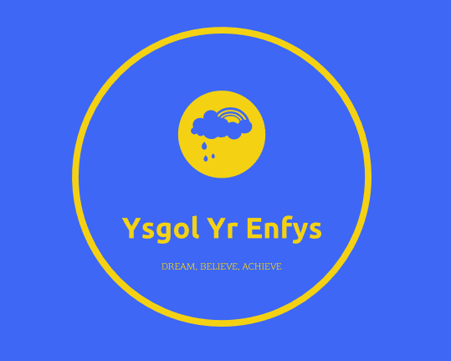
(Logo 1600242)

Year Three Progression Report.

Contributions to this report have been made by 1601574, 1601274, 1600242, 1602422, 1600020.
Each contributor has placed their relevant student number next to their contribution.

Contents Page.(1602422)

Our School.(1602422) 4
Class Overview (1601574) 5
Predicated Attainment using current value added throughout Foundation Phase. (1602422) 5
Free School Meals and the effects of poverty. (1602422) 6
Graph 1.1 FSM Attainment Comparison. 6
1.2 An overview of attainment and the Foundation Phase Indicator. 7
1.3 An example of an ‘I want to’ plan. 8
Gender (1601574) 9
Overview 9
Figure 2.1- Differences in gender attainment. 9
Strategies to close ‘gender attainment gap’ 10
Figure 2.2- How seating is arranged in Year Three. 10
Figure 2.3- Our extra-curricular clubs. 11
Reasoning 11
Monitoring and Assessment. 12
Future Progression. 12
Additional Learning Needs (1600242) 13
Language, Literacy and Communication (1600020) 15
Mathematics (1601274) 18
The Children 18
Intervention 18
Case studies 18
Tewkesbury C of E Primary School 19
St Edward’s Preparatory 19
Ashford Hill Primary School 19
Raising attainment 20
Class Development Plan (1601574) 21
Reference list. (1602422) 22
Reference List 1601574 (Presentation on Gender) 24
1601274 26
1600242 (presentation on BESD) 27
1600020 (Presentation for Language, Literacy and Communication. 28

Our School.(1602422)

We are dual stream school in the center of Cardiff and currently have two hundred and fifty-five pupils on role. The community we serve is culturally, socially and economically diverse offering a wealth of resources to provide our pupils with a relevant, realistic and rich educational experience. We hope that by striving to provide our children with enriching experiences and opportunities we will expand their horizons and increase the number of children achieving the expected outcome in foundation phase and expected levels at key stage two.

We are a rights respecting school, and aim to encourage all pupils to be the best they can be. We feel it is important to recognise and celebrate individuality and hope to develop pupil’s talents and strengths by encouraging them to believe in themselves and equipping them with the confidence to take on challenges, even ones that seem impossible.

We currently have 33.6% of pupils eligible for Free School Meals (FSM) and a school budget of £4,933 per pupil. We intend to use a proportion of our budget to continue professional development within our staff and implement the use of incentives to increase attendance from the current 94% to 95.3% which will bring us in line with the Welsh Governments target for the academic year 2019/2020 (WAG 2016). As a school, we hope that by raising attendance, we will increase attainment. Currently at the end of foundation phase, 87.5% of pupils achieve outcome 5 or above whilst in Key Stage 2, 84% of pupils achieve level 5 or above.

As a school we pride ourselves on our strong links with the community and the families we cater for. We understand that many of our families rely heavily on our school and the facilities we offer such as food banks, launderette services and breakfast/after school clubs. We endeavor to continue to place our families and our community at the heart of this school so that our children can dream big, believe in themselves and achieve all that they wish too.

Class Overview (1601574)

Total number of children: 26
Number of boys: 15
Number of girls: 11
Age: 7-8 years old
Percentage of pupils entitled to Free School Meals: 50%
Total number of children with additional learning needs: 65%
- According to Government outcomes, children entering year three should be achieving outcome five and they should be leaving the end of year three having achieved outcome five or outcome six (equivalent to Level Two or Three).
- Majority of the children are achieving their expected outcomes.
- These children are transitioning from foundation phase to key stage two.
- There is a high percentage of children with additional learning needs in this class
NB: It has been identified through scrutinising the data that teacher marking may be lenient or inconsistent therefore causing anomalies in the data. As can be seen below, when these anomalies are applied through to year six, the children achieve unprecedented success. This progress report was compiled six weeks in to the autumn term and therefore, personal knowledge and understanding of each child has superseded some of the data received from Foundation phase.

Predicated Attainment using current value added throughout Foundation Phase. (1602422)

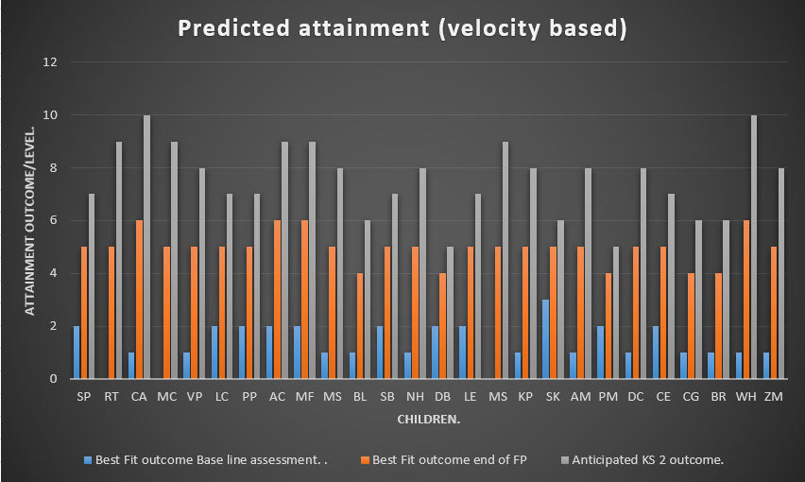

Free School Meals and the effects of poverty. (1602422)

According to the National Foundation for Educational Research (2014) (NFER) children living in poverty are likely to experience a double negative impact on attainment due to their family background. The Children’s Society (2017) agrees with the NFER (2014), warning that parental unemployment is strongly linked to educational attainment and child poverty. Thus, leading to children having a lack of experiences and opportunities to reach their full protentional (Estyn 2014). Therefore, as a rights respecting school, one of our core principles is that no child should suffer discrimination due to their family background (CNCRC Article 2, no-date).
NFER (2014) state that children eligible for Free School Meals (FSM) are, on average, lower attaining than non-free school meals pupils. Unfortunately, when reviewing the attainment at the end of Foundation Phase, our current year three cohort's attainment replicates this statement. As demonstrated in graph 1.1 bellow.

Graph 1.1 FSM Attainment Comparison.

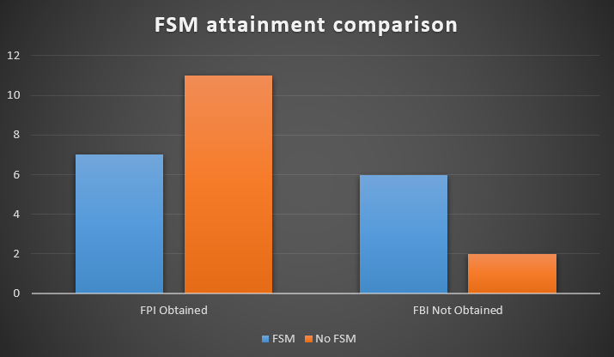
At the end of Foundation Phase thirteen children did not achieve Foundation Phase Indicator, 75% of these children were eligible for FSM.
However, upon further examination of the data, the FSM children who failed to obtain the required level for the Foundation Phase Indicator (FPI) all have Additional Learning Needs (ALN). Whilst there are eight FSM children who obtained FPI, Donaldson (2015) advises viewing the children as individuals and catering for their individual needs therefore, a measurement of attainment based only on FSM should be considered unreliable.

1.2 An overview of attainment and the Foundation Phase Indicator.

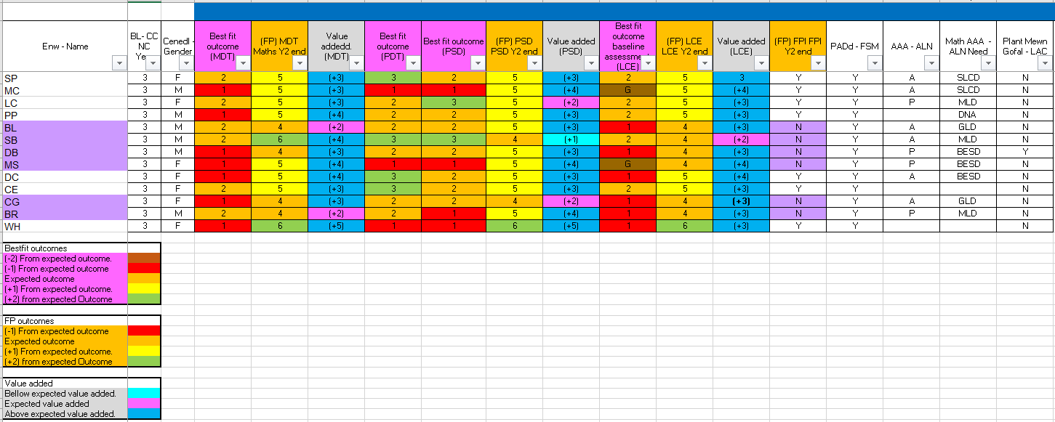

NB: Due to confidentiality the children’s names have been reduced to initials. This information can be provided upon request.

According to Estyn (2014), early intervention is key to tackling the effects of deprivation and poverty. Therefore, upon entering the school each child creates an ‘I want to’ plan, which allows the children, parents/carers and teachers to set high and achievable expectations.

1.3 An example of an ‘I want to’ plan.

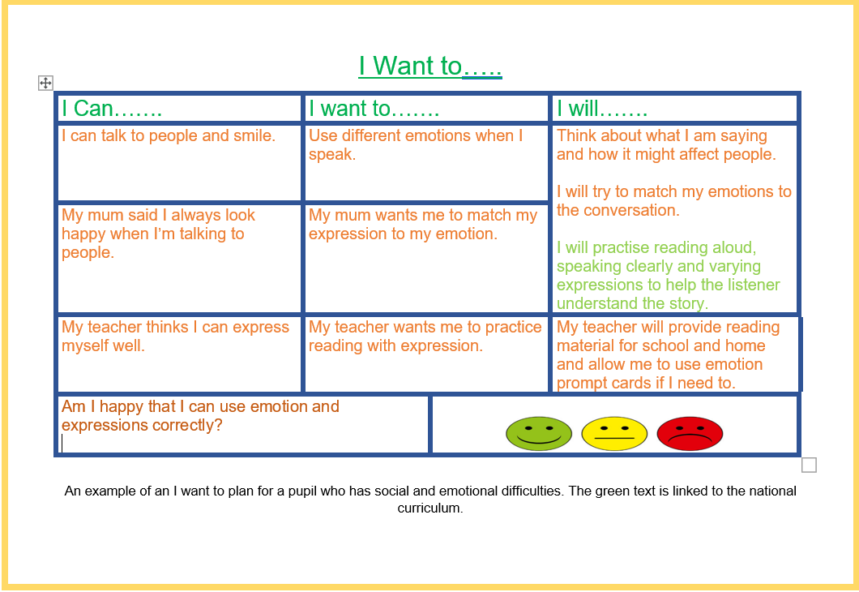
Dweck (2014) and WAG (2015) both state that by setting high, achievable expectations, children will have an intrinsic want to meet said expectations. However, Hattie (2001) believes that such expectation can only be effective if pupil voice is incorporated. Therefore, our ‘I want to’ plans incorporate a significant amount of pupil voice. Furthermore, as a school, we feel that it is important to include our parents/carers in the process. This not only strengthens home-school links, it allows us to build a casual and personal rapport with each family.
Donaldson (2015) and Estyn (2016) raises the question of how an influential environmental can affect attainment. Therefore, as a school we have carefully considered the environments our children are exposed to. To further parental links we have incorporated our parent's council by asking them to help with fund raising and events organising. This enables our school to offer the children engaging and influential experiences through educational school trips, expert key speakers and extracurricular clubs. The success of these strategies will be monitored and assessed on an ongoing basis with adaptations being implemented if and when required. We feel that this will be of significant benefit to pupils eligible for FSM as well as expecting to see an increase in value added across all our pupils.

Gender (1601574)

Overview
In this class it could be suggested that the girls are currently slightly academically outperforming the boys. Throughout the data, there is a slight trend where there is a minutiae gender gap in the children’s baseline data. However, the children have recently been assessed at the end of foundation phase and it is this data the practitioner has utilised to base conclusions upon. The Foundation Phase Indicator (FPI) is a combined measure of performance of pupils at the end of the Foundation Phase (Welsh Government, 2018). In this class, five out of fifteen boys did not achieve their foundation phase indicator, equating to 33%. Whereas three out of eleven girls did not achieve equating to 27%. Wales Online (2016) suggest that nationally for the first time since the statistics were introduced, the difference between boys and girls in the key Foundation Phase Indicator has widened. When the data from the three assessed areas is triangulated and mean attainment average is worked out it results in Outcome 4.86 for the boys and Outcome 5.08 for the girls (Figure 2.1). This results in .22% gap which is arguably quite startling. Hence there is a need to address and find suitable strategies or interventions to remedy.
As a rights’ respecting school, we ensure that our children are free from discrimination whatever their gender (UNICEF, unknown date). To elaborate, as a school we aim to ensure that we avert from gender stereotypes and ensure pupils’ progress regardless of their gender and help them to achieve their full potential. Several articles and documents were analysed in order to find potential strategies and ideas to close the gender attainment gap. Estyn (2008) highlighted that many schools continue to use too limited a range of strategies to cater for the differences between girls and boys in terms of their overall maturity and capability as individual learners. Therefore, when assessing and concluding what strategies to use we placed the pupils at the centre and endeavoured to make sure all strategies respected the pupils’ as individuals.
 | Boys Mean Attainment | Girls Mean Attainment | Difference
LCE | 4.66 | 4.90 | 0.24
MDT | 4.86 | 5.09 | 0.23
PSD | 5.06 | 5.27 | 0.21
Combined | 4.86 | 5.08 | 0.22

Figure 2.1- Differences in gender attainment.

Strategies to close ‘gender attainment gap’

Strategy One: Mixed gender seating plan.
Focus: Ensure children are sat in a mixed gender seating plan and in a boy-girl pattern where possible. However, ensure children are sat with ability groups for differentiation purposes.
Rationale: Skelton, Francis and Valkanova (2007, cited in Department for Children, Schools and Families, unknown date) suggest that the peer group can be of central importance in reinforcing gender stereotypes. Given the choice, pupils usually sit in same-gender groups and this could result in children being influenced by the gendered behaviour of their peers (Department for Children, Schools and Families, unknown date). Hence it could be beneficial to, where appropriate, sit children in mixed gendered tables.
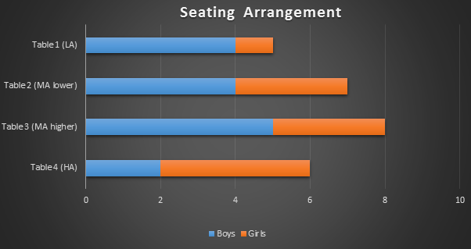

Figure 2.2- How seating is arranged in Year Three.

Strategy Two: Ensure extra-curricular clubs are non-gender restricted.
Focus: Incorporate pupil voice by asking children what extra-curricular clubs they would like to participate in. Examine resources available to implement clubs.
Rationale: As suggested by Department for Children, Schools and Families (unknown date) by adhering to gender stereotypes and creating an idea that only some activities and behaviours are gender appropriate may limit rather than enhance pupils’ engagement with the curriculum. One of the recommendations Estyn (2008) suggest is that schools should challenge gender stereotyping. We ensure that our clubs are not exlusive and non-gender restricted. We ensure that children have access to majority of our clubs by running them both during lunchtime and after school.
 | Monday | Tuesday | Wednesday | Thursday | Friday
Lunchtime | Book club | Debate club | Choir | Film club | Sign Language
After school | Maths | Netball | Rugby | Coding

Figure 2.3- Our extra-curricular clubs.

Strategy Three: Deliver a broad, well-rounded curriculum that engages all our learners and prioritises pupil voice and appeals to pupils’ individualised learning styles.
Focus: Understand pupils individualised learning preferences and interests.
Rationale: Donaldson (2015) envisages a curriculum that engages pupils’ interest. Schools which attempt to alter the curriculum to provide a ‘boy-friendly’ curriculum have been found to reinforce gender stereotypes, but their actions have been shown to be ineffective (Department for Children, Schools and Families, unknown date). Hence, we intend to encourage a curriculum that engages pupils’ interests and avoids stereotypes could raise attainment of all learners regardless of gender.

Reasoning

Closing the Gap Between Boys' and Girls' Attainment in Schools (Estyn, 2008) highlighted a case study that demonstrated how a school modified its overall ethos rather than implementing a singular strategy to improve gender attainment. This arguably effective practice has included identifying learning styles, utilising an effective assessment system to track pupil’s progress toward targets and utilising consistent implementation of positive behaviour policies (Estyn, 2008). Therefore, as a school, we concluded to trial a combination of these suggestion and ensure our extra-curricular clubs are non-gendered restricted in order to further close the marginal attainment gap that exists in this class data.

Monitoring and Assessment.

We aim to further close marginal gender attainment gap by implementing strategies that have been discussed throguhout this report. As a school we shall monitor and track progress using Incerts (Assessment Foundation, unknown date). We aim to endeavour to ensure the marginal attainment gap does not widen and if it does, we shall intervene at the earliest possible point and will reassess chosen strategies.

Future Progression.

If the strategies implemented are successful, we endeavour to share good practice with our staff if they discover there is a marginal gender attainment gap in their classes also. Our school might possibly be entitled to Raise Attainment and Individual Standards in Education (RAISE) Funding (Welsh Government, 2012). The strategy provides schools with funding to target disadvantaged pupils and potentially raise their level of performance. The one condition schools need to have to qualify for additional funding is a free school meal percentage higher than twenty percent. Our school has approximately thirty four percent free school meals. So we concluded that we would investigate this additional funding in future if our school needed to implement specific interventions or purchase resources that would help to close the marginal gender attainment gap. According to Estyn (2008) some schools are using RAISE funding specifically to support boys.

Additional Learning Needs (1600242)
KidsTalk is something that I became interested in during my electives fortnight that I have recently undertaken. The scheme is designed to specifically help with students who have Behaviour, social and emotional difficulties and covers topics such as bullying, behaviour and social situations to familiarise students with these and develop strategies to help them in certain situations. Within Year 3, there are 6 pupils who I have referred to this program as they have been identified as having BESD (behaviour, emotional and social difficulties).
After analysing the data given, it was interesting to see that all 6 pupils with BESD achieved outcome 5 in their end of Foundation Phase Outcomes. As talked about in the presentation, these outcomes suggest that the students have behaviour problems as opposed to social difficulties as they would not have achieved these outcomes if the students had social difficulties. This suggests that behaviour is the key issue with these pupils.
BESD, or Behaviour, Emotional and Social Difficulties effects children who have behavioural issues, may have suffered a highly emotional episode during their lives or maybe socially awkward. These issues also stem from attachment issues and can be a result of how they live their lives at home. According to Government guidelines, BESD is defined as
“Pupils with behavioural, emotional and social difficulties cover the full range of ability and continuum of severity. Their behaviours present a barrier to learning and persist despite the implementation of an effective school behaviour policy and personal/social curriculum. They may be withdrawn or isolated, disruptive and disturbing, hyperactive and lack concentration, have immature social skills or present challenging behaviours.” (DfES, 2015)
BESD is classed as an Additional Learning Need (ALN). This means that the pupils who are classed as having BESD require extra attention inside and outside of the classroom. This requires pupils to complete a one-page profile stating their interests and needs. This one page profile forms the basis of what the pupil needs to succeed in school. These are very much individual and are all unique as they are completed by students themselves and are tailored to what their needs are.
I have decided to use KidsTalk as my main strategy for these 6 students. As found in your handout, this gives information about the topic of “school”. This is predominantly based on behaviour issues and aims to develop strategies to combat bad behaviour within school. This would highly benefit these 6 students as they may be missing vital lessons due to bad behaviour. By going through the KidsTalk program, students will develop strategies and coping mechanisms that could be used during lessons. Judging by the students’ outcomes, it is clear that they have made good progress.
The theory behind KidsTalk is interesting. The way in which the materials are organised appears to replicate the way in which (according to constructivist theories) we develop frameworks of knowledge into which new experiences can be incorporated. The materials are very much based on reality in many and varied ways. (Langdon, n.d) This allows the students to relate to the situations in a personal way as they can understand what is happening in school. The pupils may have even been in the situation before.

Language, Literacy and Communication (1600020)

I have looked at the literacy aspect of the 26 learners within the year 3 class at Ysgol Yr Enfys. All of the learners have made significant progress throughout the foundation phase, however 8 pupils have not reached outcome 5 at the end of this phase, which is the WAG (2015) issued outcome guidelines. WAG (2018) state that 84% of children achieve outcome 5 in Language, Literacy and communication at the end of Foundation phase compare to 93.4% of children achieving outcome 5 in personal and social development, cultural diversity and well-being, showing that literacy teaching needs to be improved to raise standards of attainment. Estyn (2018) show a steady rate of improvement across the curriculum, however there is room of improvement within the literacy and mathematics aspects of the curriculum.
The children within this year 3 class were grouped at the beginning of the school year using the teacher assessment for literacy in year 2. It can be seen in the graph the higher ability group working at outcome 6 have 2 pupils, the middle ability group working at outcome 5 have 16 pupils, which have subsequently been split into 2 groups to enable more cohesive learning and the lower ability group working at outcome 4 have 8 pupils. The lower ability group are in most need of an intervention at this stage to enable them to progress within year 3.

To enable this group to progress it is suggested that the Lexia programme be used to aid the children in their literacy development. The programme is a reading programme which incorporates phonics, spelling, grammar and sentence structure. It will assess the pupil at the start of their learning journey and then create an individualised programme of study to aid the pupil in the areas that need development as Donaldson (2015), Brooks (2016) and Huf & Raggl (2017) advises viewing the children as individuals and catering for their individual needs is an essential part of raising attainment. As the pupil progresses it will alter the learning for the pupil in order to develop them further. The programme will record their progress and development which the teacher can then access to track the pupils progression in order to aid planning within the classroom. Estyn (2017) and Donaldson (2015) state that monitoring and tracking pupil progress will aid in raising pupil attainment. The pupils will be able to access this at home as well as in school, allowing parents to be involved in their child’s learning which Estyn (2018) have suggested helps children achieve.
It is a computerised programme which can be accessed on a tablet, laptop or Ipad which will help the pupils develop their use of ICT also. The children gain points and certificates for their achievements which gives them incentive to want to progress through the program. The cost of the Lexia programme is between £22 and £32 per pupil. To start, the programme will be used for the children in most need of development however if it proves to be successful it could be rolled out throughout the whole school depending on funding. As this is an individually constructed programme of study for the pupil, all pupils could benefit from using the program enabling them to progress at whatever level they start at. It would be expected that the children working at outcome 4 would be able to reach level 5 or higher at the end of year 3 through the use of this program. This program has been successful in many schools such as Maes Yr Haul School and Caerau Shool where they have seen a significant improvement in the pupil’s literacy development within the lower attaining pupils. A study carried out by Brooks (2016) has supported the use of Lexia within schools explaining that the reading scores are improved, it closes the reading gap and builds on early literacy skills.
There are other strategies that could be used, such as one to one reading time, however staffing levels would not allow for this. After school literacy clubs could be introduced however there may not be sufficient uptake of the club to be effective. Read write inc could be used throughout the school, however children are grouped through ability. This may leave some pupils with gaps in their development and a formal assessment is needed in order for them to progress through the program as seen on PTE experiences and the electives. Through the use of Lexia the children have an individualised learning program where they do not have to wait for assessment to be moved on as the program is constantly assessing the pupil’s development and alters the learning for the pupil as they progress which is a more formative way of assessment. Donaldon (2015) has suggested formative assessment as being the way forward for pupil assessment in the future. As there is no formal assessment or test for the pupil with Lexia, it allows the pupils to develop their skills without the worry of a test.
It is felt that this program would benefit the pupils and progress them to their expected outcome or exceed their expected outcome.

Mathematics (1601274)

The Children
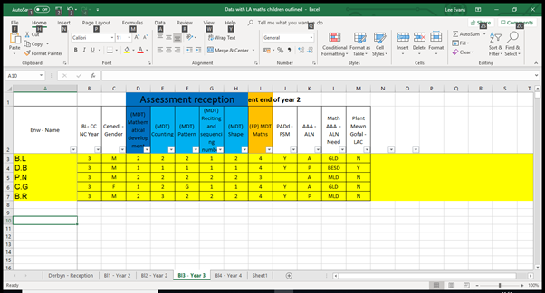
Through assessing the data 81% of the class received outcome 5 or above. However, this table highlights the children identified as needing the intervention doodle maths. Each one of these children are currently below the outcome 5 grade which is expected at the end of foundation phase.

Intervention
The intervention chosen is doodle maths, the is specifically for children aged between 7-11 and so would be suitable for these year 3 children. It begins by the classroom teacher inputting where each child currently sits within the academic year and tailors questions based around the curriculum. There is also a teacher portal which gives the teachers instant feedback on the children and gives reports on each individual childs strengths and weaknesses, allowing the teacher to give appropriate feedback. The programme is designed to be used 10 minutes daily so teachers can fit it around their regular classroom routine. The doodle maths intervention group will be run by an LSA, with both the LSA and the classroom teacher having access to the teacher portal.

Case studies
There has been evidence to suggest that using doodle maths can help raise attainment. In a recent study by the university of Bath they outlined that children that over summer months children lose on average 2.8 marks in their mathematics progress in just 7 weeks. Whilst the children who used doodle maths for as little as 20 minutes per week were 4 times less likely to experience any learning loss.
Link to case study -https://www.doodlemaths.com/wp-content/uploads/2016/10/doodlemaths_study_summary.pdf

Tewkesbury C of E Primary School

What really works for you about DoodleMaths?
DoodleMaths allows the students to work independently and take control of their learning. The work programmes are personalised so it caters for differing abilities and the user friendly nature of the app really engages the children. We use DoodleMaths in a number of ways including lunchtime and early morning clubs, mental maths starters, changeover time between teachers and during wet play.

St Edward’s Preparatory

What really works for you about DoodleMaths?
It works independently and raises areas of weakness through its progressive approach to maths development. This gives the opportunity to individualise teaching at a time when the child is motivated to learn.

Ashford Hill Primary School

All children from Y1 upwards are given DoodleMaths homework. They have to get 50 stars across the week as part of the whole package of what we expect weekly. Teachers keep regular tabs on how many stars the children have earned and we have a catch-up session for those who haven’t managed to achieve the magic 50 in the week.
Children are very motivated to complete their homework this way as they can do it on the go, at the breakfast table or just in a spare 5 minutes. It is leading to our children’s fluency with number being improved and a hot topic of conversation amongst our learners about how many stars they have earned in a week!

Raising attainment

Raising attainment in numeracy and literacy is always a key element within Estyn reports. Estyn (2017) outline the benefits monitoring can have raising attainment within numeracy. Estyn (2017) suggest by teachers successfully utilizing a RAG system for numeracy it can help them monitor progress and raise attainment in numeracy. The teacher portal within the doodle maths application allows teachers to have instant access to each child’s report. It also outlines where the children’s strengths and weaknesses are within the current curriculum. This can help the teacher tailor lessons activities to each individual child’s needs.
Link to report - https://www.estyn.gov.wales/effective-practice/raising-attainment-through-monitoring-pupil-progress

Class Development Plan (1601574)

Priority | Actions
Close marginal gender attainment gap (1601574) | -Develop mixed gender seating plan.  -Aim for boy/girl arrangement where possible | -Ensure extra-curricular clubs are not exclusive  -Utilise pupil voice to decide upon extra-curricular clubs | -Deliver a well-rounded curriculum that incorporates pupil voice.  -Recognise individual leaning styles.
Ensure pupils are not disadvantaged by priority  (1602422) | -To offer pupils many diverse experiences and opportunities for learning.  -Set out clear, high expectations. | -Ensure the school uses local rich resources to give learning a purpose and cement community relationships. | -Build local relationships with families, local business and other relevant resources.
Raise standards of lower attainers in numeracy.  (1601274) | -Incorporate the doodle maths program for our year 3 lower ability children. | -Ensure teachers are frequently monitoring the focus childrens progress on doodle maths. | -Send parental logins out following the childrens assessment on doodle maths.
Raise standards of in literacy | -Implement lexia
Raise standards of children with BESD  (1600242) | -have more parental engagement within the class | –Pupils to complete kids talk program | -Whole class to complete 1 page profile for cover teacher knowledge

Reference list. (1602422)

(N.B. This reference list contains references for both this report and 1602422 presentation)
Dweck, C. (2014) The Power of Yet. Available at: https://www.ted.com/talks/carol_dweck_the_power_of_believing_that_you_can_improve (Accessed 9th January 2019)
Donaldson, G. (2015) Successful Futures. Cardiff: Welsh Assembly Government.
Estyn (2016). Creating a Welcoming Learning Environment. Available at: Estyn (2014). Pupil Deprivation. Available at: https://www.estyn.gov.wales/effective-practice/creating-welcoming-learning-environment (Accessed 19th January 2019)
Estyn (2014). Pupil Deprivation. Available at: https://www.estyn.gov.wales/thematic-reports/pupil-deprivation-may-2014 (Accessed 19th January 2019)
Hattie, J. (2001) Visible Learning for Teachers. Addington: Routledge.
Nation Foundation for Education Research (2014) What Works in Supporting Children and Young People to Overcome Persistent Poverty? Available at: https://www.nfer.ac.uk/media/2027/nieq01.pdf (Accessed 12th January 2019)
Nation Foundation for Education Research (2014) Deprivation in Education. Available at: https://www.nfer.ac.uk/media/2237/wgde01.pdf (Accessed 12th January 2019)
Welsh Assembly Government (2017) A Curriculum for Wales, A Curriculum for Life. [online] Available at: Welsh Assembly. Learning Wales. (2016) Digital Competency Framework [online] Available at: http://learning.gov.wales/resources/browse-all/digital-competence-framework/?lang=en (Accessed 27th December 2018)
Welsh Assembly Government (2017) A Curriculum for Wales, A Curriculum for Life. [online] Available at: Welsh Assembly. Learning Wales. (2016) Digital Competency Framework [online] Available at: http://learning.gov.wales/resources/browse-all/digital-competence-framework/?lang=en (Accessed 27th December 2018)
Welsh assembly Government. (2015) Foundation Phase Framework. [Online] Available at: http://gov.wales/docs/dcells/publications/150803-fp-framework-en.pdf (Accessed 15th Janruray 2019)
Welsh assembly Government. (2010) Guidance on School Attendance. [Online] Available at: https://beta.gov.wales/sites/default/files/publications/2018-03/guidance-on-school-attendance-codes.pdf (Accessed 15th Janruray 2019)
Welsh assembly Government. (2014) Rewriting the Future: Raising ambition and attainment in Wales. [Online] Available at: https://beta.gov.wales/sites/default/files/publications/2018-03/rewriting-the-future-raising-ambition-and-attainment-in-welsh-schools.pdf (Accessed 15th Janruray 2019)
Unicef (No data) UN Convention Rights of the Child. Available at: https://www.unicef.org.uk/what-we-do/un-convention-child-rights/ (Accessed 9th February 2019)
Vygotsky,L (1986) Thought and Language. Massachusetts. MIT Press.

Reference List 1601574 (Presentation on Gender)
- Assessment Foundation (unknown date) Incerts. Available at: http://www.assessmentfoundation.org/about-incerts.html Accessed on: 22nd February 2019]
- Department for Children, Schools and Families (unknown date) Gender issues in school – What works to improve achievement for boys and girls. Available at: https://dera.ioe.ac.uk/9094/1/00601-2009BKT-EN.pdf [Accessed on: 22nd February 2019]
- Donaldson, G. (2015) Successful Futures. Cardiff: Welsh Assembly Government.
- Estyn (2008) Closing the gap between boys' and girls' attainment in schools. Cardiff: Crown Copyright.
- UNICEF (unknown date) The United Nations Convention on the Rights of the Child. Available at: https://downloads.unicef.org.uk/wp-content/uploads/2010/05/UNCRC_united_nations_convention_on_the_rights_of_the_child.pdf?_ga=2.73137811.1295377229.1541588333-330392546.1515010700 [Accessed on: 30th December 2018)
- Wales Online (2016) Girls outperform boys across the board in 'frightening' schools gender gap. Available at: https://www.walesonline.co.uk/news/education/girls-outperform-boys-across-board-11733184 [Accessed on: 26th February 2019]
- Welsh Government (2012) Evaluation of the first three years of RAISE: Final Report. Available at: https://dera.ioe.ac.uk/14459/1/1204019raisereporten.pdf. [Accessed on: 26th February 2019]
- Welsh Government (2018) National Data Collection (NDC) 2018 Question and answer. Available at: https://beta.gov.wales/sites/default/files/publications/2018-03/national-data-collection-question-and-answer-version-1.pdf [Accessed on: 27th February 2019]

Reference List (1601274)
References for both presentation and report.
Donaldson, G. (2015) Successful Futures. Cardiff: Welsh Assembly Government.
Doodle maths education. (date unknown). Case studies. Available: https://www.doodlemaths.com/case-studies/. Last accessed 1st Mar 2019.
Estyn. (2018). Parental involvement with schools helps pupils achieve.Available: https://www.estyn.gov.wales/news/parental-involvement-schools-helps-pupils-achieve. Last accessed 27th Feb 2019.
Estyn. (2017). Raising attainment through monitoring pupil progress.Available: https://www.estyn.gov.wales/effective-practice/raising-attainment-through-monitoring-pupil-progress. Last accessed 27th Feb 2019.
Estyn. (2015). Establishing behaviour groups. Available: https://www.estyn.gov.wales/effective-practice/establishing-behaviour-groups. Last accessed 27th Feb 2019.
Joyner, R & Lyons, S. (2016). The use of an adaptive learning tool prevents and even reverses summer learning . Available: https://www.doodlemaths.com/wp-content/uploads/2016/10/doodlemaths_study_summary.pdf. Last accessed 27th Feb 2019.
Lewis, B. (2018). Pupils' digital skills not keeping pace, Estyn reports.Available: https://www.bbc.co.uk/news/uk-wales-42791009. Last accessed 28th Feb 2019.
Vygotsky,L (1986) Thought and Language. Massachusetts. MIT Press.

1600242 (presentation on BESD)

GOV.UK. (2015). Behaviour and discipline in schools. [online] Available at: https://www.gov.uk/government/publications/behaviour-and-discipline-in-schools [Accessed 1 Mar. 2019].
Langdon, Linda (n.d) Dept of child & adolescent psychiatry. Hounslow. London

1600020 (Presentation for Language, Literacy and Communication.

Brooks, G (2016) What works for children and young people with literacy difficulties? The effectiveness of intervention schemes, Fifth Edition. University of Sheffield. Dyslexia-SpLD Trust.
Donaldson, G. (2015) Successful Futures. Cardiff: Welsh Assembly Government.
Huf, C & Raggl, A (2017) The normativity of the helping child – meta-ethnographic perspectives on individualised learning in age-mixed classrooms, Ethnography and Education, 12:2, 165-177, DOI: 10.1080/17457823.2016.1192479
Caerau Primary School http://www.caerauprimary.co.uk/lexia-club.html (last accessed 27th February 2019).
Estyn. (2017). Raising attainment through monitoring pupil progress. https://www.estyn.gov.wales/effective-practice/raising-attainment-through-monitoring-pupil-progress. (Last accessed 26th Feb 2019.)
Estyn (2018) Annual Report 2017 – 2018 https://www.estyn.gov.wales/sites/default/files/documents/ESTYN_Annual%20Report_Accessible_English__2018.pdf (last accessed 25th February 2019).
Estyn. (2018). Parental involvement with schools helps pupils achieve. https://www.estyn.gov.wales/news/parental-involvement-schools-helps-pupils-achieve.(Last accessed 26th Feb 2019.)
Lexia Reading skills software file:///C:/Users/Sam%20D/AppData/Local/Packages/Microsoft.MicrosoftEdge_8wekyb3d8bbwe/TempState/Downloads/LxUK_Core5_Primary_Leaflet.pdf (last accessed 25th of February 2019).
Maes Yr Haul Primary School http://www.maesyrhaul.com/downloads/prospectus.pdf (last accessed 24th February 2019).
WAG (2015) Foundation phase outcomes and National Curriculum teacher assessment of core subjects at key stage 2 and 3. https://gov.wales/statistics-and-research/end-foundation-phase-outcomes-national-curriculum-teacher-assessment-core-subjects-key-stages-2-3/?lang=en (last accessed 24th February 2019).

