
Riccardo Russo
1815101
Marketing Essential
M4X01916

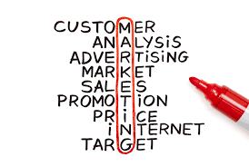

Lecture: Dale Clarke

Content Page
- Introduction to MIS…………………………………….……………………………………………….3

- The four main components of MIS……………………..…………………………………………….4

- MIS for Marketing and MIS for Information Gathering…..…………………………………………5

- MIS for Communication………………………………………………………………………………..6

- What is Marketing Mix? ……………………………………………………………………………….7

- The 7Ps………………………………………………………………………………………………….8

- Conclusion………………………………………………………………………………………………8

- Reference……………………………………………………………………………………………….9

Marketing Information System

As part of this assignment, Marketing Information System will be explored to look at how this is used in the hotel industry.

My work place, the famous hotel “The Connaught” located in Mayfair will be examined during this assignment.

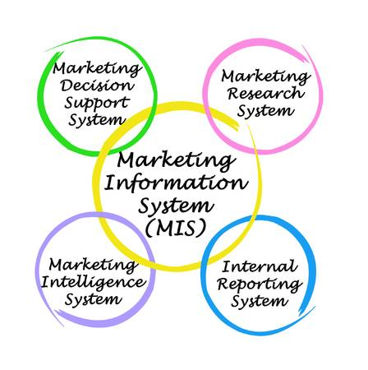

According to “Principles of Marketing”, the intention of marketing is to produce value for customers and capture value from customers in return (Kotler and Armstrong, 2017).

Marketing Information System, abbreviated “MIS”, is a mix of procedures and techniques designed to generate and analyze marketing decisions. (Bhasin, 2019)

MIS is one of the components of Marketing and is a constantly evolving system of receiving information for future business decisions.

The most important role of “MIS” is to provide through different components as many resources as possible to take the best marketing decision in the interests of the company.
This information is collected, analyzed and distributed to those responsible for the final decision, usually the Marketing Manager.
The Marketing Information System, usually, receive information from facts, studies, opinions, regulations, internet, statistics, and so on.
These data are essentials for marketing decisions and they are collected by internal and external sources.
Marketing Information System collects the data required, the data are analyzed and then they are supplied to the Marketing Manager who will take the decision on how to act.

The four main components of MIS

The four main components of MIS are:

Internal Records
The Internal Records are all the information about the company, which can be past information, present information, future previsions.
Sales, costs, inventories, cash flow and account receivable and payable, and so on.
All these components are often kept for years and archived to be accessible.

Marketing Intelligence
The second component of MIS is Marketing Intelligence, which allows us to obtain data from external sources.
These data can be easily gathered from magazine, trade journal, commercial press and so on.
They can be of decisive importance to understand how the market and, therefore, the external environment is evolving.

Marketing Research
The third component is the most specific one.
It is used in cases where is important to analyze a given market and its risks and benefits.
Marketing Research (MR) is a specific system that influences that good or service, searches for certain information and release them to those who must act and take decisions.

Marketing managers may look for advice from marketing specialists. It is important that research reports should specify alternative ways of action and the probability of success (Crawford, 1997).

Marketing Decision Support System
This component is made of all technological and non-technological supports that help the development of the three previous points.
Elements that allow us to obtain the information we need, which can be: Hardware, software, computer program and so on.

MIS for Marketing

Marketing is the set of techniques used to put goods and services for the consumer in a given market, in a given time and place, at the lowest cost for the consumer and at the same time remunerative for the company.

The process where companies create value for customers building a strong relationship with them, in order to have their return, is called Marketing. (Kotler, Armstrong and Opresnik, 2013)

The MIS allows us to create Marketing, therefore to create an environment in which we know we can go out with profit.

“The Connaught” Hotel is established since 1815 in the heart of Mayfair, London.
Surely this can be an expression of using the right techniques of Marketing to deliver a hospitality service for more than two hundred years.
Right service in the right place and time, at affordable prices for determined guests, making profit and creating value.

MIS for Information Gathering

In gathering information, MIS allows us to use internal and external sources to achieve the final goal.

The collection sources are internal when:
they are mainly developed within the company and give us a general picture (past, present and future) of what is happening.

The external collection sources instead:
they are developed externally to the company and follow mainly the market and its events.
These sources allow us to adapt to what is happening on main field and that will influence the final choices of the company.

Another very current example of MIS for Information Gathering, certainly today widespread, is the use of the APP - “WhatsApp”.
In large companies and, especially in large teams, the use of a WhatsApp group is very widespread to speed up the transfer of information between the various colleagues as we do in “The Connaught”.
All this has certainly speeded up the collection and dissemination of important data that allow us to be always updated on what happens inside and outside the company for which we work.
I think this can be an example of Information Gathering in 2019, much used by hospitality companies given the growing number of very demanding guests.

MIS for Communication

Communicating is becoming increasingly important every day; transmitting a message, a concept, an experience and so on is at the base of a winning project.
Using MIS to communicate involves an arduous research (MR) that will lead us to be more incisive than our competitor.

A clear example of MIS for communication is the birth of the “Social Media Manager”, a professional figure dedicated to involving as many followers as possible to the company.

At "The Connaught", our Social Media Manager implements a very open policy where, the help of all the staff is required. Each of us can send photos or videos of daily events, which then, will be posted on the various social networks to keep them updated daily.
According to Seth Godin, today is more important the way we sell something than what we sell! (Godin, 2018)

All companies that have a direct sale of a good or service must be particularly specialized in communication.
A hotel like "The Connaught" must surely create an environment, inside and outside, winning in the communication field.
The direct contact with the guest, our source of profit, needs a certain approach.

In the moment where we lose a single customer, we are losing not only a single sale.
It means losing the entire stream of purchases that the customer would make over a lifetime of patronage. (Kotler and Armstrong, 2017)

Marketing Mix

Marketing Mix is ​a sale strategy created thanks to the union of the 4Ps:
- Product;
- Place;
- Promotion;
- Price;

The extended version of the Marketing Mix adds 3Ps to the previous 4 and so we will have:
- People;
- Process;
- Physical evidence.

The right calibration of these elements leads us to introduce our good or service in the market with the high probability of having success in the daily competition: the right product in the right place at the right time at the right price! (Adcock, Halborg and Ross, 2002)

However, companies need to think about the customer's point of view.
That is why are born the 4Cs:
- Customers Value;
- Cost for the customer;
- Communication;
- Convenience;
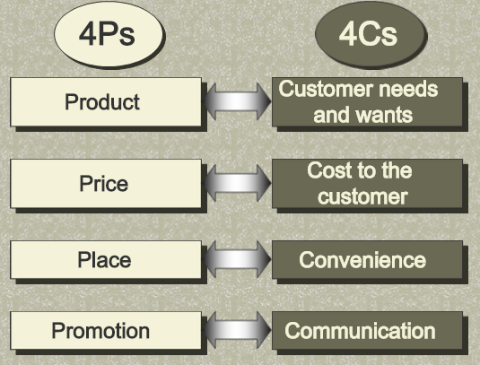

THE 7 Ps
- Product
For a Hotel, such as "The Connaught" is their proposal of Hospitality.

- Place
Taking into consideration the hotel for which I work, there are different sales channels: direct, online, travel agents, etc.

- Promotion
At "The Connaught" we try to keep our guests always informed about what happens daily using social media; in this way we also create an ongoing interest for the hotel.

- Price
The luxurious hospitality service presented at "The Connaught" has a high price given the very high standards.

- People
In the hospitality industry, nothing is more important than the team.
At "The Connaught" continuous training is provided to keep always the standards as high as possible.

- Process
General control of how the sales process is evolving and how much we have influence with our product into the market.

- Physical Evidence
The evidence that our Marketing is successful as it allows us to create value and profit, recognized from years of customer satisfaction, awards and so on.

Conclusion

During this presentation, we have examined different aspects of Marketing.
Starting from the MIS, we can see how receiving the right information can allow us to be influential in the market and competitive.
Furthermore, the reception of the information we need allows us to reduce costs considerably, being fully focused on what is the right thing to do.
All these thanks to the 4 components of the MIS, which help us clearly to define where to work and focus.

The Marketing Mix allowed me to clearly see the right elements for the company and the consumer to create value and profit.
The 4Ps that later became 7, are the clear elements on which to focus your proposal before putting it on the market.

I think the whole of the MIS and the Marketing Mix are already an excellent match to create a valid proposal within a market.
I am sure that many other fascinating elements create Marketing itself but surely with the right analysis of these two studied in this assignment, we can already create value with our product.

References

Adcock, D., Halborg, A. and Ross, C. (2002). Marketing. London: Financial Times Pitman
Bhasin, H. (2019).
What is MIS? What is a Marketing information system? Explained in detail. [online].
Available at: https://www.marketing91.com/mis-marketing-information-system/ [Accessed 1 Mar. 2019].

Crawford, I. (1997). Marketing Research and Information System. FAO, p.8.

Godin, S. (2018). This is marketing. ROIEDIZIONI

Kotler, P., Armstrong, G. and Opresnik, M. (2013). Principles of marketing. Pearson Education.

Kotler, P. and Armstrong, G. (2017). Principles of Marketing. 14th ed. Pearson Education, p.31.

Kotler, P. and Armstrong, G. (2017). Principles of Marketing. 14th ed. Pearson Education, p.49.

