

Data Mining Report

Programme: BSc Applied Computing

Module: Data Warehousing & Data Mining
Module code: ACCA6026
Student Name: John Gabriel Kak Yomon Meki
Student ID: 2321436
Lecturer: Md Abrar Jahin Almazi Bipon

Submission Date: 31 July 2026

Table of Contents
1. Introduction 3
2. Data Mining in Customer Analytics 3
2.1 Purpose and Practice of Data Mining 3
2.2 Dataset Description and Exploration 4
2.3 Data pre-processing and post-processing 5
2.4 Sample Runs and Analysis Methods 7
3. Business Recommendations 12
4. Reflective Commentary 13
5. Conclusion 14
6. References 16
7. Appendix A Weka Confusion Matrices 18
A.1 ZeroR Confusion Matrix 18
A.2 J48 Decision Tree Confusion Matrix 18
A.3 Logistic Regression Confusion Matrix 19
A.4 Random Forest Confusion Matrix 19
A.5 Naïve Bayes Confusion Matrix 20

1. Introduction
Retaining existing customers is a major challenge in the telecommunications industry, where customer churn can significantly affect revenue, profitability, and long-term business growth. As competition increases, organisations rely on data-driven approaches to identify customers likely to leave and develop targeted retention strategies. Data mining provides techniques for analysing large datasets to support customer behaviour analysis and business decision-making. This report investigates customer churn prediction and customer segmentation using the IBM Telco Customer Churn dataset. Several classification and clustering techniques are implemented and evaluated in Weka to determine their suitability for supporting customer retention and improving business decisions.

2. Data Mining in Customer Analytics

2.1 Purpose and Practice of Data Mining
Data mining is the process of discovering meaningful patterns, relationships, and trends from
large datasets to support informed decision-making [2]. It combines statistical analysis, machine
learning, and data exploration techniques to transform raw data into useful knowledge. Rather
than simply describing past events, it enables organisations to predict future outcomes and
identify opportunities for improving business performance [2], [3].
In retail and business environments, data mining supports a wide range of activities, including
customer segmentation, sales forecasting, fraud detection, recommendation systems, and
customer relationship management (CRM). One of its most valuable applications is customer
analytics, where historical customer data are analysed to understand purchasing behaviour,
predict future actions, and improve service delivery [2]. These insights enable organisations to
make evidence-based decisions and allocate resources more effectively.
Customer churn prediction is a common application of classification techniques, which estimate
the likelihood that a customer will discontinue a service. Clustering techniques complement this
process by identifying groups of customers with similar characteristics, allowing businesses to
tailor products, services, and retention strategies to different customer segments [2], [3].
However, predictive performance alone is insufficient. Effective data mining models should also
produce reliable, interpretable, and practical results that support business decision-making [4].
Consequently, organisations increasingly combine predictive modelling with customer
segmentation to improve retention strategies and maintain long-term customer relationships.

2.2 Dataset Description and Exploration
The analysis was conducted using the IBM Telco Customer Churn dataset, a publicly available
dataset widely used for customer analytics and machine learning research [5]. It contains
customer demographic information, subscribed services, account details, billing records and a
binary target variable indicating whether a customer remained with the telecommunications
provider or discontinued the service. The combination of numerical and categorical attributes
makes the dataset suitable for both classification and clustering tasks, allowing customer churn
to be predicted while supporting customer segmentation.
The original dataset consisted of 7,043 customer records described by 21 attributes, including
the unique customerID field. During the initial inspection, 11 records were found to contain
missing values in the TotalCharges attribute. As these represented only a small proportion of
the dataset, they were removed rather than imputed to preserve the integrity of the financial
information. The customerID attribute was also excluded because it functions solely as a unique
identifier and provides no predictive value. Following these adjustments, the analytical dataset
contained 7,032 complete customer records and 20 predictive attributes, with Churn retained as
the target variable.
The dataset includes four main categories of information. Demographic variables describe
customer characteristics such as gender, senior citizen status and partnership. Account-related
variables include contract type, tenure, payment method and billing preferences. Service-related
attributes record the telecommunications services subscribed to by each customer, while
financial variables capture monthly and cumulative charges. Together, these attributes provide a
comprehensive representation of customer behaviour and the factors that may influence
customer attrition.
Exploratory data analysis (EDA) was performed using Microsoft Excel and Tableau before
predictive modelling. The purpose of this stage was to verify data quality, understand the
distribution of key variables and identify patterns that could influence model performance [6].
The analysis showed that approximately 73.42% of customers remained with the provider,
whereas 26.58% had churned. Although this represents a moderate class imbalance, the
original distribution was retained because it reflects realistic business conditions.
Further exploration identified several behavioural trends. Customers on month-to-month
contracts were considerably more likely to churn than those on longer-term contracts.
Higher churn rates were also observed among customers using fibre optic internet services and
electronic cheque payment methods, while shorter customer tenure was associated with a
greater likelihood of service cancellation. These observations are consistent with findings
reported in previous customer churn studies [7], [8]. Consequently, the exploratory analysis not
only improved understanding of the dataset but also identified the variables most likely to
influence predictive modelling.

2.3 Data pre-processing and post-processing
Data pre-processing is a critical stage of the data mining process because the quality of the
input data directly influences the reliability of predictive models [2]. Real-world datasets
frequently contain missing values, redundant attributes and inconsistencies that can reduce
model performance if left unaddressed. The objective of this stage was therefore to prepare a
clean, consistent and representative dataset for analysis.
The first step involved examining the dataset for missing values and data quality issues.
Inspection identified 11 incomplete records containing missing values in the TotalCharges
attribute. As these represented less than 0.2% of the dataset, the records were removed rather
than replaced with estimated values, preserving the accuracy of the financial information while
avoiding potential bias introduced through imputation [9]. Following their removal, the dataset
contained 7,032 complete customer records.
The customerID attribute was excluded before model development because it serves only as a
unique identifier and contains no information relevant to predicting customer churn. Including
identifier fields may increase model complexity without improving predictive performance [2].
The remaining variables were then verified to ensure that numerical attributes such as tenure,
MonthlyCharges and TotalCharges were correctly formatted, while categorical variables
including Contract, InternetService and PaymentMethod were checked for consistency before
importing the dataset into Weka Explorer.
Although the dataset exhibited a moderate class imbalance, with approximately 73% non-churn
and 27% churn observations, no balancing technique was applied. Maintaining the original class
distribution provides a more realistic representation of operational business data and allows
model performance to be evaluated under practical conditions [10]. Instead of just relying on
classification accuracy, several complementary performance measures were considered,
including precision, recall, ROC Area and Cohen's Kappa, providing a more balanced
assessment of predictive capability [11].
All classification experiments were conducted using 10-fold cross-validation, a widely accepted
validation technique that divides the dataset into ten subsets. Each subset is used once for
testing while the remaining subsets are used for training, with the final performance obtained by
averaging the results across all iterations [12]. Compared with a single train-test split, this
approach reduces sampling bias and produces a more reliable estimate of model performance.
Following model development, post-processing activities were carried out to organise and
interpret the experimental results. Performance measures generated by Weka, including
classification accuracy, precision, recall, ROC Area and Cohen's Kappa, were summarised in
comparative tables to facilitate objective evaluation across the five classifiers. Confusion
matrices were also examined to assess each model's ability to distinguish between customers
who churned and those who remained. Finally, Tableau was used to produce visualisations that
summarised both the exploratory analysis and the comparative algorithm performance,
presenting the findings in a clear and accessible manner. These post-processing activities
transformed the raw experimental outputs into meaningful business insights and established a
sound foundation for the comparative analysis presented in the following section.

2.4 Sample Runs and Analysis Methods
The prepared IBM Telco Customer Churn dataset was analysed using Weka Explorer, an open-
source platform for implementing and evaluating machine learning algorithms [2], [13]. The
overall analytical process followed in this study is illustrated in Figure 1, showing the
progression from data preparation to model evaluation.
Data Preparation Workflow Figure
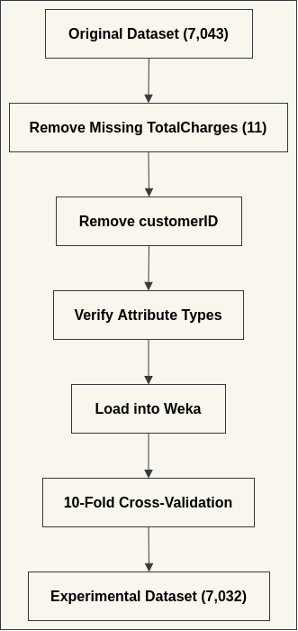

Figure 1: Data Preparation Workflow

The Churn attribute was defined as the target class for all supervised learning experiments.
Each classifier was evaluated using 10-fold cross-validation, in which the dataset was divided
into ten subsets, with nine used for training and one for testing in each iteration [12]. This
approach provides a reliable estimate of predictive performance while reducing sampling bias.
Five supervised classification algorithms were evaluated. ZeroR served as the baseline
classifier by predicting the majority class [2]. J48 Decision Tree generated interpretable decision
rules [14], Logistic Regression estimated the probability of customer churn through statistical
modelling [15], Random Forest combined multiple decision trees to improve prediction accuracy
[16], and Naïve Bayes applied probabilistic classification based on Bayes' theorem [17].
In addition, SimpleKMeans clustering grouped customers with similar characteristics without
predefined class labels, producing three distinct customer segments that support targeted
retention strategies (Table 2) [18].
Classifier performance was evaluated using accuracy, precision, recall, ROC Area and Cohen's
Kappa, providing a balanced comparison of predictive capability [11]. The overall performance
of the classification models is summarised in Table 1, while the corresponding confusion
matrices, which provide a detailed breakdown of correct and incorrect classifications for each
algorithm, are presented in Appendix A.
Cluster | Distribution
Cluster 1 | 32%
Cluster 2 | 43%
Cluster 3 | 26%
Table 1: SimpleKMeans Cluster Distribution

The comparative performance of the five classification algorithms is presented in Table 2.
Classification Algorithm | Accuracy (%) | ROC Area | Cohen's Kappa
ZeroR | 73.42 | 0.500 | —
J48 | 78.36 | 0.774 | 0.4098
Logistic Regression | 80.48 | 0.845 | 0.4723
Random Forest | 78.34 | 0.821 | —
Naïve Bayes | 73.36 | 0.818 | —
Table 2: Comparative Performance of Classification Algorithms
The results indicate clear differences between the evaluated models. ZeroR produced the
weakest performance because it predicted only the majority class. J48 improved classification
while remaining easy to interpret, whereas Random Forest achieved competitive predictive
performance through ensemble learning. Naïve Bayes provided acceptable discrimination
despite lower overall accuracy. Logistic Regression achieved the strongest overall performance
across the selected evaluation metrics, making it the most suitable model for predicting
customer churn in this dataset. The Weka results were supported by Tableau visualisations.
Figure 2 shows that 73.42% of customers remained with the provider, while 26.58% had
churned, confirming a moderate class imbalance.
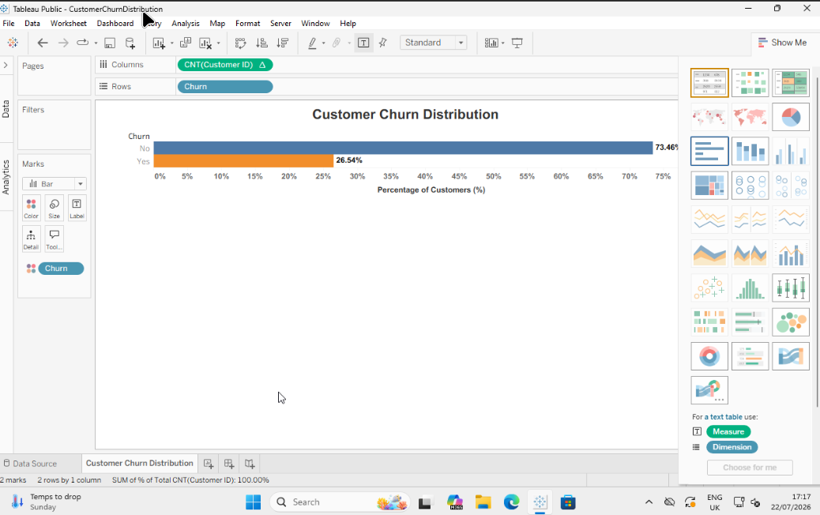

Figure 2: Customer Churn Distribution.
Further visual analysis identified the characteristics most strongly associated with churn.
Customers on month-to-month contracts experienced considerably higher churn rates than
those with longer contracts (Figure 3).
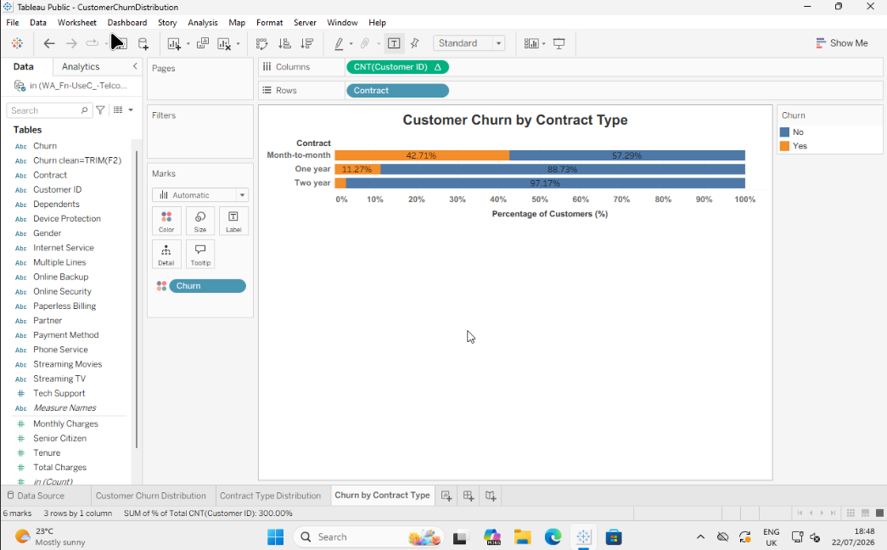

Figure 3. Customer churn by contract type.
Figure 4 illustrates customer churn by internet service type
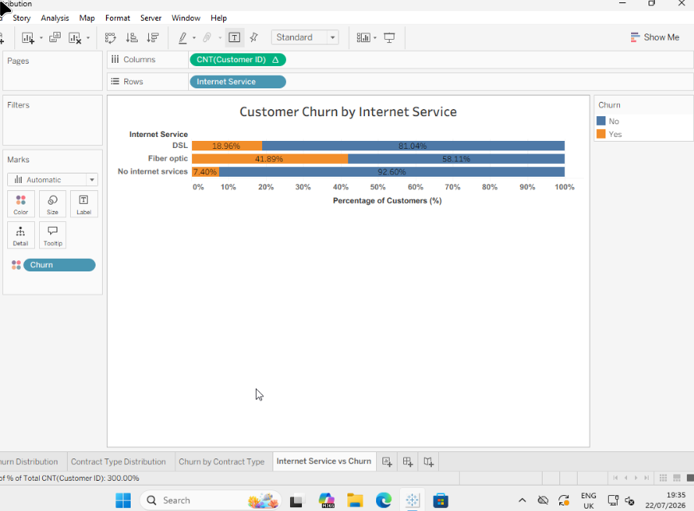

Figure 4: Customer churn by internet service
Customer churn by payment method is shown in Figure 5
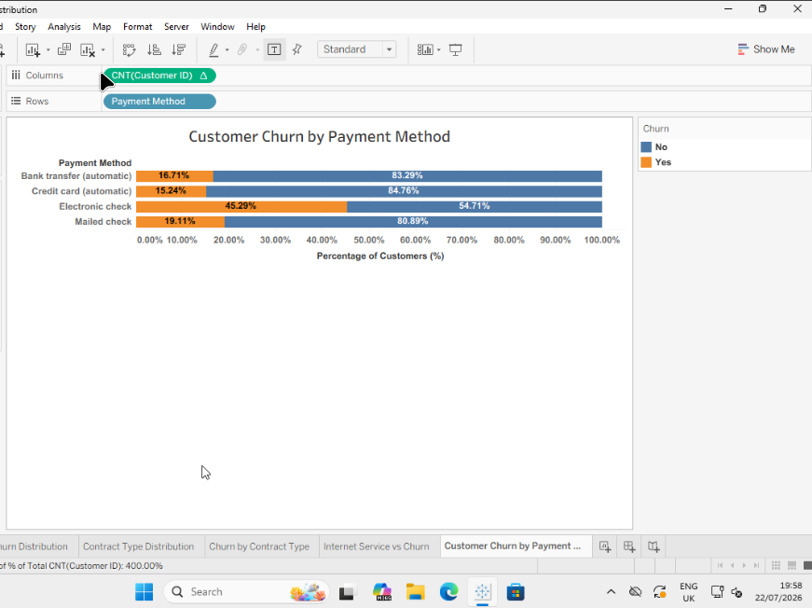

Figure 5: Customer churn by payment method.
Finally, customers with shorter service tenure were more likely to leave the provider than long-term subscribers (Figure 6).
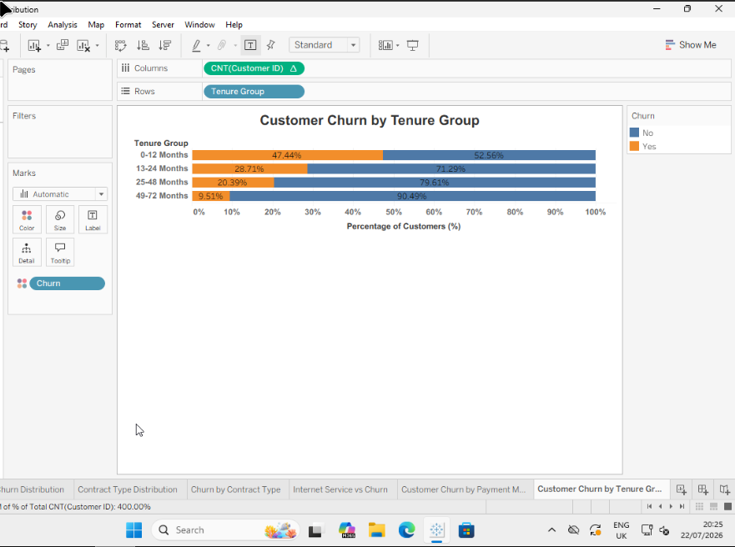

Figure 6: Customer churn by tenure.
These findings are consistent with the Weka classification results, reinforcing that service tenure is a key factor associated with customer churn and supporting the business recommendations presented in the following section.

3. Business Recommendations
The comparative analysis demonstrated that data mining can provide valuable support for
customer retention by identifying customers with a higher probability of churn before they
discontinue the service. Although all classification algorithms improved upon the ZeroR
baseline, Logistic Regression achieved the strongest overall predictive performance, making it
the most suitable model for this dataset. However, model selection should also consider
business requirements such as interpretability, computational efficiency and ease of
implementation rather than just relying on predictive accuracy.
The findings suggest that organisations should prioritise customers identified as high risk for
proactive retention initiatives. These may include personalised pricing offers, contract renewal
incentives, loyalty rewards or enhanced customer support before the contract expires. Such
targeted interventions allow organisations to allocate retention resources more efficiently while
reducing the costs associated with acquiring new customers. By focusing on customers who are
most likely to leave, organisations can improve retention rates without applying costly incentives
across the entire customer base.
Exploratory analysis also identified several customer characteristics associated with higher
churn. Customers with month-to-month contracts, short service tenure, fibre optic internet
services and electronic cheque payment methods were more likely to discontinue their
subscriptions. These behavioural patterns provide useful business intelligence that can support
customer relationship management. For example, organisations may encourage customers to
move from short-term to longer-term contracts or introduce onboarding programmes that
improve customer engagement during the early stages of a subscription.
The customer segments identified using SimpleKMeans clustering provide additional

opportunities for targeted decision-making. Rather than applying a single retention strategy to all
customers, organisations can tailor marketing campaigns and service improvements according
to the characteristics of each customer group. This segmented approach is more likely to
improve customer satisfaction while making better use of marketing resources.
Predictive models should not be considered static solutions. Customer behaviour changes over
time in response to market conditions, pricing strategies and competitor activity. Consequently,
organisations should regularly retrain and validate predictive models using updated operational
data to maintain classification accuracy and ensure that business decisions continue to reflect
current customer behaviour.
Overall, this study demonstrates that data mining offers practical value beyond predictive
modelling. By combining customer churn prediction with customer segmentation, organisations
can support evidence-based decision-making, improve customer retention and allocate
business resources more effectively. The results highlight the importance of selecting predictive
models that achieve an appropriate balance between accuracy, interpretability and practical
business application.

4. Reflective Commentary
This project provided valuable practical experience of applying data mining techniques to a real-
world business problem. Before undertaking the analysis, my understanding of customer churn
prediction was largely theoretical. Through working with the IBM Telco Customer Churn dataset,
I developed a greater appreciation of the importance of data preparation, model selection and
performance evaluation in producing reliable analytical results. The project demonstrated that
effective predictive modelling depends not only on choosing appropriate algorithms but also on
ensuring that the underlying data are accurate, consistent and suitable for analysis.
Using Weka Explorer allowed me to compare different machine learning algorithms and
understand that predictive accuracy alone is not sufficient when selecting a model. The
evaluation highlighted the importance of considering additional measures such as precision,
recall, ROC Area and Cohen's Kappa, together with model suitability for practical use.
Comparing the strengths and limitations of the classifiers reinforced the idea that different
business problems may require different analytical approaches rather than a single best-
performing algorithm.
The project also strengthened my ability to interpret technical findings within a business context.
Rather than viewing machine learning as an isolated technical exercise, I recognised how
predictive analytics can support customer retention strategies, improve resource allocation and
contribute to evidence-based decision-making. This broader perspective increased my
understanding of the relationship between data analysis and organisational objectives.
Overall, this assignment enhanced both my technical and analytical skills while reinforcing the
importance of combining sound data preparation, appropriate model evaluation and critical
interpretation. These experiences have increased my confidence in applying data mining
techniques to future business analytics projects and provided a strong foundation for further
study in data science and machine learning.

5. Conclusion
This report examined the use of data mining techniques for customer churn prediction and
customer segmentation using the IBM Telco Customer Churn dataset. After data preparation
and exploratory analysis, five classification algorithms and the SimpleKMeans clustering
algorithm were implemented and evaluated using Weka Explorer.
The results showed that all classification models outperformed the baseline ZeroR classifier,
with Logistic Regression delivering the best overall balance of predictive accuracy, reliability and
interpretability. SimpleKMeans also identified meaningful customer segments, demonstrating
how clustering complements predictive modelling by supporting targeted retention and
marketing strategies.
The findings emphasise that successful predictive analytics relies not only on selecting
appropriate algorithms but also on high-quality data, robust evaluation methods and accurate
interpretation of results. Combining classification and clustering enables service providers to identify customers at risk of churn more effectively and develop targeted retention strategies.
Overall, the study demonstrates the practical value of data mining for customer analytics and
highlights the importance of aligning analytical techniques with organisational objectives. Future
research could investigate advanced ensemble methods, deep learning and explainable artificial
intelligence to further improve predictive performance and model transparency.

6. References
[1] V. Kumar and W. Reinartz, Customer Relationship Management: Concept, Strategy, and
Tools. Berlin, Germany: Springer, 2018.

[2] I. H. Witten, E. Frank, M. A. Hall, C. J. Pal, and M. Mayo, Data Mining: Practical Machine
Learning Tools and Techniques, 5th ed. Cambridge, MA, USA: Morgan Kaufmann, 2025.

[3] J. Han, J. Pei, and H. Tong, Data Mining: Concepts and Techniques, 4th ed. Cambridge,
MA, USA: Morgan Kaufmann, 2022.

[4] IBM, "Telco Customer Churn," IBM Community – Base Sample Data Sets, Jul. 11, 2019.

[5] V. Kotu and B. Deshpande, Data Science: Concepts and Practice, 2nd ed. Burlington,
MA, USA: Morgan Kaufmann, 2019.

[6] W. Verbeke, D. Martens, C. Mues, and B. Baesens, "Building comprehensible customer
churn prediction models with advanced rule induction techniques," Expert Systems with
Applications, vol. 38, no. 3, pp. 2354–2364, 2011.

[7] A. Khattak et al., "Customer churn prediction using composite deep learning technique,"
Scientific Reports, vol. 13, Art. no. 17294, 2023.

[8] S. García, J. Luengo, and F. Herrera, Data Preprocessing in Data Mining. Cham,
Switzerland: Springer, 2015.

[9] H. He and E. A. Garcia, "Learning from imbalanced data," IEEE Transactions on Knowledge
and Data Engineering, vol. 21, no. 9, pp. 1263–1284, 2009.

[10] S. Bates, T. Hastie, and R. Tibshirani, "Cross-validation: What does it estimate and how
well does it do it?," Journal of the American Statistical Association, vol. 119, no. 546, pp.
1434–1445, 2024.

[11] J. R. Quinlan, C4.5: Programs for Machine Learning. San Francisco, CA, USA: Morgan
Kaufmann, 1993.

[12] A. Géron, Hands-On Machine Learning with Scikit-Learn, Keras & TensorFlow, 3rd ed.
Sebastopol, CA, USA: O'Reilly Media, 2022.

[13] A. K. Jain, "Data clustering: 50 years beyond K-means," Pattern Recognition Letters, vol.
31, no. 8, pp. 651–666, 2010.

[14] D. M. W. Powers, "Evaluation: From Precision, Recall and F-Measure to ROC,
Informedness, Markedness and Correlation," Journal of Machine LearningTechnologies,
vol. 2, no. 1, pp. 37–63, 2011.

[15] G. W. Cassales, J. J. Liu, A. Bifet, B. Pfahringer, and E. Frank, "Accelerated Weka: GPU
Machine Learning with Weka Workbench," Neurocomputing, vol. 646, Art. 130432, 2025.

7. Appendix A Weka Confusion Matrices
This appendix presents the confusion matrices generated by Weka Explorer for each classification algorithm evaluated in the study. These matrices provide detailed classification outcomes by showing the numbers of correctly and incorrectly classified churn and non-churn instances, supporting the comparative performance discussed in Section 1.4.

A.1 ZeroR Confusion Matrix
Presents the baseline classification results, illustrating the performance achieved by predicting only the majority class.
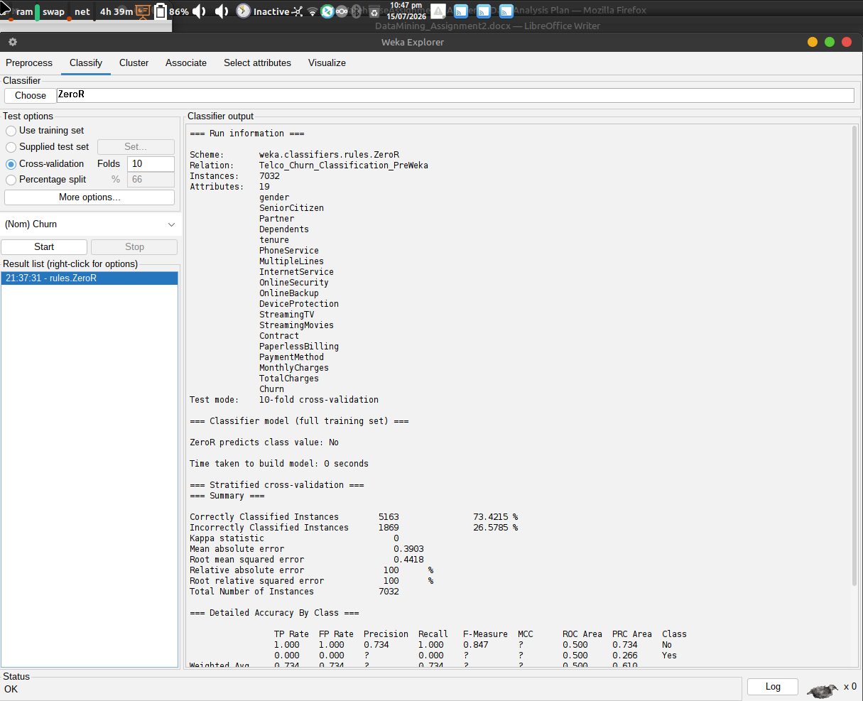

Figure 1: ZeroR Confusion Matrix

A.2 J48 Decision Tree Confusion Matrix
Shows the classification results produced by the J48 decision tree algorithm, including correctly classified instances and prediction errors.
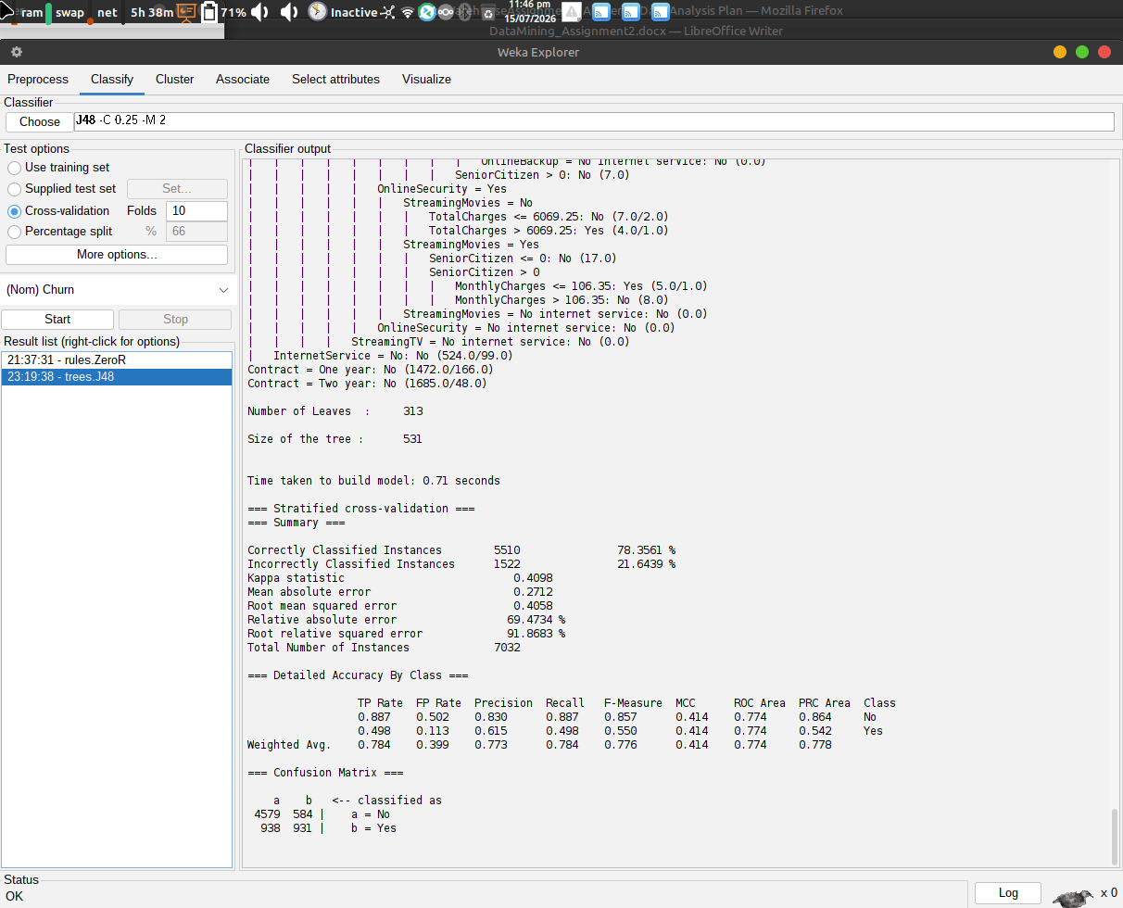

Figure 2: J48 Decision Tree Confusion Matrix

A.3 Logistic Regression Confusion Matrix
Presents the classification outcomes for Logistic Regression, the best-performing model in this study, illustrating its ability to distinguish between churn and non-churn customers.
Figure: Logistic Regression confusion matrix.
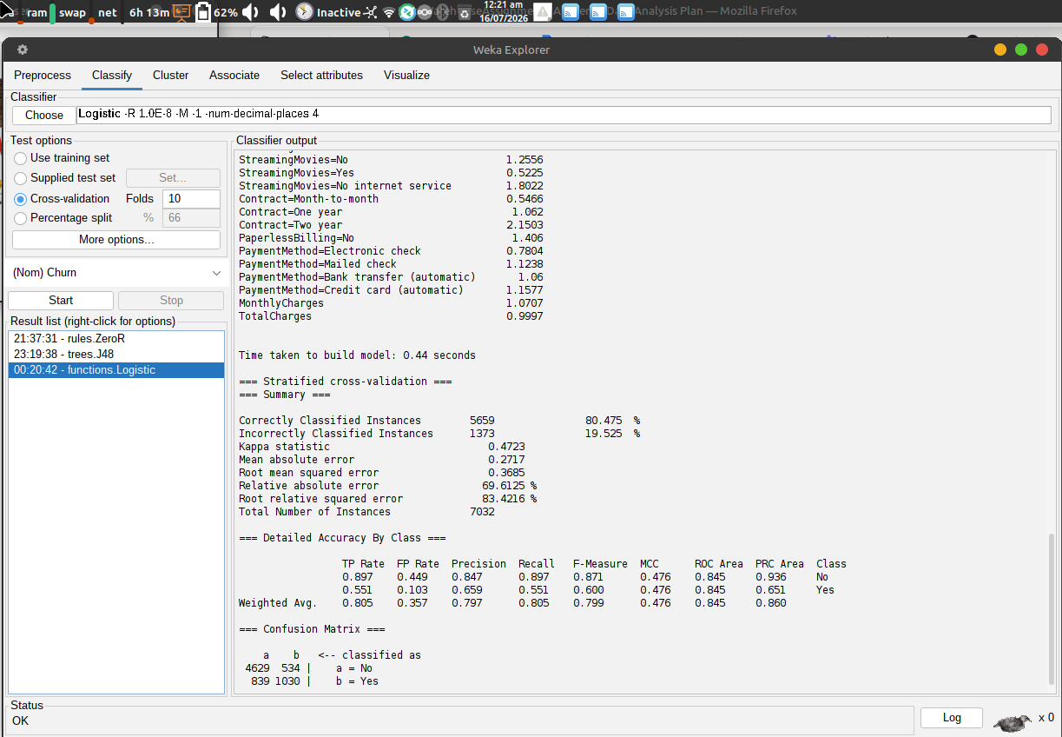

Figure 3: Logistic Regression Confusion Matrix

A.4 Random Forest Confusion Matrix
Shows the classification performance of the Random Forest algorithm, highlighting the distribution of correct and incorrect predictions.
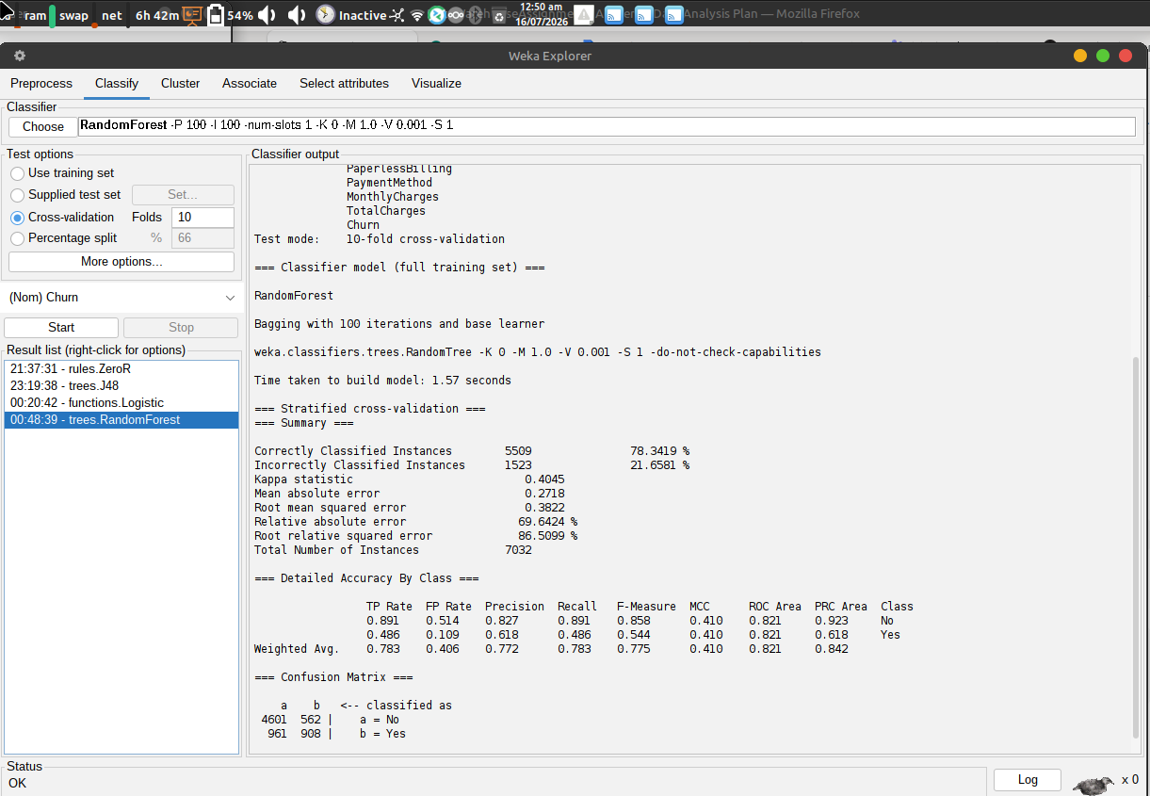

Figure 4: Random Forest Confusion Matrix

A.5 Naïve Bayes Confusion Matrix
Presents the confusion matrix for the Naïve Bayes classifier, illustrating its prediction performance relative to the other evaluated models.
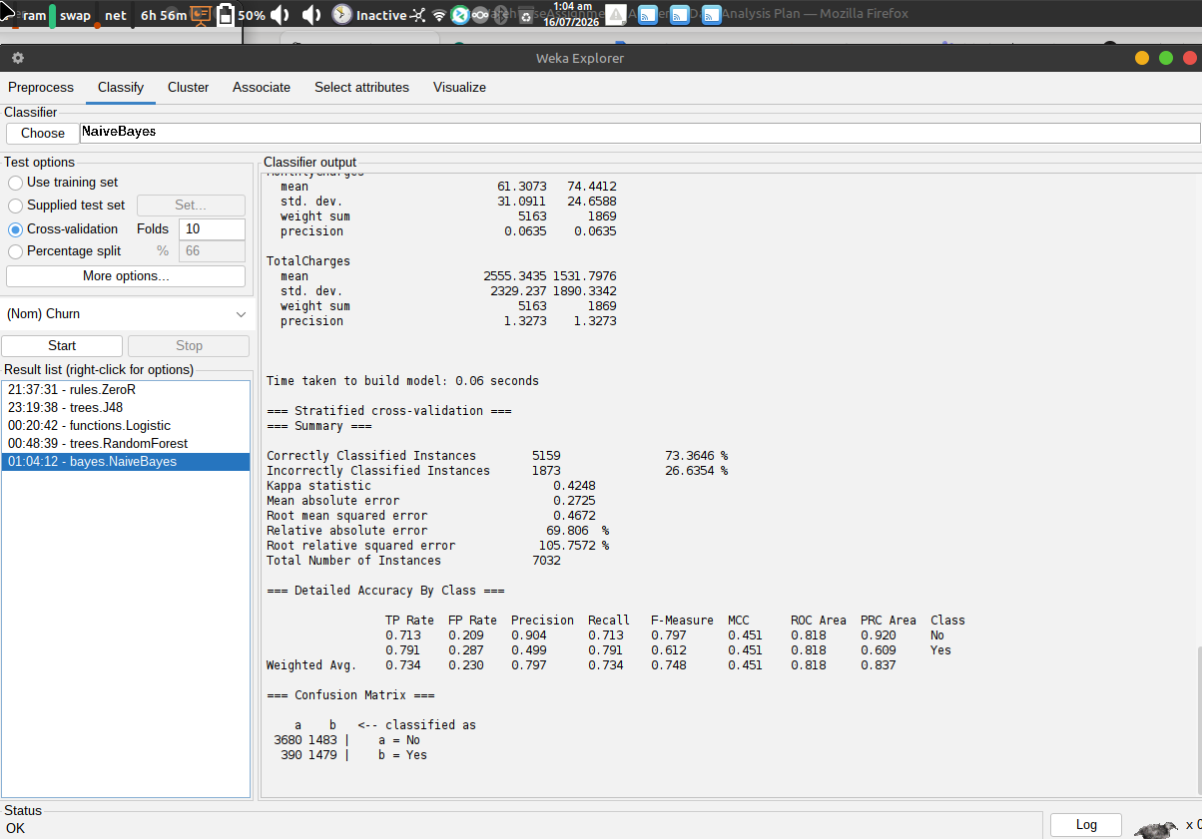

Figure 5: Naïve Bayes Confusion Matrix

