Marketing Management LCMB 7001
2019-2020

Customer journey and marketing study for Next PLC | Professor: Tushara Balendran  Student: Vasile Somesan  Student ID number: 1907997

Table of Content
- Integrated Marketing Communication ……………………………………………… 3
- Customer journey …………………………………………………………………….13
- Total Engagement Model …………………………………………………………….20
- Conclusions and recommendations …………………………………………………..21
References ……………………………………………………...…………………… 21

Brief brand history
Next PLC is one well known clothing retailer in UK. Considering official Next UK PLC website, their history started early in 1864 when J. Hepworth & Son, Gentleman’s Tailors is established in Leeds, England. After 130 years, in 1981 Hepworth buys Kendalls rainwear shop focused on womenswear. 12th February 1982 was opened the first Next shop and in the same year there were in UK in the end of July 70 Next stores. In the year1984 Next for Men started to work in August of this year establishing by December 52 menswear stores. The first store in Edinburgh contained womenswear, menswear, shoes and completely new for the brand a café.
In 1985 is the year of Next for home (interiors range) and first Regent Street London shop.
J. Hepworth & Son in 1986 changed completely the name to Next PLC. Grattan PLC as a mail order company was acquired by Next in the same year 1986. The first Next children wear shop appeared in 1987. Two events are the most important in 1988 so they are innovative concept in home shopping and David Jones appointed as a Chief Executive of Next PLC.
Next PLC was selling Grattan group to Otto Versand in 1991. In 1993 Next announced its brand strategy: “One Brand; Two Ways of Shopping” bringing together both ranges retail and home shopping style. The international brand dimension is started to be impressive in 1994 that Next is trading in 16 countries having around the world 300 stores (John Thompson, M. C., Apr-Jun2017).
1. Integrated Marketing Communication
Communication definition
The main aspect of human interaction is communication so bussines as part of our lifes is absolut necessary. In Collins Dictionary definition of “Communication is the act of sharing or exchanging information with someone, for example by speaking, writing, or sending radio signals” (Collinsdictionary.com, 2019). Considering Entrepreneur Handbook author group Communication is a Latin word which means ‘to share’. It is the spread of information between persons individuals. Can be shared ideas, concepts, imaginations, behaviours and written content.
Communication is defined as the transfer of information from one to other. The information transfer can be conducted in different paths. Communication is a process that is showing complexity in vary aspects. Different ways of communication and the distances over which one is required to transfer the information make the process complicated (Editorial team, 2014)

Steps of communication
In communication are three major steps. This includes the thought, encoding and decoding. The Subject of information is the thought that exist in the sender mind as ideas or concepts being transformed into verbal speech or a written message conduct to a called encoding (Editorial team, 2014). The communication is translated in information to be understood and to be interpreted by receiver so this process is called decoding. When the receiver clearly understands the information sent to him, two-way the communication process ends here. Communication process is dual one way or two way process. Types of communication are variated as they are verbal (people hear in media) and is influenced by non – verbal communication compounded by eye contact, gesture and facial expressions. Usually TV, radio, newspaper are one way communication but can be transformed in two way communication by reviews or receptors response or action. (Editorial team, 2014)
Non verbal communication as is is no use of words, and the recipient understands what the sender is asking, then it is known as non-verbal communication. Non-verbal communication are being represented by eyes contact, postures, gestures, facial expressions. We are using in our non verbal communication pictures, symbols and graphs can help a person communicate effectively. Other personal characteristics hairstyles and clothing of a person give us information about individual nature, status and intentions. People use architectures, and different colours and textures for home and office surfaces to represent their interests and preferences (Editorial team, 2014)
Considering Klepek opinion in MARKETING COMMUNICATION MODEL FOR SOCIAL NETWORKS, that all business including retail industry in this studied case, that contrary to online advertising available on social media where traditional advertising logic provides explanation, the content creation and dialogue via social networks lack of sufficient understanding so many companies which tend to misunderstand customers communication needs within the social media landscape. The reason of this is a lack of knowledge combined with resistance to change. To avoid this gap are necessary more researches which will clarify the current communication needs of customers (Klepek and Starzyczná, 2018).
Next PLC as a company is using all the media to promote their products as the clothing competition is strong they would keep their market position and to attract new customers using all these media communication ways, for example in their official website are included many pages about “New Collection Lookbook” (Next Retail Limited, 2019).
Communication model
Considering Shannon and Weaver Model of Communication, here the message actually originates from the person who gets the thought or has the information. The sender can be the company is also called the Source of information or the Information Source in their economical interests. The information then gets transmitted from the brain to the mouth and comes out as a signal which then reaches the recipient after joining hands with several noises and other disturbances. The recipient then further passes on the message to its final destination or other minds of other individuals (Managementstudyguide.com, 2019). Generalising from individual to the company and mass of customers the communication process is suffering the same transformation.
One Communicational Scheme is discussed by Wilbur Schramm introducing the concept of feedback and a two-way interchange into the communication model.
Communication model includes three processes:
- Sender is sending message
- Transmission using the right channel to the receiver
- Noise is an factor present in all the communication process (Surbhi Rawat, 2016)

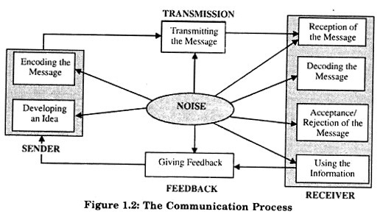
(Surbhi Rawat, 2016)

Advertising

In the Marketing Management, Philip Kotler considers that communication values are 4 considering marketing area interests so they are as follow: first being managing advertising, second managing direct marketing, third managing sponsorship and fourth one but not the last as importance being exploring the potential of word of mouth all together resonating on the culture and on the national level context (Philip Kotler, 2009).
From Kotler point of view advertising represent all the forms of non personal presentation and promotion of ideas, goods or services having as an advertising goal to stimulate and to increase the sale that all this process having as a target pre-selected audience in the specific established time (Philip Kotler, 2009). Considering this complex aspect of business life, Next PLC is using all the media ways to promote their goods having target their brand image and to increase their sales using clear and focused message: “Brighten up your wardrobe” (Next Retail Limited, 2019)

(Next Retail Limited, 2019).
Considering Types of mass media are grouped in different category considering the channel of communication and the target public so we can divide them in 3 distinct categories:
- Print media (newspapers, magazines)
- Electronic media (radio, TV)
- New age media (mobile phone, internet, computers) (Nurer Asif, 2015).

Without these channels we still have other ways to communicate with customers in the traditional way outdoor, mouth to mouth but these ways being limited to the small groups and they sometimes are not 100% reliable having more subjective and surficial content.
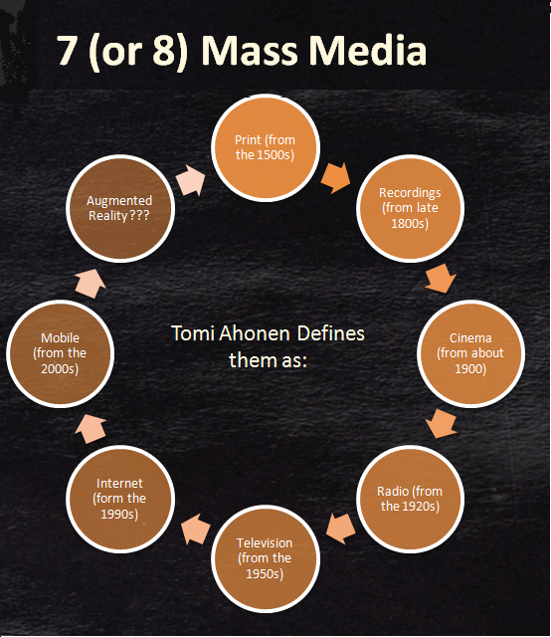
(D.Masouleh, 2013)

In the image we can visualise the historical evolution of mass media channels from traditional and natural ones to the very advanced technologically and modern ones (internet or mobile phones). Next PLC is using almost all this channels to the customers. The main target is to attract and to keep informed their own customers.
Next PLC is delighted to help with all customers enquiries for womenswear, menswear, children’s wear by creating three ways of shopping – NEXT stores, NEXT Directory and NEXT online (Next Retail Limited, 2019).

Considering Philip Kotler point of view about sales promotion that they are being short-term incentive to encourage trial or purchase of a product or services (Philip Kotler ... [et Al.].2009).
Comparing advertising and sales promotion the main difference is the incentive component missing, so the customers are informed by the brand using advertise but for sales promotion are used more financial incentives or discounts.
This is on line on the Next PLC official website so we can consider this a sales promotion
(Next Retail Limited, 2019)

After this banner are following image and categories of products included in this process or promotion but the colour and the message is already directed for incentive and for sales.

Push versus Pull marketing

Next is using more push marketing using internet, radio or TV channels to promote their products. Also customers are encouraged to promote Next PLC products to families or friends offering discounts or gift cards for future acquisitions.
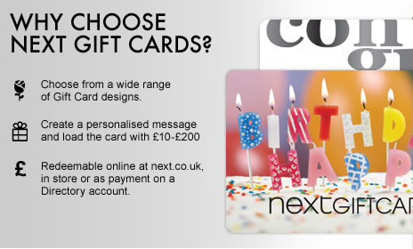
The company is using more feelings attachment to the brand creating profitable gift cards for both sides including seller and customer as well.
(Next Retail Limited, 2019)

Push and pull marketing strategies represent two different marketing approaches to customer buying behaviour. Push marketing strategies is set to attract the attention to a company or product, typically through disruptions such as advertisements, in the hope that such disruptions raise consumer awareness and interest ( it can be a message pushes to potential customers through mass-market channels, such as TV, radio, print or mail). Pull marketing strategies aim to draw consumers into the fold more subtly, typically through content generation and engagement, in the hopes that consumers solicit products or services from the business (is asking to the friends, families and acquaintances to accept an in-home product demonstration or pitch) (Dontigney, 2017).
Public relations
Next PlC as a well known brand created one important PR department which can be contacted by all customers, suppliers, or other social entities. They can be contacted by phone, e-mail or post. Public relation department is dealing with different public issues at regional and international level considering Next PLC public image as a group and brand.
Considering Philip Kotler point of view, the Public Relations (PR) is representing a multitude of programmes having target to promote or to protect a company image or its individual products or services (Philip Kotler ... [et Al.].2009).
Next PLC Public Relation department is having main attribution to protect the company and their product and services image against external or internal attacks which can affect the brand and company image.

REGIONAL AND INTERNATIONAL MEDIA ENQUIRIES:
Public Relations Department
NEXT Plc.
Desford Road
Enderby
Leicester
LE19 4AT
Tel: 0333 777 4577
Email: press@next.co.uk
PR & SOCIAL MANAGER - UK/NATIONAL
Vicki Fogwill
0116 284 3214
Email: vicki_fogwill@next.co.uk
PR & SOCIAL MANAGER – INTERNATIONAL & CORPORATE
Chantelle Binley
0116 284 3169
Email: chantelle_binley@next.co.uk
(Next Retail Limited, 2019)

Publicity
“The main objective of publicity is not sales promotion, but creation of an image through editorial or independent source commentary. While the publicist can control the comment of the story , he or she may not have any control over its placement or interpretation by the media” (BusinessDictionary.com, 2019).
IMC Plan (Integrated Marketing Communication Plan)
Companies are using a calendar to know what content is being sent at what time to prospects, and on what channel. Considering this, the company will be able organize their campaigns by bringing the communication in the right place and time and finally is built a decision-making journey.
Customer-focused marketing communications mix is keening to educate their customers by differentiating in the product or service aspects. The company aim to satisfy customer needs is an important part of the integrated marketing approach. Companies are willing to adopt marketing methods that most effectively reach their audience by creating a consistent message. Being unique and different from the rest engaging their prospects and customers at various levels of the buying cycle is helping the business to reassure their position in the market.
Communication strategy and results-driven will give the company one great advantage by continuing to monitor the needs of their prospects also being concentrated on the capabilities of their product that solve their problem. Inspiration brings more confidence to the brand itself and attracts the audience and customers. Company is building their unique marketing communication strategy different from their competitors having the real desire that their communications effort will contribute to the value of the brand (Elyse Flynn Meyer, 2019). Marketing Mix considering Next PLC is based on advertising (in all media available), public relations, direct marketing and sales promotion as is mention in their website
(Next Retail Limited, 2019)
Sponsorship is other aspect of public relations and increasingly popular, particularly with larger businesses. The business has interest to be involved in important social events having their scope to build brand awareness. The owner of a leading company is making effort to receive a number of offers from schools, college, national level associations as well as social service groups asking for sponsorship for their event. The company will take in consideration to finance their work out of a major feel of goodwill as well as some personal agenda. It is like a win-win situation for both the parties (Bhasin, 2018).
Digital marketing refers to advertising delivered through digital channels such as search engines, websites, social media, email, and mobile apps. Next PLC is using these digital marketing tools doubled by in store experience and experience.
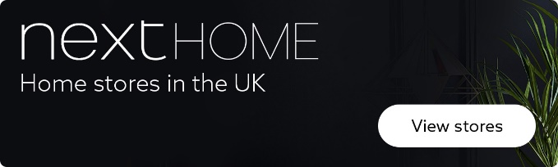

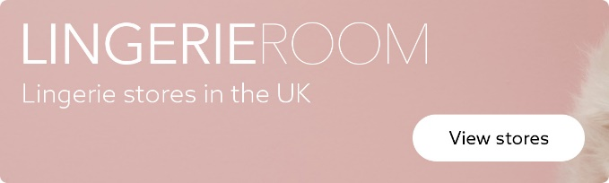

(Next Retail Limited, 2019)
These banners are willing to connect you via website straight to the virtual store and to find the store or shop location the closest one for the customer.
IMC campaign is structured on 5 basic steps. First step is to define the targeted audience (group of age, geographical area), second step is to set promotional objectives (sell new collection or to inform about new products), third step is focused on promotion budget (how much cost this campaign and all the logistics connected with this process), fourth step is to implement one design for marketing MIX by connecting all the available channel for promotion and the fifth step is the conclusions and evaluation campaign results.
2. Customer Journey
Customer Journey is described as being the path of sequential steps and interactions that a customer goes through with a company, product and/or service.
From Taylor point of view, professor at Illinois State University, Customer in this case can be widely interpreted to be customers, stakeholders, donors and other groups whose journeys can be mapped and whose experiences can then be planned, measured and managed so these variation of involved people and business. Journeys are typically broken down into stages and sub-stages and journey maps may be represented as full end-to-end journeys and/or individual segments (Taylor, 2020). The concept of a “customer journey” originally derives from marketing practice (McKinsey & Co.). Lemon and Verhoef (2016) conceptualize customer experience as a customer’s journey with the firm over time during the purchase cycle across multiple touch points; it is the total customer experience as a dynamic process. Customer experience is the aggregate of feelings, perceptions, and attitudes formed during the entire process of decision making and consumption chain involving an integrated series of interaction with people, objects, processes and environment, leading to cognitive, emotional, sensorial and behavioural responses (Taylor, 2020).
First stage is awareness
Brand awareness describes the degree of consumer takes in consideration a product by its name. Creating brand awareness is a key step in promoting a new product or revitalising an older brand. Awareness may include the qualities that make different a product from its competition (Kopp, 2019).
Next PLC is trying to do something different by taking in account customer lifestyle and to inform them for example:

Effortless everyday style ((Next Retail Limited, 2019)
Second stage is consideration as Kopp mention, consumers point of view interacting with social media posts and updates makes the brand awareness to increase. Brand awareness to be most productive, consumers should be able to connect to the company's website seamlessly from the social media platform and to take in consideration new trends or position for the company as they are interested in that also aspects are making different from competitors (Kopp, 2019).

Skincare Saviours (Next Retail Limited, 2019)
Third stage is Decision making
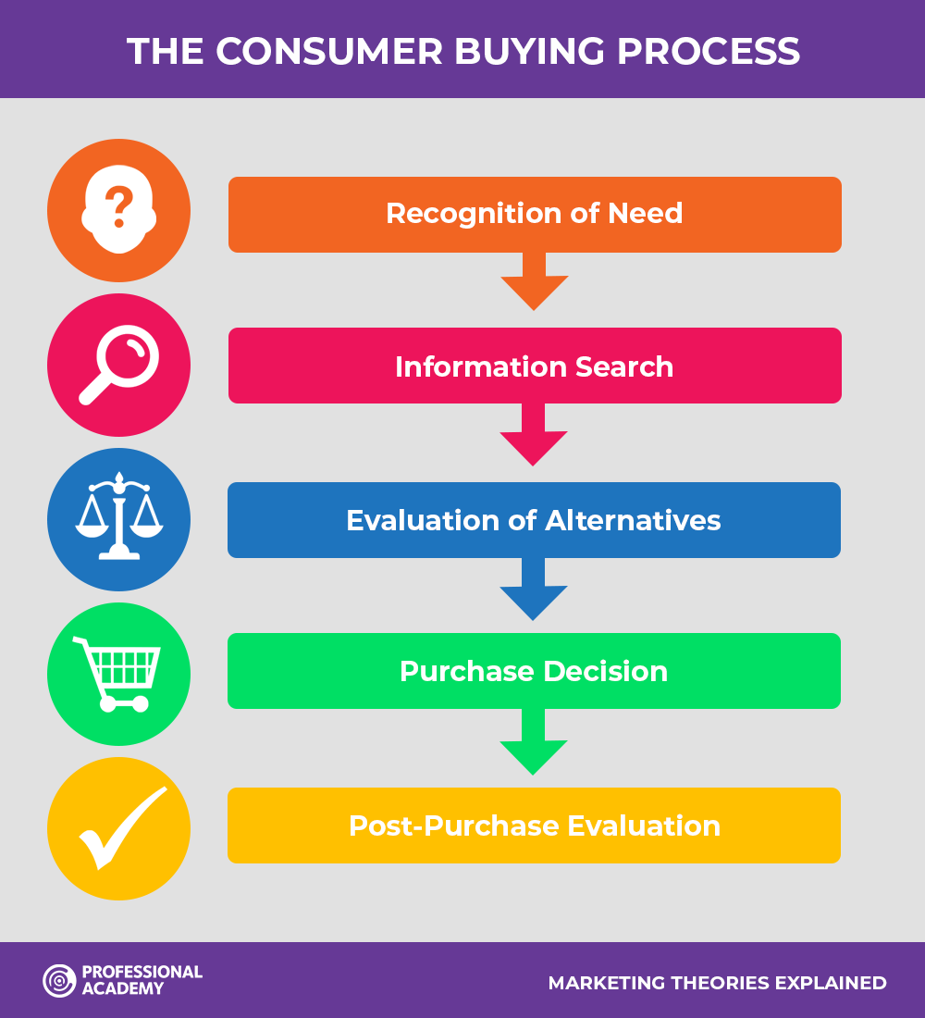
(Professional Academy, 2015)

The Consumer or Buyer Decision Making Process is the method used by marketers to identify and track the decision making process of a customer journey from start to finish. It is staged in 5 distinct individual stages which we have decided to demonstrate with our latest decision making journey.
Customer X recognise the himself or herself problem that their trainer shoes are damaged or old so customer is trying to find information by reliable trainer shoes by searching online or in store for different providers in these stages are occurring kind of alternative evaluation.
Considering cost, here we talk mostly about budget or quality expected from the new possible acquisition. Finally deciding to buy the process will go through after consuming time to the Post-Purchase Evaluation so this stage reflect the most customer feedback and possible product appreciation (Professional Academy, 2015).
Retention is capacity to keep their loyal customers but as a prolonged effect in time to attract the new possible customers using the current positive feedback or reviews from actual happy customers. One happy customer will spread his or her positive feelings about the product or service to other family members, friends or known people, so this should be an important step to the last stage called Advocacy.
Advocacy marketing is getting existing customers to share their positive experience with your company to other people. Enthusiasm of customers is amplifying the voice of company brand and is bringing more customers in business. In the Next PLC Strategy and Objectives one important point is: “Focussing on customer service and satisfaction levels in both Retail stores and Directory” because, they know that the customer satisfaction means also customer favourable advocacy (Next Retail Limited, 2019).
Creating a Customer Journey Map. Considering Mike 35 years old as a persona will build a customer journey map. Customer journey touchpoints are website (official company website is reliable), store in store experience is the most useful experience having real contact wit the products. So considering the pre buying and post-buying process the website as a virtual shopping place and the real shop are different but are offering different kind of advantages. Online shopping is saving time and in store experience is more effectively in checking product quality and physical characteristics. Touchpoints interactions exist in a number of areas and are present in different channels, this is called channels of communication. For each interaction document the channel used to provide the information, for example an advertising board or social media platform (Edwards, 2017).
Call center and e-mail details are in the website but also can be obtained in store by asking from customer service desk. These contact channels are useful both pre and post buying process.
Contact Details

By e-mail
You can e-mail us your query or any feedback (positive or negative) by using our contact form.

By Post
Our address is:
Next, Desford Road, Enderby, Leicester, LE19 4AT . This is from Next PLC website being very fast way to contact them for vary queries(Next Retail Limited, 2019). In case of unpleasant experience or willing of product return this can be an efficient channel to follow.
Web forums

Top of Form
Bottom of Form
Categories Log in Sign up For companies
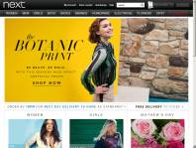

Next Reviews
2,612 • Poor
(Trust Pilot, 2019)

Mike checking online review is finding out that the online Next PLC services online are quoted just with 2.6 star so that is one step back in processing queries via online.
Mike is asking his work colleagues about the return procedures for Next PLC because he is concerned about online effectively working process. Their opinion are different so he will find out the way to communicate with customer service and to avoid spending unwilling time for listen to vary people advices or opinions.
Social media channels as Facebook or Instagram are bombarded by opinions about different brands and products but the most reliable one should be direct interaction with the product for Mike but also all the online materials will affect or balance for his buying decision making.
By post regularly Mike is receiving few leaflets in the post about Next PLC about new promotion, products or discount or sometimes he is able to take home the catalogue. Is a good way to keep Mike informed about this brand but in the post maybe daily arrive a lot of other company offers.
For buying a trainer shoes Mike builds his Customer journey by using Next PLC services
Customer Journey Map | Awareness | Discover | Purchase | Use | Bond
Website |  | Review of available price for trainer shoes |  | Review details about warranty and useful information about product
Store |  | Visiting the store to see real the product in store if the size and colour are available | Purchase the new trainer shoes
Call Centre
Facebook
Web Forums
Word of Mouths |  | Check the websites review about this product seems to be attractive |  |  | Mike express his satisfaction after few days of using these shoes
E-mail | Catalog for new season products
Post |  |  |  |  | Existing Next PLC customer

This cycle is starting from customer and in the end as a reflection of satisfaction is coming back as an opinion informative for others future customers. In case of unsatisfaction the cycle is interrupted but the company will find out what the problem is and will give alternative products or return support.

The Total Engagement Model is based on:
- Customer value proposition
- Branding
- Internal culture elements
- Customer experience. Philip Kotler ... [et Al.]. (2009)
Mike feels his value as customer in store but also in the on line communication with the company this being strictly connected with branding principles of company image from customer point of view.
Internal culture elements are affecting customer purchasing effectively because Mike likes to be included in young generation and in his 30-40 years age group as clothing style and activities. One brand is well known because the quality of product and services but also because the customer satisfaction and engagement in promoting company culture and image.
Customer experience is valuable for every business and their feedback is helping the business to evolve.
3. Total Engagement Model
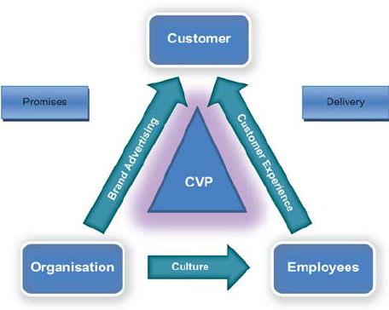
(Emerald, 2010)

From Total Engagement Model customer being central top figure, essential position, is interacting with company and their employees. Mike as a customer is interacting with company promises and with company employees which are delivering products or services. The interaction between customer and company employees is generated customer experience through all the channels available (in store or online pathways). Brand Advertising and customer experience are relative with the customer. Company culture is generated by company and employees interaction being one of the most important characteristic of the brand.

4. Conclusions and recommendations

Many aspects are available for all companies engaged in the retail and clothing industry. Considering the modern approach that the customer are using mostly online shopping and searching on line products companies as Next PLC is nowadays focused on developing and improving online customer experience by consulting reviews and elaborating internet selling strategies. In this field my customer persona named Mike find the 2.6 star review on the Trust Pilot website. This kind of issue could affect his brand perception, so the constant communication with customer doubled by an efficient in store experience (professional in store staff) is building a better relationship between the brand and the customer.
Customers are able to combine in store, on line, mass media and word of mouth communication information to define their own position about the brand. Customer experience is an external factor for the brand but in essence is the most valuable for the business progress.

References
Bhasin, H. (2018). Sponsorship Marketing - The concept of sponsorship Marketing. [online] Marketing91. Available at: https://www.marketing91.com/what-is-sponsorship-marketing/ [Accessed 11 May 2020].
BusinessDictionary.com. (2019). What is publicity? definition and meaning. [online] Available at: http://www.businessdictionary.com/definition/publicity.html [Accessed 10 May 2020].
‌Collinsdictionary.com. (2019). Definition of communication. [online] Available at: https://www.collinsdictionary.com/dictionary/english/communication [Accessed 9 May 2020].
D.Masouleh, N. (2013). Integrated Advertising and Mass Media. [online] Future Media. Available at: https://futuremediablog.wordpress.com/2013/02/15/terminology-terms-integrated-advertising/ [Accessed 10 May 2020].
Dontigney, E. (2017). The Difference Between Push and Pull Marketing Strategies. [online] bizfluent. Available at: https://bizfluent.com/13296054/what-is-an-example-of-a-situation-in-which-an-organization-would-use-a-pull-strategy [Accessed 10 May 2020].
Editorial team (2014). What is communication? [online] Entrepreneur Handbook. Available at: https://entrepreneurhandbook.co.uk/what-is-communication/ [Accessed 9 May 2020].
Emerald (2010). Figure 2 The total engagement model. [online] ResearchGate. Available at: https://www.researchgate.net/figure/The-total-engagement-model_fig2_49513186 [Accessed 14 May 2020].
Edwards, S. (2017). What are customer touchpoints? [online] Make it Clear. Available at: https://www.makeitclear.co.uk/what-are-customer-touchpoints/.
‌Elyse Flynn Meyer (2019). 4 Steps to Developing an Integrated Marketing Communications Strategy. [online] Prismglobalmarketing.com. Available at: https://www.prismglobalmarketing.com/blog/4-steps-to-developing-an-integrated-marketing-communications-strategy [Accessed 10 May 2020].
Klepek, M. and Starzyczná, H. (2018). MARKETING COMMUNICATION MODEL FOR SOCIAL NETWORKS. Journal of Business Economics and Management, 19(3), pp.500–520.
Kopp, C.M. (2019). Why Brand Awareness Matters. [online] Investopedia. Available at: https://www.investopedia.com/terms/b/brandawareness.asp [Accessed 13 May 2020].
‌Managementstudyguide.com. (2019). Shannon and Weaver Model of Communication. [online] Available at: https://www.managementstudyguide.com/shannon-and-weaver-model-of-communication.htm [Accessed 10 May 2020].
Next Retail Limited (2019). Womens Clothing | Going Out Outfits & On-Trend Fashion | Next. [online] Next.co.uk. Available at: https://www.next.co.uk/women [Accessed 10 May 2020].
Nurer Asif (2015). Role of mass media in the development of. [online] Available at: https://www.slideshare.net/asifiubat/role-of-mass-media-in-the-development-of [Accessed 10 May 2020].
Philip Kotler ... [et Al.]. (2009) Marketing Management: First European Edition, Publisher: Pearson Education M.U.A.
Surbhi Rawat (2016). 5 Main Processes of Communication (With Diagram). [online] Essays, Research Papers and Articles on Business Management. Available at: https://www.businessmanagementideas.com/communication/processes/5-main-processes-of-communication-with-diagram/3084 [Accessed 10 May 2020].
Taylor, S.A. (2020). CUSTOMER JOURNEYS THROUGH THE EYES OF UNDERGRADUATE COLLEGE STUDENTS. [online] Uwtsd.ac.uk. Available at: https://web-b-ebscohost-com.ezproxy.uwtsd.ac.uk/ehost/pdfviewer/pdfviewer?vid=1&sid=530bbba8-7995-4e64-97f3-366f3fb5c6a1%40pdc-v-sessmgr06 [Accessed 11 May 2020].
‌

‌

‌

‌

‌

