

BA (Honours) Business Management

Entrepreneurship (LCBB5001)
Lecturer: Vasilios Tavlaridis

Assignment Title: Written Report/Business Plan
Veronica Cusciac- 2123297

Contents
Introduction 3
PESTEL 3
Political Factors 4
Economic Factors 4
Social Factors 5
Technological Factors 5
Environmental Factors 5
Legal Factors 6
The 4Ps of marketing models and how they apply to DOUBLE V Pizzeria 7
References 9

Introduction

Today, almost everyone aspires to be their own boss to improve their standard of living and amass greater riches. However, not everyone is aware of how much effort goes into making a business profitable. This report focuses on the knowledge of PESTEL and the 4Ps of marketing models, as well as how they relate to my business concept to start a pizzeria. In this article, you will become familiar with the PESTEL study, which is a standard method for analysing the wider external environment of an organisation regarding the political, economic, socio-cultural, technical, environmental, and legal elements. The utilisation of this organisational model and diagnostic tool will assist in comprehending the effects of external elements and will have an impact on the decisions made by the organisation (CIPD, 2023). Followed by the 4Ps of the marketing models, the report will outline its connection to the business idea I started.

PESTEL

In order to solve an issue, it is necessary to gather relevant data. Many methods exist for determining which details should be gathered. PESTLE analysis is one such method. Understanding the context in which one operates is essential for success in any endeavour.
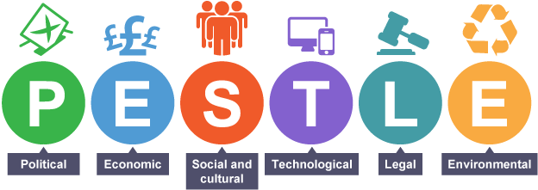
BBC (2023, a).

Political Factors

Each company is significantly influenced by the decisions that are made by the government. It is possible that individuals' total financial freedom will decrease if the government makes the decision to raise the rate at which taxation on income is levied. When one has a lower amount of discretionary income, they have less money available to spend on consumer products and services offered by companies (BBC,2023 b). A high level of political stability creates an atmosphere that is favourable to business and is characterised by predictable patterns of market expansion. Taking into consideration the decision of the United Kingdom to withdraw from the European Union, however, resulted in trade restrictions and taxes. If you work in the food sector, the implications of this ruling will make things somehow more difficult. Especially in the case of my pizzeria business, where we exclusively use Italian materials since we want to convey the authentic flavour of a pizza of high quality. In this regard, the Brexit will have an immediate and significant effect on my company's imports and employability. Also, Government grants and funding will play an important role in developing our business if the personal budget will not be enough.

Economic Factors

Businesses' ability to turn a profit and boost productivity is often affected by a wide range of economic factors, including currency exchange rates, inflation, wage rates, and the laws of supply and demand. Businesses may use this information to better target their marketing and anticipate customer buying patterns. Learning about the many economic elements that go into a company's hiring and spending decisions is essential (Indeed, 2022). In order to establish whether our pizzeria makes a profit from its import operations, we need a firm grasp of currency exchange rates. How much a company pays its foreign suppliers is affected by the volatility of the currency exchange rate. The emergence of new industries and the health of financial markets are both affected by alterations in legal and policy frameworks. Another important factor are taxes effect prices and sales, making them vital to the economy. After earning money, we will have to pay taxes and having less funds to invest and develop while tax rates are high, that will slow the business success.

Social Factors

It seems doubtful that natural systems would be protected during times of conflict, when societal conditions are not optimal. Social concerns, such as shifting demographics, social influence structures, women's involvement in the workforce, etc., have significant effects on a country's economy, customer demand, the availability of ability in employment, and other aspects (EmbaPro, 2018). Double V Pizzeria cares deeply about its employees and is committed to doing everything it can to help them grow professionally and personally. The success and stability of a corporation might be put in risk if it fails to adapt to changing societal norms. The timely recognition of, and reaction to, shifts in cultural norms and preferences can contribute to the growth of a company's sales and profits (Edumecate, 2020).

Technological Factors

Improvements in technology have far-reaching effects on organisations. An efficient worker is a productive worker. There is a correlation between a company's ability to stay in connected with its consumers and the loyalty those customers feel towards that company. Keep being up to date with the new trends is possible through technology. Businesses' ability to gather information, store it, retrieve it, and put it to good use has been revolutionised by technological advancements, as has the development of innovative approaches to running a company. The availability of data allows businesses to track consumer preferences and assess the market for a certain product (Shaw A. A., 2023). Since the pizzeria will function based on takeout and delivery orders, advances in IT will allow us to study customer preferences, assess the market as a whole, and craft effective promotional plans.

Environmental Factors

The environmental analysis is based on the factors such as the climate change, the environmentally friendly of the goods and the services, and atmospheric scenarios. Given that the restaurant/food service sector is one of the world's most lucrative and populous markets, Double V Pizzeria will focus on the sustainability in order to have success. The restaurant's hygiene is our priority. In addition, companies will work on recycling and garbage collection plans. It will aid in reducing ecological damage concerns by cooperating with the authorities. We are aware of and respect the growing trend of vegetarian and vegan clients who are concerned about the environmental impact of the meat sector (EdrawMax, 2023).

Intercard (2023).

Legal Factors

Legal considerations play an important part in the restaurant and hospitality businesses. Because of the ongoing changes to the law, businesses have little choice but to adapt their expansion and growth strategy. The criteria of hygiene and the quality of the food are two essential aspects that fall under the umbrella of product safety in relation to the legal aspects. If we wish to expand consistently in any setting, in addition to complying with the safety regulations, we are also obligated to ensure that our workers receive a minimum daily salary and that they are provided for in terms of their general well-being.

The 4Ps of marketing models and how they apply to DOUBLE V Pizzeria
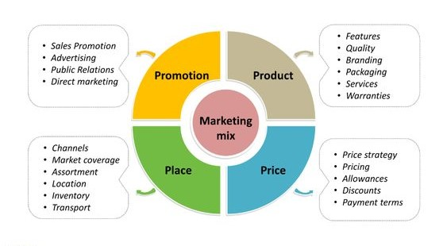
Pinterest.co.uk (2023)
To be able to successfully advertise our service and good, it is necessary to give careful attention to each of the four Ps and to put those concerns into practise in a strategic manner. When we take all of these aspects into consideration, we will be able to comprehend what it is that customers want, how the product or service satisfies or falls short of satisfying those desires, how the product or service is viewed in the world, how it differentiates itself from the other options available, and how the business communicates with its clientele. Advertising initiatives begin with product knowledge. Who needs it? Why? What can't its rivals do? Maybe it's new and so appealing in its form or use that people will buy it immediately (Twin A. 2023). At Double V Pizzeria there will be special discounts and offers for family and kids, as the pizzeria will be placed in an area designed for families all ages. There is a large competition in the Pizza industry, however costumers are willing to pay for a good quality and we will make sure that the prices match consumers expectations. To succeed attracting the target clients, we will promote our pizza online and offline, using the banners and main platforms, such as Deliveroo, Just Eat etc.

Conclusion
The PESTEL analysis and the 4Ps of marketing were discussed in this study. It outlined them in terms of how my business plan would approach them. The research stressed the significance of the role played by external forces on the company. Because it aids entrepreneurs, in making timely, well-informed decisions across a wide range of contexts. As owner, I need to keep all this in mind when I make decisions, respond appropriately to changing conditions, and remain flexible. Following this tools analysing tools and strategies, will lead to a successful business.

References

BBC (2023 a). PESTLE Analysis. Available at: https://www.bbc.co.uk/bitesize/guides/zcjhfcw/revision/2 (Accessed on: 25/07/2023).
BBC (2023 b). PESTLE Political. Available at: https://www.bbc.co.uk/bitesize/guides/zcjhfcw/revision/3 (Accessed on: 25/07/2023).
CIPD (2023). PESTLE Analysis. Available at: https://www.cipd.org/uk/knowledge/factsheets/pestle-analysis-factsheet/ (Accessed on: 25/07/2023).
EdrawMax (2023). Restaurant industry PSTEL analysis. Available at: https://www.edrawmax.com/article/restaurant-industry-pestel-analysis.html#:~:text=These%20include%20scarcity%20of%20raw%20material%2C%20recycling%2C%20pollution%2C,also%20develop%20strategies%20for%20recycling%20and%20waste%20management. (Accessed on: 27/07/2023).
Edumecate, (2020). Social Influences on Business (External Influences on businesses) [Vodcast]. Available at: https://www.youtube.com/watch?v=XsozC-25hEw (Accessed on: 27/07/2023).
EmbaPro, (2018). Importance of PESTEL Analysis in Strategy Management. Available at https://embapro.com/frontpage/pestelcase/14922-accor-supplements. (Accessed on: 27/07/2023).
Indeed (2022). What Are Economic Factors? (9 Factors Affecting Business). Available at: https://ca.indeed.com/career-advice/career-development/what-are-economic-factors (Accessed on: 27/07/2023).
Intercard (2023). Environmentally Friendly Cards. Available at: https://intercard.co.uk/environmentally-friendly-cards/ (Accessed on: 27/07/2023).
Pinterest (2023). 4Ps marketing mix. Available at: https://www.pinterest.co.uk/pin/838514024361747994/ (Accessed on: 27/07/2023).
Shaw A. A. (2023). MarketingTutor.net. Available at: https://www.marketingtutor.net/technological-factors-affect-business/. (Accessed on: 27/07/2023).
Twin A. (2023). The 4 Ps of Marketing and How To Use Them in Your Strategy. Available at: https://www.investopedia.com/terms/f/four-ps.asp. (Accessed: 27/07/2023).

