Body Composition Sheet

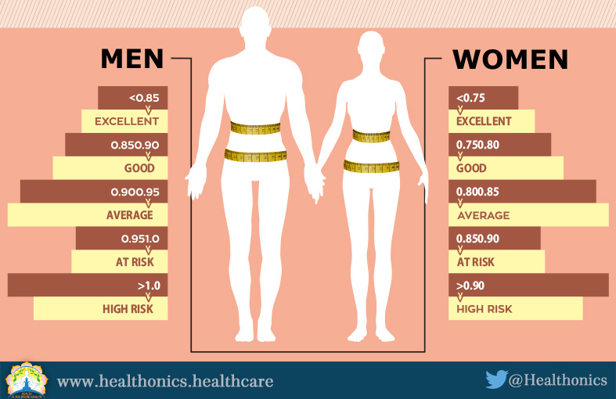
Hip to Waist
Hip to Waist

Measurements
Waist:______________

Hip:_______________

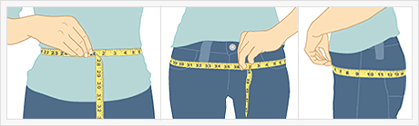

Measurements
Height:______________

Weight:______________

BMI



