

LEVEL 4

SEMESTER 2

MODULE CODE: SHSS4066
INTRODUCTION TO HEALTH AND EXERCISE PSYCHOLOGY
aSSESSMENT TYPE: REPORT
Assessment/Component: 1

COMPONENT WEIGHTING: 50%

WORD COUNT: 1500 WORDS

MODULE TUTOR: ALISON CONNAUGHTON

SUBMISSION DETAILS:
Assignments should be submitted via Turnitin (Moodle) by 3pm on Friday the 5th of April, 2019.

TASK:
Write a report on the following topic:
As a group, you will gather data using the measure provided for at least 20 participants within the School of Sport, Health and Outdoor Education.

Exercise and mood state

Aim: To compare the mood state of (at least 20) students from the School of Sport, Health and Outdoor Education before and after an exercise session lasting at least 20 minutes.

Introduction – Review of relevant literature relating to mood state and exercise (approx. 500 words).
This should include research relating to differences found following exercise for various activities and within different population groups (including students / males and females).

Method – Briefly outline the participants, procedures and design of the study (approx. 200 words).

Results – Using the data provided, present the results in an appropriate format. This should include descriptive statistics, table, figure and associated narrative (approx. 250 words).

Discussion – Discussion of your findings in relation to previous research (approx. 550 words).
In this section you need to relate your findings to the research discussed in the introduction and either support or reject previous research findings. Briefly explain the practical implications of your findings and the research literature.

The format required for the different section of the report will be discussed during lectures, with further guidance placed on Moodle.

Word count – 1500 Words

Submission Date: Friday the 5th of April, 2019

School of Sport, Health & Outdoor Education
Assessment Feedback Sheet

Student No./Name: Ceri Lewis 1800731
Module: Introduction to Health and Exercise Psychology

Module Code: SHSS4066

Personal Evaluation – to support your academic progress please complete the section below BEFORE submitting your work.
What do you consider to be the best aspects of this work? |  |  | I think that the best aspects of this work were the discussion and explain the strengths, implications and further improvements
Which aspects do you consider could have been improved in this piece of work? |  |  | I think the area that could have been improved was talking about the results found.
What have you found most satisfying whilst undertaking this submission? |  |  | The research of how exercise can have positive psychological impacts to a persons’ wellbeing.
ASSESSMENT CRITERIA | Learning  Outcomes |  | GRADE
ASSESSMENT CRITERIA |  |  | Poor  < 20% | Weak  20-29% | Unsatisfactory  30-39% |  | Satisfactory  40 – 49% | Good  50 – 59% | Very Good  60 – 69% | Excellent  70 – 84% |  | Exceptional  85– 100% | %
1. Introduction:  Review of appropriate literature relating to mood state and exercise / physical activity.  (approx. 500 words) | 1,2,3 |  |  |  |  |  |  |  |  |  |  |  | 30%
2. Method:  Outline the participants, procedures and design of the study (approx. 200 words) | 1 |  |  |  |  |  |  |  |  |  |  |  | 15%
2. Results:  Descriptive statistics, use of tables, figures and associated narrative (approx. 250 words) | 1,3 |  |  |  |  |  |  |  |  |  |  |  | 25%
3. Discussion:  Discussion of your findings in light of previous research & practical implications.  Use of appropriate resources (approx. 550 words) | 2,3,4 |  |  |  |  |  |  |  |  |  |  |  | 30%
It is expected that students will present work that is proof read, correctly referenced and adheres to the Assessment Checklist. Therefore a range of 0 – 10 marks will be deducted for non-completion of any of the points on the checklist below.
TUTOR COMMENTS:
Submission date: 5/4/19 via Turnitin |  | Return date:  (at least within 4 weeks) |  |  |  | Tutor: Alison Connaughton |  |  |  |  | Mark:

Assignment Checklist

- Please complete the Personal Evaluation section of the Assessment Feedback sheet, add your name and details, and paste the whole of this assignment document into the front of your assignment

- Submission is a single word file, clearly labelled with your name and module code
- Font style - Times New Roman, size -12 for text and 14 for headings
- Ink colour – black only
- Line spacing – 1.5 line spacing and 2cm- 2.5cm page margins
- Quotations more than three lines to be indented 1 line spacing
- One line space between paragraphs, paragraphs must be left aligned
- Pagination (your assignment should have page numbers)
- All tables and figures are internally referenced and have a title
- Word count checked and written at end of text (before references and any appendix)
- Assignment is within 10% of the word limit (excluding references and any appendices)
- All references in the text are included in the reference list
- Correct referencing following the Harvard style, as described in the UWTSD referencing guide.
- Correct spelling using UK English
- Correct use of punctuation
- Grammar and syntax correct- double check anything that has a green line under it
- I have read my assignment out loud to myself and it makes sense and is easy to read
- Somebody else has read my work and it makes sense to him or her!
- I have checked and I have not plagiarised
Failure to follow these guidelines will cost you marks!
Exercise and Mood State
Introduction

This report will identify whether exercise can affect the mood state and behaviour of an adult through various tests before and after carrying out a twenty-minute exercise. It is known that there are many physical health benefits from exercise, however there are still very little amount of people who carry out continuous exercise for a long period of time, with approximately only 70% of men and 80% of women in the United Kingdom (UK) carried out the recommended level of exercise for their age group (Yeung, 1996).
As well as the physical benefits, exercise can benefit individuals psychologically. It has been proven that effective exercise can be a treatment method used for depression and anxiety as well as improving self-perceptions and self-esteem, specifically aerobic and resistance exercise. It is known that depression has decreased in those that maintain acute exercise for a long period of time and that those who suffer extreme depression do very little, if any exercise (Fox, 1999). Exercise can improve the self-esteem meaning that individuals are feeling more and more positive about themselves, allowing them to have happier more positive thoughts (Penedo et al, 2005). This results in their mental state improving due to their confidence in their own body growing, as low self-esteem can be an indicator to further mental health illnesses. Research has found that those who carry out continuous physical activity have a higher physical and general self-esteem and can therefore live a happier lifestyle compared to those with lower self-esteem. This was found across all ages, male and female, showing that a simple activity can benefit anyone (Mental Health Foundation, 2019).
There are many ways that the research to find whether exercise can affect the mood state, however, the most common is the Brunel Mood Scale (BRUMS). This scale looks at anger, confusion, depression, fatigue, tension and vigour through a word scale measuring between ‘not at all’ to ‘extremely’. Once they are answered it then goes by which words fit into the categories later adding the score to reveal the results of each category mentioned above (Lane et al, 2002).
Another method that can be used to measure how exercise effects the mood state of an individual is the Exercise-Induced Feeling Inventory (EFI). According to the Gauvin and Rejeski (1993) the EFI “consist of 12 items that capture four distinct feeling states: Revitalisation, tranquillity, positive engagement, and physical exhaustion”. This is used to identify any changes to ones’ mental state after exercise, as research shows that acute episodes of exercise can be a good medication and rehabilitation method for those with any mental health issues. This is a similar method to the Brunel Mood Scale, however, only focuses on psychological benefits instead of psychological and physical. This method has been used since 1992 with only minor changes in time showing that this is a strong and well used method to identify the relationship between exercise or physical activity and mental wellbeing (Gauvin and Rejeski, 1993).

Method

In order to carry out this investigation, questionnaires were used from the Brunel Mood Scale (BRUMS) and the Exercise-Induced Feeling Inventory (EFI). Participants that were investigated on were adults ranging from the ages of 18-60. On each questionnaire, the participants would state their age, gender and the activity they completed. The Brunel Mood Scale questionnaires had numerous of statements that each participant had to rate how they felt from ‘not at all or Extremely’, regarding each statement, looking at both physical and emotional factors. The Exercise-Induced Feeling Inventory scale was very similar, however looking more at the psychological factors rather than physical. Each questionnaire was filled out prior to any exercise, they would then complete an exercise of their choice for 20 minutes. After the exercise was completed, they would then complete the exact same questionnaires, allowing them to view and compare their results on whether exercise affected their mental mood state and behaviour in any way; positively or negatively. When all of this was complete there was a scale where they would add up the score that they gave to the statements which are put into categories. These results showed how their mood improved or declined after completing an exercise activity.
This was repeated for each participant on 20 different people ranging in ages and activities. Having a large range of data allowed the results to be analysed, in order to give a set statement of whether exercise does affect the mood state and behaviour of the human body or not.

Results
As shown below in Table 1 all categories in the Brunel Mood Scale, apart from Fatigue and Vigour saw a decrease in results following acute exercise. Anger decreased by 2.72 following exercise from 3.44 to 0.72 with confusion being very similar with a decrease of 2.02 from 3.13 to 1.11. Tension started at a slightly higher score of 3.96 decreasing 2.67 resulting in a score of 1.29 following exercising. Similar to depression, with a higher score prior to any exercise of 4.74 decreasing by 2.8 leaving the final score at 1.94. These all show that exercise can improve one’s mental state and mood behaviour. However, the result increases by 2.96 for vigour from 3.08 to 6.04. Unfortunately, the results for fatigue roughly maintained the same after exercise with only a slight increase of 0.3.
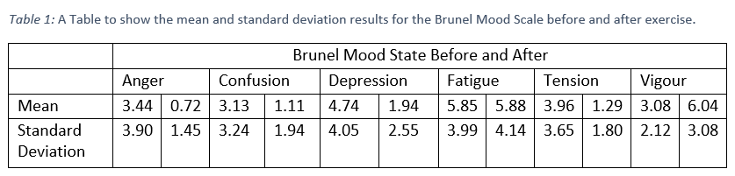
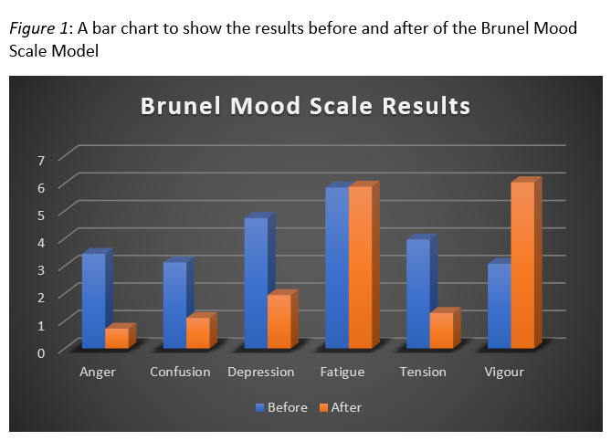

As seen below in Table 2 all categories have increased quite drastically. Revitalisation increased the most almost doubling with an increase of 3.95. Followed by tranquillity which has an increase of 3.16 from 4.17 to 7.33. Positive engagement started at the highest and increased by 3 following exercise from 4.72 to 7.72. However, physical exhaustion also increased slightly by 0.61 showing more people were tired and fatigued after completion of exercise.
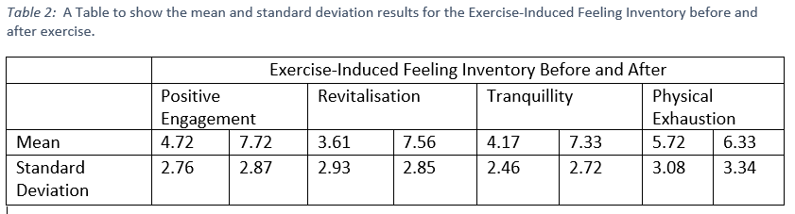
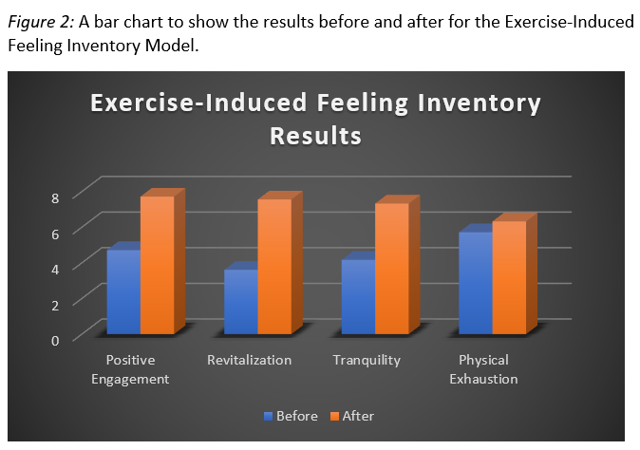

Discussion

Overall, all the results did show an improvement on the participants mental state from acute exercise which goes in conjunction to the research previously found.
Most results decrease in score showing positive results on their mental well-being in the Brunel Mood Scale. The category that decreased the most was depression with a decrease of 2.8 following any exercise. Supporting the previous evidence found stating that “depression has decreased in those that maintain acute exercise for a long period of time” (Fox, 1999).

This is the most important category that they wanted to decrease for the mental wellbeing of individuals. This allows people to be prescribed less medication if exercise of their choice can be a helping factor. Although, the results for the other categories decreased, the score for Vigour almost doubled after completing acute exercise. This also supports previous research as it improves the strength of an individual, this can then lead to an increase in self-esteem and self-perception, allowing the person to be more confident within their own body when exercising (Mental Health Foundation, 2019).
The Exercise-Induced Feeling Inventory model looks purely at psychological benefits of exercise and therefore all results improved. The category that improved the most after exercise was tranquillity increasing by 3.16 showing that the participants felt calmer and more destressed with a clear head.
Although, exercise has proven to improve the mental well-being, there is a resemblance from both models where results for fatigue and physical exhaustion after exercising is increasing. This shows that despite the positive benefits on the mental behaviour it can also negatively impact the physical factors for the individuals. This be viewed as negative as this may prevent people from exercise with the aftermath making them more exhausted than they already felt prior.
Strengths
There are many strengths that came from the outcome of this investigation as well as the process of the experiment. Firstly, most evidence collected from this investigation supported research found that exercise can have positive impacts on ones’ mental well-being. One strength that came from this investigation was that the questionnaires included closed questions, which therefore, allowed it to be easier for each participant to fill out effectively before and after exercise. The Next strength was the conclusion of a wider range of ages (18-60) covering most ages of adulthood and allowing them to specify in their own chosen exercise. This meant that results could prove whether different exercises can improve the mental wellbeing rather than providing a group of specific activities. Also allowing them to enjoy the exercise more resulting with a more positive impact to their mental mood.
Limitations
As well as having many strengths that went along with this research, there were also some weaknesses that could have affected the results found. Firstly, the questionnaires only gave certain statements and had closed questions, meaning that there were only chosen statements for the participants to go by when answering them. Having these as closed questions meant that they had to tick boxes of how strongly they felt on that statement rather than giving open questions allowing them to express their opinions. There were many statements on each questionnaire which meant that it could be time consuming to fill out. Another limitation was the research provided, there is not a great deal of research stating negative impacts from exercise but only positive. Whereas, the results found were that it makes people more fatigued and exhausted as well as the positive psychological impacts.
If this investigation had to be carried out again the method could be changed slightly. Rather than using a large age range (18-60), it could be focused on a specific age category. There could also be a specified category of audience for the experiment such as students or non-students to show whether exercise can affect the mental state in different environmental areas.
Word Count: 1592

References
Lane, A. Lane, H. (2002) 'Predictive Effectiveness of Mood Measures', SAGE Journals, Volume 94, pp. 785-791.
Fox, K. R. (1999) 'The influence of physical activity on mental well-being', Cambridge University Press, 2(3a), pp. 411-418.
Mental Health Foundation (2019) Mental Health Foundation.
Available at: https://www.mentalhealth.org.uk/publications/lets-get-physical-booklet-2013
(Accessed 31 March 2019).
Penedo. Frank, J. Dahn. Jason, R. (2005) 'Exercise and weel-being: a review of mental and physical health benefits associated with physical activity', Opinion on Psychiatry, 18(2), pp. 189-193.
Rejeski, J. Gauvin, Lise. (1993) 'Journal of Sport & Exercise Psychology', Volume 15, pp. 403-425.
Yeung, R. R. (1996) 'The acute effects of exercise on mood state', Elsevier, 40(2), pp. 123-141.

