

LCBB6000: Dissertation
Student Name: Gheorghe Bogatii
Student ID:2020309
Topic: The influence of leadership styles on employee performance in the construction industry- a case study on Galliford Try

Abstract
The performance of the employees determines the growth and success of any business organization in this highly competitive business atmosphere. This research has focused on identifying whether different leadership styles have any impact on employee performance in the construction industry. The construction industry in the UK is encountering several problems and increased productivity can address this problem. Within the methodological approach, an implementation of quantitative analysis has been depicted with gathering numerical data of respondents thoroughly about the subject matter. Here, a primary questionnaire has been used with a collection of 50 employees in order to figure authentic findings of the study. Challenges that leaders in Galliford Try have come across in the process of implementing diverse leadership approaches have been addressed throughout the findings section. Further, some recommendations for using qualities of different leadership styles according to the demands of the situation have been provided in this research.
Acknowledgement
It is intended to express sincere gratitude to the guides and mentors whose insight and encouragement have been crucial in helping to shape the project. Their direction has enhanced the learning process and highlighted the path of knowledge. It also extends sincere gratitude to every member, whose participation and contributions have greatly enhanced the value of the group project. Moreover, this cooperative endeavor, driven by participants' passion and directed by mentors' knowledge, is a monument to the degree to which a cohesive community is committed to development and quality.

Table of Contents
Chapter One: Introduction 7
1.1 Introduction 7
1.2 Research Background 7
1.3 Organizational Background 7
1.4 Aim 8
1.5 Objectives 8
1.6 Research questions 8
1.7 Research Rationale 9
Chapter Two: Literature Review 10
2.1 Introduction 10
2.2 Examining the connection between various leadership philosophies and workers' output in the construction sector along with related theories. 10
2.3 Recognizing and evaluating the obstacles that management in the construction sector encounters when putting strong leadership philosophies into practice. 13
2.4 Presenting suggestions to construction industry leaders for ways to improve worker performance by using effective leadership techniques. 15
2.5 Secondary Analysis 15
2.6 Literature Gap 18
2.7 Summary 18
Chapter Three: Research Methodology 20
3.1 Introduction 20
3.2 Research Onion 20
3.3 Research Design 21
3.4 Research Philosophy 21
3.5 Research Approach 22
3.6 Research Method 22
3.7 Research Strategy 23
3.8 Data Collection Tool 23
3.9 Data Analysis 24
3.10 Sampling Method 24
3.11 Time Horizon 25
3.12 Ethical Consideration 25
3.13 Gantt Chart 25
3.14 Summary 26
Chapter Four: Findings and Analysis 27
4.1 Primary Analysis 27
4.2 Discussion 36
Chapter Five: Conclusion and Recommendations 38
5.1 Conclusion 38
5.2 Recommendations 40
References 42
Appendix One: Gantt Chart 47
Appendix Two: Questionnaire 49
Appendix Three: Figures 51

Chapter One: Introduction

1.1 Introduction
The leadership of an organization plays a pivotal role in ensuring overall success and employee productivity. Hare, a study will be conducted to gain a clear idea regarding the influence of leadership styles on the performance of employees. A detailed background of the organization where the research is being conducted will be provided in this section. The problem statement will be incorporated into the research rationale for discussing the importance of choosing this topic.

1.2 Research Background
Leadership is often defined as the capability of individuals to guide people towards a direction for the fulfilment of unified objectives (Acosta and Guthrie, 2021). There are various leadership styles and choosing the most appropriate one for the situation is important for successful business operations (CFI, 2023). Democratic, autocratic, transformational, transactional and Laissez-faire are some popular leadership styles in the contemporary business environment (Johnson, 2023). The primary aim of this research is to find out the impact of leadership styles on employee performance in Galliford Try which is an established business in the construction industry. The challenges encountered by leaders in Galliford Try while implementing effective leadership styles will be identified and analyzed in this research.

1.3 Organizational Background
Galliford Try is one of the leading businesses in the UK construction industry that focuses on conducting ethical business operations in the country. 3700 people are working with this brand across the country who are committed to providing high-quality services to their customers (gallifordtry, 2023). The business of this organization is divided into three particular sections building, specialist services and infrastructure. Galliford Try designs, constructs and refurbishes properties in the UK market with the intention of meeting customer demands. The current revenue of this organisation has gone up by 12.6% to £ 1,394 m. Galliford Try has prioritised its sustainability approaches by introducing strategies such as ensuring employee health and safety (gallifordtry.co.uk, 2023).

1.4 Aim
To understand the influence of leadership styles on employee performance of Galliford Try in the construction industry.

1.5 Objectives
1. To analyze the relationship between different leadership styles and employee performance in Galliford Try within the construction industry.
2. To identify the challenges faced by leaders in Galliford Try regarding implementing effective leadership styles.
3. To propose recommendations for leaders in Galliford Try within the construction industry to enhance employee performance through appropriate leadership styles.

1.6 Research questions
1. What is the relationship between different leadership styles and employee performance in Galliford Try within the construction industry?
2. What are the challenges faced by leaders in Galliford Try regarding implementing effective leadership styles?
3. What are strategies and recommendations for leaders in Galliford Try within the construction industry to enhance employee performance through appropriate leadership styles?

1.7 Research Rationale
The purpose of this study is to comprehensively analyse the impact of leadership styles on employee performance within Galliford Try which is a leading farm in the construction industry. Dastane (2020) elaborated on the relationship between leadership and employee performance which worked as a motivation for this study. Hence, this study focuses on finding out the broader concept of leadership and the role it plays in enhancing the overall performance of the organisation. Moreover, the research will be conducted to find out more about the challenges that leaders in Galliford Try come across while introducing suitable leadership styles. The rationale for conducting this study is to recommend some overcoming strategies that can be useful for leaders in Galliford Try. Through exploring these facets, the study seeks to provide insightful information that will assist leaders in fine-tuning their management strategies in order to improve worker performance in the construction sector as a whole.

Chapter Two: Literature Review

2.1 Introduction
The comprehension of the leadership styles employed in the construction sector and their impact on personnel is the only focus of the ensuing literature review. Additionally, it will discuss implementation-related problems and approaches to solving them. A brief discussion of the idea of leadership and the several common leadership philosophies chosen by modern leaders will be covered in the literature study section. It focused on autocratic leadership, in which the decision-making process is controlled by the leader. Conversely, ethnic leadership will be assessed in which staff input is considered while making decisions.

2.2 Examining the connection between various leadership philosophies and workers' output in the construction sector along with related theories.
Concept of leadership
The skill of inspiring and directing a group of people toward a single objective is known as leadership. As per Atasoy, (2020), it entails persuading, inspiring, and enabling teamwork in order to accomplish common goals. Effective leaders promote transparency and confidence within their team in addition to displaying traits like vision, integrity, and flexibility. Instead of being limited to a label, leadership is an ongoing process that overcomes obstacles, promotes personal development, and gives others confidence. It combines emotional intelligence, strategic decision-making, and the capacity to mentor and grow people to propel success and positive change in a community or organization.
Innovation Diffusion Theory as an important theory of leadership: Through highlighting the method by which new technologies are embraced within a social system, leaders in the construction sector can learn from the Creativity Diffusion Theory. Through an awareness of the phases of interest, awareness, trial, and acceptance, leaders may customize their approaches to enable the seamless integration of complicated technology, resolving issues and optimizing advantages for their groups and initiatives. The idea describes four stages of innovation adoption that people or organisations go through interest, awareness, trial, and adoption. Using this approach, leaders may assess how well their teams are performing and adjust their support and communication tactics accordingly. The point highlights how crucial good communication is to the adoption process. Hence, to overcome apprehensions and generate excitement among team members, leaders can use successful and persuasive communication techniques to explain the advantages of new technologies. Clear and enlightening communication promotes a more positive outlook on innovation and aids in managing resistance.
Types of leadership style
Autocratic
One decision-maker with considerable power and control is a characteristic of autocratic leadership. According to Baloyi (2020), in this approach, the team is not consulted during decision-making; instead, the leader uses their own discretion. Although it guarantees prompt decision-making and effective work completion, it could result in a decline in one of the team member's morale and creativity. Autocratic leaders create a distinct line of command and demand that their commands be strictly adhered to strictly, with little to no input from their subordinates.
Democratic
Democratic leaders routinely include their members of the team in decision-making procedures, appreciating their opinions and encouraging cooperation. As per Coccia, (2020), this strategy promotes candid communication, shared accountability, and a feeling of group ownership. Democratic leaders foster an environment that is more accessible and motivated by taking into account different points of view. Whenever team members are competent and committed to their jobs, as well as when varied viewpoints are valued, this kind of management works very well.
Bureaucratic
Bureaucratic executives follow protocols and guidelines to the letter. Standard operating processes, hierarchies, and transparent structures are prioritized under this leadership approach. According to Coulter et al., (2021), top-down decision-making is common, and staff members are expected to abide by established policies. Although bureaucratic leadership offers stability and order, its inflexibility can make it difficult for it to adapt to change and can hinder creativity. This type of work is common in establishments where following certain procedures and regulations is crucial.
Laissez-faire
Laissez-faire management is a detached style in which team members are given significant liberty and allowed to decide for themselves. Team members who adopt this approach feel more invested in the group, which stimulates innovation and creativity. As suggested by Wilson, (2020), although it may allow self-directed people, it might not provide clear direction, which could result in a breakdown in communication or a feeling of cohesiveness. Laissez-faire leadership works well in some situations, but it works best with motivated, experienced teams that can function well with less direct supervision.
Relationship among various leadership styles and employee performance; highlighting the influence
There is a strong correlation between employee performance and leadership styles. Transformational leadership inspires and motivates staff members, which has a beneficial impact on performance. As per Hunt and Fitzgerald, (2018), democratic leadership encourages cooperation, which raises team morale and output. Even while it works well in times of crisis, autocratic leadership can be demoralizing to workers. Laissez-faire leadership, which promotes independence, works well for individuals with autonomy but may not provide enough direction. The key is to match employee demands and organizational culture with leadership philosophies.

2.3 Recognizing and evaluating the obstacles that management in the construction sector encounters when putting strong leadership philosophies into practice.
Diverse workforce
The construction industry faces difficulties with a varied workforce because of disparities in language, culture, and skill levels. In order to narrow these gaps, a heterogeneous team needs good leadership in order to motivate and coordinate. As per Pellitteri, (2021), different backgrounds can affect how people communicate, which could result in miscommunication. For the construction team to function cohesively and reach its full potential, navigating these complications is essential.
High-pressure environment
There are a lot of challenges in the construction sector because of the high-pressure atmosphere. Stress is a result of strict deadlines and budgets, which affects decision-making and the final product's quality. As stated by Vasilescu, (2019), workers may become fatigued due to the pressure to fulfill project goals, which could compromise their safety and output. In order to manage the high demands and ensure optimal performance while minimizing any potential negative consequences of a high-pressure areas construction workplace, strong management, and strategic thinking are essential.
Safety concerns
There are a lot of security concerns facing the construction business. Heavy machinery operation, high-risk situations, and intricate project dynamics all contribute to the ongoing worry about accidents. As per Amor et al., (2020), it is essential to make sure that safety procedures are strictly followed. In addition to endangering the health and safety of employees, putting safety last causes delays in projects, legal problems, and harm to the industry's reputation in general.
Complex projects
Complex Stakeholder Dynamics: Managing a variety of stakeholders, such as engineers, architects, and regulatory agencies, can be difficult in complex building projects. As per Kreiner et al., (2021), coordinating divergent interests calls for strong communication and leadership abilities.
Meticulous Planning and Execution: Large-scale initiatives must be carefully planned and carried out due to their complexity. Managing many teams, resources, and deadlines becomes a difficult balancing act that calls for skilled project management to get around possible roadblocks.
Environmental compliance
There are challenges for the building sector to comply with changing environmental standards. Strict specifications necessitate sustainable practices, which affect project budgets and schedules. As suggested by Leopoulos et al., (2021), complexities related to compliance, such as waste management and emission controls, provide difficulties for builders. It's critical to strike a balance between environmental responsibility and building efficiency, which calls for constant adaptation to satisfy evolving regulations and preserve industrial sustainability.
Complex technology inclusion
The seamless integration of sophisticated technology such as Building Information Modelling (BIM) in the construction sector is fraught with challenges. It will need a significant amount of money, training, and flexibility to put these advances into practice. Industry resistance to change can impede the smooth integration of cutting-edge technologies, affecting productivity and perhaps causing project delays.

2.4 Presenting suggestions to construction industry leaders for ways to improve worker performance by using effective leadership techniques.
Invest in Technological Education and Integration Plans: Executives in the construction sector should give top priority to extensive training initiatives that equip their staff to handle and use sophisticated technology such as Building Information Modelling (BIM). As stated by Edwards et al., (2022), provide funds for training programs, certifications, and continuing education to guarantee a seamless integration process. Create a strategy plan that outlines the technology to be used in each project, with a focus on gradual adoption and ongoing improvement.
Encourage an Innovative and Adaptable Culture: Leaders must foster an environment that recognizes innovation and welcomes change. Encourage team members to share their thoughts and concerns about technology advancements through open lines of communication. Adopting an adaptable attitude makes sure that workers are more open to new technology, which lowers resistance and creates a collaborative atmosphere where workers actively participate in the integration process.

2.5 Secondary Analysis
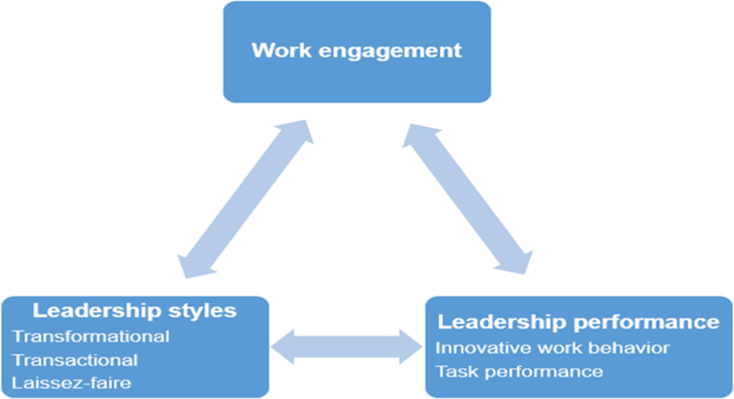
Figure 11: Connection between leadership styles and employee performance
Source: (Kergall, 2022)
Galliford Try's leadership philosophies have a significant impact on how well employees perform. It is made clear through a case study that transformational leadership encourages a positive work environment and pushes staff members to go beyond what they think they are capable of. Higher levels of creativity and job satisfaction are associated with this strategy, which eventually improves performance as a whole. Conversely, autocratic management styles can inhibit innovation and lower staff morale. A democratic leadership approach that promotes cooperation and candid communication frequently yields a motivated workforce. The framework has demonstrated the strong influence that leadership philosophies can have on an organization's ability to succeed by highlighting the clear relationship between Galliford Try employees' productivity and their leadership dynamics (Kergall, 2022).
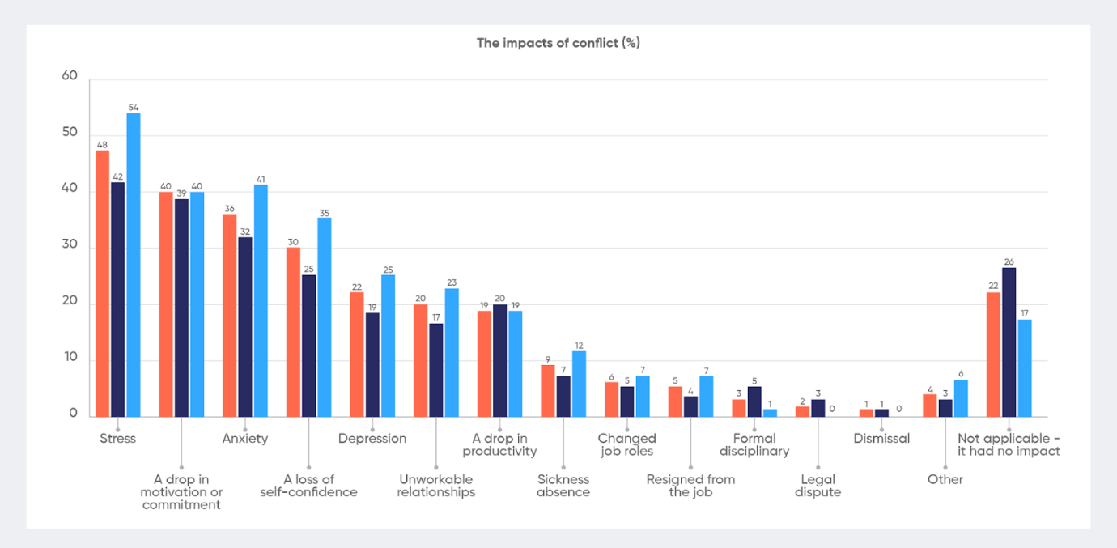
Figure 12: Common leadership challenges
Source: (Wooll, 2022)
Galiford Try has regular leadership issues that can affect worker performance, just like any other organization. Employees may struggle to comprehend company objectives and expectations due to unclear leadership communication. A demotivated and unsatisfied workforce can have a negative impact on productivity through a lack of acknowledgement and feedback. Furthermore, a bottleneck that restricts the progress of both individuals and teams may arise from improper task and responsibility delegation (Wooll, 2022). Throughout the dynamic industries, flexible leadership must be required which results in a lack of adaptability to change and can impede progress. Ultimately, a lack of efforts to promote an inclusive and diverse workplace may have a detrimental effect on staff morale and cooperation. Taking these issues on is essential for Galliford. Aim to maximize worker productivity and guarantee long-term company success.
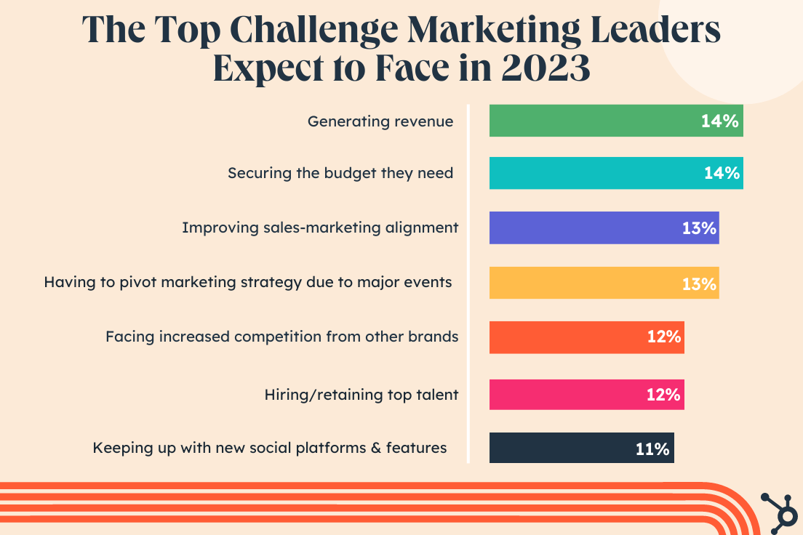
Figure 13: Top leadership challenges leaders want to overcome
Source: (Forsey, 2022)
It is common for leaders to try to improve their effectiveness by overcoming various obstacles. First and foremost, it is critical to manage change and navigate through uncertainty because dynamic environments call for flexible leadership. Another major challenge is building effective communication skills to express a compelling vision and guarantee team alignment. It is always difficult to strike a balance between the operational requirements of daily tasks and strategic thinking. Long-term success depends on efficient personnel management, which includes hiring and retaining talent. Fostering innovation and upholding a continuous improvement culture are other challenges faced by leaders (Forsey, 2022). Lastly, maintaining a positive and effective work environment requires striking the correct balance between confidence and collaboration. Therefore, by overcoming these obstacles, leaders can better guide their teams towards achievement in a constantly changing environment.

2.6 Literature Gap
With the goal of providing adequate data or information for the following dissertation, numerous reliable secondary sources of study have been consulted. In addition, a variety of relevant magazine articles, books, and journals have been compiled, allowing for the required information to be obtained to meet the requirements and provide a thorough grasp of the subjects. Along with secondary research, primary research also has been done in order to find the right data. However, there were a few gaps in it like evidence gap and knowledge gap. Thus, in an effort to lessen the limits, more primary inquiries are required. Therefore, obtaining for other methods like conducting interviews can be helpful too in further times.

2.7 Summary
Knowing the many leadership philosophies employed in the construction business and that they affect workers is the only goal of the literature review that follows. In addition, the implementation challenges can be discussed, along with approaches to resolving them. The notion of leadership and the several common leadership philosophies that modern leaders choose to adopt have been briefly covered in the literature review section. Autocratic leadership, in which the leader controls the decision-making process, has been covered in research. Alternatively, it has been observed that in demographic leadership, employee input is considered while making decisions.

Chapter Three: Research Methodology

3.1 Introduction
Research methodology is the step-by-step procedure that is followed by researchers while carrying out a research process. It consists of multiple steps that provide some specific techniques which can regulate the total research procedure. During initiating any research, specific philosophies, approaches and methods are chosen by the researchers first so that they can complete the research successfully.

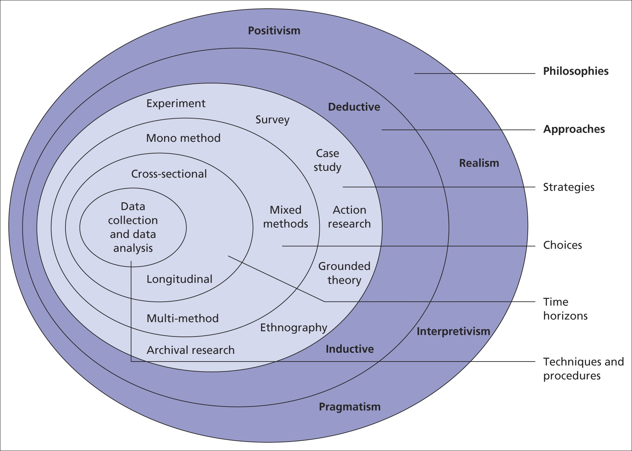
3.2 Research Onion
Figure: Research Onion
Source: (Saunders, 2019)
Research onion is one of the most popular and suitable models that is used by researchers to determine research methodologies. This model was introduced in 2007 by Saunders, Lewis and Thornhill. Several types of research methods are represented through this model which looks like an onion and each layer showcases specific methods and techniques. Here, the researcher has taken this model to perform the whole process in a periodical way. Each layer has been met serially and elongated the ways of entering into deep research and introducing credible data and information (Saunders, 2019).

3.3 Research Design
Research design is an approach that helps to conduct the whole research in a specific way suitable for meeting research objectives and questions. The main research objectives used by researchers are descriptive, exploratory and explanatory research designs. During this research, the Descriptive research design was followed which allowed precise data collection of particular incidents or phenomena. This allows the collection of both quantitative and qualitative data based on research objectives and goals. Through this research design, the researcher got the advantage of analysing particular behaviours and complex situations. Creating relationships between different variables was also possible through the principles of this research design. Moreover, data was collected based on realistic subjects and different characteristics of particular factors were also identified properly. The researcher also got the opportunity to collect data through flexible methods in a short time and with less expenses (D O'Gorma and MacIntosh, 2015).

3.4 Research Philosophy
Research philosophy is one of the essential stages of research methodology that regulates the beliefs, concepts and assumptions of researchers. It extends a specific path for proceeding with the whole research work. Widely used research philosophies are mainly of three types which are positivism, interpretivism and pragmatism. Here the philosophy that was decided to follow was positivism. This philosophy guided the researchers towards a scientific approach by collecting data directly through observation and measurement. Through this philosophy, the researcher was able to set particular beliefs and use multiple quantitative data for broader and deeper analysis. It provided scientific reliability to the results and the researcher was able to examine various patterns and trends in less time. Despite that, it provided inflexibility as research was mainly based on measurements and deep information about human feelings or opinions could not be collected (Duignan, 2016).

3.5 Research Approach
The research approach is another important stage under the methodology of research that decides the strategies for proceeding with the whole work. Inductive and deductive are the major approaches followed by researchers and here deductive approach was preferred. The Deductive approach allows a method where researchers conduct the whole data collection and analysis process by taking the support of some previously published theories and concepts. Through the help of this approach, the researcher gathered a large number of quantitative data and proceeded with a structural procedure. It also saved time and helped in establishing concepts to compare the theories and presenting reliable conclusions. The researcher got the benefit of proceeding with objective research and analysing precise concepts and factors. The results and conclusion of the research have more validity and the possibility of any error or misconduct was also less due to this approach. On the other hand, due to its inflexible techniques, not much creativity and scope were gained during research. Moreover, the approach did not allow the creation of any new concept or theory (Pearse, 2019).

3.6 Research Method
This stage helps in deciding the data collection methods for conducting appropriate observation and analysis. The mainly used research methods are of three types namely mono, mixed and multi method. Here, the mixed method was followed as both qualitative and quantitative data were collected. The researcher was able to collect a large number of numerical data to conduct statistical analysis and also gathered detailed information for representing detailed concepts and theories. It has provided greater validity to the research and using both types of data helps in creating a better understanding and reliable results. Some negative instances also arose such as the researcher had to invest more time in collecting data and arranging large numbers of data in the proper way was a difficult task (Patton, 2015).

3.7 Research Strategy
The procedure of gathering specific types of data is determined by the stage of the research strategy. The widely used research strategies are surveys, interviews, case studies and action research. Among these, this research was conducted by using the survey method. This method allows the collection of desired data by setting some specific questions and asking them to participants. This method has helped to collect necessary data regarding the research objectives for a large sample in a very short time. The method is also cost-effective and facilitates the way of conducting more scientific research. Despite that, the method did not allow for gathering detailed information and in some cases, biasedness in answers was also found (William, 2023).

3.8 Data Collection Tool
Data collection tools include different types of procedures that help in collecting data for proceeding with the analysis method. During conducting the survey, questionnaires were used as data collection tools for this research. Through this method, the researcher made some specific questions related to the research objectives and with the help of Google Forms, an online survey was conducted. The questionnaire was an efficient tool for this research which helped to collect appropriate quantitative data and expand the opportunity for a credible analysis. It also took less time to collect data and was cost-effective. Besides these, the method restricts the way of asking detailed questions which worked as an obstacle in the way of conducting in-depth research (Lindemann, 2023).

3.9 Data Analysis
Data analysis is the process of analyzing `gathered data and information through specific procedures. Here both primary and secondary analysis was conducted to confer a more reliable and valid research. During primary analysis, precise quantitative data regarding the research questions were gathered through the survey questionnaire method. For secondary analysis, highly authentic detailed qualitative information has been gathered by thoroughly reading various books, journals and articles. Through these analysis procedures researcher was able to present several results to enhance the credibility of the research. On the contrary, conducting both types of analysis were time-consuming and made the total analysis process more complex (Sileyew, 2019).

3.10 Sampling Method
The sampling method widens the ways of collecting necessary data from the total sample in suitable ways. The main sampling methods are simple random sampling, stratified sampling, systematic sampling and cluster sampling. Here, the researcher collected data through the sample group through the simple random sampling procedure. The sample consisted of 50 individuals who answered the questions through the survey. This sampling procedure has helped to collect data randomly from the sample group where every individual has an equal possibility of being selected and used for analysis. It helps to conduct a non-biased observation analysis of collected data and establish more reliable results. Moreover, this sampling also helped in conducting the data collection procedure easier and the researcher was also able to apply different statistical techniques during analysis. Despite that, the risk of occurrence of errors was there and more time was invested in conducting this technique (Cherry, 2022).

3.11 Time Horizon
This stage helps in deciding the total time frame invested in the research work. Through this stage, researchers determine the total time allotted for conducting the data collection and analysis. Time horizon is mainly of two types which are cross-sectional and longitudinal time horizon. For this research, the cross-sectional time horizon was followed which allowed to collect data in a limited period. Through this method, the researcher was able to conduct a comparative analysis of different variables collected at the same time. Besides this, due to limited time, it restricted detailed analysis and observing factors over time (Cherry, 2022).

3.12 Ethical Consideration
The whole research was carried out by maintaining all ethical aspects and providing clarity and transparency. During data collection, the consent of all participants was taken properly and no one was forced to participate in the survey. Collected data were stored properly and appropriate confidentiality was maintained. For ethical practice regulations of the Data Protection Act 2018 were obeyed throughout the research. While collecting information from literary sources the credits were given to the authors through giving citations. The entire reference list has been also provided to maintain the validity of the research. No kind of illegal practice was encouraged through the research procedure and integrity has been maintained properly (Fiesler, 2019).

3.13 Gantt Chart
Referred to the appendix.

3.14 Summary
The research methodology has described all the stages that have followed during the whole data collection and analysis process. The researcher proceeded with the whole research with beliefs of positivism and deductive approach. A mixed method was used to collect data and the researcher conducted an in-depth analysis by arranging both numerical and non-numerical data. Moreover, conducting both primary and secondary research has helped to increase the validity of the research and provided more reliable results.

Chapter Four: Findings and Analysis

4.1 Primary Analysis
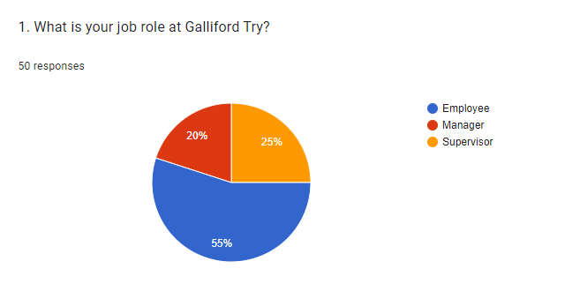
Figure 1
Source: (Google Forms. 2023)
Analysis
The following question mainly figures out the particular job role that individuals have within Galliford Try. Here, the majority of respondents depend upon employees by stating their roles and responsibilities within the market field. Alternatively, 25% of participants think that they have worked for the organization as a manager with showcasing their expertise. The rest 20% of people have considered themselves as supervisors with expressing their roles and responsibilities to fulfil organizational needs in the business field.
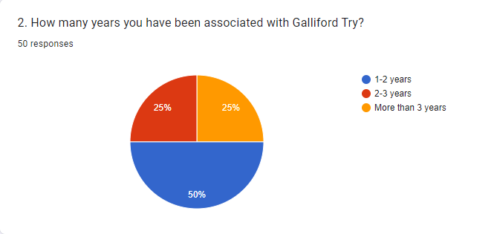
Figure 2
Source: (Google Forms. 2023)
Analysis
The current question has demonstrated the process of worker’s experience level within Galliford Try. Being a construction-based business, the primary objective for them is to build long-lasting services by fulfilling community needs. Nearly about 50% of participants said that they have some knowledge about their job role with having an experience level of 1-2 years. Alternatively, the remaining 25% of respondents proposed that they have worked for the organization for almost 2-3 and more than 3 years by showcasing their position.
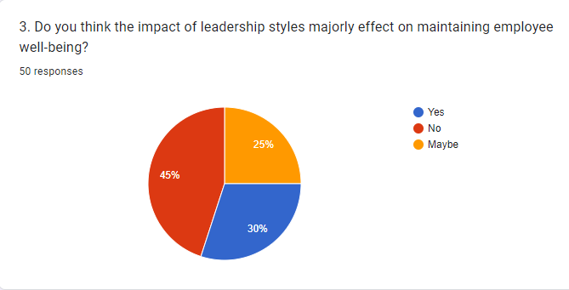
Figure 3
Source: (Google Forms. 2023)
Analysis
Talking about the recent question, it has to look at the impact of leadership styles on maintaining employee health and well-being. Within most businesses, leaders put extra effort into building trust with employees by maintaining strong bonds. Based on that, it becomes easier to encompass communication patterns and influencing organizational behavior, which directly reflects on organizational performance as well. Almost 45% of participants do not agree with the situation and stated a clear direction of this style on hampering workers’ needs and requirements. Alternatively, 30% of respondents stated that they have been widely influenced by these leadership styles and consider their effect on recruiting quality-based workers within the business field. Apart from that, the remaining 25% of people have provided controversial thought processes about the subject matter by stating different ideas.
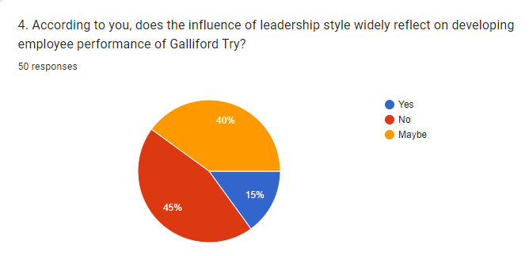
Figure 4
Source: (Google Forms. 2023)
Analysis
Here, the question has arisen whether the impact of leadership styles directly reflects on developing employee performance at Galliford Try. The primary motive for this business is to offer quality-based service facilities and build exceptional infrastructures with maintaining their long-term value. Based on that, they need to drive excellence for clients so that workers can put more effort into their work and sustain environmental practices. Here, about 45% of participants disagreed with this decision by suggesting that the organization must overcome their material shortages so that they can maintain their supply-chain practices and stabilize profitability rate. Apart from that, 40% of respondents deliver a different thought process by building a clear understanding of this subject matter. The rest 15% of people literally agreed with this situation and stated its effectiveness in developing employee performance.
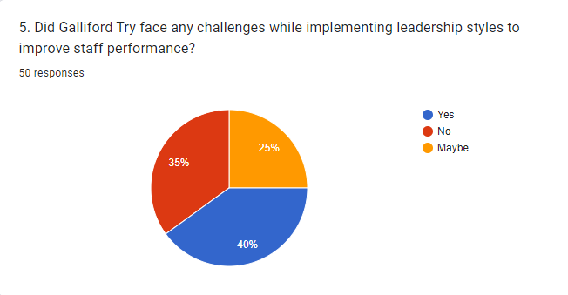
Figure 5
Source: (Google Forms. 2023)
Analysis
The recent question has forecasted whether Galliford Try faces any challenges while initiating leadership styles within their business to improve staff performance. Based on the data, nearly about 40% of participants understand the importance of this situation by stating that it is easier for the organization to adopt these styles with maintaining workers' needs and requirements. Along with that, 35% of respondents do not acknowledge the situation and state its problematic actions within the market field. Further, the remaining 25% of people do not understand the situation and its effectiveness in developing employee-employer relationships.
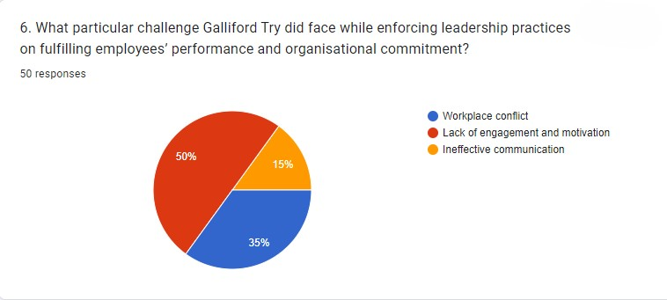
Figure 6
Source: (Google Forms. 2023)
Analysis
Here, the particular challenge has been addressed that Galliford Try might face while enforcing leadership practices within their business operations. Based on the data, the majority of respondents think that lack of engagement and motivation might be the biggest concern for the business in terms of generating a strong workplace culture. Apart from that, 35% of participants realize that workplace conflict creates a significant impact on hampering the relationship between employees and employers. Also, the rest 15% of individuals stated that due to ineffective communication, ethical work standards might corrupt hugely, and it directly reflects on the business’s performance level.
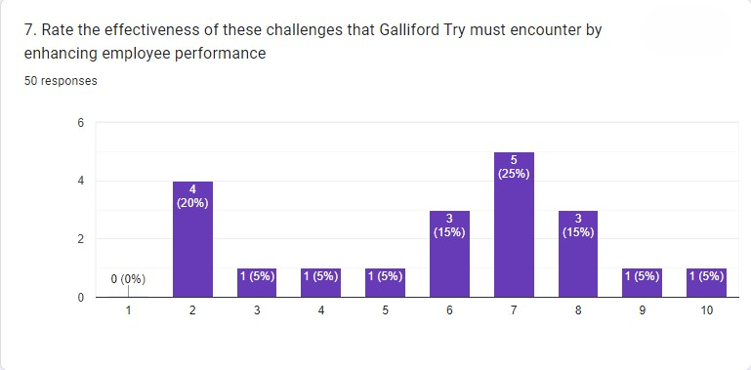
Figure 7
Source: (Google Forms. 2023)
Analysis
Based on the current statistics, appropriate rating of challenges has been showcased which Galliford Try must encounter to enhance employee performance. Nearly about 5 respondents stated a rate of 7 by expressing its effect on the market field. Apart from that, 3 participants correspondingly presented a rate of 6 and 8 by addressing the impact of this process on hampering organizational requirements. However, the concern has also been raised when 4 people deliver a rate of 2 in terms of proposing their current market situations that they want to reduce immediately.
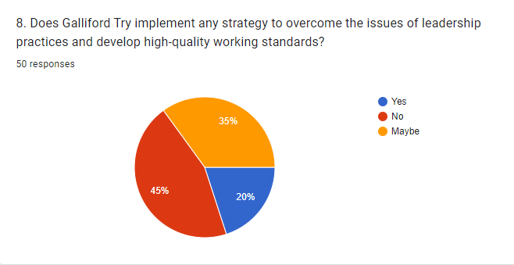
Figure 8
Source: (Google Forms. 2023)
Analysis
Here, the question has identified the strategies of Galliford Try with the target of overcoming leadership issues and improving the quality of work standards. Depending on the situation, 45% of respondents stated a bad impression about the effect of these leadership styles. On the other hand, 35% of participants delivered a neutral thought process by mentioning its effect on the business field. Apart from that, 20% of people agreed with that situation by expressing that these strategies definitely assist the business with evolving leadership styles in terms of maintaining employee performance effectively.
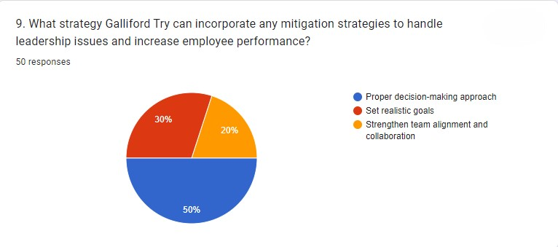
Figure 9
Source: (Google Forms. 2023)
Analysis
Here, a particular strategy has been mentioned through which Galliford Try can overcome leadership issues and develop staff experiences. Based on the data, 50% of respondents think that a poor decision-making approach might create major concerns due to bad implementation of leadership styles. Alternatively, 30% of participants said that utilizing realistic goals generally becomes tougher for most businesses which has also been witnessed by the firm in terms of motivating others within the workplace. Further, 20% of people think that collaboration issues create vital issues for the business in terms of generating an unsterilized productivity rate.
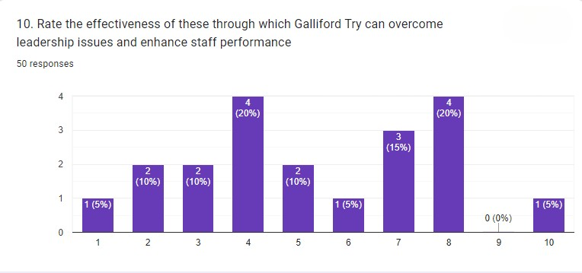
Figure 10
Source: (Google Forms. 2023)
Analysis
The last statistics mentioned the effectiveness of these strategies through which Galliford Try can overcome leadership issues and enrich staff performance. Talking about the data, nearly about 4 respondents stated a rate of 4 and 8 by addressing a neutral decision of this process. Apart from that, 3 respondents proposed a rate of 7 by analyzing the impact of leadership styles on influencing workers’ requirements through gaining an extra advantage within the market field.

4.2 Discussion
The utilisation of primary and secondary research methodologies can yield a comprehensive understanding of the dynamics involved in investigating the impact of leadership styles on staff efficiency at Galliford Try. The literature review offers a thorough grasp of the various leadership philosophies used in the construction industry and how they affect worker performance. It highlights the significance of matching organisational culture and worker demands with leadership styles. A key component of improving staff performance is the Innovation Diffusion Theory leadership approach, which instructs construction industry leaders on how to successfully incorporate new technologies. It offers a framework for comprehending the phases of technology adoption, enabling leaders to adjust their tactics, encourage dialogue, and handle resistance in order to maximise team productivity. High-pressure work environment, security issues, intricate tasks, environmental compliance, and technological integration are the biggest concerns for businesses to build a diverse workforce. Hence, priotising Building Information Modelling probably the suitable approach through in order to initiate training and development programs through enhancing staff performance and build an adaptive culture in the marketplace. While gathering of primary research data entails firsthand information that is pertinent to the study question. Here, the questionnaire system has collaborated with 50 staff members with finding the leadership at Galliford Try may provide subtle insights into the opinions and experiences of people. Though there are drawbacks, such as imprecise communication and a lack of inclusivity, transformational leadership is linked to a happy workplace, innovation, and job satisfaction. According to the survey results, fixing problems with motivation, engagement, conflict at work, and communication is necessary to overcome leadership obstacles. Strategic planning and flexibility are key to overcoming obstacles, promoting an inventive culture, and giving technological education top priority are among the managerial takeaways for related industries. These personal testimonies can provide a more profound comprehension of the corporate culture and how leadership affects day-to-day operations. Hence, these sorts of analysis provided an option for Galliford try to adopt suitable leadership styles with improving staff performance and willing to foster long-lasting infrastructures for consumers.

Chapter Five: Conclusion and Recommendations

5.1 Conclusion
An effective leadership style is important for an organization to operate seamlessly in this highly competitive market. This research has chosen a mixed method for completing this study where both the secondary and primary data have been used for addressing the set objectives. Styles of leadership define the way leaders address their team members and their decision-making process. A positivist philosophy has been selected in this research to complete the study that allows the collection of factual data. It allows the collection of qualitative and quantitative data for drawing conclusions in the research. A deductive research approach that supports the philosophy has been chosen making the research more feasible. The literature review section has briefly discussed the concept of leadership and different popular leadership styles that are selected by contemporary leaders. The research has discussed autocratic leadership where leaders have the control over decision-making process. On the contrary, demographic leadership has been evaluated where the opinion of employees is valued during the decision-making process. For the primary quantitative data collection, a survey was completed that identified that only 30% of the employees in Galliford Try think that employee well-being is impacted by leadership style. Similarly, only 15% of the employees in this organisation think that the development of employee performance is dependent on leaders. Findings of the literature review and the primary study have some differences in this study. Literature review emphasised on the different leadership styles whereas primary study proved that majority employees feel leadership style can hugely influence on their performance. The second objective of this research is to find out the various challenges encountered by leaders while implementing their appropriate leadership style within the organization. A diverse workforce, high-pressure working environment, complex technological inclusion and safety concerns are some of the challenges that could be identified from existing previous studies. The majority (40%) of the participants in Galliford Try have explained that leaders in this organization came across barriers in the process of using different styles. Difference in the previous studies and the primary responses can be witnessed as 50% population think that lack of engagement and motivation among these people is the primary challenge that makes the situation problematic. Ineffective communication with the employees can also make it challenging to enforce leadership practices and style. Moreover, a risk related to workforce conflicts due to a sudden change in leadership approach and style is also a challenge that needs to be handled. The majority of the primary participants have explained that the organisation does not incorporate any strategies for overcoming these challenges. However, some have mentioned about overcoming strategies that are incorporated within the organisation. A proper decision-making approach within the organisation is a significant strategy that is incorporated in Galliford Try to enhance the implementation of different leadership approaches. Similarly, secondary data and qualitative data have also mentioned communication is the most suitable method to overcome the challenges. In conclusion, the research has explored that leadership styles are important however they may not always play the most vital role in enhancing employee performance.

5.2 Recommendations
The research has identified that Galliford Try has encountered various problems in utilizing different leadership styles for the purpose of enhancing employee performance. Some recommendations to improve workforce efficiency with the help of situational leadership theory is presented below (Cherry, 2023). The leaders in Galliford Try can incorporate the different values of various leadership styles to deal with different problems and situations.
Maintain transparency and communication.
It is recommended that Galliford Try maintain a level of transparency within the workplace and utilize transformational leadership qualities for achieving that. Clear communication channels should be incorporated to ensure that employees get the opportunity to share their ideas and opinions with the leaders (smartinsights, 2019). This can help in encouraging teamwork and avoiding miscommunication. Employees can become more engaged with their responsibilities and remain committed to their job roles when leaders implement the positive qualities of transformational leaders (Kuligowski, 2023). Moreover, the organization should also introduce the systems for recognizing and rewarding the hard work among the employees. This use of transformational leadership style can be effective in keeping the workforce motivated and enhancing their productivity over time.
Clear objectives and training
The leaders in Galliford Try are recommended to use the qualities of autocratic leadership for setting the objectives and guiding the employees. Galliford Try should set clear goals for the employees to follow and communicate the goals to ensure their alignment with personal development goals (Woodruff, 2019). Moreover, the leaders can provide opportunities for training and skill development to their employees to enhance employee efficiency. A skilled employee can complete their job role more efficiently and contribute to the fulfilment of organizational strategic goals. Furthermore, autocratic leadership qualities can be utilized by the leaders in Galliford Try to make quicker decisions during an emergency situation instead of relying on employee opinions. Hence, utilizing the positive qualities of the autocratic leadership style can enhance the overall performance of the employees.
Employee motivation
Employee motivation strategies are one of the most popular management policies to improve the overall performance of the workforce. It is recommended that leaders in Galliford Try should focus on keeping the employees motivated to successfully incorporate different leadership styles without affecting employee performance (Schooley, 2023). Autocratic, democratic and transformational styles have completely different approaches and effective motivation can prepare employees to accept these changes. It is recommended that Galliford Try should provide the employees with financial incentives, paid vacations, bonuses and promotions based on appraisals for keeping employees motivated. Similarly, maintaining a healthy working environment that ensures employee safety can motivate employees to perform better.

References
Acosta, A.A. and Guthrie, K.L., (2021). DEFINING A LEADER: The Leadership Identity Development of Latino Men. Journal of Leadership Education, 20(4).
Adams, J., (2014). Research Methods for Business and Social Science Students. New Delhi: SAGE Publications.
Atasoy, R., (2020). The Relationship between Principals' Leadership Styles, Organizational Change. International Journal of Progressive Education.
Baloyi, G.T., (2020). Toxicity of leadership and its impact on employees: Exploring the dynamics of leadership in an academic setting. HTS Teologiese Studies/Theological Studies.
CFI, (2023). Leadership Styles. [Online] Available at: https://corporatefinanceinstitute.com/resources/management/leadership-styles/ [Accessed 2 November 2023].
Cherry, K., (2022). How Do Cross-Sectional Studies Work?. [Online] Available at: https://www.verywellmind.com/what-is-a-cross-sectional-study-2794978 [Accessed 04 November 2023].
Cherry, K., (2022). Samples in Psychology Research. [Online] Available at: https://www.verywellmind.com/what-is-a-sample-2795877 [Accessed 04 November 2023].
Cherry, K., (2023). Situational Leadership Theory. [Online] Available at: https://www.verywellmind.com/what-is-the-situational-theory-of-leadership-2795321 [Accessed 2 November 2023].
Coccia, M., (2020). Comparative critical decisions in management. Global Encyclopedia of Public Administration, Public Policy, and Governance. Springer Nature Switzerland AG.
D O'Gorman, K. and MacIntosh, R., (2015). Research methods for business and management: A guide to writing your dissertation. Goodfellow Publishers Ltd.
Dastane, D.O., (2020). Impact of leadership styles on employee performance: A moderating role of gender. Australian Journal of Business and Management Research, 5(12), pp.27-52.
Duignan, J., (2016). A dictionary of business research methods. Oxford University Press.
Fiesler, C., (2019). Ethical considerations for research involving (speculative) public data. Proceedings of the ACM on Human-Computer Interaction, 3(GROUP), pp.1-13.
Forsey, C., (2022). The Top Challenges Marketing Leaders Expect to Face in 2023 & How You Can Solve For Them [Expert Insights & Data]. [Online] Available at: https://blog.hubspot.com/marketing/anticipated-marketing-challenges [Accessed 31 October 2023].
gallifordtry, (2023). Business model and strategy. [Online] Available at: https://www.gallifordtry.co.uk/investors/business-model-strategy/ [Accessed 2 November 2023].
gallifordtry.co.uk, (2023). Sustainability is central to our strategy. [Online] Available at: https://www.gallifordtry.co.uk/sustainability/ [Accessed 1 November 2023].
Griffin, R.W., Robbins, S.P., Bergman, R., Stagg, I. and Coulter, M., (2021). Management. Pearson Australia. Management. Cengage Learning.
Hunt, J. and Fitzgerald, M., (2018). Styles of leadership. Leadership: Global and regional perspectives.
Johnson, A., (2023). How to Lead: 6 Leadership Styles and Frameworks. [Online] Available at: https://www.verywellmind.com/leadership-styles-2795312#:~:text=Some%20of%20the%20most%20widely,perform%2C%20create%2C%20and%20innovate. [Accessed 2 November 2023].
Kergall, A., (2022). How Your Leadership Style Can Increase Performance Under Pressure. [Online] Available at: https://www.forbes.com/sites/forbescoachescouncil/2022/09/26/how-your-leadership-style-can-increase-performance-under-pressure/?sh=46d9f9b411ae [Accessed 29 October 2023].
Kuligowski, K., (2023). 20 Employee Engagement Ideas That Work. [Online] Available at: https://www.businessnewsdaily.com/15969-employee-engagement-ideas.html [Accessed 1 November 2023].
Lindemann, N., (2023). 12 advantages and disadvantages of questionnaires. [Online] Available at: https://pointerpro.com/blog/questionnaire-pros-and-cons/ [Accessed 04 november 2023].
Ng, S.T., Antwi-Afari, P. and Amor, B., (2020). Circular economy and the construction industry: Existing trends, challenges and prospective framework for sustainable construction. Renewable and Sustainable Energy Reviews.
Ogunsanya, O.A., Aigbavboa, C.O., Thwala, D.W. and Edwards, D.J., (2022). Barriers to sustainable procurement in the construction industry: an exploratory factor analysis. International Journal of Construction Management.
Patton, M.Q., (2015). Qualitative research & evaluation methods: Integrating theory and practice. Sage publications.
Pearse, N., (2019), June. An illustration of deductive analysis in qualitative research. In 18th European conference on research methodology for business and management studies (p. 264).
Pellitteri, J., (2021). Emotional Intelligence and Leadership Styles. Psychology & its Contexts/Psychologie a Její Kontexty.
Saunders, M.N.K., (2019). Research methods for business students. 8th ed. Harlow: Pearson.
Schooley, S., (2023). Beyond the Clock: The Benefits of Highly Motivated Employees. [Online]Available at: https://www.business.com/articles/the-benefits-of-highly-motivated-employees/ [Accessed 2 November 2023].
Sileyew, K.J., (2019). Research design and methodology. Cyberspace, pp.1-12.
smartinsights, (2019). How to maintain transparency in your business at different levels. [Online]Available at: https://www.smartinsights.com/customer-relationship-management/how-to-maintain-transparency-in-your-business-at-different-levels/ [Accessed November 2023 2023].
Stanitsas, M., Kirytopoulos, K. and Leopoulos, V., (2021). Integrating sustainability indicators into project management: The case of the construction industry. Journal of Cleaner Production.
Vasilescu, M., (2019). Leadership styles and theories in an effective management activity. Annals-Economy Series.
Wieser, A.A., Scherz, M., Passer, A. and Kreiner, H., (2021). Challenges of a healthy built environment: Construction industry. Sustainability.
William, K., (2023). 9 Types of Survey Methods and How They Work. [Online] Available at: https://surveysparrow.com/blog/different-types-of-survey-methods/ [Accessed 04 November 2023].
Wilson, D.E., (2020). Moving toward democratic-transformational leadership in academic libraries. Library Management.
Woodruff, J., (2019). The Importance of Clear Objectives, Directions & Project Plans. [Online]Available at: https://smallbusiness.chron.com/importance-clear-objectives-directions-project-plans-32965.html [Accessed 2 November 2023].
Wooll, M., (2022). How to deal with 17 common leadership challenges. [Online] Available at: https://www.betterup.com/blog/leadership-challenges [Accessed 30 October 2023].

Appendix One: Gantt Chart
Features | 1st week | 2nd week | 3rd week | 4th week | 5th week | 6th week | 7th week | 8th week | 9th week | 10th week | 11th week | 12th week | 13th week | 14th week | 15th week
Choosing research topic
Picking the aim
Objectives
Literature Review
Methodology
Finding Analysis
Finding resources
Discussion
Improvements
Conclusion
Submission

Appendix Two: Questionnaire
1. What is your job role at Galliford Try?
Employee
Manager
Supervisor
2. How many years you have been associated with Galliford Try?
1-2 years
2-3 years
More than 3 years
3. Do you think the impact of leadership styles majorly effect on maintaining employee well-being?
Yes
No
Maybe
4. According to you, does the influence of leadership style widely reflect on developing employee performance of Galliford Try?
Yes
No
Maybe
5. Did Galliford Try face any challenges while implementing leadership styles to improve staff performance?
Yes
No
Maybe
6. What particular challenge Galliford Try did face while enforcing leadership practices on fulfilling employees’ performance and organisational commitment?
Workplace conflict
Lack of engagement and motivation
Ineffective communication
7. Rate the effectiveness of these challenges that Galliford Try must encounter by enhancing employee performance
8. Does Galliford Try implement any strategy to overcome the issues of leadership practices and develop high-quality working standards?
Yes
No
Maybe
9. What strategy Galliford Try can incorporate any mitigation strategies to handle leadership issues and increase employee performance?
Proper decision-making approach
Set realistic goals
Strengthen team alignment and collaboration
10. Rate the effectiveness of these through which Galliford Try can overcome leadership issues and enhance staff performance

Appendix Three: Figures

Appendix four:
Participant Information Sheet
University of Wales Trinity Saint David (London Campus)
Winchester House
11 Cranmer Road
London – SW9 6EJ
Tel: +442075667600
Email: info.london@tsd.ac.uk
londonstudentservice@tsd.ac.uk


 | Rhif Adnabod Cyfranogwr:  Participant Identification Number: | 2020309
FFURFLEN GANIATÂD CYFRANOGIAD | SAMPLE PARTICIPANT INFORMATION SHEET
Teitl Y Prosiect: / Project Title: The influence of leadership styles on employee performance in the construction industry a case study on Galliford Try.

Dear Sir/Madam,

My name is Gheorghe Bogatii and I am a student in the School of Business, Finance and Management (London Campus), Faculty of Business and Management in University of Wales Trinity Saint David, United Kingdom. At present, I am conducting a research on The influence of leadership styles on employee performance in the construction industry. The purpose of this research is to to understand the influence of leadership styles on employee performance of Galliford Try in the construction industry.

I would like to invite you to participate in my research project by answering the attached short questions developed by the researchers. Those questions will assess your opinions, experiences, knowledge, suggestions and views. Through your participation in the interviews, I hope to ascertain my research purpose to get the best opinion from you. I believe your opinion will be extremely helpful to me to carry out this research.

All questions will be kept strictly confidential to the researchers involved and at NO time will individual questions will be released to the general public. This gives you a chance to express your views on your programme a confidential and anonymous forum and still be able to make a difference. Your participation in this study is completely voluntary so you can withdraw from the questionnaire at any stage.

Please note, questionnaire should take no more than 30 minutes to complete but however, there is no time constraint. There are also no right or wrong answers. Attached to this letter along with the questionnaire there is a consent form where you will better understand researchers intension As this is a new project, your feedback is also important to me and I would be much obliged if you could also complete the feedback sheet along with the questionnaire. I understand that your time is at a premium, but your opinions are very valuable to me.
After careful and precise analysis of the data obtained from this questionnaires/interviews, I will be happy to provide you with a copy of the findings at your request. The results of this questionnaire will hopefully enhance my understanding of current level of knowledge and future findings. The results of the research will be feedback to Director of Studies, Supervisor, University and British Library.

I thank you in advance for your time and participation. If any questions do arise, feel free to contact me at your convenience.

NAME & ADDRESS OF RESEARCHER
Gheorghe Bogatii
University of Wales Trinity Saint David (London Campus)
Winchester House
11 Cranmer Road
London – SW9 6EJ
Tel: +442075667600
Email: info.london@tsd.ac.uk
londonstudentservice@tsd.ac.uk

Appendix four:
Participation Consent Form
University of Wales Trinity Saint David (London Campus)
Winchester House
11 Cranmer Road
London – SW9 6EJ
Tel: +442075667600
Email: info.london@uwtsd.ac.uk
londonstudentservice@uwtsd.ac.uk



 | Rhif Adnabod Cyfranogwr:  Participant Identification Number: | 2020309
FFURFLEN GANIATÂD CYFRANOGIAD | PARTICIPATION CONSENT FORM
Teitl Y Prosiect: / Project Title: The influence of leadership styles on employee performance in the construction industry a case study on Galliford Try.
Enw'r Ymchwilydd / Name of Researcher: Gheorghe Bogatii

1 | I confirm that I have read and understand the information sheet dated 25 november the above study. I have had the opportunity to consider the information, ask questions and have had these answered satisfactorily. |  |  | V
2 | I understand that my participation is voluntary and that I am free to withdraw at any time, without giving any reason. |  |  | V
3 | I understand that any information given by me may be used in future reports, articles or presentations by the research team. |  |  | V
4 | I understand that my name will not appear in any reports, articles or presentations. |  |  | V
5 | I agree to take part in the above study. |  |  | V
Name of Participant |  | Ion Jardan | Signature  JARDAN
Researcher |  | Gheorghe Bogatii | Signature  BOGATII

You may decline to participate in this study. You may end your participation in this study at any time. If you decide to remain anonymous, maintaining your anonymity will be a priority and every practical precaution will be taken to disguise your identity. If you prefer anonymity, there will not be any identifying information on audiotapes or transcripts of this or any interview. No one will hear any audiotapes or see any transcripts without your prior consent. All materials generated from this or any interview will remain confidential.
When completed please return in the envelope provided. One copy will be given to you and the original to be kept on the file of the research team at:

NAME & ADDRESS OF RESEARCHER
Gheorghe Bogatii
University of Wales Trinity Saint David (London Campus)
Winchester House
11 Cranmer Road
London – SW9 6EJ
Tel: +442075667600
Email: info.london@uwtsd.ac.uk
: londonstudentservice@uwtsd.ac.uk

Appendix four:
APPLICATION FOR ETHICAL APPROVAL

In order for research to result in benefit and minimise risk of harm, it must be conducted ethically. A researcher may not be covered by the University’s insurance if ethical approval has not been obtained prior to commencement.

The University follows the OECD Frascati manual definition of research activity: “creative work undertaken on a systematic basis in order to increase the stock of knowledge, including knowledge of man, culture and society, and the use of this stock of knowledge to devise new applications”. As such this covers activities undertaken by members of staff, postgraduate research students, and both taught postgraduate and undergraduate students working on dissertations/projects.

The individual undertaking the research activity is known as the “principal researcher”.

Ethical approval is not required for routine audits, performance reviews, quality assurance studies, testing within normal educational requirements, and literary or artistic criticism.

Please read the notes for guidance before completing ALL sections of the form.

This form must be completed and approved prior to undertaking any research activity. Please see Checklist for details of process for different categories of application.

SECTION A: About You (Principal Researcher)
1 | Full Name: |  | Gheorghe Bogatii
2 | Tick all boxes that apply: |  | Member of staff: | ☐ | Honorary research fellow: | ☐
 | Undergraduate Student | ☒ | Taught Postgraduate Student | ☐ | Postgraduate Research Student | ☐

3 | Institute/Academic Discipline/Centre: | ACADEMIC DISCIPLINE OF BA (Hons) BUSINESS MANAGEMENT INSTITUTE OF INNER-CITY LEARNING (IICL)
4 | Campus: | LONDON
5 | E-mail address: | 2020309@student.uwtsd.ac.uk
6 | Contact Telephone Number: | 07586400544
 | For students:
7 | Student Number: | 2020309
8 | Programme of Study: | BA (Hons) Business Management
9 | Director of Studies/Supervisor: | Dr Asad Jaffari

SECTION B: Approval for Research Activity
1 | Has the research activity received approval in principle?  (please check the Guidance Notes as to the appropriate approval process for different levels of research by different categories of individual) |  | YES | ☒ | NO | ☐
 |  |  |  |  | Date
2 | If Yes, please indicate source of approval (and date where known): Approval in principle must be obtained from the relevant source prior to seeking ethical approval | Research Degrees Committee |  | ☐
2 |  | Institute Research Committee |  | ☐
2 |  | Other (write in)  By the supervisor |  | ☒

SECTION C: Internal and External Ethical Guidance Materials
 | Please list the core ethical guidance documents that have been referred to during the completion of this form (including any discipline-specific codes of research ethics, location-specific codes of research ethics, and also any specific ethical guidance relating to the proposed methodology). Please tick to confirm that your research proposal adheres to these codes and guidelines. You may add rows to this table if needed.
1 | UWTSD Research Ethics & Integrity Code of Practice | ☒
2 | UWTSD Research Data Management Policy | ☒
3 | [List any other relevant documents here] | ☐

SECTION D: External Collaborative Research Activity
If there are external collaborators then you should gain consent from the contact persons to share their personal data with the university. If there are no external collaborators then leave this section blank and continue to section E.
1 | Institution
2 | Contact person name
3 | Contact person e-mail address
4 | Is your research externally funded? |  | YES | ☐ | NO |  | ☒
5 | Are you in receipt of a KESS scholarship? |  | YES | ☐ | NO |  | ☒
6 | Are you specifically employed to undertake this research in either a paid or voluntary capacity? | Voluntary | YES | ☐ | NO | ☒
7 |  | Employed | YES | ☐ | NO | ☒
8 | Is the research being undertaken within an existing UWTSD Athrofa Professional Learning Partnership (APLP)? | If YES then the permission question below does not need to be answered. | YES | ☐ | NO |  | ☒
9 | Has permission to undertake the research has been provided by the partner organisation? | (If YES attach copy)  If NO the application cannot continue | YES | ☐ | NO |  | ☒

Where research activity is carried out in collaboration with an external organisation
10 | Does this organisation have its own ethics approval system? | YES | ☐ | NO | ☒
 | If Yes, please attach a copy of any final approval (or interim approval) from the organisation (this may be a copy of an email if appropriate).

SECTION E: Details of Research Activity
1 | Indicative title: | The influence of leadership styles on employee performance in the construction industry
2 | Proposed start date: | 25 august | Proposed end date: | 25 October
Introduction to the Research (maximum 300 words per section)
Ensure that you write for a Non-Specialist Audience when outlining your response to the points below:
- Purpose of Research Activity
- Proposed Research Question
- Aims of Research Activity
- Objectives of Research Activity
Demonstrate, briefly, how Existing Research has informed the proposed activity and explain
- What the research activity will add to the body of knowledge
- How it addresses an area of importance.
3 | Purpose of Research Activity  The goal of the study is to examine the connection between management practices and  workforce productivity in the construction sector. The study also  aims to pinpoint the difficulties leaders in the construction sector have when  putting good leadership practices into practice.  (this box should expand as you type)
4 | Research Question  1. How does the leadership style employed by construction industry leaders influence the  performance of employees?  2. What are the primary challenges faced by construction industry leaders in implementing  effective leadership styles?  3. What strategies can be proposed to construction industry leaders to enhance employee  performance through the application of appropriate leadership styles?  (this box should expand as you type)
5 | Aims of Research Activity  To understand the influence of leadership styles on employee performance in the construction  industry.  (this box should expand as you type)
6 | Objectives of Research Activity  1. To analyse the relationship between different leadership styles and employee performance  in the construction industry.  2. To identify and analyse the challenges faced by leaders in the construction industry  regarding implementing effective leadership styles.  3. To propose strategies and recommendations for leaders in the construction industry to  enhance employee performance through appropriate leadership styles.  (this box should expand as you type)
Proposed methods (maximum 600 words)
Provide a brief summary of all the methods that may be used in the research activity, making it clear what specific techniques may be used. If methods other than those listed in this section are deemed appropriate later, additional ethical approval for those methods will be needed. You do not need to justify the methods here, but should instead describe how you intend to collect the data necessary for you to complete your project.
7 | Mixed qualitative and quantitative research methods, within a single study to capture both the measurable impacts of IoT adoption and the nuanced managerial perspectives. Qualitative research used to test a theoretical proposition or propositions, followed by further quantitative or qualitative research to develop a richer theoretical understanding. Existing literature also is going to be used to provide direction for the research.  (this box should expand as you type)
Location of research activity
Identify all locations where research activity will take place.
8 | The questionnaire will be sent effectively to decision makers, managers, stakeholders and administration employees  (this box should expand as you type)
Research activity outside of the UK
If research activity will take place overseas, you are responsible for ensuring that local ethical considerations are complied with and that the relevant permissions are sought. Specify any local guidelines (e.g. from local professional associations/learned societies/universities) that exist and whether these involve any ethical stipulations beyond those usual in the UK (provide details of any licenses or permissions required). Also specify whether there are any specific ethical issues raised by the local context in which the research activity is taking place, for example, particular cultural and/or legal sensitivities or vulnerabilities of participants. If you live in the country where you will do the research then please state this.
9 | N/A  (this box should expand as you type)

10 | Use of documentation not in the public domain: Are any documents NOT publicly available? | NO | ☒
10 |  | YES | ☐
11 | If Yes, please provide details here of how you will gain access to specific documentation that is not in the public domain and that this is in accordance with the current data protection law of the country in question and that of England and Wales.  (this box should expand as you type)

 | Does your research relate to one or more of the seven aims of the Well-being of Future Generations (Wales) Act 2015? | YES | NO
12 | A prosperous Wales | ☐ | ☒
13 | A resilient Wales | ☐ | ☒
14 | A healthier Wales | ☐ | ☒
15 | A more equal Wales | ☐ | ☒
16 | A Wales of cohesive communities | ☐ | ☒
17 | A Wales of vibrant culture and thriving Welsh language | ☐ | ☒
18 | A globally responsible Wales | ☐ | ☒
19 | If YES to any of the above, please give details:
 | (this box should expand as you type)

SECTION F: Scope of Research Activity
 | Will the research activity include: | YES | NO
1 | Use of a questionnaire or similar research instrument? | ☒ | ☐
2 | Use of interviews? | ☐ | ☒
3 | Use of focus groups? | ☐ | ☒
4 | Use of participant diaries? | ☐ | ☒
5 | Use of video or audio recording? | ☐ | ☒
6 | Use of computer-generated log files? | ☐ | ☒
7 | Participant observation with their knowledge? | ☒ | ☐
8 | Participant observation without their knowledge? | ☐ | ☒
9 | Access to personal or confidential information without the participants’ specific consent? | ☐ | ☒
10 | Administration of any questions, test stimuli, presentation that may be experienced as physically, mentally or emotionally harmful / offensive? | ☐ | ☒
11 | Performance of any acts which may cause embarrassment or affect self-esteem? | ☐ | ☒
12 | Investigation of participants involved in illegal activities? | ☐ | ☒
13 | Use of procedures that involve deception? | ☐ | ☒
14 | Administration of any substance, agent or placebo? | ☐ | ☒
15 | Working with live vertebrate animals? | ☐ | ☒
16 | Procedures that may have a negative impact on the environment? | ☐ | ☒
17 | Other primary data collection methods. Please indicate the type of data collection method(s) below. | ☐ | ☐
 | Details of any other primary data collection method:  (this box should expand as you type) | ☐ | ☐
If NO to every question, then the research activity is (ethically) low risk and may be exempt from some of the following sections (please refer to Guidance Notes).

If YES to any question, then no research activity should be undertaken until full ethical approval has been obtained.

SECTION G: Intended Participants
If there are no participants then do not complete this section, but go directly to section H.

 | Who are the intended participants: | YES | NO
1 | Students or staff at the University? | ☐ | ☒
2 | Adults (over the age of 18 and competent to give consent)? | ☒ | ☐
3 | Vulnerable adults? | ☐ | ☒
4 | Children and Young People under the age of 18? (Consent from Parent, Carer or Guardian will be required) | ☐ | ☒
5 | Prisoners? | ☐ | ☒
6 | Young offenders? | ☐ | ☒
7 | Those who could be considered to have a particularly dependent relationship with the investigator or a gatekeeper? | ☐ | ☒
8 | People engaged in illegal activities? | ☐ | ☒
9 | Others. Please indicate the participants below, and specifically any group who may be unable to give consent. | ☐ | ☒
 | Details of any other participant groups:  (this box should expand as you type) | ☐ | ☒

Participant numbers and source
Provide an estimate of the expected number of participants. How will you identify participants and how will they be recruited?
10 | How many participants are expected? | 50  (this box should expand as you type)
11 | Who will the participants be? | Employees, managers, supervisors  (this box should expand as you type)
12 | How will you identify the participants? | By position held in company.  (this box should expand as you type)

 | Information for participants: | YES | NO | N/A
13 | Will you describe the main research procedures to participants in advance, so that they are informed about what to expect? | ☒ | ☐ | ☐
14 | Will you tell participants that their participation is voluntary? | ☒ | ☐ | ☐
15 | Will you obtain written consent for participation? | ☒ | ☐ | ☐
16 | Will you explain to participants that refusal to participate in the research will not affect their treatment or education (if relevant)? | ☐ | ☐ | ☒
17 | If the research is observational, will you ask participants for their consent to being observed? | ☐ | ☐ | ☒
18 | Will you tell participants that they may withdraw from the research at any time and for any reason? | ☒ | ☐ | ☐
19 | With questionnaires, will you give participants the option of omitting questions they do not want to answer? | ☒ | ☐ | ☐
20 | Will you tell participants that their data will be treated with full confidentiality and that, if published, it will not be identifiable as theirs? | ☒ | ☐ | ☐
21 | Will you debrief participants at the end of their participation, in a way appropriate to the type of research undertaken? | ☒ | ☐ | ☐
22 | If NO to any of above questions, please give an explanation
 | (this box should expand as you type)

 | Information for participants: | YES | NO | N/A
24 | Will participants be paid? | ☐ | ☒ | ☐
25 | Is specialist electrical or other equipment to be used with participants? | ☐ | ☒ | ☐
26 | Are there any financial or other interests to the investigator or University arising from this study? | ☐ | ☒ | ☐
27 | Will the research activity involve deliberately misleading participants in any way, or the partial or full concealment of the specific study aims? | ☐ | ☒ | ☐
28 | If YES to any question, please provide full details
 | (this box should expand as you type)

SECTION H: Anticipated Risks

Outline any anticipated risks that may adversely affect any of the participants, the researchers and/or the University, and the steps that will be taken to address them.

If you have completed a full risk assessment (for example as required by a laboratory, or external research collaborator) you may append that to this form.
1 | Full risk assessment completed and appended? |  | Yes | ☐
1 |  |  | No | ☒
2 | Risks to participants  For example: sector-specific health & safety, emotional distress, financial disclosure, physical harm, transfer of personal data, sensitive organisational information
 | Risk to participants:  No risk  (this box should expand as you type) | How you will mitigate the risk to participants:  (this box should expand as you type)
3 | If research activity may include sensitive, embarrassing or upsetting topics (e.g. sexual activity, drug use) or issues likely to disclose information requiring further action (e.g. criminal activity), give details of the procedures to deal with these issues, including any support/advice (e.g. helpline numbers) to be offered to participants. Note that where applicable, consent procedures should make it clear that if something potentially or actually illegal is discovered in the course of a project, it may need to be disclosed to the proper authorities
N/A

(this box should expand as you type)
4 | Risks to the investigator  For example: personal health & safety, physical harm, emotional distress, risk of accusation of harm/impropriety, conflict of interest
 | Risk to the investigator:  N/A  (this box should expand as you type) | How you will mitigate the risk to the investigator:  (this box should expand as you type)
5 | University/institutional risks  For example: adverse publicity, financial loss, data protection
 | Risk to the University:  N/A  (this box should expand as you type) | How you will mitigate the risk to the University:  (this box should expand as you type)
6 | Environmental risks  For example: accidental spillage of pollutants, damage to local ecosystems
 | Risk to the environment:  N/A  (this box should expand as you type) | How you will mitigate the risk to environment:  (this box should expand as you type)

 | Disclosure and Barring Service
 | If the research activity involves children or vulnerable adults, a Disclosure and Barring Service (DBS) certificate must be obtained before any contact with such participants. | YES | NO | N/A
7 | Does your research require you to hold a current DBS Certificate? | ☐ | ☐ | ☒
8 | If YES, please give the certificate number. If the certificate number is not available please write “Pending”; in this case any ethical approval will be subject to providing the appropriate certificate number.

SECTION I: Feedback, Consent and Confidentiality

1 | Feedback  What de-briefing and feedback will be provided to participants, how will this be done and when?
The Questionnaires will be sent online
(this box should expand as you type)
2 | Informed consent  Describe the arrangements to inform potential participants, before providing consent, of what is involved in participating. Describe the arrangements for participants to provide full consent before data collection begins. If gaining consent in this way is inappropriate, explain how consent will be obtained and recorded in accordance with prevailing data protection legislation.
Participation consent form will be provided prior to questionnaire.

(this box should expand as you type)
3 | Confidentiality / Anonymity  Set out how anonymity of participants and confidentiality will be ensured in any outputs. If anonymity is not being offered, explain why this is the case.
Confidentiality will be strictly kept. Anonymity Will be offered.

(this box should expand as you type)

SECTION J: Data Protection and Storage

 | Does the research activity involve personal data (as defined by the General Data Protection Regulation 2016 “GDPR” and the Data Protection Act 2018 “DPA”)? | YES | NO
1 | “Personal data” means any information relating to an identified or identifiable natural person (‘data subject’). An identifiable natural person is one who can be identified, directly or indirectly, in particular by reference to an identifier such as a name, an identification number, location data, an online identifier or to one or more factors specific to the physical, physiological, genetic, mental, economic, cultural or social identity of that natural person. Any video or audio recordings of participants is considered to be personal data. | ☐ | XX
 | If YES, provide a description of the data and explain why this data needs to be collected:
2 | (this box should expand as you type)
 | Does it involve special category data (as defined by the GDPR)? | YES | NO
3 | “Special category data” means sensitive personal data consisting of information as to the data subjects’ –  (a) racial or ethnic origin,  (b) political opinions,  (c ) religious beliefs or other beliefs of a similar nature,  (d) membership of a trade union (within the meaning of the Trade Union and Labour Relations (Consolidation) Act 1992),  (e) physical or mental health or condition,  (f) sexual life,  (g) genetics,  (h) biometric data (as used for ID purposes), | ☐ | X
 | If YES, provide a description of the special category data and explain why this data needs to be collected:
4 | (this box should expand as you type)

 | Will data from the research activity (collected data, drafts of the thesis, or materials for publication) be stored in any of the following ways? | YES | NO
5 | Manual files (i.e. in paper form)? | ☐ | ☒
6 | University computers? | ☐ | ☒
7 | Private company computers? | ☐ | ☒
8 | Home or other personal computers? | ☒ | ☐
9 | Laptop computers/ CDs/ Portable disk-drives/ memory sticks? | ☐ | ☒
10 | “Cloud” storage or websites? | ☐ | ☒
11 | Other – specify:  Data will be stored in personal computer during a short period of time when the research is taking place, and then destroyed. The PC is secure and running an antivirus program, and locked with finger print and password not shared with anybody. | ☒ | ☐
12 | For all stored data, explain the measures in place to ensure the security of the data collected, data confidentiality, including details of backup procedures, password protection, encryption, anonymisation and pseudonymisation:
Data will be stored in a secure PC with only the researcher access, which is running an antivirus and is updated to date and only programs which use data encryption will be used for online corespondence. E.g. Whatsapp)

(this box should expand as you type)

 | Data Protection
 | Will the research activity involve any of the following activities: | YES | NO
13 | Electronic transfer of data in any form? | ☐ | ☒
14 | Sharing of data with others at the University outside of the immediate research team? | ☐ | ☒
15 | Sharing of data with other organisations? | ☐ | ☒
16 | Export of data outside the UK or importing of data from outside the UK? | ☐ | ☒
17 | Use of personal addresses, postcodes, faxes, emails or telephone numbers? | ☐ | ☒
18 | Publication of data that might allow identification of individuals? | ☐ | ☒
19 | Use of data management system? | ☐ | ☒
20 | Data archiving? | ☐ | ☒
21 | If YES to any question, please provide full details, explaining how this will be conducted in accordance with the GDPR and Data Protection Act (2018) (and any international equivalents, where appropriate):
Secure with encryption transfer sources will be used.

(this box should expand as you type)
22 | List all who will have access to the data generated by the research activity:
The researcher

(this box should expand as you type)
23 | List who will have control of, and act as custodian(s) for, data generated by the research activity:
The researcher

(this box should expand as you type)
24 | Give details of data storage arrangements, including security measures in place to protect the data, where data will be stored, how long for, and in what form. Will data be archived – if so how and if not why not.
During the reseach for a short period of time, the data will be stored in the computer where only researcher have access, and destroyed after.

(this box should expand as you type)
25 | Please indicate if your data will be stored in the UWTSD Research Data Repository (see https://researchdata.uwtsd.ac.uk/ ). If so please explain. (Most relevant to academic staff)
N/A

(this box should expand as you type)
26 | Confirm that you have read the UWTSD guidance on data management (see https://www.uwtsd.ac.uk/library/research-data-management/) | YES | ☒
27 | Confirm that you are aware that you need to keep all data until after your research has completed or the end of your funding | YES | ☒

SECTION K: Declaration
The information which I have provided is correct and complete to the best of my knowledge. I have attempted to identify any risks and issues related to the research activity and acknowledge my obligations and the rights of the participants.

In submitting this application I hereby confirm that I undertake to ensure that the above named research activity will meet the University’s Research Ethics and Integrity Code of Practice which is published on the website: https://www.uwtsd.ac.uk/research/research-ethics/
1 | Signature of applicant: | Gheorghe Bogatii | Date:01.12.23

For STUDENT Submissions:
2 | Director of Studies/Supervisor: |  | Date:
3 | Signature: |  | Date:

For STAFF Submissions:
4 | Academic Director/ Assistant Dean: |  | Date:
5 | Signature: |  | Date:

Checklist: Please complete the checklist below to ensure that you have completed the form according to the guidelines and attached any required documentation:
☒ | I have read the guidance notes supplied before completing the form.
☒ | I have completed ALL RELEVANT sections of the form in full.
☒ | I confirm that the research activity has received approval in principle
☒ | I have attached a copy of final/interim approval from external organisation (where appropriate)
☒ | I have attached a full risk assessment (where appropriate) ONLY TICK IF YOU HAVE ATTACHED A FULL RISK ASSESSMENT
☒ | I understand that it is my responsibility to ensure that the above named research activity will meet the University’s Research Ethics and Integrity Code of Practice.
☒ | I understand that before commencing data collection all documents aimed at respondents (including information sheets, consent forms, questionnaires, interview schedules etc.) must be confirmed by the DoS/Supervisor, module tutor or Academic Director.

RESEARCH STUDENTS AND STAFF ONLY
All communications relating to this application during its processing must be in writing and emailed to pgresearch@uwtsd.ac.uk , with the title ‘Ethical Approval’ followed by your name.
You will be informed of the outcome of your claim by email; therefore it is important that you check your University and personal email accounts regularly.
STUDENTS ON UNDERGRADUATE OR TAUGHT MASTERS PROGRAMMES should submit this form (and receive the outcome) via systems explained to you by the supervisor/module leader.

This form is available electronically from the Academic Office web pages: https://www.uwtsd.ac.uk/academic-office/appendices-and-forms/

