

The Media and how it affects Public Perception of Policing

Sean Patrick McGuinness O’Neill
2124735

Acknowledgements
First and foremost, I want to thank my partner Jennifer for her love, support and patience through a very challenging three years of academic work. Her guidance and encouragement through this academic process has been pivotal in enabling me to continue through the most challenging times and I cannot thank you enough. I hope that through this hard work we can build a better future together.

Declaration
This work has not previously been accepted in substance for any degree and is not being concurrently submitted in candidature for any degree.
Signed: Sean McGuinness O’Neill
Date: 04/11/2024

STATEMENT 1
This dissertation is being submitted in partial fulfilment of the requirements for the degree of BA.
Signed: Sean McGuinness O’Neill
Date: 04/11/2024

STATEMENT 2
This dissertation is the result of my own independent work/investigation, except where otherwise stated.
Other sources are acknowledged by footnotes giving explicit references. A bibliography is appended.
Signed: Sean McGuinness O’Neill
Date: 04/11/2024

STATEMENT 3
I hereby give consent for my dissertation, if accepted, to be available for photocopying and for interlibrary loan, and for the title and summary to be made available to outside organisations.
Signed: Sean McGuinness O’Neill
Date: 04/11/2024

STATEMENT 4
I hereby give consent for my dissertation, if accepted, to be available on the university’s IT system to those who have consent to use the system.
Signed: Sean McGuinness O’Neill
Date: 04/11/2024

Abstract
The aim of this dissertation was to explore how the media affects the public’s perception of Policing in western society and to conduct primary and secondary research to allow for analysis of the data and to provide recommendations.
The researcher conducted an in depth way to explore the way that the public perceives the Police and how this has been melded by both the traditional media and social media. This research was conducted in the form of a survey which was disseminated amongst a diverse participant pool to allow for accurate data to be collected.
The findings were then documented and expressed to allow for recommendations of how the media, the public and the Police can form a better relationship to improve the publics confidence in the police that serve them.

Contents
Table of Contents
Chapter 1.1: Introduction 6
1.2 Background and Rationale 7
1.3 Aim and Objectives 8
1.3.1 Aim 8
1.4 Research Structure 8
1.5 Conclusion 9
Chapter 2 – Literature Review 9
2.0 Introduction 9
2.1 What is the media? 10
2.2 What influences topics reported by the media and why? 11
2.3 News reporting’s effect on Public Perception of Policing 11
2.4 Conclusion 13
Chapter 3 Methodology 14
3.0 Introduction 14
3.1 Research Onion 14
3.2 Research Philosophy 15
3.3 Approach 15
3.4 Strategy and choice 16
3.7 Time Horizon 16
3.8 Techniques: Data collection and Analysis 16
3.9 Sample 17
3.9.1 Reliability and Validity 17
3.9.2 Limitation 17
3.9.3 Ethical Considerations 17
3.9.3 Conclusion 18
Chapter 4: Analysis of results 18
4.1 Introduction 18
4.2 Data Analysis 19
4.3 Advantages of using Google Docs 19
4.4 Disadvantages of using Google Docs 19
4.5 Demographics and Descriptive Statistics 19
4.6 Questionnaire Findings 19
4.6.1 Is the Media influencing people’s perceptions? 19
4.6.2 How is the media impacting people’s perspective on Policing? 20
4.6.3 Is the media reporting fairly? 21
4.6.4 How are the public consuming the news? 21
4.7 Conclusion 22
5. Findings and conclusions 23
5.1 Introduction 23
5.2 The achievement of objectives 23
5.3 Main findings 24
5.4 Recommendations/Further research 24
5.4.1 Recommendation One: Media accountability 25
5.4.2 Recommendation Two: Police positive action 25
5.5 Reflection 25
6. Bibliography 25
7. Appendices 30
7.1 Appendix one: Questionnaire 30
7.2 Appendix Two: Questionnaire Results 40
7.3 Appendix Three: Dissertation proposal 51
7.4 Appenxix Four: Ethics Form 54

Chapter 1.1: Introduction

This dissertation aims to examine how the media, both traditional and social, influences public perception of Policing. The relationship between Police forces in the West (Western Hemisphere) predominantly Police forces in the United Kingdom and the United States has long been shaped by the ways in which Policing is portrayed in the media. This research seeks to analyse the complex dynamics between media representations and public opinion, focusing on factors such as bias, sensationalism and the rise of social media platforms for real time, often unfiltered, information.
The influence of media on public perception of Policing is not a straightforward process. Traditional sources of media such as newspapers and televised outlets have historically shaped public narratives about crime and Policing, however the rise of social media has introduced a new era of publication and new complexities. Today, citizens can be both consumers and producers of media, with platforms such as Twitter, YouTube and Facebook enabling real-time documentation of Police Activities to large audiences with no filter for bias or fact. This democratization of media production has blurred the lines between official (validated and sanitised) narratives and public discourse, offering different versions of events.
The publications of Police activities, incidents or interactions has resulted in the public being exposed to often fragmented and emotionally charged portrayals of Policing, which can significantly alter their perceptions particularly in publications about high profile criminal cases, incidents of misconduct or routine operations. With matters involving the Police being covered in the media becoming more in demand, it begs the question of whether this has become sensationalism, and if the information being reported is accurate, informative and in the public interest of transparency, or if this is an effort by media companies to provoke a public interest or excitement at the expense of accuracy.
This dissertation will explore the negative or positive consequences that the media narratives have on public perception and trust in Policing. The research aims to examine if positive portrayals of Policing in the media have a positive effect on Policing, as well as the contrary to ascertain if the perception and trust in Policing is swayed in either direction dependant on what media companies publish.
By examining the portrayal of Police in both traditional and digital media, and the publics response to such portrayals, this highlights certain questions such as “How does media coverage influence public trust in Police” and “What role does Social Media play in shaping Public attitudes towards Policing”. It also begs the exploration of if there are any discrepancies of how Policing is represented across different platforms and user groups.
Understanding this impact that Media has on the perception of Policing is vital for Police Forces in the West to guide and in some cases, reform police policies and enact change within Police to better relationships with the public whilst also promoting transparency and fostering a more effective approach to media coverage. This dissertation will explore these dynamics, contributing to a broader understanding of the role media has in shaping public perception of Policing.

1.2 Background and Rationale

The role of the media in shaping Public Perception of Policing has become evermore influential in modern times, particularly within western societies where law enforcement agencies operate under intense scrutiny. Historically, public opinion about Police services was largely formed through personal experiences and interactions with Police officers and the direct experience of local communities. However, with the expansion of mass media in the 20th century and the rapid rise of digital and social media platforms in the 21st century, media has emerged as a powerful intermediary in shaping how policing is now understood by the public and consumers.
The rise of the media particularly online has been explosive and has grown in unprecedented size in a short period of time. In comparison, it took the telephone seven years to reach fifty million users, it took television thirteen years however it took the internet (web) only five years (Sagan and Leighton, 2010).
In such a short space of time the internet has become a novelty used by those who were fortunate enough to either afford or have access to a computer, to a necessity for everyday people to get by their normal day. The internet has grown exponentially, where it now hosts up to 5.35 billion users worldwide and is expected to reach 7.9 billion by the end of 2029. Additionally, research suggests that 5.04 billion people are on social media as of 2024 with platforms such as Facebook, Instagram, Reddit and TikTok taking the internet by storm (Pelchen, 2024).
This rapid growth of the internet has provided a framework from which the media can utilize to reach a larger audience, whilst also making information sharing faster, more convenient and accessible for a larger population. The media has offered people the opportunity to access to rapid communication channels and media that offers an insight into a larger audience beyond geographical boundaries (Heavens and Obasi, 2024). The internet offered individuals information and news from another continent, which whilst is extraordinary and impressive it incites a response from the reader either positively or negatively even when reading from another continent. An example of this would be the case of George Floyd in the United States of America, which had a profound affect on Public Perception of Policing not only in the United States but also across western society due to its media coverage globally. This adverse effect that is being had on Police perception as a result of a global media network is complex but also massively effective, and Police forces across the West have a task of combating this.
This dissertation will explore how the Media’s growth and increasing prominence, aided by the increasing number of internet users has affected public perception of Policing.

1.3 Aim and Objectives

1.3.1 Aim
The aim of this project is: To observe and acknowledge the affect that the media is having on the public perception of Policing. As well as: To provide recommendations on how Police Forces can improve the public perception and tackle negative media portrayals on media outlets.
These aims will be achieved by completing the following objectives:
- Objective 1: To critically research and analyse previous and current literature surrounding the traditional and social media’s influence on public perception of Policing.

- Objective 2: To identify an appropriate research approach to better understand the publics views on how/if the media has influences perceptions of Policing.

- Objective 3: To analyse the data obtained to better understand the publics relationship with the media and how/if it influences perceptions of Policing and why.

- Objective 4: To conclude the findings of this research project and provide recommendations on how the relationship between the media, Police and public can be improved for the betterment of public interest.

1.4 Research Structure
To meet the objectives of this project, the dissertation with contain five chapters.
The first chapter has outlined why the research is being investigated, the aims and the four objects that are needed to have a well-rounded understanding of the topic. This research will consist of both primary and secondary data provided through a questionnaire and a literature review showing a good understanding of both existing literatures, but also a direct sample from the public and their relationship with the media and their perception of Policing.
Chapter two relates to the literature review whereby the topic being researched and analysed is the Media and how it affects public perception of Policing. By conducting this review, it will develop an understanding of how the Media has an affect on the public’s perception of Policing through both traditional media and the rise of social media. This research will then be followed by research methods discussed in the third chapter of this project.
Chapter three will outline the method and methodology used when conducting primary research techniques for this research and aims to provide this project with a sample of data which can be used to analyse and form a consensus.
Chapter four will analyse the data gathered through the questionnaire and statistical analyses will examine and the findings will be shown and discussed in chapter five.
Chapter five will discuss the findings and form a conclusion based on all information presented in the previous four chapters, considering existing literature and also primary sources data as part of this project. This will then allow for recommendations to be presented.

1.5 Conclusion
This chapter has introduced the research being investigated whilst also outlining what aims are being sought and why this research is beneficial. The chapter to follow will present all the existing literature review which will help to form a better understanding of the topic as a whole whilst also helping for direct the project going forward.

Chapter 2 – Literature Review

2.0 Introduction
This chapter of the dissertation will aim to analyse and understand relevant, key academically valued sources of literature in relation to the subject of how/if the media, whether it be traditional media, or the development of social media has influenced the publics perception of Policing in the West. It will also examine the discrepancies of how the media reports on policing matters with aggravating factors such as Police misconduct and the involvement of the BAME (Black and Minority Ethnicity) communities and whether this inevitably has an impact on public perception. The fundamental objective of this research is to understand what material is being reported by the media relating to Policing in the west, and whether there is a deliberate strategy to have an impact on public perception, either negatively or positively or if this is simply collateral damage because of unbiased media production. Additionally, the aim of this research is to understand the role of social media and the affect that is having on public perception, if any.

This chapter will complete the first objective for this project:
“To critically research and analyse previous and current literature surrounding the traditional and social media’s influence on public perception of Policing.”

The literature review following contains sources which have been obtained from outlets such as Google Scholar, Google Books as well as online documents. Many of the sources used in this project are of an academic nature such as journals and existing literature relating to the topic being researched in this dissertation. The literature being examined and researched will be used to assist the researched in formulating an accurate and informed consensus as well as aiding the creation of primary research for the purpose of methodology and data analysis.

2.1 What is the media?
Media is defined as “the means of communication, as radio and television, newspaper, magazines, and the internet, that reach or influence people widely” (dictionary.com, 2018). The very definition of ‘Media’ states there is an inherent influence upon people through the various means of publication such as newspapers or online stimulus based on the stories they are publishing and reporting on. During this project when referring to media, there will be a prominent focus on ‘news’ related media and its impact, if any, on public perceptions.
The media plays a vital role in communicating to the public what is happening not only in their local communities but around the world. In the article produced by Catherine Happer and Greg Philo, they investigated the role of the media in the construction of public believe and social change. They found that the media plays an important role of informing their consumers about matters which the person does not have any direct knowledge on or experience therefor relying on the media to inform them, often through “expert” correspondents, journalist or self-proclaimed reliable news corporations (Happer and Philo, 2013).
The development of technology has massively changed the media and its ability to reach the masses, in the 19th Century developments of photographic technologies led to a development such as television and cinema. In 1947 there were an estimated 178,000 television sets made in the United States, however only 5 years later, 15 million were made worldwide (Author, 2016). According to this same source, they detail that one of the media’s objectives is to provide education and information to the public, but this can also be difficult to separate from entertainment. Stories from around the world are made available to consumers with little to no understanding of the stories being reported, ultimately allowing the consumer to form their own opinions and beliefs based on the limited information provided to them at the time through the lens of the publisher.
In the United Kingdom, the media dates back hundred of years and has developed exponentially through. In 1476 William Caxton set up the first English Printing press in West Minister and in 1702 the first daily newspaper was launched. This launch of daily news paper brought around the birth of commercial news corporations such as “The Daily Courant” (news media association, 2023). Today, the largest news outlet in the UK is the BBC which was formed in 1922 and has over 426 million people around the world accessing it every week (BBC, 2021).
It’s clear that the media is expansive and has a large outreach, but this research aims to understand what impact this is having on its consumers and their perception. Whilst the media is said to be informative and educational, what does the media report on, why and is there any bias?

2.2 What influences topics reported by the media and why?
This section aims to understand what influences the topics for the media to report on and what affect this has on public perception. It is crucial to understand if these topics are being reported in line with the public interest and transparency, of if there is an agenda.
Research by Emma Bryant “How the newspapers are reporting on disability” aimed to examine how the media is covering disability and to document the change in that coverage and to document how this is changing public attitudes towards disabled people. This research found that there had been a significant increase in the reporting of disability, particularly print media. They found that there had been 713 disability related articles between 2004/5 compared to an increased 1015 articles between 2010/11. They additionally found that there was a reduction of articles that described disabled people in a sympathetic light but villainised them as benefit frauds. When a survey was conducted, participants were asked to justify their belief that up to 70% of benefit claimants were fraudulent, they referred to articles they had read in the newspaper (Bryant, 2011). This research indicated that there is a direct correlation between what the media is reporting and an affect that it is having on public perception, where participants evidence their beliefs that disabled people claiming benefits are frauds, are from news articles. Finally, the study found that there appeared to be a political influence, whereby news outlets who were more in favour of the coalition government, were more likely to publish articles attacking the labour government rather than actually supporting disabled people due to a conflict of political policy.
Our perception of the world is heavily influenced on what we see on the media, whether it is online, TV, radio or printed press. In a piece by Gaye Tuchman it was described that” the news should be a veridical account of occurrences in the everyday world” however it was also described that due to the vast amount of matters to report on, there needed to be a selection of what is being reported on any given day (Tuchman, 1978).
This exposes that the beliefs and topics being discussed by consumers are a direct reflection of what they are being exposed to via the media which subsequently portrays a skewed version of reality (Vrij and Winkel, 1991). This has subsequently lead to the public perceiving that crime is far more prevalent than it actually is, leading to a belief that they are in more danger than they actually are (Erskine, 1974).
Research by Todd Belt ‘The local news story: Is quality a Choice?’ utilised a study over a period of five years, including 33,911 local news stories from 154 Tv stations and ultimately found that accurate and “solid” reporting and a focus on significant issues produced better rating than slapdash or superficial tabloid journalism (Belt and Just, 2008).

2.3 News reporting’s effect on Public Perception of Policing
The previous sections first discussed ‘What is the Media’ and ‘What influences topics report on by the media’ which will help to better understand how the media affects public perception of Policing.
Rogers and Dearing research into Agenda setting which aimed to understand why news outlets pick one story over another ultimately found that the media does not directly influence a person’s opinion or feelings on a particular topic but does however influence what the person is being exposed to such as issues when the media is reporting on them (Rogers and Dearing, 1988).
The public perception of crime and Policing is interesting given that people voice their perception of Police forces, however some of which have never actually been a witness or a victim of crime (Williams and Dickinson, 1993). Additionally, they investigated the connection between crime news coverage and the affect it has on the publics fear of crime, highlighting how the British media afford space and prominence on crime stories being published. Their study concluded that the way crime is being reported by the media can have a significant impact on the publics fear of crime and the perception of Policing.
Beyond influencing public perceptions of crime, the media frequently offered contrasting depictions of the police and their effectiveness. These portrayals were often extreme. Doyle (1998) observed that the media tended to present the police as exceptionally effective, often exaggerating their success. On the other hand, Graber (1980) contended that news outlets commonly emphasized police failures in crime control, while underreporting their achievements in maintaining public safety.
According to research conducted by The End Violence Against Coalition they found that as a direct result of the Sarah Everard murder by a serving Police Officer Wayne Couzens, more than 47% of women and 40% of men had a declining trust in the Police force following the publication of details about the rape and murder (End Violence Against Women, 2021). This again shows a direct involvement between the media publications and the public trust in Policing. This is substantiated by study by Ronald Weitzer who discussed the affects on Public perception of the Los Angeles and New York City Police departments as a result of high profile cases involving what was described as “Police Misconduct”. The findings of this piece were that inflated reporting of matters relation to misconduct put a stain on the public’s perception of Police (Weitzer and Tuch, 2005).
The influence of the media is far reaching, as previously discussed the media can influence a person’s perception from another continent, this is evident in the murder of George Floyd who as a result of a United States Police officer being convicted of his murder it sparked protests worldwide, including in London. (Nivette, Nägel and Gilbert, 2023).
Members of BAME communities appear to be less confident in the Police forces that serve them, a government statistic shows that between 2017 to 2020, only 68% of Black men had confidence in the Police compared to 75% of white men during that same period (GOV.UK, 2021). Individuals of the BAME community have been subject to a rising number of high-profile cases of Police misconduct that have been heavily publicised on Western Media (Gau, Paoline and Paul, 2022). As a result of high-profile cases, more recently the aforementioned case of George Floyd which was visually showed the incident leading up to George Floyds subsequent death, leading to a significant and dramatic rise in distrust in the Police and has been seen affecting African communities (Gau, Paoline and Paul, 2022). Cases such as the George Floyd case and the video footage of the incident circulating the media and social media alike are believed to have a dramatic increase of public trust declining and has led to a lower number of persons from BAME communities interacting with the local Police force (Kwon and Wortley, 2020).
Both studies (Gau, Paoline and Paul, 2022) and (Kwon and Wortley, 2020) shows that whilst a person’s race has a huge impact on a persons perception of Police in the West, the research shows that high profile cases such as the case of George Floyd and more recently Chris Kaba (Boxerman, 2023) shared through traditional media sources and social media have had a significant impact and show an increased negativity towards Policing from racialized communities.
Research by Deepshikha Chatterjee and Ann Marie Ryan looked into whether or not Policing has become a tainted profession, and during the course of this research they found that the more media any person consumes, the more likely they are to form a shaped opinion based on the particular media they are exposed to. The study examines data which reflects that if a persons consumes positive news stories relating to Policing then they will form a more positive perception of Policing and Police officers as a whole, but those whom consume negative media stories about Policing will form a negative opinion and perception of Policing. (Chatterjee and Ryan, 2020). The media provides a basis for the public to consume information relating to Policing matters which are not readily available in their local community, but matters which could be happening in another county, country or even continent. Regardless, it remains a platform for discussion amongst consumers and dissect the stories they have read, where Chatterjee and Ryan show In their study that persons whom consume this media are more likely to discuss it with their peers and friend groups, solidifying their opinions on Policing whether positive or negative regardless of the nature of the material they read such as negatively reported policing matters or positive (Chatterjee and Ryan, 2020).Finally, they concluded that a trend appeared through their research that the more that media is consumed, it directly links to a more negative perception overall regardless of if the media they consumed reported positively, negatively or neutrally on the Police. The analysis of the data presented shows that 71.35% of the public believe that the media has a direct impact on their perception of Policing whether positive or negatively (Chatterjee and Ryan, 2020).

2.4 Conclusion
This chapter has achieved objective one: “To critically research and analyse previous and current literature surrounding the traditional and social media’s influence on public perception of Policing.”
In conclusion, this literature review has critically examined the existing body of research surrounding the influence of both traditional and social media on public perceptions of policing in Western societies. The evidence suggests that media outlets, through selective reporting and agenda-setting, can shape public beliefs and attitudes, particularly in relation to sensitive topics like police misconduct, crime, and race relations. The literature reveals a nuanced picture: while some studies indicate the media plays a role in exacerbating negative perceptions, particularly among minority communities, others suggest that the media's impact can vary depending on the tone and focus of coverage. High-profile incidents, such as police misconduct involving BAME individuals or the George Floyd case, highlight how media and social media amplification can lead to widespread shifts in public trust and perception of law enforcement. As a result, the media’s portrayal of policing is seen not only as a mirror reflecting reality but also as a powerful force in shaping public consciousness, sometimes in ways that are politically or socially charged. This literature review has laid the groundwork for further exploration in this dissertation, which will seek to build on these findings through primary research, enabling a more detailed understanding of media influence on the perception of policing today.

Chapter 3 Methodology

3.0 Introduction
The prior chapter to this dissertation has achieved objective one by analysing existing and current literature surrounding the topic of the media’s affect on public perception of Policing. This chapter will seek to achieve objective three which is:
“To identify an appropriate research approach to better understand the publics views on how/if the media has influences perceptions of Policing”.

This chapter aims to inform the reader on how this study will be conducted, and this is known at the methodology. A methodology is a section that outlines the approach and techniques that will be used to conduct research, whilst considering a range of fundamental aspects to allow the data to be sanitised, accurate and fair. This methodology will aim to explain the rational behind the research design, the data collection methods and how the data is analysed. This methodology is crucial because it allows others to evaluate the validity of the research and potentially replicate the study. This will also help to justify the methods chosen and will help to explain why they’re appropriate for addressing the research question and hypotheses. Research is key for learning and acts to increase awareness and knowledge of a subject topic that is being discussed or examined (Cassell, Grandy and Cunliffe, 2017).
Primary research is described as data that has been directly collected by the researcher from a particular sample pool as opposed to obtaining the data from already existing data that may have been collected from already existing studies or surveys. This data obtained from already existing studies is known as secondary research (Bryman, 2016).
The literature review presents the available literature surrounding the topic of how the media affects the public’s perception of Policing, and it appears that there is significant evidence and literature to suggest that the media does in fact have a significant impact on the publics perception whether it is a positive or negative. This study will aim to conduct primary research to better understand how the sample pool believes their perception is being altered by the media, and why their perception is swayed either positively, negatively or perhaps even neutrally. It is the intention of this study to obtain data that will help to allow a detailed analyses of the answers provided and pave the way for a discussion and recommendations as to how the relationship between the media and the Police can be improved for the betterment of the public interest, this will achieve objective 4 in a later segment.

3.1 Research Onion
Having reviewed existing literature and research techniques used to collect primary data, one of the most used and highly regarded is “The research Onion” which was developed by Saunders et al. (2016) and is a conceptual model developed to help researchers systematically design their research. It visually represents the different areas and stages involved in the research proves whilst guiding the individual through a series of decisions that will help to shape the study’s methodology. The model is shown and described as an onion with layers that will represent different aspects of the research process, from philosophical considerations to data collection techniques. Each layer must be carefully considered and worked through to arrive at the core, which works to help the researcher reach an analysis and conclusion (Saunders et al., 2019). This dissertation will aim to outline the different sections and “layers” of the onion and provide detail at each level.
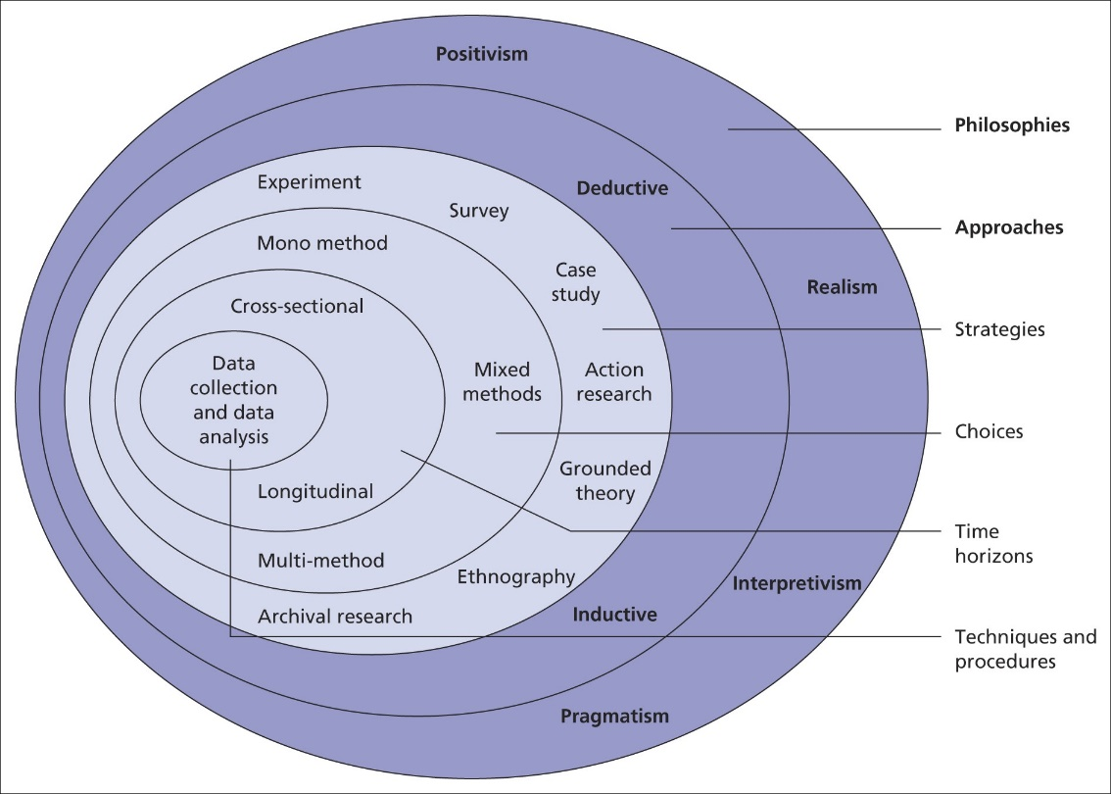
Fig 1. Diagram of the research onion (Saunders et al, 2019)

3.2 Research Philosophy
There are 4 philosophies that form the first layer of the research onion and are to be considered when carrying out research. These include positivism, realism, interpretivism and pragmatism which each offer a different perspective into how the researcher views the world and approach knowledge creation. These philosophies shape research design and guide decisions on which methods and techniques they will choose to use. The chosen philosophy for this research is realism which sits between positivism and interpretivism. It argues that while there is no objective reality that exists independently of human thought, our understanding of that reality is shaped by social, cultural and historical influences. Realism acknowledges that the observable work is real, but the way we perceive it can be flawed or incomplete. The realism philosophy is suitable as it makes allowances for not only statistical data but also underlying social or institutional factors such as systemic racism that have been shown to influence how people interact with Police as discussed in the literature view (Saunders et al, 2019).

3.3 Approach
This next section will discuss the research approaches which refer to strategies used to connect theory with the data collection process. There are two main types of approaches: Deductive and Inductive. Each one of these types informs how the researcher will engage with the study hypothesis, data and the methodology.
The Deductive approach will start with the researcher formulating their own theoretical framework, formulates a hypothesis and then designs research to test their hypothesis. This is often associated with testing already existing data.
The inductive approach essentially works in the opposite direction, the researcher will not formulate their own hypothesis first but will instead focus on exploring data to identify patterns, trends and from observations they will build theories or explanations, ultimately coming to their own hypothesis.
This research will follow a Deductive research approach as it allows for the researcher to examine previous literature and formulate a hypothesis. In this case, the hypothesis being that previous literature indicates that public perception is directly influenced by the media being consumed whether it’s traditional media or newer social media. This deductive research method will also aim to identify what impact the media is having on public opinion, whether it’s positive or negative.

3.4 Strategy and choice
This research will utilise a Mono-Method in the for of an online questionnaire developed using Google Forms which will be accessible using a website link and will be accessible through social media websites. This approach was selected as it presents an opportunity for interested persons to participate voluntarily in a formal which ensures anonymity. Research by (Regmi et al., 2016) shows that this method has benefits such as cost and time effectiveness as well as benefits such as allowing data to be obtained in a short time frame but also offering a means of engagement for participants who would otherwise be unwilling had the survey been face to face. The survey being completed via an online link which can be accessed at the participants discretion and time best suitable to them assures more confidentiality and quality of the responses received. This survey will contain both closed and open-ended questions which have shown to produce the best results when used in conjunction with one another.
The disadvantage to this method of obtaining data is that this will require a significant amount of time to review and analyse the data found.

3.7 Time Horizon
In the research onion, the time horizon layers refers to the time frame over which the research is conducted. It is designed to address whether the study was conducted to capture data of a specific point in time or over an extended period. This is important as it impacts how the data is collected and offers insights that can be gained from the research. There are two types of time horizons depicted by (Saunders et al, 2019) and they are longitudinal and cross sectional.
Cross sectional involves the collecting of data at a single point in time. This is usually employed when time or resources are limited, or when the research objective is to understand the current state of condition, in this case the state of the perception of Policing.
This research will utilise the cross sectional method as it provides a quick and inexpensive means of obtaining quality data but also offering minimal ethical difficulties (Wang and Cheng, 2020).

3.8 Techniques: Data collection and Analysis
Due to several factors such as needing to disseminate the survey to a large audience in order to obtain a suitable number of responses for analysis, this will be conducted online by using google forms. This can them be disseminated to a larger audience utilising social media and online web links whereby participants can access and complete at a time convenient for them.
The data obtained will then be analysed and displayed into graphs and charts to accurately show the findings as well as any trends or patterns which can be then used to inform on reasonable recommendations.

3.9 Sample
A sample is defined as “A finite part of a statistical population whose properties are studied to gain information about the whole”. Perez Ghauri states in his book that its essential to use a small sample of the population when conducting research as the general population would be too large to analyse (Ghauri, 2020). This research will aim to get between 25 and 50 respondents from both the web link and social media platforms to offer quantitative data and qualitative data.
By utilising a combination of both quantitative and qualitative data, this will allow the researcher to obtain a better understanding of how the participants perception of Policing is affected by media.

3.9.1 Reliability and Validity
Reliability and Validity are essential concepts and dependability of the research methods, data collection and findings. Reliability is referred to the stability of findings, whereas validity represents the truthfulness of the findings, ultimately leading to the question of if the research was conducted again, would it produce the same results? (Altheide, 1994).
A survey is considered effective, valid and dependable as they allow the researcher to collect a large amount of data which help to outline the primary data (participants)’s view points (Cinla Akinci and Mark NK Saunders, 2015)

3.9.2 Limitation
This research has presented with several limitations which may have an affect on the results and findings. The first limitation being that of time, this research was to be conducted and presented within a 10-month period therefor only allow for research to be conducted within that time frame.
Another limitation found throughout the course of this research was that of the sample pool and sensitivity of the research topic and the results of the survey were completed by a number of serving Police officers who may possess a bias view point, but also participants whom are aware that the researcher is of a Policing profession therefor may be inclined to answer in a certain fashion or simply not take part at all.
Through the short time that the survey was completed, the survey found limited response ultimately offering a lower pool of answers to analyse and disparity between results.

3.9.3 Ethical Considerations
When conducting primary research there needs to be room for ethical considerations which are of serious importance, hence a comprehensive ethics form was completed at the beginning of this research to ensure that this project had appropriate approval. Prior to applicants taking part in the survey and the primary data being obtained, applicants were informed how the data would be used and the nature of the project. Applicants were also ensured that participation was voluntary and could withdraw from the process at any time.
Whilst this survey is being conducted about a topic that is relatively controversial especially for Police officers as it dissects how they are perceived, this survey does not restrict Police officers from participating as data from all members of the public, whether police or not offers a more varied, accurate and fair account of how people believe that the media affects their perception. Participants will be anonymous; no personal data will be collected and is entirely confidential.

3.9.3 Conclusion
This chapter has successfully identified and researched the most appropriate research method known as the methodology.
This section has completed objective 2 of this project.
The next section of this project will aim to achieve objective three
- “To analyse the data obtained to better understand the publics relationship with the media and how/if it influences perceptions of Policing and why.”

Chapter 4: Analysis of results

4.1 Introduction
Chapter 3 identified the methods and methodology for this research, this chapter will aim to achieve the third objective:
“To analyse the data obtained to better understand the publics relationship with the media and how/if it influences perceptions of Policing and why?”
This chapter will aim to present primary data obtained and analyse it to help produce a further discussion and recommendation later in this study. Additionally, the aim it to identify if there are any patterns or trends in the responses from the participants which may help the researcher reach a consensus and provide a better understanding of the public perception of Policing.
An online survey was conducted whereby x participants took part offering their own individual perception of if and how the media affects their perception of Policing. The questions and findings from the study can be found in the appendix.

4.2 Data Analysis
Data analysis is the process of systematically applying statistical, logical and thematic techniques to describe and summarise the data that has been collected during this research. This section is critical to help make sense of the data obtained through the primary research and draw a meaningful conclusion that answers the research question and will test hypotheses. The data analysis typically follows methodology and precedes the discussion and conclusion (Bryman and Hardy, 2009).

4.3 Advantages of using Google Docs
Using google docs to complete the survey was advantageous as it facilitated the collection of quick results from participants. Additionally, it allowed for a large number of participants which is key for the quantitative data needed for the research. Using Google docs allows for the option to keep participants anonymous, which was essential as outlines in the ethics form but also encouraging participation. Google docs allowed for the survey to be created in a very timely manner but was also simplistic, allowing for easy-to-read questions and providing automatic graphs and charts which can be used to analyse the results. Another positive of using Google Docs was that if offered the ability to maintain answer integrity, such as offering the creator an option to only allow participants to choose one answer per question rather than picking multiple.

4.4 Disadvantages of using Google Docs
Some of the disadvantages of using Google Docs were that some of the participants did not answer all of the questions. For example, question 19 was often left unanswered. This may have either been due to the way the question was worded or perhaps participants didn’t know where to answer or see the answer box. This will have had some affect on the overall analysis and findings due to the question being the only open answered question in the survey, offering the participant and opportunity to offer their opinions in their own words.

4.5 Demographics and Descriptive Statistics
Participants were asked to describe themselves through a series of questions such as age, gender and ethnicity but also allowing for the participant to remain anonymous by offering an option not to answer that question. The survey was completed by 50 participants who were aged 18 years or older and was shared using social media as well as through WhatsApp groups. This was done to reach a larger audience, however offered the limitation to those who do not actively use social media. The purpose of ascertaining the participants characteristics was to determine if there was a disparity in answers based on a person’s demographic or other personal characteristics such as the BAME community. This is important as research conducted by Amber Evans, Patrick Olajide and Jon Clements showed that whilst there as support from mostly all members of public for Police, they showed that Black people were less favourable due to their treatment in instances such as being disproportionately stop and searched (Evans, Olajide and Clements, 2022).

4.6 Questionnaire Findings

4.6.1 Is the Media influencing people’s perceptions?
Throughout the survey 57 participants were asked a series of questions relating to how the media has an affect on perception of Policing. The questions were designed to offer a range of options such as “Strongly Agree” through to “Strongly Disagree” which the alternative option of “Neutral” or another neutral worded option for those who were either unsure or preferred not to say. The participants of this survey were asked to state their ethnicity, to which 70% of the participants answered ‘White British’ leaving the remaining 30% that of a minority ethnicity. With these results in mind, it’s important to remember how the findings of this survey may have been different if there was a more equal number of minority ethnicity participants to white British participants.
The purpose of this dissertation was to understand whether the media is having an adverse change on the public’s perception of Policing, the survey suggests that not only is the media having an impact on people’s perception, but it’s having a significant negative impact. The 57 participants were asked if they believed if the media portrays Police officers in a generally Positive, neutral or negative way and of those participants 65% believes that the Police are portrayed in a negative light. Additionally, 22% believe that the media portrays Policing in a neural light leaving only 12% thinking Police are portrayed positively. This shows clear evidence that not only is the media having an effect on public perception, but a significantly negative affect. The results of this survey further cement the work done by Chartterjee and Ryan who found that 71% of the public believed the media had a direct impact on their perception (Chatterjee and Ryan, 2020).
The 57 applicants were asked if the media has influenced their trust in Police officers to which 63% answered ‘No Change’, with the next most prominent answer being 29% saying their trust was more negative. Of all the answers selected, the most disturbing was that only 6% of participants stated that their perception of Policing had improved as a result of the media portrayal of Police.

4.6.2 How is the media impacting people’s perspective on Policing?
At the beginning of the survey participants are asked how often they watch/read news related media to which 64% of people answered ‘Daily’ and only 1% answering ‘not at all’. As per work done by (Vrij and Winkel, 1991) they have shown that topics and beliefs are discussed as a direct reflection of what they are being exposed to, and given that this survey has shown that 99% of participants are exposed to media through either their daily or weekly lives, this has a massive impact.
The participants were asked specifically about the media’s reporting of Police Misconduct and how often do they encounter those sorts of articles, to which 36% answered ‘Occasionally’ and 33% answering often. This is further supported by one of the following questions whereby a staggering 71% of participants believed that the sharing and Police related incidents on social media had an affect on Public perception.
This is further supported by work highlighted in the literature review by Weitzer and Touch who founds that inflated reporting on Policing matters relating to misconduct had a profound impact on people’s perception (Weitzer and Tuch, 2005).
Tuchman discussed, as per the literature review, that whilst our perception of the world is heavily influenced by what we see on the media, we are only exposed to a very minimal amount of topics due to the media having to be selective due tothe vast amount of reports available. This is again concerning given that 91% of participants stated that they encountered news relating to Police Misconduct or abuse of power either on a ‘Very often’ or ‘occasionally’ basis whilst only 1.8% stated ‘never’. It’s clear through this survey and in conjunction with (Tuchman, 1978) that people are exposed to negative press surrounding the Police on a regular basis.
One of the final questions in the survey asked, if their perception of Policing has changed, what has caused it? This question allowed for the participants to give a short answer whereby one answered “Seeing media reporting such incidents such as George Floyd or the Manchester incident”. Of the 36 responses to this question, 8 of them referred to either George Floyd, Waynze Cousenz or the incident at Manchester Airport in 2024. This correlates with previous studies such as (Kwon and Wortley, 2020) who showed that incidents such as the George Floyd case have had a significant impact on the BAME communities impact on the perception of Policing.
Finally, work done by (Erskine, 1974) showed that the public, because of the media they are consuming believed that crime rates were higher, and crime is more prevalent that it actually is. This survey sought to challenge this, however when asked “Do you think that media coverage of Policing influences public fear of crime?” 73% said that they agreed. This is substantial, as the media is clearly having a huge impact on peoples perception of not only the Police, but how prevalent crime is in their area despite this not necessarily being the case.

4.6.3 Is the media reporting fairly?
Given that there is substantial evidence to show that the media is having a significant impact on people’s perception of Policing, it surely is important that what is being reported is fair, however the survey suggests that 66% of participants believed that the media showed a negative bias towards the Police and only 7% believed there to be a positive bias. Interestingly, whilst two thirds of participants believed that the media shows a negative bias towards Police, 90% of participants believed that the media has a responsibility to show a balanced view of Policing. It’s clear the public expect the media to report fairly and show a balanced depiction of the Police, however it’s even more clear the media is not fulfilling this expectation, not even close.
Not only does the public believe that the news is negatively biased, participants were asked if they believed that the news coverage of Policing is accurate, to which 46% believe that the news is inaccurate as opposed to the 3.5% who believe what is reported is ‘Very accurate’.

4.6.4 How are the public consuming the news?
Whilst it’s clear that 99% of the public, according to the survey, are consuming news on a regular basis it’s important to understand how the news is being consumed. Participants were asked how they consume news to which of the 57 responses, 42 people answered ‘Social Media’. This is interesting, as one would presume that given that the participants were primarily over the age of 40 and only 5.3% of participants were under 20 years of age, one would expect that the amount of users of social media would be lower.
To delve deeper, the next question asked which platform participants use the most to consume Media, to which 31% answered ‘Instagram’, 28% said ‘Facebook’ and 15% said ‘Twitter’. Ultimately this is unsurprising and correlates with work done by (Pelchen, 2024) who shows that the internets growth and birth of social media has exploded with over 5.04 billion people accessing any form of social media. It’s become clear through this research that the primary method of accessing media has become the social platform.
This is relatively concerning given that as per the literature review, work done by (Happer and Philo, 2013) stated that the purpose of the media was to inform the public through “expert” correspondents and journalists using sanitised information, however given that social media appears to be how the public are consuming the media, this raises the question as to whether the media is being sanitised before being disseminated, possibly answering for why some applicants believed the news to be inaccurate, stating “Don't believe everything you hear or read”

4.7 Conclusion
This chapter achieved the third objective of:
“To analyse the data obtained to better understand the publics relationship with the media and how/if it influences perceptions of Policing and why?”
The findings of this survey indicate a clear and significant influence of media on the publics perception of Policing, with a notably negative Bias emerging from the data collected. A majority of participants perceive the media portrayals of Police as skewed towards negatively, with 65% stating that Police are often depicted in an unfavourable light. This aligns with (Chatterjee and Ryan, 2020), that highlights the medias role in shaping peoples influence towards Policing.
The survey also revealed that almost the entirety (99%) of applicants consume the news, mostly through social media platforms. Given that social media allows for rapid sharing of events, often sensationalised or selective, it seems to increase the publics exposure to cases of Police misconduct or abuse of power. This increase and continuous exposure to such narratives, as exposed by Tuchman 1978, has arguably fuelled a world whereby incidents involving the police significantly influence perception through the media.
Responses to open ended questions demonstrated how high profile incidents like George Floyd’s death and other major incident such as the Manchester Airport incident in 2024 have shaped public attitude, particularly with minority ethnicities which aligns with findings from Kwon and Wortley (2020). With incidents such as these being increasingly reported and discussed in the media, it reinforces the idea that media portrayal heavily influences the collective outlook on policing within society.
Additionally, the public expressed an expectation for balanced reporting, with 90% believing that the media have a responsibility to report fairly and accurately, yet only 7% belived that the media presently meets this standard. The clear disconnect between expectation and perception shows a clear concern that the public feel that the media is biased and questions the integrity of the news coverage surrounding Policing.
Finally, this study underscores the media’s substantial role in shaping the publics perception of Policing. It demonstrates the prominence of how news is being disseminated through social media but also raises the concern of how accurate and bias this news is. This raises the need to media accountability and suggests that there is a real need for balanced and accurate reporting, as the media’s portrayal of Policing plays a significant role in shaping the public’s perception of Policing.

5. Findings and conclusions

5.1 Introduction
The preceding chapters of this work have navigated the research project through its introductory, research, planning and analytical stages, culminating in the previous chapters analysis of primary data collected through quantitative methods. This data analysis has revealed prominent themes that align closely with findings from the literature review. This chapter will explore these trends and offer recommendations as to how the media and the Police can form a better relationship and improve public perception, whilst also keeping the public informed with accurate information.

5.2 The achievement of objectives
The researcher set out to achieve several objectives in order to answer the ultimate question of if the media has an affect on the public perception of policing. This study has completed the set objectives.

- Objective 1: To critically research and analyse previous and current literature surrounding the traditional and social media’s influence on public perception of Policing.
This objective was achieved by completing an exhaustive literature review, focusing on examining existing research and studies surrounding the topic of the media’s relationship with Police and how it Molds the public’s perception, whilst also looking at various case studies such as George Floyd as reference.

- Objective 2: To identify an appropriate research approach to better understand the publics views on how/if the media has influences perceptions of Policing.
Objective three was achieved by building a survey which was disseminated to an appropriate group of participants who could offer an insightful and non-biased view of how the media affects their perceptions. The research onion developed by (Saunders et al, 2016) was used to identify an appropriate research method, ultimately leading to the creation of the survey

- Objective 3: To analyse the data obtained to better understand the publics relationship with the media and how/if it influences perceptions of Policing and why.

This objective was achieved by using the results provided by Google Forms and examining the results given by the participants. This information was then presented in the form of charts which helped to show clear trends and tendencies in the participants answers. Examining this data helped to develop a conclusion and ultimately leads to recommendations.

- Objective 4: To conclude the findings of this research project and provide recommendations on how the relationship between the media, Police and public can be improved for the betterment of public interest.
This final objective will be met through the course of this final chapter and will be revisited.

5.3 Main findings
The primary research conducted in this dissertation have shown clearly that not only does the media does have a profound impact on the public’s perception of Policing, but it’s having a predominately negative impact. The primary data obtained from the survey supports the secondary data shown in the literature review. When comparing both sets of data, it has become clear that the media is having a negative impact on people’s perception of Policing, but also that the public feels that the media is not reporting accurately on matters surrounding the Police.
The primary data showed that 71% of participants felt that the media has a direct influence on their perception of Police and when asked how they believe the media portrays Police, 65% believed it to be negatively. These two pieces of data show a definitive trend that the public feel their perception is being influenced negatively, which is even more concerning considering that 66% of the public felt that the media reports a negative bias towards Police. Interestingly, whilst 66% of the public believe that the media is biased, an overwhelming majority of 91% believe that the media has a responsibility to report fairly.
The researcher also aimed to understand not only if there if an influence on perception, but if the information being disseminated is accurate, and when questioned about this 47.3% answered that the media relating to Policing is “Inaccurate”. Whilst this is less then half, it is aggravated by the fact 26% believed the media reported neutrally, ultimately meaning that only 31.6% of participants believed the news to be accurate.
It has become clear through all of these data points that the public feel their perception is influenced by the media, but also that the information is not only inaccurate but biased too. The public expressed that they overwhelmingly believed the media has a responsibility to report fairly, and this is clearly not being achieved.
Finally, the development of social media has played a significant role in the media’s influence of public perception relating to Police. The growth of social media is well documented throughout the dissertation, and the primary data obtained clearly compliments the already existing research with 84% of the public believing that social media has more of an influence on their perception compared to traditional media.
With a growing social media influence of Policing perception and a tendency for the media to report negatively on Policing matters, it raises concerns that information is being shared in an unsensitised domain leading to the spread of false information. All of this ultimately leads to a public having a negative perception of the Police that serve them and a growing fear of crime.

5.4 Recommendations/Further research
The recommendations to follow are based on the findings and discoveries made whilst conducting research of the topic. The overwhelming opinion abstracted from the surey was that the public believes the media to reporting negatively on Policing matters and is having a negative influence of public perception. The public believes the news reported to be inaccurate and biased against Police. It is clear that there needs to be some improvement between the way the Police and the media from a relationship and the way that the media is reporting on Policing. The relationship between the Police, the media and the public can be improved through accomplishing the following:

5.4.1 Recommendation One: Media accountability
The public expressed through this research that they believe the media has a responsibility to report fairly, however it is clear this is not being achieved. The media is having a profound negative impact on Policing and it’s clear the public feel this to be unfair and inaccurate. There needs to be some accountability on the media to report fairly and accurately. This can be done either by the public as a consumer holding the media accountable and rebutting the information being disseminated and not engaging with media outlets, ultimately putting pressure on them to report more fairly or risk losing profit and consumers. Additionally, there is scope for a legislative approach, ensuring that media outlets are responsible for reporting fairly and accurately and not becoming sensationalised. An example of this would be the Manchester Airport incident in 2024, whereby the media initial reporting of the incident sparked public outrage. This outrage was then lessened with the publication of the full facts of the incident, but nonetheless the damage had already been done and the media lost the opportunity to present a fair and accurate account of Police matters.

5.4.2 Recommendation Two: Police positive action
Police need to do more to improve their perception directly rather than relying on the media to report accurately and fairly, which clearly isn’t the case. This can be achieved by Police forces taking a proactive step to improve perception by releasing information directly such as utilising Body Worn video more effectively. Incidents such as the Manchester Airport incident would have been a perfect opportunity for the police to show a true and accurate account of what happened without relying on the media to release footage that was not comprehensive in documenting the entire event. Police forces may see an improvement in their perception by showing from a Policing perspective the challenges and difficulties of Policing in the face of adversity. Often the public sees what the media wants them to, and this is often negatively.

5.5 Reflection
Throughout the study the researched gained a deep understanding of what is a very controversial but important topic. The study has at times presented difficulties to the researcher, such as obtaining an adequate amount of participants for data analysis, managing time effectively but also engagement with feedback. The researcher seeked to gain a better understanding of the role the media play in affecting public perceptions, and with the knowledge gained throughout this research it is the hope that the recommendations can be used for the betterment of public perception and confidence in Policing.

6. Bibliography
Reference list
Altheide, D. (1994). APA PsycNet. [online] psycnet.apa.org. Available at: https://psycnet.apa.org/record/1994-98625-029.
Author (2016). 1.3 The Evolution of Media. [online] Umn.edu. Available at: https://open.lib.umn.edu/mediaandculture/chapter/1-3-the-evolution-of-media/#:~:text=In%20addition%20to%20the%20breakthroughs [Accessed 27 Sep. 2024].
BBC (2021). 1920s. [online] Bbc.com. Available at: https://www.bbc.com/historyofthebbc/timelines/1920s#:~:text=The%20British%20Broadcasting%20Company%2C%20as.
Belt, T.L. and Just, M.R. (2008). The Local News Story: Is Quality a Choice? Political Communication, 25(2), pp.194–215. doi:https://doi.org/10.1080/10584600801985714.
Boxerman, A. (2023). U.K. Police Officer to Be Charged With Murder in Shooting of Black Man. The New York Times (Digital Edition), [online] p.NA-NA. Available at: https://go.gale.com/ps/i.do?id=GALE%7CA767118134&sid=googleScholar&v=2.1&it=r&linkaccess=abs&issn=15538095&p=AONE&sw=w&userGroupName=anon%7E3d39d45e&aty=open-web-entry [Accessed 2 Oct. 2024].
Bryant, E. (2011). Bad News for Disabled People. [online] Available at: https://www.gla.ac.uk/media/Media_214917_smxx.pdf.
Bryman, A. (2016). Social Research Methods. [online] Google Books. Available at: https://books.google.co.uk/books?hl=en&lr=&id=N2zQCgAAQBAJ&oi=fnd&pg=PP1&dq=bryman+2016&ots=dqKzCTH4oc&sig=A1xcvkMjk2fOI9nXV52TF_udNxQ&redir_esc=y#v=onepage&q=bryman%202016&f=false [Accessed 4 Oct. 2024].
Bryman, A. and Hardy, M. (2009). The Handbook of Data Analysis. [online] Available at: http://tailieudientu.lrc.tnu.edu.vn/Upload/Collection/brief/brief_8849_15019_21201285113DATAANALYSISbm00001.pdf [Accessed 4 Oct. 2024].
Cassell, C., Grandy, G. and Cunliffe, A.L. (2017). The SAGE Handbook of Qualitative Business and Management Research Methods. www.torrossa.com, [online] pp.1–1056. Available at: https://www.torrossa.com/en/resources/an/5018777#page=503.
Chatterjee, D. and Ryan, A.M. (2020). Is policing becoming a tainted profession? Media, public perceptions, and implications. Journal of Organizational Behavior, 41(7), pp.606–621. doi:https://doi.org/10.1002/job.2471.
Cinla Akinci and Mark NK Saunders (2015). Using Questionnaire Surveys for Within-Organisation HRD Research. [online] ResearchGate. Available at: https://www.researchgate.net/publication/283329027_Using_Questionnaire_Surveys_for_Within-Organisation_HRD_Research [Accessed 4 Oct. 2024].
dictionary.com (2018). the definition of media. [online] www.dictionary.com. Available at: https://www.dictionary.com/browse/media.
End Violence Against Women (2021). Almost half of women have less trust in police following Sarah Everard murder. [online] END VIOLENCE AGAINST WOMEN. Available at: https://www.endviolenceagainstwomen.org.uk/almost-half-of-women-have-less-trust-in-police-following-sarah-everard-murder/.
Erskine, H. (1974). The Polls: Fear of Violence and Crime. The Public Opinion Quarterly, [online] 38(1), pp.131–145. Available at: https://www.jstor.org/stable/2747843.
Evans, A., Olajide, P. and Clements, J. (2022). Crime, policing and stop and search: Black perspectives in context. [online] Available at: https://64e09bbc-abdd-42c6-90a8-58992ce46e59.usrfiles.com/ugd/64e09b_9b1fcbf31faf478db21e05fb34bd73b8.pdf.
Gau, J.M., Paoline, E.A. and Paul, N.D. (2022). De-policing as a result of public scrutiny: examining officers’ perceptions of negative media attention and willingness to engage in self-initiated activity. Journal of Crime and Justice, 45(5), pp.1–13. doi:https://doi.org/10.1080/0735648x.2021.2024082.
Ghauri, P. (2020). Research Methods in Business Studies. [online] Google Books. Available at: https://books.google.co.uk/books?hl=en&lr=&id=1gvUDwAAQBAJ&oi=fnd&pg=PR14&dq=ghauri+et+al+2020&ots=xP-SVhfkUJ&sig=DTzX01PjngDrXjvImSQI8SPyw5k&redir_esc=y#v=onepage&q=ghauri%20et%20al%202020&f=false [Accessed 4 Oct. 2024].
GOV.UK (2021). Confidence in the local police. [online] www.ethnicity-facts-figures.service.gov.uk. Available at: https://www.ethnicity-facts-figures.service.gov.uk/crime-justice-and-the-law/policing/confidence-in-the-local-police/latest/.
Graber (1980). Crime news and the public. [online] Nii.ac.jp. Available at: https://cir.nii.ac.jp/crid/1130282273324700160 [Accessed 27 Sep. 1980].
Happer, C. and Philo, G. (2013). The Role of the Media in the Construction of Public Belief and Social Change. Journal of Social and Political Psychology, [online] 1(1), pp.321–336. doi:https://doi.org/10.5964/jspp.v1i1.96.
Heavens, U. and Obasi (2024). ISRG PUBLISHERS THE LINK BETWEEN NEW MEDIA, INTERNET AND DISSEMINATION OF INFORMATION. ISRG Journal of Arts. [online] doi:https://doi.org/10.5281/zenodo.11112277.
Kwon, J. and Wortley, S. (2020). Policing the Police: Public Perceptions of Civilian Oversight in Canada. Race and Justice, 12(4), p.215336872092456. doi:https://doi.org/10.1177/2153368720924560.
Merriam-Webster (2010). Definition of SAMPLE. [online] Merriam-webster.com. Available at: https://www.merriam-webster.com/dictionary/sample.
news media association (2023). History of British Newspapers. [online] News Media Association. Available at: https://newsmediauk.org/history-of-british-newspapers/.
Nivette, A., Nägel, C. and Gilbert, E. (2023). Examining the Effects of the Killing of George Floyd by Police in the United States on Attitudes of Black Londoners: a Replication. Police Practice and Research, 24(5), pp.1–22. doi:https://doi.org/10.1080/15614263.2023.2185241.
Pelchen, L. (2024). Internet Usage Statistics In 2024. [online] Forbes Home. Available at: https://www.forbes.com/home-improvement/internet/internet-statistics/#:~:text=Key%20Internet%20Statistics&text=Working%2C%20streaming%2C%20scrolling%20and%20gaming.
Regmi, P.R., Waithaka, E., Paudyal, A., Simkhada, P. and Van Teijlingen, E. (2016). Guide to the Design and Application of Online Questionnaire Surveys. Nepal Journal of Epidemiology, [online] 6(4), pp.640–644. doi:https://doi.org/10.3126/nje.v6i4.17258.
Rogers and Dearing (1988). The Anatomy of Agenda-Setting Research . [online] Available at: https://www.researchgate.net/profile/James-Dearing/publication/249471082_The_Anatomy_of_Agenda-Setting_Research/links/5d444988a6fdcc370a74c98e/The-Anatomy-of-Agenda-Setting-Research.pdf.
Sagan, P. and Leighton, T. (2010). The Internet & the future of news. Daedalus, 139(2), pp.119–125. doi:https://doi.org/10.1162/daed.2010.139.2.119.
Saunders, M., Lewis, P., Thornhill, A. and Bristow, A. (2019). ‘Research Methods for Business students’ Chapter 4: Understanding Research Philosophy and Approaches to Theory Development. [online] Researchgate. Available at: https://www.researchgate.net/publication/330760964_Research_Methods_for_Business_Students_Chapter_4_Understanding_research_philosophy_and_approaches_to_theory_development.
Tuchman, G. (1978). Television News and the Metaphor of Myth. Studies in the Anthropology of Visual Communications, 5(1), pp.56–62. doi:https://doi.org/10.1525/var.1978.5.1.56.
University of Nebraska (2022). What is Newsworthy? [online] university of nebraska at omaha. Available at: https://www.unomaha.edu/office-of-strategic-marketing-and-communications/public-relations/what-is-newsworthy.php.
Vrij, A. and Winkel, F.W. (1991). Cultural patterns in Dutch and Surinam nonverbal behavior: An analysis of simulated police/citizen encounters. Journal of Nonverbal Behavior, 15(3), pp.169–184. doi:https://doi.org/10.1007/bf01672219.
Wang, X. and Cheng, Z. (2020). Cross-sectional studies: Strengths, weaknesses, and Recommendations. Chest, [online] 158(1), pp.65–71. doi:https://doi.org/10.1016/j.chest.2020.03.012.
Weitzer, R. and Tuch, S.A. (2005). Racially Biased Policing: Determinants of Citizen Perceptions. Social Forces, [online] 83(3), pp.1009–1030. doi:https://doi.org/10.1353/sof.2005.0050.
WILLIAMS, P. and DICKINSON, J. (1993). FEAR OF CRIME: READ ALL ABOUT IT? The British Journal of Criminology, 33(1), pp.33–56. doi:https://doi.org/10.1093/oxfordjournals.bjc.a048289.

7. Appendices

7.1 Appendix one: Questionnaire
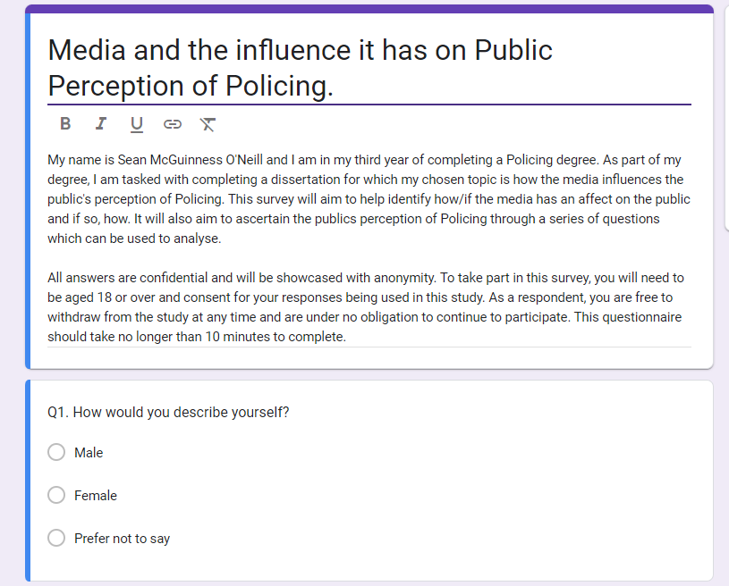
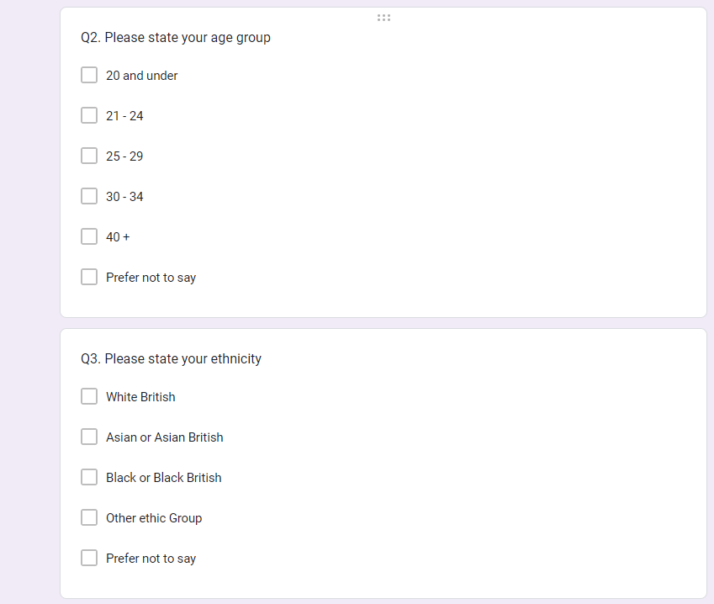
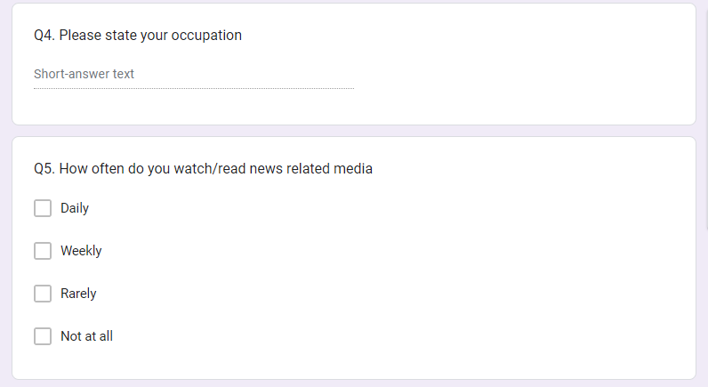

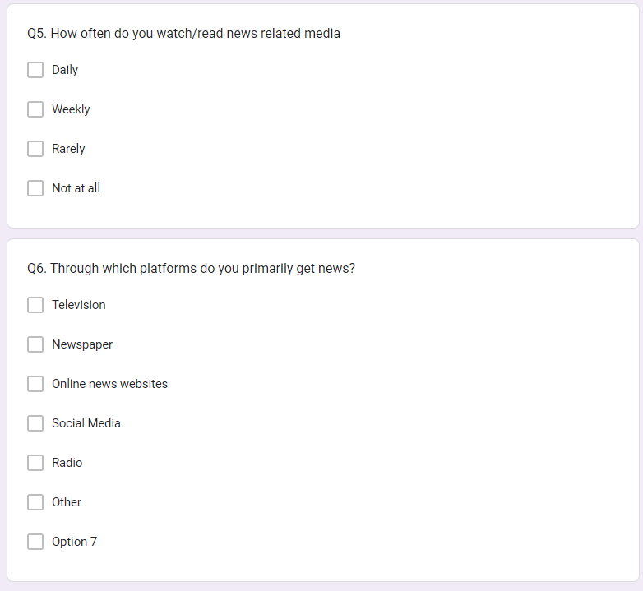
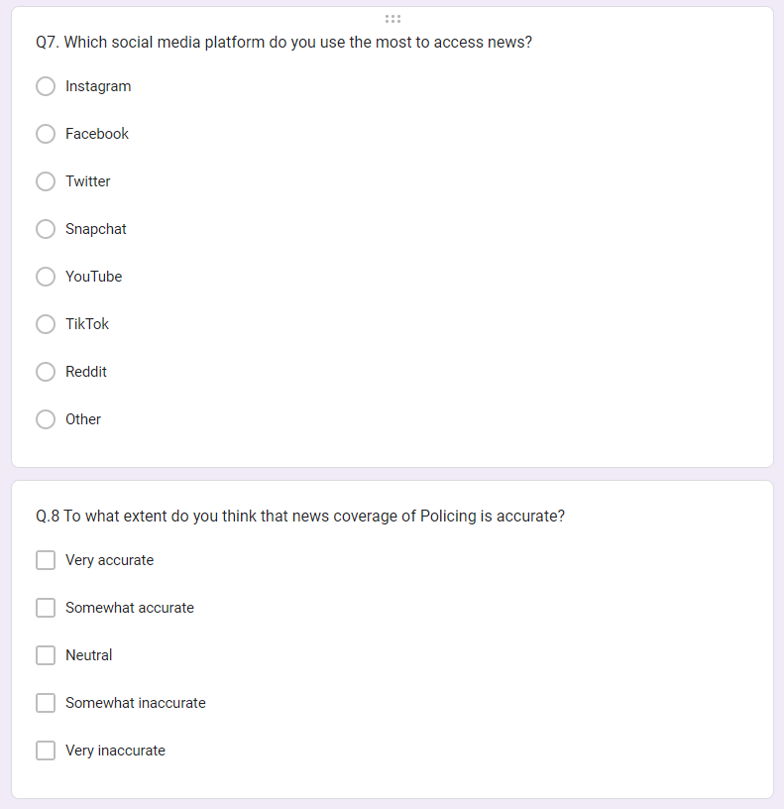

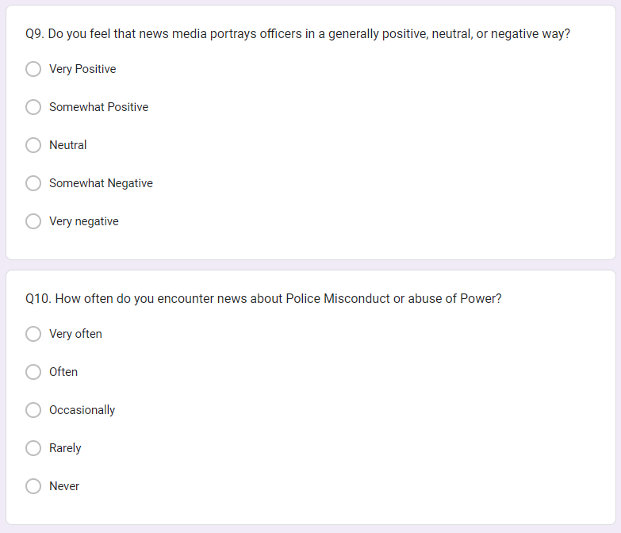
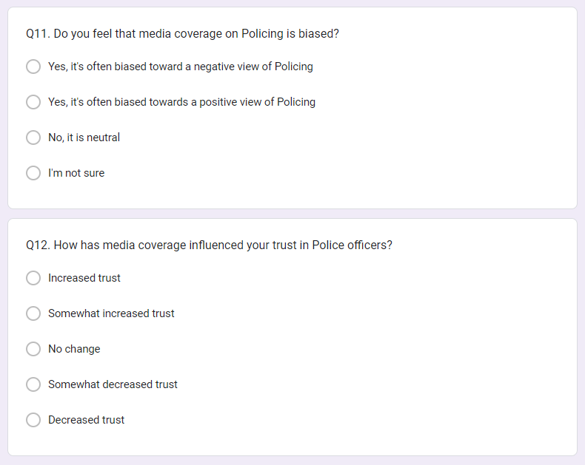
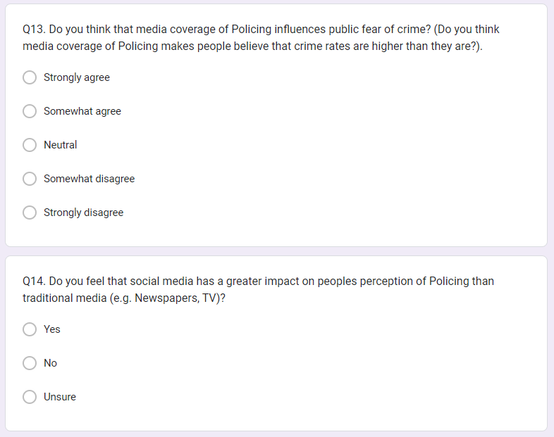
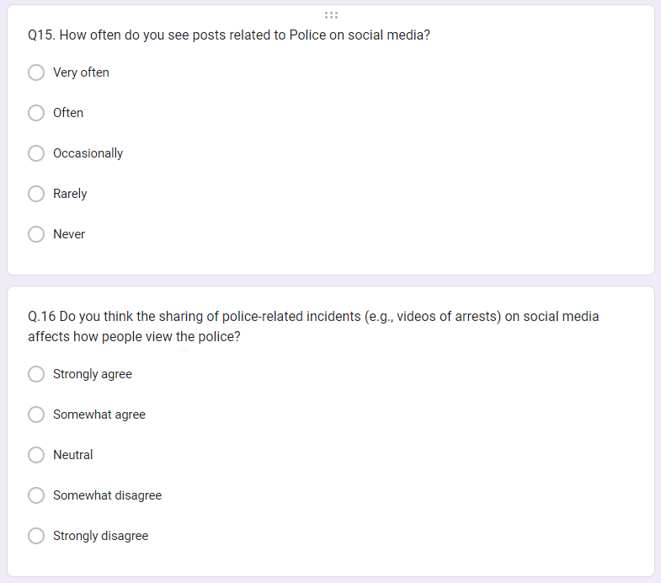
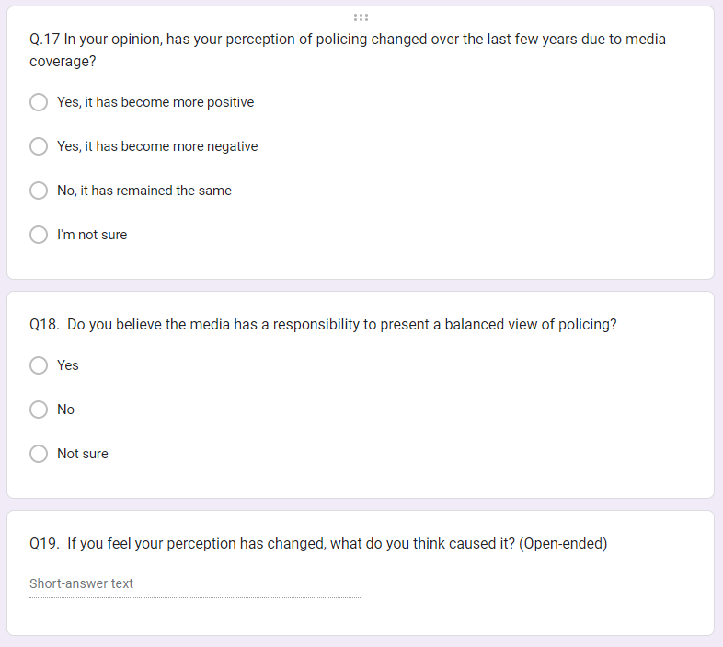

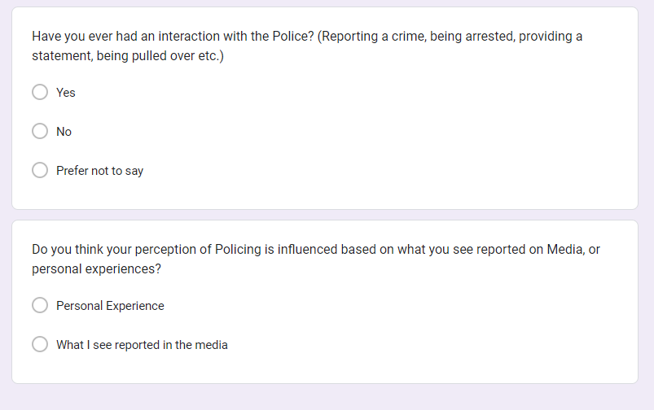

7.2 Appendix Two: Questionnaire Results
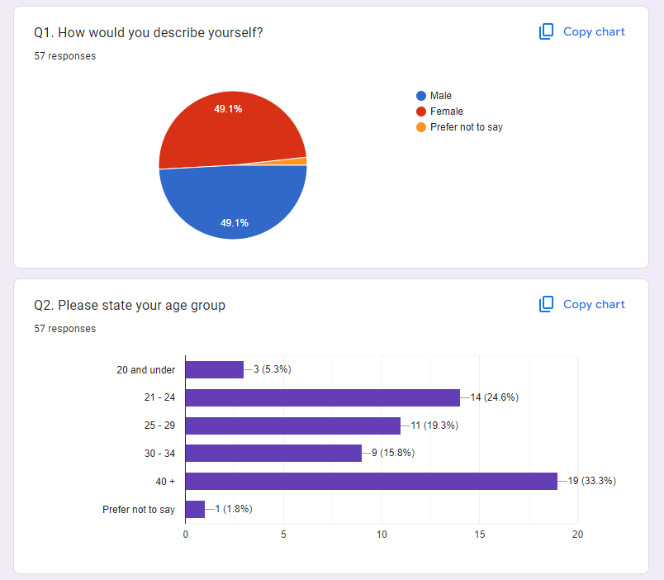
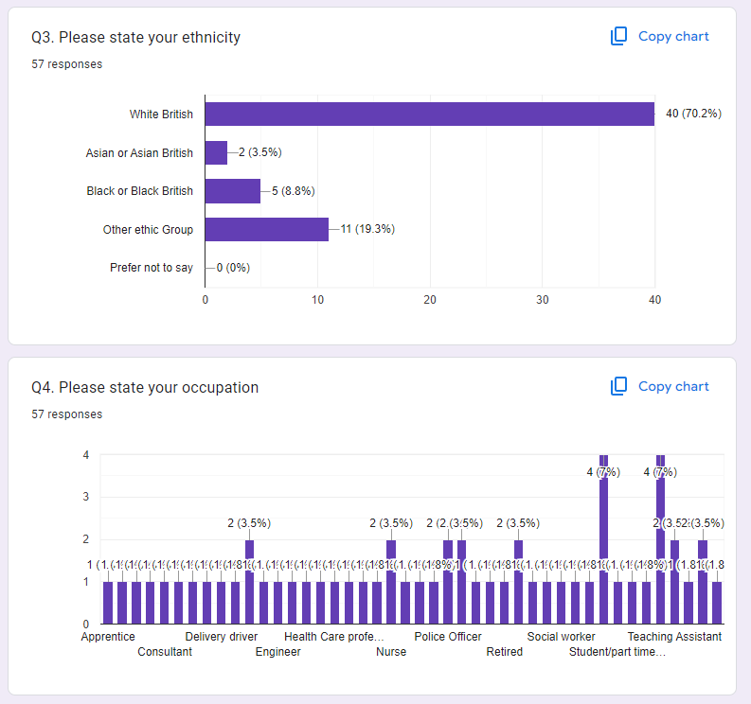
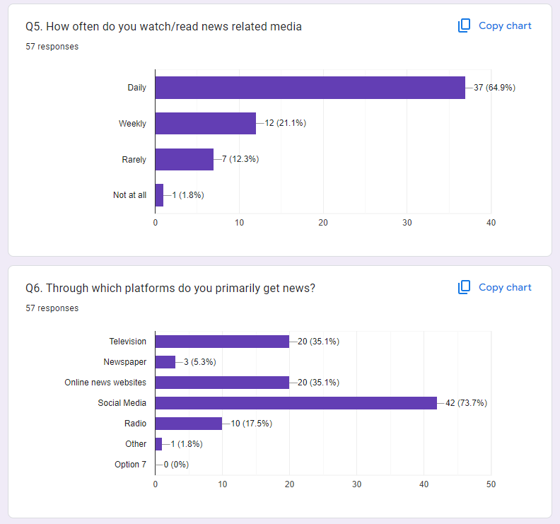
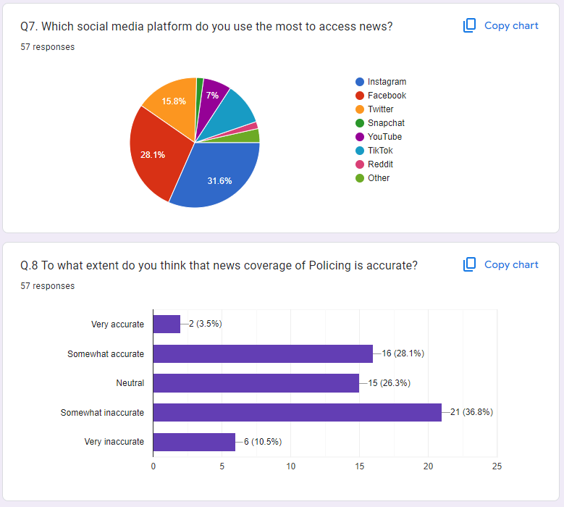
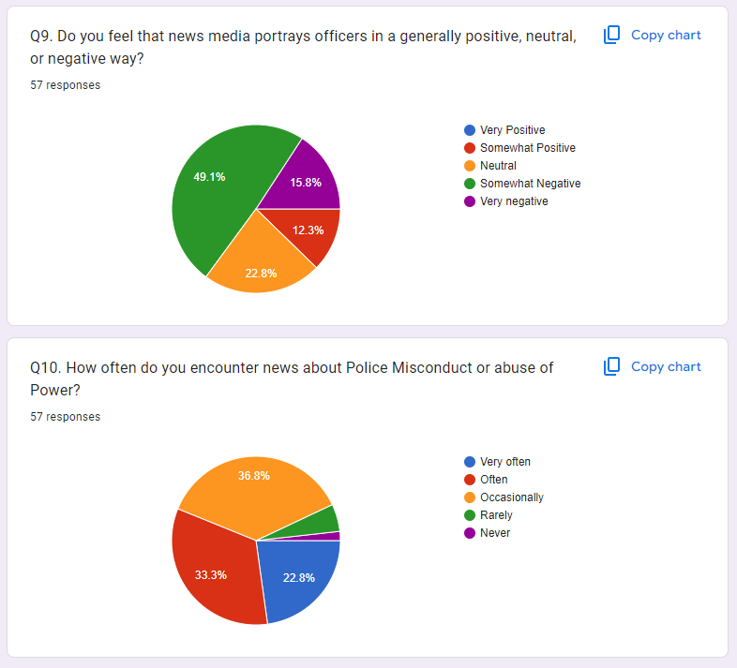
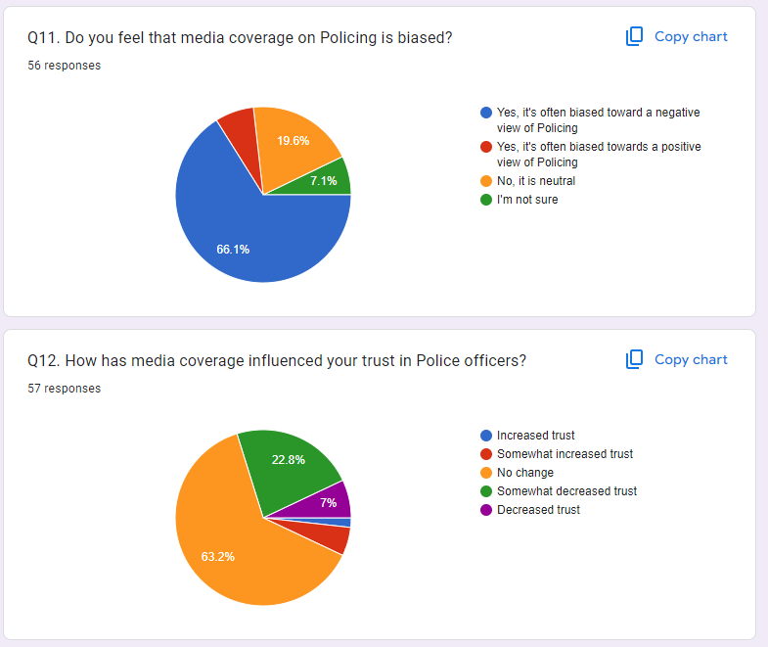
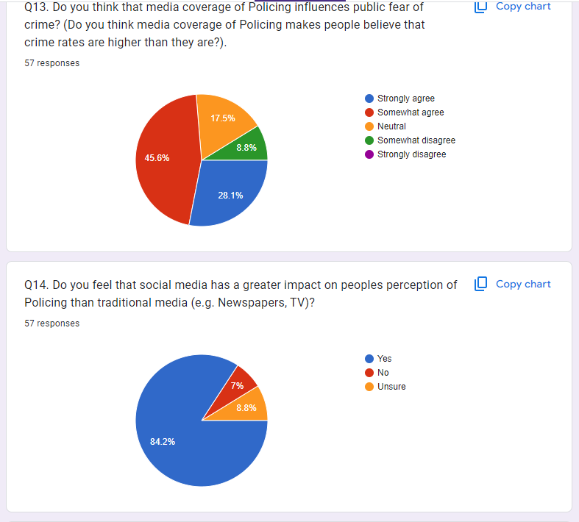
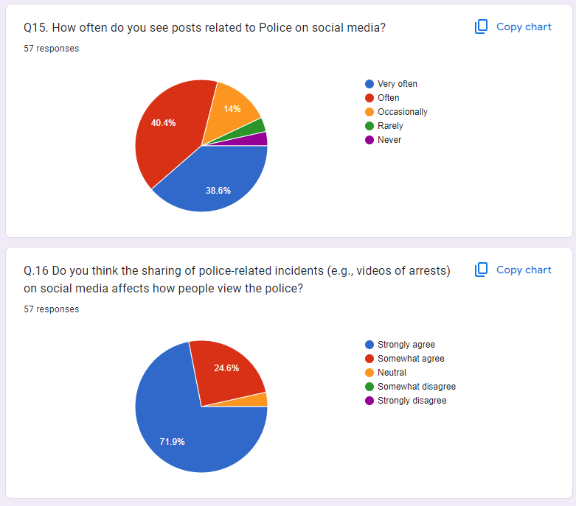
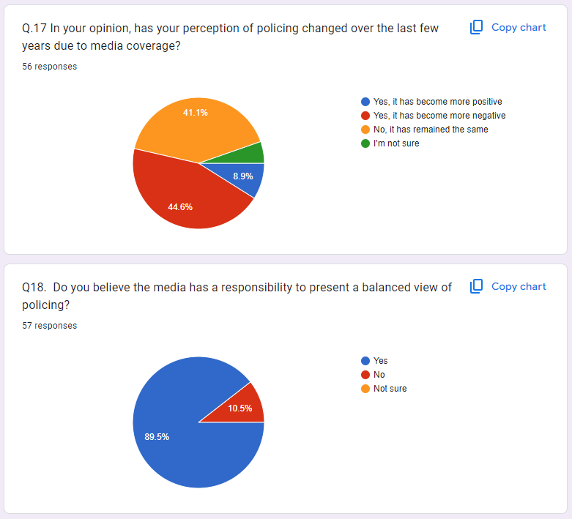
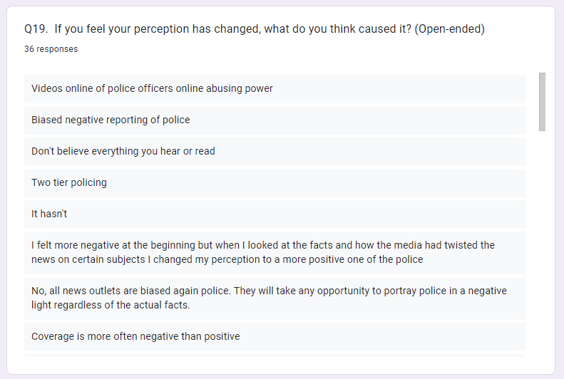
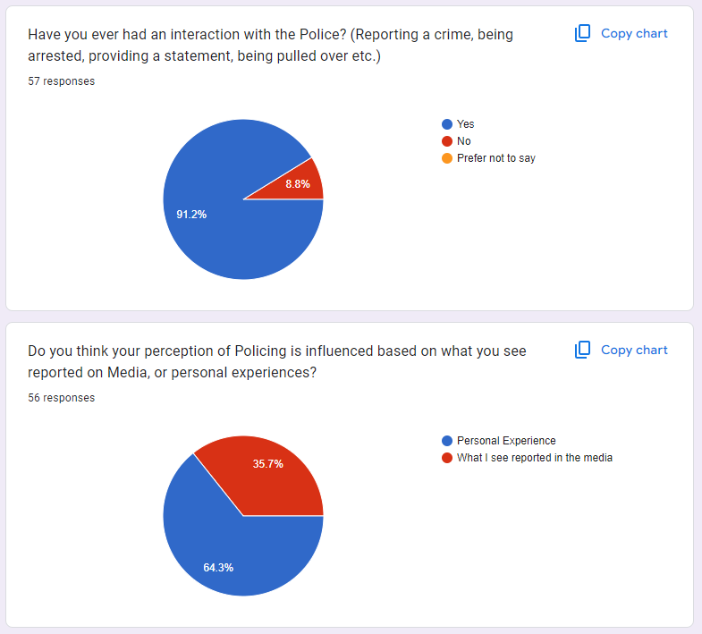

7.3 Appendix Three: Dissertation proposal



UNDERGRADUATE DISSERTATION
RESEARCH PROPOSAL FORM

Please complete the following research proposal and submit it to Turnitin.

Which project option are you taking? Please tick:

8,000 word project

Please remove the red writing for your final submission.

NAME: Sean Patrick McGuinness O’Neill | STUDENT ID No.: 2124735
DRAFT RESEARCH TITLE QUESTION:
INTRODUCTION:
Police Services in Western Society and their relationship with the Media – What effect is the media having on Public Perception on Policing.

I believe this topic to be worthy of consideration as it offers an important insight into how Police services in the West are being seen by the public whom they serve. I believe there is extensive amounts of consideration for varying perspectives within this topic, many of which beg to be explored and examined for an interesting conclusion.

I believe this subject to be Hot Topic and there is a vast amount of data, case studies and interesting perceptions to explore. Police Services across Western Society have been scrutinised publicly and I want to explore if this has influenced public perception and what leads the media to cover these stories. Furthermore, I want to explore the relationship between Police forces and their media counter parts. Is this a collaborative working relationship or a political standoff.

SUMMARY OF RESEARCH OBJECTIVES:

Within this topic I have several objectives. This is an extensive topic and I believe there are a lot of perspectives and interesting avenues to explore.
- How has the Media Affected Public Perception of Policing in Western Society.
- How is this impacting Police forces across Western Society.
- To identify and explore and discrepancies or biases in media depictions of Policing and their potential influence on public opinion.
- To explore the influence of demographic factors (age, race, age, ethnicity) on how individuals interpret and respond to media representation of Western Policing.
- To explore how Police Services in Western Society communicate with Media outlets and how this relationship has developed.
- To explore the effectiveness of communications strategies employed by law enforcement agencies in western societies to counteract negative media portrayals and manage public perception.
- What is the motivation for Police portrayal across media outlets (financial, fact finding, political or a moral obligation)
- Summaries whether the media is portraying the Police services fairly.

LITERATURE REVIEW:

Given the topic, there are many media examples and case studies of negative, and positive portrayals of Policing. I intend on researching these portrayals and how they have developed over time. Mainstream media will be essential when researching this. I also intend on consulting government reports and legislation, has the media been given more or less power to scrutinise Policing.
Case studies will be essential, I want to explore data that underlines public perception, does the community feel confident in reporting crimes and the Police ability to produce positive results. This will be found through government reports and media surveys.

I also intend on enquiring with Local Police forces on the results they have seen, such as number of reported Crimes in a particular demographic (BAME) and whether the influence of social media has caused an increase or decrease in the number of incidents reported to Police as a direct result of media.

SUMMARY OF RESEARCH –SURVEY METHOD:
I will conduct a survey with both Police staff, officers, partnering agencies and the public. The objective is to explore their observations from both a Policing standpoint, but also a potential non-bias standpoint. I want to discover whether participants believe the media to be portraying the Police fairly, or whether the media negatively portrays Police Services for financial or political gain.

SUMMARY OF SAMPLING FRAMEWORK:

I intend to speak directly to media outlets. I want to understand their objectives and motivations for reporting Police related stories. Is there fairness? Or is there a bias towards reporting more negative policing stories as opposed to positive ones. I also want to understand what affect media outlets believe they are having on public perception, and was that the desired outcome?

Also, I want to speak directly to media teams working within Policing organisations to explore tactics and ways of fighting misinformation being portrayed in the media.

With the use of the survey, I hope to obtain results from members of the public who offer a unique perception.

ETHICAL ISSUES:
Confidentiality and Privacy – I intend on ensuring that all participants for my surveys and professional discussions are consulted about their privacy and their confidentiality.
Bias – I intend on ensuring that my research is based only on fact and not on any unconscious bias.

TIME SCALE:
I intend on affording myself plenty of time to conduct the surveys, professional discussion, and research into case studies.
REFERENCE LIST:

7.4 Appenxix Four: Ethics Form
APPLICATION FOR ETHICAL APPROVAL

RESEARCH STUDENTS
This form is to be completed by the student within SIX months for full-time students and TWELVE months for part time students, after the commencement of the research degree or following progression to Part Two of your course.

Once complete, submit this form via the MyTSD Doctoral College Portal at (https://mytsd.uwtsd.ac.uk).

This document is also available in Welsh.

RESEARCH STAFF ONLY
All communications relating to this application during its processing must be in writing and emailed to pgresearch@uwtsd.ac.uk , with the title ‘Ethical Approval’ followed by your name.

STUDENTS ON UNDERGRADUATE OR TAUGHT MASTERS PROGRAMMES should submit this form (and receive the outcome) via systems explained to you by the supervisor/module leader.

In order for research to result in benefit and minimise risk of harm, it must be conducted ethically. A researcher may not be covered by the University’s insurance if ethical approval has not been obtained prior to commencement.

The University follows the OECD Frascati manual definition of research activity: “creative work undertaken on a systematic basis in order to increase the stock of knowledge, including knowledge of man, culture and society, and the use of this stock of knowledge to devise new applications”. As such this covers activities undertaken by members of staff, postgraduate research students, and both taught postgraduate and undergraduate students working on dissertations/projects.

The individual undertaking the research activity is known as the “principal researcher”.

Ethical approval is not required for routine audits, performance reviews, quality assurance studies, testing within normal educational requirements, and literary or artistic criticism.

Please read the notes for guidance before completing ALL sections of the form.

This form must be completed and approved prior to undertaking any research activity. Please see Checklist for details of process for different categories of application.

SECTION A: About You (Principal Researcher)
1 | Full Name: |  | Sean Patrick McGuinness O’Neill
2 | Tick all boxes that apply: |  | Member of staff: | ☐ | Honorary research fellow: | ☐
 | Undergraduate Student | ☒ | Taught Postgraduate Student | ☐ | Postgraduate Research Student | ☐

3 | Institute/Academic Discipline/Centre: | UWTSD
4 | Campus: | Swansea
5 | E-mail address: | 2124735@student.uwtsd.ac.uk
6 | Contact Telephone Number: | 07488476080
 | For students:
7 | Student Number: | 2124735
8 | Programme of Study: | Professional Police Practice
9 | Director of Studies/Supervisor:

SECTION B: Approval for Research Activity
1 | Has the research activity received approval in principle?  (please check the Guidance Notes as to the appropriate approval process for different levels of research by different categories of individual) |  | YES | ☒ | NO | ☐
 |  |  |  |  | Date
2 | If Yes, please indicate source of approval (and date where known): Approval in principle must be obtained from the relevant source prior to seeking ethical approval | Research Degrees Committee |  | ☒
2 |  | Institute Research Committee |  | ☐
2 |  | Other (write in) |  | ☐

SECTION C: Internal and External Ethical Guidance Materials
 | Please list the core ethical guidance documents that have been referred to during the completion of this form (including any discipline-specific codes of research ethics, location-specific codes of research ethics, and also any specific ethical guidance relating to the proposed methodology). Please tick to confirm that your research proposal adheres to these codes and guidelines. You may add rows to this table if needed.
1 | UWTSD Research Ethics & Integrity Code of Practice | ☒
2 | UWTSD Research Data Management Policy | ☒
3 | [List any other relevant documents here] | ☐

SECTION D: External Collaborative Research Activity
If there are external collaborators then you should gain consent from the contact persons to share their personal data with the university. If there are no external collaborators then leave this section blank and continue to section E.
1 | Institution
2 | Contact person name
3 | Contact person e-mail address
4 | Is your research externally funded? |  | YES | ☐ | NO |  | ☐
5 | Are you in receipt of a KESS scholarship? |  | YES | ☐ | NO |  | ☐
6 | Are you specifically employed to undertake this research in either a paid or voluntary capacity? | Voluntary | YES | ☐ | NO | ☐
7 |  | Employed | YES | ☐ | NO | ☐
8 | Is the research being undertaken within an existing UWTSD Athrofa Professional Learning Partnership (APLP)? | If YES then the permission question below does not need to be answered. | YES | ☐ | NO |  | ☐
9 | Has permission to undertake the research has been provided by the partner organisation? | (If YES attach copy)  If NO the application cannot continue | YES | ☒ | NO |  | ☐

Where research activity is carried out in collaboration with an external organisation
10 | Does this organisation have its own ethics approval system? | YES | ☐ | NO | ☐
 | If Yes, please attach a copy of any final approval (or interim approval) from the organisation (this may be a copy of an email if appropriate).

SECTION E: Details of Research Activity
1 | Indicative title: | The study of the relationship between the Media and Policing in western society and the effect it has on Public Perception
2 | Proposed start date: |  | Proposed end date:
Introduction to the Research (maximum 300 words per section)
Ensure that you write for a Non-Specialist Audience when outlining your response to the points below:
- Purpose of Research Activity
- Proposed Research Question
- Aims of Research Activity
- Objectives of Research Activity
Demonstrate, briefly, how Existing Research has informed the proposed activity and explain
- What the research activity will add to the body of knowledge
- How it addresses an area of importance.
3 | Purpose of Research Activity  The purpose of this study is to investigate the relationship between Western Police forces and the impact that Media is having on Public perception.  I wish to research whether the media is having a positive or negative affect on public perception of policing. It will investigate what impact this is having on police forces and what the motive is for media reports on Policing.  Social media and Policing go hand in hand, it is important for the public to be informed about their communities, the question is if this is being done fairly, or if there it an ulterior motive for Media outlets i.e. financial.  This study will explore what options are available to Police forces to combat misinformation.  (this box should expand as you type)
4 | Research Question  The relationship between the media and Western Police forces, and what affect this is having on public perception.  (this box should expand as you type)
5 | Aims of Research Activity  - How has the Media Affected Public Perception of Policing in Western Society.  - How is this impacting Police forces across Western Society.  - To identify and explore and discrepancies or biases in media depictions of Policing and their potential influence on public opinion.  - To explore the influence of demographic factors (age, race, age, ethnicity) on how individuals interpret and respond to media representation of Western Policing.  - To explore how Police Services in Western Society communicate with Media outlets and how this relationship has developed.  - To explore the effectiveness of communications strategies employed by law enforcement agencies in western societies to counteract negative media portrayals and manage public perception.  - What is the motivation for Police portrayal across media outlets (financial, fact finding, political or a moral obligation)  - Summaries whether the media is portraying the Police services fairly.  (this box should expand as you type)
6 | Objectives of Research Activity  Review literature surrounding the media’s relationship with Policing  Review literature surrounding how public perception has changed as a direct result of media.  To establish the motive for media organisations publishing police related content  Is there a BIAS when media are reporting on Police matters  Has media reports on Policing affected public perception, if so how?  (this box should expand as you type)
Proposed methods (maximum 600 words)
Provide a brief summary of all the methods that may be used in the research activity, making it clear what specific techniques may be used. If methods other than those listed in this section are deemed appropriate later, additional ethical approval for those methods will be needed. You do not need to justify the methods here, but should instead describe how you intend to collect the data necessary for you to complete your project.
7 | I will consider using a survey to ask individuals a series of questions to assist with gathering data and information to help with analysing how/if media is affecting public perception.  (this box should expand as you type)
Location of research activity
Identify all locations where research activity will take place.
8 | Swansea  (this box should expand as you type)
Research activity outside of the UK
If research activity will take place overseas, you are responsible for ensuring that local ethical considerations are complied with and that the relevant permissions are sought. Specify any local guidelines (e.g. from local professional associations/learned societies/universities) that exist and whether these involve any ethical stipulations beyond those usual in the UK (provide details of any licenses or permissions required). Also specify whether there are any specific ethical issues raised by the local context in which the research activity is taking place, for example, particular cultural and/or legal sensitivities or vulnerabilities of participants. If you live in the country where you will do the research then please state this.
9 | N/A  (this box should expand as you type)

10 | Use of documentation not in the public domain: Are any documents NOT publicly available? | NO | ☒
10 |  | YES | ☐
11 | If Yes, please provide details here of how you will gain access to specific documentation that is not in the public domain and that this is in accordance with the current data protection law of the country in question and that of England and Wales.  (this box should expand as you type)

 | Does your research relate to one or more of the seven aims of the Well-being of Future Generations (Wales) Act 2015? | YES | NO
12 | A prosperous Wales | ☐ | ☒
13 | A resilient Wales | ☐ | ☒
14 | A healthier Wales | ☐ | ☒
15 | A more equal Wales | ☐ | ☒
16 | A Wales of cohesive communities | ☐ | ☒
17 | A Wales of vibrant culture and thriving Welsh language | ☐ | ☒
18 | A globally responsible Wales | ☐ | ☒
19 | If YES to any of the above, please give details:
 | (this box should expand as you type)

SECTION F: Scope of Research Activity
 | Will the research activity include: | YES | NO
1 | Use of a questionnaire or similar research instrument? | ☒ | ☐
2 | Use of interviews? | ☒ | ☐
3 | Use of focus groups? | ☐ | ☒
4 | Use of participant diaries? | ☐ | ☒
5 | Use of video or audio recording? | ☐ | ☒
6 | Use of computer-generated log files? | ☐ | ☒
7 | Participant observation with their knowledge? | ☐ | ☒
8 | Participant observation without their knowledge? | ☐ | ☒
9 | Access to personal or confidential information without the participants’ specific consent? | ☐ | ☒
10 | Administration of any questions, test stimuli, presentation that may be experienced as physically, mentally or emotionally harmful / offensive? | ☐ | ☒
11 | Performance of any acts which may cause embarrassment or affect self-esteem? | ☐ | ☒
12 | Investigation of participants involved in illegal activities? | ☐ | ☒
13 | Use of procedures that involve deception? | ☐ | ☒
14 | Administration of any substance, agent or placebo? | ☐ | ☒
15 | Working with live vertebrate animals? | ☐ | ☒
16 | Procedures that may have a negative impact on the environment? | ☐ | ☒
17 | Other primary data collection methods. Please indicate the type of data collection method(s) below. | ☐ | ☒
 | Details of any other primary data collection method:  (this box should expand as you type) | ☐ | ☒
If NO to every question, then the research activity is (ethically) low risk and may be exempt from some of the following sections (please refer to Guidance Notes).

If YES to any question, then no research activity should be undertaken until full ethical approval has been obtained.

SECTION G: Intended Participants
If there are no participants then do not complete this section, but go directly to section H.

 | Who are the intended participants: | YES | NO
1 | Students or staff at the University? | ☒ | ☐
2 | Adults (over the age of 18 and competent to give consent)? | ☒ | ☐
3 | Vulnerable adults? | ☐ | ☐
4 | Children and Young People under the age of 18? (Consent from Parent, Carer or Guardian will be required) | ☐ | ☒
5 | Prisoners? | ☐ | ☒
6 | Young offenders? | ☐ | ☒
7 | Those who could be considered to have a particularly dependent relationship with the investigator or a gatekeeper? | ☐ | ☒
8 | People engaged in illegal activities? | ☐ | ☒
9 | Others. Please indicate the participants below, and specifically any group who may be unable to give consent. | ☐ | ☒
 | Details of any other participant groups:  (this box should expand as you type) | ☐ | ☒

Participant numbers and source
Provide an estimate of the expected number of participants. How will you identify participants and how will they be recruited?
10 | How many participants are expected? | I ANTICIPATE THERE WILL BE AROUND 30 – 45 PARTICIPANTS  (this box should expand as you type)
11 | Who will the participants be? | POLICE STAFF, POLICE OFFICERS AND MEMBERS OF THE PUBLIC  (this box should expand as you type)
12 | How will you identify the participants? | I WILL GIVE EACH PERSON A NUMBER TO IDENTIFY THEM. I WILL NOT USE NAMES OR ADDRESSES. NO PERSONAL DATA WILL BE DISCLOSED.  (this box should expand as you type)

 | Information for participants: | YES | NO | N/A
13 | Will you describe the main research procedures to participants in advance, so that they are informed about what to expect? | ☒ | ☐ | ☐
14 | Will you tell participants that their participation is voluntary? | ☒ | ☐ | ☐
15 | Will you obtain written consent for participation? | ☒ | ☐ | ☐
16 | Will you explain to participants that refusal to participate in the research will not affect their treatment or education (if relevant)? | ☐ | ☐ | ☒
17 | If the research is observational, will you ask participants for their consent to being observed? | ☐ | ☐ | ☒
18 | Will you tell participants that they may withdraw from the research at any time and for any reason? | ☒ | ☐ | ☐
19 | With questionnaires, will you give participants the option of omitting questions they do not want to answer? | ☒ | ☐ | ☐
20 | Will you tell participants that their data will be treated with full confidentiality and that, if published, it will not be identifiable as theirs? | ☒ | ☐ | ☐
21 | Will you debrief participants at the end of their participation, in a way appropriate to the type of research undertaken? | ☒ | ☐ | ☐
22 | If NO to any of above questions, please give an explanation
 | (this box should expand as you type)

 | Information for participants: | YES | NO | N/A
24 | Will participants be paid? | ☐ | ☒ | ☐
25 | Is specialist electrical or other equipment to be used with participants? | ☐ | ☒ | ☐
26 | Are there any financial or other interests to the investigator or University arising from this study? | ☐ | ☒ | ☐
27 | Will the research activity involve deliberately misleading participants in any way, or the partial or full concealment of the specific study aims? | ☐ | ☒ | ☐
28 | If YES to any question, please provide full details
 | (this box should expand as you type)

SECTION H: Anticipated Risks

Outline any anticipated risks that may adversely affect any of the participants, the researchers and/or the University, and the steps that will be taken to address them.

If you have completed a full risk assessment (for example as required by a laboratory, or external research collaborator) you may append that to this form.
1 | Full risk assessment completed and appended? |  | Yes | ☒
1 |  |  | No | ☐
2 | Risks to participants  For example: sector-specific health & safety, emotional distress, financial disclosure, physical harm, transfer of personal data, sensitive organisational information
 | Risk to participants:  N/A  (this box should expand as you type) | How you will mitigate the risk to participants:  (this box should expand as you type)
3 | If research activity may include sensitive, embarrassing or upsetting topics (e.g. sexual activity, drug use) or issues likely to disclose information requiring further action (e.g. criminal activity), give details of the procedures to deal with these issues, including any support/advice (e.g. helpline numbers) to be offered to participants. Note that where applicable, consent procedures should make it clear that if something potentially or actually illegal is discovered in the course of a project, it may need to be disclosed to the proper authorities
n/a

(this box should expand as you type)
4 | Risks to the investigator  For example: personal health & safety, physical harm, emotional distress, risk of accusation of harm/impropriety, conflict of interest
 | Risk to the investigator:  n/a  (this box should expand as you type) | How you will mitigate the risk to the investigator:  (this box should expand as you type)
5 | University/institutional risks  For example: adverse publicity, financial loss, data protection
 | Risk to the University:  n/a  (this box should expand as you type) | How you will mitigate the risk to the University:  (this box should expand as you type)
6 | Environmental risks  For example: accidental spillage of pollutants, damage to local ecosystems
 | Risk to the environment:  n/a  (this box should expand as you type) | How you will mitigate the risk to environment:  (this box should expand as you type)

 | Disclosure and Barring Service
 | If the research activity involves children or vulnerable adults, a Disclosure and Barring Service (DBS) certificate must be obtained before any contact with such participants. | YES | NO | N/A
7 | Does your research require you to hold a current DBS Certificate? | ☐ | ☐ | ☒
8 | If YES, please give the certificate number. If the certificate number is not available please write “Pending”; in this case any ethical approval will be subject to providing the appropriate certificate number.

SECTION I: Feedback, Consent and Confidentiality

1 | Feedback  What de-briefing and feedback will be provided to participants, how will this be done and when?
ALL RESULTS WILL BE KEPT FOR MY OWN PURPOSE AND USE. NO PARTICIPANTS WILL BE CONTACTED BUT SHOULD PERSONS WISH TO UNDERSTAND RESULTS, MY CONTACT DETIALS WILL BE AVAILABLE TO THEM.

(this box should expand as you type)
2 | Informed consent  Describe the arrangements to inform potential participants, before providing consent, of what is involved in participating. Describe the arrangements for participants to provide full consent before data collection begins. If gaining consent in this way is inappropriate, explain how consent will be obtained and recorded in accordance with prevailing data protection legislation.
TERMS AND CONDITIONS WILL TAKE BE APPARENT BEFORE TAKING PART IN THE SURVEY AND CONSENT FULLY EXPLAINED.

(this box should expand as you type)
3 | Confidentiality / Anonymity  Set out how anonymity of participants and confidentiality will be ensured in any outputs. If anonymity is not being offered, explain why this is the case.
ANOYMITY WILL BE OFFERED FROM THE BEGINNING, NO PERSONAL INFORMATION WILL BE INPUTTED FROM PARTICIPANTS. FROM INTERVIEW, NO NAMES OR DETAILS WILL BE USED WHEN RETRIEVING RESULTS.

(this box should expand as you type)

SECTION J: Data Protection and Storage

 | Does the research activity involve personal data (as defined by the General Data Protection Regulation 2016 “GDPR” and the Data Protection Act 2018 “DPA”)? | YES | NO
1 | “Personal data” means any information relating to an identified or identifiable natural person (‘data subject’). An identifiable natural person is one who can be identified, directly or indirectly, in particular by reference to an identifier such as a name, an identification number, location data, an online identifier or to one or more factors specific to the physical, physiological, genetic, mental, economic, cultural or social identity of that natural person. Any video or audio recordings of participants is considered to be personal data. | ☐ | N/A
 | If YES, provide a description of the data and explain why this data needs to be collected:
2 | (this box should expand as you type)
 | Does it involve special category data (as defined by the GDPR)? | YES | NO
3 | “Special category data” means sensitive personal data consisting of information as to the data subjects’ –  (a) racial or ethnic origin,  (b) political opinions,  (c ) religious beliefs or other beliefs of a similar nature,  (d) membership of a trade union (within the meaning of the Trade Union and Labour Relations (Consolidation) Act 1992),  (e) physical or mental health or condition,  (f) sexual life,  (g) genetics,  (h) biometric data (as used for ID purposes), | ☐ | n/a
 | If YES, provide a description of the special category data and explain why this data needs to be collected:
4 | (this box should expand as you type)

 | Will data from the research activity (collected data, drafts of the thesis, or materials for publication) be stored in any of the following ways? | YES | NO
5 | Manual files (i.e. in paper form)? | ☐ | ☒
6 | University computers? | ☐ | ☒
7 | Private company computers? | ☐ | ☒
8 | Home or other personal computers? | ☐ | ☒
9 | Laptop computers/ CDs/ Portable disk-drives/ memory sticks? | ☒ | ☐
10 | “Cloud” storage or websites? | ☐ | ☒
11 | Other – specify: | ☐ | ☒
12 | For all stored data, explain the measures in place to ensure the security of the data collected, data confidentiality, including details of backup procedures, password protection, encryption, anonymisation and pseudonymisation:
LAPTOP IS PASSWORD PROTECTED AND ONLY I HAVE ACCESS

(this box should expand as you type)

 | Data Protection
 | Will the research activity involve any of the following activities: | YES | NO
13 | Electronic transfer of data in any form? | ☐ | ☒
14 | Sharing of data with others at the University outside of the immediate research team? | ☐ | ☒
15 | Sharing of data with other organisations? | ☐ | ☒
16 | Export of data outside the UK or importing of data from outside the UK? | ☐ | ☒
17 | Use of personal addresses, postcodes, faxes, emails or telephone numbers? | ☐ | ☒
18 | Publication of data that might allow identification of individuals? | ☐ | ☒
19 | Use of data management system? | ☐ | ☒
20 | Data archiving? | ☐ | ☒
21 | If YES to any question, please provide full details, explaining how this will be conducted in accordance with the GDPR and Data Protection Act (2018) (and any international equivalents, where appropriate):
 | (this box should expand as you type)
22 | List all who will have access to the data generated by the research activity:
ONLY MYSELF

(this box should expand as you type)
23 | List who will have control of, and act as custodian(s) for, data generated by the research activity:
ALL INFORMATION AND RESEARCH IS FOR MYSELF

(this box should expand as you type)
24 | Give details of data storage arrangements, including security measures in place to protect the data, where data will be stored, how long for, and in what form. Will data be archived – if so how and if not why not.
 | (this box should expand as you type)
25 | Please indicate if your data will be stored in the UWTSD Research Data Repository (see https://researchdata.uwtsd.ac.uk/ ). If so please explain. (Most relevant to academic staff)
 | (this box should expand as you type)
26 | Confirm that you have read the UWTSD guidance on data management (see https://www.uwtsd.ac.uk/library/research-data-management/) | YES | ☒
27 | Confirm that you are aware that you need to keep all data until after your research has completed or the end of your funding | YES | ☒

SECTION K: Declaration
The information which I have provided is correct and complete to the best of my knowledge. I have attempted to identify any risks and issues related to the research activity and acknowledge my obligations and the rights of the participants.

In submitting this application I hereby confirm that I undertake to ensure that the above named research activity will meet the University’s Research Ethics and Integrity Code of Practice which is published on the website: https://www.uwtsd.ac.uk/research/research-ethics/
1 | Signature of applicant: | SEAN MCGUINNESS | Date:20/02/2024

For STUDENT Submissions:
2 | Director of Studies/Supervisor: |  | Date:
3 | Signature: |  | Date:

For STAFF Submissions:
4 | Academic Director/ Assistant Dean: |  | Date:
5 | Signature: |  | Date:

Checklist: Please complete the checklist below to ensure that you have completed the form according to the guidelines and attached any required documentation:
☒ | I have read the guidance notes supplied before completing the form.
☒ | I have completed ALL RELEVANT sections of the form in full.
☒ | I confirm that the research activity has received approval in principle
☐ | I have attached a copy of final/interim approval from external organisation (where appropriate)
☐ | I have attached a full risk assessment (where appropriate) ONLY TICK IF YOU HAVE ATTACHED A FULL RISK ASSESSMENT
☒ | I understand that it is my responsibility to ensure that the above named research activity will meet the University’s Research Ethics and Integrity Code of Practice.
☒ | I understand that before commencing data collection all documents aimed at respondents (including information sheets, consent forms, questionnaires, interview schedules etc.) must be confirmed by the DoS/Supervisor, module tutor or Academic Director.

