Julita Goralczyk 2030630

Effective team working and communication
BMSW4002_LON
Lloyd Beharry

Table of Contents
Introduction 3
Models of communication 3
1. Shannon and weaver 3
2. Shramm 4
3. Berlo 4
Communication skills 5
1. Verbal communication 5
2. Non-verbal 5
3. Listening 5
3.1. Active listening 5
3.2. Empathetic listening 5
The disadvantaged of modern technology 5
Summary 5
References 6

Introduction

Models of communication

- Shannon and Weaver

In the1949 Shannon and Weaver had created model of communication that became “mother of all models” (Communication, 2018).

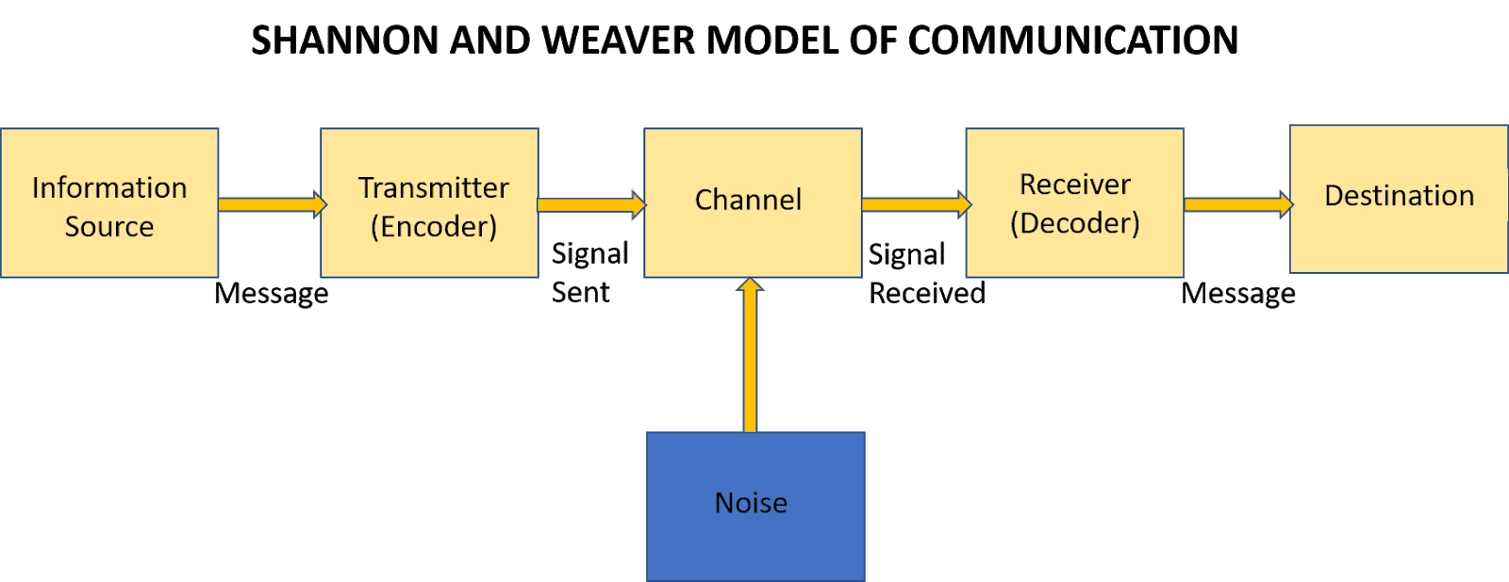

This model was created for the Bell Telephone Company. What do we need to understand from the graph SMCR is that sender sends a message through the channel and receiver has to decode it, however when message is interfered with noise it may not be received? Another issue here is that sender does not get feedback from receiver and there is no guarantee that message was delivered.

In case study Maria and Pedro, we can see clearly issues of that model. Maria calls Pedro to ask him to bring chicken home. Pedro doesn’t get message correct as the noise on the building site is disturbing conversation and as result Pedro heard work “kitchen” not “chicken”. This situation could be happened on many occasions for example at my workplace, very busy restaurant; manager is asking receptionist to bring coats to table 7 and at the time he says it waiter drops tray with drinks making a lot of noise and mess. Girl didn’t hear what table number she supposed to go to, and Manager run away to help with accident. Manager assumes that he passed the message, but receptionist only heard “Can you bring coat….

- Shramm

In 1954 Wilber Shramm created model based on Shannon and Weaver’s highlighting importance of feedback. He says that communication cannot be completed until sender receives feedback from receiver, communication must be both ways. In case of noise interference receiver will be able to inform sender and clarify message. Simple example can be taking booking reservation in restaurant, with background noise it is easy to take wrong details, to make sure receptionist has it correct she will repeat all detail to guest who is a sender of the message.

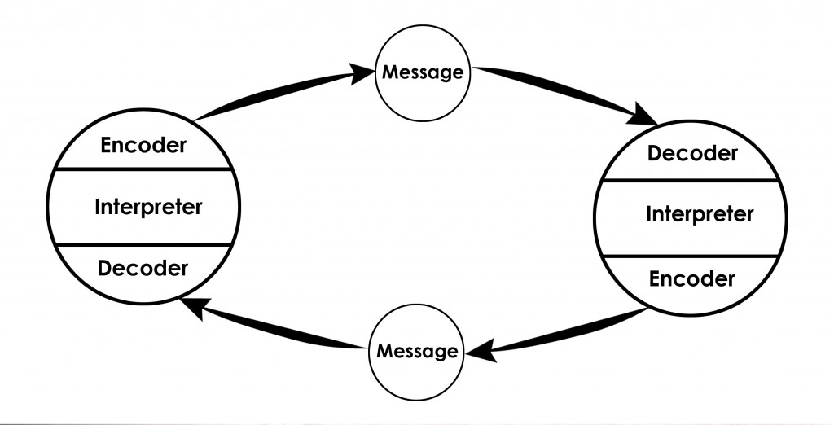

(Theory, 2022)

- Berlo 1960

Berlo model of communication is based on SMCR model (toolshero, 2022). He uses four components and explains that every one of them can be influenced by different factors. Communication starts with the sender, he is responsible for creating and sending message, but lack of right skills, knowledge or wrong attitude will affect how message is going to be received. Message is package of information, and it can be influenced by content, structure, code we use. Every each of our senses is channel and message can be affected by them. Receiver as well as sender may interpret message in different way than it was sent by lack of knowledge or culture differences. Basically, sender and receiver must share some common ground for the message to be effective and clear. Berlo doesn’t mention anything about feedback, noise or barriers in communication.

Case study the professor and the village people show how barrier of language failed in communication. Professors house who lived near village got on fire. He never went to visit villagers so he wouldn’t have any idea of their lifestyle. First time he went there when he needed some help with fire. Unfortunately, nobody understood him when he was asking for help, professor was using academic and difficult language so different than to what they know. In the result his house burnt down as he couldn’t communicate.

From life experience I can tell that I have seen that situation many times in my workplace with multi culture staff. When managers would do briefings and explain to new staff rules and sequence of service. They couldn’t understand why some of the employees learn quickly and others take long time to follow the rules. English was not their first language; they couldn’t understand also managers way of speaking wasn’t very clear. He was talking very fast and didn’t speak perfect English, his pronunciation was not spot on.

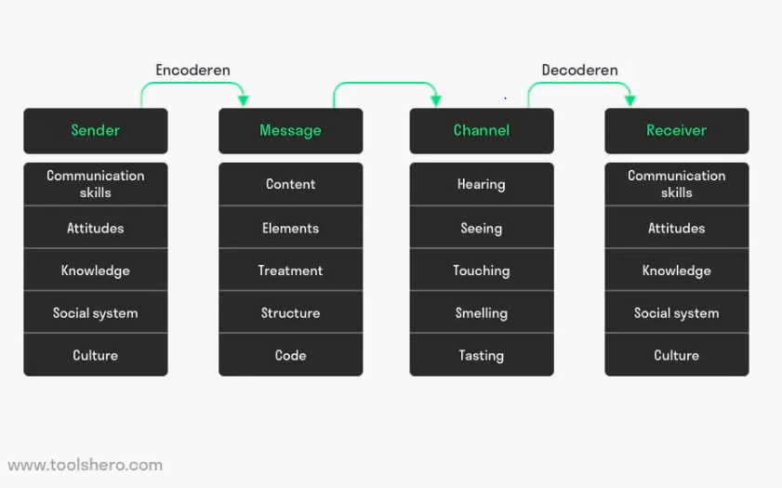

Communication skills

- Verbal communication
- Non-verbal
- Listening
  - Active listening
  - Empathetic listening

The disadvantaged of modern technology

Summary

References

Communication, b. i., 2018. Shannon and Weaver Model Of Communication. [Online]
Available at: https://www.businesstopia.net/communication/shannon-and-weaver-model-communication
[Accessed 03 05 2022].
Theory, C., 2022. OSGOOD- SCHRAMM MODEL OF COMMUNICATION. [Online]
Available at: https://www.communicationtheory.org/osgood-schramm-model-of-communication/
[Accessed 05 05 2022].
toolshero, 2022. Berlo’s SMCR Model of Communication. [Online]
Available at: https://www.toolshero.com/communication-skills/berlos-smcr-model-of-communication/?msclkid=7dc4c039d13b11ec9b96816a6e52a234
[Accessed 05 05 2022].

