Scotland: -

Curriculum for Excellence
Curriculum for Excellence (CfE) is transforming all aspects of education in Scotland. It has been developed over a number of years in partnership with teachers, parents and the wider education and business community. The curriculum comprises a broad general education up to the end of S3 followed by a senior phase of learning from S4 to S6. Increased emphasis is placed on inter-disciplinary learning, skills development and encouraging personal achievement. CfE is intended to foster four capacities in all young people: successful learners, confident individuals, responsible citizens and effective contributors.

In line with Curriculum for Excellence, new National Qualifications are now available in schools. They aim to offer increased flexibility, with a greater focus on skills and applying learning to real-life situations. National Qualifications 1 to 5 will replace Access, Standard Grade and Intermediate qualifications. Higher and Advanced Higher qualifications have also been revised to ensure they fully reflect Curriculum for Excellence; ensuring good articulation between courses and most up-to-date content. These new qualifications will be available from school years 2014/15 and 2015/16 respectively.

There is now much greater flexibility in how schools design their Senior Phase Curriculum, with a range of different approaches being adopted across the country, aimed at meeting the particular needs of learners in different areas. All 19 higher education institutions in Scotland have published statements setting out how their admissions policies will respond to Curriculum for Excellence.

Parents and carers are key partners in their children’s education and can play a vital role in supporting their child’s learning, choices and chances in life. The Scottish Government recognises the need for parents to have high quality, easily accessible information about their child’s education. One of the best ways to get involved in your child’s education is through the school parent council. Information about the school is available through the school’s Handbook.

Source: - http://www.gov.scot/Topics/Education/Schools/curriculum

Guidance from Building the Curriculum 3
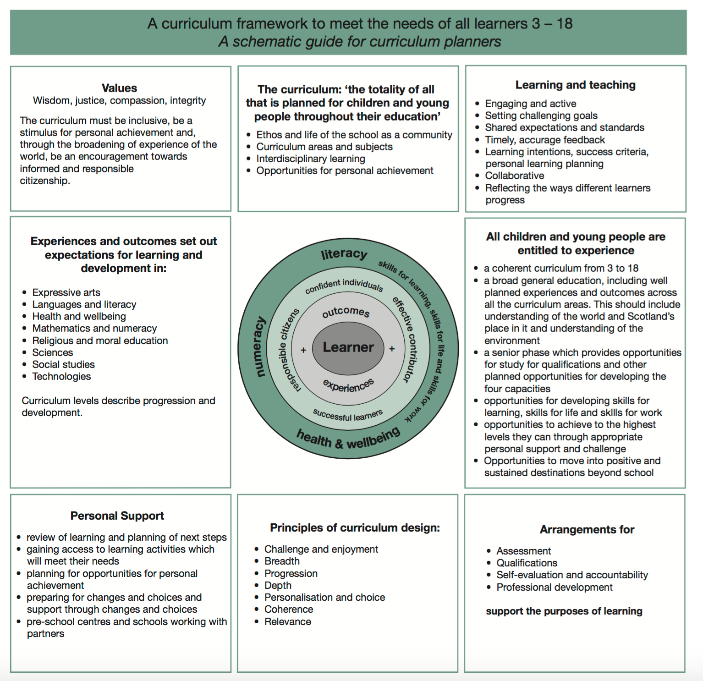

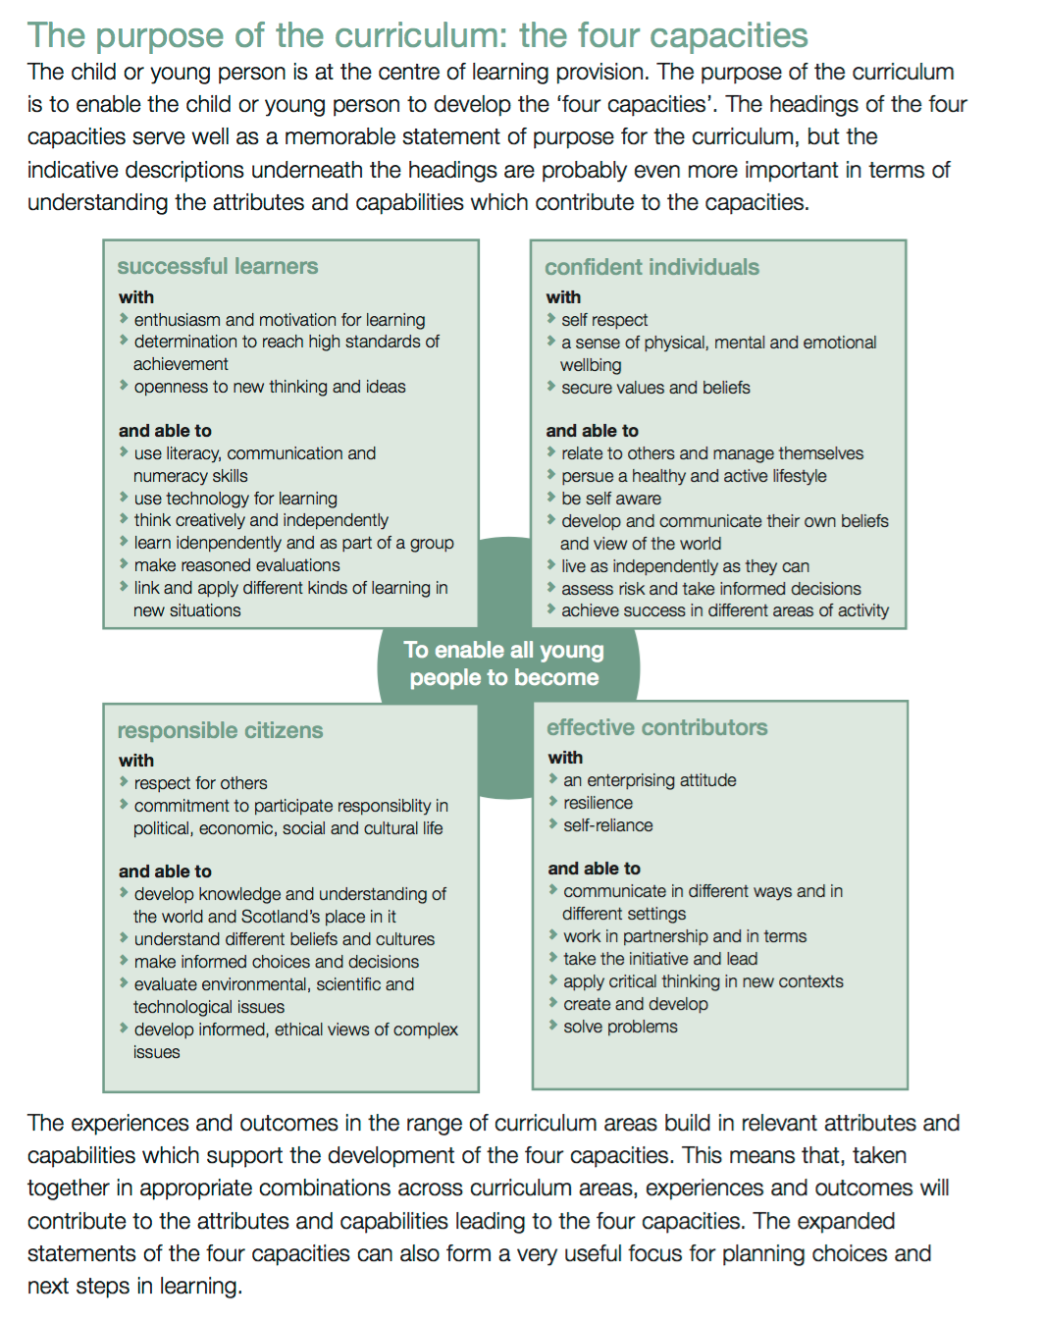

Outcomes and Experiences: - https://www.education.gov.scot/Documents/all-experiences-and-outcomes.pdf
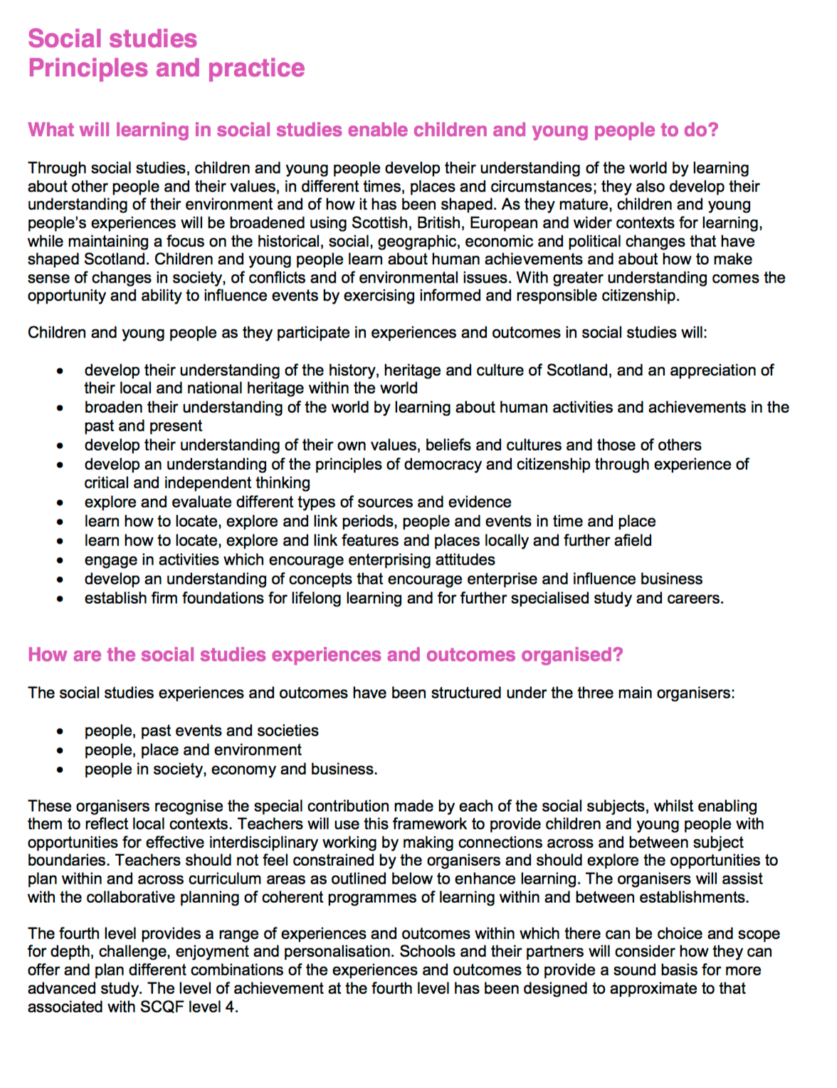
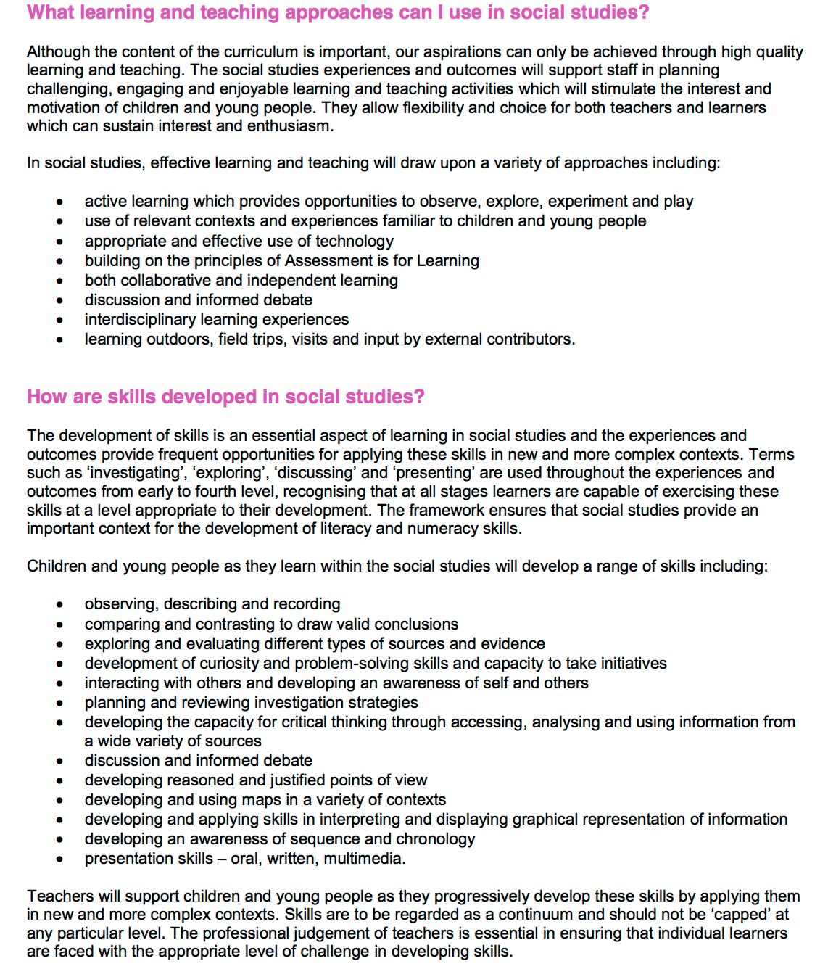

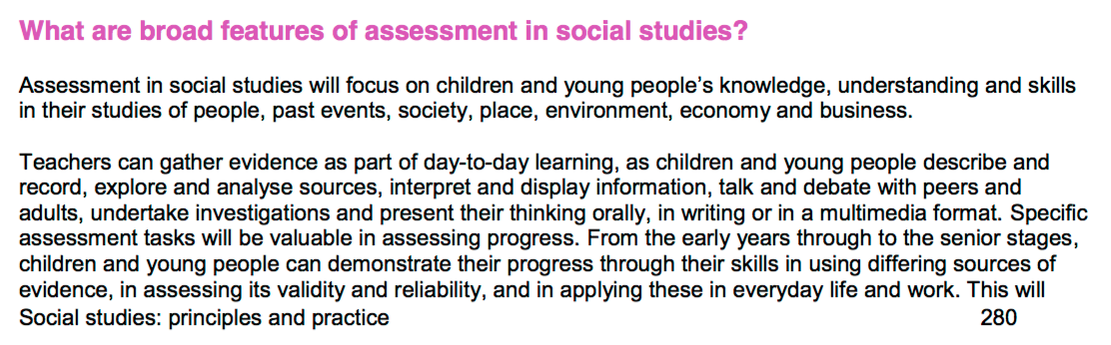

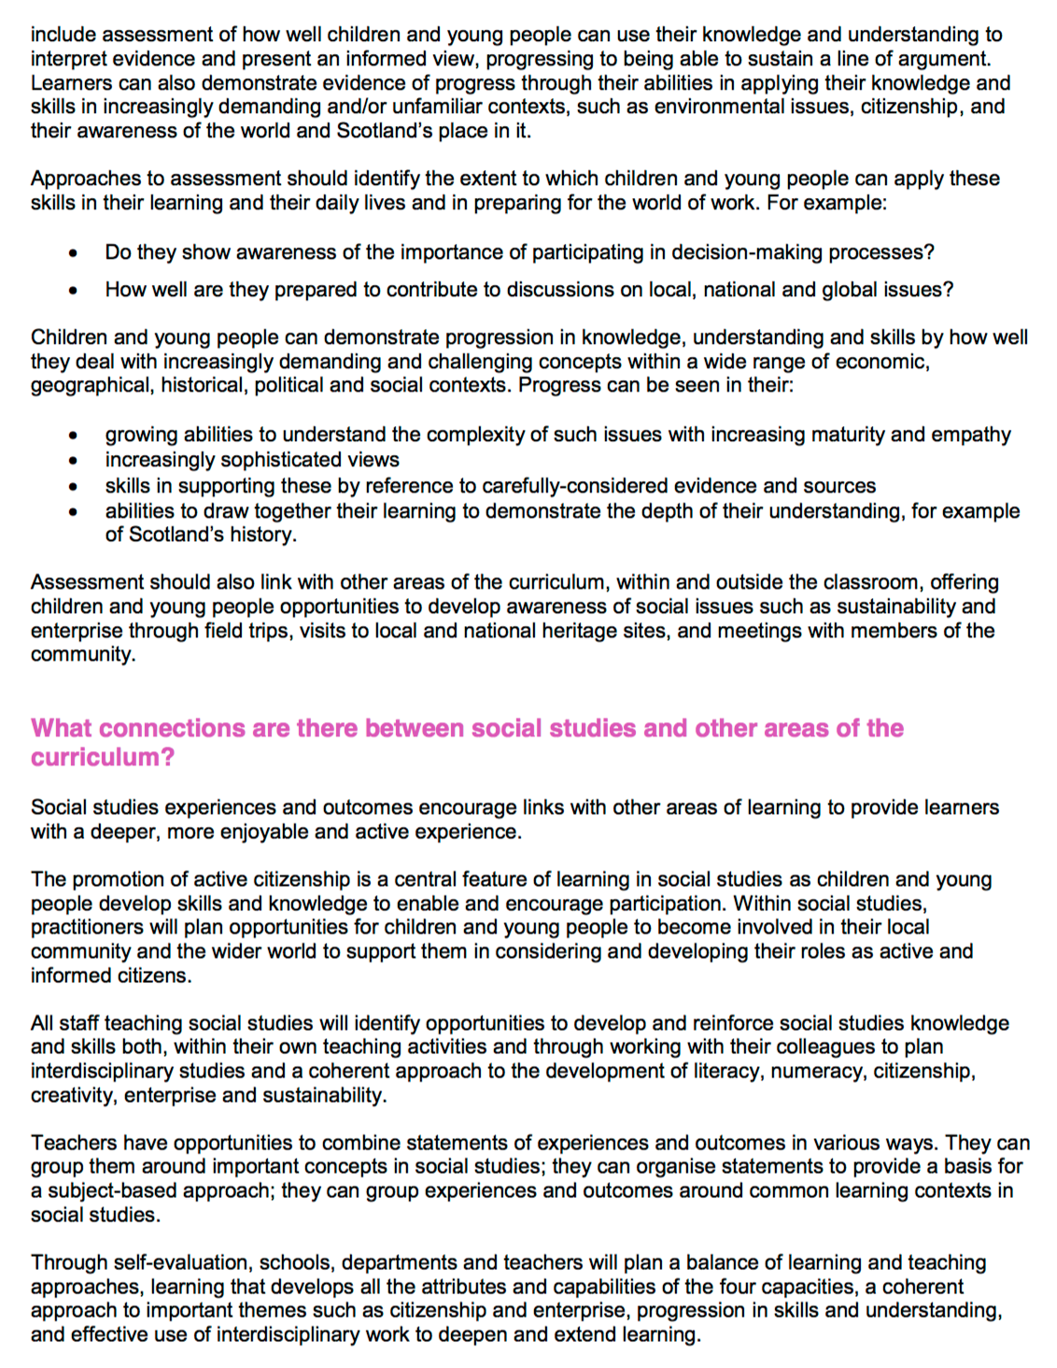

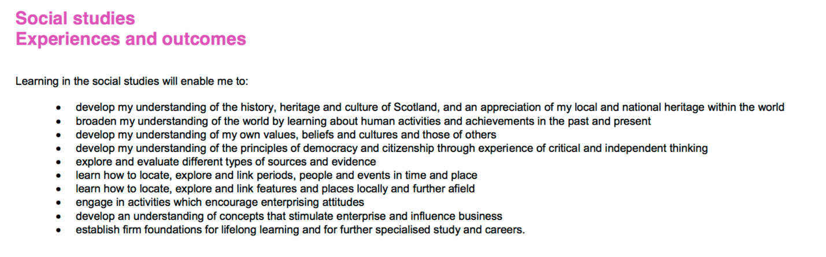

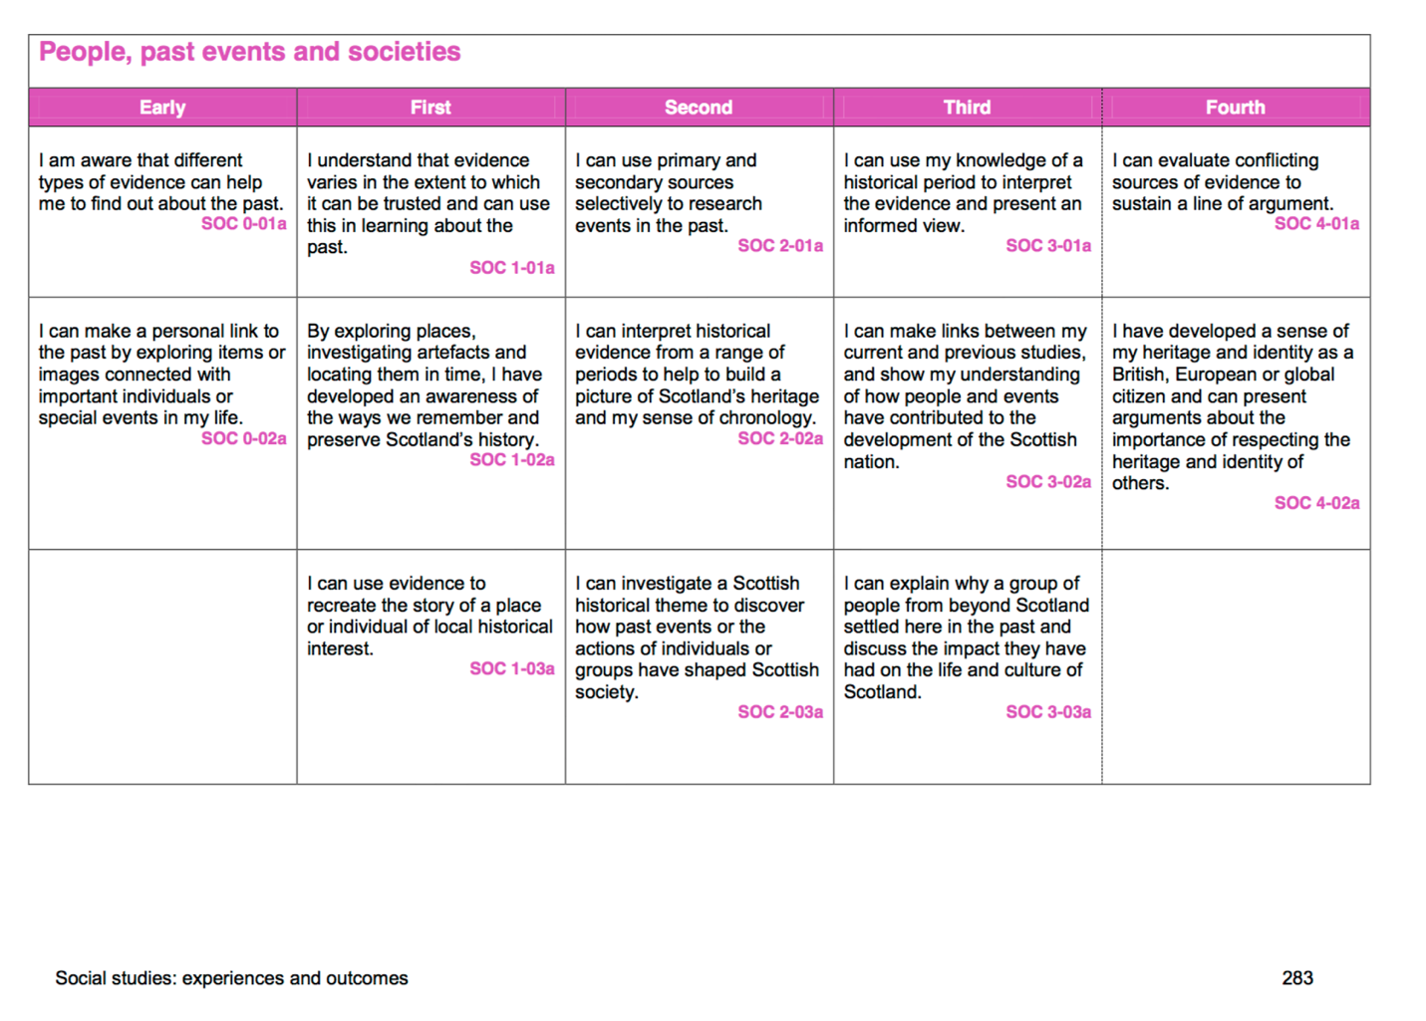

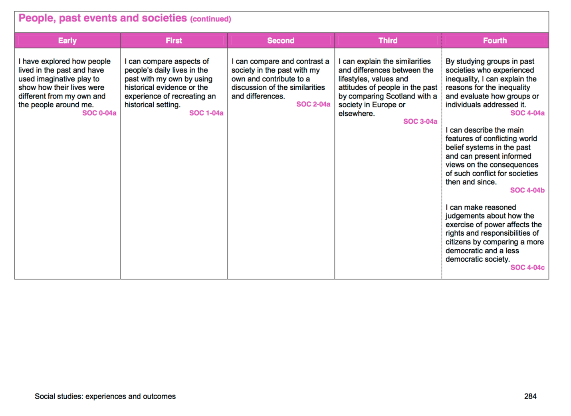
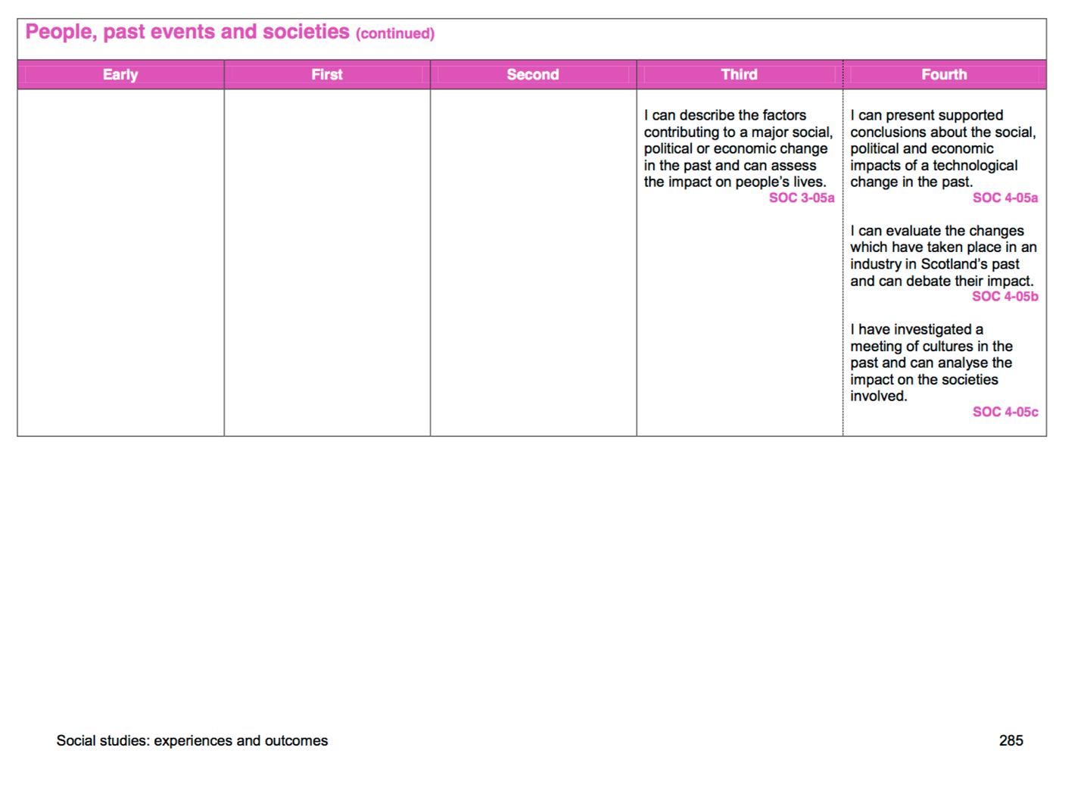

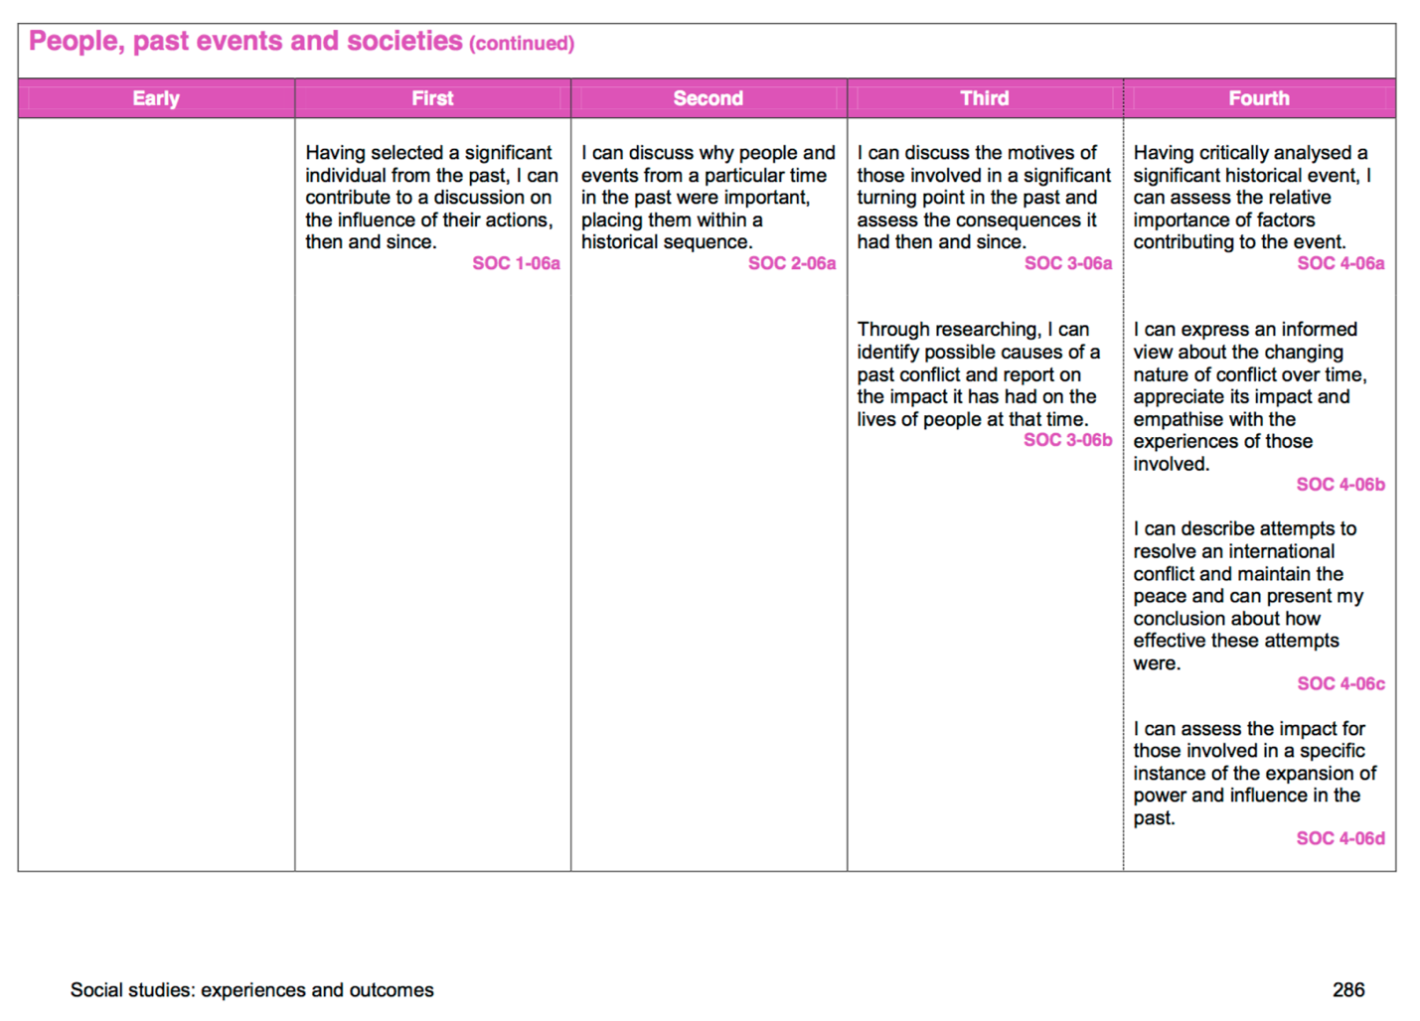

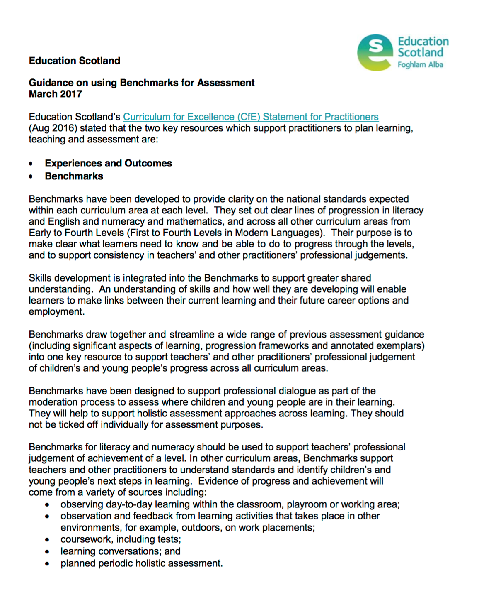
Benchmarks Document 2017



