University of Wales Trinity Saint David
School of Engineering



Coursework Title: Prioritised Improvement Plan – Basic Quality Tools
Module Name & Code: Quality & Business Improvement – ACMA4004


Name: Luke Huzzey-Evans (2205835)
Date: 17/03/2024
Contents
1 Introduction 1
1.1 Aims 1
1.2 Objectives 1
2 Literature Review 2
3 Results and Analysis 4
4 Discussion 7
5 Conclusion 9
6 References 10

Table 1 - B Pillar Check Sheet 4
Table 2 - Pareto of Check Sheet 5
Table 3 - 5 Why Analysis 6

Figure 1 - B Pillar Measles Chart of Damage 1
Figure 2 - Process Flow Chart 8

Introduction

Aims
This assignment will outline a prioritised improvement plan utilising basic quality tools to focus on improving productivity and quality of the manufacturing process for the B Pillar Trim, this is a crucial component in Aston Martins automotive production line as it serves as a key component in the assembly of the final product. However, recent observations and data analysis have indicated several challenges hindering the productivity and overall quality of this assembly.

Objectives
Using Root Cause Analysis (RCA) this report will identify and analyse the current challenges associated with the manufacturing process of the B Pillar Trim. Through data collection methods such as process mapping, observation, and historical performance data analysis, the following challenges have been identified:
a. Inefficient workflow leading to bottlenecks and delays in production.
b. High defect rates leading to rework and waste.
c. Lack of standardised procedures leading to inconsistencies in output.
Figure 1 displays a Measles Chart of the defects found on the B Pillar Trim using ‘Flags’ (Reporting, 2024), Aston Martins inline quality inspection software, whereby Inspectors document and record any defects found outside the specified Vehicle Inspection Standard (VIS).

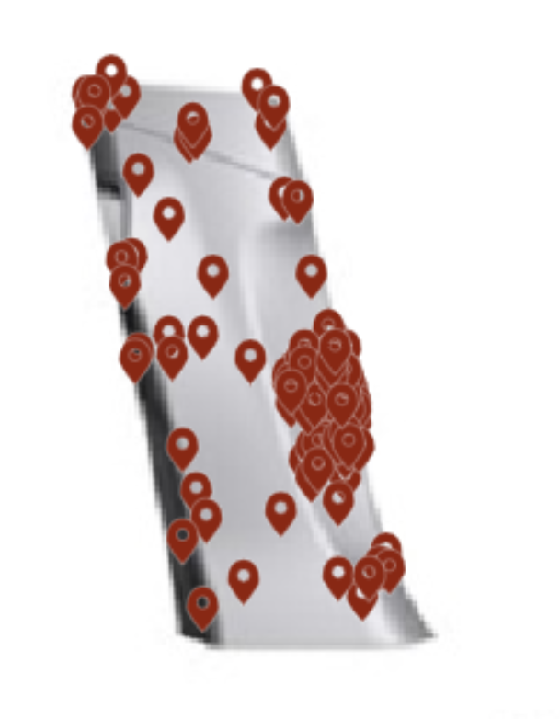
Figure 1 - B Pillar Measles Chart of Damage

Literature Review
The concept of quality improvements within automotive manufacturing processes has been extensively studied in literature and industry practices. Quality improvement practices can be traced back to the early 20th century with the pioneering work of individuals such as Frederick Taylor and Henry Ford, who introduced systematic approaches to optimize production processes and minimize defects (Womack, et al., 2007). However, it was not until the mid-20th century that quality management principles gained widespread recognition, notably with the introduction of statistical quality control by Walter Shewhart and the subsequent development of Total Quality Management (TQM) by quality gurus such as W. Edwards Deming and Joseph Juran. The book Managing Quality states that ‘’The introduction of TQM into an organization, its subsequent development, and sustaining TQM is far from easy’’ (Dale, 2007).
Several theoretical frameworks have been proposed to conceptualize quality improvement initiatives and guide organizational practices. One of these initiatives is a Plan-Do-Study-Act (PDSA) cycle, popularized by Deming (The W.Edwards Deming Institute, 2024), and later adopted by quality improvement practitioners, this provides a structured approach for iterative problem-solving and process optimization. Additionally, lean manufacturing principles primarily developed in the Toyota Production System (TPS) advocate for the elimination of waste and continuous improvement through the relentless pursuit of perfection (kaizen). Central to quality improvement efforts are basic quality tools, which serve as instruments for analysing data, identifying root causes of problems, and facilitating informed decision-making. These tools encompass a diverse range of techniques, including 5 why analysis, check sheets, and process flowcharts (Farris, 2005). Each tool offers unique capabilities for diagnosing process inefficiencies, prioritizing improvement opportunities, and monitoring performance metrics, thereby enabling organizations to systematically enhance their operational effectiveness. Kiichiro Toyoda, the founder of Toyota Motor Corporation, once said, ‘’Every defect is a treasure, if the company can uncover its cause and work to prevent it across the corporation.’’ (Ono, 1988). In his worldview, problems were worth celebrating if they led to large-scale improvements.
In this study, one of the problem-solving tools used is the ‘’5 Whys analysis’’, this is a problem-solving technique that aims to define the root cause of an issue by iteratively asking "why" until the fundamental reason behind a problem is revealed (Ranadewa, et al., 2018). This method provides a fact-based approach to problem identification and correction, focusing on both reducing and eliminating non-value-added activities (Ranadewa, et al., 2018). By delving deep into the reasons behind a problem, the 5 Whys analysis helps in formulating and implementing effective corrective actions (Benjamin, et al., 2015). Studies have shown its applicability in eliminating losses and non-value-added activities in manufacturing firms, indicating its potential to address different types of losses and inefficiencies (Womack & Jones, 2003). This demonstrates the versatility and broad utility of the 5 Whys analysis in problem-solving scenarios. The 5 Whys method is emphasized for its ability to provide a structured and systematic approach to problem-solving, ensuring that issues are thoroughly investigated to identify underlying root causes. This thorough analysis helps in developing comprehensive solutions that target the root of the problem, leading to more sustainable, effective, and optimum outcomes.

Results and Analysis
As a result of B pillar damage review, it has been revealed through a 10-week study of 500 cars that B pillar defects are of paramount importance for ensuring product quality and customer satisfaction. With 107 instances of scuffed B pillars identified, it's evident that this issue warrants immediate attention and corrective action. By employing Check Sheets, Pareto Charts, 5 Why’s, and Process Flow Charts, this study has been able to meticulously document, prioritise, and visualise the factors contributing to these defects, giving a targeted approach to problem-solving.
The first quality control tool distributed in this study was a Check Sheet as seen in Table 1, this was issued to the technician on the station of Point of Fit (PoF) to record what quality issue is being observed. This sheet allowed the technician to gather comprehensive data on each defect incident, including key details such as the defect type, and frequency. This systematic data collection process provided valuable insights into the scope and nature of the problem.

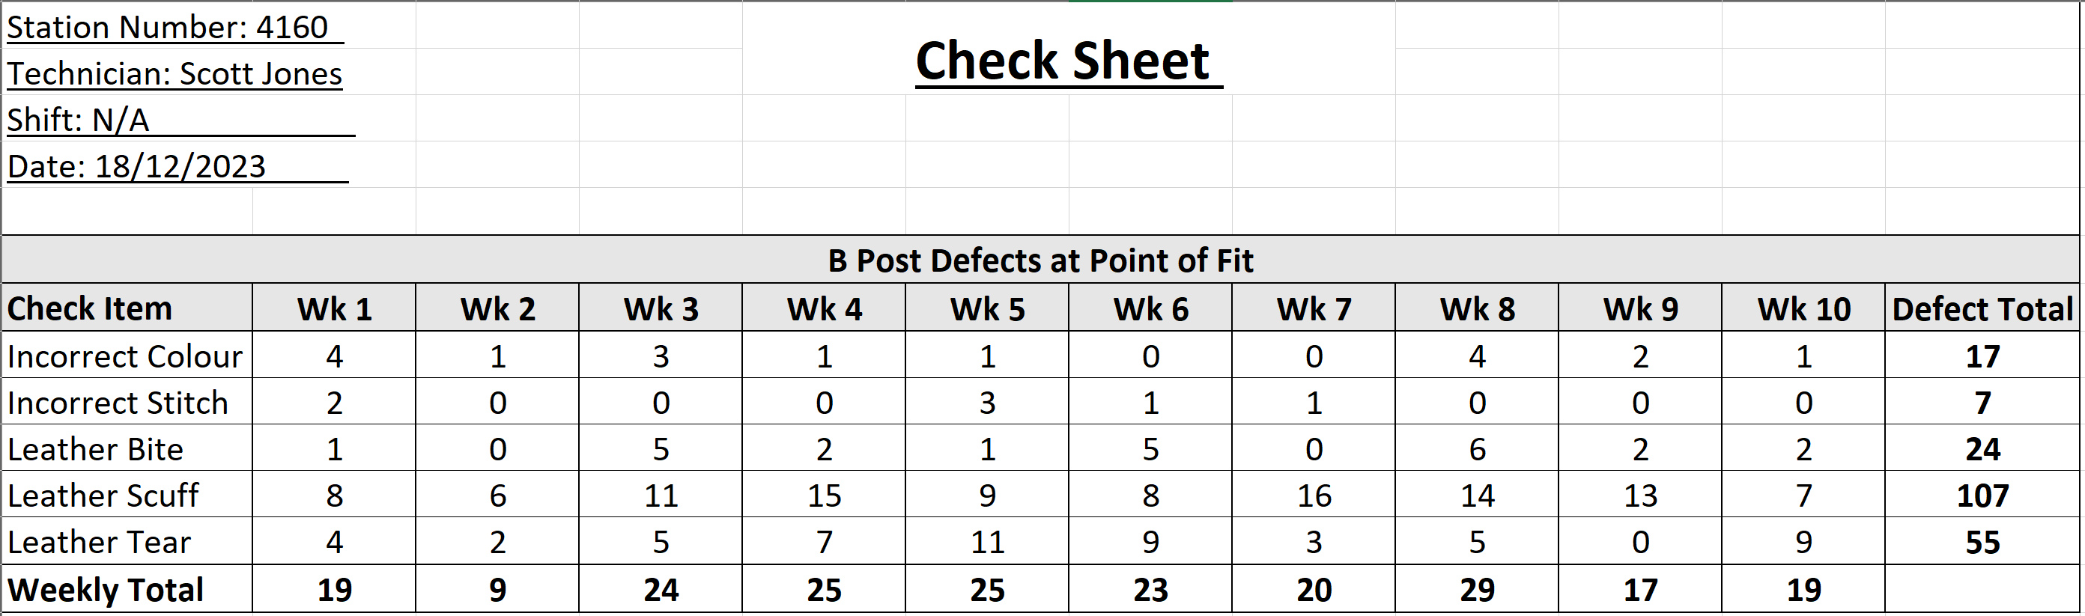
Table 1 - B Pillar Check Sheet

On the completion of the Check sheet, a Pareto chart was created to visually identify the vital few & trivial many, as roughly 80% of the defects come from 20% of the causes. Table 2 displays this perfectly as the 80% Red dash line intersects with the Orange cumulative frequency line, the vital defects are clearly identified as Leather Scuffs (107), & Leather Tears (55).
Table 2 - Pareto of Check Sheet
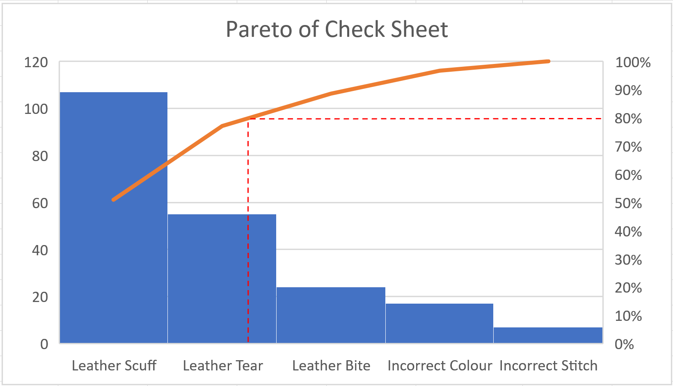

To further analyse the data from the Pareto Chart and Check Sheet, 5 Why analysis proved invaluable in identifying the root causes driving most B pillar defects. To utilise this problem-solving technique a specific 5 Why document was used in the root cause analysis of this issue, hoping to find a direct cause and implement corrective actions to reduce and improve overall vehicle quality and customer satisfaction, both internal and external. Table 2 shows the form used in diagnosing the root cause and providing Permanent Corrective Actions (PCA), focusing attention on the critical few factors that were most responsible for the problem. This prioritisation guided efforts towards implementing targeted corrective actions that would yield the greatest reduction in panel defect occurrences, that have been highlighted to be occurring during the transportation of the finished product to PoF. The following causes have been highlighted as the main contributing factors in this issue, the physical cause is the due to a lack of substantial protection, the human cause is due to inadequate operator training, the latent cause is because the business has outdated handling procedures that have not been correctly maintained with the product maturation.
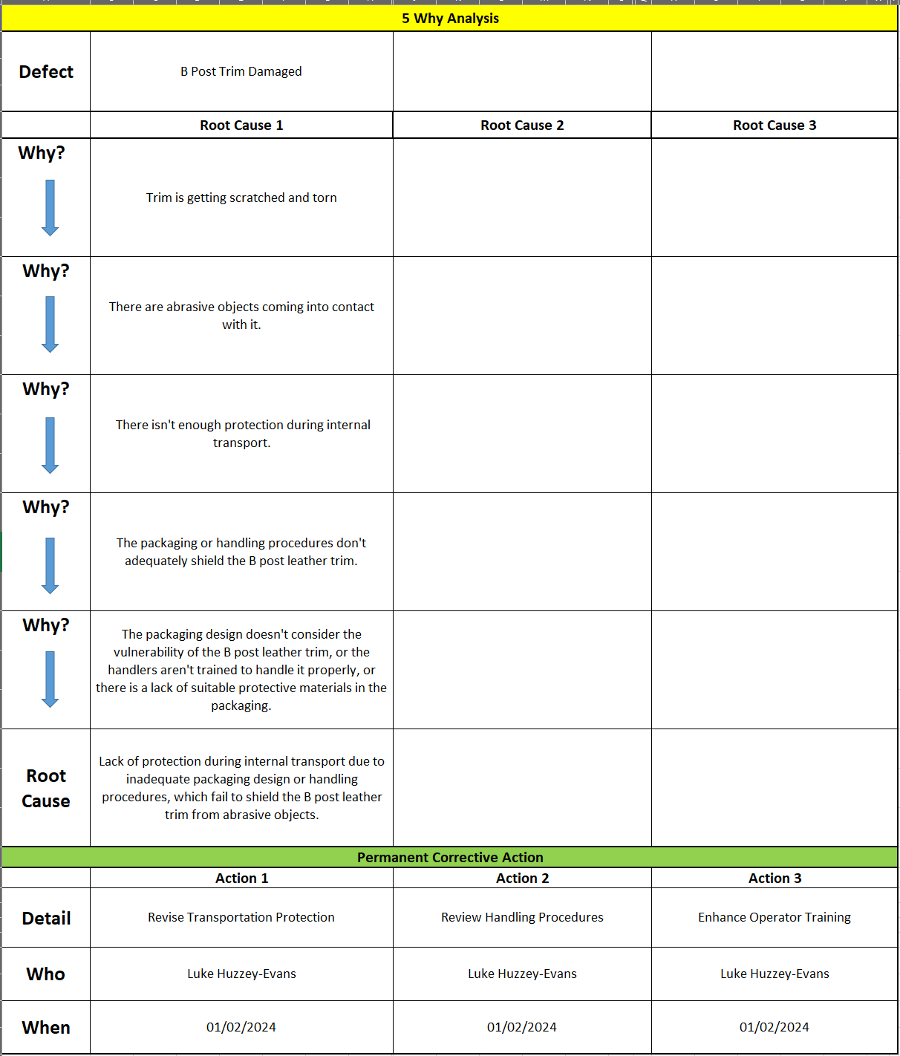
Table 3 - 5 Why Analysis

Discussion
The analysis underscored the critical need for immediate intervention to address the root causes of B-pillar defects seen within the production environment. To significantly reduce the number of calls, a multifaceted approach is required. The PCA’s found in Table 3 state to introduce enhanced packaging protection using additional and more robust protective coverings and cushioning materials specifically designed to mitigate abrasion and vibration, effectively safeguarding B-pillar components during transportation. The second PCA is to ensure a standardized handling procedure exists and is correctly maintained. The procedure will ensure uniformity and adherence to best practices for transportation of all trimmed parts. The third PCA is to provide all operators with a more comprehensive training program for handing leather trimmed parts, focusing on pre & post process part interactions, raising awareness of the importance of quality, and how to reduce waste and cost to the business.
Using the data collected in Table 1, the study has highlighted that incorrect colour, stitch, and leather bites are amongst the lowest scoring defects found on the B-pillar trim. However, it is worth noting that these defects could be more prevalent on other leather items within the vehicle. The top two defects found were Leather Tears and Leather Scuffs, both can be categorised into a broader category of leather damage. By combining both defects and therefore simplifying our defect definition, the study can seek ways to improve the quality, delivery, cost, and safety.
As seen in Figure 2, the report used a process flow chart to visually map out each step of the process, gaining a comprehensive understanding of the sequence of events that the product follows. Therefore, highlighting potential points of failure within the current process. By using this systematic approach to visual management, this report can immediately confirm the process points where the potential damage could be caused. The studies highlighted two possible processes that could be identified as potential points of failure, these are highlighted with a red border. The first process highlighted in red is the transportation of parts from the sub assembly station to the PoF, the second process is the installation of the B pillar trim. It has been determined that it is more than likely damage will occur in the transportation process and this is the best place to start the quality improvements, as gains at this step will naturally filter through to the subsequent processes. The working group agreed that best practice would be to create a protective cover that can not only be used in transportation but can also stay on the parts once they have been fitted to the car, and not be removed until the last possible point of process at the pass to sales gate.
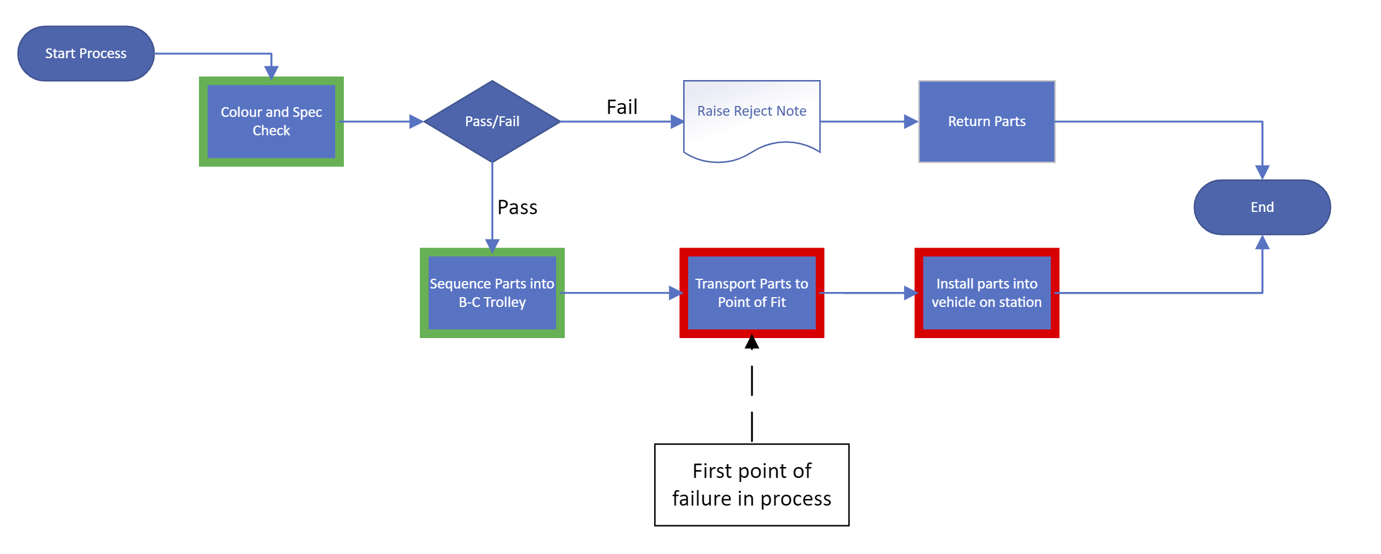
Figure 2 - Process Flow Chart

Conclusion
The resulting output of the analysed data in this report highlighted that the optimum corrective action is to add additional protection to the B pillars. This proactive measure aims to enhance the resilience of the pillars against scuffing during various stages of production, handling, and transportation. By bolstering the protective measures in place, the business aims to minimize the risk of trim damages, thereby improving the overall quality and appearance of our vehicles whilst actively reducing ageing rework work in progress (WIP), causing delay and bottle necks, and subsequently having a negative effect on the factories operational metrics of right first time (RFT) and first time through (FTT).
Moving forward, continuous monitoring and evaluation will be essential to ensure the effectiveness of the corrective action and to identify any emerging issues. By leveraging data-driven approaches and proactive measures such as robust training plans, and handling procedures. The business is committed to upholding the highest standards of quality in all manufacturing processes and delivering products that exceed internal and external customer expectations

References
Benjamin, S., Marathamuthu, M. & Murugauag, U., 2015. The use of 5-WHYs technique to eliminate OEE's speed loss in a manufacturing firm. Journal of Quality In Maintenance Engineering, 21(4), pp. 419-435.
Dale, B. G., 2007. Managing Quality. 5th ed. s.l.:Blackwell Publishing.
Farris, D., 2005. The Quality Toolbox. 38 ed. Milwaukee: American Society for Quality.
Ono, T., 1988. Toyota production system : beyond large-scale production. 1 ed. s.l.:CRC Press.
Ranadewa, U., Sandanayake, Y. & Siriwardena, M., 2018. Enabling lean among small and medium enterprise,. Sri Lanka, 26th Annual Conference of the International Group for Lean Construction.
Reporting, F., 2024. Flags Reporting. [Online]
Available at: http://sv-sta-flags01/dashboard?breadcrumbs=%5B%7B%22title%22%3A%22St.%20Athan%20Dash%22%7D%5D&filters=%7B%22location%22%3A151%7D
[Accessed 18 Febuary 2024].
The W.Edwards Deming Institute, 2024. The W.Edwards Deming Institute. [Online]
Available at: https://deming.org/explore/pdsa/
[Accessed Febuary 2024].
Womack, J. P. & Jones, D. T., 2003. Lean thinking : banish waste and create wealth in your corporation. 1st Free Press ed., rev. and updated. ed. New York: Free Press.
Womack, J. P., Jones, D. T. & Roos, D., 2007. The Machine That Changed the World. 1 ed. s.l.:Simon & Schuster UK.

