

Managing Food and Beverage (Placement)
BMIH6011

- Report Title: Portfolio
- Student Name: Simona Patrascu
- Student Number: 2123259
- Lecturer Name: Daniel Payne

I confirm that I have not used any AI tools in the research and creation of this
assignment. I confirm that I have not presented any AI generated materials as my own work. I confirm I have copies of my drafts, notes, and other resources I used, which I may be asked to provide in evidence.
Part 1: Reflective Supervisory Analysis Using Gibbs’ Model 3
1. Introduction 3
2. Description 3
3. Feelings 3
4. Evaluation 4
5. Analysis 5
6. Conclusion 6
7. Action Plan 7
Part 2- Hotel Mentor Feedback 8
Part 3-Academic Tutor Feedback 9
Part 4: Reflection on Hotel and Placement Tutor Feedback 12
1. Introduction 12
PART 1: Understanding Feedback 12
PART 2: Critical Analysis of Feedback 13
PART 3: Development Plan 14
Conclusion 14
Part 5: Presentation on Placement Experience 15
References 26

Part 1: Reflective Supervisory Analysis Using Gibbs’ Model

1. Introduction
I completed my placement at Novotel Cardiff and during this time, I also had the opportunity to work with the Food and Beverage department. I primarily worked with support services, aiding in food preparation, serving the team, and making sure everything was running smoothly. This reflection discusses my experience of assisting service flow during a very busy shift, where I needed to juggle various tasks with time constraints and maintain service quality. I will analyse my actions, feelings, and learning experiences with the help of the Reflective Cycle created by Gibbs, and I will understand how I helped to enhance guest experience and how I can improve my service in the future. The areas of skills that I learned and challenges I faced which are crucial to my growth in F&B operations will also be addressed in the analysis.

2. Description
The experience that I choose to reflect on happened on a busy morning shift during breakfast. The large number of guests put everyone was under pressure to serve food in a very fast and efficient manner. I was asked to prepare food to serve the breakfast buffet, to ensure that there was an unending supply of food and that the quality is not compromised.
My service coordination was also on track in which food was served to the dining hall and tables cleared at the appropriate time. I had participated mainly in the service operations part, but I also assisted in operations that were in contact with the guest, when my colleagues were too busy with other tasks and needed additional.
During this time, I observed that that the team demonstrated effective coordination, each of them fulfilling their own roles and responsibilities. Despite the amount of work, they had to do and the high-pressure environment created during this busy time, we were able to maintain service quality, serve clients quickly and manage operational challenges.

3. Feelings
At the beginning of the shift, I experienced a kind of lack of confidence as the environment was fast paced and I was not so experienced in F&B operations. I did not know how I would cope with the stress of organizing various activities and serving food on time without interfering with the service process.
Nonetheless, I also was keen on doing well and making a contribution to the team. I also wanted to ensure that everything was in place to meet the guest’s expectations and that it was all a success. Time factor was the thing that was always at the back of my mind, however, with the progression of the service, I became more accustomed to it and was now able to adapt to the pace and how to manage things more efficiently.
However, I was somehow anxious about my customer contact since, as stated in my job description, I was required to work more on operational tasks as opposed to dealing with guests. I was not meeting the guests as often, as I was helping my colleagues in food service, and I felt less confident to help them or upsell. This was among the areas I knew that I could improve, but the lack of customer facing activities meant that I had more problems to face in order to have the confidence to go up to the guests.

4. Evaluation
Strengths:
One of my strengths during the shift was my reliability. I always performed the duties given to me so that the buffet was continually filled and sent out. This assisted the team to ensure there was a continuous supply of food during the breakfast service that was vital in guest satisfaction. Another point that my mentor emphasized was that I took initiative in making sure that the buffet was stocked even without the need to be informed, but before the members expressed their needs. According to the Belbin’s Team Roles Theory, this makes me a reliable team worker because I was co-operative, perceptive and completed work on behalf of the team, anticipating their needs (Belbin, 2026).
I was also very effective under pressure. Time management and being a multitasker was a challenge to the time-consuming nature of the shift. This enabled me to focus on my duties without being distracted and thus maintain the service effective. I was also able to work without such close supervision and proved myself to be more and more confident with handling operational responsibilities. According to LSPM (2026), time management is a key skill in the hospitality sector that increases productivity, boosts revenue and enhance guest experience.
Weaknesses:
However, there were some aspects that I could have improved. One of the areas of improvement was customer interaction. Being involved primarily in preparing and offering services, I did not see much of the guests. This did not involve direct contact with customers, and it hindered my upselling menu items or serving guests more actively. The feedback given by my mentor was that there was little interaction with customers and this affected my skills to contribute fully to the experience of the guest. I knew guest contact was a mandatory procedure in F&B operations, and I missed several opportunities to upsell or offer additional services to the guests. This is among the aspects that I need to work on to improve my overall performance in F&B.

5. Analysis
Operations Management:
In terms of the operations management lens, the transition required appropriate management of service flow and work had to be conducted in quick and efficient way. According to Zerunyan and Evans (2026) the allocation of labour is vital in food preparation and delivery in a timely fashion. My assignment was as follows: to stock the buffet and to provide the guest with food when they needed it. However, I also observed unequal preparation and service with certain members of the staff only focusing on preparation, and others failing to serve effectively due to the high number of guests.
This imbalance could be removed by improving both the coordination of activities among food preparation and delivery team members. The bottlenecks can be reduced by properly assigning duties; food should be served within the shortest possible time and other needs of the guests should be met in time. According to Belbin’s Team role Theory, if roles overlap in a team, it can create lack of coordination and lead to poor performance because of overlapping responsibilities (McGarvie, 2026).
.
Service Quality:
The service quality theory includes food prep, which is one of the activities, directly affecting the guest experience. According to Javed et al. (2021), food is one of the most important factor in the hospitality sector that improves or alters the experience of the guest and has been often used as a metric to analyse customer satisfaction. The guests may not have been in direct contact with me, but since I was ensuring that there was plenty of buffet to serve the guests, it had an indirect, yet significant impact on the satisfaction of the guests. This would have negatively affected their service delivery in case of delayed delivery of food or poor presentation.
Leadership:
The shift was also my chance to see what leadership is in practice, although I was not in a formal leadership position. I had a chance to observe how my more experienced colleagues coped with the pressure of service and organization of work in addition to their communication with guests. I played a role within the team by helping my teammates and foreseeing their needs. I was not the formal leader of the team, but I did serve as a supportive leader because I ensured there was food replenished as much as possible and helped out in areas that involved interaction with the guests.
Critical Analysis:
Looking back at this experience, I see a chance of making something better out of it. As much as I was good in food preparation and support of services, there was a low interaction with the guests, and this led to a missed opportunity to do more to improve the guest experience. Ideally, I should have been more active to reach out to guests and go the extra mile to offer services and cross-sell products. I need to focus more on interacting with guests to enhance the entire guest experience and become more secure in those cases.

6. Conclusion
This experience has given me an understanding of the value of coordination and teamwork in an F&B setting. The fact that I was invited to participate in the process of timely food replenishment helped to keep the service flow steady, but I also realized that even with the limited interaction with the guests, I could not be able to contribute to the guest experience on a full scale. In the future, I will strive to improve customer-facing engagement, which will allow me to become confident and enhance the overall service.
Also, I noticed that I needed to work on balancing preparation and the service. The imbalance with the team members listening to prep and others serving was a minor delay in guest satisfaction. Through better distribution of tasks and making everybody actively contribute towards both preparation and service the overall output of the shift might be enhanced. Next time I will focus on prioritizing the interaction with the customers and coordinating the tasks during the shift, which will help me to make a better contribution to the service flow.

7. Action Plan
My reflection and feedback have led to developing an action plan to concentrate on critical areas of development:
Weakness | Action | Theory Link
Minimal Contact with Visitors. | Ask shifts that face customers to have a better customer interaction. | Customer Experience Theory
Confidence | Presence of norms in practice service in a guest facing position particularly upselling and communication with guests | Service Quality Theory
Knowledge Gaps | Familiarize yourself with the menu and how to upsell and enhance the guest experience and contribute to sales. | Sales and Service Theory.

Short-term goals:
- Gain more experience in customer facing positions and know how to upsell and talk to guests.
- Infer busier hours, train upselling.
- Develop trust in interacting with guests.
Long-term goal:
- F&B Supervisor: Develop leadership/managerial skills through taking up responsibilities in coordinating shifts and leading shifts during rush hours.

Part 2- Hotel Mentor Feedback
Simona has basic understanding of service standards and menu. She can explore it with more eagerness. She is good to take on tasks herself without pushing her too much. She understands time constraints and delivers satisfactory service. Interaction with customers was minimal due to shift assignment usually lunch time where the team usually preps for a busy afternoon. But she is good at communicating. Very reliable and responsible individual. Strong headed with the right training can be a leader. She can work on her customer service and become an amazing team player.

Part 3-Academic Tutor Feedback
Student Name: Simona Patrascu
Student ID: 2123259
Time Management
Simona experienced a delayed start to her placement due to circumstances at the hotel, which impacted her initial progress. Despite this, she has since engaged with a range of departments, including Reception, Leisure Club, and Breakfast Service, demonstrating a willingness to gain broad operational experience.

Simona has missed a number of scheduled shifts throughout the placement. However, she has managed to maintain an average of 18 hours per week, which shows a level of commitment to meeting the minimum requirements. Moving forward, improving reliability and consistency will be important. Attending all scheduled shifts and maintaining a more structured routine would allow Simona to gain the full benefit of the placement.

Additionally, working a wider variety of days and hours would enhance her overall experience. Limiting availability to specific days can restrict exposure to the full demands of the hospitality industry, and greater flexibility would provide valuable insight into different operational challenges.

From a tutor’s perspective, Simona has attended all scheduled placement meetings and remained engaged throughout. To ensure successful completion of the placement, she must continue to meet the required weekly hours consistently.

Communication
Throughout the placement, Simona has communicated effectively and professionally. She has maintained regular contact, attended all meetings, and responded appropriately to guidance and feedback.

A particularly positive aspect of Simona’s approach has been her proactive use of the placement handbook. Bringing this into the hotel environment and discussing it with mentors demonstrates strong engagement and a clear commitment to her own development.

Continuing to build confidence in communicating across departments and with different team members will further strengthen her professional presence.

Looking ahead, maintaining this level of communication, alongside improved consistency in attendance, will support Simona in maximising her learning experience.

Behaviour
Simona has shown a noticeable improvement in her attitude and approach compared to Level 5. She has demonstrated a more positive and proactive mindset, taking greater responsibility for her learning and development during this placement.

Her willingness to engage with multiple departments and apply skills developed at Level 5 reflects a maturing approach to her professional development. This progression is particularly evident in her confidence within Food & Beverage operations.

During tutor meetings, Simona has been engaged, prepared, and open to discussion, which has supported her overall progress. Simona often attends via her phone due to other commitments. Setting time aside and joining via a laptop may help her within the assignment workshops.

Moving forward, maintaining this positive attitude while improving reliability and consistency will be key to ensuring she gains the maximum benefit from her placement experience.

Problem-Solving
Simona has demonstrated the ability to apply skills developed during Level 5 to her current placement, which is a positive indication of her progression. Her proactive approach, particularly in using the placement handbook as a tool for discussion and clarification, highlights her willingness to take ownership of her learning.

Looking ahead, continuing to develop independence in problem-solving, and taking greater initiative in unfamiliar situations will further strengthen her confidence and professional capability.

Simona should take confidence from the progress she has made between Level 5 and Level 6. By building on this momentum and improving consistency in attendance and flexibility in working patterns, she will be well positioned to gain maximum value from her placement and future opportunities within the hospitality industry.

Tutor: Daniel Payne
Signature: Daniel Payne
Date: 19th March 2026

Part 4: Reflection on Hotel and Placement Tutor Feedback

1. Introduction
Looking back at the comments of my mentor and academic tutor in the hotel, I have learned a lot about myself as a worker of the Food and Beverage (F&B) department of Novotel Cardiff Centre. The feedback has given me a precise idea of my strengths and areas in which I need to work on.
Feedback is critical when it comes to F&B development since it helps to identify specific areas of improvement (Henderson et al., 2019). Both of the insights offered by my tutor and mentor showed that I am reliable, independent, and well-developed in customer interaction, service skills, and confidence in high-pressure situations, but there is an opportunity to develop in customer interaction, service skills, and confidence during high-pressure situations. This reflection will look into the feedback and how the same will reflect on my strengths, weaknesses, and the skills that I need to work on as the foundation of my future development plan.

PART 1: Understanding Feedback
Hotel Feedback (F&B)
My mentor in the hotel complimented me due to my reliability, responsibility, and good initiative in my shifts. I was able to work without being supervised every minute, and ensure the buffet was filled and running smoothly. I also demonstrated some basic knowledge on the service standards, thereby aiding in the delivery of efficient food service.
Areas to Improve
Despite these strengths, there were also areas that the feedback showed that it required improvement. The communication with the customers was the significant contract of the work since I was rather an operator, who worked on prep and did not have direct contact with customers. This restricted my practice in upselling and direct contact with the guests that is crucial in enhancing the satisfaction of the guests and maximizing on the revenues. My mentor explained that I need to train my service skills in order to feel more confident when interacting with direct guests.
Feedback (General but Important) by Tutor.
My academic tutor was able to reinforce the arguments that my mentor gave me. My tutor has acknowledged that I possess very good communication skills especially when collaborating with my colleagues and in taking instructions. They, however, pointed out that there was a need of more consistency particularly in my attendance and independent decision making. The tutor identified that I have to train my confidence when making decisions particularly when faced with high-pressure situations.

PART 2: Critical Analysis of Feedback
Strengths:
Some of the major strengths that are aligned with the employee development theory such as reliability, initiative and independence were also confirmed by both mentor and tutor feedback. I have also been able to cope with my duties without being constantly supervised and this aspect has helped in the smooth operation of service. The fact that I am able to predict the demand of the team, especially during the period of high demand services highlights my chances of growth in leadership roles (Cousins, 2021).
My good communication skill was also observed by the mentor and tutor. Communication is very important in an F&B setting as it will be essential in the process of coordinating the activities of various departments and the timely delivery of the needs of the guests (Indeed, 2026). I have demonstrated the same through proper communication with the rest of the team members, also letting the guests know about any delay or modification.
Weaknesses:
The feedback however highlighted areas that my development was lacking. Minimal exposure to front line jobs meant that I was not able to practice interacting with customers as much. It resulted in the lack of trust in upselling and reaching guests on a more personalized level. The results indicated that I needed to develop these skills by working in service jobs.
In addition, I was observed to be lacking in independence in decision making. I was quite diligent in getting things done but was also quite slow to take initiative in situations where a quick action was required such as when attending to customer complaints or re-arranging the service flow. This shows a sign of the need of service skills training and ability to become more decisive in stressful circumstances.
Critical Reflection:
It was my timing, not my capability that impeded my growth as a result of operation. I might have been more in contact with the guests; however, I was employed in connection with the operations. It was this exposure gap that influenced my learning experiences in service interaction and decision-making.

PART 3: Development Plan
Short-term Goals:
- Request Guest-Facing Shifts: I will request to do more guest-facing shifts to deal more with customers. This will provide further chances to meet and speak with guests one-on-one and do upselling.
- Learn Menu and Upselling: I will have an understanding of the menu and familiarize myself with the techniques of upselling. This will increase my confidence in providing more products to guests, and the guest experience.
Medium-term Goals:
- Enhance Service Communication: I will strive to enhance communication in service by getting more involved in direct customer-related duties and studying how to respond to customer feedback as it happens.
- Develop Confidence in High-Stress Situations: To resolve the problem of being confident in situations that require working at a fast-paced environment, I will apply to work at busier time. This will enable me to develop confidence and enhance my capacity to deal with pressure on my own.
Long-term Goals:
- Become F&B Supervisor: I would like to become an F&B Supervisor in future. To accomplish this, I will keep on enhancing my leadership by acquiring more responsibilities and training to lead a team under the stressful conditions. I will also be eager to know how to work and be a guest so that I would be able to serve in all the areas of service.

Conclusion
The feedback given to me by my mentor at the hotel and my academic tutor has assisted me to identify my strengths and weaknesses (Cottrell, 2021). Reliability, initiative, and excellent communication skills were identified as my strong points, and the lack of communication with guests and confidence in service were mentioned as the areas of improvement. Based on this feedback, I have formulated a clear action plan to improve my customer-facing skills, confidence in decision making, and working towards my goal of being an F&B Supervisor. In these areas, I am confident I will continue to grow and be of service to the future F&B jobs.

Part 5: Presentation on Placement Experience

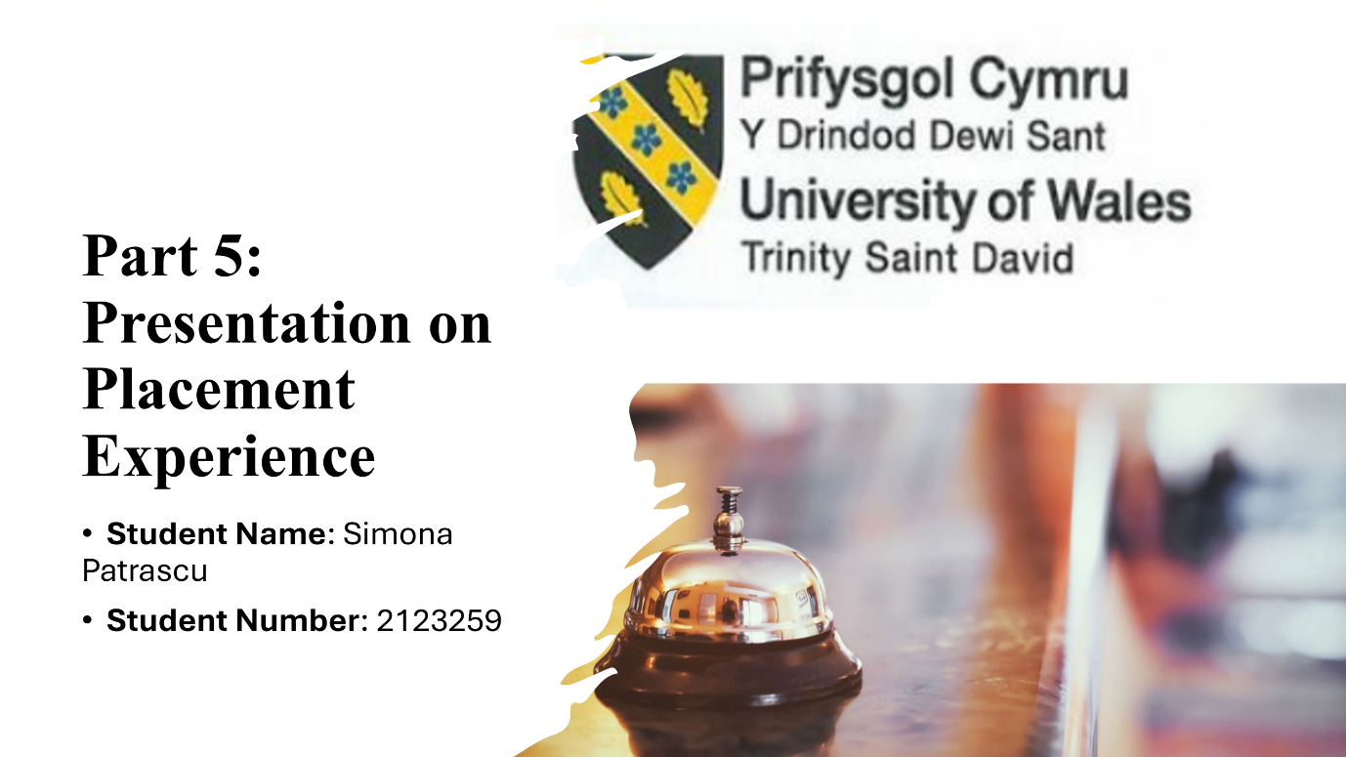
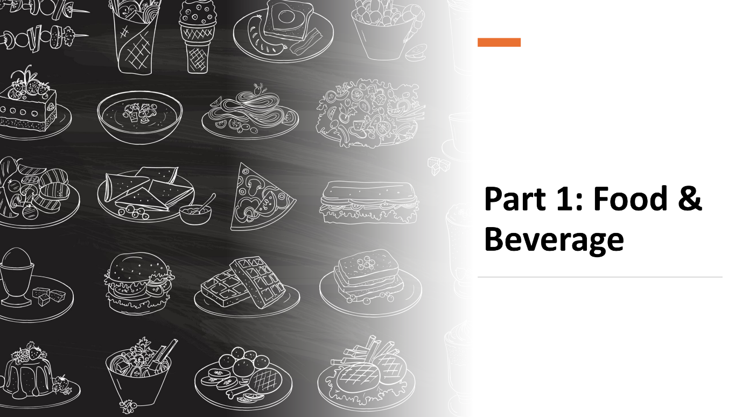
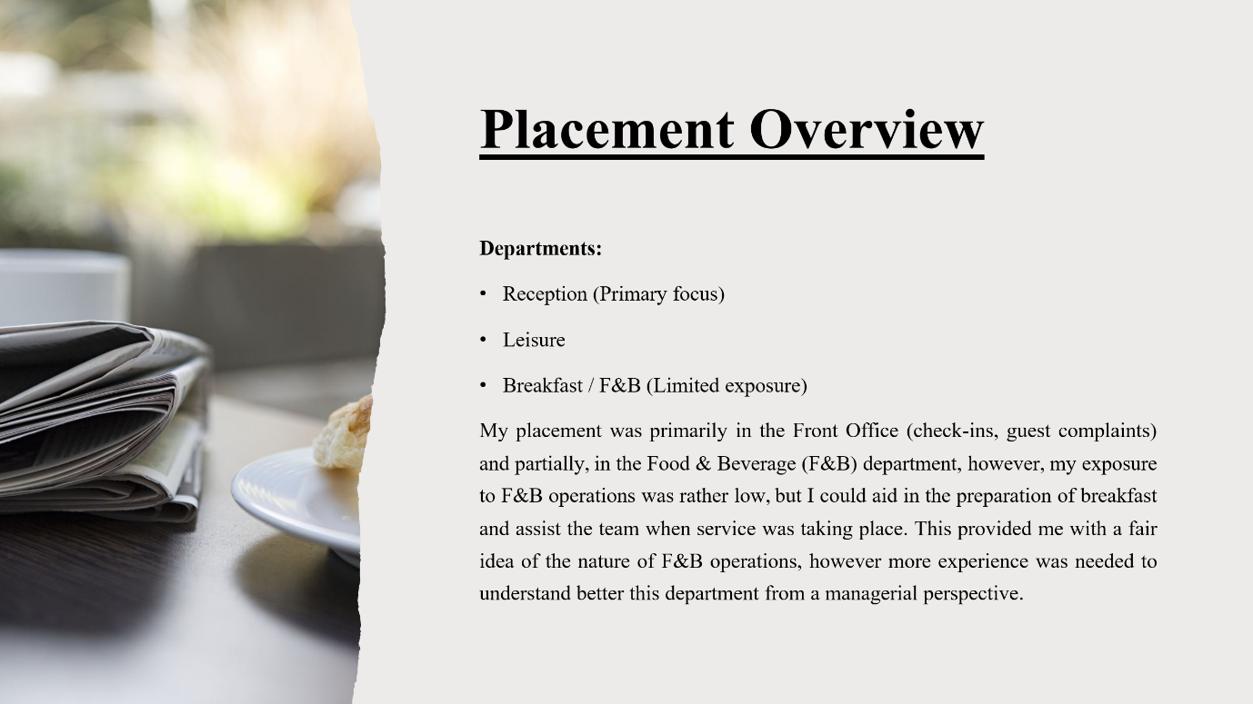
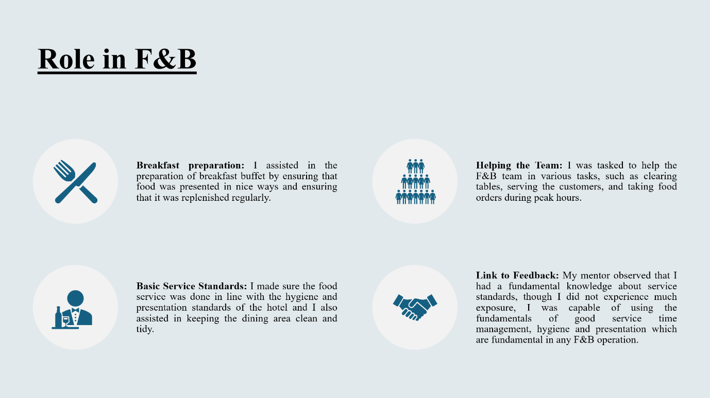
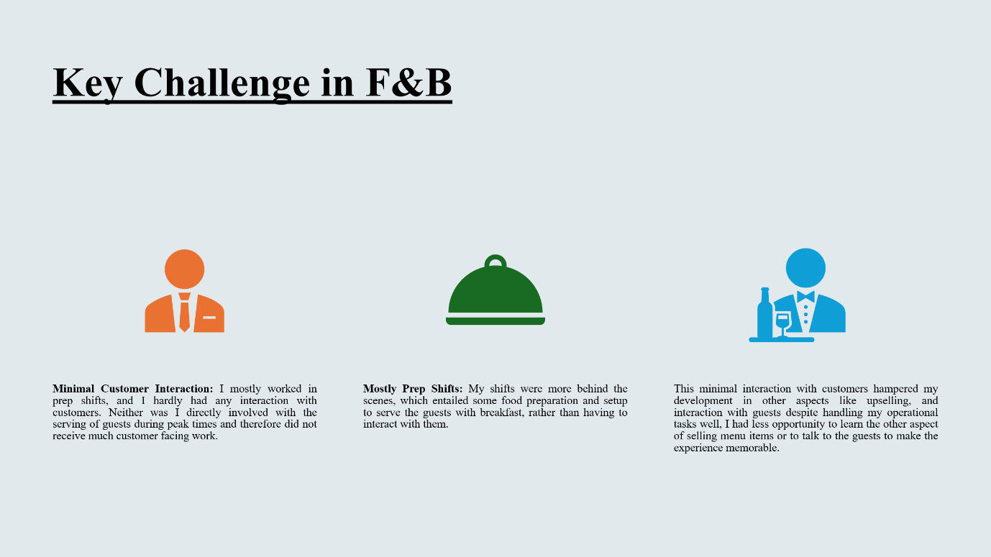
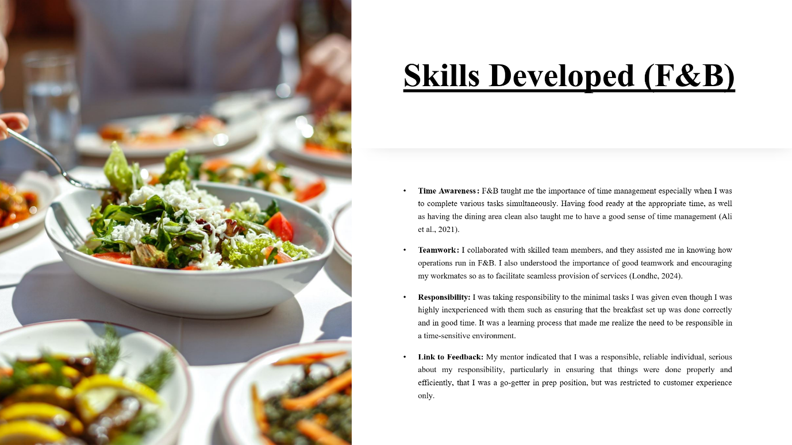
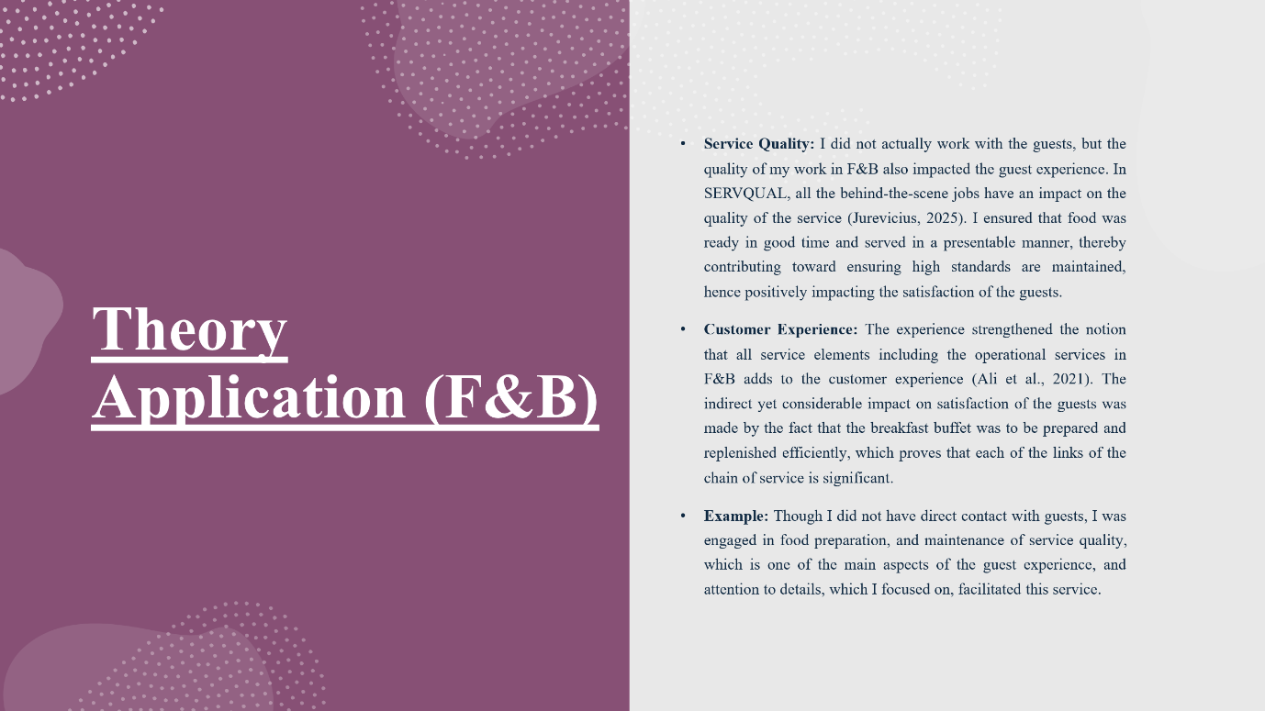
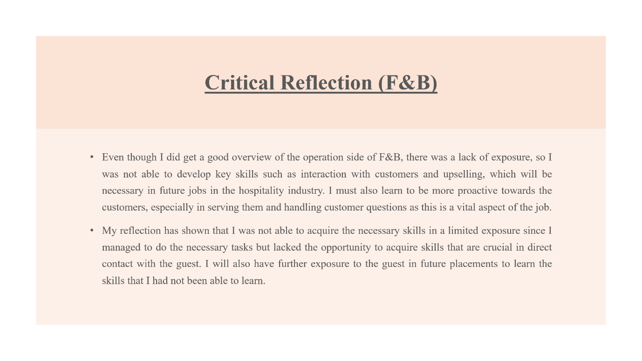
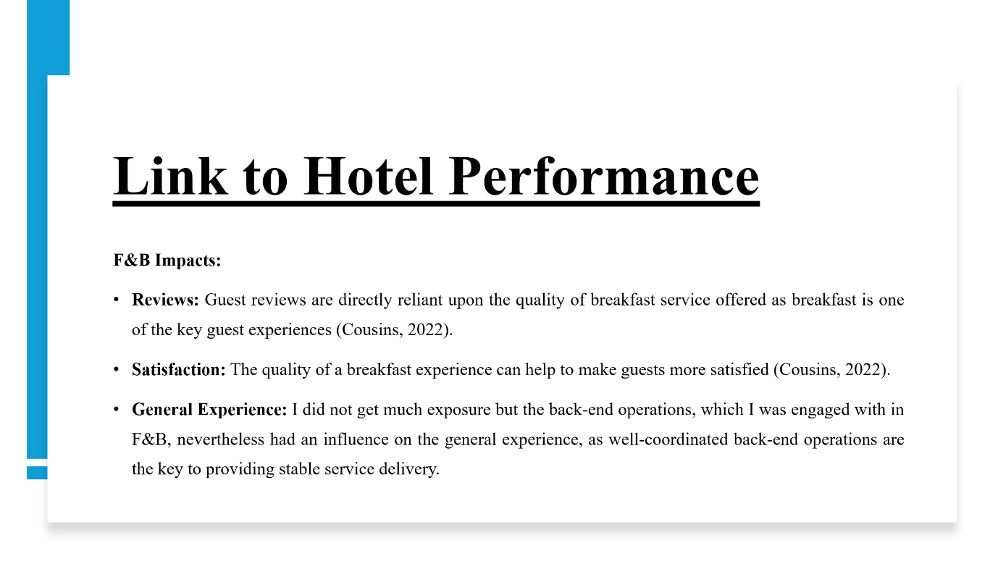
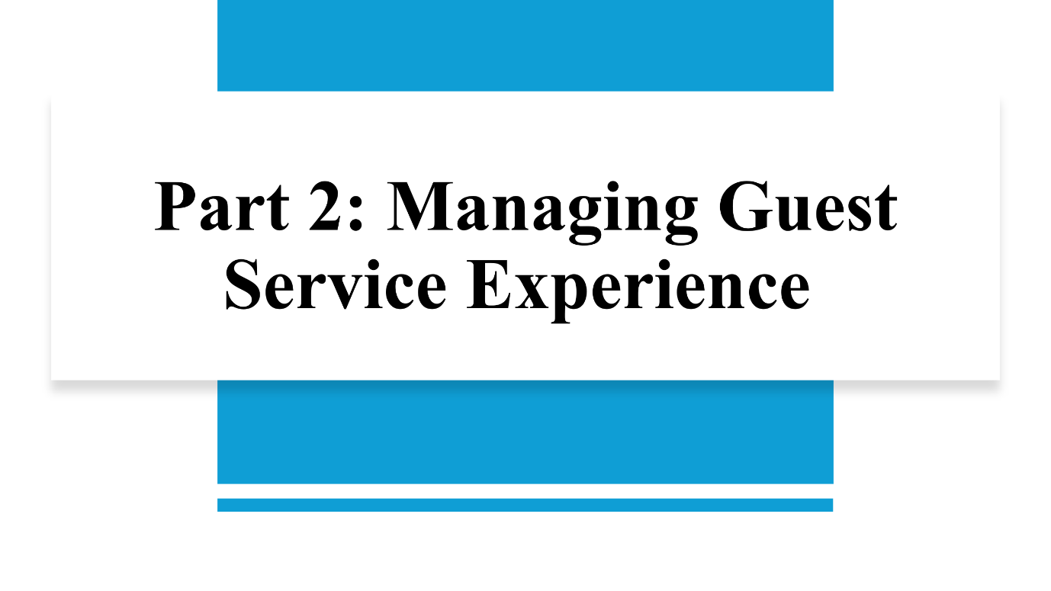
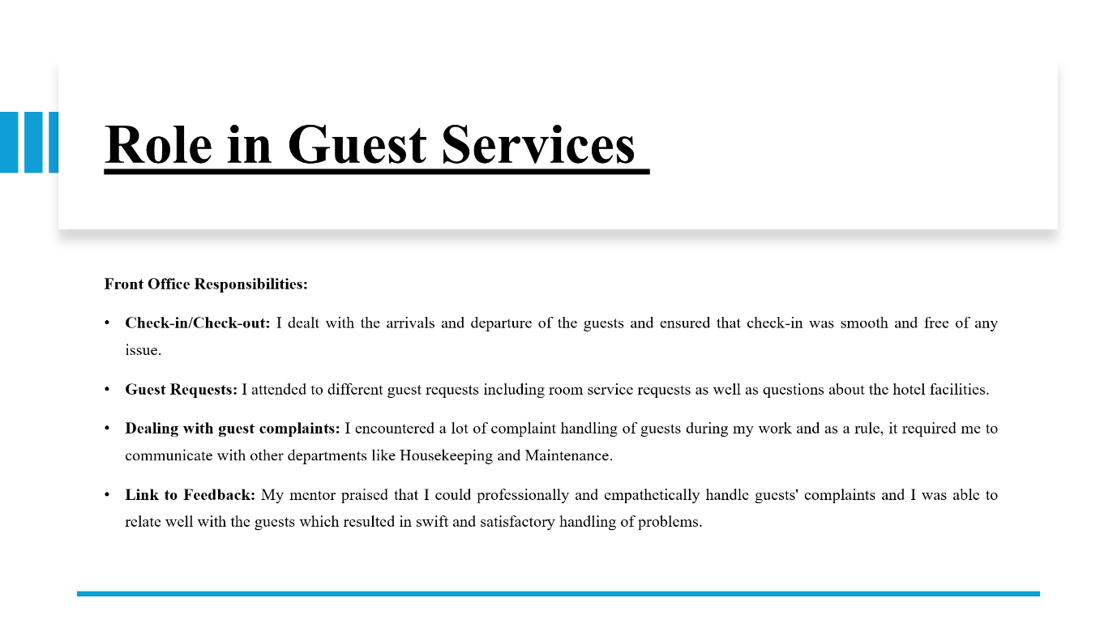
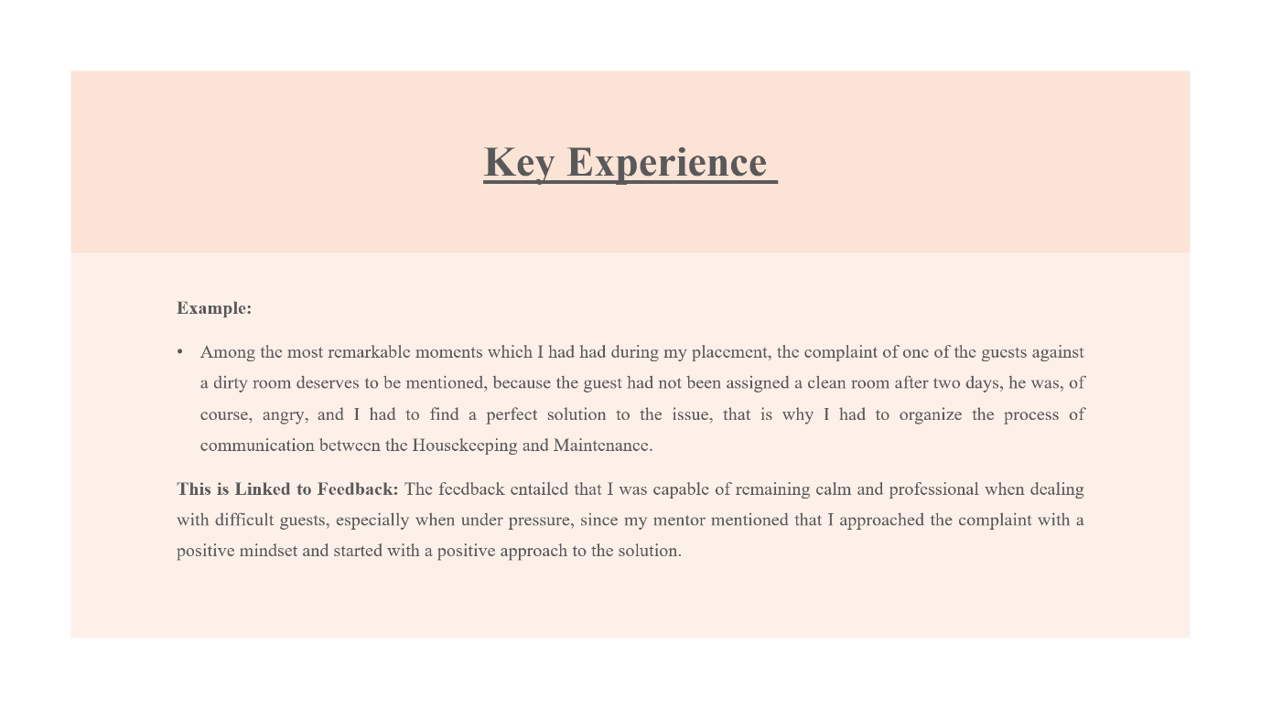
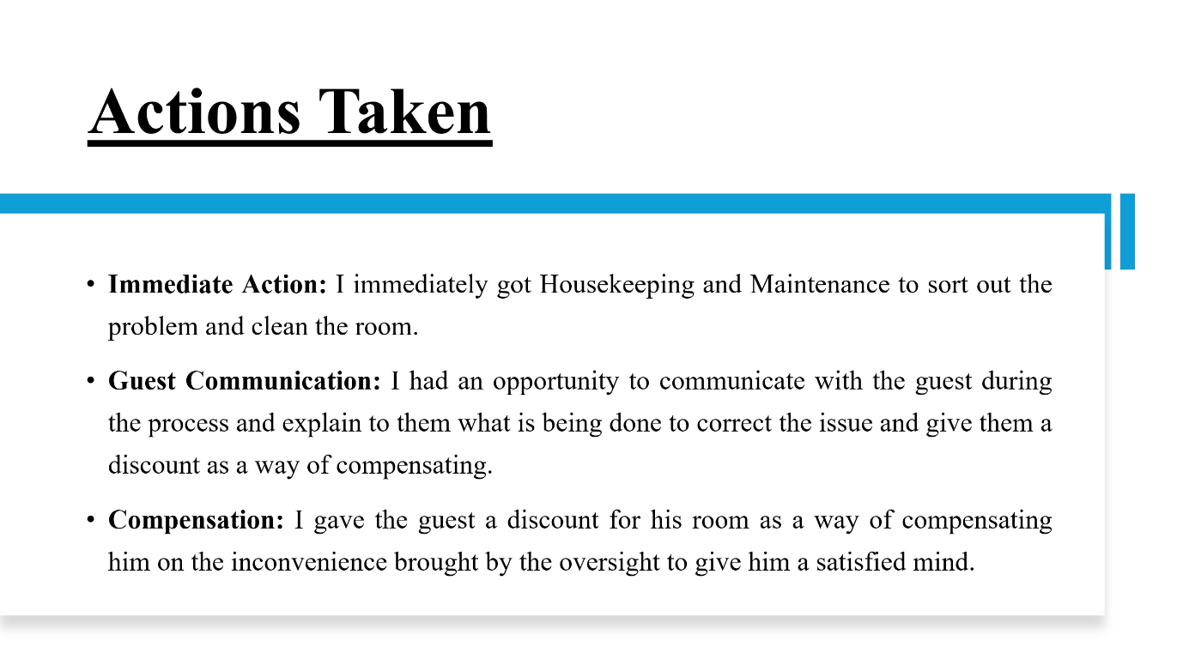
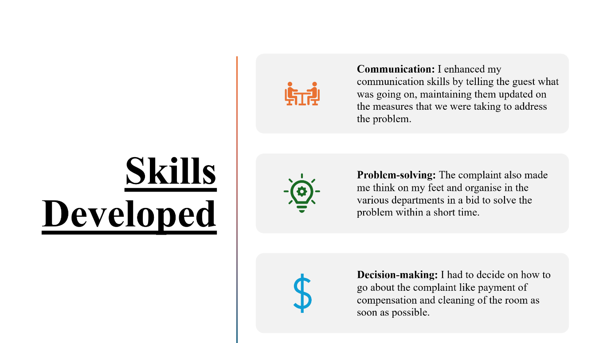
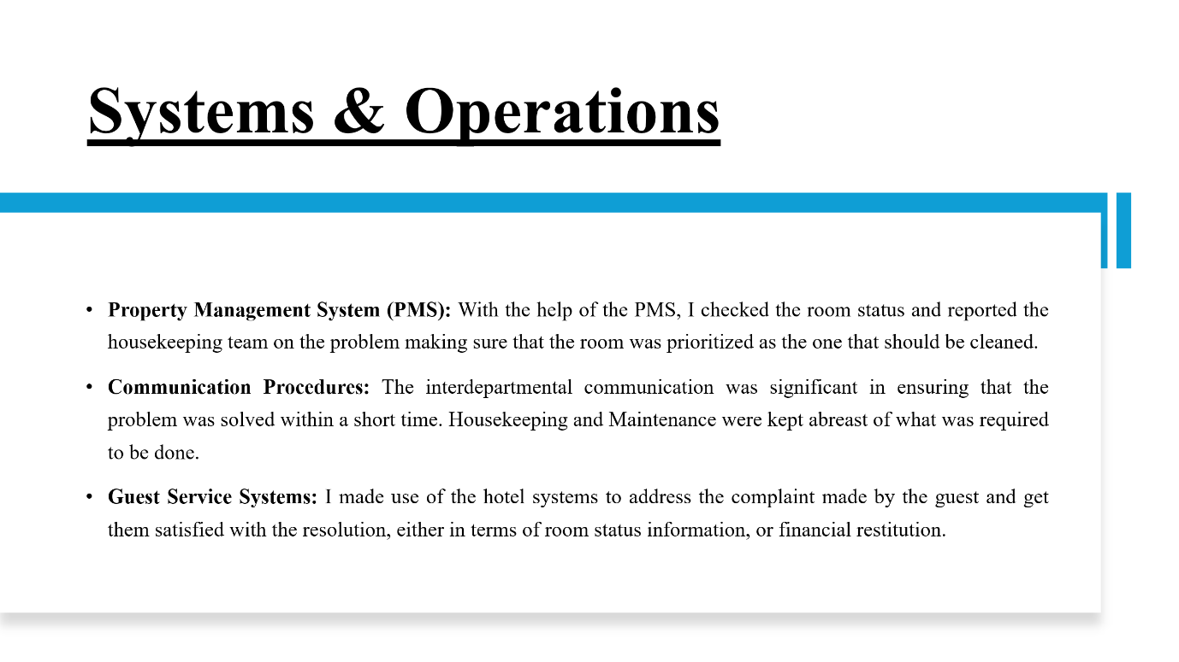
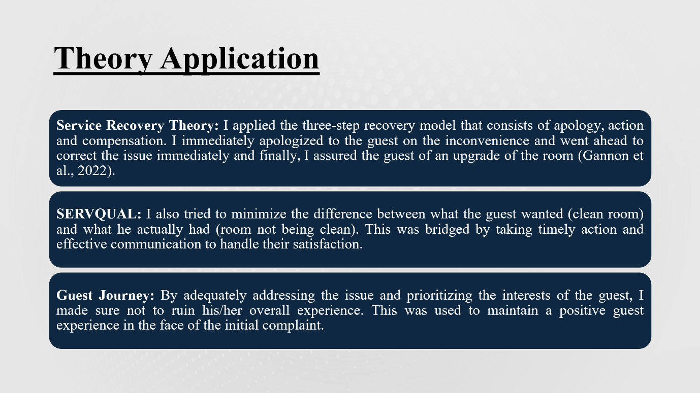
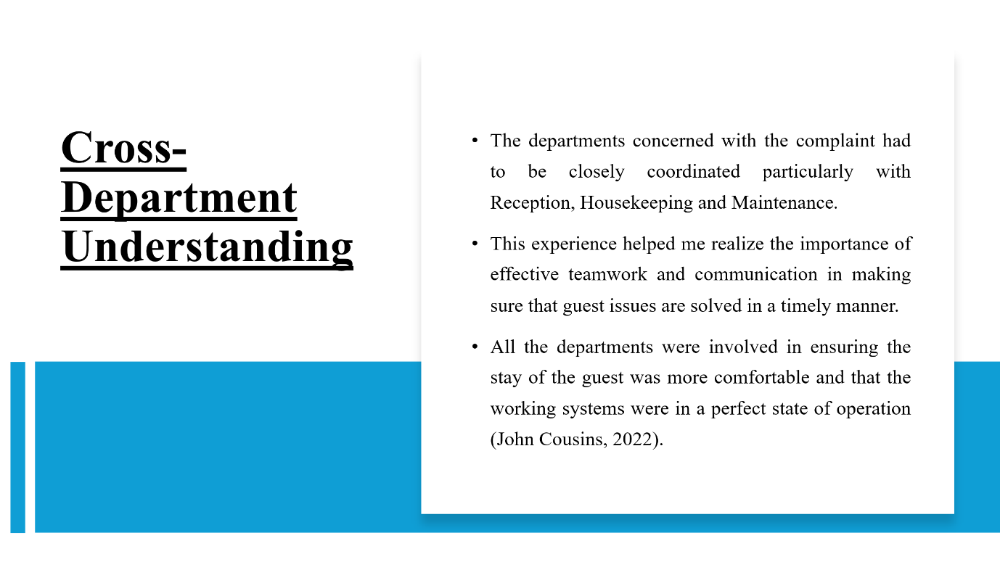
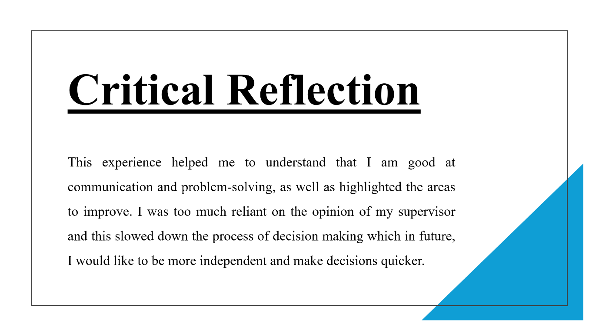
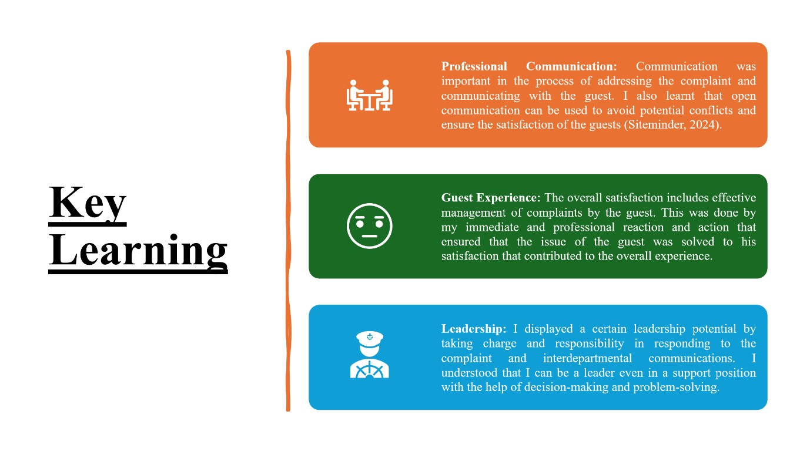
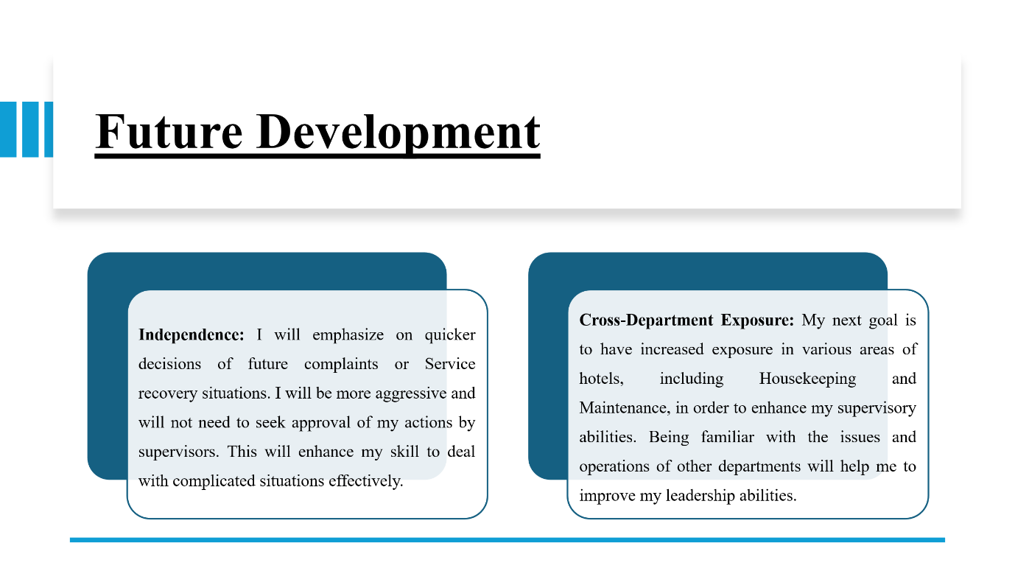
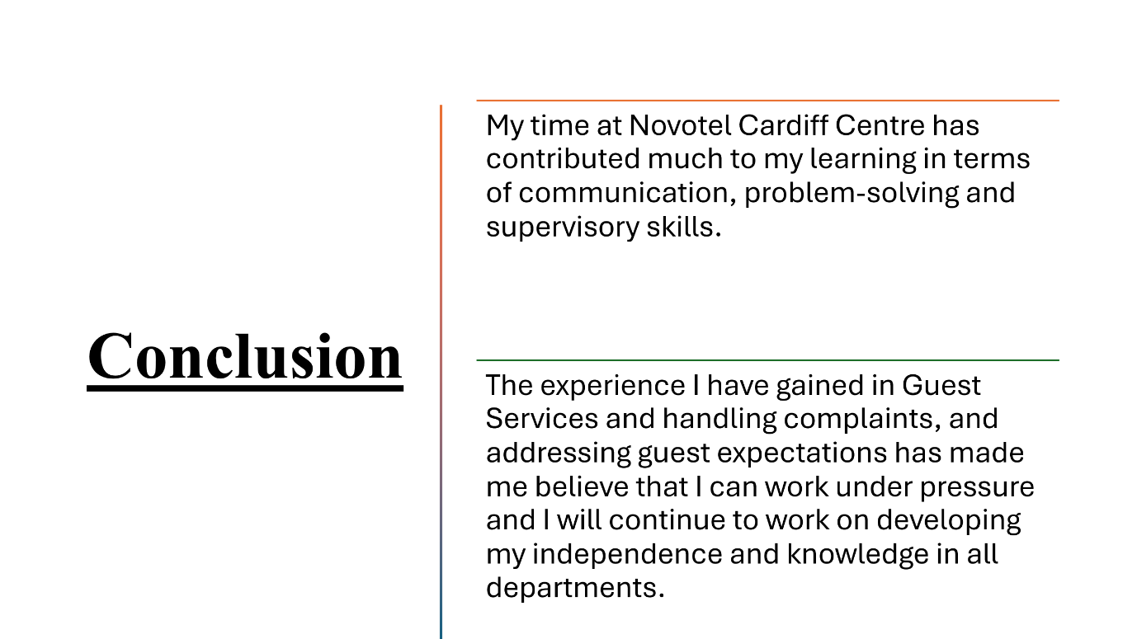
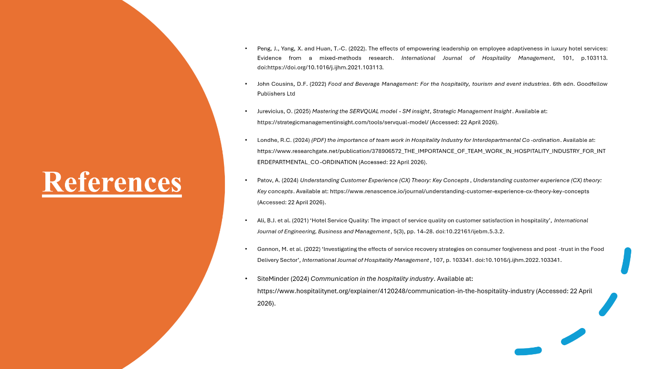

References
Belbin (2026) Belbin® – The Team Role Company the nine belbin team roles, Belbin. Available at: https://www.belbin.com/about/belbin-team-roles (Accessed: 20 April 2026).
Cottrell, S., 2021. Skills for success: Personal development and employability. Bloomsbury Publishing.
Henderson, M. et al. (2019) ‘The usefulness of feedback’, Active Learning in Higher Education, 22(3), pp. 229–243. doi:10.1177/1469787419872393.
Indeed (2026) Food and beverage manager skills: An essential guide ... Available at: https://www.indeed.com/career-advice/resumes-cover-letters/food-and-beverage-manager-skills (Accessed: 20 April 2026).
Javed, S., Rashidin, M.S., Zhu, M., Xu, Z., Jian, W. and Zuo, S., (2021) Combined Effects of Drivers and Impact of Customer Satisfaction on Brand Loyalty: The Contingent Effect of Social Trust. SAGE Open, 11(1), p.21582440211003566.
John Cousins, D.F. (2022) Food and Beverage Management: For the hospitality, tourism and event industries. 6th edn. Goodfellow Publishers Ltd
LSPM (2026) The importance of time management in the hospitality industry, Maximizing Efficiency: Time Management in Hospitality Industry. Available at: https://www.lspm.org.uk/2022/news.aspx?id=12388224&CourseTitle=The%2BImportance%2Bof%2BTime%2BManagement%2Bin%2Bthe%2BHospitality%2BIndustry (Accessed: 20 April 2026).
McGarvie, S. (2026) How belbin team roles enhance collaboration in the Workplace, PositivePsychology.com. Available at: https://positivepsychology.com/belbin-team-roles/ (Accessed: 20 April 2026).
Zerunyan, A. and Evans, B. (2026) Here’s how you can effectively manage time in the hospitality industry., Effective Time Management Tips for Hospitality Pros. Available at: https://www.linkedin.com/advice/0/heres-how-you-can-effectively-manage-time-abmhe (Accessed: 20 April 2026).

