Academic and Employability Skills Report

Balint Radu Robert
Student ID: 2115162
BMSW4001
Lecturer: Soban Sadiq

DATE:05/01/2022
Table of content

Contents
Introduction 3
Gibbs Reflective Cycle 3
CV writing 5
Referencing 5
Summarizing 6
Public speaking and giving presentations 7
CONCLUSION 8
Reference 9
APPENDIX 10

Introduction
In my report I will present the important of academic skills and how they have made my project a success in many ways, helping me to develop and transform my information in a public language and professional presentation, all this leading to perform my upgrade in employability skills. Using different methods from my lecturer such us swot, pdp , academic writing ,paraphrasing referencing, evaluation information and time management .All this helping me to manage my public speaking and my projects.

Gibbs Reflective Cycle
Gibbs' Reflective Cycle has been invented by Graham Gibbs in 1988 to change the way how we learn a new way that will improve our method of learning making and giving a structure to our time suspended in learning. It a way that helps you to learn from examining experiencing. Him create a cycle of six stage that helps you to learn form a repeat process with different result if they god or bad allowing you to improve or correct mistakes. it a method based on experience you have, and you want to draw the lesson form it to improve yourself. (The University of Edinburgh, 2020.)This method has 6 stage description, feelings, evaluation, analyse, conclusion and action plan. Each one of the stages are very important, each stage require different attention.
1 Description is the process you have to draw the details of the situation you want to analyse to take the main objects of that situation and the feelings of that and at the end you will have the conclusion.
2 Feelings here you can speak about your feelings and thought which you have in that situation and how you change and what determinate you to have that feeling in that moment . how this feelings determinate you decision in that experience.
3 Evaluation here you can evaluate you decision what have you take in that experience what determinate you to take and see what could work and what couldn’t work in that situation. Try to be as clearly is possible and honest with you self to draw the best result from that experience. Even if the situation is negative or a positive one.
4 Analysis here is the stage where you can make sense of what was happened in that situation. until now we just draw the details of the situation and what was happening in that situation . Now we can take the meaning of it. We need to see the different aspect of that situation god and bad and see way that happened. Here you can use academic literature this is the natural place for that.
5 Conclusion here we can draw our conclusion about that situation and we can summarize what we have learn from that situation and what can improve that situation what decision could take to make that experience better
6 Action plan at this stage we are planning what we should do in a similar situation in the future. This stage will help you to understand how you can help yourself in future situation to act different . We don’t just plan what we will do in the future situation, but we will make sure to take decisions that will lead to our best situation

CV writing
Cv as know curriculum vitae is a personal marketing document with the purpose to sell yourself to an employer .When you writing a cv you must put there all the details about you about your skills ,abilities and goals which you want to present to an employer each job have his skills request that means the cv must be made in that terms of request .In you cv you must put you personal details such name, age, living place social status after this you start to put the skills which you have and abilities that you need for that position and what goals you have in you cv you can speak about your projects about school about any event you have participate to get a qualify skill. An employer wants to see in your cv you history employment what job have you done before and for how long. In you cv you must writ about you experience and what achievements have you done in other jobs. in you cv you must convince an employer way are you perfect for that position and what makes you successful what sets of skills and abilities you have in that sector or for that position. and in the end in your cv you can add your hobbies interest place have you visited this part will show that you are open minded and can start an employer a easy(Content team , 2022) conversation with you. you may have something in common with your employer
*Name, professional title and contact details
* Personal profile (Who are you? What can you offer the company? What are your career goals?)
* Experience and employment history
* Education and qualification
* Additional sections (Key skills, Hobbies and interests)

Referencing
is the skill that helps student to take information form another place create by Samoan ells and use on his on purpose . referencing in helps to create citations and generate accurate bibliography. This skill help learner to manage (Griffith university, n.d.) information created by others and help avoiding plagiarism
To use correct a reference you must do these 4 steps.
1 Choe a style. There are different situations where you can use different style of reference, but you course or school will tell you what style to follow but it your responsibility to find the right one and the correct guide to use
2 Identify the resource. You need to find out what are you referencing. You must determinate the resource from where you take the information from book, journal, newspaper, book chapter, website or other type The resource type will dictate what details you will need to record.
3 Collect information. You must record all the data about resource you are referencing. You must take who, what, when and where. Make sure you check you referencing style guide during this step. It will specify exactly what information you need
4 Write your reference list. After you have collect all the information is now the time to put them together in correct order and format as per the rules of the style you are use. After you finish you writing reference list take you time to proofread it.

Reference are use in many fields and each one has his typical reference the most common are Harvard style Chicago style and ieee style most used in engineer sector. A reference can help you a lot in many ways helps you to save time helps you to use an information which is not yours.

Summarizing
In writing the summary, the main events are briefly presented, without comments, appreciations. Also, the text must be shorter than the initial one, respecting the structure of the composition (component parts of the composition: introduction, content and conclusion), and for pronouns and verbs the third person is used; at the same time, only indirect speech is used, so we do not use dialogue. Regarding verb tenses, it is recommended to use verbs in the indicative mood, present tense or perfect compound (without imperfect and perfectly simple). At the same time, it is very important to respect the cause-effect relationship, and the connection between events to be made through words and expressions, such as: then, at the beginning, after that, therefore, because, for + verb to the infinitive. The writing of the summary avoids the use of data about the author or the work, the summary of the portraits of the characters. It is also important not to use quotes, style figures, regional words, slang; archaisms are to be avoided, as well as the excessive use of verbs in the gerund, and repetitions can be reduced by synonymy.
Haw to create one in 4 steps.
1. Read and Make Notes
First of all you must read the all the text and after we start to write down . the most important part for a good summary is to extract (Mind tools team, 2022.) the main ideas and write them down on notes.
2.Find different terms
Here we have to put different word but with the same meaning. To put the text in everybody’s language.
3. Put the Text into Your Own Words
Here you can use your imagination mixing the information with you imagination to put the text down to have a nice work. what you understand from the text you put it there with your own words. In this way you will take out a beautiful text.
4. Check your work
Make sure you have done everything and double check for mistakes . and also check that we didn’t copy the text only the important parts with our words.
This skill is really use full when you need to minimalize a text or an information. It helps you to take out the main ideas and work with them. this style it often use in news first page of paper on website and on other type of public information .

Public speaking and giving presentations
My public speaking was difficult because was my first presentation in front of so many people. It was hard to breathe, to control my emotions to control myself.
In the end I manage my emotions, keep saying in my mind nothing bad can happen that was helping me going over and proceed with my presentation
After all these emotions I find that it nice to see people listen to me about my work and everything I have done. I start at point to ask questions in public making me sure about myself and delivering a nice presentation of my project
In the future i will definitely have a better control of myself after this experience and i will try to improve i am sure a presentation can be a really success if you have the right ideas in your mind and you are ready with the energy to give to your public they will feel it and they will fallow you and trust your words. If you trust yourself and believe in what are you doing nothing can go wrong

CONCLUSION
Gibbs offers a framework for examining experiences, allowing you to learn and plan from things that either
went well or didn’t go well through 6 stages.
CV give you the ability to present yourself to an employer.
Reference helps you to avoid plagiarism and prove your source.
Summarizing give you the possibility to renew your work.
Public speaking let you enjoy the attention and improve your skills by talking in public and expose your hard work.

Reference
Content team , 2022. CVlibrary. [Online]
Available at: https://www.cv-library.co.uk/career-advice/cv/how-to-write-a-cv-tips/
[Accessed 4 1 2022].
Griffith university , n.d. Griffith university. [Online]
Available at: https://www.griffith.edu.au/library/study/referencing
[Accessed 4 1 2022].
Mind tools team, 2022. Mndtools. [Online]
Available at: https://www.mindtools.com/pages/article/paraphrasing-summarizing.htm
[Accessed 4 1 2022].
The University of Edinburgh, 2020. The University of Edinburgh. [Online]
Available at: https://www.ed.ac.uk/reflection/reflectors-toolkit/reflecting-on-experience/gibbs-reflective-cycle
[Accessed 4 1 2022].

APPENDIX
Slide 1

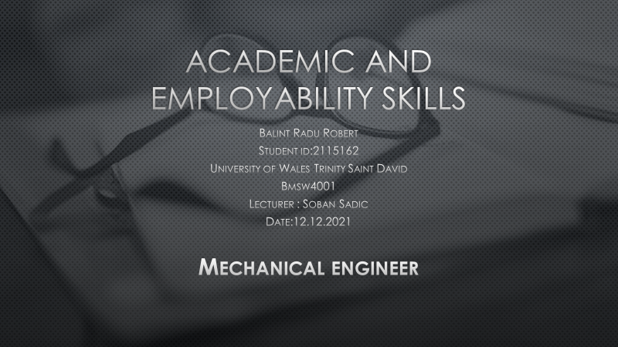
Slide 2
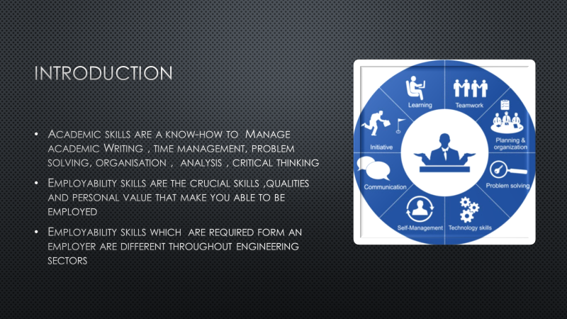
Slide 3
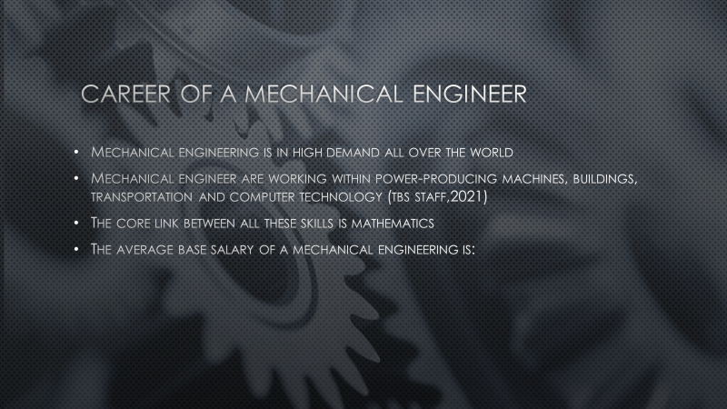
Slide 4

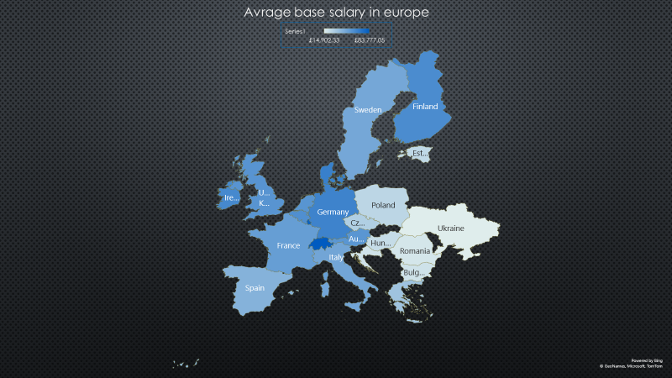

Slide 5
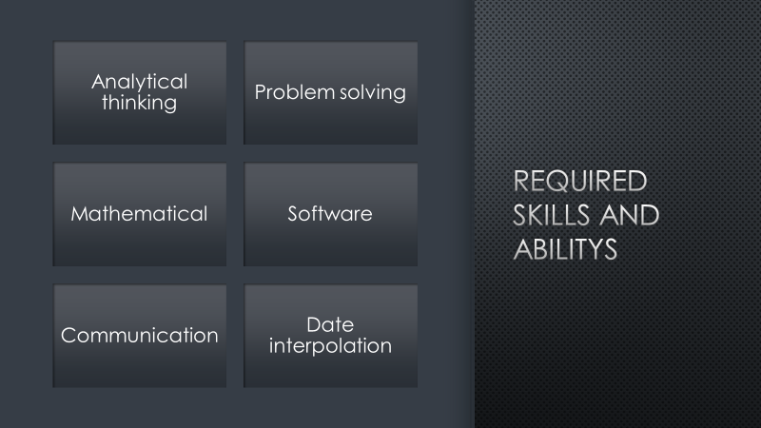
Slide 6
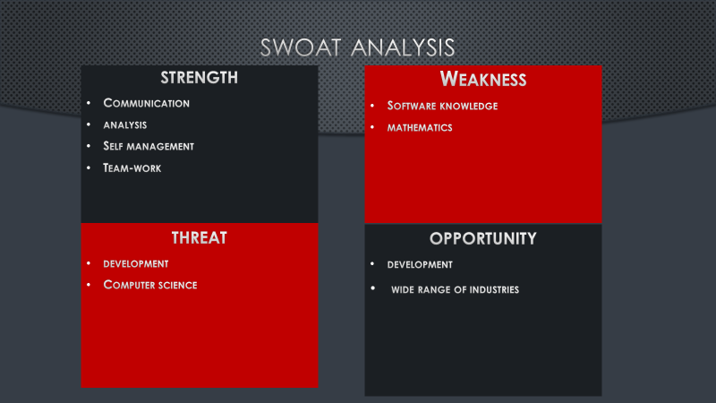

Slide 7
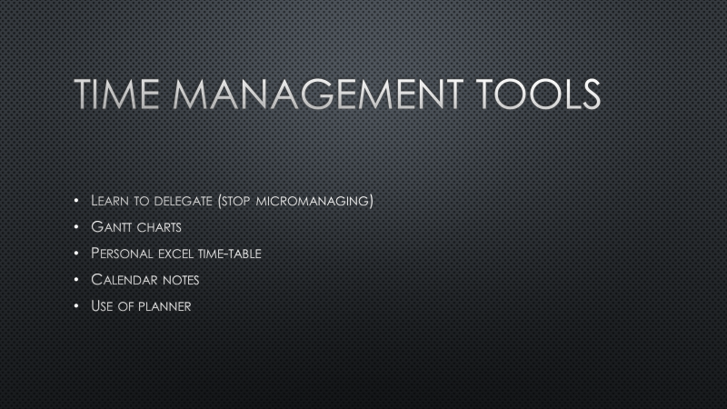
Slide 8
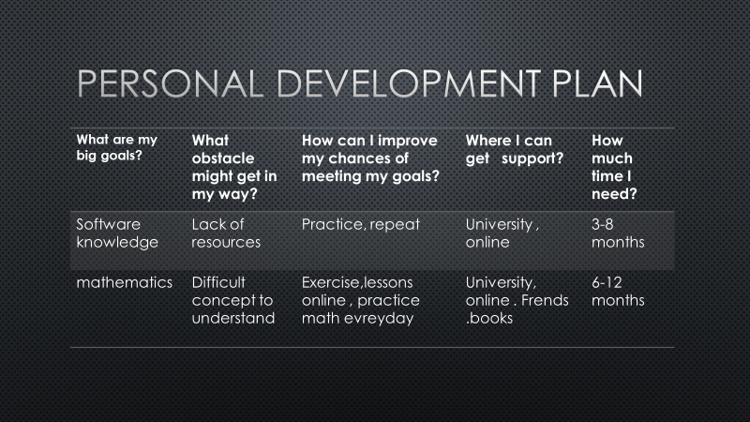

Slide 9


