Submission Date: 07/01/2019
Assessor Name: Julie Thomas, Marie Pitson
Programme: BA in Business

..
(Personal development)(assessment 2)

Candidate Name: Zexin Xu
Student ID:1905089

Word Count: 2838
Content
1.0 Introduction 1
2.0 Main finding 1
2.1 Activity 1 1
2.2 Activity 2 2
2.3 Activity 3 4
2.4 Activity 4 6
3.0 Conclusion 7
4.0 Appendix 7
Reference 15

1.0 Introduction
This article mainly introduces the criteria for becoming a professional and how to make a reasonable plan to become a professional. Besides, this article also introduces the importance of teamwork among professionals and how to use negotiation and collaboration skills to resolve conflicts between teams. Mastering these skills is very important for those who are willing to work, which means that he can improve his professional level while cooperating with his work partners. Cooperation is the primary quality and essential ability required for work. This report will use 4 activities to describe the content.

2.0 Main finding

2.1 Activity 1
The definition of professional
Professionals are people who earn a living through professional skills. Professionals need specialized knowledge and skills to perform their duties, and they are also subject to industry ethics. (Wikipedia,2019)
In the Medical Dictionary, ‘professional’ means an expert in a particular profession or field. The second is a person who has received some professional training or holds a professional certificate or professional license.
In the Financial Dictionary, ‘professional’ means a person who possesses a range of skills or knowledge sufficient for the position. (The free dictionary,2019)
Professional HR Evaluation principles:
1. People working on behalf of the organization should not only be protected by laws and regulations but also need to have intrinsic value. (CIPD,2019)
2. The interests of stakeholders are the organization's best interests. (CIPD,2019)
3. Respect every organization that acts as a corporate citizen and operates sustainably. (CIPD,2019)
4. The highest-level managers need to commit to support the worker who works for the organization and to meet relevant standards. (CIPD,2019)
Professional HR's industry standards (British human capital standards):
HR's industry standards are mainly based on the principle of evaluation by people in the organization. HR's UK human capital standards are as follows:
1. A professional HR should be able to correctly and comprehensively evaluate the people in the organization, and specifically evaluate the extent to which each employee promotes long-term effectiveness, social continuity, and common value to measure each of their contributions at work. (CIPD,2019)
2. A professional HR should treat candidates or employees with a diversity and inclusive work attitude to ensure that employees are fair and dignified in their work. To do this, HR should provide a comprehensive, diverse, principled framework for evaluating employee performance to fulfill the HR organization's commitment to evaluate employees in the broadest sense. (CIPD,2019)
3. A professional HR should be able to maximize the potential value of employees in the organization by providing a basic roadmap for employees to learn and develop to determine the knowledge and skills that each employee should prioritize and the choice of development areas. (CIPD,2019)
Professional map(Ev 1a): The HR industry map can provide employees in the HR industry with current professional excellence requirements, and lists professional HR needs to create value and substantial knowledge and behavior for the job, thereby helping HR personnel to make value-based decision making. Besides, professional maps can help HR personnel understand the changes in HR's professional needs in the future, and let HR personnel know what changes they need to make in the future to adapt to changes in industry needs. (CIPD,2019)
Four concentric circles
The four concentric circles of human resources specialization are self-management, team management, upward management, and overall organizational management. A professional HR needs to manage his skills, knowledge and development and needs to accept suggestions and feedback from others to perform frequent self-assessments to add value to his services. (StudyMoose,2016)

2.2 Activity 2
The definition of Group dynamics:(EV 2c)
Group dynamics mainly refer to the group's attitudes and behavior patterns in dealing with problems and are related to the formation and structure of the group and the operation process of the group. The group dynamics are related to the interaction between the groups and the forces within the group. (Smriti Chand,2019)
Group dynamics can be divided into group internal dynamics and group external dynamics. Group internal dynamics are systems of behaviors and psychological processes that occur within social groups, and external group dynamics are systems of behaviors and psychological processes between social groups. (Wikipedia,2019)
The factor which can affect Group dynamic:
Social Status/Leadership
For example, if a team has a member who is the apparent leader and is stronger than other members in terms of talent, wealth, and experience, then the group will follow the leader. If there are multiple leaders in a group at the same time, the group will create chaos in the conflict between the leaders. (Act for library,2019)
Group structure
Group dynamics are also affected by organizational structure, such as group size, group roles, Group Norms, Group Cohesiveness. (Smriti Chand,2019)
Culture elements
Group dynamics are also affected by cultural elements. Culture is the traditional behavior of a society, which includes beliefs, customs, knowledge, and practices, and these cultures have an impact on the behavior of members within a group. So even the same operating model will have different effects in different cultural groups. (UKEssays,2018)

Team cooperation theory
1.Tuckman’s Model – 5 Stages of Team Development and Practical Limitations (Ev2b)
Tuckman’s model can be used to build and develop a team and analyze the behavior of the team. (Knowledge centre,2019) Tuckman's Model could be used for each stage of team development. The detailed description of the task allows team members and managers to understand which stage of the team's development and gives the team a clear direction of development at each stage. However, this model is only suitable for small groups and lacks a complete explanation of how groups change over time, nor does it address the impact of team development on problem-solving creativity. (Joshua Render,2019)
2.Belbin Team Roles (Ev2a)
The Belbin team role allows team members to understand their traits and other team members to understand the characteristics of each member to analyze the strengths and weaknesses of the entire team. This theory allows each team member to understand their role in the team and better respond to the needs of the team environment (Team Building portal,2018)
The importance of cooperation for professional:
The benefits of each professional's collaboration with each other will outweigh the benefits of each professional working alone. For example, if a 72-hour report is completed by a professional within 24 hours, the report submitted by him is likely to be a low-quality report or even impossible to complete. If the professional has the cooperation skills to work with other people to complete this report at this time, he will have much time to complete the report. (Chris Leitch,2017)
If professionals collaborate, they will also improve their ability to analyze and solve problems. (Nutcache,2019) In reality, there are often multiple solutions to work problems. Employees with different personalities have different views on the solution to the problem. If professionals have teamwork skills, they can think about the problem from multiple perspectives and choose the most appropriate solutions, and finally gain new experience and skills from other people's views and opinions. (Chris Leitch,2017)
Solve conflict (EV 2d)
1.TKI is the most popular tool for managing organizational conflict, it is scored or team members self-scoring ways to help managers and team members understand their style of handling conflict (competition, collaboration, compromise, avoidance, adaptation). (Kenneth W. Thomas and Ralph H. Kilmann,2019)
In an organization environment, the manager uses TKI as a test to analyze the confliction among team member and then assign team members with different conflict-handling methods to the team to avoid conflicts.
2. A win-win negotiation method is to find a mutually acceptable result when their own positions conflict with the positions of others, and both parties can obtain as many things and satisfactory results as possible during the negotiation process. An ideal win-win situation means that what one person is preparing to trade happens to be what another person needs. In general, a win-win situation is used in which one of the parties needs to give up certain conditions to achieve a win-win goal, but both parties are still satisfied with the result. (Mind tools ,2019)
In the management of organizational contradictions, the managers and members of the organization should first separate people and affairs and focus on interests rather than positions. Second, organizational members must be able to create options that are acceptable and beneficial to both parties to the conflict. Finally, a win-win strategy requires that both parties take an objective approach to the problem.
Example: In a win-win strategy, once I was involved in selling milk, I sold ten boxes of milk to customers at 50 yuan a carton, but another merchant sold milk at 45 yuan a carton. Their low price has affected my milk sales because people are more inclined to buy cheap milk. It’s the conflict between the merchant and I. So I decided to talk to this merchant to persuade them to raise the price of milk to 50 yuan per carton of milk to solve the conflict. In this case, I used a win-win perspective to talk with merchant that the quantity of milk I want to sell is small. The merchant can lower the price after I sell ten boxes of milk. If the merchant raises the price of milk, they also can increase their profit. Finally, I successfully persuaded the merchant to temporarily raise their milk prices, so my ten boxes of milk were sold to customers quickly, and the merchants also got more profits.

2.3 Activity 3
Project management is a predictable and repeatable process. This process is usually applied to every project in the organization. The phases of project management are divided into five phases:
1. initiation, 2. planning, 3. execution, 4. monitoring 5. end. (Brendan McConnell,2019)
Project plan (Gantt chart)
Gantt chart is a bar chart that lists the tasks to be performed on the vertical axis and time intervals on the horizontal axis. It is mainly used to illustrate the progress of the project. The length of the duration of each activity will be displayed in the form of the width of the horizontal bar and indicate when the activity started and when it ended. (Wikipedia,2019)
In the appendix, a landmark project plan-a Christmas party project plan will be shown in the form of a Gantt chart. (EV 3a)
problem-solving techniques
- Brain-storming
Brainstorming is a collective creativity technique that collects group members' initiative to come up with a variety of ideas about a specific problem and seeks methods or conclusions to solve specific tasks or problems from these ideas. Brainstorming allows each group member to freely and boldly come up with their ideas, record them, and finally get practical and innovative conclusions in the group discussion. (Wikipedia, 2019) (EV 3c)
2.De Bono’s 6 Thinking Hats
Six Thinking Hats is a system that describes personal thinking and group discussion tools about six different colored hats. This system provides a cohesive and detailed thinking process for a group to provide a parallel thinking method for the group to use six different ways of thinking for more effective common thinking. (Wikipedia,2019)
3.Fish-bone diagram
Fishbone diagrams are a kind of cause and effect diagram used to show the cause of an event. This diagram explains the cause of the problem in detail and comprehensively. It can easily find the root cause of the problem for the team members and quickly find the root cause. Whether it already exists in this picture and has been found many times. Fishbone diagrams is a highly visual brainstorming tool that can see all the causes of a problem at the same time, thereby facilitating the process of presenting the problem to stakeholders. (Wikipedia,2019)
Methods of influence, persuasion and negotiation
- Nagging
Nagging is the easiest way to influence or persuade others, mainly by always instilling the same information in others and reiterating their opinions. People often have to accept the speakers' opinions in order to avoid trouble. But when this method involves some principle issues or major interest issues, it is not easy to play a role. (Skillsyouneed,2017)
- Coerce
Persuading others can also be forced, which means that others are restricted by some critical condition and have to do something they do not want to do and the speaker wants to do, however, if it is difficult for them, they will also give up This thing may fail because it is not what they want to do, but what they must do. (Skillsyouneed,2017)
3.A Better way
Speaker can find better ways to persuade others to give up their ideas, they can use what they did not know before, and better ways to get what they want. Usually, this method of negotiation makes them accept our point of view. (Skillsyouneed,2017)
Example: I played a game called Island of Opportunity with my friends. The ultimate goal of this game is to meet the needs of all participants through group negotiation (my needs can be seen in appendix). In order to meet Kurr tribe's need to occupy one third of the entire island, I explained to my team members that this is the rule of the game. Use the sentence "If the needs of my tribe are not met, the whole group will fail." to force the group members to consider my needs of tribe to achieve my goal. Besides, I need a river bank to build a house, so I used the nagging method to declare many times that my territory needs space near the river bank to persuade my group members to leave me an open space near the river bank. (EV 3b)

2.4 Activity 4
The importance of CPD
CPD can help people manage and plan their learning plans and growth plans, linking learning skills and work practices. CPD will help people continuously adapt to changes in the job market and maintain people's knowledge and skills in the most advanced state. (ILM,2017) Besides, CPD can keep candidates interested in careers and open up new areas of knowledge and skills for workers. CPD setting higher industry goals for professionals can also increase public confidence in professionals and the wholly industry. (Vivian Kloosterman,2013)
The stage of CPD circle
Identification, planning, action, reflection, application, sharing, and impact are the five stages of the CPD circle.
CPD Reflection
Reflective exercises are the process of analyzing CPD activities. This process can help professionals recognize their strengths, weaknesses and the benefits that their activities will bring to themselves, employers, and customers. Professionals can use CPD reflection to provide more ideas for personal career development to modify their behavior and learning goals. If professionals can carry out reflective exercises frequently, they can gain special benefits from their experience and potential areas for future improvement. (Chloe Fletcher,2016)
CIPD career development needs
1.Core knowledge
I will choose analytics and creating value as my core knowledge, as a professional HR needs to manage and analyze the data of many employees of a company to ensure that the performance of each employee can be treated fairly and comprehensively to evaluate the value of employees. In this way, I can make the right decision to adjust the position between the employees of the company. (EV 4a)
2.Core behavior
I will choose insights focused as the core behaviors because a professional HR must often think about the potential problems in the organization and use creative strategies to solve the problems in the organization and realize the impact of HR actions to the whole organization. (EV 4b)
3.Specialist knowledge
I would choose talent management as specialist knowledge because a professional HR needs to fully understand the personality, strengths and weaknesses of each person in the organization and deploy the personnel of each organization to complete the tasks that suit them to maximize the capabilities of everyone in the organization to maximize the overall effectiveness of the organization. (EV 4c)
Personal development plan (PDP)
My personal development plan will be shown on appendix of the report. (EV 4d)

3.0 Conclusion
Through the above 4 activities, readers can understand the definition of professional and the conditions and qualities required to become a professional. But as a professional, it is not enough to have a series of professional skills. Professionals still need to seek the cooperation of others in order to pursue higher work efficiency and improve their work level. In order to achieve this, professionals need to understand the organization's dynamics and use Tuckman's Model and Belbin Team Roles to understand the overall status of the organization and its or other group members' positioning in a group. Under the condition of teamwork, conflicts are unavoidable. At this time, TKI and win-win solution need to be used to resolve conflicts existing in the team. In the process of teamwork, there are specific problem-solving modes. Gantt charts can intuitively show the team the time requirements of various team activities. Brain-storm, De Bono's 6 thinking hats, and Fish-bone diagram. The three methods can maximize the potential value of team members. To become a professional, it is important to plan someone’s personal development. Personal development planning can be a person's plan, effectively achieve the direction of professional standards and increase self-discipline to achieve professional goals.

4.0 Appendix
Ev1a Professional map
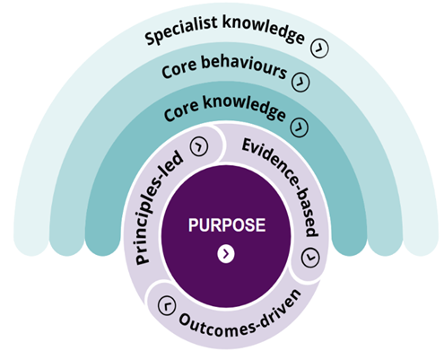
EV 2a
The article support of Belbin
Dr. Meredith Belbin is well known for his team roles concept. The team roles identified by Belbin are based on certain patterns of behaviour that people exhibit within teams. These patterns of behaviour can potentially have an impact on the performance of the team. The basic premise of the Belbin team roles theory is quite simple. When individuals become aware of their strengths and abilities and understand the role that he or she is capable of playing within a team, it helps them to deal better with the demands of the team environment. (Team Building portal,2018)
EV 2b
The article support of Tuckman
The Tuckman Stages of Team Development can be used for identifying factors that are critical for building and developing small groups.
Tuckman's Stages of Team Development model seeks to explain how a team develops over time. The five stages of development are Forming, Storming, Norming, Performing, and Adjourning. The Adjourning stage was added later in 1977. According to Tuckman, all of the phases are necessary and inevitable - in order for the team to grow, to face up to challenges, to tackle problems, to find solutions, to plan work, and to deliver results. (Kenneth W. Thomas and Ralph H. Kilmann,2019)

EV 2c
The definition of group dynamics: Group dynamics is a system of behaviors and psychological processes occurring within a social group (intragroup dynamics), or between social groups (intergroup dynamics).
EV 2d
Thomas-Kilmann questionnaire
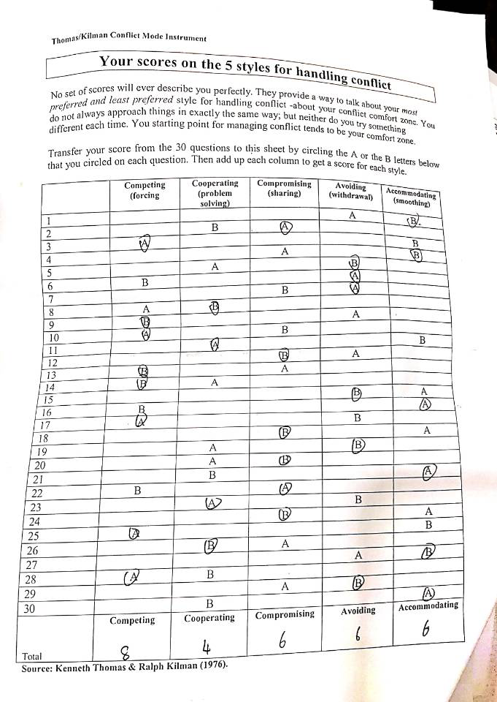

Ev3a (Gantt chart-The plan of Christmas party)
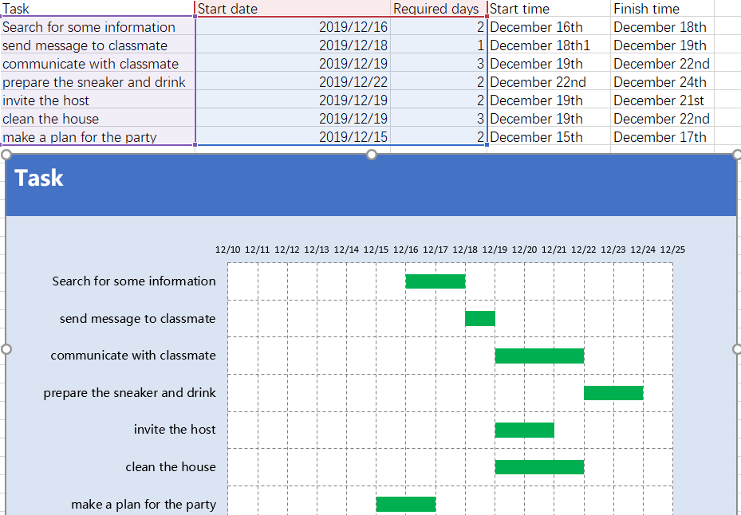
Ev3b (Methods of influence, persuasion and negotiation)
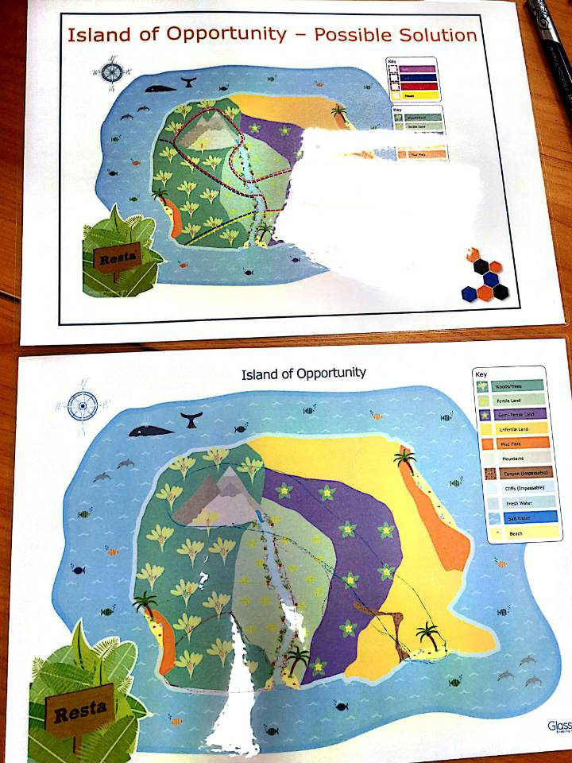
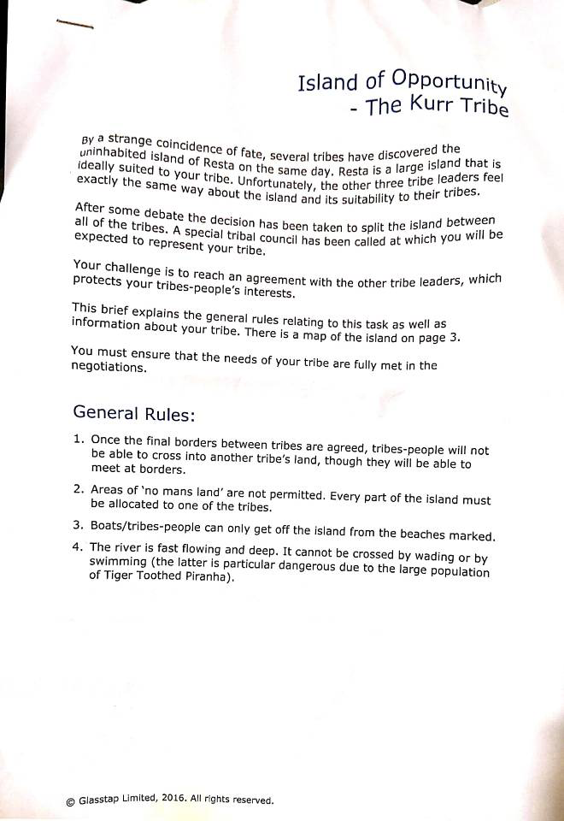

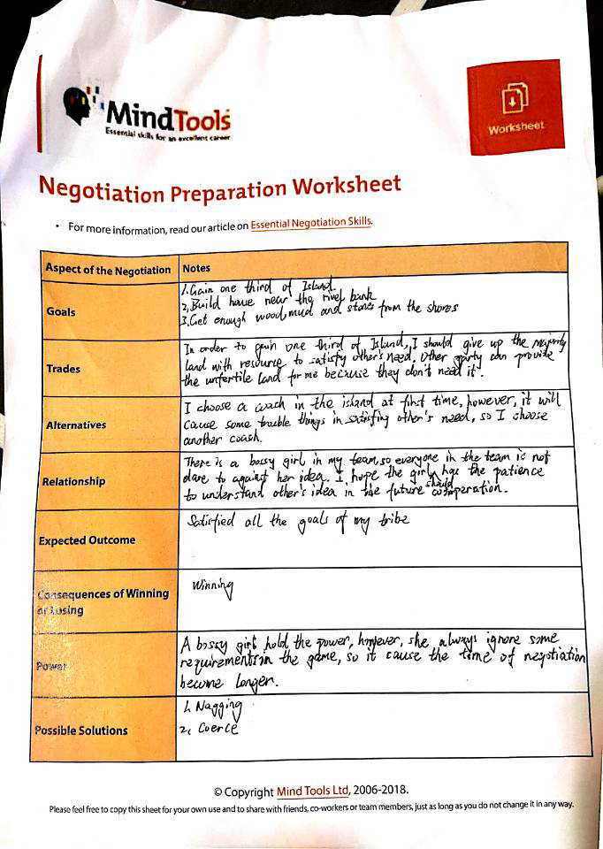
EV 3c (Brain-storm)
As a brain-storm copy, I will use a game called Thinking outside the box that I played with my teammates in class.
The game provides a piece of paper with 9 points. The participants of the game are required to connect the nine points with four uninterrupted straight lines. During this period, the participant's cannot take his pen off the paper.
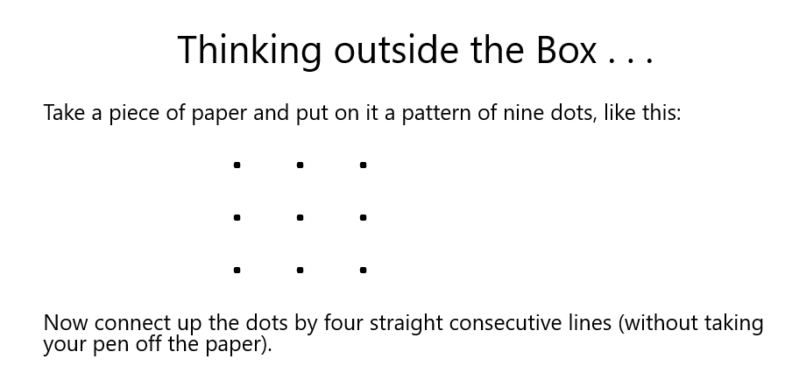
My group member came up with various ideas, and I show them in the picture below.

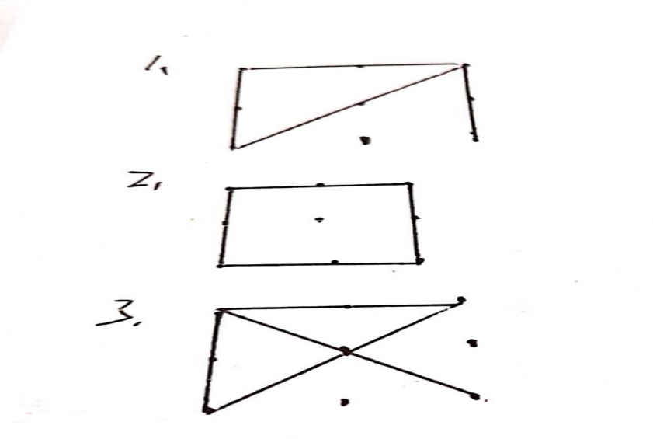
We encountered a difficulty. All members cannot connect 9 points with 4 unbroken straight lines.
From the third option, however, the group members were inspired. The center point is crossed by two straight lines, which seems a bit wasteful. So we pull one of the lines out and won this game.
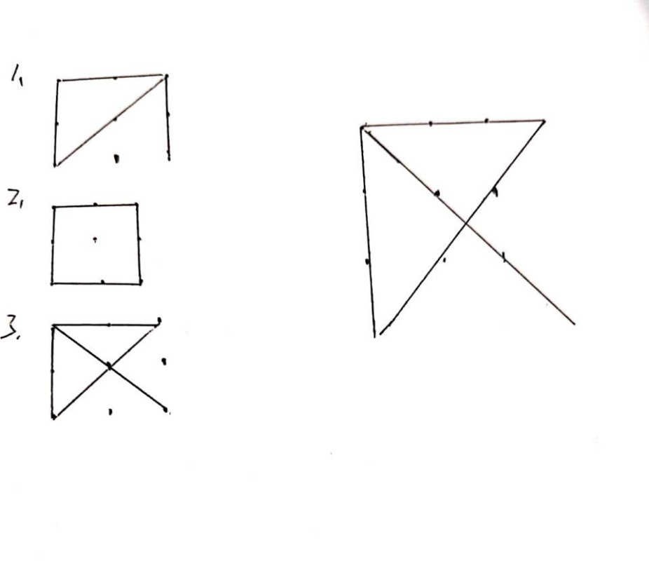

Ev 4a (Output of my professional need)
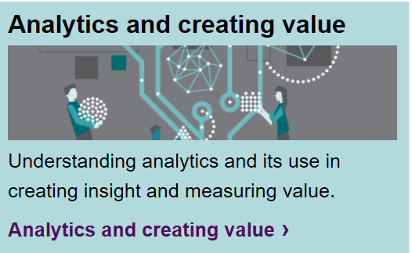
Ev 4b (Output of my professional need)
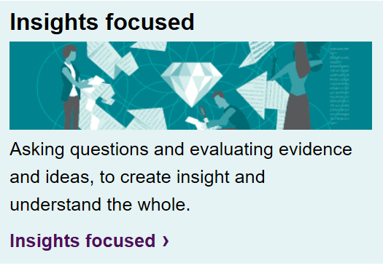
Ev 4c (Output of my professional need)
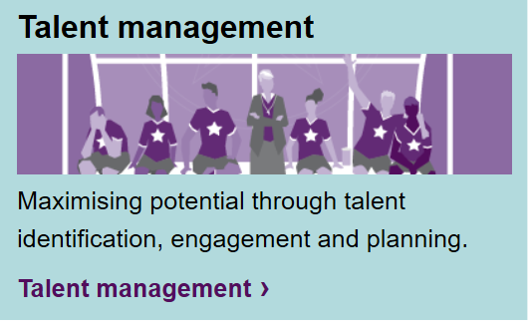
EV 4d (CIPD)
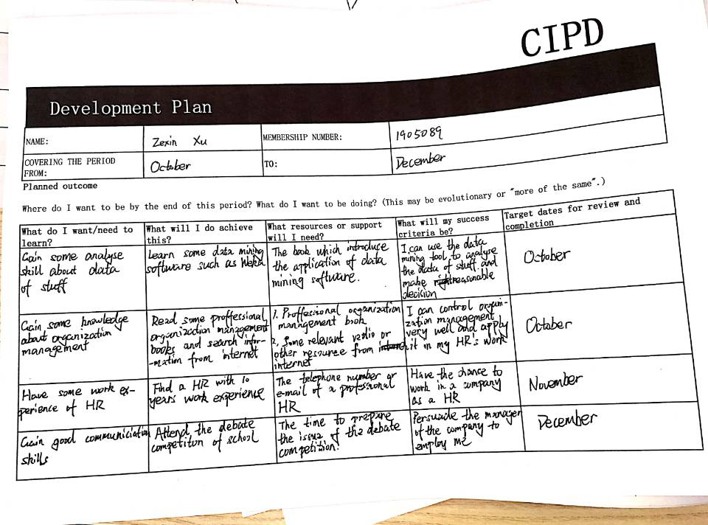

Reference
[1] Act for library (2019) ‘Factors that Influence Group Dynamics’[Online]
Available: http://www.actforlibraries.org/factors-that-influence-group-dynamics/
Accessed 2019, December, 29th
[2] Chand S. (2019) ‘Group Dynamics: it’s characteristics, stages, types and other Details | Management’[Online]
Available: http://www.yourarticlelibrary.com/management/group-dynamics-its-characteristics-stages-types-and-other-details-management/5363
Accessed 2019, December, 29th
[3] CIPD (2019) ‘The CPD cycle’[Online]
Available: https://www.cipd.co.uk/learn/cpd/cycle
Accessed 2019, December, 29th
[4] CIPD (2019) ‘HR and standards’[Online]
Available: https://www.cipd.co.uk/knowledge/strategy/hr/standards-factsheet
Accessed 2019, December, 29th
[5] CIPD (2019) ‘Profession for the future’[Online]
Available: https://peopleprofession.cipd.org/profession-map
Accessed 2019, December, 29th
[6] Chloe F. (2016)'Why your CPD reflection has to improve'[Online]
Available: https://www.the-ies.org/analysis/why-your-cpd-reflection-has
Accessed 2019, November, 29th
[7] ILM (2017) ‘The concept and importance of CPD’[Online]
Available: https://professional-futures.com/2017/07/26/concept-importance-cpd/
Accessed 2019, December, 29th
[8] Kenneth W. Thomas and Ralph H. Kilmann (2019) 'Thomas-Kilmann Conflict Mode Instrument’[Online]
Available: https://shop.themyersbriggs.com/en/tkiproducts.aspx?pc=62
Accessed 2019, December, 29th
[9] Kloosterman V. (2013)'The importance of continuing professional development'[Online]
Available: https://continuingprofessionaldevelopment.org/why-is-cpd-important/
Accessed 2019, December, 29th
[10] Kowledge centre (2019)'stage of team development (Tuckman)’ [Online]
Available: https://www.12manage.com/methods_tuckman_stages_team_development.html
Accessed 2019, December, 29th
[11] Leitch C. (2017)'10 Benefits of Teamwork in the Workplace’ [Online]
Available: https://www.careeraddict.com/5-benefits-of-teamwork-in-the-workplace
Accessed 2019, December, 29th
[12] McConnell B. (2019) ‘5 stages of the project management process’ [Online]
Available: https://www.mindjet.com/blog/2019/01/5-stages-project-management-process/
Accessed 2019, December, 29th
[13] Mind tools (2019)’ Win-Win Negotiation’ [Online]
Available: https://www.mindtools.com/CommSkll/NegotiationSkills.htm
Accessed 2019, December, 29th
[14] Nutcache (2019)'The Importance of Collaboration in the Workplace’[Online]
Available: https://www.nutcache.com/blog/the-importance-of-collaboration-in-the-workplace/
Accessed 2019, December, 29th
[15] Render J. (2019)'Tuckman’s Model – 5 Stages of Team Development and Practical Limitations’[Online]
Available: https://agile-mercurial.com/2019/04/16/tuckmans-model-5-stages-of-team-development-and-practical-limitations/
Accessed 2019, December, 29th
[16] Skillsyouneed(2017)'Persuasion and Influencing Skills’[Online]
Available: https://www.skillsyouneed.com/ips/persuasion-skills.html
Accessed 2019, December, 29th
[17] StudyMoose. (2016). Hr a Short Briefing for New Hr Colleagues to Help Them Perform Effectively and Efficiently in Their Roles.[Online].
Available at:
https://studymoose.com/hr-a-short-briefing-for-new-hr-colleagues-to-help-them-perform-effectively-and-efficiently-in-their-roles-essay
Accessed 2019, December, 29th
[18] Team Building portal (2018)'Belbin Team Roles’[Online]
Available: https://www.teambuildingportal.com/articles/systems-and-approaches/belbin-team-roles
Accessed 2019, December, 29th
[19] the free dictionary (2019) ‘professional’[Online]
Available: https://www.thefreedictionary.com/professional
Accessed 2019, December, 29th
[20] UKEssays. (2018). ‘Factors that influence individual and group dynamics’[online].
Available: https://www.ukessays.com/essays/business/factors-that-influence-individual-and-group-dynamics-business-essay.php?vref=1
Accessed 26 December 2019
[21] Wikipedia（2019）‘Group dynamics’ [Online]
Available: https://en.wikipedia.org/wiki/Group_dynamics
Accessed 2019, December, 29th
[22] Wikipedia (2019) ‘Brainstorming’[Online]
Available: https://en.wikipedia.org/wiki/Brainstorming
Accessed 2019, December, 29th
[23] Wikipedia (2019) ‘Six Thinking Hats’[Online]
Available: https://en.wikipedia.org/wiki/Six_Thinking_Hats
Accessed 2019, December, 29th
[24] Wikipedia (2019) ‘Ishikawa diagram’[Online]
Available: https://en.wikipedia.org/wiki/Ishikawa_diagram
Accessed 2019, December, 29th
[25] Wikipedia (2019) ‘Gantt chart’[Online]
Available: https://en.wikipedia.org/wiki/Gantt_chart
Accessed 2019, December, 29th
[26] Wikipedia (2019) ‘professional’ [Online]
Available: https://en.wikipedia.org/wiki/Professional
Accessed 2019, December, 29th

