This portfolio this create social marketing

This will be a study to change people's behavior into believing in yourself

Rational

Confidence

Having the ability to believe in yourself has been dwindling with young people, in gen z it has been the lowest it has ever been in years and this is backed up by shrm.org where it has been a ongoing pattern worsen by covid and negative social media having only a negative behavior and antisocial behavior causing people to not have faith in their ability to do their jobs creating job turn over at the highest it has ever been and a with under social skills cause high rate of anxiety, the way to build self esteem is by working out this helps confidence and body image there has been a rise for example within youthsense.com.au has show a shocking statistic

Optimism
Believing in the fact everything is going to be alright is a crucial fact, the ability to
Understand that things can get better is a dwindling resource due to lots of factors young people are losing hope in the future according to the pacificoaks.edu up to 42% of gen z battle with depression, this is a extreme factor because this should not be the case, in order to combat this we should start talking about the good in the world and encourage people that they can be the change and show how bright the future is this has been a problem due to how it was so hard to be optimistic during lockdown in fact using information from bma.org.uk the effects of lockdown are lack of social skills due to less human interaction and their language development has extremely suffered.

Ambition
The ambition of gen z are almost gone and contradictory for example grantthornton.co.uk has stated that over 3rd of business find it difficult to motivate gen z when comparing to previous generations but it goes further gen z have been stated to disengage with their word and lose motivation in it at least according to theforage.com in fact only 31% of gen z that they truly engage with their work while 15% of people actively disengaged with their work and while 54% are just not engage with their work furthermore young people are motivated in completely different ways, the main thing that motivates this generation is purpose this is shown in deskbird.com, purpose is the thing this generation has lacks so the main behavior change that need to implement is purpose giving yourself a mission to aspire and reach,

Positioning

How my behavior change ad will be positioned will be showing how confidence, optimism and ambition is important and how anyone can be great never give up on your dreams is crucial for person mental health, this behavior change will hopefully build a positive influence and cause people gain inner strength and avoid victim mentality

Segmentation

Demographics:
Age: my behavior change marketing will be focused on gen z which is people born between 1997 and 2012 primarily focused on people entering the work force and in higher education like university, this demographic are stressed with the workload from higher education and long work hours these people need all the motivation they can get.

Employment and Education: targeting people in high education and employed young people who are going through a massive transitioning will lack support during these moments so all the encouragement and support is needed.

Habits: people that has been introduced to positive effects of the internet such as motivational videos, self help, blogs and channels that focus on positivity is content that helps the mental health of many people and links to this is crucial for helping people with issues such as depression and anxiety.

Psychographics: people who use lots of social media and is effected by online comparison and pressure from society are suffering especially the fact that gen z biggest issue is needing a purpose a place to belong to this creates a need to be in a group

Targeting
My target market is people who use social media such as youtube, facebook, instagram and twitter/X because a large amount of young people use these platforms and the fact they overlap allows them to reach a massive market. I will be focusing on targeting people within universities and the workforce
Common needs of gen z addressed
This marketed video will be talking about how the lack of purpose within gen z has caused a massive outbreak of depression and anxiety

Positioning

The message

Absolute ambition: showing that greatness is not far anyone can become truly amazing if they work hard and have a dream

Showing a optimistic future: the future is only as bad as we make it by being believing in ourselves we can make are lives better little by little

Confidence impact: don't be afraid to make mistakes it's what you do after that matters and believing in yourself is crucial

message plan

Youtube videos
Videos can be long organized and sorted to fit social media to send a message to help as many people as possible furthermore there can be tags on the video to be marketed to those searches to spread the video more.

Market research
Video: gen z stuff happens but it is okay.

The purpose:
The video's goal is to inspire gen z in their confidence, optimism and ambition while trying to reduce depression.
The strategy:
the videos main approach is to connect with the audience being able to look at another human being and connect with that person to build a bridge with that human being to understand the message
Social media spread:
you can put youtube videos on other social media websites to spread a message further across websites like messenger, facebook and twitter/X which are known to have videos posted there which has reached a massive crowd of people.

Video length:
in order to market towards gen z the video had to be constantly moving and short to help with gen z attention span in fact they have the shortest on average to less that 8 seconds it is due to instant gratification and more according to blavityinc.com

Youtube tags:
by utilizing youtubes tags it helps youtube's algorithm to displays videos for people that it would be good for for example a person who watches lots of minecraft building videos will be support.google.com

Other videos/ channels that empowers young people

Jordan peterson

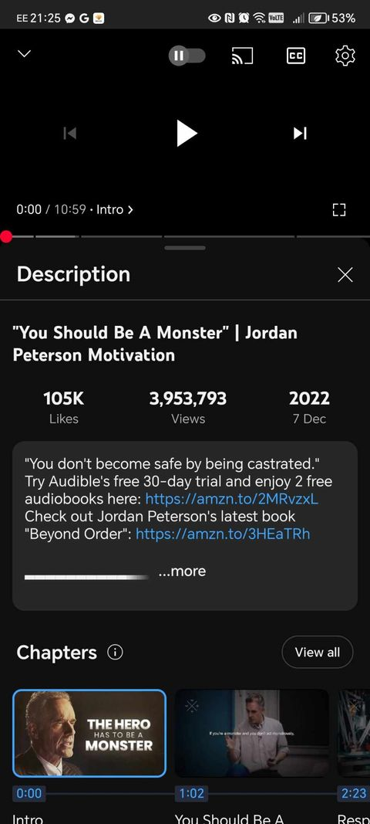
This video is about how it is how it is good to be competitive how it is good to take responsibility in order to find purpose is responsibility which is a very good thing and this is a very popular video people have watched. This video talks about how confidence stops bullying it is a fundamental necessity for survival, this video talks mostly about confidence.

David goggins

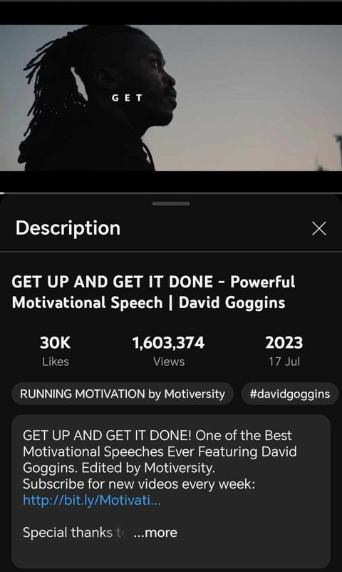

This video is about working hard never stopping how it is okay to be uncomfortable it is important to work hard how it is important to win and work hard to never quit. This video shows by giving yourself obstacles to get passed furthermore it shows accountability is suffering and when we suffer we improve and become better for example working out is not easy but the effects are rewarding with time and effort, this video is teaching people to be more ambitious and never quit.

Youtube channel psych2go

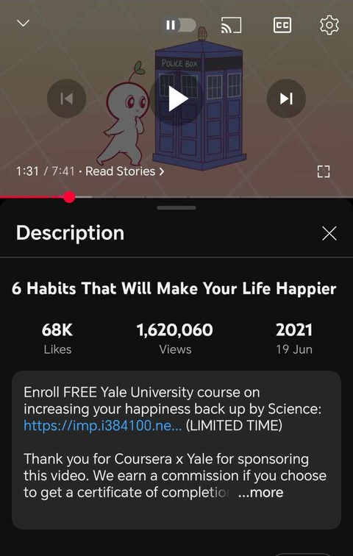

This video shows its viewers good habits to use to help with happiness with certain activities and and actions to help with issues like depression and anxiety furthermore it also shows how how values are good meaning “do what makes you happy” this is a crucial thing but it should be note things you like and things that brings you happiness are 2 different things, this video also shows how journaling can help with processing your feelings.

The video link: https://www.youtube.com/watch?v=ZSVQGIoLLS0&ab_channel=Shenaniganschannel

References

Add tags to your YouTube videos - YouTube Help. (n.d.). Support.google.com. https://support.google.com/youtube/answer/146402?hl=en

chris oldhoff. (2024, November 9). gen z stuff happens but it is okay. YouTube; Chris Oldhoff. https://www.youtube.com/watch?v=ZSVQGIoLLS0

Generation Z: “The Loneliest, Least Resilient Demographic Alive.” (2023). Shrm.org. https://www.shrm.org/topics-tools/news/inclusion-diversity/the-least-resilient-demographic-alive

GET UP AND GET IT DONE - Powerful Motivational Speech | David Goggins. (n.d.). Www.youtube.com. Retrieved July 28, 2023, from https://www.youtube.com/watch?v=Cw0hZQ8Na_Y

Kaplan, Z. (2024, February 28). “Problems” With Gen Z in the Workplace (From a Gen Zer) — And How to Fix Them. Forage. https://www.theforage.com/blog/basics/problems-gen-z-workplace

Mehlmann-Wicks, J. (2022, July 28). The impact of the pandemic on population health and health inequalities. The British Medical Association Is the Trade Union and Professional Body for Doctors in the UK. https://www.bma.org.uk/advice-and-support/covid-19/what-the-bma-is-doing/the-impact-of-the-pandemic-on-population-health-and-health-inequalities

Paulyne Sombret. (2024, August 7). What motivates Gen Z in the workplace? 11 key aspects that boost this generation. Deskbird.com. https://www.deskbird.com/blog/what-motivates-gen-z-workplace

Pilgrim, K. M. (2024, January 8). The Power of Micro-Moments: Seizing Gen Z’s Limited Attention for Maximum Impact. Blavity Inc. https://blavityinc.com/the-power-of-micro-moments-seizing-gen-zs-limited-attention-for-maximum-impact/

Psych2Go. (2021). 6 Habits That Will Make Your Life Happier. In YouTube. https://www.youtube.com/watch?v=W7_lafxj8ok

year13. (2023, February 7). Gen Z’s Body Image Problem. YouthSense. https://www.youthsense.com.au/parents/gen-zs-body-image-problem/

“You Should Be A Monster” | Jordan Peterson Motivation. (n.d.). Www.youtube.com. Retrieved December 19, 2022, from https://www.youtube.com/watch?v=-gYpCIbZjUQ

