Front Sheet
Application of Academic Tools
CANDIDATE NAME | Connor Morrison
MODULE | Academic Skills – COMPUTING, ACHA4005
FACULTY NAME | Ewa Kazimierska
DATE OF SUBMISSION | 14/11/2025

Table of Contents
Front Sheet 1
Table of Contents 2
Introduction 3
Presentation skills and Reflection 3
Communication 3
Design 4
What could be improved? 4
Self Evaluation and Progression 5
Action plans and Gnatt Charts 8
Personal Goal 8
Report action plan and Gnatt chart 9
Use of tools to enhance productivity 10
Time management and data collection 10
Tracking and calculating data 11
Depicting data as a table and graph 12
References 14

Introduction
This report aims to provide a correctly formatted report where evidence of the application of academic skills covered during this module.

Presentation skills and Reflection
When presenting the PowerPoint presentation and after getting feedback from others, it highlighted key points that worked well and what need to be improved upon. The feedback can be separated into two different categories, those being communication and design. Presentation being how the PowerPoint was being delivered to the audience and design being the PowerPoint itself.

Communication
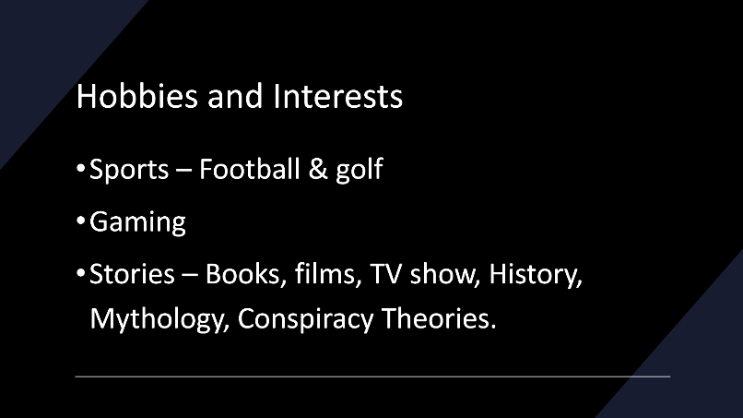
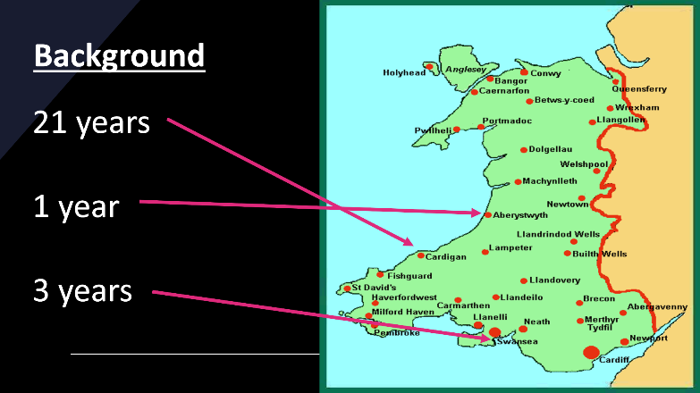
Communication is a key part of giving a presentation, one of the goals of this presentation being that it has a time of five minutes and to get it as close to this as possible. Knowing this, practice was essential before giving the presentation, as the presentation designed had 8 slides and an average of forty seconds per slide was needed as the last slide did not have any information and was merely finishing slide where thank you for listening was the purpose of it. When timing the practice presentations, it was found the speed of deliverance effected pronunciation and needed as much work as the timing did. A key part of communication being body language this was also practiced an being too static felt awkward as the speaker and closed off to practice audiences, where if too much movement was involved it became difficult to focus on remembering what to say, staying in time and pronouncing correctly and practice audiences saying it was distracting for the presentation itself.

Design
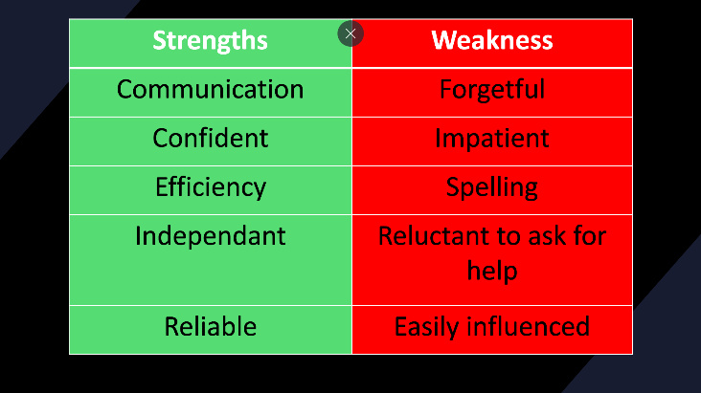
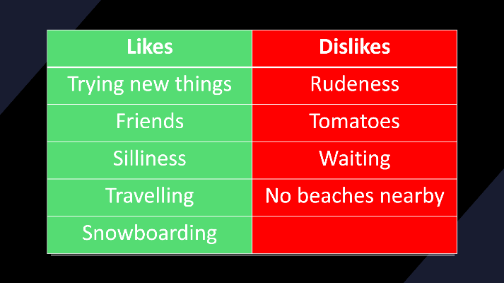
The design of the PowerPoint was simplistic, with very little written on it besides key words due to wanting to give more focus to communication and human interaction. It was felt if too much was written on the PowerPoint more time would be spent facing the audience side on or with facing the PowerPoint instead of them. This had some drawbacks however as there was more to remember when speaking and often the script would vary between practices causing the timing to go out of sync to what was intended. The colouring of the PowerPoint also turned into an issue, when the slides, likes and dislikes, strengths and weaknesses were made it was designed to have a green background for the positives and a red one for the negatives, this was giving feedback saying the words could be hard to read at parts and also that the design not being consistent due to the words being in white on one slide and black and white on the other.

What could be improved?
More thought and time could be given to the design of the PowerPoint with most feedback given being focused on that area. Over the practice done, it was learned that due to not adding much text to the PowerPoint it was sometimes difficult to remember the script prepared and that would impact the timing or the pronunciation due to going of script and muddling the words up. In future it would be good to find a better balance between the communication and design of the presentation as from the feedback given by others and personal experience it could have made the presentation overall better.

Self Evaluation and Progression
To self evaluate a few different tests were done to find out what strengths and weaknesses they would reveal, with the addition of learning style test to find out what would be best suited. The first would be the Big Five Personality Test, with results being split into five different categories, extroversion, emotional stability, agreeableness, conscientiousness and intellect/imagination.
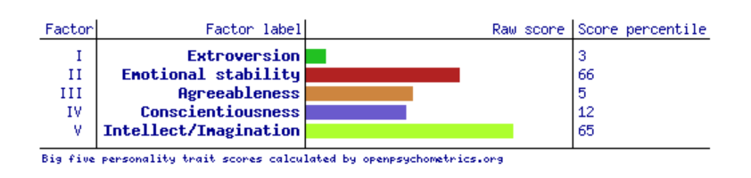
Starting with strengths, according to these results, emotional stability scoring the highest indicates emotional resilience having the ability to be more resilient to stress and adversity, being more likely to exhibit positive emotions like happiness, contentment and enthusiasm. Intellect/imagination coming in second just a single point behind emotional stability indicates being imaginative, curious, and open to new ideas and experiences. This can express itself as a preference for creativity and aesthetics. Outcomes from research that has been conducted have shown that this can lead to better mental and physical health, tending to have more stable and supportive relationships. Innovation and being more open-minded and accepting of diversity in cultures and perspectives.
Following up with weakness extroversion, agreeableness and conscientiousness all scored low, indicating from extroversion a lack of comfortability in large groups, low assertiveness and being cautious in interactions. Agreeableness shows inclination to be more competitive, skeptical and likely to express opinions forcefully even if they may conflict with others. Conscientiousness didn’t score as low as the other two weaknesses but is still closer in score to them compared with the strengths, highlighting impulsiveness and disorganization, this may cause difficulties setting and achieving goals with a higher chance to engage in behaviours not in their best interests.
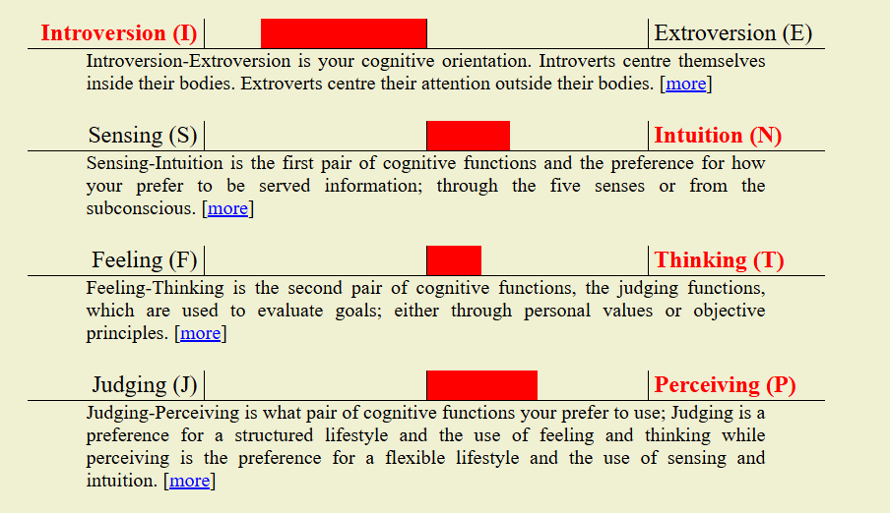
The second and third tests taken were two different Jung Personality Tests which came to the same conclusion of the personality being INTP, which stands for Introversion, Intuition, Thinking and Perceiving. After doing some research on this type of personality [1] [2] they are perceived as intellectuals and thinkers, introverts who enjoy being alone, exercising their freedom of thought and creativity in areas and interests of theirs. A weakness of this type of personality seems to be social interaction.

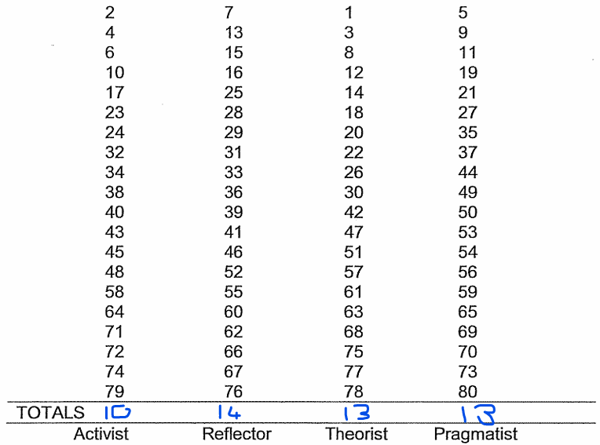
For learning styles, a Honey and Mumford Learning Style Questionnaire was filled out. The bottom row showing the scores after taking the questionnaire. With Reflector being the highest scoring, that type will be the focus, however the results do indicate a moderate preference for all the learning types. Strengths of the reflector learning type are careful, thorough and methodical, thoughtful, good at listening and assimilating information and rarely jumps to conclusions. Weaknesses of this type of learning are a tendency to hold back from direct participation, slow to make up their mind and decide, too caution and not wanting to take risks and not assertive [3].
The two areas’ weakness chosen for action plans to help improve them are being disorganized and setting and achieving goals. To do this I will be using a SMART goal, SMART goals are statements of the important results you are working to accomplish, designed in a way to foster clear and mutual understanding of what constitutes expected levels of performance and successful professional development [4].
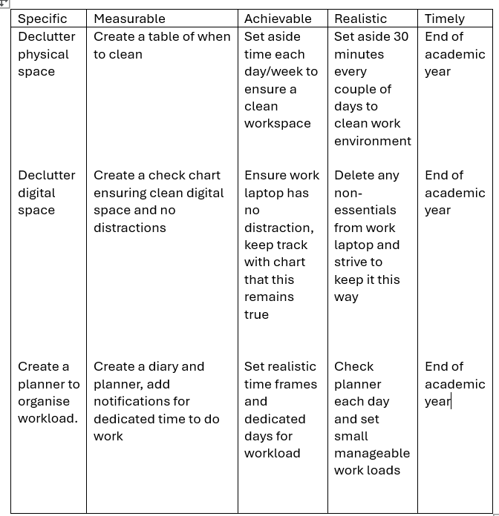
I will know whether I will be successful with my goals as I will keep a record of my actions by producing a planner within excel that will set dates and times to do the tasks decided and add in a tally to show when I have done them, this will show when the task have been completed or uncompleted along side the dates and times set giving data need to be able to track accurately and make improvements to weaknesses.

Action plans and Gnatt Charts
Two action plans and Gnatt charts have been produced, the first on a personal goal and the second on creating this report. At least ten steps were created for this along with a timeline on how to achieve these steps. Gantt charts are particularly useful for assignments, collaborative projects, or extended tasks, as they offer a clear visual representation of timelines. They provide a structured approach to managing your academic workload, helping you to stay organised and on track. [5]

Personal Goal
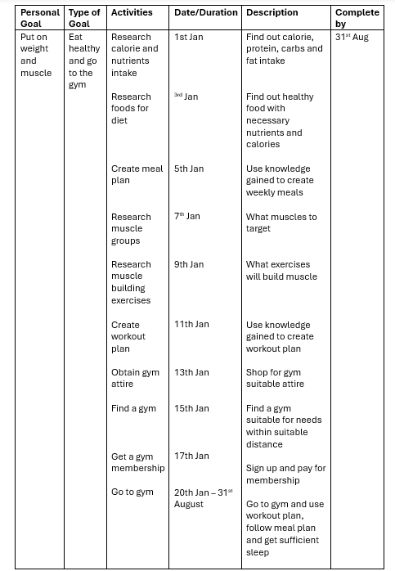
As shown, the goal is to put on weight and build muscle in a healthy way. Having no knowledge prior to creating this goal, research was needed on several aspects on how to achieve this. Starting off it was deemed the most important starting point would be how many calories and nutrients would need to be consumed to sustain healthy weight and muscle growth. For the current weight and gender of the subject as well as the exercise done weekly a calorie intake of 3157 was deemed necessary, with the main nutrients being carbohydrates, protein and fat which would need a ratio of 40%, 30% and 30%. That equates to 237 grams of protein per day working to be 947 calories, 316 grams of carbohydrates coming in at 1263 calories and 105 grams of fats which comes to 947 calories within a day.
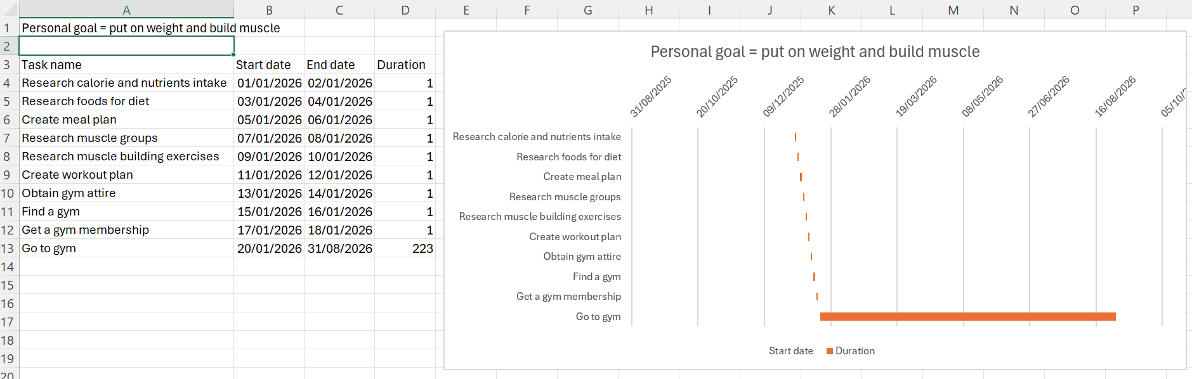
As the goal was a healthy diet, research was done on what type of foods the subject liked that would contribute to goals and good health. From there a meal plan was created using the research gathered. Next came researching different muscle groups along with correct exercises, this was necessary to make sure the goal would be achieved and to reduce the risk of injury, the knowledge gained was then created into a workout plan. Obtaining correct gym attire was deemed necessary to perform the exercise correctly and efficiently. A gym open 24/7 was found in the town’s subject to facilitate his goals and signed up with a paid monthly membership. Going to the gym and seeing progress will take many months requiring discipline and commitment.

Report action plan and Gnatt chart
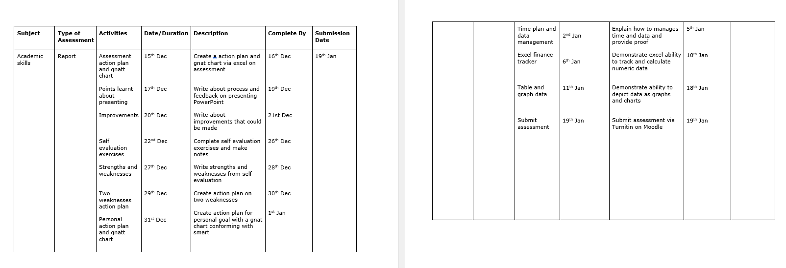
Compared to the last action plan, the one for the report ended up with more detail and a greater time needed to complete each individual task with the goal lasting weeks instead of months, due to the need for more preparation and numerous drafts to ensure quality up to standards. Breaking the task down to the requirements of the report and adding a reasonable time frame to complete each broken down activity.
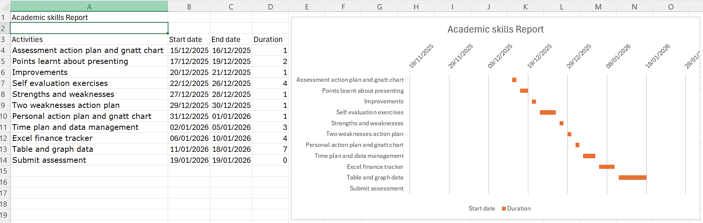
Due to some of the activities taking longer to work on the Gnatt chart reflects this as seen below.

Use of tools to enhance productivity

Time management and data collection
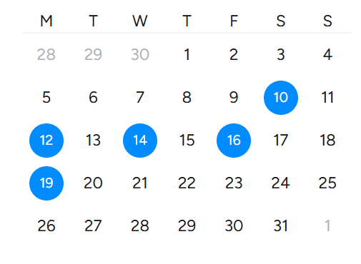
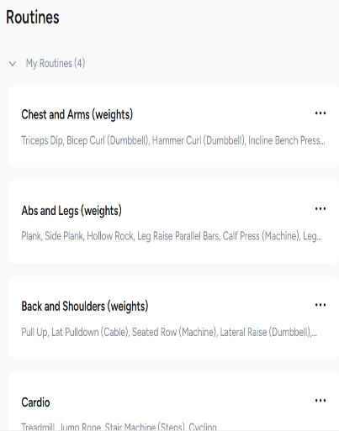
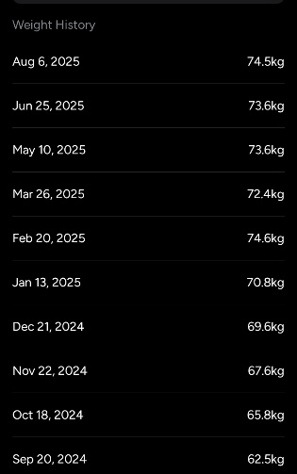
To aid in the use of time management and data collection electronic calendars and diaries are used for different aspects of personal, academic and work life. For personal life an app called Hevy is used for tracking what days the gym has been used, it also tracks data such as what exercises have been completed with the muscle groups have been worked on as well as tracking weight gained monthly, data that is very useful to help achieve personal goals that have been set.
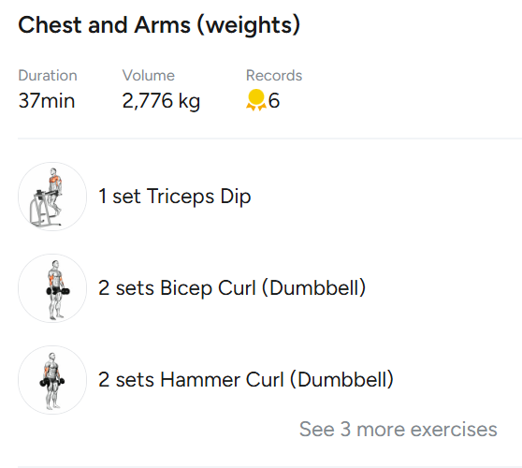
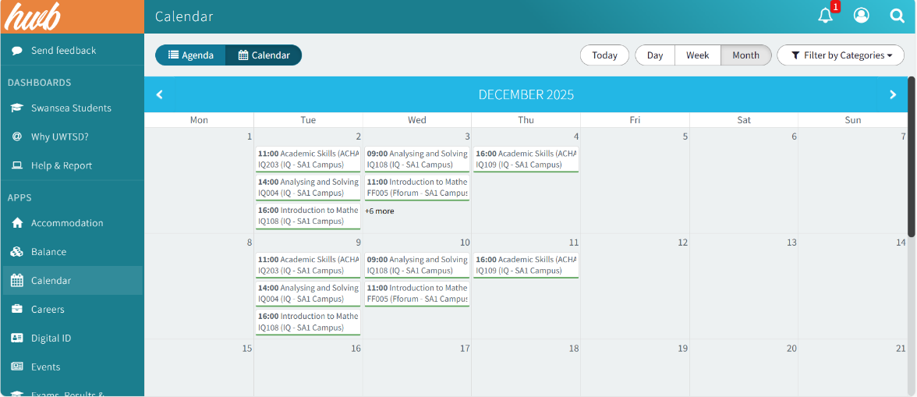
For academic life the electronic calendar on Moodle is used to keep track of when lessons are along with exams.

Tracking and calculating data
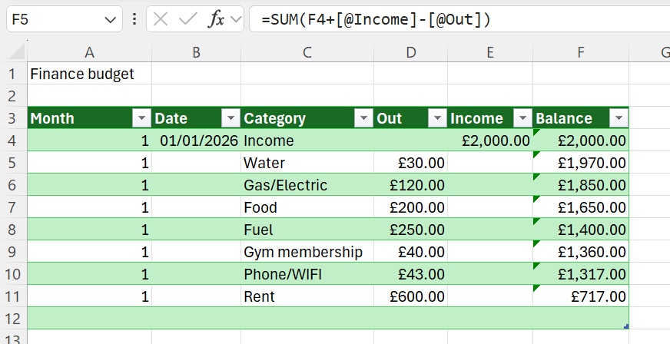
To track and calculate data, such as finances and budgeting, Excel has been chosen as the software to manage this task, with the use of tables, dates, lists and sums it allows finances to be tracked and calculated efficiently in an easy-to-read format while keeping simplicity. This was achieved using table format, data validation and sums that auto fill once more expenses or months get added, ensuring that once set up it is easy and quick to expand upon as and when is necessary.

Depicting data as a table and graph
To demonstrate and display data as a table and bar chart, data has been taken from the previous screengrab depicting weight of the subject that was being track via a personal use app to keep track of weight gain as per the personal goal. It tracks what the subject’s weight was in kg monthly, spanning the course of a year, results showing that the weight gain was not linear and fluctuates.
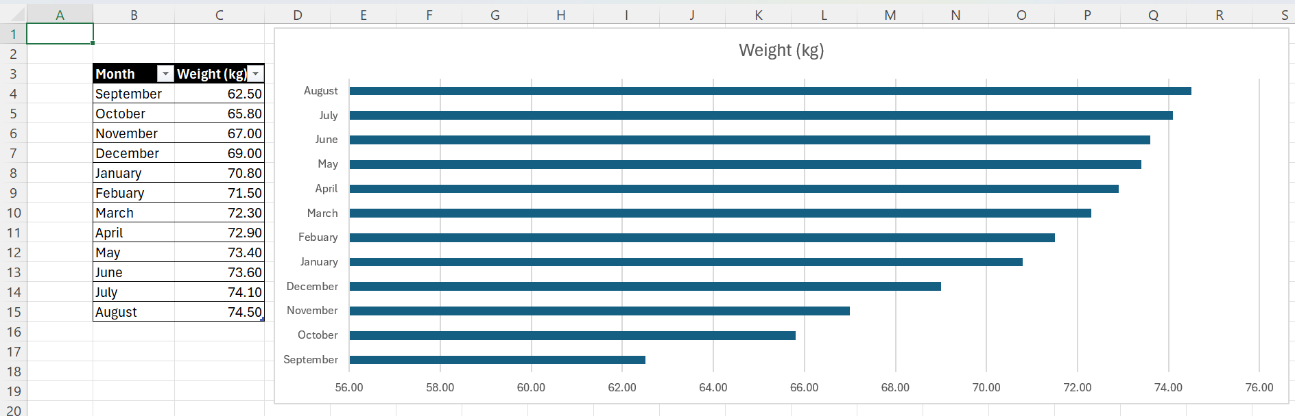
To demonstrate and display data as a table and pie chart, data has been taken from the previous screengrab depicting learning styles the subject filled in a questionnaire on. It depicts four learning styles activist, reflector, theorist and pragmatist, and the points scored in each learning style. As the pie chart displays the scores were similar or the same in one instance with activist having the smallest piece, reflector having the largest piece and theorist and pragmatist having the same size pieces.
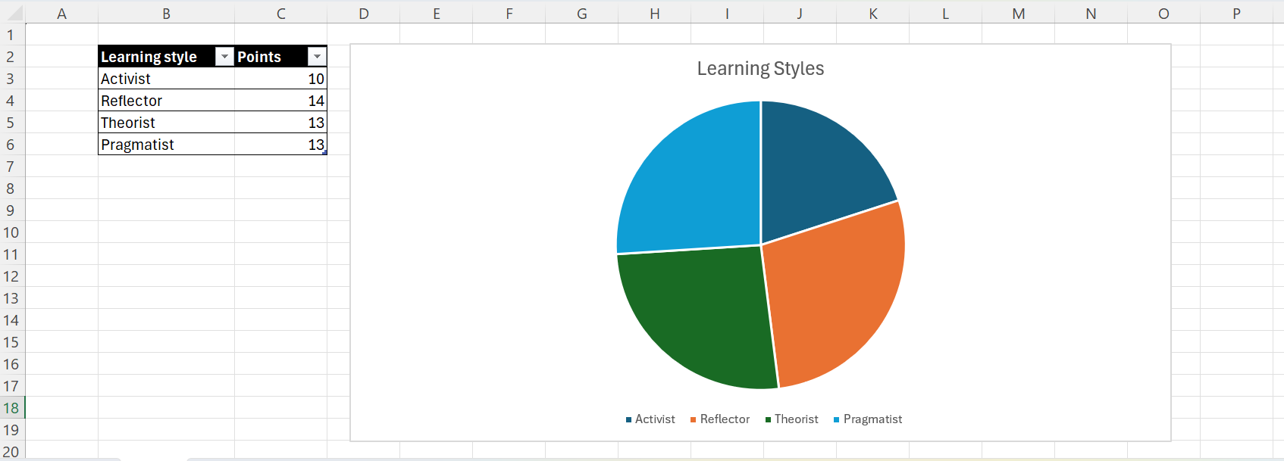

References
[1] 16Personalities, “Logician INTP Personality” 16personalities.com [Online]. Available: https://www.16personalities.com/INTP-personality [accessed 22nd December 2025]
[2] A.J.Drenth, “INTP Personality Type Profile” personalityjunkie.com [Online]. Available: https:// personalityjunkie.com/the- intp/ [accessed 22nd December 2025]
[3] Honey and Mumford 1986, “Honey and Mumford Handout” madeinheene.hee.nhs.uk [Online]. Available: https//madeinheene.hee.nhs.uk/Portals/6/Honey%20and%20Mumford%20Handout.pdf [accessed 23rd December 2025]
[4] University of California, “SMART goals: A How to Guide” ucop.edu, 2016-2017 [Online]. Available: https://www.ucop.edu/local-human-resources/_files/performance-appraisal/How+to+write+SMART+Goals+v2.pdf [accessed 23rd December 2025]
[5] University of Derby, “Gantt Charts - Self-Direction and Planning”, libguides.derby.ac.uk, 18 November 2025 [Online]. Available: https://libguides.derby.ac.uk /develop-at-derby/self-direction-and-planning/gantt-charts [accessed 2nd January 2026]

