
report on team work and communication in the workplace.
Component 2

Ashleigh Johnson 2018649
University of Wales Trinity Saint David
August 27th 2021

Executive Summary
Belbin and Tuckman will be discussed in this study, with an eye toward ABC technology determining who the leaders are within their existing teams. This is the initial component of the organization's communication problem; they have yet to appoint leaders to lead the current teams. As a result of this, the teams are lacking in motivation, which is causing them to be less productive at work. Using Tuckman's idea, the organisation can then go through each stage in order to create a successful team in the future.
Additionally the report will cover further communication models which can be used to encourage effective teamwork and communication going forward. Furthermore the report will briefly cover why effective teamwork is essential to a successful business.

Table of Contents
Executive Summary 1
Terms of Reference 3
Procedure 3
Introduction 3
Findings 4
Task one 4
Team work using Dr Meredith Belbin Theory 4
Team work using Bruce Tuckman Theory 5
Forming stage 5
Storming stage 5
Norming stage 6
Performing stage 6
Adjourning stage 6
Task Two 7
Shannon-Weaver 7
Berlo Model of communication 8
Schramms model of communication 9
Why is effective teamwork important? 9
Conclusion 10
Bibliography/References 11
Acknowledgements 12

Terms of Reference

My tutor Melanie Squire has requested the report for the evaluation of the module effective team working and communication, which was originally scheduled for June 25th, 2021, but was rescheduled for August 27th, 2021.

Procedure

The sources and resources used to compile and research this report included attending module lectures, internet sources, academic text books and journals.

Introduction
The report focuses on the case study analysis and compares various teamwork theories and communication models in relation to this specific scenario. The given organisation in the case study has been experiencing a number of issues since beginning to work from home during the pandemic, with the majority of the issues being related to a lack of communication and ineffective leadership skills. ABC Technology confirm they are facing difficulty with conflict, new software, and a lack of team motivation.
The report will discuss how teamwork theories can improve teamwork for ABC Technology, as well as the significance of two-way communication and why verbal and nonverbal communication are important for teamwork success. This report will also cover three communication models which have been researched in order to determined which model would benefit the issues ABC technology are currently facing in their workplace. Additionally this report will cover why effective team work is important within the workplace.

Findings

Task one

Team work using Dr Meredith Belbin Theory
Dr. Meredith Belbin and his research team at Henley Management College began observing teams in the 1970s with the goal of determining where and how these differences occur. They wanted to manipulate team dynamics to see if, and how, problems could be predicted and avoided. As the study progressed, it became clear that the difference between success and failure for a team was determined by factors other than intelligence. The study team began to uncover unique behavioural clusters that each comprised specific team contributions or Team Roles. A Team Role was eventually defined as “A tendency to behave, contribute and interrelate with others in a particular way.” It was discovered that different people played various team roles to varying degrees. (Belbin, 2015). Belbin (2010) advised that teams are a question of balance. What is needed is not well-balanced individuals but individuals that balance well together.
Belbin's theory can assist ABC technology in identifying the team's strengths and weaknesses and working on them in order to improve the team's overall performance. The team manager or leader must understand how the team is structured and who plays what role within the team. Using Belbin’s theory will assist in determining which team roles are missing and how the organisation can overcome team deficiencies. Belbin Team Roles theory can help teams go from one stage to the next faster by offering team members an insight into one another and the contributions needed to make the team work. (Brown, 2017)
ABC Technology must determine who plays what roles in their teams; this will determine who needs to take the lead in getting the team back to performing as they should in order to be successful. According to Belbin's theory, people-focused team roles ensure that all employees collaborate while maintaining diplomatic relationships. At the same time, they are all focused on the same objective (Lessem & Baruch, 2000). Belbin confirms there are nine major jobs, two of which could be leaders, and a ninth function that is a specialist. All of the positions are important, however some have a bigger profile than others; which ones matter the most depends a lot on the conditions of the current team - team size, job nature, team development stage, and so on. Teams can function even if some positions are lacking, but to function at their best, they need:
• a leader, a Co-ordinator to balance duties and people, or a Shaper to drive projects to completion.
• people who communicate and support others: Team Worker, Resource Investigator.
• several types of 'doers,' such as Implementer, Completer-Finisher, Monitor-Evaluator
• a 'ideas person,' such as Plant-Innovator
• and possibly an Expert-Specialist to provide depth of knowledge.
(Pete, Business coaching resource, 2009-2021)

Team work using Bruce Tuckman Theory
ABC technology can use an alternative theory to help grow a successful team and this is the Bruce Tuckman theory. Bruce Tuckman proposed four stages of group development in 1965. These stages are based on his review of intense research studies, and the most frequently cited stages are forming, storming, norming, and performing. Twelve years later in 1977,Tuckman, along with Mary Jenson added a fifth component to the theory which was adjourning (Tuckman and Jenson, 1977). Each of these stages are essential for a successful working team. Given the struggles that ABC Technology are facing in their current workplace, implementing Tuckman’s theory could help in regards to their conflict and breakdown in communication.
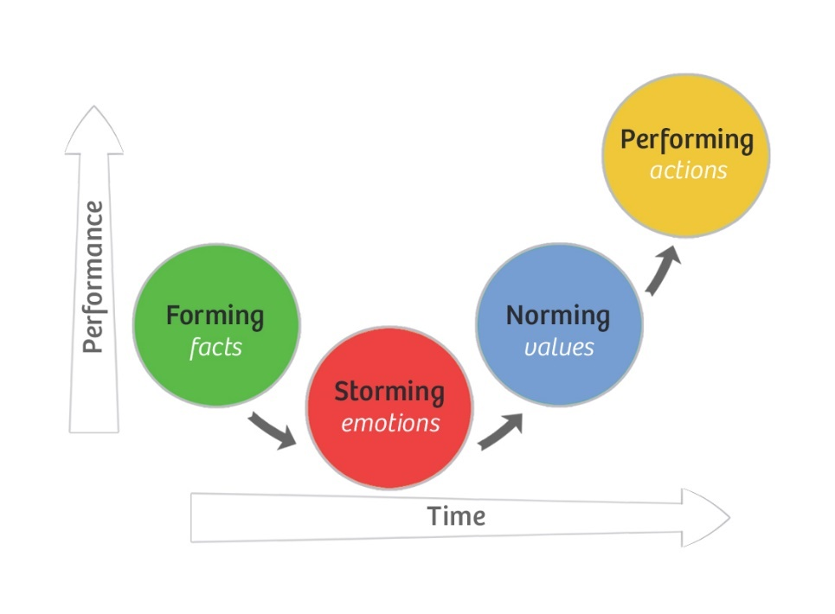

Forming stage
Every small group begins with the formation stage, in which members have high passion but limited skills for the task at hand. Team members are reliant on the team leader, who will benefit from an explaining or directing leadership style at this level (Largent, 2016)
During the formation stage, group members become acquainted with one another by observing others, learning what they know and don't know, and determining how they might fit into the group. In addition, the group begins to investigate the work that has brought them together by evaluating what will be required of them. Overall, this is a stage in which group members are generally polite to one another and are likely to avoid upsetting other members of the group, this stage is likely to be very short (Tuckman, 1965)

Storming stage
The Forming stage is quickly followed by the storming stage, during which enthusiasm reaches a all-time low, mainly due to their lack of skills. As the group realises the magnitude of the task before of them, they may feel overwhelmed and unable to fulfil it. As team members try to establish themselves within the group, there is frequently a lot of disagreement and conflict during this stage (Tuckman and Jenson, 1977). This is the current stage that ABC are suffering from. In this stage, exhibiting or facilitating leadership might be extremely beneficial. This is where ABC technology need to look into who is best suited for the leadership role within the current teams they already have.
During the storming stage, the generally positive attitudes group members held towards each other are replaced by agitation, rage, and frustration. Because most of a group's energy is spent storming, little productive work gets done at this stage. The sooner a group resolves or accepts its differences, the sooner it may move on to being a productive team.

Norming stage
After the storm, a team will enter the norming stage, where both their enthusiasm and skill levels will begin to rise. At this point, the group will begin to produce results. The group's cohesiveness and identity begin to emerge, and members begin to adopt their assigned duties. As a result, team members can be assigned tasks and expected to complete them independently, but they still require significant guidance and direction from the team’s leader to ensure the work is completed satisfactorily (Largent, 2016). Roles and relationships have now been defined, allowing people to focus on the skills that brought them into the team in the first place.

Performing stage
The group's energies may now be concentrated almost entirely on the task at hand, and this is the stage at which the group is most productive, as evidenced by high skills and passion. The group is now a well-oiled machine with all of its cogs working. Plenty of healthy conflict, the kind that does not harm the relationships' fabric. It has a lot of humour and enjoyment in it. The leader and team members have learnt to devote their all to the task at hand, and success almost seems to manifest itself. (Wilson, 2010)

Adjourning stage
The additional final stage is called adjourning. This stage is about giving a team that has completed a project a sense of finality. If the team successfully navigated the first four stages, there may be some bonding among the members as well as a sense of loss as the connections come to an end. People will also be thinking back to the beginning, noting how far they have come and assessing their overall contribution (Wilson, 2010)

Task Two

Shannon-Weaver
Communication is the transactional use of symbols, influenced, guided and understood in the context of relationships (Duck and McMahan, 2015). In 1948 Shannon and Weaver collaborated to create A Mathematical Theory of Communication, also known as the Shannon-Weaver model of communication. According to this theory, human communication is comprised of six stages, each of which is interrelated and equally important. This model was created with the goal of improving the sender-to-receiver communication. They also discover noise-related elements that alter the communication process. Initially, the model was created in order to better technical communication. Later on, it was widely used in the communication industry (communication theory, 2021)
The model deals with various concepts like Information source, transmitter, Noise, channel, message, receiver, channel, information destination, encode and decode.

Sender : The communication's originator or information source chooses the desired message.
Encoder : The transmitter which converts the message into signals
Decoder : The reception place of the signal which converts signals into message. A reverse process of encode
Receiver : The destination of the message from sender
Noise: The messages are sent from the encoder to the decoder via a channel. Messages may be distracted or influenced during this process by physical noise such as horn sounds, thunder, and crowd noise, or encoded signals may distract in the channel during the transmission process, disrupting communication flow or causing the receiver to receive the incorrect message.
This is just one of the theories that ABC technology could use to help their breakdown in communication.

Berlo Model of communication
David Berlo created the SMCR (source, message, channel, receiver) model in 1960, which broke away from linear models and depicted communication as a cyclical system in which the sender receives feedback from the receiver. Communication skills, attitudes, knowledge, social structure, and culture all influence the source and receiver. The communication's structure, content, treatment, and code are all critical components. The sensory elements of the channel, such as vision, hearing, and other senses, define it. (Kunzar and Yagar, 2020)
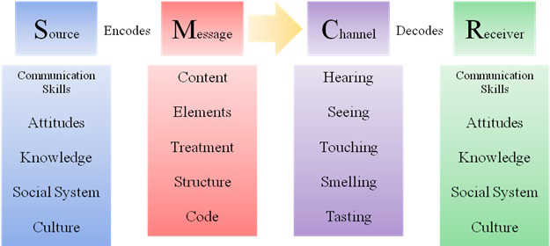

Berlo's model identifies four critical aspects of the communication process, each of which can lead to message failure. A sender may misidentify a recipient's interests, utilise the correct channel at the incorrect moment, the receiver may be more influenced by his or her background than the sender realised, or even use the wrong words to alienate or confuse the receiver. In the scenario of ABC technologies current issues I do not think Berlo’s models would be sufficient.

Schramms model of communication
A simple communication model was devised by Wilbur Schramm, a well-known communications theorist. Schramm's model, emphasises the importance of three factors in communication: the source, the message, and the destination. In an ideal world, the source encrypts a message and sends it via some channel to its destination, where it is received and decoded.
However, when considering the sociological components of communication, Schramm points out that in order for the source and the destination to understand each other, they must share something in common. When the source and destination have similar levels of experience, communication is possible. If there is no overlap or only a small area in common, communicating is difficult, if not impossible (Akinfeleye, 2010, p17)
ABC Technologies can use this communication approach in their workplace as a result of this research. This model will provide an opportunity for everyone to express their thoughts and opinions. As a result, the communication model would be good for the organization's lack of communication.
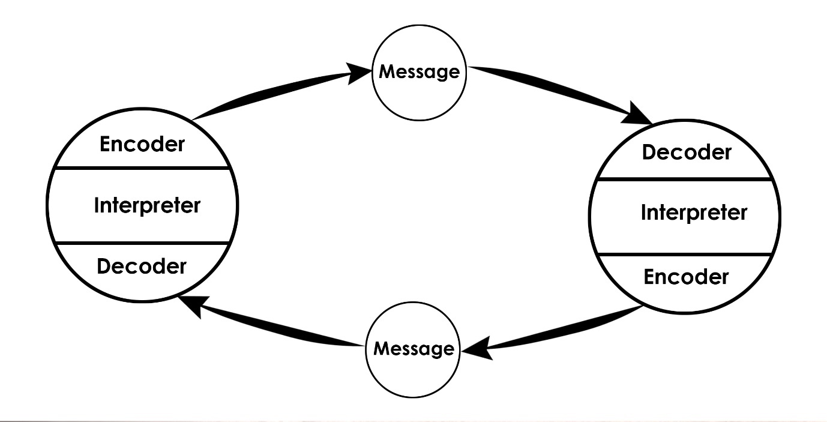

Why is effective teamwork important?
Effective teamwork is important in any organisation as when work is divided among team members, it gets done faster, allowing the business to run more efficiently. As you work toward a common objective, a team will build a sense of camaraderie. Morale rises when people work together. When team members contribute to anything that creates results, they will feel that their job is respected.

Conclusion
The main issue discovered from the case scenario of ABC technology is the breakdown and lack of communications between team members. The theory of Belbin and Tuckman are going to be essential for ABC technology to discover who in the teams play what role. By establishing this they can then decipher who the leaders need to be in order to delegate work. Following this they can then use one of the models of communication to ensure an effective communication procedure is put in place for he organisation going forward.

Bibliography/References

Akinfeleye, R. A (2010) From "One to One, to Many to Many". Mass Communication: A Book of Reading. Lagos: Department of Mass Communication, University of Lagos p.17
Belbin (2015) https://www.belbin.com/ (accessed on 25/08/2021)
Belbin, R. Meredith (2010) Management teams: why they succeed or fail. Butterworth Heinemann, 3rd edition.
Brown (2017) Supporting your team at every stage available at https://www.belbin.com/resources/blogs/belbin-and-tuckman (accessed on 17/06/2021)
Bruce W. Tuckman. 1965. Developmental Sequence in Small Groups. Psychol. Bull. 63 (1965), 384–399.
Bruce W. Tuckman and Mary Ann C. Jensen. 1977. Stages of small-group development revisited. Group Organ. Stud. 2 (1977), 419–427.
Carole Wilson (2010) Bruce Tuckman’s forming, storming, norming and performing team development model. https://www.coachingcultureatwork.com (accessed on 02/07/2021)
Communication Theory (2021) Shannon and Weaver Model of Communication https://www.communicationtheory.org/shannon-and-weaver-model-of-communication/ (accessed on 27/08/2021)
Duck, S & McMahan, D.T (2015) communication in everyday life: a survey of communication. Sage publications.
Largent, David. (2016) Measuring and Understanding Team Development by Capturing Self-assessed Enthusiasm and Skill Levels. ACM transactions on computing education. [Online] 16 (2), 1–27.
Lawrence A Kumzar and Mariah Yager (2020) The Development of Communication Models
Lessem, R., & Baruch, Y. (2000). Testing the SMT and Belbin inventories in top management teams. Leadership & Organization Development Journal, 21(2), 75–84
Pete (2009-2021) Business Coaching Belbins Team Role Theories. https://www.businesscoaching.co.uk/resources/downloads (accessed on 23/08/2021)

Acknowledgements
I would like to specifically thank my lecturer Melanie for the unlimited support! Her lectures made this module easy to understand and the additional support received when sending drafts were incredibly helpful. I would also like to thank my fellow students for their continuous support and forever remaining upbeat and encouraging.

