Student Name: Nadeie Seaied
Student ID:2212621
Module Code: LCHS7002
Module: Health Care System Organisation & Leadership
Lecturer: Dr Fahad Khan

Case Study Analysis Report: Comparative Report On COVID-19 Leadership Responses

Table of Contents
Introduction 3
An Evaluation Of The Centralised And Decentralised Approaches To The Pandemic In Each Nation 3
Spain 3
Overview of the Healthcare System 3
Centralised and Decentralised Strategies During the Pandemic 4
Advantages and Disadvantages of Spain’s Approach 4
South Korea 5
Overview of the Healthcare System 5
Centralised and Decentralised Strategies During the Pandemic 6
Advantages and Disadvantages of South Korea’s Approach 6
Canada 7
Overview of the Healthcare System 7
Centralised and Decentralised Strategies During the Pandemic 8
Advantages and Disadvantages of Canada’s Approach 9
Critical Analysis Of The Leadership Styles Taken In Each Country 10
Leadership Styles in Spain 10
Leadership Styles in South Korea 11
Leadership Styles in Canada 13
Recommendations 15
Conclusion 16
References 18

Introduction
The COVID-19 crisis, proclaimed a global health emergency by the World Health Organisation in March of 2020, revealed the strengths and weaknesses of the national health care systems and the ability of political leadership to take decisive actions in a crisis. Being confirmed in more than 770 million cases across the world, and with more than 7 million deaths reported as of 2024, the pandemic was not just a biomedical test, but an organisational and governance test run (WHO, 2024). The success of countries in terms of containing infection, protecting populations, and introducing vaccination policies differed significantly, and they were determined by systematic structures and leadership styles.
Comparisons with Spain, South Korea, and Canada are especially informative, as they are all forms of health system organisation in their own right: Spain has a tax-funded system devolved to autonomous communities, South Korea has a centralised and technologically empowered public health system, and Canada has a highly decentralised federal system. All of them had different problems with the balance of central power and regional autonomy, and their leaders used opposite approaches to communication, decision-making, and the implementation of vaccines. This report analyses the influence of health system organisation and leadership on COVID-19 responses across three of these jurisdictions, focusing specifically on centralisation and decentralisation and the leadership approaches of relevant political leaders.

Vaccine rollout delayed coordination, later improved with national guidance
Vaccine policy differing regional strategies, unified national procurement
Leadership approach cooperative but sometimes fragmented
Leadership style decisive, data-driven, clear public communication
Leadership communication inconsistent between central & regional levels
Coordination challenges varied responses across provinces
Technology use advanced contact tracing & data transparency
Regional variation different lockdown measures and timing
Federal & decentralised system provinces lead health decisions
Centralised public health system strong national control
Vaccine rollout efficient distribution & high public trust
Tax-funded health system devolved to autonomous regions
CANADA
SOUTH KOREA
SPAIN
COVID-19 CRISIS

An Evaluation Of the Centralised And Decentralised Approaches To The Pandemic In Each Nation

Spain

Overview of the Healthcare System
The National Health System (SNS) of Spain is a universal, tax-subsidised system founded in the General Health Law of 1986, and provides equal access to universal care to every citizen. Although the overall governance is shared, the central government still has the role of defining health policy, regulation, and coordination through the Ministry of Health. It monitors pharmaceutical authorisations, national health policies, and emergency preparedness, in addition to setting up funds for regional health authorities (Anderson et al., 2021). This core position was vital in the context of COVID-19, where the Ministry aimed to centralise decision-making amid extraordinary measures by the public health authorities in Spain, comprising the 17 autonomous communities.
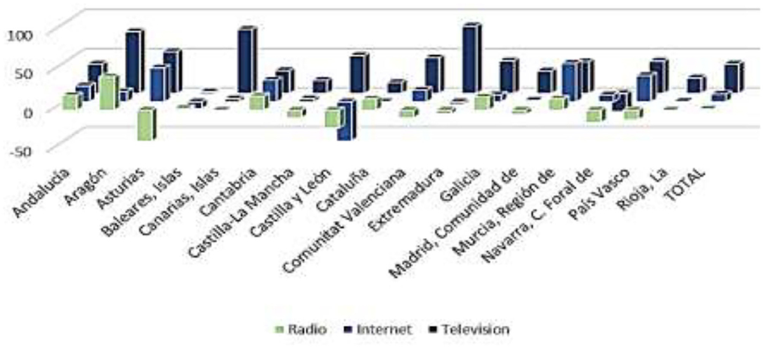
Figure 1 Spanish Healthcare Sector Management in the COVID-19 Crisis Under the Perspective of Austrian Economics and New-Institutional Economics

Centralised and Decentralised Strategies During the Pandemic
Spain went into the COVID-19 crisis with an extremely decentralised healthcare system, where its 17 autonomous communities had the power to determine service delivery and public health measures. This design first led to the disjointed reactions, as regions had different ways of testing, imposing lockdown, and distributing the resources (Jugl, 2023). An example is Madrid opposed to strict restrictions, and Catalonia added stricter restrictions, which created discrepancies undermining efforts to contain. The central government in March 2020 declared a national state of alarm due to the increasing cases, making the national authority temporarily subordinate to the Ministry of Health. It facilitated lockdowns across the globe, established standardised communication policies, and ordered necessary supplies like ventilators and PPE (Jasanoff et al., 2021).
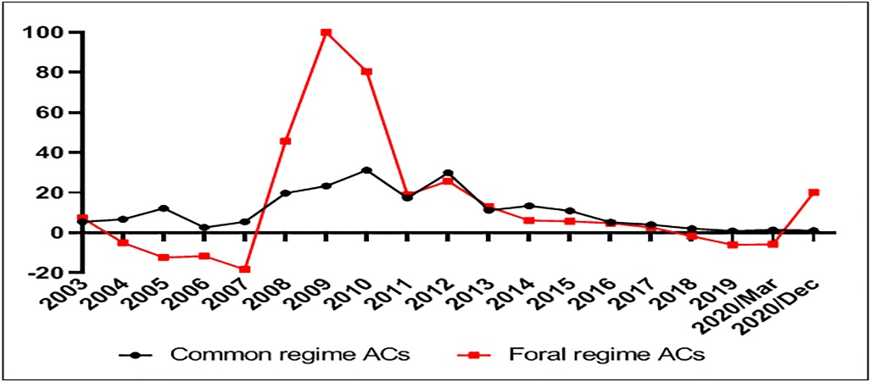
Figure 2Decentralization: A handicap in fighting the COVID-19 pandemic? The response of the regional governments in Spain
When the case numbers evened out, the responsibility was eventually shifted back to regional governments, but coordination was challenging. Nevertheless, during the vaccination campaign, centralisation resurfaced again, the government negotiated its purchase in the European Union, and evenly distributed doses across the regions. As of mid-2021, Spain has one of the highest vaccination coverage rates in Europe, with over 80% of the population fully vaccinated, which can be credited to the high level of coordination on the national level and to the trust of the population in the system (Martínez-Baz et al., 2024).

Advantages and Disadvantages of Spain’s Approach
The strategy used by Spain in handling COVID-19 showed significant positive outcomes, especially in the area of vaccination implementation, but was also affected by slow reaction and organisational disintegration. The high vaccine coverage in the country was a major strength. Spain recorded that more than 80% of its population was fully vaccinated by the end of 2021, one of the highest rates in Europe (European Centre for Disease Prevention and Control, 2022). According to Nicoli and Beetsma (2024), the success of Spain was due to a high level of trust of the population in vaccinations and the successful coordination of distribution by using the joint procurement mechanism of the European Union. The central government created equal distribution to the autonomous communities, and regional primary care networks assisted in effective distribution. This flexibility was used to show how a temporary centralisation can be used to transcend the shortcomings of a decentralised system.
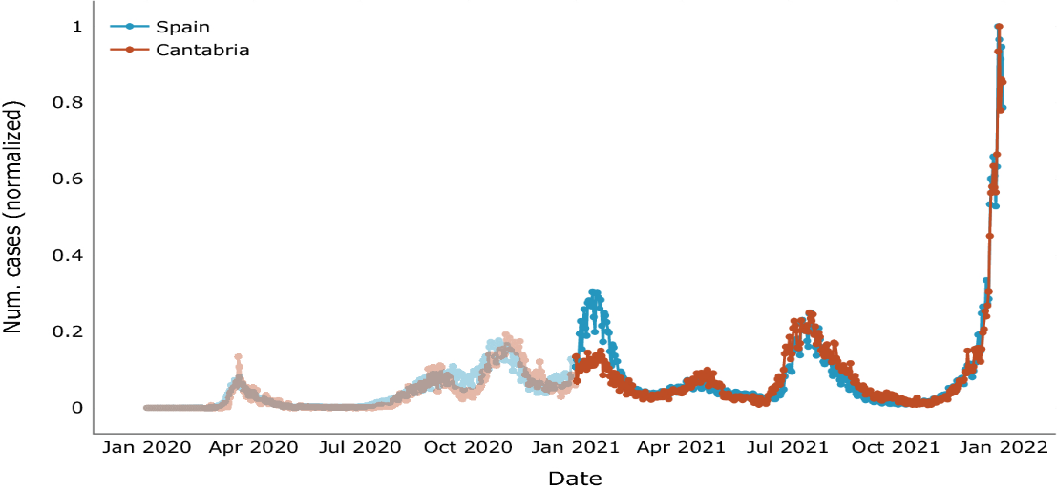
Figure 3Forecasting COVID-19 spreading through an ensemble of classical and machine learning models: Spain’s case study
Furthermore, Repullo (2024) points out that the mobilisation of the universal health system to carry out mass immunisation in Spain is the manifestation of resilience despite previous failures. Nevertheless, the early attempts of the government to minimise the threat and react slowly to it resulted in a rapid surge in cases in March 2020. Barquero and Hebbert (2022) express criticism of the absence of early coordination between the central government and regions, which helped to make Spain one of the most affected countries in Europe during the first wave. Other weakening factors of containment were regional fragmentation, where various autonomous entities imposed contrasted restrictions on movement and mass meetings. Simón (2022) also points out that the political polarisation between Madrid and the national government was another hindrance to coherent action. Hospitals, especially in Madrid and Catalonia, were overcrowded, uncovering a lack of ICU beds and ventilators.
This argument is supported by findings of Kontis (2022), who revealed that the excess mortality had a strong correlation with delays in implementing uniform restrictions. This situation in Spain, therefore, exemplifies the conflict between decentralisation that typically encourages responsiveness to local demands and centralisation, which is needed when a crisis requires a quick and consistent response. Whereas decentralisation gave the regions the opportunity to tailor measures, it postponed a unified response where speed was essential.

South Korea

Overview of the Healthcare System
The healthcare system in South Korea is a single-payer system through the National Health Insurance Service (NHIS), which covers all people in the country and is funded by mandatory contributions, government subsidies, and co-payment (Jeong, 2024). Although the delivery of services is mostly private, the government dominates the regulatory and supervisory role to make services affordable and accessible. The surveillance, response to outbreaks, as well as emergency preparedness, are centralised to the Korea Disease Control and Prevention Agency (KDCA). Tejerina et al. (2024) report that the ability of the KDCA to make decisions and integrate with the NHIS quickly established a strong framework to address the COVID-19 pandemic, with the effectiveness of the NHIS.
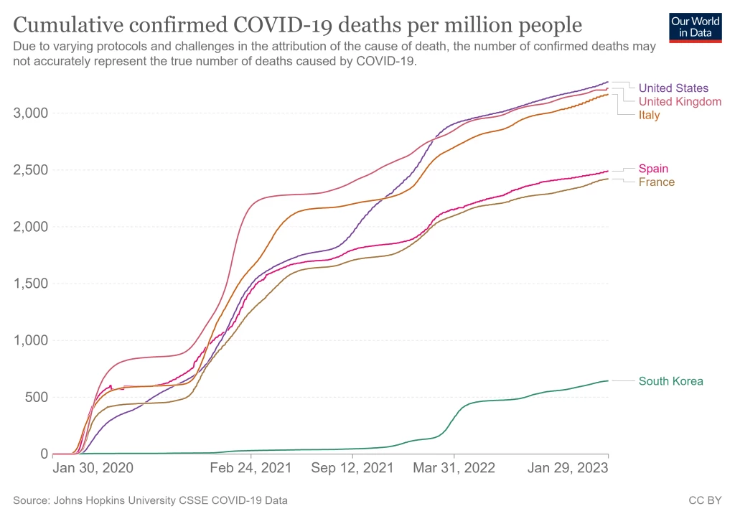

Centralised and Decentralised Strategies During the Pandemic
The COVID-19 response in South Korea was defined by a very centralised approach taken by the Korea Disease Control and Prevention Agency (KDCA) as an institution backed by the Prime Minister's Office and the Ministry of Health. Since the first instances in January 2020, the government organised national mass testing, rapid contact tracing, and isolation. The use of digital tools, such as mobile applications and credit card or GPS-centred data, became part of the tracing systems and allowed the authorities to swiftly pinpoint clusters and contact individuals who have been exposed (Yang, 2022).
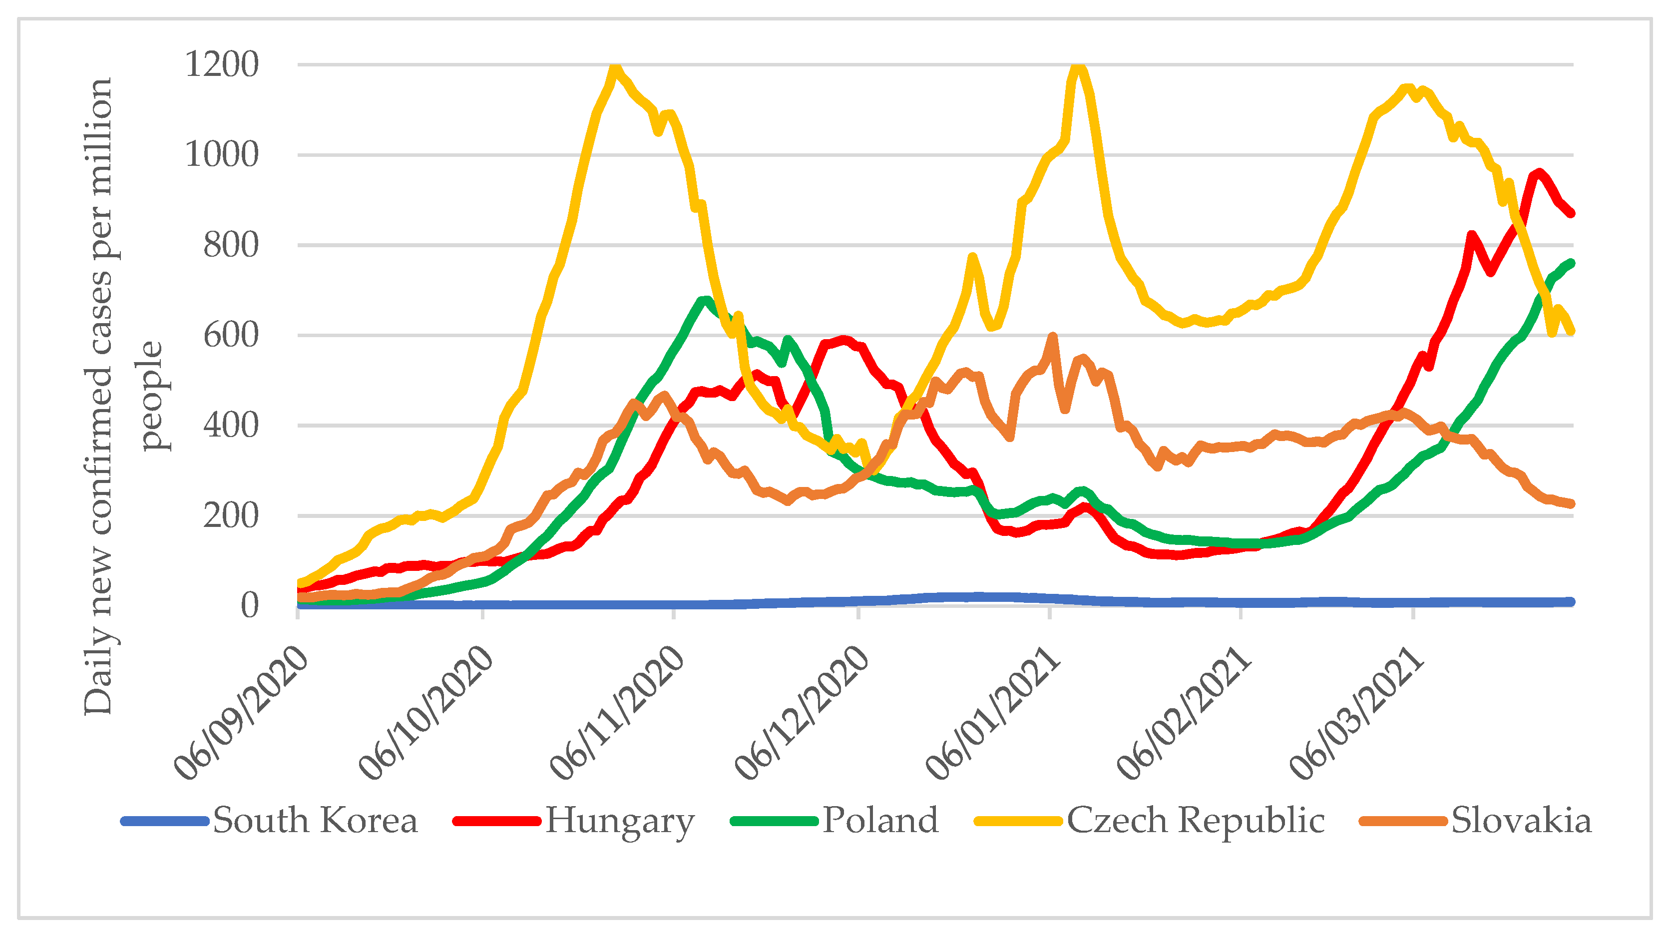
Figure 4Experiences and Lessons Learned from COVID-19 Pandemic Management in South Korea and the V4 Countries
Nonetheless, decentralisation was also reflected in the flexibility of operations that local governments had. Municipalities adjusted their testing plans and developed drive-through and walk-in testing centres, and regional governments-maintained quarantine facilities based on the local requirement (Osewe, 2021). However, Siddiqui et al. (2023) argues that the hybrid model improved efficiency because it did not have the delays of the fragmented systems but still had the ability to accommodate regional differences. The centralised nature of power alongside minimal decentralised implementation was largely attributed to the capacity of South Korea to contain the spike of infection without a countrywide lockdown.

Advantages and Disadvantages of South Korea’s Approach
The centralised approach to the COVID-19 situation in South Korea provided substantial benefits, with the most evident ones being the ability to control the outbreak on a fast scale and the high confidence among the population in the effectiveness of the state in managing the crisis. By February 2020, the government had also increased testing capacity to over 20,000 tests each day, which allowed early case detection without going into full national lockdowns (Kehinde, 2021). Another characteristic was transparency: press briefings, the open publication of infection statistics, and well-defined rules contributed to compliance, which, according to Caro (2021), is one of the most important factors in governing a pandemic. The findings were quite remarkable, as by mid-2020, South Korea registered considerably lower rates of infection and mortality than in the majority of OECD states and became an international example of dealing with pandemics (Kang et al., 2024).
Nonetheless, the very centralised and technology-based approach also created drawbacks. The use of surveillance devices became so common that technologies like GPS tracking, CCTV footage, and credit card records started attracting concerns over privacy and civil liberties. Li et al. (2022) criticise the fact that such tools proved effective in the process of tracing contacts, but they also posed a threat of normalising the state invasion of personal information. Such considerations were not so acute in decentralised frameworks such as that in Canada, which confined the extent of digital surveillance through fragmented jurisdiction at the price of slower containment (Scharf, 2025). Moreover, the use of centralised testing and tracing caused a burden on the economies and social structures. Small enterprises especially lamented losses caused by movement restrictions. The IMF (2021) reported that even without a total lockdown, South Korea suffered a 1% GDP contraction in 2020.
A comparative outlook brings out the advantages and weaknesses of the centralised model of South Korea. South Korea, in contrast to Spain, where the delay of first response was caused by decentralisation, enjoyed the advantages of quick mobilisation and coordination in KDCA leadership. However, the less intrusive surveillance in Spain did not encounter the high level of privacy concerns found in Seoul. Equally, Canada faced the challenge of disjointed vaccine implementation, but its decentralised system gave provinces the capacity to implement policies to fit local conditions, whereas uniformity in South Korea was overlooked at times. This criticism is supported by the findings of Al Khatib (2025), who states that the central model based on one size can lead to the needs of the regions and vulnerable groups. Overall, the governance of healthcare in South Korea was centralised, and strong leadership allowed effective containment and gaining the world, but issues of surveillance, civil liberties, and socio-economic effects expose the trade-offs of centralised management of the pandemic.

Canada

Overview of the Healthcare System
Canada has a universal and publicly funded healthcare system called Medicare that is mostly funded by general taxation and provided by provincial and territorial governments. The role of the federal government is that of coordination, whereby it establishes national principles in line with the Canada Health Act (1984) and offers financial transfers to create equity among the regions (Marchildon et al., 2021). Provinces have considerable freedom in the way they arrange and provide services, and this leads to differences in wait times and access. Research shows that, even though Medicare provides universal coverage of medically necessary services, there are still loopholes in such aspects as dental and vision care and prescription drug coverage (Wolownik and Cohen, 2024).
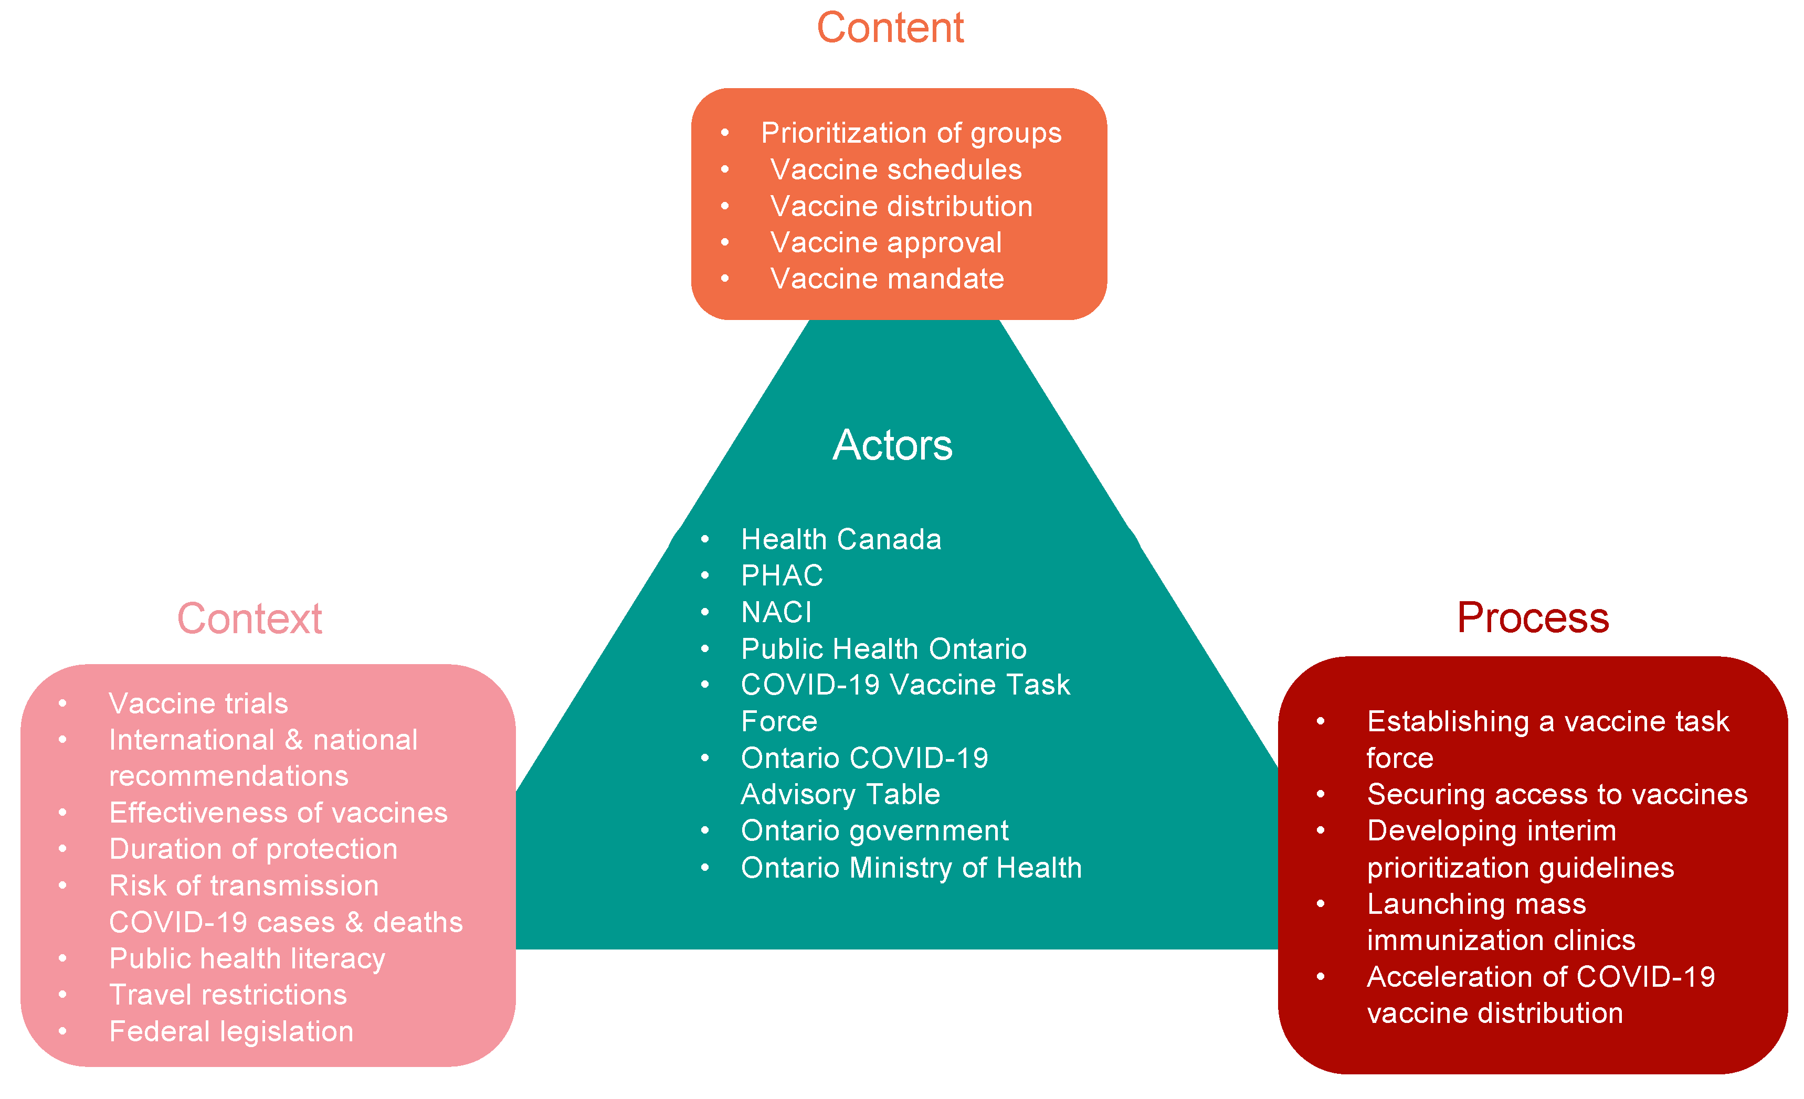
Figure 5 Understanding the COVID-19 Vaccine Policy Terrain in Ontario Canada: A Policy Analysis of the Actors, Content, Processes, and Context

Centralised and Decentralised Strategies During the Pandemic
The response of Canada to the pandemic showed its intensely decentralised healthcare governance, where the provinces and the territories were the most influential in making public health decisions, including lockdowns, mask usage, and vaccine rollout plans. This decentralisation caused a high level of regional discrepancy in the time and severity of interventions, with the long-time restrictions in Ontario in contrast to lax methods in Alberta (Creighan, 2021). The federal government also contributed to filling the complementary role, coordinating closures of international borders, mobilising emergency funding via the Canada Emergency Response Benefit (CERB), and centralising the procurement of vaccines and personal protective equipment (Brock and Hale, 2023).
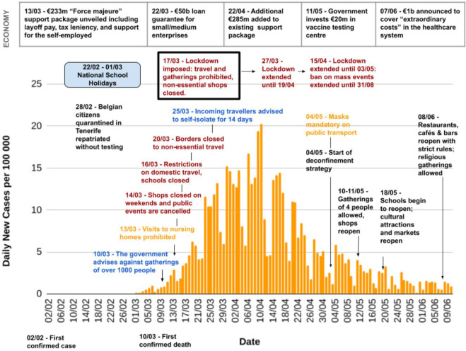
Figure 6 An analysis of the policy responses to the COVID-19 pandemic in France, Belgium, and Canada
Although this two-tiered government allowed individual provincial responses, it also revealed the problem of coordination, specifically with the allocation of vaccines and discordant communication with people. According to a study by Eidelman et al. (2022), these inconsistencies damaged the trust of the population when people in other provinces received different levels of care and had different limitations. Moreover, the absence of a national standard digital health infrastructure did not facilitate real-time sharing of data, which complicated the process of surveillance and contact tracing (Towett et al., 2023). Nonetheless, in Canada, the situation was more positive, with high vaccine coverage rates by mid-2021, in large part because of the successful procurement at the federal level, but because decentralised implementation hindered equitable rollout, especially among rural and Indigenous communities (Fitzpatrick et al., 2023).

Advantages and Disadvantages of Canada’s Approach
The decentralised healthcare governance in Canada during the COVID-19 pandemic had its benefits and costs. On the positive side, decentralisation enabled the provinces to tailor their policies to their local epidemiological and social factors. Indicatively, Quebec used more restrictive curfews because its infection rate went higher, whereas those with lower cases applied less restrictive measures (Cameron-Blake et al., 2021). The flexibility reflects the argument put forward by Afif Uddin et al. (2025) that systems can be decentralised to better meet the needs of locals rather than highly centralised nations such as South Korea, which tried to have uniform national approaches. Moreover, as per the initial delays, Canada has obtained one of the highest vaccination coverage rates in the world, with more than 83% of the qualified population being fully vaccinated towards the end of 2021 (Public Health Agency of Canada, 2021).
Efforts by the federal government to procure vaccines proved to be pivotal in the provision of a stable supply of such vaccines in the long term in case provincial rollout was delayed. Nevertheless, the implementation of the vaccines was fragmented without a coordinated national implementation plan, and the implementation was slow. As criticised by Tremblay (2023), decentralisation resulted in duplication of work, unequal eligibility standards, and varying results in different provinces, which destroyed equity. For example, Indigenous populations were much slower in getting vaccinated than urban ones, which indicates shortcomings in the federal-provincial response (Smith et al., 2023). There was also a lack of consistency in communication whereby provincial and federal leaders sent conflicting messages, which Denison (2025) claims undermined people's trust and obedience. This was in contrast with the centralised implementation approach used in the United Kingdom, in which one national vaccination plan allowed faster and more consistent implementation, although with less customisation.
The problems of the Canadian approach are also pinpointed by economic and social implications. Different provinces used different lockdown policies, which created unequal business shutdowns and job recovery (Hall and Vinodrai, 2021). By contrast, the federal nature of Germany was a mixture of regional control and tight federal control, which led to a superior initial containment due to coordinated testing and tracing (Eckersley, 2024). The poorer connections between federal and provincial digital health infrastructure in Canada hindered the sharing of data and the acceleration of the contact tracing technologies, further dividing the response capacity (Arpin et al., 2024). Thus, even though the decentralisation approach provided the region with flexibility and the eventual victory in the fight against the pandemic, the situation with the pandemic response in Canada demonstrates how disjointed governance, ineffective communication, and unequal health care can be. The results of Adams (2024) reinforce the idea that the decentralised systems in the absence of more effective coordination mechanisms might not be able to provide quick and fair responses in rapidly spreading global health emergencies.

High vaccination rates, but uneven rollout across regions (Lee et al., 2021),
Federal government handled vaccine supply & funding (Brock and Hale, 2023)
Decentralised federal system – provinces lead health measures Eidelman et al. (2022)
Decentralised system – 17 autonomous regions (Anderson et al., 2021)
Strong national coordination during vaccination (80%+ coverage) (Martínez-Baz et al., 2024)
Early fragmented response, later centralised under State of Alarm (Jasanoff et al., 2021)
Problems: poor coordination, mixed messaging, and inequality (Creighan, 2021)
Highly centralised system led by KDCA
CANADA
Drawbacks: privacy concerns and economic strain Kang et al. (2024)
Issues: slow early action, political tension, and hospital strain Simón (2022)
SOUTH KOREA
Rapid testing, tracing, and isolation using technology
Strong leadership & transparency built public trust transparency Repullo (2024)
SOUTH KOREA
COVID-19 PANDEMIC RESPONSE
CANADA

Critical Analysis Of The Leadership Styles Taken In Each Country

Leadership Styles in Spain
The experience of the Minister of Health of Spain, Salvador Illa, during the COVID-19 crisis, is an example of leadership ambivalence: initial communicative caution and apparent minuscule risk were later replaced by a subsequent, more successful vaccination mobilisation. At a time when everything seemed going well, at the beginning of the pandemic, the framing of Illa became a matter of publicity itself, as he wrote in his January 30, 2020 commentary, that “we do not minimise anything… The system is prepared…” was the expression that has been interpreted by scholars as symbolic of a situational leadership failure to keep pace with the response to a quickly escalating situation (user-supplied quote; Dubin, 2021). According to the theory of Situational Leadership, leaders are required to diagnose the task, the willingness of the followers, and transform the style very fast (Hersey and Blanchard). In Spain, several critics argue that national and regional leaders failed to go decisively when the epidemiological indicators required a directive, crisis-management stance (Bermejo-Casado, 2024).
The outcome was a late national plan in March 2020, geographical disjunction, and overwhelmed health services in Madrid and Catalonia - results that are empirically connected to increased excess mortality (Indirili et al., 2020). Therefore, scholars criticise the fact that his initial strategy was an under-use of the crisis leadership command presence and quick decision-making process that were most needed by Illa at the time. Nonetheless, since the end of 2020 and the beginning of 2021, the vaccination process in Spain became a comparative advantage: central negotiation through EU procurement, equal distribution to autonomous communities, and mobilisation of primary care networks led to high uptake (Falcon et al., 2023). This turnaround can be explained by the Transformational Leadership theory. Transformational leaders present an inspiring vision, align people, and foster change; it has been indicated that in Spain, the leadership in the health sector was effective in reframing the national priority in mass immunisation, mobilising administrative machinery, and motivating professionals to commit to their work on a regional level (NIH, 2020).
The results of Guo et al. (2025) corroborate the statement that the organisational resilience and workforce mobilisation under central guidance played a pivotal role in facilitating >80% coverage by mid-2021. In such a manner, the subsequent behaviour of Illa was based on transformational aspects of it, i.e., clear objectives, decentralisation of actions by means of regional actors, and communication campaigns that rebuilt trust in the population. Using Crisis Leadership theory, which focuses on timeliness, communication openness, and adaptive learning, presents a mixed judgment. About communication, critics (Bermejo-Casado, 2024) claim that the initial situation, which contributed to the lack of clarity in the population, was the mixed messages between the central government and the regional leaders; political polarisation indeed contributed to fragmentation and slowing down compliance. On the other hand, at the vaccination stage, the centralised purchasing and more coherent information approach enhanced transparency and uptake, demonstrating flexibility.
The results of both articles by Martínez-Baz (2024) and Repullo (2024) indicate that the effectiveness of leaders during crises is more or less path-dependent: even successful actions cannot erase previous mistakes, but can control the momentum. The direction of Illa is in stark contrast to that of South Korean and Canadian leaders. The leadership of South Korea was both a crisis and a transformational leader early on, as they were both decisive and transparent (Yang, 2022). The distributed and unifying leadership of the federal government of Canada under Trudeau was negotiating federal-provincial tensions at the cost of quick uniform action (Kang et al., 2024). The Spanish experience underscores a valuable theoretical observation: in a very decentralised health system, such as Spain, leadership during times of crisis is not just essential, but also demands the timely exercise of coordination authority and the predetermined existence of mechanisms to harmonise quickly. Thus, the leadership of Illa was a mixture of poor situational judgement in the initial stages and the emerging transformational skills, which became both disastrous in the initial stages and very successful in the latter ones.

Leadership Styles in South Korea
The pandemic leadership of South Korea led by Prime Minister Chung Sye-kyun has often been seen as an example of a quick, citizen-focused crisis management approach that combined centralised power with operational flexibility, and its approach is conveniently viewed through a lens of servant leadership -that is, leadership that aims to serve the needs of citizens, open communication, and empower frontline responders to work effectively. According to Perry World House, in its description of Chung, the leadership prioritised transparency, clarity, and respect towards the rights of citizens, which was important in keeping the society united in the face of repeating cycles of infection. At the very beginning, South Korea organised mass diagnostic potential and scaled contact tracing on a high level, which was recorded in clinical and public-health reviews and demonstrated how testing and tracing decreased onward transmission without the need to lock down the whole country.
A study of tens of thousands of contacts in the period between January and March 2020 by Jeong (2024) demonstrated the work of intensive tracing and targeted quarantine as a material constraint of the spread, which could only be effective with a decisive top-level lead and simplified the interagency collaboration. These operational achievements indicate some of the major qualities of servant leadership, namely, focusing on the common good, hearing experts in technical matters, and eliminating obstacles. Implementers and researchers have contended that these very characteristics were manifested by Chung and South Korean leaders in reality. Nevertheless, data-intensive approaches to centralisation that supported the speed of containment were largely based on retrospective applications of personal data (CCTV, credit-card trails, mobile location), which created long-term privacy issues and scholarly backlash that the model of South Korea tends to normalise invasive surveillance despite potential benefits to the population-health outcomes.
Privacy-oriented commentaries, including Kang et al. (2024), state that even though they were effective in epidemiological investigation, they questioned the proportionality, data-governance, and the civil-liberties trade-off in the long run. Additionally, the centralised nature of the focus on homogeneous strategies could at times lead to inattention to vulnerable subpopulations: certain critics observe that a national one-size-fits-all posture may not be attentive to the local inequalities or the unique needs of the marginalised groups, which is supported by studies that emphasise the importance of local adjustment to national organisation. Relative to Spain and Canada, the leadership in South Korea is comparatively instructive. The late central claim of Spain and its early regional fragmentation are both well-known (Lee et al., 2021), and researchers suggest that the early lack of action there was a manifestation of the weaknesses in crisis command and uneven message transmissions, which Chung made it clear were not the case in Spain.
Distributed federal-provincial leadership in Canada created flexibility but created coordination failures that slowed national harmonisation of actions and made it harder to share data; critics have argued that Canada's federated system needed greater central facilitation to be as fast as South Korea. In this way, the advantages of the servant-oriented, centralised leadership of Chung are apparent: speed, coherent communication with the population, as well as efficient mobilisation of testing and tracing capacity that reduced mortality during early waves. Empirical research and literature note that such a combination of decisive leadership and technical dexterity is just the reason why South Korea is reporting comparatively fewer case-fatality outcomes (as of early 2020) than many of its OECD counterparts.
However, servant leadership during a pandemic involves prioritising the immediate safety of citizens as well as protecting rights, openness regarding the use of data, and mechanisms of citizens' input; critics point out that the ease with which intrusive tools are accepted during an emergency urgently needs subsequent legal and ethical protections against mission creep. Yang (2024) advises improving the privacy-preserving architectures without refusing the epidemiological utility, and Kang et al. (2024) mention that to be successful in the long run, it is necessary to balance the centralised coordination with the local adaptability. Therefore, the leadership of Chung reflected both the benefits of servant-style, as well as the trade-offs.

Leadership Styles in Canada
The national approach to the COVID-19 pandemic under Justin Trudeau as Prime Minister of Canada should be viewed through the prism of limitations and avenues that the federal structure of the country suggests: provinces and territories maintain their dominant role in providing health care. Therefore, the role of Trudeau was not similar to the command-and-control exemplified by more centralised regimes, but the coordination, persuasion, and resource mobilisation. As others, like Marchildon et al. (2021), assert, federations need a distributed leadership model where the national units empower the subnational organisation yet maintain coherence using rhetorical framing and coordination strategies. Practices characteristic of distributed leadership also came to characterise Trudeau's praxis most visibly through his dependence on daily federal briefings, which conveyed overall plans of the nation and the principles of national solidarity, and which devolved the implementation to provincial governments. Simultaneously, these empathetic, yet reassuring briefings follow the transformational leadership theory because they aimed to inspire trust, develop solidarity, and present the national crisis as a nationwide challenge (NIH, 2020).
Trudeau's transformational leadership sparks perceptions of strengths by allowing relatively high levels of trust in federal institutions through Phase 1 of the pandemic. Public opinion polls performed throughout 2020 indicated a majority of Canadians approved of Trudeau's crisis communications, particularly with respect to his focus on inclusivity and the Canada Emergency Response Benefit (CERB) (Pettinicchio et al., 2021). The ability to mobilise trust reflects Bass's (1990) transformational leadership framework in which effective leaders create a shared vision and foster togetherness during times of uncertainty. The federal government additionally played a key role in centralising vaccine procurement for the provinces, which resulted in Canada, despite early delays, having one of the highest per capita supplies of COVID-19 vaccines worldwide (Ramsbottom, 2022). By the summer of 2021, over 70% of Canadians had received at least one vaccination dose, ranking Canada in the upper tier of global vaccination stats (Richardson & Crawford, 2022). It can be delineated; these outcomes signal a major success of Trudeau in delivering key national objectives despite being limited by the institutional constraints of his role.
Nonetheless, researchers claim that the distributed nature of Canadian leadership created fragmentation, especially in the first year of the crisis (Cameron-Blake et al., 2023). Trudeau's unifying rhetoric was regularly at odds with varying provincial approaches to lockdowns, masks, and school closures, which resulted in mixed messaging and engendered public confusion. For instance, the Prime Minister's national messages promoted "staying home," while provinces like Alberta imposed less strict rules on restrictions, raising questions about the coherence of the federal narrative (Brock and Hale, 2023). This fragmentation illustrates what Ansell et al. (2021) refer to as flawed crisis leadership in a federation, or the inability to mandate cooperative norms across jurisdictions. To draw a comparison to South Korea, Prime Minister Chung was able to exercise consistent, decisive action in a centralised servant-leader role as the basis of action, which, in the constitutional framework of Canada, Prime Minister Trudeau will find difficult to achieve.
A second significant criticism relates to the initial vaccination rollout, which was considerably slower than in peer economies like the United States and the United Kingdom. Trudeau did well to acquire vaccines but let provinces decide how to deliver them, with the result that there were inequalities of access and delays, most notably in Indigenous and rural populations (Kholina et al., 2022). Academics like Challoumis (2025) contend that it reflects a structural weakness in distributed leadership: coordination rather than direct control can lead to inequities even when there are plenty of resources. The initial mistakes of the Spanish were in procedures, and it was copied to the EU-wide procurements and centralised distribution, which in turn resulted in more successful roll-out and more vaccinations per capita than in Canada until mid-2021 (Lee et al., 2021).
Aspirational rhetoric and practise as it applies to the leadership of Prime Minister Trudeau is contradictory. His daily briefings seemed logically sound and simple, but critics would say that he risked causing more unity than unity itself in some instances only by provincial and federal interests running against each other. To exemplify only one example, the desire of the federal government to complicate the border restrictions was in contradiction with the will of the provincial governments to reopen their economies, hence creating the conflict of jurisdictions (Friedman and Trautman, 2023). This shortfall between rhetoric and action illustrates what Chatzipanagiotou and Katsarou (2023) outline in crisis leadership theory as "coordination without authority" - national leaders in federations have to make do with persuasion instead of coercion, which can be inadequate under emergencies where there has to be quick, consistent action.
Comparatively, Trudeau's leadership falls between Spain's initial inaction and subsequent centralised vaccination campaign, and South Korea's active servant leadership. In contrast to Illa in Spain, Trudeau eschewed early denial in favour of swift communication and mobilisation of federal resources to sustain trust. The opposite, however, is the case, where the decentralised system of government structure in Canada has left the nation without much space to enlist a coordinated action response at the national level and, indeed, the decentralised leadership system is inefficient in terms of high-risk contingency. It has been established that in transformative leadership a bit of unity can be achieved but the assistance must be enhanced by the organisational structures so that there is stabilisation of the governance powers between jurisdictions. In general, the Trudeau governing the COVID-19 issue revealed the advantages of the distributed and transformational leadership styles and the weaknesses of their application to the federalism system.

Recommendations
c proposal is about leadership communication. Although both Spain and Canada were initially faced with mixed or lagging messages, South Korea's focus on transparency and prompt public interaction created trust and adherence, even when strict monitoring practices were contentious. Data from comparative research indicate that citizens are more likely to follow measures when they feel openness and respect from the leaders (Badman et al., 2022). Thus, integrating crisis communication training into leadership positions, with a focus on transparency and inclusivity, would enhance future responses.
The equity-oriented plans should be incorporated within the emergency planning. The notion of inclusive planning needs to encompass structural inequalities that come along with the hardships that Canada has had to endure and undertake to ensure timely access to vaccines of the Indigenous people and those in rural settings. The possibility of Spain managing high percentages of vaccine coverage and the absence of inequalities in South Korea was in part explained by the fact that Spain used the current infrastructure of universal care and the mass scale of testing. There is no marginalisation of the marginalised communities because the accessibility of equity is incorporated in the national strategies that boost resilience and confidence in the society.

Conclusion
The authors cite the case studies of Spain, South Korea and Canada, that point to the significance of health system organisation as well as leadership on the determinants of the pandemic. On the one hand, the successful response was undermined by a decentralised structure of Spain, which gave in to the regional inequalities and the high mortality rate, but on the other hand, further centralisation of the vaccination process put on the centre-stage in Europe the country. The South Korean nation was helped by the planning and people-oriented leadership, which allowed the country to possess efficient testing, tracing, and communication which was popular on the international level. The effect of decentralisation that occurred in Canada through the federal structure was that provinces were given self-reaction apparatus but this came at the cost of failure to provide vaccines in time and uneven distribution. In all the three settings, the levels of trust, compliance, and policy greatly depended on the leadership styles. The lesson on the future pandemic in general is that the central authority is not irrelevant and the dynamic, participative, and inclusive type of leadership is engineered with the opportunity of aligning fragmented systems during crisis.

References
Adams, F., (2024). Strengthening International Cooperation to Manage Global Health Security Risks from Emerging Infectious Diseases: Experiences from Ghana During COVID-19.
Afifuddin, A., Amri, M., Latif, A., Rosmini, R., and Bin Tahir, S.Z., (2025), July. Negotiating Multicultural Values within Centralized Education Systems: A Case Study of Indonesia. In Frontiers in Education (Vol. 10, p. 1620685). Frontiers.
Al Khatib, A.M.G., (2025). Beyond linearity: a critical review of the finance–growth nexus. Cogent Economics & Finance, 13(1), p.2514690.
Anderson, M., Forman, R. and Mossialos, E., (2021). Navigating the role of the EU Health Emergency Preparedness and Response Authority (HERA) in Europe and beyond. The Lancet Regional Health–Europe, 9.
Arpin, E., Quesnel-Vallée, A., Allin, S. and Marchildon, G.P., (2024). Canada’s health care system: the promises and challenges of a federated system. In Research Handbook on Health Care Policy (pp. 393-417). Edward Elgar Publishing.
Badman, R.P., Wang, A.X., Skrodzki, M., Cho, H.C., Aguilar-Lleyda, D., Shiono, N., Yoo, S.B.M., Chiang, Y.S. and Akaishi, R., (2022). Trust in institutions, not in political leaders, determines compliance in COVID-19 prevention measures within societies across the globe. Behavioral Sciences, 12(6), p.170.
Barquero, A.V. and Hebbert, M., (2022). Spain: economy and state in transition. In Uneven development in southern Europe (pp. 284-308). Routledge.
Bermejo-Casado, R., (2024). Spain, between its waves and experts–Navigating through a complex network of advisory committees in a context of political confrontation. In Comparing the place of experts during the first waves of the COVID-19 pandemic. Stockholm University Press.
Brock, K.L. and Hale, G. eds., (2023). Managing Federalism Through Pandemic. University of Toronto Press.
Cameron-Blake, E., Breton, C., Sim, P., Tatlow, H., Hale, T., Wood, A., Smith, J., Sawatsky, J., Parsons, Z. and Tyson, K., (2021). Variation in the Canadian provincial and territorial responses to COVID-19. Blavatnik School of Government Working Paper Series, 39.
Caro, D.H., (2021). Transforming Nations After the COVID-19 Pandemic: A Humanitarian and Planetary Systems Perspective. Springer Nature.
Challoumis, C., 2025). Economocracy: Global economic governance. Economies, 13(8), p.230.
Chatzipanagiotou, P. and Katsarou, E., (2023). Crisis management, school leadership in disruptive times and the recovery of schools in the post COVID-19 era: A systematic literature review. Education Sciences, 13(2), p.118.
Creighan, K.A., (2021). Cutting the threads of patchwork policy: the impact of decentralization on pandemic containment in Nova Scotia and British Columbia.
Denison, C.S., (2025). Enhancing Misinformation Response in Local Government Communication: A Systems Inquiry with the Alberta Municipal Communicators Association (Master's thesis, Royal Roads University (Canada)).
Dubin, K.A., (2021). 19 sPain’s resPonse to covid-19. Coronavirus Politics, p.339.
Eckersley, P., (2024). Balancing cooperative federalism with local autonomy: subnational governments and governance in Germany. In Handbook on Subnational Governments and Governance (pp. 299-311). Edward Elgar Publishing.
Eidelman, G., Hachard, T., Cabaj, J., Fierlbeck, K., Loh, L., McLaren, L., Watson-Creed, G. and Rosalle, R., (2022). The Municipal Role in Public Health. Institute on Municipal Finance and Governance.
European Centre for Disease Prevention and Control (2022). COVID-19 Vaccine Tracker | European Centre for Disease Prevention and Control. [online] vaccinetracker.ecdc.europa.eu. Available at: https://vaccinetracker.ecdc.europa.eu/public/extensions/COVID-19/vaccine-tracker.html [Accessed 25 Sep. 2025].
Falcon, M., Rodríguez-Blázquez, C., Romay-Barja, M., Ayala, A., Burgos, A., De Tena-Dávila, M.J. and Forjaz, M.J., (2023). COVID-19 vaccine hesitancy in Spain and associated factors. Frontiers in Public Health, 11, p.1129079.
Fitzpatrick, T., Camillo, C.A., Hillis, S., Habbick, M., Mauer-Vakil, D., Roerig, M., Muhajarine, N. and Allin, S., (2023). Comparison of COVID-19 vaccination rollout approaches across Canada: case studies of four diverse provinces.
Friedman, K. and Trautman, L., (2023). Canada–US Border Governance during the COVID-19 Pandemic. Managing Federalism through Pandemic, pp.140-153.
Guo, B., Li, Y., Fu, Y., Li, M., Wang, Y., Liu, S., Zhou, Y., Liu, Y. and Tang, P., (2025). Strengthening workforce resilience to sustain community health services during crises: evidence from Chinese general practitioners. Frontiers in public health, 13, p.1633175.
Hall, H. and Vinodrai, T., (2021). COVID-19 and rural economic development in Canada: Insights on impacts, responses, and recovery. Journal of Rural and Community Development, 16(4).
IMF (2021). Policy Responses to COVID19. [online] International Monetary Fund. Available at: https://www.imf.org/en/Topics/imf-and-covid19/Policy-Responses-to-COVID-19 [Accessed 25 Sep. 2025].
Indirili, M., Di Maio, V., Martinelli, L. and De Pascale, F., (2021). An analysis of Italian resilience during COVID-19 pandemic: first phase from January to June 2020. Geographies of the Anthropocene. Lago, Italy. Il Sileno Edizione.
Jasanoff, S., Hilgartner, S., Hurlbut, J.B., Özgöde, O. and Rayzberg, M., (2021). Comparative Covid response: crisis, knowledge, politics. Ithaca: CompCoRe Network, Cornell University.
Jeong, H.S., (2024). National Health Insurance in Korea. The Korean Welfare State: Social Investment in an Aging Society, p.103.
Jugl, M., (2023). Administrative characteristics and timing of governments' crisis responses: A global study of early reactions to COVID‐19. Public Administration, 101(4), pp.1408-1426.
Kang, M., Choi, Y.J., Kim, Y., You, S. and Fried, C., (2024). Sustainability and Resilience in the Republic of Korea Health System.
Kehinde, L.K., (2021). Appraisal of COVID-19 Response in Nigeria: The Role of Test Data in Response Strategy (Doctoral dissertation, Central European University).
Kholina, K., Harmon, S.H. and Graham, J.E., (2022). An equitable vaccine delivery system: Lessons from the COVID-19 vaccine rollout in Canada. PLoS One, 17(12), p.e0279929.
Kontis, V., Bennett, J.E., Parks, R.M., Rashid, T., Pearson-Stuttard, J., Asaria, P., Zhou, B., Guillot, M., Mathers, C.D., Khang, Y.H. and McKee, M., (2022). Lessons learned and lessons missed: impact of the coronavirus disease 2019 (COVID-19) pandemic on all-cause mortality in 40 industrialised countries and US states prior to mass vaccination. Wellcome open research, 6, p.279.
Lee, E.Y., Song, Y.K., Hunter, S., Jeon, J., Kuzik, N., Predy, M. and Carson, V., (2021). Levels and correlates of physical activity and screen time among early years children (2–5 years): Cross‐cultural comparisons between Canadian and South Korean data. Child: Care, Health and Development, 47(3), pp.377-386.
Li, V.Q., Ma, L. and Wu, X., (2022). COVID-19, policy change, and post-pandemic data governance: a case analysis of contact tracing applications in East Asia. Policy and Society, 41(1), pp.129-142.
Marchildon, G.P., Allin, S. and Merkur, S., (2021). Health systems in transition third edition. University of Toronto Press.
Martínez-Baz, I., Trobajo-Sanmartín, C., Miqueleiz, A., Egüés, N., García Cenoz, M., Casado, I., Navascués, A., Fernández-Huerta, M., Echeverría, A., Guevara, M. and Ezpeleta, C., (2024). Hospitalisations and Deaths Averted by COVID-19 Vaccination in Navarre, Spain, 2021–2022. Vaccines, 12(1), p.58.
Nicoli, F. and Beetsma, R., (2024). Joint public procurement as a tool for European Union industrial policy (No. 18/2024). Bruegel Policy Brief.
NIH (2020). Transformational Leadership and Evidence-Based Management. [online] Nih.gov. Available at: https://www.ncbi.nlm.nih.gov/books/NBK216194/ [Accessed 25 Sep. 2025].
Osewe, P.L., (2021). Pandemic preparedness and response strategies: COVID-19 Lessons from the Republic of Korea, Thailand, and Viet Nam. Asian Development Bank.
Pettinicchio, D., Maroto, M. and Lukk, M., (2021). Perceptions of Canadian federal policy responses to COVID-19 among people with disabilities and chronic health conditions. Canadian Public Policy, 47(2), pp.231-251.
Public Health Agency of Canada (2021). Demographics: COVID-19 vaccination coverage in Canada - Canada.ca. [online] Government of Canada. Available at: https://health-infobase.canada.ca/covid-19/vaccination-coverage/ [Accessed 25 Sep. 2025].
Ramsbottom, C., (2022). Policy Coordination in a Federal State: Lessons from the Canadian Covid-19 Vaccine Implementation Experience.
Repullo, J.R., (2024). Health system resilience in Spain. In Handbook of Health System Resilience (pp. 248-261). Edward Elgar Publishing.
Scharf, S.A., (2025). Digital Regulation and Innovation in Sweden, Korea and Canada.
Siddiqui, N., Limon, G.Q., Hossain, M.S. and Mintoo, A.A., (2023). A Systematic review of ERP implementation strategies in the retail industry: integration challenges, success factors, and digital maturity models.
Simón, P., (2022). The multiple Spanish elections of April and May 2019: The impact of territorial and left-right polarisation. In The Politics of Polarisation (pp. 189-222). Routledge.
Smith, R.W., Jarvis, T., Sandhu, H.S., Pinto, A.D., O'Neill, M., Di Ruggiero, E., Pawa, J., Rosella, L. and Allin, S., (2023). Centralization and integration of public health systems: Perspectives of public health leaders on factors facilitating and impeding COVID-19 responses in three Canadian provinces. Health Policy, 127, pp.19-28.
Tejerina, L., Lee, H. and Kang, D., (2024). The Republic of Korea's Digital Tools for Fighting COVID-19.
Towett, G., Snead, R.S., Grigoryan, K. and Marczika, J., (2023). Geographical and practical challenges in the implementation of digital health passports for cross-border COVID-19 pandemic management: a narrative review and framework for solutions. Globalization and Health, 19(1), p.98.
Tremblay, P., (2023). The Devolution Dilemma.
WHO (2024). COVID-19 epidemiological update – 15 July 2024. [online] www.who.int. Available at: https://www.who.int/publications/m/item/covid-19-epidemiological-update-edition-169 [Accessed 25 Sep. 2025].
Wolownik, G. and Cohen, S.S., (2024). Dental Coverage for Medicare Beneficiaries. Policy, Politics, & Nursing Practice, 25(4), pp.205-215.
Yang, C., (2022). Digital contact tracing in the pandemic cities: Problematizing the regime of traceability in South Korea. Big data & society, 9(1), p.20539517221089294.

