

Common Law

BMPL4011

Student Name: Ionela Daniela Mirsu
Student ID:2132560

Introduction

The English legal system is a legal system, which is an amalgamation of the passing of legislation along with the creation of precedents via case law (Lacey, 2019). In this regard, the assignment will reflect upon the history of common law and civil law. Further, examples of common law working in practice will also be provided in this assignment. Additionally, some of the most vital common law principles within the English legal system will be discussed while also reflecting upon the dependency of the English legal system on the principles of common law.

Main Body

History of Common Law

As opined by Rose (2020) that common law is the legal system that is declared by the judges while driving from precedents and customs. Further, common law, also referred to as Anglo-American Law is a customary law that is dependent upon judicial decisions and is generally administered by the codes of England past the Middle Ages. Additionally, Kearns (2019) also opined in their studies that the English common law originated in the King's Court during the middle ages and for this, a single royal court was also set up for the majority of the nation near London in Westminster. However, like other legal systems, common law does not consist of any substantial rights. Additionally Anidjar, Katz and Zamir (2020) asserted that common law in the United Kingdom is generally dealing with the principle of freedom to contract, which states that the parties are free to decide their agreement terms. However, there is a single exception that the agreement needs to be lawfully possible. The British common law further includes the basis of the legal system of Northern Ireland, England, and the United States of America.

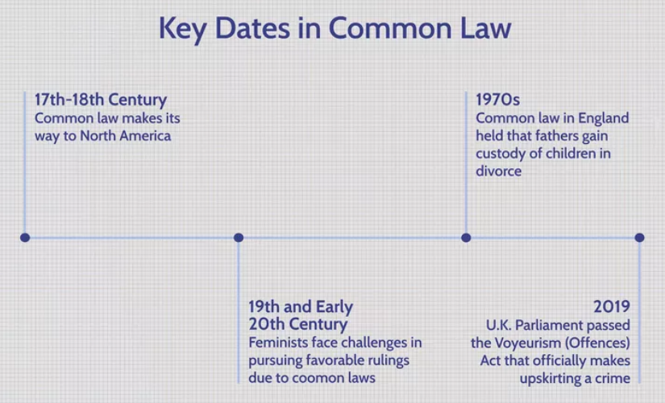
Figure 1: Important Dates in Common Law
Source: Wardhani, Noho and Natalis (2022)

Moreover, common law is generally made by judges and not by the Parliament for meeting the modern day needs while applying old principles. Purpose of common law is to ensure that their laws supersede the decisions rather than going to the legal courts. Some of the major instances of common law are the outraging public decency. Lastly, Kearns (2019) also suggested that the common law has ‘common’ in its term as it was common for all the Kings of the England courts. Common law was divided into two parts, generally common law, and interstitial common law which is required for determining and interpreting the distinctions and boundaries in English law.

Overview of Civil Law

Civil law, as suggested by Chuasanga and Victoria (2019) is a set of laws of a nation which is generally concerned with the private affairs of the people, such as property ownership or marriage rather than focusing on criminology.

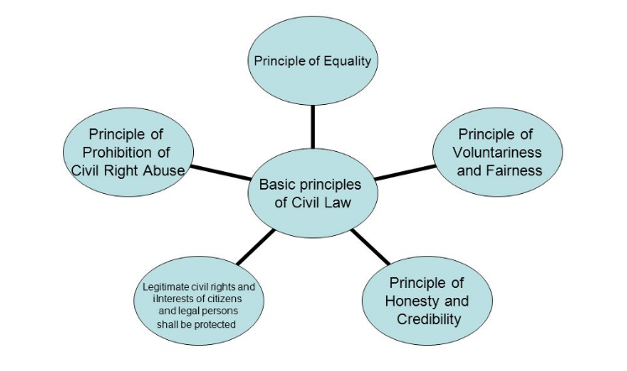
Figure 2: Principles of Civil Law
Source: Arlen and Buell, 2019

Moreover, the four most vital types of civil law deal with property, contracts, and civil wrongs, such as physical injury, and family relations. Additionally, Arlen and Buell (2019) opined in one of their studies that the most common principles of civil law or fairness, compensation, recall, value, credibility, voluntariness, and honesty. Similarly, it has also been observed that civil law defines the responsibilities and rights of the government entities, individuals, and non-government organizations with respect to their interactions with each other. Moreover, a thing to note is that a breach of civil law right does not lead to criminal sanctions or processes. Lastly, Tang (2020) opined that the cases of civil law often tend to establish whether the accused person or an organization is having a duty of care towards the claimant. For instance, if an employee at work has been injured, then this must be proved by a personal injury solicitor that the employer has breached the duty of care with respect to civil law.

Common Law Working in Practice

Common law working in practice has always formed the basis for new legislation that needs to be written. An example of common law working in practice is that the United Kingdom has had a common-law offender for outraging public democracy (Koto and Hanifah, 2021). However, in the last decade, the legal authorities have utilized traditional common law policies and practices to introduce a new activity known as upskirting which is a common law working practice of sticking a camera in between the legs of an individual without their knowledge or consent in order to take a video or a photo of their private parts for humiliating them or for the purpose of sexual gratification.

In this regard, a Voyeurism Act was passed by the UK Parliament in 2019 for making upskirting a major crime with respect to common law. Moreover, anyone found involved in this criminal activity could be punishable by up to 2 years in prison, and there is also a possibility of placing the name of the convicted person on the register of sexual offenders (Chouaibi, Chouaibi and Rossi, 2022). Additionally, another working practice in terms of common law is the common law on divorce in England provided the custody of the child to its father till the 1970s.

Dependency of English Legal System on Common Law Principles

The English legal system is based upon the principles of common law which were established by the judges of the legal court. Moreover, currently, the English legal system takes into consideration the common laws that are applicable across the whole of Northern Ireland and Britain. However, there can be differentiations such as in property law which determines more of civil law as juxtaposed to the English law (Smith, 2020). Furthermore, the English legal system is dependent on common law inheritance, which is one of the most distinctive features of the English legal system. This is because this feature is majorly linked with English law within western Europe imbibing the common law traditions. On the contrary, the development of the common law within Great Britain and England evolved after the adoption of the Norman conquest where the English legal system. The English legal system is reliable on the common law because judges were selected by the king for traveling the nation while resolving arguments and were also assisted by a jury that was introduced by the Normans into the Royal courts of Great Britain and Ireland (Partington, 2021). Moreover, the common law within the English Legal System is characterized by an adversarial system. There is always a contest between the two parties before a judge. Moreover, within the English legal system in common law, the judge determines the appropriate sentence based on the verdict of the jury. Therefore, Smith (2020) told that it can be stated that one of the most common advantages of the English legal system and its dependency upon common law is that common law places major emphasis on precedent while permitting interpretation for freedom. law, the English legal system can be adapted to different situations that have not ever been compared and contemplated in the legislature of the Britishers and other people belonging to Ireland.

Conversely, with respect to their legal system and common law, the judges tend to present the precedents whichever is applicable to the case, while influencing the criteria that the jury is generally utilized for interpreting and determining the cause of the case. However, Partington (2021) suggested that the traditions of the historical common law have always led to an unfair marginalization of different groups of individuals. Therefore, the system of common law and the dependency of the English legal system on it makes it difficult for the marginalized parties to have efficient rulings while interpreting the common law. Additionally, the English legal system is so dependent upon common law because the common law system generally promotes one cistern see instability within the judicial system in the United Kingdom while also providing the lower courts with the opportunity to select to deviate or modify from the precedent. In case they become obsolete and outdated and if the present case is different from the precedent case. Furthermore, Koto and Hanifah (2021) with respect to the English legal system in the common law stated that the lower courts can also select to overturn the prevention but that occurs very rarely in terms of the dependence on the English legal system. Lastly, another vital reason why the English legal system is more dependent upon common law is that this legal system is less prospective as compared to other law systems such as civil. Moreover, there are only a few provisions that are applicable to a contract under the common law system which makes it easier for the parties to set out all the terms and conditions related to the contract. Therefore, it can be suggested that the dependence on the English legal system is proficient in terms of the British common law.

Conclusion

In summation, it can be concluded that common law is highly important in the English legal system as it tends to produce eminent results while applying the traditional definitive requirements for modern day problems. Further, it is also observed that common law also clarified the issues while implementing legislation.

References
Anidjar, L.Y., Katz, O. and Zamir, E., 2020. Enforced Performance in Common Law Versus Civil Law Systems: An Empirical Study of a Legal Transformation. The American Journal of Comparative Law, 68(1), pp.1-54. Available at:https://academic.oup.com/ajcl/article-abstract/68/1/1/5898818 [Accessed on 23 February 2023]
Arlen, J. and Buell, S.W., 2019. The law of corporate investigations and the global expansion of corporate criminal enforcement. S. cal. l. Rev., 93, p.697. Available at: https://heinonline.org/hol-cgi-bin/get_pdf.cgi?handle=hein.journals/scal93&section=25 [Accessed on 23 February 2023]
Chouaibi, S., Chouaibi, J. and Rossi, M., 2022. ESG and corporate financial performance: The mediating role of green innovation: UK common law versus Germany civil law. EuroMed Journal of Business, 17(1), pp.46-71. Available at: https://www.emerald.com/insight/content/doi/10.1108/EMJB-09-2020-0101/full/html [Accessed on 23 February 2023]
Chuasanga, A. and Victoria, O.A., 2019. Legal Principles Under Criminal Law in Indonesia Dan Thailand. Jurnal Daulat Hukum, 2(1), pp.131-138. Available at: http://jurnal.unissula.ac.id/index.php/RH/article/view/4218 [Accessed on 23 February 2023]
Kearns, D.R., 2019. Common Law Judicial Office, Sovereignty, and the Church of England in Restoration England, 1660-1688 (Doctoral dissertation). Available at: https://ses.library.usyd.edu.au/handle/2123/21468 [Accessed on 23 February 2023]
Koto, I. and Hanifah, I., 2021. The Legal Protection for Female Workers in the Perspective of Islamic Law and Law No. 11 Year 2020 on Job Creation. Randwick International of Social Science Journal, 2(4), pp.524-534. Available at: http://randwickresearch.com/index.php/rissj/article/view/333 [Accessed on 23 February 2023]
Lacey, N., 2019. Populism and the Rule of Law. Annual Review of Law and Social Science, 15, pp.79-96. Available at: https://www.annualreviews.org/doi/abs/10.1146/annurev-lawsocsci-101518-042919 [Accessed on 23 February 2023]
Partington, M., 2021. Introduction to the English legal system. Oxford University Press. Available at: https://books.google.com/books?hl=en&lr=&id=o-krEAAAQBAJ&oi=fnd&pg=PP1&dq=Dependency+of++English+Legal+System+on+Common+Law+Principles++&ots=va3jsz1A9O&sig=SagiTj7jFTzLT13ECRaCNbgMEcE [Accessed on 23 February 2023]
Rose, J., 2020. A Godly Law? Bulstrode Whitelocke, Puritanism and the Common Law in Seventeenth-Century England. Studies in Church History, 56, pp.273-287. Available at: https://www.cambridge.org/core/journals/studies-in-church-history/article/godly-law-bulstrode-whitelocke-puritanism-and-the-common-law-in-seventeenthcentury-england/423DF9A739ED60F362F210907CAE316A [Accessed on 23 February 2023]
Smith, H.E., 2020. Equity as Meta-Law. Yale LJ, 130, p.1050. Available at: https://heinonline.org/hol-cgi-bin/get_pdf.cgi?handle=hein.journals/ylr130&section=23 [Accessed on 23 February 2023]
Tang, K.H.D., 2020. A comparative overview of the primary Southeast Asian safety and health laws. International Journal of Workplace Health Management, 13(6), pp.601-632. Available at: https://www.emerald.com/insight/content/doi/10.1108/IJWHM-10-2019-0132/full/html [Accessed on 23 February 2023]
Wardhani, L.T.A.L., Noho, M.D.H. and Natalis, A., 2022. The adoption of various legal systems in Indonesia: an effort to initiate the prismatic Mixed Legal Systems. Cogent Social Sciences, 8(1), p.2104710. Available at: https://www.tandfonline.com/doi/abs/10.1080/23311886.2022.2104710 [Accessed on 23 February 2023]

