Assignment 01

Learning in Digital Era

Essential Skills

Link to my E-portfolio
Go to this Sway

Name: Luck Peiris - 2216058
Date : 03/10/2022

Task 01

Essential skills for study and employment

- Critical Thinking Skills
Practically every career calls for the capacity for critical thought. The ability to assess data in any format, refute assumptions, testable theories, observe, and draw conclusions is required of all workers. Critical thinking is not only a skill, but it may also develop into a habit that aids in problem-solving. [1], [2]

By taking part in social activities learning, learners will begin to apply critical thinking techniques to their work. The options for student engagement are numerous.Through cooperative educational opportunities, internships, practicums, laboratories, and field experiences, active learning places students in situations that are similar to those they will face in the workplace. [2]

- Oral & Written Communication Skills
Today's modern age makes it possible to send a short text to friends or family without using good grammar, which might impair your ability to communicate in writing or verbally.
Systems and mobile is one area that might use better but is potentially simple to fix. The more straightforward a message is, the more likely it is that it will be correctly comprehended. Keep your message succinct, specific, and unambiguous. [3]

Engaging your audience is another way to enhance oral communication. You may more effectively express your thoughts and notions as well as hear fresh ideas, queries, or other information by not just talking but also by starting a discussion. [4]

- Leadership Skills
Despite the reality that 68.6% of companies look for graduates having good leadership abilities, the organisations feel that only 33% of workers demonstrate leadership qualities. You must first identify your preferred leadership style. You may start to build your leadership style around those attributes once you've determined your leadership strengths and standards of excellence. [5]

Reference:

[1] M. Campbell, “Top 5 Skills Employers Look For | Nth Degree,” Newmanu.edu, 2018. https://newmanu.edu/top-5-skills-employers-look-for (accessed Oct. 3, 2022).

‌[2] “6 important critical thinking skills you should master,” www.betterup.com. https://www.betterup.com/blog/critical-thinking-skills (accessed Oct. 6, 2022).

[3] “How to Demonstrate Oral and Written Communication on Your Resume,” Chegg Internships. https://www.internships.com/career-advice/search/communication-skills (accessed Oct. 9, 2022).

[4] Study.com, 2022. Oral vs. Written Communication Skills | Overview, Purpose & Differences - Video & Lesson Transcript | Study.com (accessed Oct. 13, 2022).

[5] “Important Leadership Skills for Workplace Success,” The Balance. https://www.thebalancemoney.com/top-leadership-skills-2063782 (accessed Oct. 15, 2022).

Similarity Score check

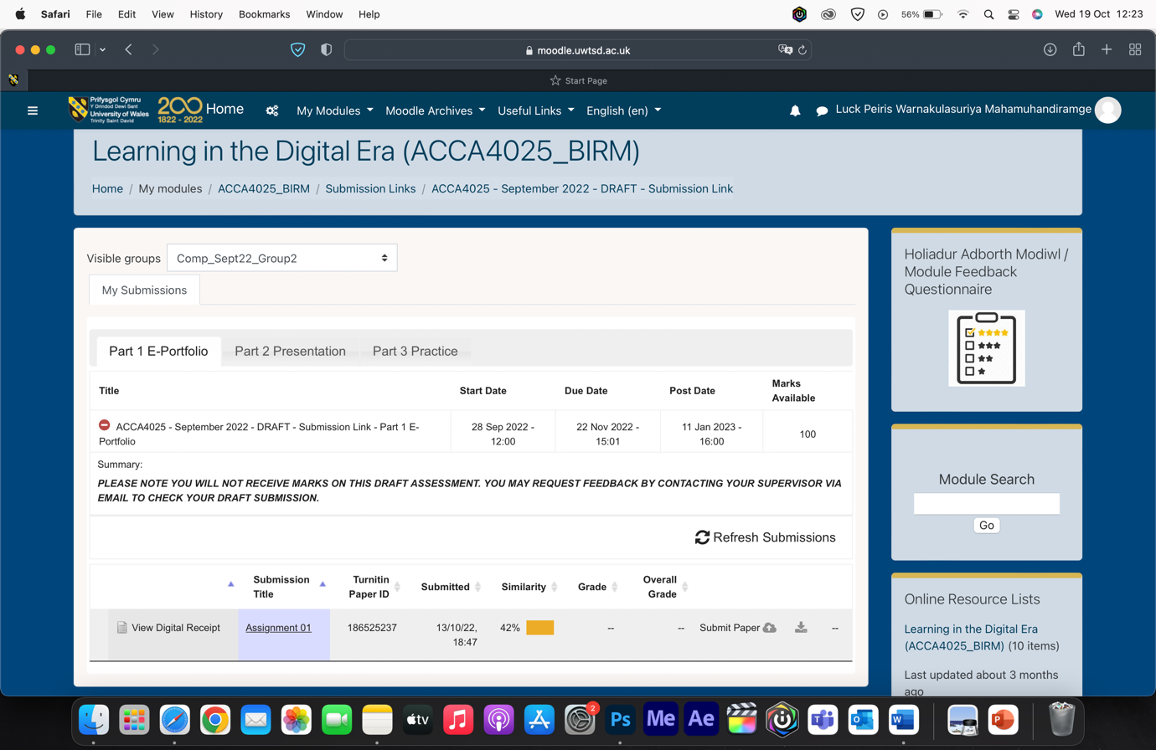

As seen in this screenshot my similarity score is 42 percent which is higher than 30 percent. I would make adjustment to improve my similarity score to get under 30 percent. This 42 percent similarity score is high because I have copied original content from the resources, in future I will get information from resources and write my own content so the similarity score would be less to score and will include my opinions as well so I can create some unique essays and summaries. And I will always try to maintain a low percent of similarity score under 30 percent.

Using the General Assessment Criteria as a guide I will give 65% out 100% which I think is very fair and equitable.

Task 02
E-portfolio
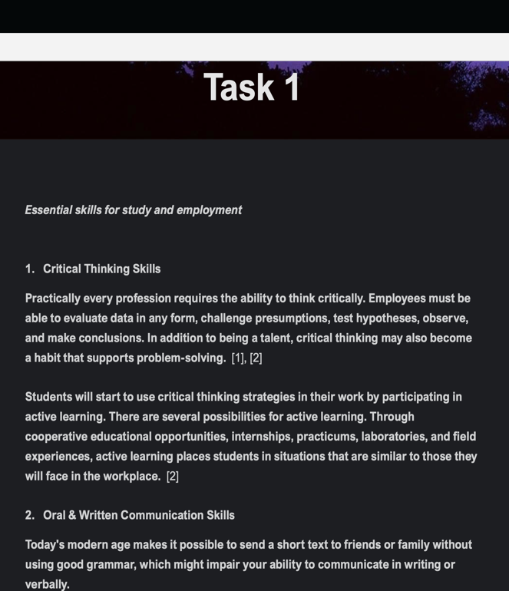
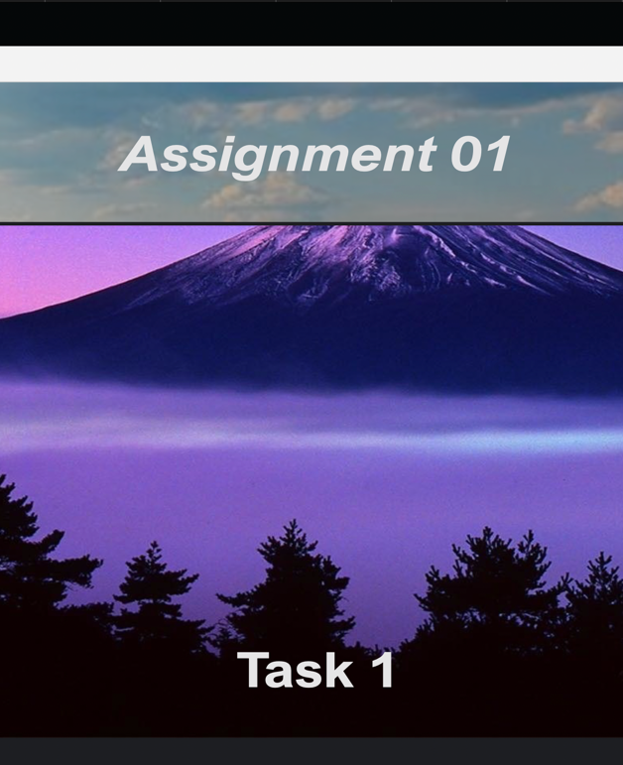

Link to my E-portfolio
Go to this Sway

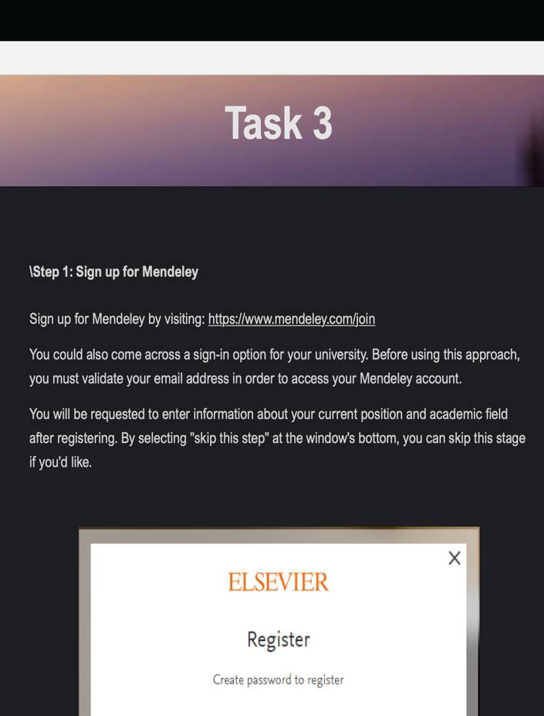
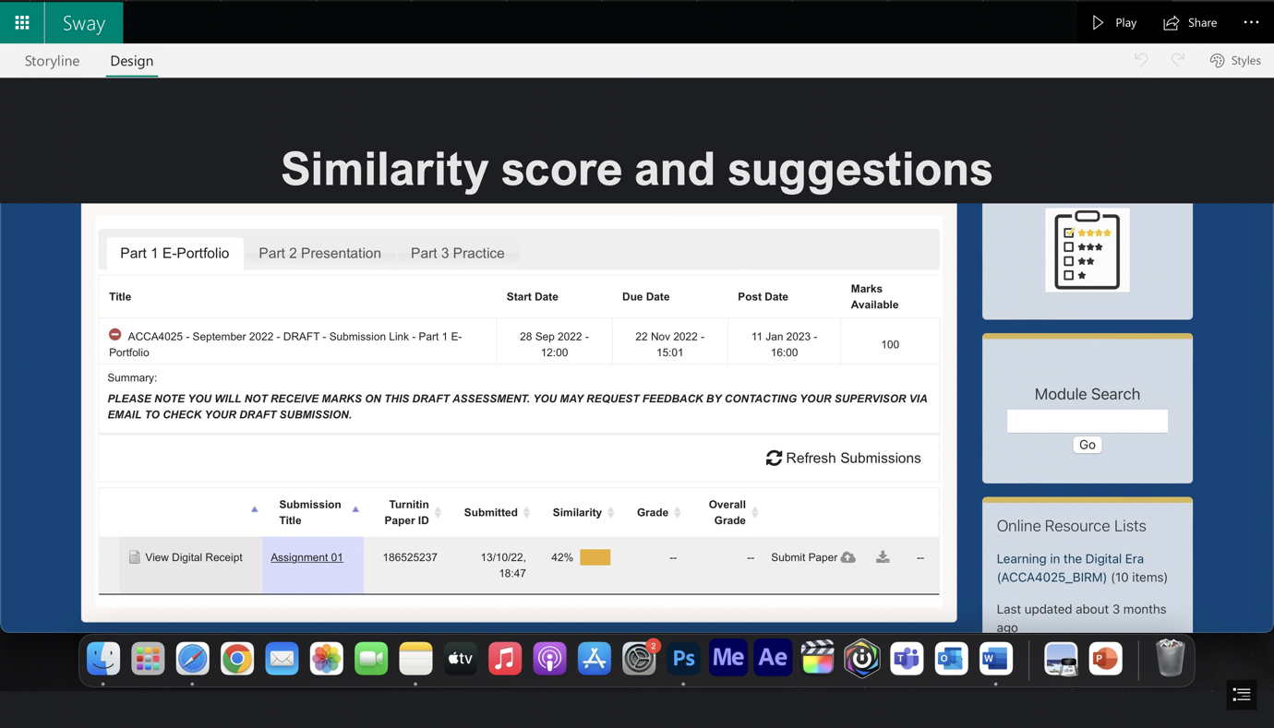
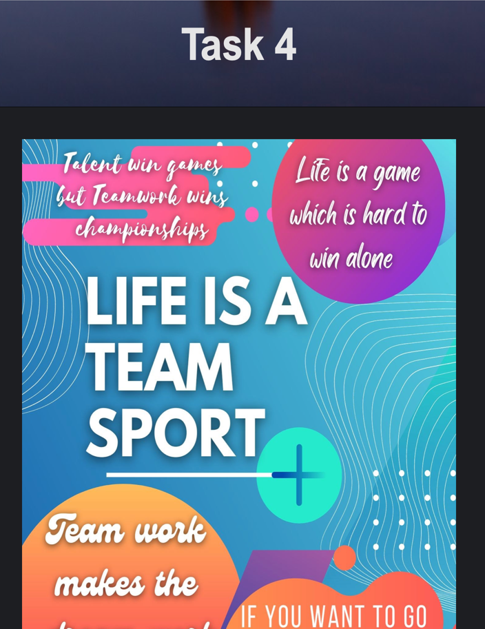

Task 03

Step 1 & 2: Download Mendeley & Install Mendeley Desktop
‌ Step 1: Download Mendeley
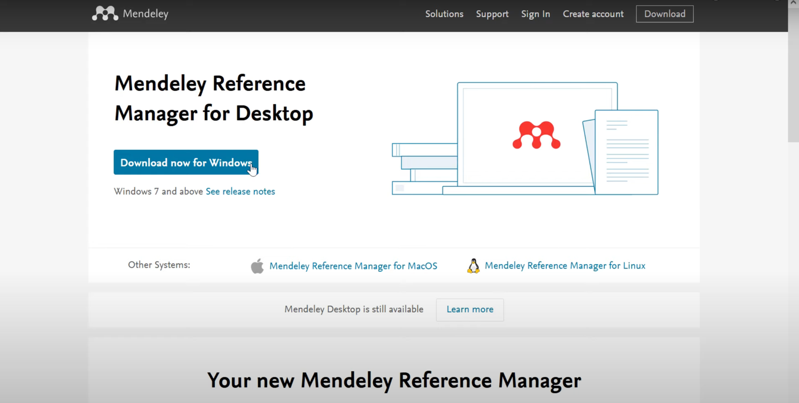
Download Mendeley by visiting: https://www.mendeley.com/download select the system Windows or Mac OS
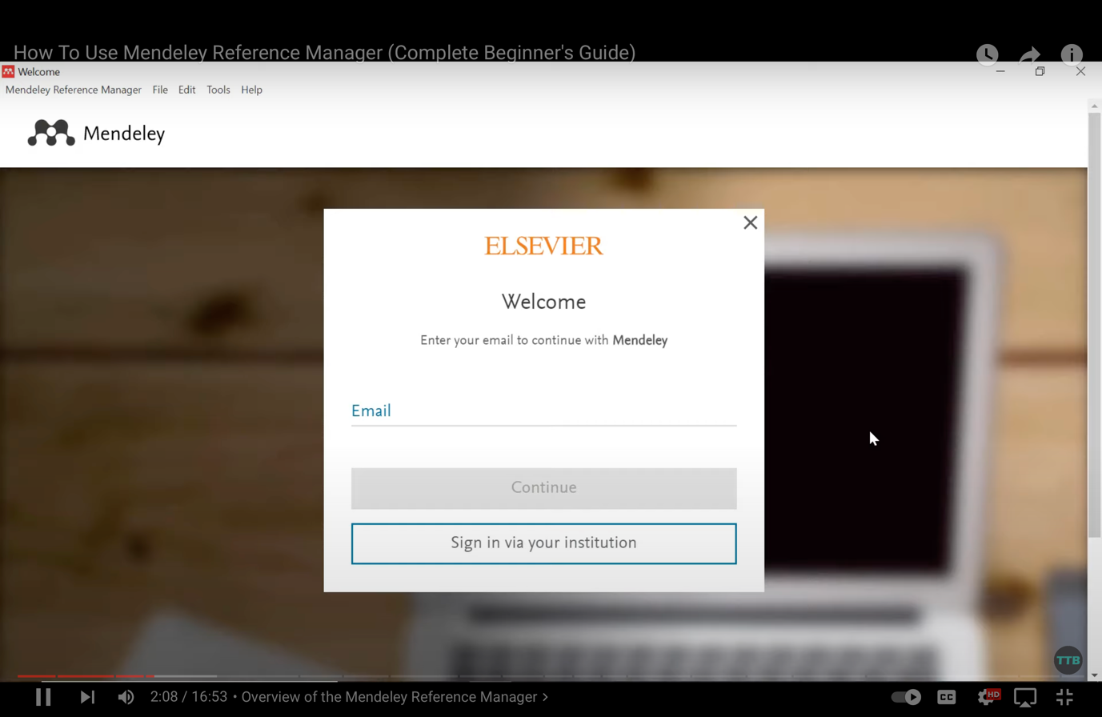
Step 3 : Creating an Account
Create an Account after downloading if you already have an account you can log in using your e-mail and password. You could also come across a sign-in option for your university. Before using this approach, you must validate your email address in order to access your Mendeley account.

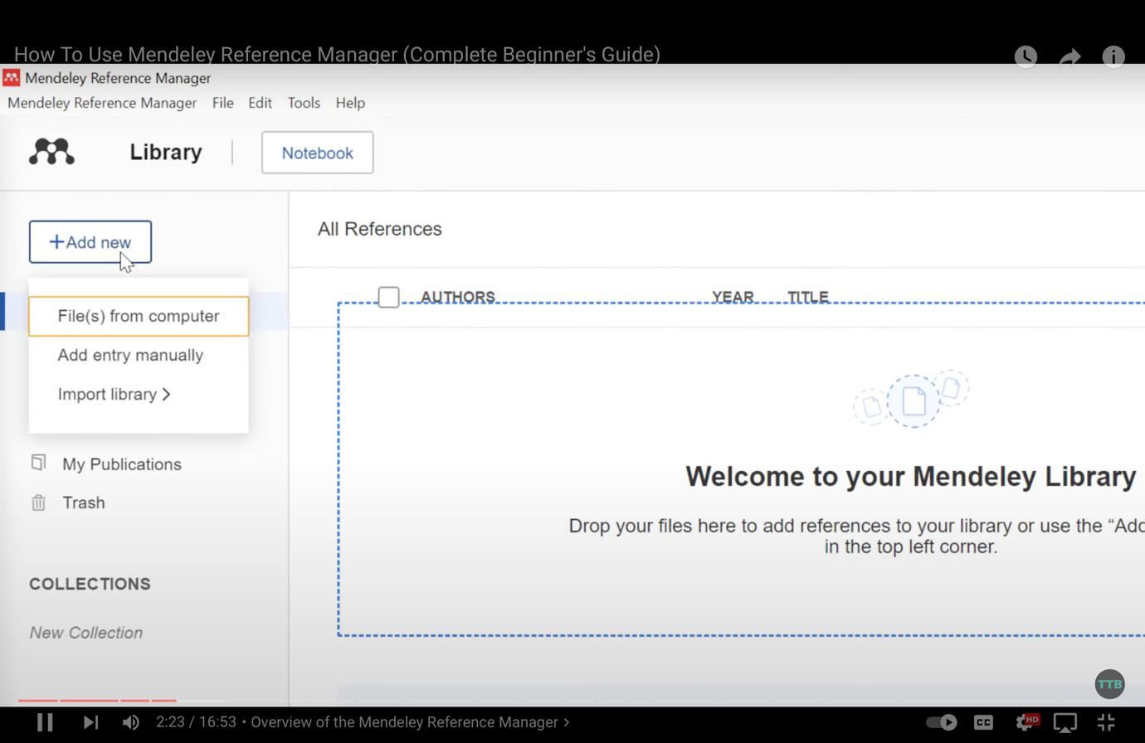
Step 4 : Import Documents to Mandeley

Open Mendeley and click add new, select from where you want to import the file from (files from computer, from library or add manually) and select the file from prompt and open the file

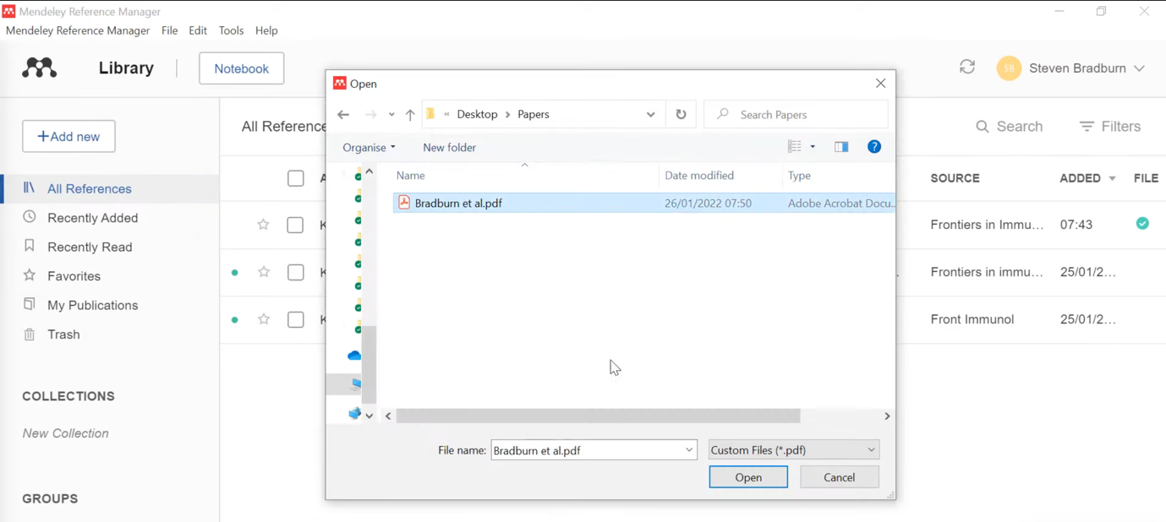
Step 5 : Add Mendeley to Microsoft Word

Click on the Get Mendeley Cite button on the Mendeley download page and you will be redirected to Microsoft Store and click on get it now
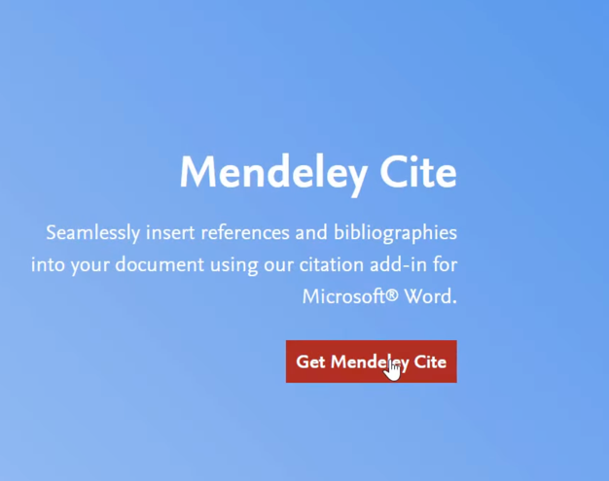

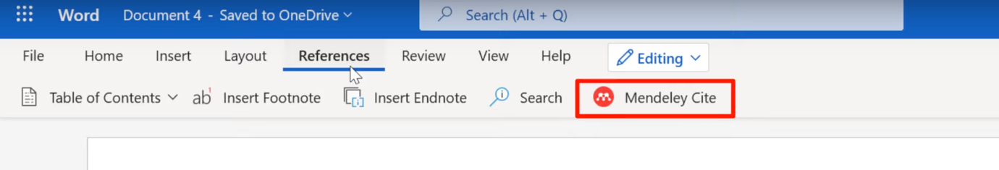
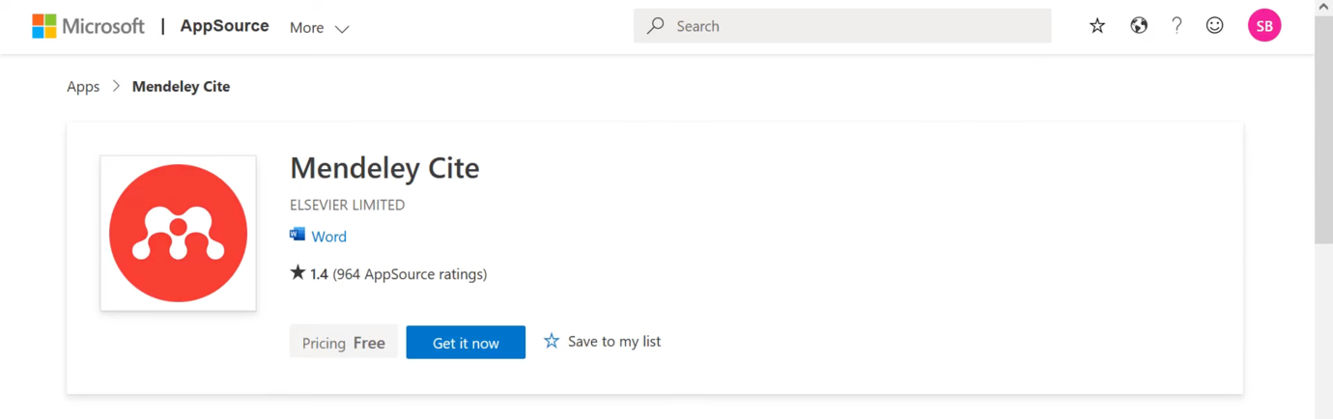

Open Microsoft Word and click on reference tab on the toolbar and you can see the Mendeley cite option
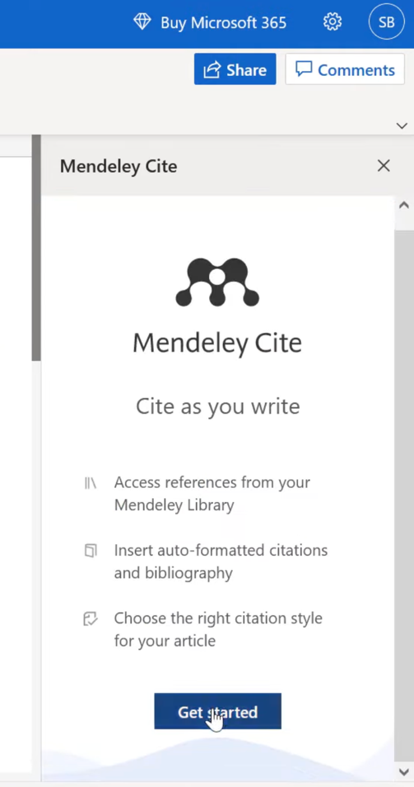
Step 6 : Cite using Mendeley on Microsoft Word

Click on Mendeley cite option on reference tab and click get started on the side bar then select the paragraph end in the document where you want to add citation and then select the reference and click on the insert citation button. You can select multiple reference and add citation

To add reference select the area you want to add the reference and click on more in sidebar and select bibliography and you can see the reference has been inserted

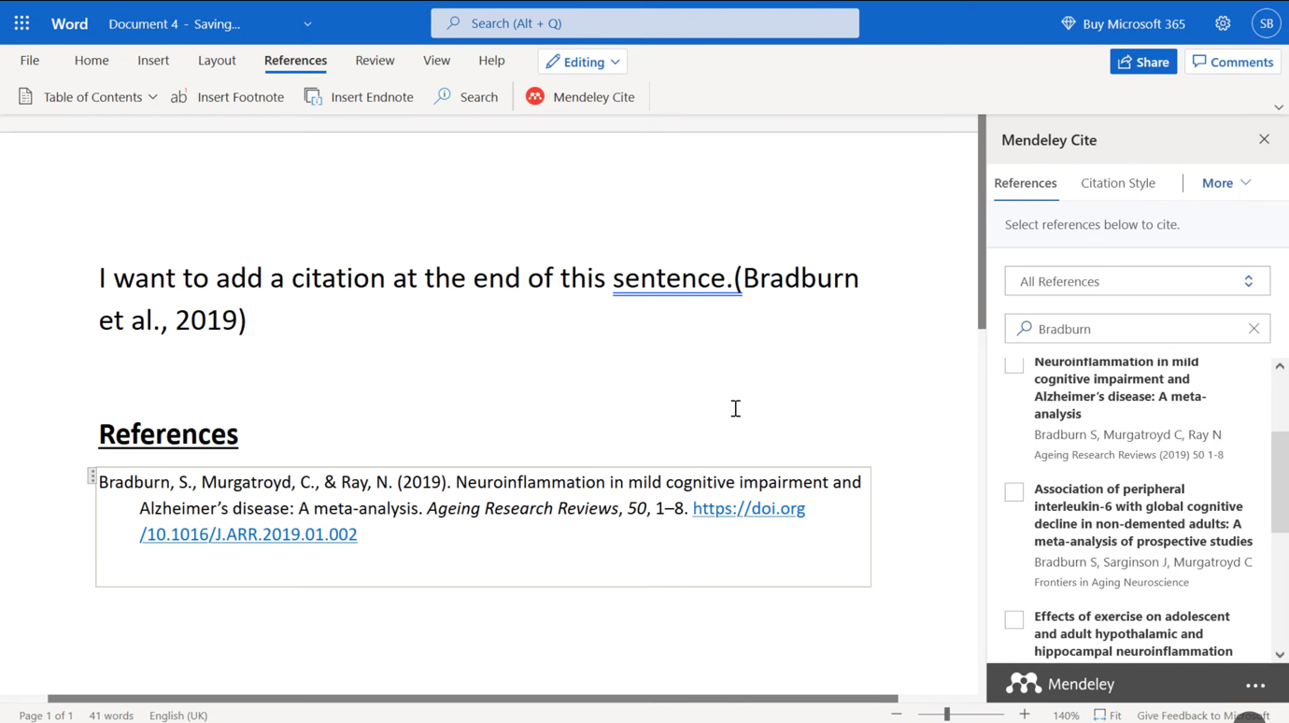

Referance:

[1] Mendeley.com, 2022. https://www.mendeley.com/guides/desktop/
(accessed Nov. 6, 2022).

[2] “How do I install Mendeley Reference Manager? - Mendeley Support Center,” service.elsevier.com.https://service.elsevier.com/app/answers/detail/a_id/18116/supporthub/mendeley/kw/18116/p/16075/ (accessed Nov. 10, 2022).

[3] E. Barry, “LibGuides: Reference Management: Legacy - Using Mendeley Desktop,” libguides.napier.ac.uk.
https://libguides.napier.ac.uk/refman/mendeleymanage (accessed Nov. 10, 2022).

[4] U. T. SL, “Mendeley Desktop (Windows),” Uptodown.com.
https://mendeley-desktop.en.uptodown.com/windows (accessed Nov. 11, 2022).

‌

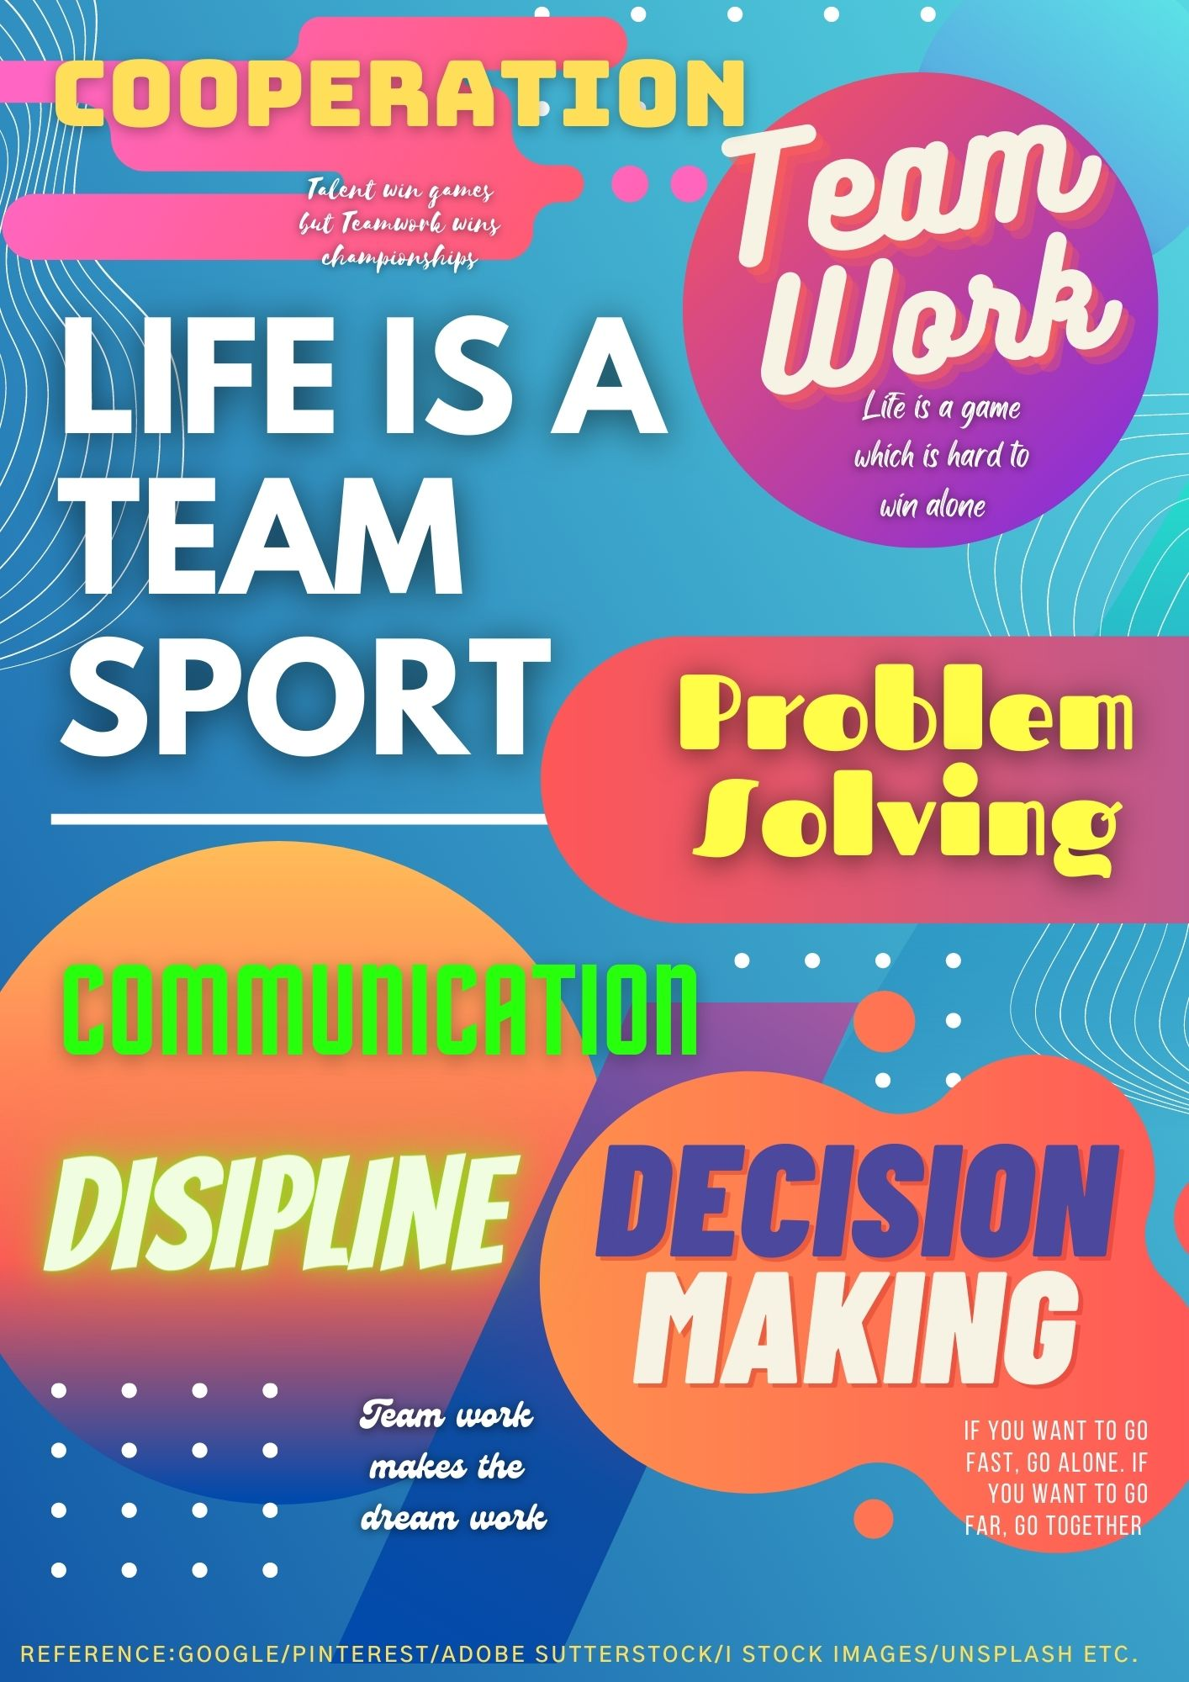
Task 04
Team members: Maher Rassar, Luck Peiris, Adil El Shafe
My part in this group activity is creating the Quotes and texts
Team members: Maher Rassar, Luck Peiris, Adil El Shafe
My part in this group activity is creating the Quotes and texts


