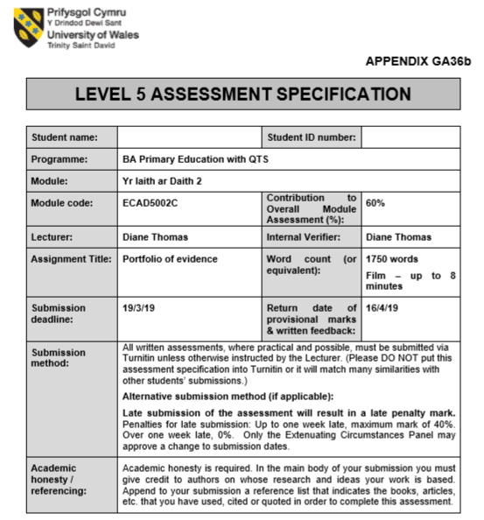
1700921
Corrie Jeremiah

Portfolio of Evidence.
Task 1: Choose a suitable story to be presented to a group of children noting the rationale behind the choice of story and the main learning objectives that are relevant to the story. You should note the intended audience and the type of language teaching opportunities the story would offer. Prepare one resource based on the story to teach Welsh as a first or second language.
The story that I have chosen to present to a group of children whilst out on placement in a primary school is ‘Tedi Twt a’r Tywydd’. The Tedi Twt books are popular in primary schools particularly in the Foundation Phase. Tedi Twt is a character which is associated with introducing basic topics and simple concepts of the Welsh language to young children. This book will be read in the Foundation Phase to a Year 1 class in order to introduce them to the topic of weather. However, some of the children may already be familiar with or may even know the translation of a few of the key words and terms due to brief previous exposure through the use of songs and rhymes.
During this planned session, the pupils were tasked with listening to the story of Tedi Twt carefully whilst following the print and responding to it appropriately. Most pupils in this age range should be able to respond appropriately to the story whether it be verbally, or non-verbally using actions or pictures; for example, some pupils should be able to recognise words which they have likely already come across before whether it be from a story or a song, words such as: Tedi Twt, braf, bwrw glaw, heulog, etc.
This book is being presented to the children in Year 1 as it is language appropriate with its basic and clear demonstrations of weather phrases and correct use of sentence structures which they are expected to learn and repeat orally with or without the help of pictured prompts. Furthermore, by the end of the lesson the children will be expected to demonstrate that they can converse simply and on occasion replace English words with Welsh when involved in specific activities.

Task 2: Read a story to a group of children during your PTE and undertake one activity using the resource you have prepared. You will need to film this activity for you to analyse and submit it as part of the assignment.
Video link: https://youtu.be/2lX_4MxIG0M (Approximately 6 minutes).

Task 3: A written reflection of task 2 (up to 1500 words).
Welsh Language Development is one of the seven Areas of Learning in the Foundation Phase Framework for Children’s Learning. However, it is an Area of Learning which is only delivered in primary schools where English is the main medium and method of communication. According to a past segment on the ITV news, although there has been growing demand for Welsh medium schooling in recent years, a majority of pupils in Wales still attend English-medium schools opting instead to learn Welsh as a second language (Sheldrick, 2015). Therefore, there are certain standards and individual needs which need to be met an upheld when teaching Welsh as an additional language. The framework for Children’s Learning in the Foundation Phase states that:
“Skills are developed through communicating in a range of enjoyable, practical planned activities, and using a range of stimuli that build on and increase children’s previous knowledge and experiences, in safe and stimulating indoor and outdoor learning environments.”
- Estyn (January 2013)

When learning Welsh as an additional language within the Foundation Phase the Welsh government has specified that children should learn naturally and gradually through first hand experiences which demonstrate one or more of the following: support and respect; sensitivity; praise for effort; fun and enthusiasm; and a rich and lively environment (Welsh Assembly Government, 2008). The activities that I had planned were designed to appeal to the children whilst also supporting the introduction given on the topic of weather by simply revising key words and phrases (see appendix 1). There was a total of four activities planned for each group of children, these activities were: playing a weather pairs game; playing a game of snap; matching the different kinds of weather using suitable pictures cards and key terms; and use of a roulette wheel. These activities appeal to the children as they are games they have come across and possibly play regularly. By creating these games into weather activities the Welsh language is embedded in a fun and interactive way. Children are known to have an amazing and natural potential to learn, and play has been acknowledged as being a way to harnesses and build on their learning potential. Play is considered to be both natural and necessary to children’s development hence the significance of the approach ‘Learning through Play’ in the Foundation Phase and my attempt to create a situation of structured play towards the particular learning goal of revising key weather terms.
For this lesson, the children were split into their attainment groups and due to festivities, such as the schools Christmas show one group was taught at a time in the afternoon for 40 minutes. Each individual group was given the opportunity to participate in each of the four activities through use of a carousel. The teaching strategy that is a carousel allows pupils to actively engage often in hands-on learning. The children were split into pairs or in some cases groups of three within their attainment groups, in order to give each child the opportunity to participate in activities either as individuals, pairs and/or in differently sized groups (Curriculum for Wales, pg.37). The purpose of each activity to ensure and encourage the children to revise weather phrases through the use of weather pictures and phrase cards. Each activity was introduced to the children after the story had been read to them in order to ensure that they were all able to participate and to ensure that vocabulary and language patterns were embedded into each activity. The pupils seemed to benefit from the smaller groupings as it helped to prevent disruptions to learning caused by other children. Children in smaller groups also seem to be more confident when answering and asking questions, it also provided more time for the teacher to respond to the individual needs of the children. Three out of the four activities were somewhat independent as they took the form of card games the children were familiar with. Therefore, the children were able to participate in them with little guidance or support. However, the fourth activity was teacher led to begin with, and took the form of a roulette wheel (see appendix 2). During this activity, I would go over the different weather symbols with the children whilst they were in their pairs/small groups. The children would be tasked with identifying and imitating the pronunciation of each of the weather symbols presented on the wheel and once they felt comfortable enough I would spin the arrow on the feel and ask them to identify the weather the arrow had landed on in Welsh. The purpose of this activity is to familiarise them with the subject specific vocabulary such as heulog, bwrw glaw, etc and to introduce them to the sentence pattern ‘mae hi’n…’. Should the children experience much difficulty we would then go back to identifying and imitating the pronunciation of each weather symbol, but should the children continue to make good progress then each child will be given a wheel of their own and will be tasked with asking ‘sut mae’r tywydd heddiw?’ within their pairs/groups whilst also answering appropriately using the ‘mae hi’n’ sentence pattern they have been introduced to. Furthermore, the sole purpose of these activities was to implement and embed simple sentence patterns and subject specific vocabulary in a way which would appeal and be memorable to the children.
This session was planned with specific outcomes and opportunities in mind. According to the Foundation Phase Framework, children in the Foundation Phase should be given opportunities to enjoy reading and to make progress in their ability to listen to a story being read by following the print. During this session, I believe that I modelled how to handle a book correctly and appropriately by demonstrating how to hold a book, showing them that we read a book from front to back and by displaying that we go through a book page by page. The pupils’ attention was also brought to recognising that printed letters and words run from left to right across the page and from and from top to bottom. This recognition of word direction can be seen being emphasised by myself as I occasionally point to the first word on a line and run a finger beneath the words as I read the passage from left to right and from top to bottom. It is vital to model reading correctly as it is an essential skill which provides children with a starting point for developing thinking (Northern Ireland Curriculum, unknown). It is also important to acknowledge that children’s’ understanding of reading mainly comes from past experiences such as storytelling and the modelling of stories given either by educators or relatives. Therefore, by modelling reading correctly children gain the necessary skills to successfully become independent readers and independent thinkers. The Foundation Phase Framework also lists six possible learning outcomes in regard to Welsh Language Development and I believe that the pupils in Year 1 achieved at least two of these six outcomes. The pupils have achieved outcome 1 which states that children should begin to follow stories that are read to them and begin to respond appropriately either verbally or non-verbally and they have also achieved outcome 2 which states that children converse simply, sometimes replacing English words with Welsh when involved in activities. The children in this lesson demonstrated that they are able to follow simple instructions and made a good effort when attempting to use sentence patterns and pronounce key vocabulary.
The classroom experience during this lesson was overall adequate and satisfactory as the children became more comfortable and confident when pronouncing and identifying topic specific vocabulary. However, upon further inspection there are many possible adaptations to be made. Whilst I had prepared a promoting Welsh planning sheet (see appendix 1), it was not kept in a place of sight when I delivered the lesson therefore phrases that I had planned for such as ‘pwy yw hwn?’ and ‘beth yw hwn?’ were forgotten about in the moment. For future references it would serve me well to place the sheet somewhere I can see it and revisit it before delivering the lesson. In hindsight, it could also be beneficial to use incidental Welsh phrases such as ‘gwrandewch os gwelwch yn dda’ and ‘peidiwch a gweiddi’r ateb’. Furthermore, there is plenty of opportunity to incorporate more Welsh whether it be subject specific or incidental into lessons such as this one.
Overall, I believe that this lesson was successful in introducing weather in Welsh to the children as they became able and more confident when identifying and pronouncing the different types of weather and they appeared to enthusiastic when doing so. The learning challenge which the children were presented with at the start of the lesson, ‘By the end of the lesson, you should be able to name three different types of weather in Welsh’, was achieved and helped to demonstrate which individuals felt comfortable and confident with that they had learnt but also helped to identify which individuals require more support and guidance.

Bibliography:
Estyn. (January 2013) Welsh Language Development in the Foundation Phase. Available at https://www.estyn.gov.wales/sites/default/files/documents/Welsh%20Language%20Development%20in%20the%20Foundation%20Phase%20-%20January%202013.pdf . (Accessed on 14th March 2019).
Northern Ireland Curriculum. (Unknown) Language and Literacy in the Foundation Stage. Reading. Available at: https://ccea.org.uk/sites/default/files/docs/curriculum/area_of_learning/language_and_literacy/fs_LL_Reading.pdf. (Accessed on 19th March 2019).
Sheldrick, T. (July 2015) Exclusive poll: 64% oppose compulsory Welsh to age 16. Available at: https://www.itv.com/news/wales/2015-07-10/exclusive-poll-64-oppose-compulsory-welsh-to-age-16/. (Accessed on 14th March 2019).
The Lego Foundation. (November 2017) Learning through play: a review of the evidence. Available at: https://www.legofoundation.com/media/1063/learning-through-play_web.pdf. (Accessed on 16th March 2019).
Welsh Assembly Government. (May 2008) Welsh Language Development. Available at: https://learning.gov.wales/docs/learningwales/publications/08welshlangdeven.pdf. (Accessed on 14th March 2019).
Welsh Government. (Revised 2015) Curriculum for Wales. Available at: https://beta.gov.wales/sites/default/files/publications/2018-02/foundation-phase-framework-revised-2015.pdf. (Accessed on 17th March 2019).

Appendix 1:

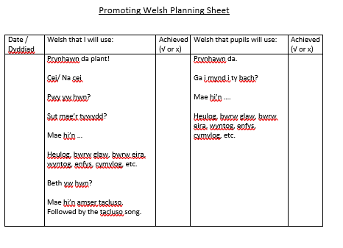

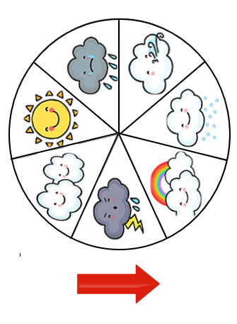
Appendix 2:

