Change & Stability Management (BMMB7000D)
Lecturer: Dr Roisin Mullins
Assignment Title: Individual Presentation

Presentation on Key Change Management Models for Netflix

Submitted by:
Omar Khan
Student No: 2219359

Link to the video

https://youtu.be/BV_J_VWMjnI

Presentation Slides/ Script/Notes
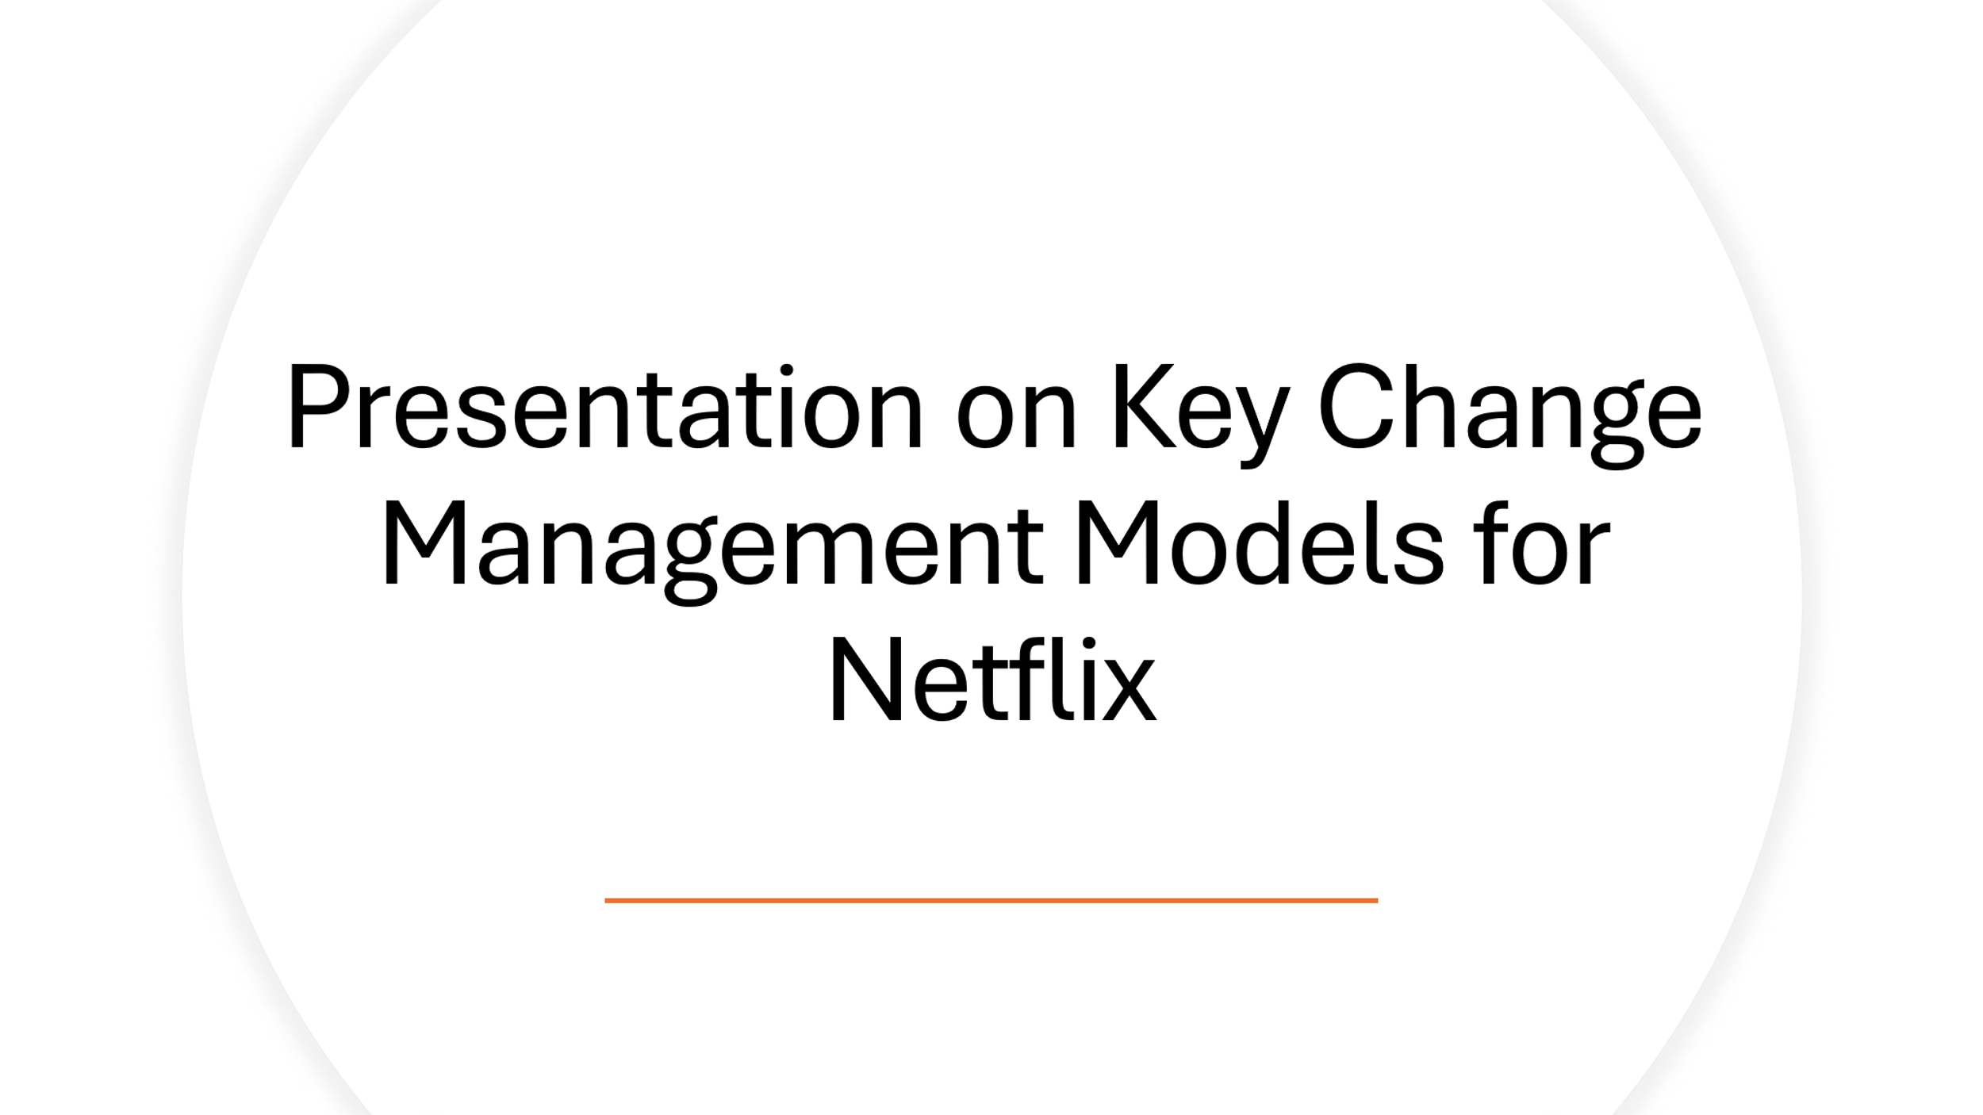
Slide 1

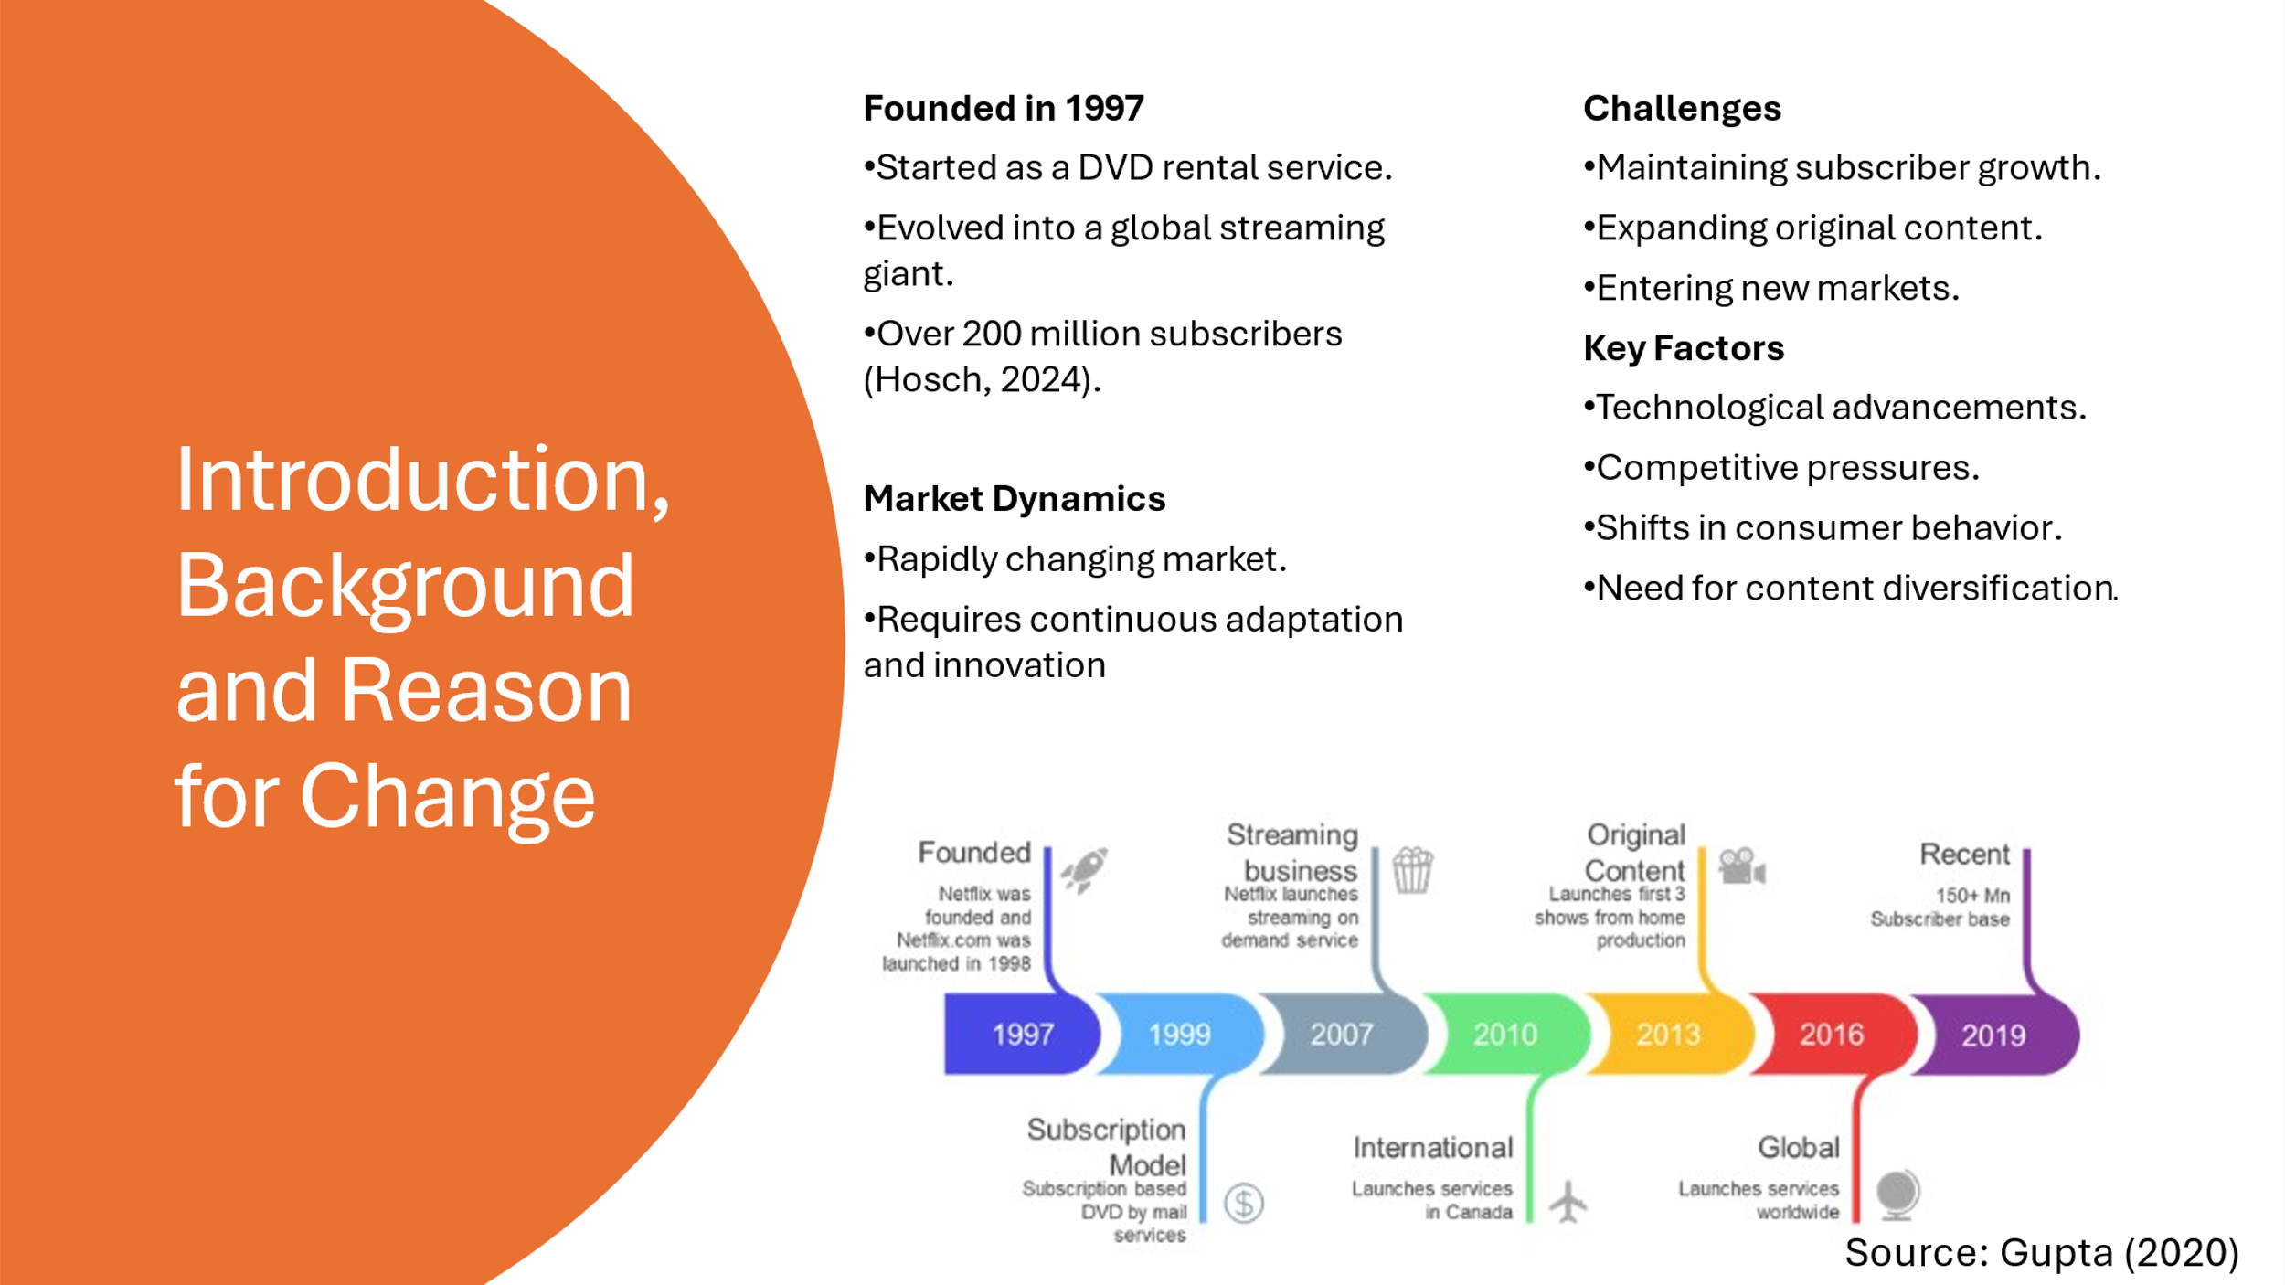
Slide 2
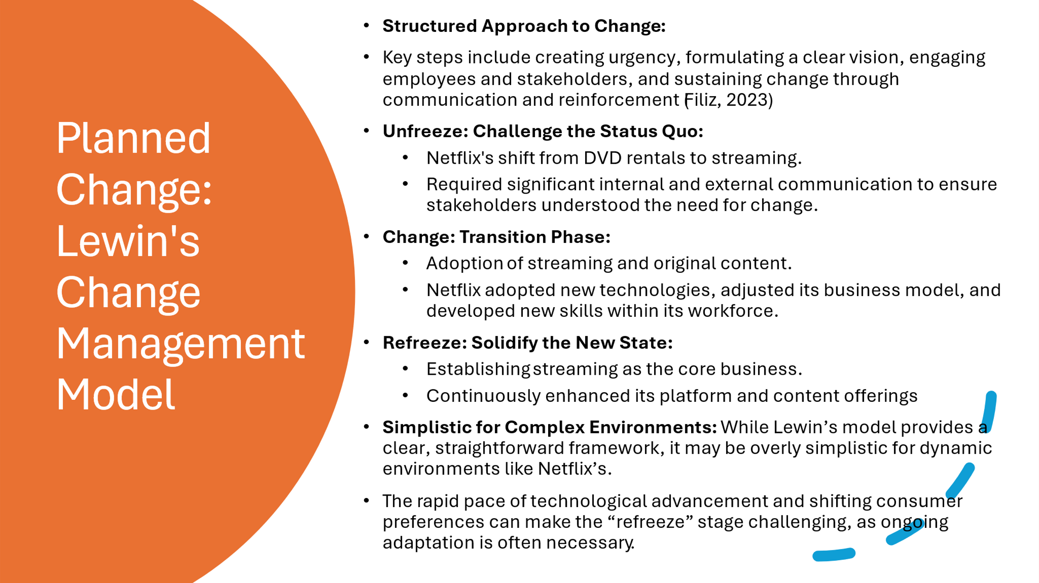
Slide 3

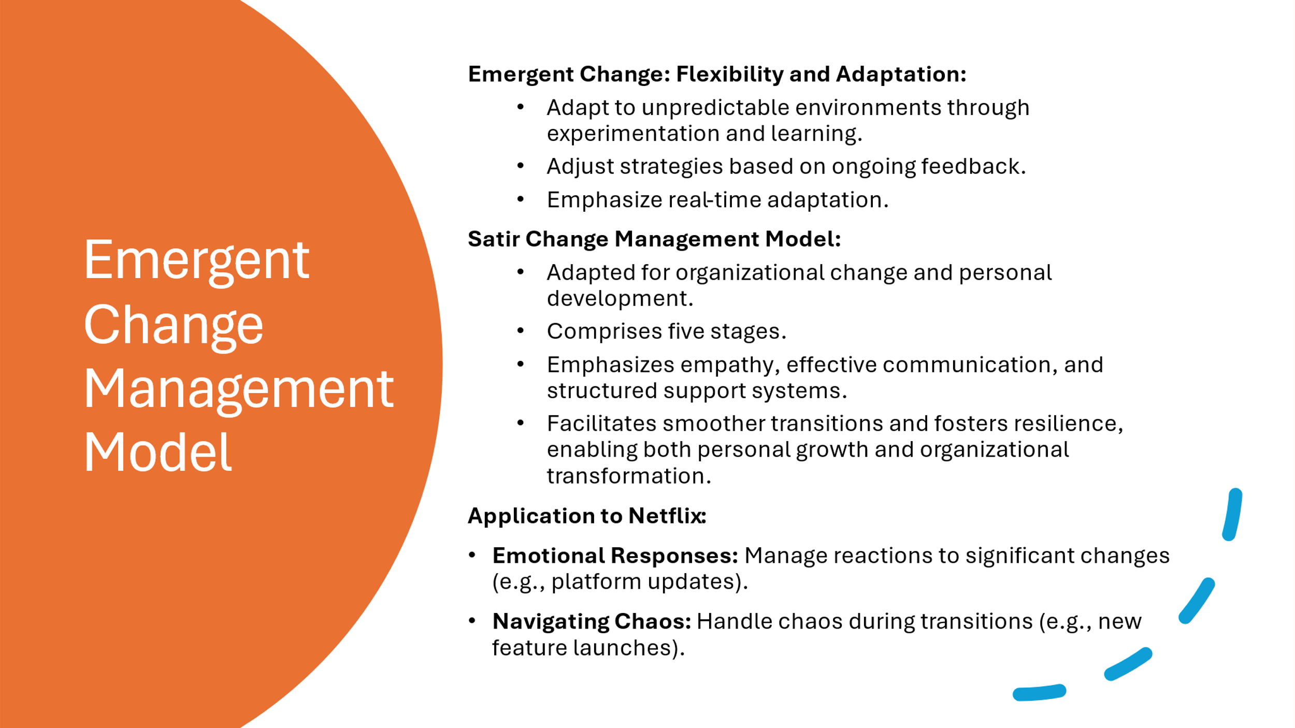
Slide 4
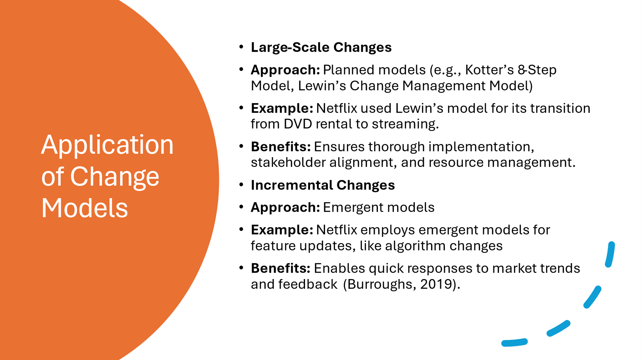
Slide 5

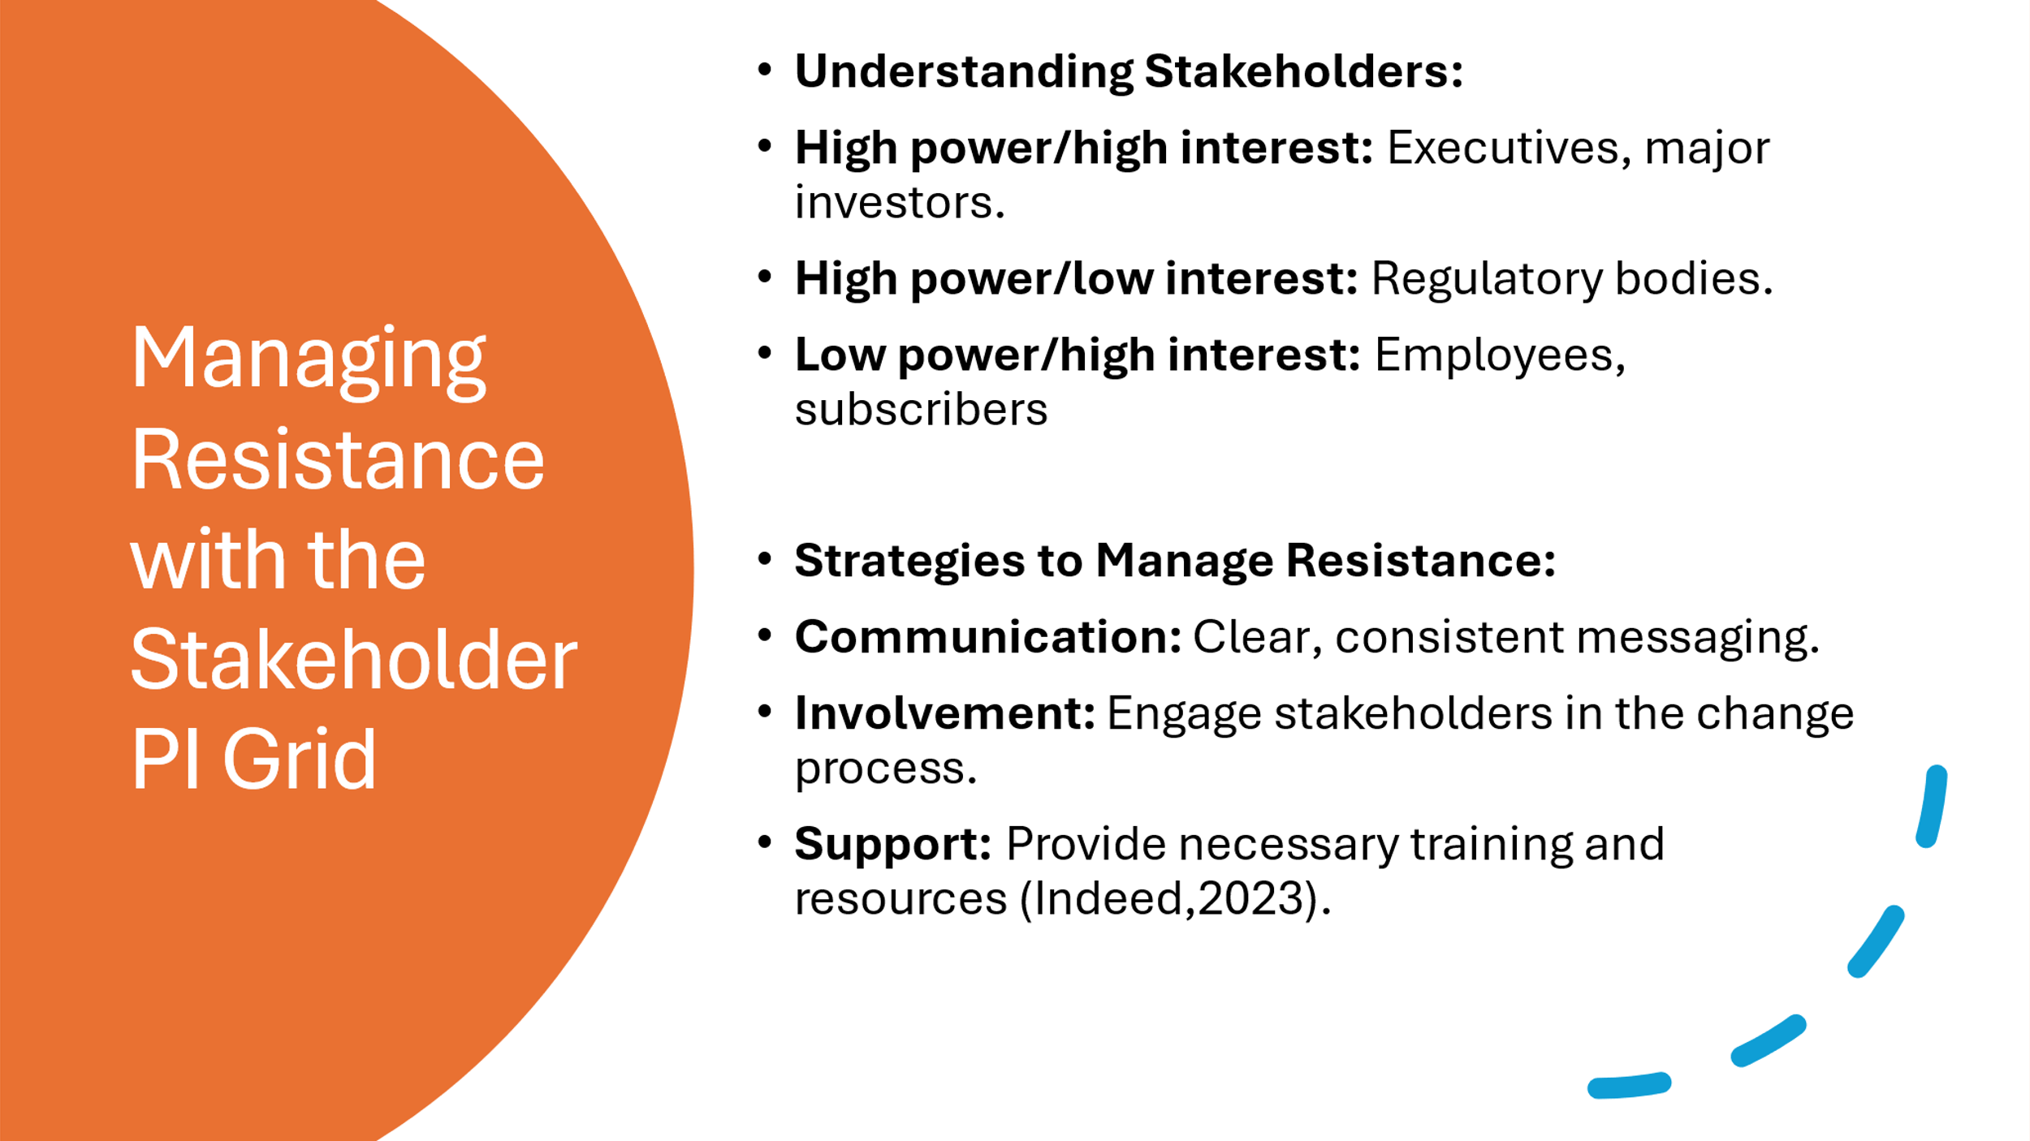
Slide 6
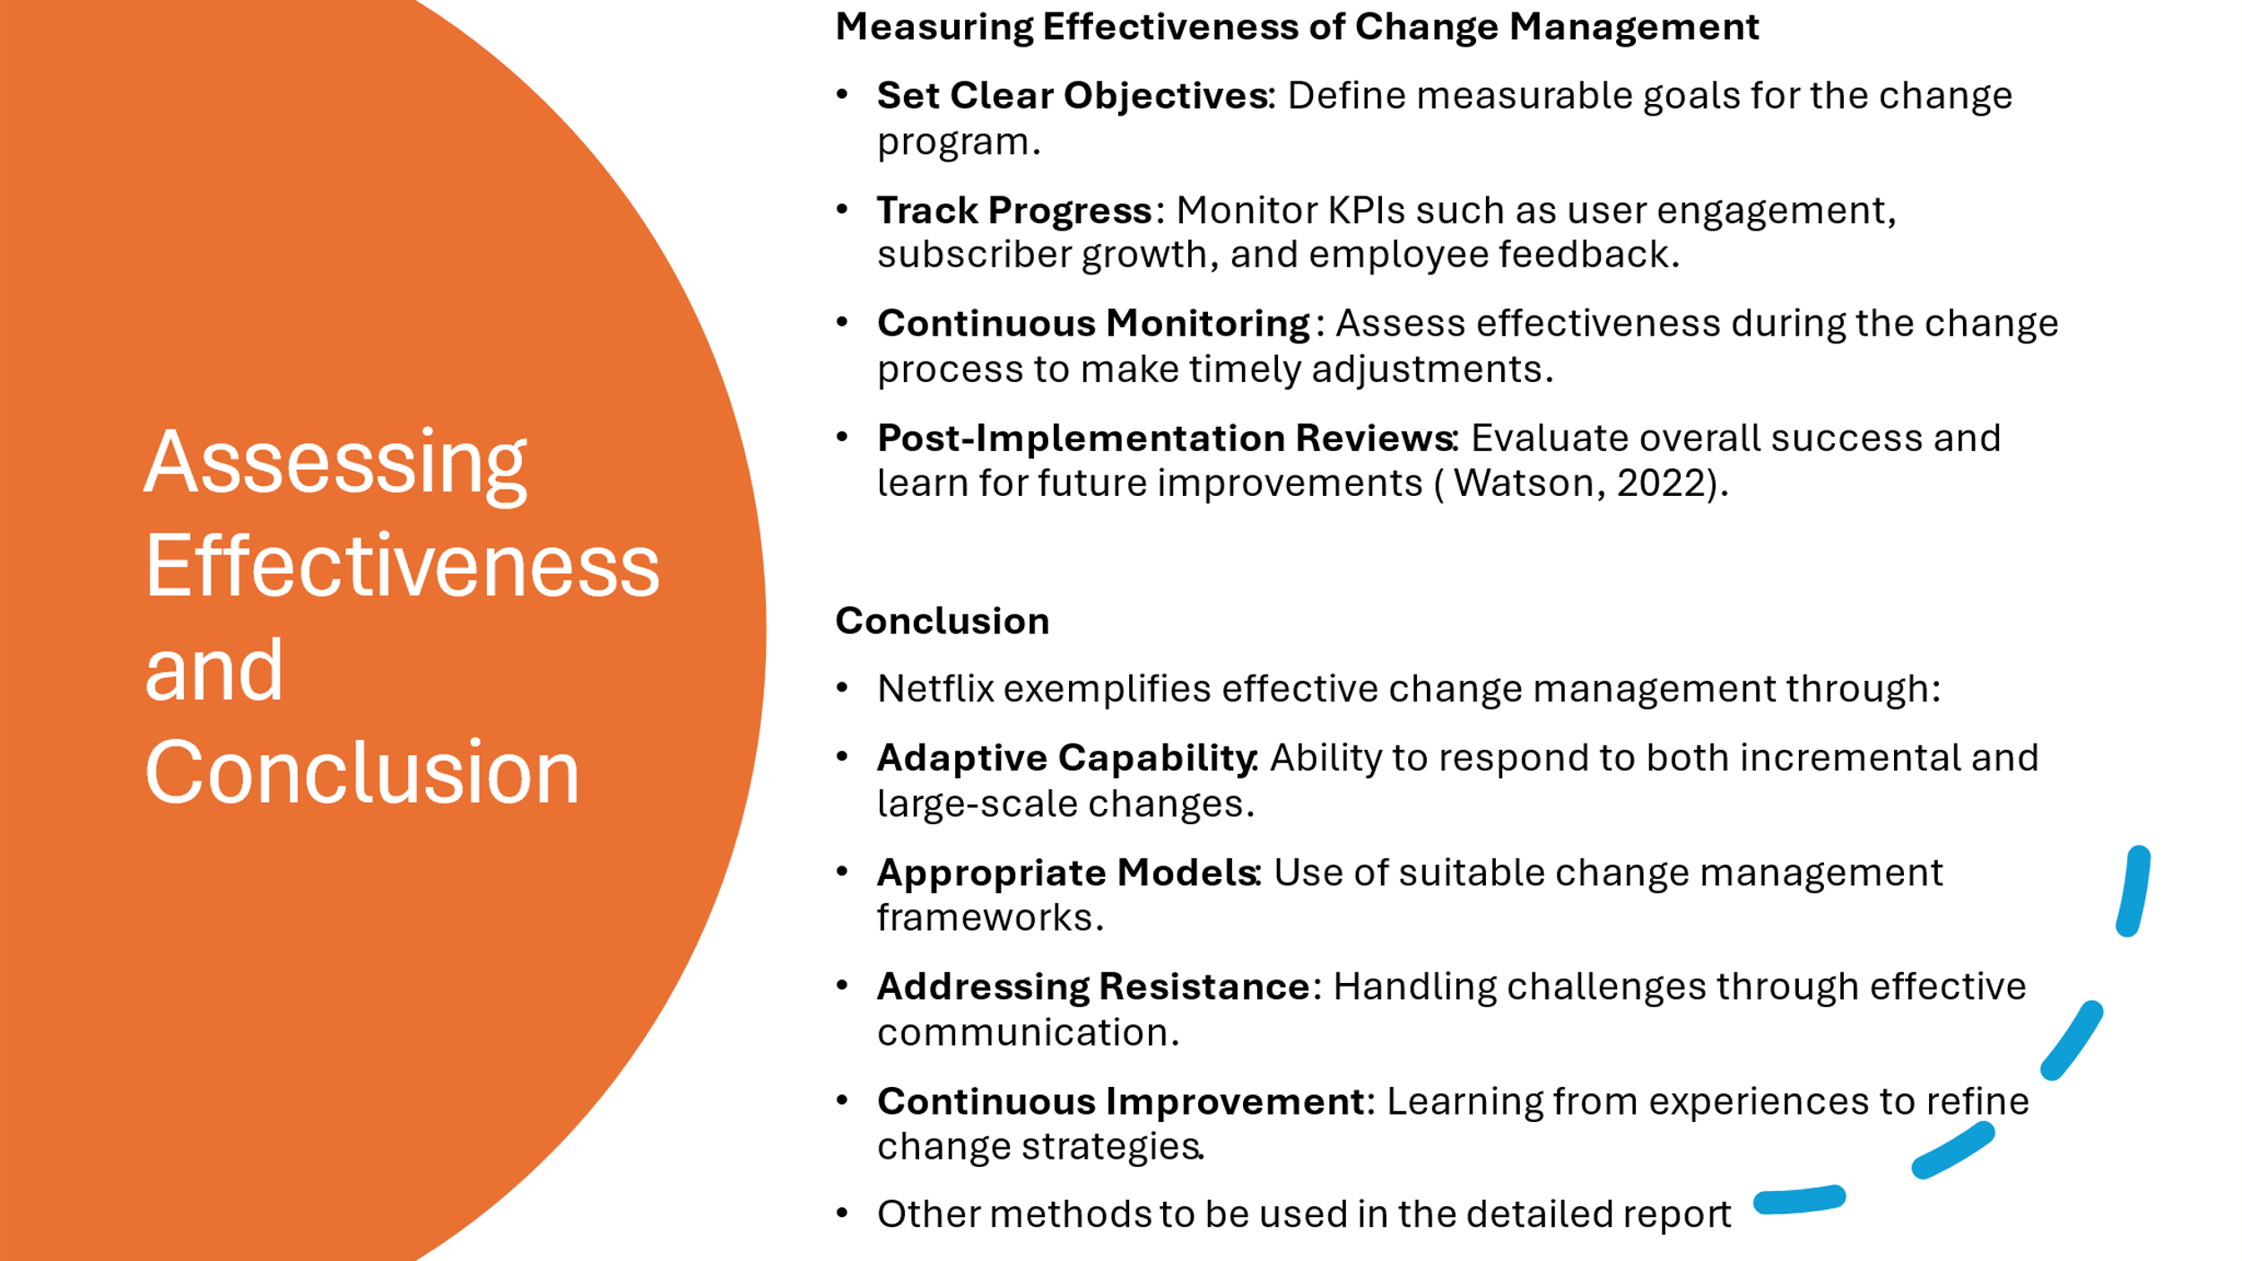
Slide 7

Reference List
Burroughs, B. (2019). House of Netflix: Streaming media and digital lore. Popular Communication, 17(1), 1–17. doi:10.1080/15405702.2017.1343948

Filiz, Mizrak. (2023). Effective Change Management Strategies: Exploring Dynamic Models for Organizational Transformation. 10.4018/978-1-6684-9814-9.ch009.

Gupta, V., 2020. Netflix - How Organizations Evolve. [online] LinkedIn. Available at: https://www.linkedin.com/pulse/netflix-how-organizations-evolve-varun-gupta/ [Accessed 5 July 2024].

Hosch, W.L. & Ashburn, N., 2024. Netflix. Encyclopaedia Britannica. Available at: https://www.britannica.com/money/Netflix-Inc [Accessed 1 July 2024].

Indeed. (2023). How To Manage Stakeholders With a Power Interest Grid. Retrieved from https://www.indeed.com/career-advice/career-development/power-interest-grid [Accessed 5/7/2024]

Pinto, P. (2024) 'SATIR Change Model: Navigating Transformative Processes in Organizations', LinkedIn, February 27. Available at: https://www.linkedin.com/pulse/satir-change-model-navigating-transformative-pedro-pinto-mba-mcc-kyamf/ (Accessed: 6 July 2024).
Watson, M.D.M., 2022. How Do You Measure The Effectiveness of Change Management. [online] LinkedIn. Available at: https://www.linkedin.com/pulse/how-do-you-measure-effectiveness-change-management-matt-d-m- [Accessed 7 July 2024].

