LEVEL 4 ASSESSMENT SPECIFICATION

Student name: | Iulica Codreanu | Student ID number: | 2511908
Programme: | Certificate in Higher Education Business Skills for the Workplace
Module: | Enterprise and Entrepreneurship
Module code: | LCLM4006
Lecturer: | Birmingham:  Dr Chung Lai Johnny Wan  London:  Dr Charles Oham | Internal Verifier: | Dr Lizeta Demetriou  Naomi Doerge  Dr Chung Lai Johnny Wan  Fatima Hashmi
Assignment Title: | Task 1:  Individual Written Business Plan | Word count | 1632
Executive Summary
Refill Environment Ltd. is a UK company which provided environmentally friendly retailing services. It provided customers with refillable household cleaning products, personal care products and grocery products without any plastic wrapping. There were two ways to buy products. Customers could use both the offline shop and the online subscription service. The target audience was environmentally-conscious people aged 20-45 years, including families, students and young professionals. This business model included three features, such as refill shopping, reusable packing, home delivery and community sustainable learning. The main contribution of this business model to the circular economy and Net Zero goals in the UK was the decrease in the amount of plastic wrapping and promotion of reusing. The total capital necessary to start the business amounted to £35,000. There were many opportunities due to high demand in the UK for environmentally-friendly retail products.

Table of Contents
1. Overview of the Business Idea 5
1.1 Company Introduction 5
1.2 Product and Service Offering 5
1.3 Unique Selling Proposition (USP) 6
1.4 Management Structure and Legal Structure 6
2. Market Research 7
2.1 PESTEL Analysis of the UK Market 7
2.2 Competitor Analysis 8
3. Marketing Communications Strategy 10
3.1 STP Analysis 10
3.2 Marketing Mix (4Ps) 10
3.3 Sustainability Communication 11
4. Financial Plan 12
4.1 Funding Requirement 12
4.2 First Month Start-up Costs 13
References 14
Appendix 15
Appendix A: First Month Start-up Costs 15

List of figures
Figure 1: Refill Environment Ltd. (Source: Author, 2026) 5
Figure 2: Refillable Packaging Market (2025 - 2030) (Grand View Research, 2024) 7

List of tables
Table 1:PESTEL Analysis 7
Table 2:Competitor Analysis 8
Table 3:STP Analysis 10
Table 4: Marketing Mix (4Ps) 10
Table 5:Proposed Funding Structure 12
Table 6:Projected Break-even Analysis 12
Table 7: Estimated Monthly Cash Flow Forecast 13

1. Overview of the Business Idea

1.1 Company Introduction
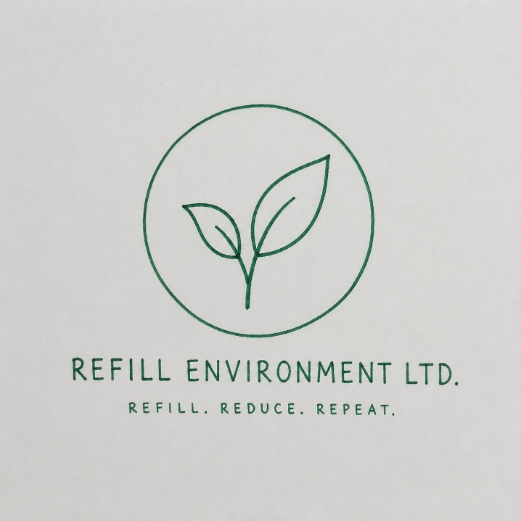
Figure 1: Refill Environment Ltd. (Source: Author, 2026)
Refill Environment Ltd. is a sustainable retail startup based in the UK, which tries to minimise the waste of single-use plastic in the form of providing refills for household goods and personal care products, as well as zero-waste grocery essentials. It will start with a refill shop in Birmingham, backed up with the online store, which will offer delivery across the entire country. The main objective of Refill Environment Ltd. is to be one of the key participants in the creation of the circular economy of the UK.

1.2 Product and Service Offering
Refill Environment Ltd. utilizes the business model where customers buy products that do not require buying plastic containers because there is an option for refills. Consumers may use the products available in their own containers or buy reusable containers at the store that can be refilled when making subsequent purchases. The products sold include everyday cleaning products like washing-up liquid, laundry detergent, and all-purpose cleaners, personal care products such as shampoo, conditioner, hand wash and body wash and zero-waste groceries including rice, pasta, cereals, nuts, seeds and dried fruit.
To increase convenience, the company will offer monthly subscription refill services for delivering products to customers in reusable bottles that get collected, cleaned and used again on the following delivery. With this approach, the business eliminates packaging waste and encourages a circular economy. In addition, Refill Environment Ltd. provides consumers with information about sustainable living and consumption. It is obvious that the model offered by the company directly addresses the problem of reducing plastic waste and achieving net zero emissions in the UK.

1.3 Unique Selling Proposition (USP)
The main distinguishing feature of Refill Environment Ltd is the presence of all three factors, affordability, convenience, and sustainability, which can be achieved at the same time through one purchase process. While other retailers use disposable plastic products extensively, Refill Environment Ltd provides its customers with a convenient solution that allows reducing household expenses over time and minimising plastic usage. Also, the subscription service, reusable packaging, and sustainability workshops add more value to customers.

1.4 Management Structure and Legal Structure
The company Refill Environment Ltd. will be operating as a Private Limited Company (Ltd). In addition to protecting the company owners against unlimited liability, it is likely to increase investor trust and credibility. The company will have the following management positions: Founder and Managing Director, who will be in charge of strategic planning and business development, an operations Manager whose responsibility will include purchasing, inventories and logistics, a Marketing Executive whose responsibility will be digital marketing and sustainability campaigns, as well as customer interaction and finally, a Customer Service Assistant who will offer excellent customer service both on-line and off-line.

2. Market Research

2.1 PESTEL Analysis of the UK Market
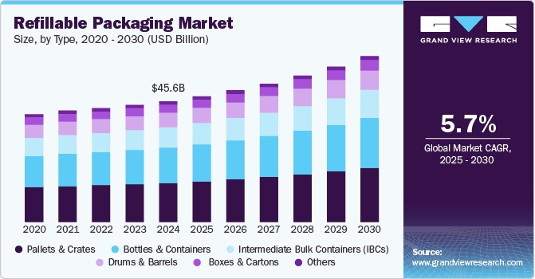
Figure 2: Refillable Packaging Market (2025 - 2030) (Grand View Research, 2024)
Table 1: PESTEL Analysis
Factor | Analysis
Political | The UK Plastic Packaging Tax and Environmental Improvement Plan encourage businesses to limit their plastic waste output. The UK's legally binding Net Zero 2050 goal also supports refill retail through circular economy efforts (Statista, 2025).
Economic | Despite UK inflation staying at 3.4% in 2024 (ONS), sustainable packaging is seeing continuous growth in terms of demand. As shown in the figure, the global market size for refillable packaging is expected to reach USD 45.59 billion in 2024, growing by a 5.7% CAGR, providing long-term opportunities that positively impact the UK's market growth (Grand View Research, 2024).
Social | According to WRAP, more than 70% of UK consumers worry about plastic waste, thus creating high demand for refill and reusable packaging (WRAP, 2023). Higher environmental awareness especially affects the purchase decisions of young consumers and families.
Technological | E-commerce, mobile orders, contactless payments and inventory management software increase the efficiency of operations while providing subscription-based refill services.
Environmental | The UK produces around 2.5 million tonnes of plastic packaging waste each year, hence the high demand for refill solutions that lower carbon emissions and promote the circular economy (Cullen, Yang and Sule, 2026).
Legal | Compliance with the Environmental Act 2021, Plastic Packaging Tax, Consumer Rights Act 2015 and Food Safety Regulations ensure legal business activity and customer satisfaction.
Critical Analysis
In summary, the macro environment in the UK is positive for Refill Environment Ltd. The policies of the government, awareness about the environment, and technological advancements offer many prospects for growth, but inflation and compliance are increasing operational costs. In that case, it will be crucial to maintain competitiveness.

2.2 Competitor Analysis
Table 2: Competitor Analysis
Competitor | Strength | Weakness
The Source Bulk Foods UK | Extensive refill product range and recognised sustainability brand. | Premium pricing targets higher-income consumers.
The Clean Kilo | Established refill retailer with online and physical stores. | Limited geographical coverage across the UK.
Waitrose / Ocado Refill Initiatives | Strong brand recognition and nationwide distribution. | Refill options remain limited compared with conventional packaged products.
Competitive Advantage
Refill Environment Ltd will gain a competitive edge through its combination of low-cost pricing, subscription refills, sustainability workshops for communities, and customised customer interaction. It differs from high-end refill providers and supermarkets offering only a few refill products by providing a more convenient refill service that builds consumer loyalty and contributes to the UK circular economy.

3. Marketing Communications Strategy
A successful marketing communication campaign is very important for brand awareness creation and encouraging customer interaction in order to establish customer loyalty within the sustainable retail market in the United Kingdom (Agu et al., 2024). The Refill Environment Ltd. will be using the STP marketing communications strategy together with the marketing mix concept in order to communicate their environmental offer to eco-friendly customers.

3.1 STP Analysis
Table 3: STP Analysis
Element | Application to Refill Environment Ltd.
Segmentation | The segmentation of the UK market will be done in terms of demographic factors (20-45 years old age group, students, families, and young professionals), psychographic (eco-friendly and health-aware individuals), and behavioural (individuals looking for refill options).
Targeting | The main target market will include eco-conscious individuals residing in urban cities such as Birmingham and purchasing household and personal care products on a frequent basis.
Positioning | Refill Environment Ltd. would position itself as an affordable and community-oriented sustainability store where customers can minimise plastic waste generation without making any extra payment while working for the UK’s circular economy goals.

3.2 Marketing Mix (4Ps)
Table 4: Marketing Mix (4Ps)
Marketing Mix | Strategy
Product | A wide selection of refilling options for household cleaning goods, personal care products and zero-waste groceries that are offered via reusable packaging will also be offered.
Price | The pricing strategy will involve competitive diffusion pricing along with offering discounts on subscriptions and loyalty programs to retain customers.
Place | Refilling will be provided at the store, e-commerce site and home delivery service, which will offer multiple purchasing options for the customers.
Promotion | Promotional activities will involve the use of Instagram, TikTok and Facebook campaigns, partnering with sustainability influencers from the UK, email marketing, referral programs and participating in environmental events and university sustainability campaigns.

3.3 Sustainability Communication
All marketing communications will reinforce the company’s commitment towards zero-waste shopping through digital campaigns, product labelling, workshops and partnership programs to highlight the environmental impact that consumers have by choosing to purchase products using refill shopping. This way, the customers will be educated about the environmental benefits of refill shopping while minimising plastic waste in the UK retail industry.

4. Financial Plan

4.1 Funding Requirement
Refill Environment Ltd. will require £35,000 in order to set up its retail refill store in Birmingham, establish its e-commerce site and have enough working capital for its initial period of operation. This budget has been meticulously prepared to cover costs for infrastructure, inventory, marketing efforts, operations cost until such time that the company earns its income.
The budgeted financing plan for Refill Environment Ltd. will include £15,000 or 42.9% from a UK Start Up Loan, £10,000 or 28.6% from the founder's contribution and another £10,000 or 28.5% from the UK Government Green Start-up grant. Such a combination of funding sources ensures that there will be little to no risk involved in funding through debt, equity investments, and grants. Additionally, this combination helps to demonstrate the financial dedication of the entrepreneur.
Considering the average expenditure of £22 per purchase made by one customer, with an average of 25 daily customers, Refill Environment Ltd. can expect its monthly sales revenue to be around £16,500. Based on this, it should reach its break-even point in 12–15 months.
Table 5: Proposed Funding Structure
Funding Source | Amount (£) | Share (%)
Founder's Personal Investment | 10,000 | 28.6
UK Start Up Loan | 15,000 | 42.9
UK Government Green Start-up Grant | 10,000 | 28.5
Total Funding Required | 35,000 | 100
Table 6: Projected Break-even Analysis
Financial Indicator | Estimate
Average Customer Spend | £22
Average Customers per Day | 25
Estimated Monthly Revenue | £16,500
Estimated Gross Profit Margin | 45%
Estimated Monthly Gross Profit | £7,425
Estimated Monthly Fixed Operating Costs | £6,000
Expected Break-even Period | 12–15 months
Table 7: Estimated Monthly Cash Flow Forecast
Cash Flow Item | Amount (£)
Forecast Monthly Sales Revenue | 16,500
Less: Monthly Operating Costs | (13,000)
Estimated Net Operating Cash Flow | 3,500

4.2 First Month Start-up Costs
Investment has been made in such a way that there is operational readiness while also ensuring that liquidity remains high in the first month of operations of the company. (See Appendix A)
This financial plan makes the flow of cash smooth, lowers risks, and builds up the trust of the investors (Chahar, 2025). The planned investments are directed towards earning sources in the form of inventory and refilling station investments, as well as online sales portals. The working capital reserve of £9,000 would be used for paying salaries, buying inventory, making supplier payments, and handling any other expenses in operations in the first month of operation.

References
Agu, E.E., Iyelolu, T.V., Idemudia, C. and Ijomah, T.I. (2024) ‘Exploring the relationship between sustainable business practices and increased brand loyalty’, International Journal of Management & Entrepreneurship Research, 6(8), pp. 2463–2475. Available at: https://www.researchgate.net/profile/Tochukwu-Ijomah-2/publication/383847817_Exploring_the_relationship_between_sustainable_business_practices_and_increased_brand_loyalty/links/66dc447d2390e50b2c7212e7/Exploring-the-relationship-between-sustainable-business-practices-and-increased-brand-loyalty.pdf (Accessed: 3 July 2026).
Chahar, K.V.S. (2025) Fundamentals of Finance. Chyren Publication.
Cullen, E., Yang, M. and Sule, M.N. (2026) ‘Barriers to replacing single-use packaging with circular reuse business models: A UK and Vietnamese context’, Cleaner and Responsible Consumption, p. 100405. Available at: https://www.sciencedirect.com/science/article/pii/S2666784326000197 (Accessed: 3 July 2026).
Grand View Research (2024) Refillable Packaging Market Size | Industry Report, 2030. Available at: https://www.grandviewresearch.com/industry-analysis/refillable-packaging-market-report (Accessed: 3 July 2026).
Statista (2025) UK emission reduction targets to net zero by 2050. Available at: https://www.statista.com/statistics/1449790/carbon-budget-emission-reduction-targets-uk/?srsltid=AfmBOorUIZSZbn_vgB1gAdqbXzA5w0fmSl1Ts-X8DLeHE07q0pTwpnLQ (Accessed: 3 July 2026).
WRAP (2023) UK Plastics Pact latest report. Available at: https://www.wrap.ngo/media-centre/press-releases/uk-plastics-pact-latest-report (Accessed: 3 July 2026).

‌

Appendix

Appendix A: First Month Start-up Costs
Expense | Estimated Cost (£) | Purpose
Shop rent and security deposit | 4,500 | Secure Birmingham retail premises
Initial refill inventory | 9,000 | Household, personal care and grocery products
Refill dispensers, shelving and equipment | 5,000 | Refill stations and store fit-out
Website and e-commerce platform | 2,000 | Online ordering and subscription system
Marketing and launch campaign | 3,000 | Digital advertising and local promotion
Insurance | 800 | Public liability and business protection
Business registration and licences | 700 | Legal compliance and registration
Utilities and internet | 1,000 | Essential operating expenses
Working capital reserve | 9,000 | Staff wages, supplier payments and contingency
Total Estimated Start-up Cost | 35,000

