
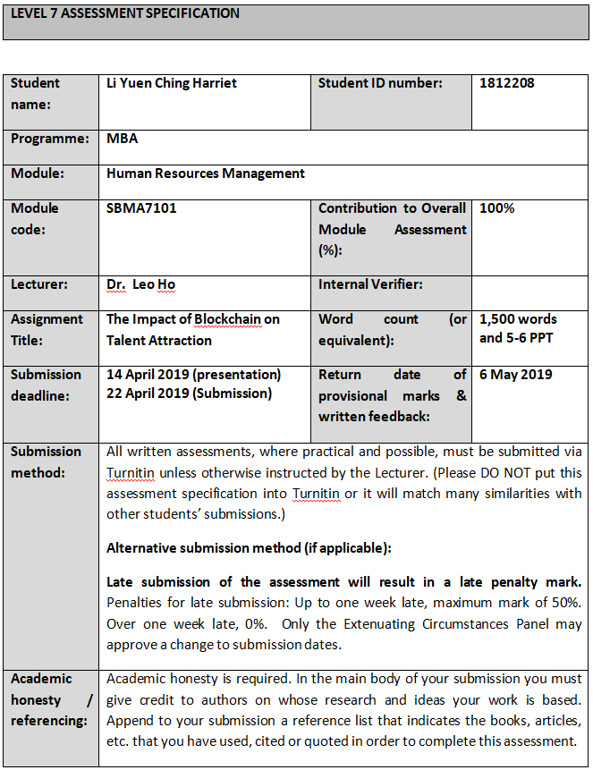
Table of Contents

1. Introduction 1
2. Analysis and Discussion 2
2.1 What is Blockchain? 2
2.2. Benefits of Blockchain 2
2.3. Should Talent Attraction Process Go Through By Blockchain? 3
2.4. Use Case: Use Blockchain to Perform TA 4
2.5 Blockchain helps Talent Attraction 5
2.5.1 Better Capability of Screening Potential Candidates 5
2.5.2. Avoiding the Lengthy Background Check 6
2.6. Disadvantage and Limitations of Blockchain 6
3. Conclusion 8
3.1. Challenge and Recommendations 8
Bibliography I

List of figures

Figure 1: benefits of blockchain technology. 3
Figure 2: decision tree for assessing if blockchain is the right solution for a problem. 4

- Introduction
Blockchain technology has been developed in ten year time, but different entities, including world governments, technology companies and financial institutions, alike are already flinching at its potential. It is predicted that the Blockchain market will reach $60.7 billion by 2024. (Chronobank.io, 2018) And a World Economic Forum survey (2015, quoted in Carson, et al., 2018) suggested that 10% of global gross domestic product (GDP) will be stored on Blockchain by 2027. From doing shopping and tracking banks’ transactions, to protecting critical assets, Blockchain has become inevitable to be utilized by organizations to execute those secure, efficient and immutable operations. Blockchain nowadays seems poised to become the backbone of the new-age Internet. (Chakladar & Kannepalli, 2018)
Blockchain technology refers to a decentralized ledger of records transactions that are real-time verified. Records on Blockchain are traceable, immune to fraud, falsification, and modification. (Chakladar & Kannepalli, 2018)
From CareerBuilder Survey revealed (2017, quoted in Onik, et al., 2018) that 74% of employers experienced wrong hiring while 45% employees’ skills did not match with what they claimed in the interview and 33% of workers had lied on their qualifications. However, one of five recruiters said that they spend not more than 30 seconds to check the authenticity of the resume they received. (Mire, 2018)
With those characteristics of Blockchain, can this technology solve such problem that concerning the authenticity of human resources (HR) information? And how would Blockchain provide authentic and effective decision support information for HR manager in talent attraction (TA) process?

- Analysis and Discussion
  - What is Blockchain?
People’s general perception of blockchain is that it is a secure payment option and use it interchangeably with Cryptocurrency, one of the examples is Bitcoin. (Chakladar & Kannepalli, 2018) It is essentially to know that blockchain is not just about money—it’s about transactions. But with that transaction, it is not necessarily have to involve any money. (Kramer, 2018)
Blockchain is a continually updated list of all the transactions, or this is traditionally well known as shared digital ledgers. These records of transactions are duplicated numerous times across many computers nodes and stored on a network in digital blocks that are connected to preceding blocks, thereby creating a chain. These records are validated in real-time. (Ravindra, 2018) It is the decentralized network of computers that verifies and automates the flow of values / information. (Ahmed, 2018) To conduct the information validation, each block is referring to the preceding block. This chain structure is time-stamped permanently. And it is avoiding anyone from altering the ledger. (Tapscott & Tapscott, 2017)
Chakladar & Kannepalli (2018) suggested that blockchain can be applied to the processes that are time consuming, and involved much human effort and costs owing to the need for large amount of data collection, and third-party validation.
  - Benefits of Blockchain
The core principles of blockchain technology are trustable, decentralization, cryptographic security, transparency, and immutability. It allows the verified value to be transferred without having to depend on a third-party involvement. (Carson, et al., 2018)
Oracle (The HRT News Desk, 2017) has considered Blockchain’s applications to mainstream its business. And its senior management expounded the benefit of blockchain in storing digital records secure and in making value transfer simpler and easier between entities.

Figure 1: Benefits of Blockchain Technology. (Source: www.peoplemattersglobal.com)
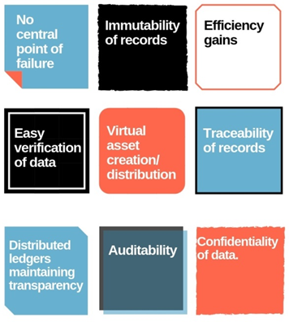
From the figure 1, it depicts characteristics of blockchain - decentralized, tamper-resistant, and a secure atmosphere to store data, (Ravindra, 2018) with those benefits, it is appropriate to provide support in various applications for Human Resources (HR) management.
  - Should Talent Attraction Process Go Through By Blockchain?
According to Mulligan, et al., (2018), blockchain technology should not be a goal for any organization, but this is a tool to be deployed aims to achieve designated purposes. Blockchain technology definitely brings HR management benefits. But should TA process go through by blockchain? Mulligan, et al. (2018) depicted a tool (Figure 2) that assesses if the Blockchain is a right solution for a specific issue.

Figure 2: Decision Tree for assessing if blockchain is the right solution for a problem.
(Source: http://wef.ch/blockchainhype)
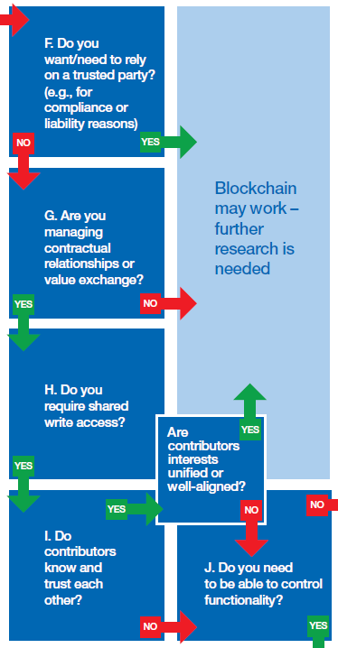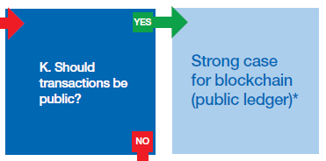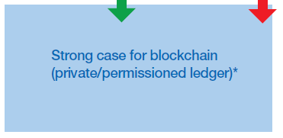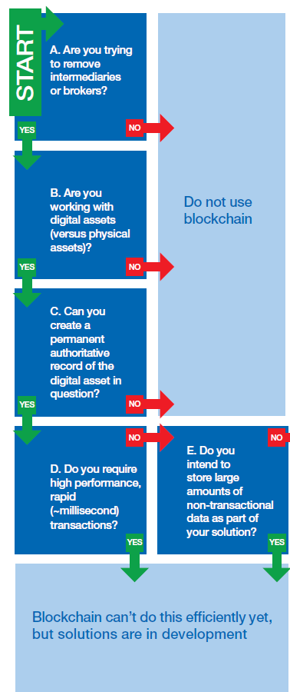
  - Use Case: Use Blockchain to Perform TA
- In the case of TA, the goal is to eliminate the intermediaries between the employer and candidates. Blockchain allows peer-to-peer interactions and candidates can go directly to the masses but keep candidates’ data confidentially. It decreases agencies (such as advertisement media, recruiting firms) costs and streamline the flow of data needed in the TA process. (Sharma, 2019)
- The records (assets) created in TA process are digital native – electronic personal files and advertisements can be classified as digital records.
- If both employer and candidate decide to provide the blockchain, both of them have full control over the records and maintain the state of that records digitally, as well as the historical assets.
- The record processed in the TA does not require performed in millisecond.
- No large amounts of data would be created during the TA process, thus it is not necessary to store huge amounts of value.
- No trusted party is needed during the TA process.
- A contractual relationship is built during the TA process.
- The shared write accesses of both employer and candidate are required. So both of them are able to write the TA process record on the blockchain.
- The employer and candidate are not known each other before the interview.
Once questions A to I are fulfilled, these indicate that blockchain technology is an appropriate solution for TA process. Questions J and K are used for differentiating the type of blockchain which should be utilized by an organization.
  - Blockchain helps Talent Attraction
Blockchain would totally change the way how the companies employ candidates. It allows employees to control over the access of trustworthy Blockchain-based record in which storing the data of their academic degrees, employment history, skill sets, training records and even performance index. By providing potential employers with access to their Blockchains instead of writing up a CV, companies would be able to match candidates with the positions offering much more accurately and effectively.
    - Better Capability of Screening Potential Candidates
Blockchain could help employers to know who are visiting their recruitment portal in real-time and effectively engage them by presenting the potential candidates with the right set of jobs and competencies to tag against. Such tailor-made job profiles for prospective candidates will ensure that the people attracted are the employers want and are good matched as jobs posted on employers’ sites. (Chakladar & Kannepalli, 2018) Also, Blockchain links to and collects candidates’ information across the network to get the correct profile matching against the job description (JD). (Sharma, 2019) This better matching ability associated with Blockchain exactly solves the wrong hiring problems which mentioned in previous section. Finding right talents are always challenging to human recruiters. Blockchain’s capability to automate the step of determining pre-qualified employees, therefore, helps saving a lot of hiring time and performing more effectively and efficiently, and thus boosting the overall productivity.
    - Avoiding the Lengthy Background Check
Lee (2018) mentioned that 75% of HR managers found candidates lie on resumes and they are always unreliable. Currently, verifying the credentials of the new employee against what is mentioned in their resumes is a time consuming and painful process. Instead of this process taking weeks, Blockchain processes this smoother and more streamlined. On Blockchain, the candidates are not able to lie about their academic qualification and other records because their data along with electronic signatures would be posted on the Blockchain and the organizations can access it. Alternating the data is not allowed since it has to engage taking over the entire blockchain which is an impossible action. (Ravindra, 2018) By having schools, colleges, and organizations on distributed ledgers that are linked with each other, a series of immutable records posted on the Blockchains that neglect the background check procedure. The HR can assured that the interviewee is exactly who they claimed they are on Blockchain. The costs and resources associated with the verification process is greatly reduced or nearly to zero.
Companies wind up their operations at a quicker rate than ever before, in such a mutable Blockchain mechanism, a central repository of authenticated, genuine candidates’ data would ensure quicker, easier and reliable background checks happen.
  - Disadvantage and Limitations of Blockchain
With the immutable feature of Blockchain, the comprehensive and completed picture of the candidate is readily available and all the subjectivity from the human recruiter should be taken out during the hiring process. The candidates are not able to adjust resumes or alter how they present themselves based on the specific job they are applying to. Blockchain stores both their successes and failures. This is forced candidates to embrace those failures, rather than just leaving them out, it is encouraging them to tell others what they have learned from the mistakes. (Ahmed, 2018) However, how many of us are willing to show the failures to the public? Would candidates rather abandon to use the Blockchain instead of telling others the truth? On the other side, even though a human have already changed or improved over a period of time, this may lead to increased prejudices because of their prior history.
With raising the concern on Government Data Privacy Regulations, people may not 100% believe in the technology security and not willing to pose their information on the Blockchain. This would definitely limit the usage and development of the Blockchain.

- Conclusion
Performing the TA process by Blockchain would be definitely a new open-standard protocol in the future. Having the trusted identity and tamper-proof records of transactions, it drives process effectively and efficiency by providing easier, more secure platform with lower costs by removing the intermediaries as well as saving HR resources or administrative efforts on record keeping and transaction reconciliation. (Carson, et al., 2018)
  - Challenge and Recommendations
Blockchain is still an immature technology and it is still nascent to HR field. The big challenge is where to begin. Blockchain brings benefits to HR functions only when it is deployed at scale. (Gale, 2018) For instance, if only a handful of universities provide that data on Blockchain, it doesn’t add much value on academic check process. The Chief Technology leader of Xerf, an automated reference checking company, Mr. Griffiths (Gale, 2018) predicted that there are still two to five years away from seeing any meaningful applications of blockchain for HR functions. Meanwhile, Jeff Mike, vice president and HR leader from Deloitte believed that “once the network effect kicks in, the growth of blockchain technology could be exponential” (Zielinski, 2017)
We still have time to prepare ourselves today. HR leaders should get familiar with the Blockchain technology and liaise with IT leaders to investigate the actual effect on the way will do in HR in their organization in the future. Lacking of Blockchain talent is concerning. The recruiters or other HR business partners should equip with the Blockchain knowledge before the technology get mature. At least, the employers are able to pose questions to the job seekers on the Blockchain.
To enable a smooth transition to the Blockchain technology era, the organization should ensure HR and other business partners’ buy-in the new technology. Be prepared for resistance among reluctant staff by setting expectations of the new services with a communication plan that assists the smooth transition.

Bibliography

Ahmed, A. (2018) How Blockchain Will Change HR Forever. Available at: https://www.forbes.com/sites/ashikahmed/2018/03/14/how-blockchain-will-change-hr-forever/#7c845b53727c (Accessed: 31st March 2019).
Carson, B., Romanelli, G., Zhumaev, A. & Walsh, P. (2018) Blockchain beyond the hype: What is the strategic business value? Available at: https://www.mckinsey.com/business-functions/digital-mckinsey/our-insights/blockchain-beyond-the-hype-what-is-the-strategic-business-value (Accessed :14th April 2019).
Chakladar, P. & Kannepalli, R.R. (2018) Here's How Blockchain Is Going To Impact Human Resources. Available at: https://www.peoplematters.in/article/hr-industry/heres-how-blockchain-is-going-to-impact-human-resources-18464 (Accessed: 31th March 2019).
Chronobank.io (2018) Four Blockchain Developments That Will Reinvent Your HR Department. Available at: https://blog.chronobank.io/four-blockchain-developments-that-will-reinvent-your-hr-department-9bd0b4a50142 (Accessed: 31th March 2019).
Gale, S.F. (2018) Blockchain: The Future of HR? Available at: https://www.workforce.com/2018/05/21/blockchain-future-hr/ (Accessed: 31st March 2019).
Kramer, S. (2018) Blockchain's Impact On HR and the Future of Work. Available at: https://futurumresearch.com/blockchains-impact-on-hr-and-the-future-of-work/ (Accessed: 31st March 2019).
Lee, W. (2018) How Blockchain Technology Is Upending the HR Department. Available at: https://www.influencive.com/how-blockchain-technology-is-upending-the-hr-department/ (Accessed: 31st March 2019).
Liew, V.K. (2018) HR Digital Transformation-powered by Blockchain. Available at: http://www.blockchainguide.biz/hr-digital-transformation-powered-by-blockchain/ (Accessed: 31st March 2019).
Mire, S. (2018) Blockchain In Human Resources: 8 Possible Use Cases. Available at: https://www.disruptordaily.com/blockchain-use-cases-human-resources/ (Accessed 14th April 2019).
Mulligan, C. et al. (2018) Blockchain Beyond the Hype A Practical Framework for Business Leders. Switzerland: World Economic Forum.
Onik, M.M.H., Miraz, M. & Kim, C.S. (2018) 'A Recruitment and Human Resource Managemnet Technique Using Blockchain Technology for Industry 4.0', Proceeding of Smart Citites Symposium, pp. 11-16.
Ravindra, S. (2018) How Can HR Professionals Get Benefited From Blockchain? Available at: https://www.analyticsinsight.net/how-can-hr-professionals-get-benefited-from-blockchain/ (Accessed: 31st March 2019).
Sharma, A. (2019) Is HR ready for blockchain?. Available at: https://www.peoplemattersglobal.com/author/anushree-sharma?utm_source=story_nav&utm_medium=author_link&utm_content=Anushree+Sharma&utm_campaign=author_track&utm_term=click (Accessed: 31st March 2019).
Tapscott, D. & Tapscott, A. (2017) 'How Blockchain Will Change Organizations', MITSloan Management Review, 58(Winter 2017), pp. 2.
The HRT News Desk (2017) Oracle Considers Using Blockchain to Boost Employee Productivity.
Available at: https://www.hrtechnologist.com/news/hr-analytics/oracle-considers-using-blockchain-to-boost-employee-productivity/ (Accessed: 31st March 2019).
Vizard, M. (2018) Blockchain Poised to Transform HR Talent Management. Available at: https://www.itbusinessedge.com/articles/blockchain-poised-to-transform-hr-talent-management.html (Accessed: 31st March 2019).
Zielinski, D. (2017) Is HR Ready for Blockchain Technology? Available at: https://www.shrm.org/resourcesandtools/hr-topics/technology/pages/is-hr-ready-for-blockchain-technology.aspx (Accessed: 31st March 2019).



