Tabitha Kalyan ( 2020004)

Module- ChangeMakers: Creativity and Value Creation
Module- BMHP5014
E-Portfolio evidence of learning comprising of 2 separate artefact items
Lecturer- Azora Hurd

Contents
Introduction 3
Artefact-2 3
Artefact-3 5
References 7

Crowdfunding platform to help poor people by raising fund for taking expensive medical treatment

Introduction

In this report, addressed two artefacts, namely Artefact 2 and artefact 3. The proposed idea for this project is to facilitate the best crowdfunding platform to help poor people by raising funds to take expensive medical treatments. Nowadays, crowdfunding for medical expenses has gained much popularity. It enables people to meet their healthcare needs by taking expensive medical treatments. From the perspective of people’s inability to take expensive medical treatment, we come to this idea.

Artefact-1 blog
Medical expense is one of the leading causes of bankruptcy in the UK. According to a survey, around 65% of personal bankruptcy was due to substantial medical bills in 2010, although most people have medical insurance. The concept of healthcare insurance is still not compatible with the mower &iddle-class people. Thus, medical crowdfunding is considered the most growing to raise funds for medical treatments. Medical crowdfunding is a small & swiftly growing phenomenon in which individual healthcare costs get funded by raising money from a larger group of people who want to contribute through an open Internet-based platform. Crowdfunding has enough potential to shape the healthcare system by providing potential chances for attired healthcare to everyone. Crowdfunding can potentially bridge the gaps between people & healthcare by offering a variety of methods. Medical crowdfunding can fight, in many ways to, the existed disparity in the healthcare system by providing an efficient solution to potential medical challenges (Jainn, 2022). With the rapid advancement of crowdfunding technologies & platforms can open effective campaigns for raising funds with a high success rate. It will encourage other bloggers to engage with the idea. Medical crowdfunding is the most viable option for reciprocal, experimental, and finance volition. GoFundMe is one of the most famous & largest UK-based crowdfunding platforms for raising funds for needy people. The analysis of listed general diseases & conditions in the crowdfunding campaigns will help the public health insurance firms to extend their lists of the funded medical interventions.
Generally, medical crowdfunding is developing for social projects or communities. It includes some most popular crowdfunding websites like YouCaring, GiveForward, and GoFundMe for helping patients by raising funds to meet their healthcare costs. The environmental trends motivate the caregivers and patients on these platforms to raise medical care funds. The campaigns for medical crowdfunding include fundraising for many reasons like disease treatment, homecare needs, general support, hospital expenses, and postoperative care in terms of postdiagnosis & drug protocols.
The below-illustrated figure addresses the primary fundraising purposes of running medical crowdfunding campaigns.
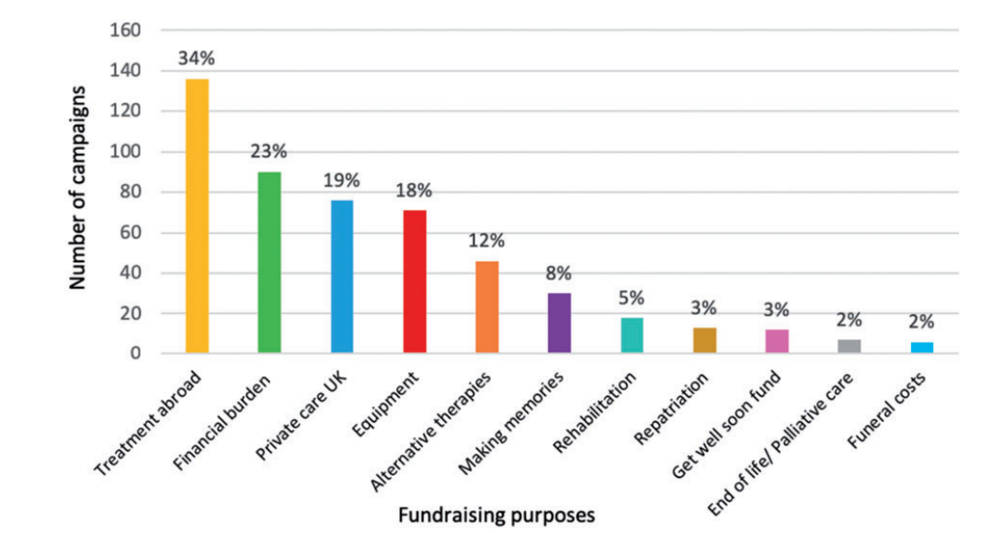
Figure 1: Fundraising purposes in the UK through GoFundMe
GoFundMe is the largest crowdfunding platform, which is the largest platform in terms of the raised funding amount. Fundraising categories are memorials, medical, charitable causes, and emergencies.
Several conditions as highlighted in different crowdfunding campaigns when a person needs finances. These conditions include disorders & diseases which prompt individuals to ask for donations. The most frequent diseases, conditions, or disorders force people to ask for the covered cost, as shown in the table below (Lublóy, 2020). According to this table, the most frequent health issues comprise mental disorders, cancer, accident, disability, rare diseases, genetic disorders, lipoedema, oral health, sclerosis, and dementia.
Table 1: Most frequent conditions in the crowdfunding campaigns
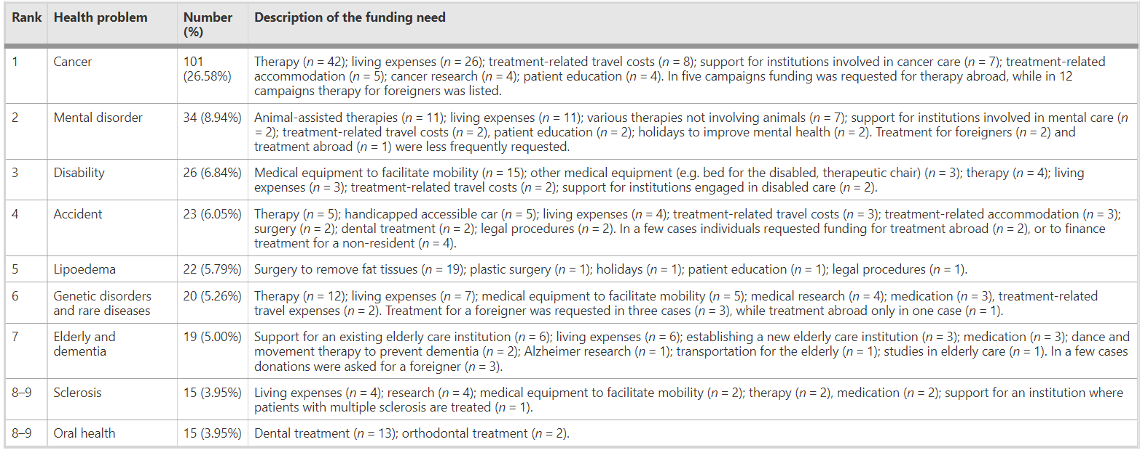
Thus, medical crowdfunding not only makes up for the deficiencies of the health insurance system but also addresses the issues related to the lower capital utilization rates and limited financing channels.

Artefact-2 Elevated Pitch
No matter how well someone plans for the future, medical emergencies will always occur. Furthermore, it might be challenging to afford high-quality medical treatment. It can consume all savings and put that person's family in financial difficulties (Renwick and Mossialos, 2017). Here, we want to make it easier to raise funding through crowdfunding for those who cannot afford expensive cancer treatments. With the use of the fundraising concept, we hope to specifically motivate males between the ages of 25 and 44 who are also eligible since they are familiar with the idea and can give comfort. In our view, creating a crowdfunding platform ensures that no one prevents from receiving a second opportunity due to a lack of financing. The purpose of the idea is to facilitate an efficient crowdfunding platform to raise funds for poor people to enable them to take expensive medical treatments. We request all to donate money for Chhavi, a 24-year-old girl who loves to bake and wants to open her bakery. During the COVID-19 pandemic, she knew that her mother had breast cancer. She was shocked after knowing it. The doctor tells her there is hope because there is a specific medicine that can help her mother, but the cost of the medicine is around £900/month. She was both happy & scared simultaneously because they had already exhausted all their savings. Thus, here we request donating money as much as possible to help her to fight this challenging situation and save her mother. Here we provided Chhavi's account details. Also can donate money via PayPal, Shopify, Worldpay, and Opayo.
As we all know, crowdfunding significantly impacts those who need health care services. That is the easiest way to raise funds for cancer patients who cannot receive treatment such as chemotherapy. Medical crowdfunding provides expanded participation of the funder in the health market, improves social engagement, improves access to financial support, and funds neglected health issues, as crowdfunding will enable Chhavi to spend donated money on the treatment of her mother's cancer. It is urgent to raise money for Chhavi to deal with this acute disease. Applying for a loan is not the best option during this challenging time because it is very time-consuming, and Chhavi is not eligible for the loan due to her low income. Therefore, the proposed idea of medical crowdfunding is the most viable option in this type of distressed medical situation. Thus, with this proposed idea, we mainly aim to target the diseases and medical disorders in which people need funds like Chhavi. We recommend that lending-based crowdfunding is the most efficient method to enable people to meet their donation goals to fight against acute diseases like cancer. We mainly intend to map out the unmet healthcare needs in the medical crowdfunding campaigns. Public health insurance companies do not finance most unmet healthcare needs related to different therapies.

References
Bassani, G., Marinelli, N. and Vismara, S., 2019. Crowdfunding in healthcare. The Journal of Technology Transfer, 44(4), pp.1290-1310.

Burtch, G. and Chan, J., 2014. Reducing medical bankruptcy through crowdfunding: evidence from GiveForward. In 35th international conference on information systems: Building a better world through information systems, ICIS 2014. Association for Information Systems.
Chiara, A., 2022. Medical Fundraising Works For Everyone. [online] Impactguru.com. Available at: <https://www.impactguru.com/blog/why-are-people-choosing-medical-fundraising-over-medical-loans-and-insurance> [Accessed 23 June 2022].
Jainn, C., 2022. How crowdfunding proved to be a low-cost healthcare financing option. [online]
Lublóy, Á., 2020. Medical crowdfunding in a healthcare system with universal coverage: an exploratory study. BMC Public Health, 20(1).
Renwick, M. and Mossialos, E., 2017. Crowdfunding our health: Economic risks and benefits. Social Science &amp; Medicine, 191, pp.48-56.
Singh, V.K. and Banerjee, R., 2022. Medical crowdfunding and COVID-19: awareness and perception of healthcare professionals and role of crowdfunding platforms in India. International Journal of Community Medicine and Public Health, 9(4), p.1884.

The Economic Times. Available at: <https://economictimes.indiatimes.com/small-biz/money/how-crowdfunding-proved-to-be-a-low-cost-healthcare-financing-option/articleshow/88729688.cms> [Accessed 19 June 2022].

