
2019
Matthew Howells (1702520)
University of Wales Trinity Saint David
1/1/2019

Programming in C++
Matthew Howells (1702520)

L4 - Software Development (ACCA4017)

(FACE)

Friday 12th April 2019
(Extended Deadline)

Table of Contents

1. Introduction and Aims 2
2. Planning a program 3
2.1. Evidence of problems being solved before carrying out any coding. 4
2.1.1 Listing and solving tasks, from easiest to hardest. 9
3. Functions 9
4. Implementation 10
4.1. Excersize 1 10
4.1.1. Breaking down Problems 11
4.1.2. Exercise 1 11
5. Testing Programme Exercises 13
5.1. Excersize 1 13
5.2. Testing Tables 18
6. Conclusion 21
7. Appendix 22
7.1. Excersize 1 22
8. Bibliography 26

Introduction and Aims

As society continues to develop positively, the amount of technical software continues to rise. As expected, this can mean further programmers are required in order to work towards keeping up with further developments. However further developments can lead to difficult problems. As part of this assignment students must put their skills to the test in order to complete a selection of tasks. This can include thinking skills as well as programming. The aim of this assignment is to allow students to analyse, solve and explain a number of problems that have been created, and assigned by the programming module lecturer. All students must have the ability to be able to create and understand the code using a high-level: programming language known as c++. All programming tasks must be developed and completed using software called Microsoft Visual Studio. This assignment documentation also looks into how students can work towards solving problems in a number of different ways while working in different situations.

The goal is to plan and develop solutions that may not be accurately correct but attempted sufficiently to a high standard. These tasks also allow myself to work toward developing through different techniques. This can be completed and explained within the assignment implementation section. All Exercises provided within this assignment allow students to challenge themselves while offering an opportunity to improve their programming skills.

Planning a program

While completing any form of important document planning is always an ideal point to begin. Before proceeding with any tasks planning is always the first phase in any project [1]. This can allow further investigations to be carried out by students. All information that has been investigated can always be useful to users. This can assist especially while working towards solving any further developments which may be made within the future.
Planning can consist from making simple notes and splitting up any problems into smaller sections to designing a mind map in order to collect multiple thoughts and ideas. The first main form of planning is identifying a full list of ways relative topic can be developed further. This can be done by conducting secondary research. [2]
As identified supplementary research must be carried out and referenced in a suitable manor if undertook. All research helps to support and back up statistical information. This can include choosing to make use of: -

- Books
- Journals
- Websites
- Forums
- Questionnaires
[2]

As researched and expected all problems can be broken down into different sections. These sections can consist by: -
- Drawing estimated design ideas
- Taking Photographs
- Making notes
- Creating flow charts
- Creating mind maps
- Creating pseudo code
- Bullet Pointing ideas

In order to address and solve a problem, programmers often require the need to break down any complex tasks into a set of slightly smaller responsibilities. These responsibilities can, usually, contribute towards solving the problem. This topic must be researched appropriately in order to gain the best outcome.

Evidence of problems being solved before carrying out any coding.

Evidence can be known as anything important that’s used to prove something. Evidence can be demonstrated in different areas. An example of evidence could be performing sources of planning. Planning can include describing problems and solutions using sources of text before carrying out any tasks. It is also important to include comments within programming tasks. Comments can be used to help humans understand exactly what the code is designed to do. By providing evidence programmers have the opportunity to address ideas before and possibly after completing their tasks. This procedure can allow further amendments to be made within the future. Research demonstrates that most programmers choose to use pseudo code [3]. Companies may wish to carry out essential changes in order to retain presence within the industry. This proves that further improvements can be made in order to compete with further programmers.
All attached evidence can also be used as a precaution to demonstrate any possible errors that could arise during the process of these programmes being build. This can be demonstrated by using the researched Mindtools planning cycle [4]. Until all exercises are completely planned to their best ability it is irrelevant to begin coding as developers have nothing to work against.

Why provide evidence?
It is always ideal to provide evidence as this can assist developers who may choose to invest within projects. Programmers may choose to work towards making improvements on this code later within the future. Evidence can be collected by writing different ideas down on paper using alternative methods. These methods can include; -
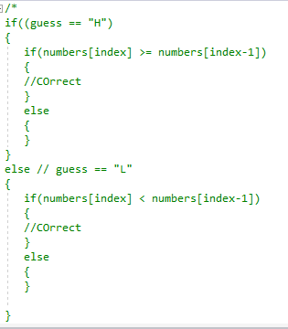
- Pseudo code
- Bullet points
- Mind maps

These methods can be provided to senior managers in order to allow developers to plan projects further. All information must be documented sensibly.

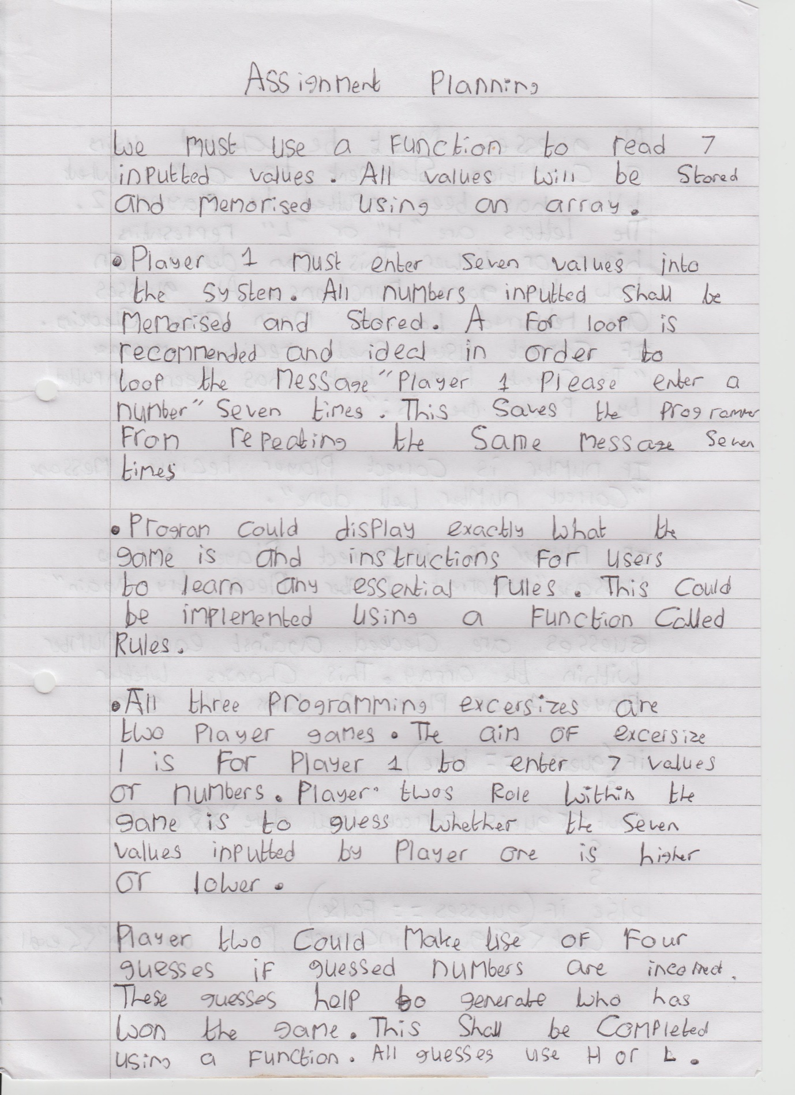
Figure 1 - Excersize 1 Plan page 1

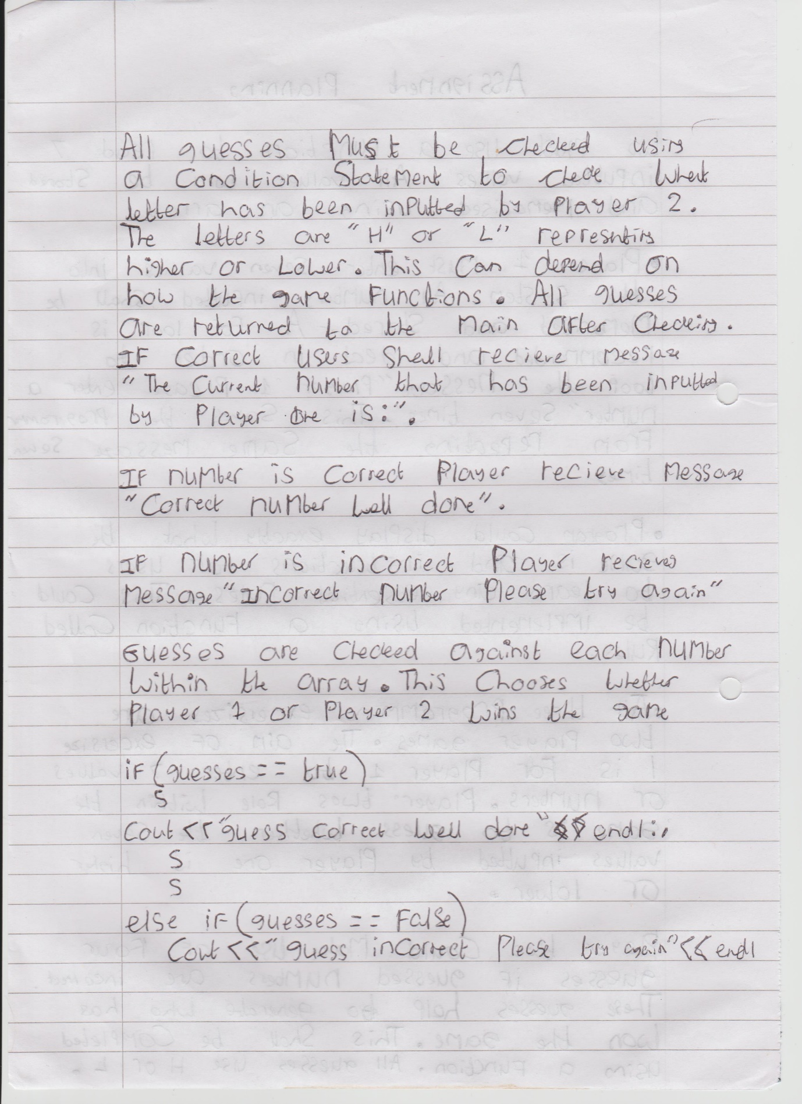
Figure 2 - Excersize 1 Plan page 2

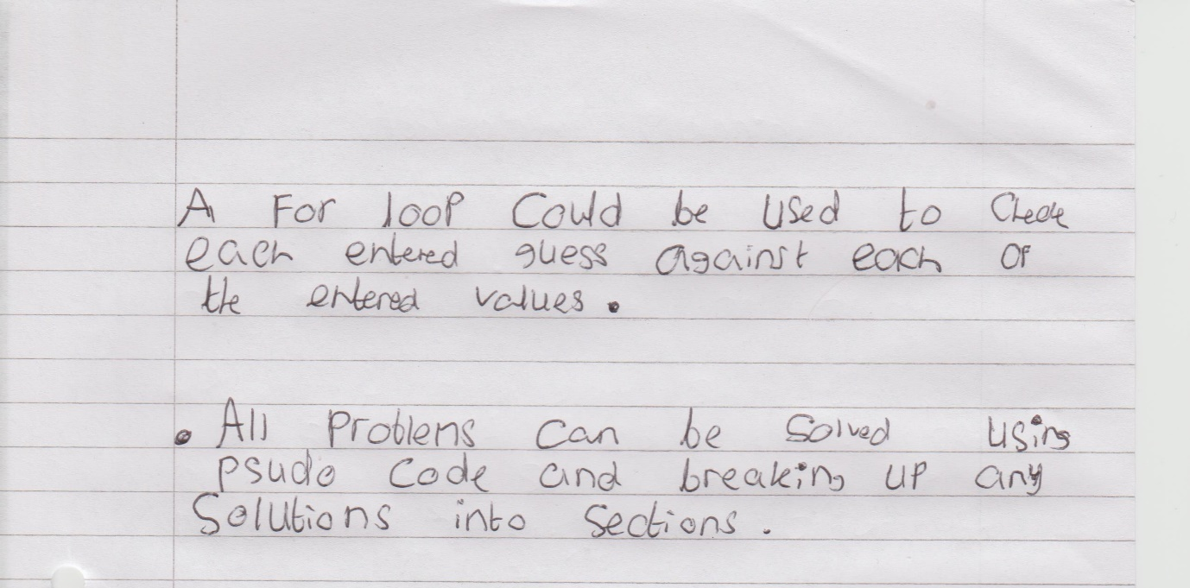

Figure 3 - Excersize 1 Plan page 3

All documents included above demonstrate how programming tasks can be split up. These bullet points can provide guidance while designing exactly what the final outcome will look like. A design breakdown can be viewed below.

Figure 4 - Excersize 1 design breakdown

Listing and solving tasks, from easiest to hardest.

As previously explained while working towards solving problems it can occasionally be ideal to break down a big problem that has been set into smaller blocks. In order to address a problem professionally and appropriately developers often choose this method. Problems can be broken up into small chunks, so developers are able to work on certain parts of their code. This process helps programmers carry out necessary changes without affecting any working parts of their code. Eventually, while all problems are split up programmers can solve difficulties more rapidly. Decomposition can help ensure that all tasks are attempted, examined and investigated properly [5]. This is demonstrated within the assignment implementation section.

Functions

Array – A array memorises and stores each number entered in a function

For loop – A loop is a statement that allows a process to be repeatedly executed

Integer – An integer can be used to input a number

cout = cout can be used to display a message within a program

Boolean – A Boolean is used to display a true or false value. This can be used to display a 1 or 0 value.

If statements – This is a condition to check if anything falls between two or more values.

All identified functions have been researched using a book called c++ Programming for beginners [6].

Implementation

Excersize 1

Exercise one consists of building a game suitable for two-players. The first player enters seven values between one and ten. The first value is shown to the second player. Later player two is asked to guess whether the next value is higher or lower than the one being shown. Once their guess Is entered the next value is shown. This process repeats until all seven values are displayed. When all the values are discovered, the game comes to a halt. If any correct guesses are made the second player takes victory, but player one can win if player two fails to input the correct guesses.

Here is an example of what the programme should look like
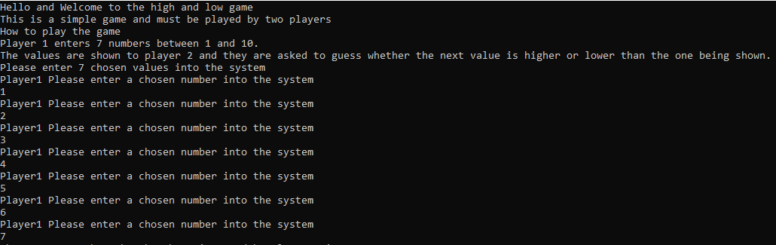
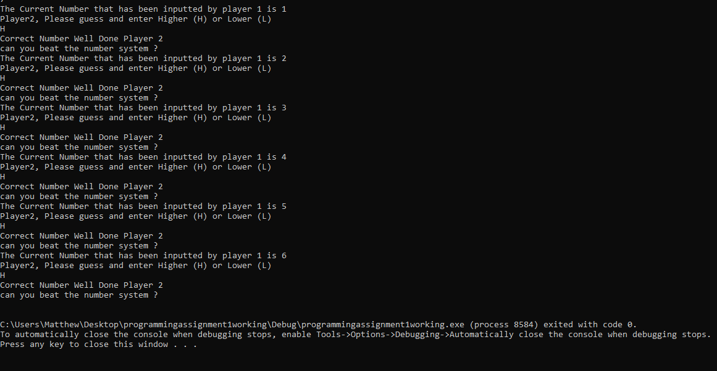

Breaking down Problems

Exercise 1

- How to display game rules

The game shall begin by displaying a polite opening greeting message to welcome users to the game. An instructive breakdown of game rules shall follow. All rules shall be inputted using the cout command.

- How do users know how many people can play the game?

The game shall include a message displayed informing users that the game must be played by two players. This can be done using the cout command which can output the printed message.

- How to Enter a value or number into the number system

Player one shall receive a message to input a value. All values are checked using the stored array. The check can be carried out by using a function followed by a getline command. The message” Player1 Please enter a chosen number into the system” shall be looped around seven times in order collect values from player one.

- How to Store 7 values using an array

In order to store seven values an integer array must be created. The array has ideally been designed to store and memorise 7 values inputted by player one.
This array can be known as int numbers [7];.

- How to Enter 7 values into a loop

All values can be entered into a loop known as for loop. The for loop has been chosen to repeat a message seven times, which shall be stored in an array. The array memorises the number ready to assist player two to guess if the number is high or low later in the game.

- How does player 2 enter a high or low number?

Player two has the option to enter a high or low guess using an if statement. The if statement is linked to the array within the program. If the number within the array is high and player two has inputted a high guess the program shall output “correct” else if the player has inputted low and the guess is wrong a message “Incorrect Number! Player 1 wins! Thanks for Playing High or Low" shall appear before ending the game.

- How do users compare numbers stored by player 1?

All inputted numbers shall be compared against an array. The array has the ability to detect and decide whether player two has won or lost the game. This makes the game as fair as possible.

- How do users know if anybody has lost the game?

If anybody has lost the game a message displaying "Incorrect Number! Player 1 wins! Thanks for Playing High or Low" should appear else if a player wins the game the game shall input "Correct Number Well Done Player 2 Has Won the Game”. All messages are outputted using a cout command.

Designing
While analysing Exercise one to identify the problem I found it useful to design my implementation similarly to the design idea provided on the assignment brief. This is due to the example design demonstrating a simple enough process of the Excersize. By using a making the program brief and easier for users to use without any complications.

Using Pseudo code
While designing the program I chose to make use of pseudo code. The aim of Pseudo code is to plan the structure of a program. Pseudo code is known where an individual sketch out the structure of a program. This must get approved before any actual coding takes place. Pseudo code is a key part of programming.

Testing Programme Exercises

The idea of carrying out tests allows developers to ensure their designed programme functions, positively, as intended. As expected, developers choose to record any carried-out tests of their programmes ensuring the program remain stable performing to their best ability throughout. In order to keep the tests as accurate as possible it was ideal to introduce a testing grid [7]. The testing grid contains logs of all information that has been tested. All Evidence Supporting Testing can be discovered further within the documentation under testing.

This section demonstrates a series of tests that has been carried out and conducted multiple times. All results have been recorded and stated by using screen shots as provided. These attached screenshots can be referred to as supported evidence.

Excersize 1

Programme begins by displaying a welcome message
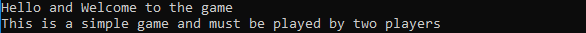
Ideally every program must contain a polite opening greeting in order to attract a user’s attention. The code is currently running and displaying the correct opening messages. The opening is set up to display a polite welcome message to greet the Players, explaining as expected that the game is simple enough to play but only suitable to be played by two players.

Player one must begin the game by entering seven chosen values into the games number system. The number system is known as an array. All values must be between one to ten in order for the program to work properly. All numbers have been memorised within the programming code.

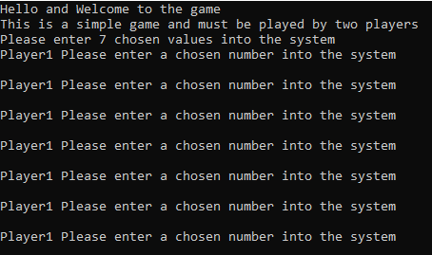
This message was introduced to prompt player one to input a number. The message has been set to repeat the seven times. This has been set up by using a for loop. This saves programmers from repeating the same message over again.

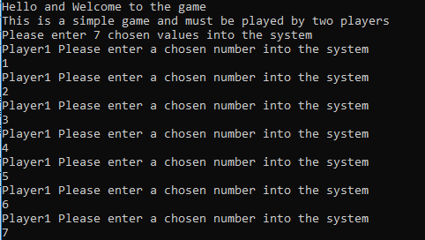
Here are seven values that have been inputted into the number system. All numbers are memorised and stored into the program by using an array.

Does Higher or Lower features work?
The message displaying the current number has been inputted by player one. This message has been set to loop around seven times.
This follows a prompt message informing player two to enter their high or low guess choice.
As displayed the number system has picked up the first number inputted by player one to be number one.
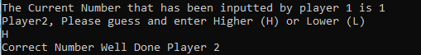
The first number has been guessed correctly as a High guess
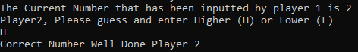
The number system has picked up the second value inputted by player one to be the number two. The next value has been guessed correctly as a High number.
The number system has picked up the third number inputted by player one to be the number two. The next value has been guessed correctly as a High number.
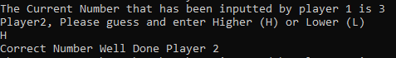
The number system has picked up the third value inputted by player one to be the number three. The next value has been guessed correctly as a High number.

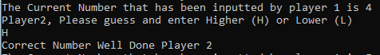
The number system has picked up the fourth value inputted by player one to be the number four. The next value has been guessed correctly as a High number.

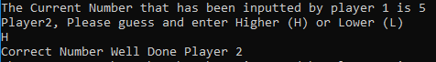
The number system has picked up the fifth value inputted by player one to be the number five. The next value has been guessed correctly as a High number.

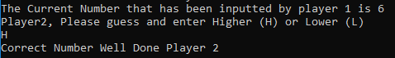
The number system has picked up the sixth number inputted by player one to be the number six. If player can not continue without breaking the code player 2 has won, the game.

After the game has finished the code shall break leading the debugging to stop.

Inputting incorrect guesses test

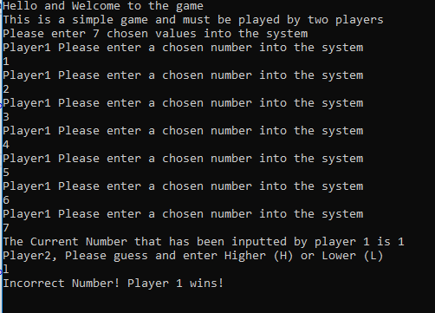
Every game must have a way of a player losing in order to end the game. At this point player two could input a guess. If any number guesses are inputted incorrectly throughout the game the game shall end automatically, which means that player one has won, the game. This has been set using a break, which is designed to break the running of the code. A message has been set to appear informing the user that the game has ended.

Test Implemented Changes
As expected, testing is important as this process can outcome whether the program works properly for all the correct reasons. Later after testing took place it seemed ideal to make some slight amendments to the program. This included added extra content to improve users experience.

Name of game
The game has been set to open displaying a welcome message. Originally this had been introduced but did not include the name of the game. Later it was decided that the game should be named. The name was named “High and Low Game” based on the aim of the game to guess high and low values.
Instructions
After gathering feedback from a small number of course members it was recommended that instructions on how to play the game should be introduced. This can help certain players, learn. This has been set to display after informing users that the game requires two players.

Rhetorical Question
Based on current gameshows it seemed ideal to introduce a rhetorical question. This was introduced in order to help make the game sound competitive and exciting to users.

Testing Tables
Inputting correct values test
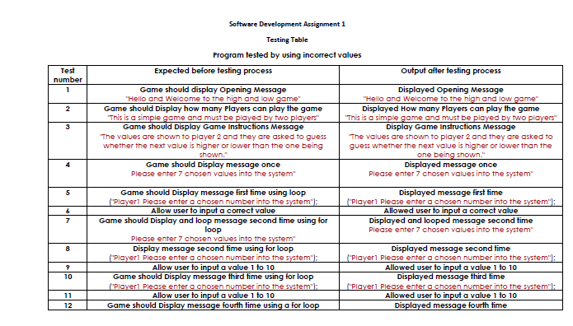
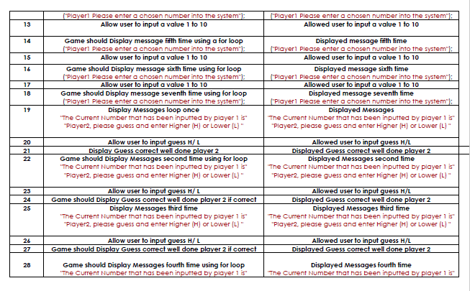
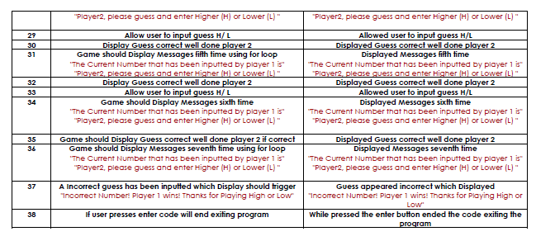

Inputting Incorrect values test
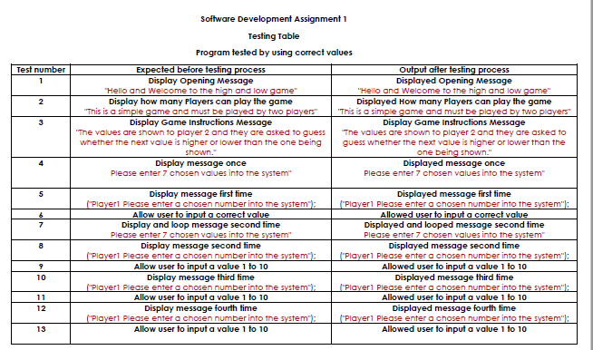
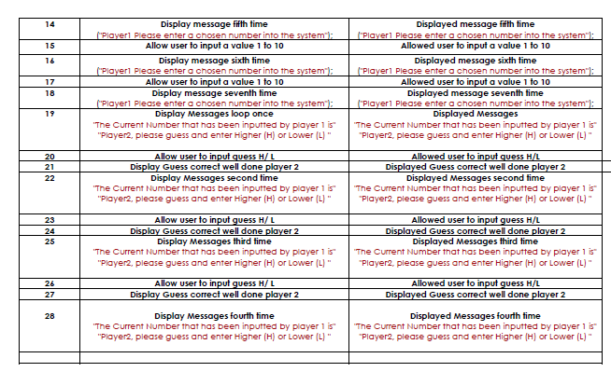
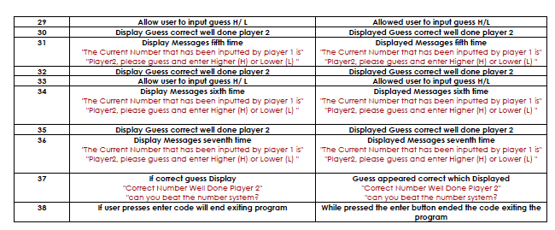

Conclusion

As a full time, student studying basic programming I have learnt that it is always important to make the most of any research available. This can include making use of the university’s library resources in order to gather further information which could possibly help develop my assignment content. Some examples which have helped gather further information is the amount of programming journals which can be accessed using the online library.
Based on the assignment brief it was recommended that all students planned their work before developing any code. All notes were written on pieces of paper which could be used as reminders while developing our code. All notes could be linked and uses as part of our research. This can also help save us time which could be used within the programming process.
I also found applying comments to my programming code useful as it helped ensure the programmed code carried out the correct task as expected. The goal before this assignment was to design a basic game that allowed players to guess high and low numbers. While finalising and commenting this Excersize I can confirm that goal was successfully reached and achieved.
If this program had to be carried out later within the future it would be wise to keep track of time better in order to complete the extra exercises.

Appendix

Excersize 1

#include <iostream> //
#include <string> // using a string
#include <sstream> //
#include <random> // input random digit

using namespace std;

int readNumber(string message); // System reads number
void enterNumbers(int numbers[]); // Player 1 enters numbers
void guessNumbers(int numbers[]); // Player 2 guesses numbers

int guesses = 4; // User has four guesses
int num1;
int num2;

int main(int argc, char** argv)
{
int numbers[7]; // Array of 7 numbers

cout << "Hello and Welcome to the high and low game" << endl;
// This is a greeting which is displayed welcoming users to the game

cout << "This is a simple game and must be played by two players" << endl;

// How do I How play the game?" << endl;
cout << "How to play the game" << endl;

cout << "Player 1 enters 7 numbers between 1 and 10. " << endl;
cout << "The values are shown to player 2 and they are asked to guess whether the next value is higher or lower than the one being shown. " << endl;
// This displays instructions for the two players on how to play the game

cout << "Please enter 7 chosen values into the system" << endl;
// Player 1 must enter 7 values in to the system

enterNumbers(numbers);
// this function is used to pick the number

guessNumbers(numbers);
// This is passing the picked number

cin.get();
}

int readNumber(string message)
{
string input;
stringstream stream;
int number;

cout << message << endl;

getline(cin, input);
stream.str(input);
stream >> number;
stream.clear();

return number; // system returns numbers
}

void enterNumbers(int numbers[])
{
int index;

for (index = 0; index < 7; index++)
{
numbers[index] = readNumber("Player1 Please enter a chosen number into the system");
//Player 1 must enter a number into the number system

}
}

void guessNumbers(int numbers[]) // user guesses numbers
{
int index;

for (index = 1; index < 7; index++) // while (index <= 7 && flag == true ) {}
{
string input;
cout << "The Current Number that has been inputted by player 1 is" << " " << numbers[index - 1] << endl;
//this displays the current number that has been inported into the system

cout << "Player2, Please guess and enter Higher (H) or Lower (L) " << endl;
//Player 2 must guess the number thats has been inputted by player 1 using high or low
getline(cin, input);

if (input == "H" || input == "h") // if users inputs high or low letters
{
if (numbers[index] >= numbers[index - 1])
{
cout << "Correct Number Well Done Player 2 " << endl;
cout << "can you beat the number system ? " << endl;
//If user guesses correct display "Correct Number Well Done Player 2 Has Won The Game"

}
else
{
cout << "Incorrect Number! Player 1 wins!Thanks For Playing High or Low" << endl;

//if user guesses incorrect display "Incorrect Number Player 1 Wins"
break;
}
}
else if (input == "L" || input == "l") // If User Inputs Lower (l) (L)
{
if (numbers[index] < numbers[index - 1])
{
cout << "Correct Number Well Done Player 2 Has Won The Game" << endl;
//If user guesses correct display "Correct Number Player 2 Has Won The Game"
}
else
{
cout << "Incorrect Number! Player 1 wins. Thanks For Playing High Or Low !";
//if user guesses incorrect display "Incorrect Number Player 1 Wins"
//break; //break the code
return;
}
}
}
}

bool GuessAmount(char guesses)//input four guesses
{
int i = 0;
bool match;

for (int index = 0; index < 6; index++)
{
cin >> guesses;
if (guesses == 'H')
{
if (num1 > num2)
{
match = true;
}
else if (num1 < num2)
{
match = false;
cout << "Player 1 wins" << endl;
}
}
else if (guesses == 'L')
{
if (num1 > num2)
{
match = true;
}
else if (num1 < num2)
{
match = false;
cout << "Player 1 wins" << endl;
}
}
}
return match;
}
//break;

Bibliography

[1] | “www.ite.org/,” [Online]. Available: https://www.ite.org/pub/?id=4869d329-a7b5-39ec-79f9-193d903b579d. [Accessed 05 April 2019].
[2] | S. Cottrell, The Study Skills Handbook, 2019.
[3] | K. Academy, “Planning with Psudo Code,” Khan Academy, 2019.
[4] | M. t. c. team, “The Planning Cycle - A Planning Process for Medium-Sized Projects,” Mindtools, [Online]. Available: https://www.mindtools.com/pages/article/newPPM_05.htm. [Accessed 12th April 2019].
[5] | B. Bitesize, “What is decomposition?,” [Online]. Available: https://www.bbc.com/bitesize/articles/z8ngr82. [Accessed 12th April 2019].
[6] | M. Lee, C++ Programming 2nd Edition for the absolute beginner.
[7] | “Using Test Tables,” http://openl-tablets.org/, [Online]. Available: http://openl-tablets.org/files/openl-tablets/5.10.1/OpenL%20Tablets%20-%20Reference%20Guide/SMPUserTestTable.html. [Accessed 14th April 2019].

