Professional Career Development

Abstract:
Being students is one of the best opportunities that we ever get to learn things well before facing the competitive corporate world outside. Career goals are set by us from initial days of our studies so that we can undertake our learning patterns as desired to help us achieve the targets that we have set for ourselves. This study is a reflective review on how I discovered my competencies as well as the areas that I need to develop in order to help me achieve my dream of becoming a Restaurant Manager of a five-star hotel.
By working on this reflective review model about myself I aimed at helping students like me to understand the importance of evaluation of their own learning styles, as well as evaluating the skills that they already possess as well as the skills that they would need to cultivate in order to be successful managers in future.
I have done a SWOT analysis on my skills which has helped me to come up with a Personal Development Plan (PDP). This plan would help me to take proper actions which are required in order to achieve my set target.
Finally I have discussed about the action plans that I would take in order to achieve the set goals mentioned in the PDP. Focusing on career needs a lot of determination, hard work and above all efforts in the correct direction, hence, this module would help me to give correct direction to the efforts that I am taking to build my career in Business Management.

Contents:

Abstract: 2
Introduction: 4
Task 1: Making sense of learning through self-awareness: 4
1.1 Research and analysis of my learning styles: 4
1.2 Personal and Key Skills: 11
1.3 Analysing my strengths, weaknesses, opportunities, threats (SWOT): 22
1.4 Preparing a Personal Development Plan: 24
Conclusion: 26
References: 27

Introduction:
Personal development is a continuous process. As a student it helps in developing skills and competencies that would help in doing well in academics, and on the other hand career-wise, personal development also complements with professional development, which can be one of the biggest reason for the individual to do well in his/her professional background, which indirectly can a reason for business development (Becker Professional Education, 2017). It’s very important for one to analyse their own skills and potentials and indulge in the process of self-examination and self-awareness so that necessary plans for improving the necessary skills can be taken at appropriate time (Kaplan Test Prep, 2017). Below reflective report is my evaluation about my existing skills as well as the desired skills along with the action plans that can be taken to minimise the gap between these two.

Task 1: Making sense of learning through self-awareness:
Learning is a never ending task. May it be learning theories and academic books as students or learning daily business activities as managers in future, an individual always enhances his experiences as much as he takes efforts towards learning and hence can accomplish the undertaken task more efficiently and effectively (World Bank Group, 2017)

1.1 Research and analysis of my learning styles:
Being a high school student I am already been exposed to various types of learning styles. Different assignments helped me learn with different learning styles. Lectures in the classrooms helped me with Verbal style of learning; the different presentations and modules introduced helped with Visual style of learning, and the practical sessions helped with the Physical style of learning. In addition to this the group and individual assignments given to us by our mentors till date has helped me to develop the Social and Solitary style of teach (Kostelnik et al., 2016). All these different styles of learning are used by me in the academics in some or the other way.
Theoretically different researchers have come up with different learning frameworks in order to help the mentors categorise students as per their leaning skills. Few of the learning styles defined by some researchers are evaluated below;
- Kolb’s theory of learning says that people learn in a cyclic pattern. According to him, people develop different styles of learning as they grow up. It is demonstrated in the diagram below. According to him we develop a particular style of learning and grasping things without realising and the developed style helps to do, review, conclude and plan for the future. This model is related to the Learning Style Inventory instrument (LSI) (Kaplan Test Prep, 2017). This tries to understand the preference of the learners with respect to actions versus reflection and abstract versus concrete.
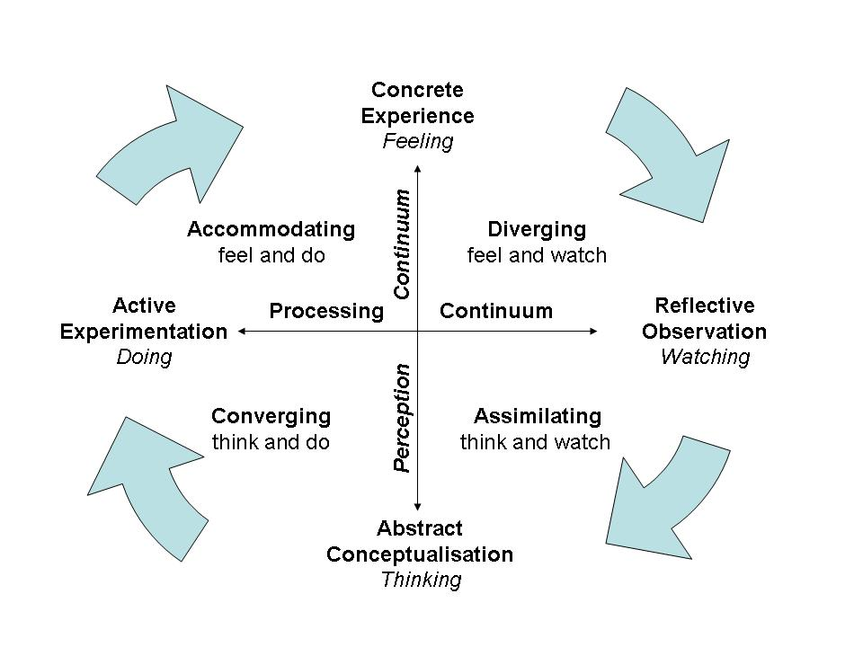
Figure 1: Source; (Peterson & Kolb, 2017)
- Honey and Mumford came up a learning style assessment which is also known as Learning Style Questionnaire (LSQ). According to LSQ, the types of learners are – activists (those who learn by experience), reflectors (those who learn from reflective observation), theorists (those who learn by exploring interrelations and associations), and finally pragmatics (those who learn by doing things practically). The other alternative for LSQ is CLSI (Canfield Learning Inventory), which elaborates about the learning styles with four dimensions which are – mode of learning, condition of learning, are of the interest and finally the conditions of performance (Beard & Wilson, 2018).
- To take this even further, Felder and Silverman came up with a new concept of learning style assessment which was designed specifically for classroom style learning method. This framework consists of multiple choice questions which were divided into 3 sections – preferences of the learners in terms of learning styles which can be intuitive, verbal, sensory or visual; approach of the learners towards approaching and organising the information learnt which can be active or reflective approach; the student’s rate of progressive understanding which are global or sequential. This model developed is known as Index of Learning Survey (ILS) (Heywood, 2018).
Below are few of the assessments that I underwent in order to evaluate about my own learning style.
- Honey and Mumford Learning Style Questionnaire:

- VAK Learning styles Self Assessment Questionnaire (Visual, Auditory and Kinaesthetic):

- Learning Style Quiz:
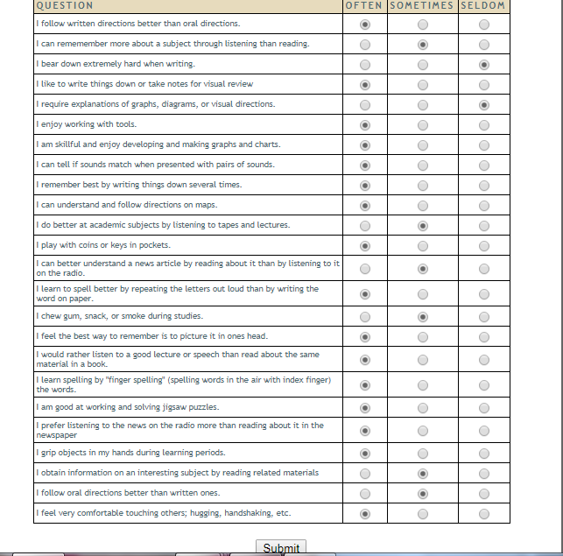
The above questionnaires attempted by me help to evaluate that I have adopted visual style of learning during my progress as an individual. I believe that all the assessment styles are best; however, the VAK style of learning assessment is more beneficial according to me as it helps to evaluate self-assessment more precisely (Walsh, 2011). Multiple choice questions which depend on condition are easy to understand and hence the result can be considered to be accurate and true.
I prefer the mixture of Visual and Kinaesthetic styles of learning. I believe that I am able to grasp and understand things more easily by visually and practically doing things rather than just going through the written theories and academics verbally. In order to become a more effective learner, I need to indulge myself into more practical learning’s as well undertake projects that would help me work in groups. This would help me in developing a teamwork spirit within me as well as it would also help me with inculcate a habit and confidence of working in team which is essential for my future aspects (Tudor & Carlo, 2018). I can develop my learning skills by indulging myself into some physical activities like dodging a ball, shooting hoops, etc which would help me concentrate more on learning, conducting more experiments and action required tasks would help me be more active learner than just plain lectures and notes.
When I evaluated about my skills, I scored myself as below in each and every area out of 5;
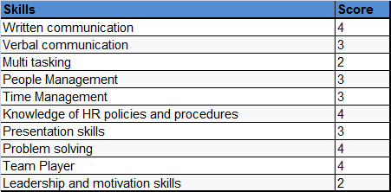
The areas that are scored as 3 and 2 need more initiative of development by me. The qualities like multi-tasking, people management, time management, presentation skills, leadership and motivation skills, etc can be enhanced when I work in groups and take responsibility of other individuals. Time management can be done by sorting my day to day activities as per preference and importance. Disciplining my life and making small changes in my day to day activities would help me develop the qualities that I am lacking behind.

1.2 Personal and Key Skills:
Employees are expected to be skilled and experts in the tasks allocated. As I aspire to be a manager in future, along with expertise in my field, I am expected to have various other skills like – problem settling, managing people, etc (Žarkić-Joksimović & Marinković, 2018). The below assessment tool has helped me to evaluate my strengths and weaknesses.
- Started but need more practice | - Able to do this with some help
- Competent without help | - Competent and able to help others
 | 1 | 2 | 3 | 4 | Evidence /Justify your rating
MANAGEMENT of SELF

- Use, evaluate and adapt a range of academic skills (analysis, synthesis, evaluation, argument) |  |  | 3 |  | I am able to work competently on evaluating academic skills. In group discussions, I argument pretty well on the points put forth by me
- Manage your time effectively (meet deadlines, get to appointments/classes on time) |  |  | 3 |  | I am never late to my classes. If in case of any emergencies I always try to inform my mentor well before in hand. All my assignments and other academic submissions are always done on time without delays
- Set realistic objectives, priorities & standards |  | 2 |  |  | Though I am good at achieving my set targets on time, still I need my mentors help to make me understand about the actual sequence or prioritisation of the tasks I have undertaken.
- Monitor, evaluate and adapt own performance |  | 2 |  |  | When in group my group members help me by monitoring my work, however in case of individual tasks, I report to my mentor on timely basis just to make sure that my work and progress is in the correct direction
- Clarify personal values |  |  | 3 |  | During group tasks I am always comfortable in explaining my view points and justifying them with valid rationale.
- Evaluate your own potential for employment | 1 |  |  |  | As I am into my learning phase presently and have no work experience, I am still evaluating my employability skills on the basis of academic learning’s.
- Show intellectual flexibility (be willing to see that there may be more than one way to solve a problem) |  |  | 3 |  | I am good at exploring things. Being a visual and kinaesthetic learner, I usually prefer to use intellectual experiments on my assignments rather than working on the basis of theoretical aspects. Hence, due to experiments I am able to solve a problem in more than one ways.
- Take responsibility for acting in a professional/ethical manner |  |  | 3 |  | I have a good rapport among my mentors as far as my ethical manners are concerned. I am regular to classes; submit my work on time, active participant in lectures and so on.
- Deal with criticism constructively |  |  | 3 |  | At the end of every assignment and group work our mentors give us positive as well as negative feedbacks of our work. I always take these feedbacks seriously so that I do not end up with same mistakes next time.
MANAGING YOUR LEARNING

- Take responsibility for your own learning and  personal growth (monitor, evaluate and adapt your  own performance; work towards long term aims  and goals) |  |  | 3 |  | I am very much determined about being a manager in future. I know that there are many skills that I need to develop as a manager like time management, problem solving, team handling, conflict resolution, and decision making and so on. Along with theoretical knowledge I need to be more competent with the practical knowhow’s as well, hence, I usually take active participation in all the management development skills assignments given by our mentors.
- Set realistic objectives, priorities and standards |  | 2 |  |  | I take help from my mentors to set my priorities and objectives. Being into learning phase, I want to take my efforts into correct direction, hence, seeking help from mentors help me a lot in this case.
- Develop, evaluate & adapt learning strategies |  |  | 3 |  | My learning style basically includes a combination of visual and kinaesthetic style of learning. Hence, I go through many graphs, diagrams, indulge myself into physical experiments, etc so that I can enhance my learning skills even more.
- Use learning in new or different situations/contexts |  |  | 3 |  | I am able to utilise my expertise analytically in almost all the situations I am into. As we are always given new case studies, and learning assignments, my knowledge and learning style help me with productive and qualitative results.
- Learn through collaboration |  |  | 3 |  | Team assignments need good collaboration with team members as well as capability to justify the points that are put forth by the students. I am good at doing this. As I usually think analytically, I am usually able to debate on the points suggested by me.
- Purposefully reflect on own learning and progress |  | 2 |  |  | I need my mentors help to always evaluate about my learning’s. Though I try to evaluate myself, still the confidence level is not up to the mark to consider my evaluation as final. Mentors help me with better scores on my progress as well as help me with correct directions.
- Demonstrate an awareness of learning processes |  |  | 3 |  | I am aware of the three main types of learning process, Visual, Verbal and Kinaesthetic. As me my self assessment, I evaluated that I have a combination of visual and kinaesthetic style of learning.
PROBLEM SOLVING
- Identify the key features of the problem |  |  | 3 |  | I am usually able to understand the problems in the given situations. Linking of the theoretical knowledge with the case studies as well as analysing the complete situation helps me to come up with the exact problem areas to take the study further.
- Think laterally about the problem |  | 2 |  |  | I need help from the books, journals, mentors and even fellow students to think laterally about the problems found. Lack of confidence about my own knowledge can be reason to seek help from others.
- Conceptualize the issues |  | 2 |  |  | Conceptualising the issues found is a difficult task for me. I take help from theories and other relevant literatures available.
- Identify the options |  | 2 |  |  | Literature is used to identify the options as well.
- Identify solutions |  | 2 |  |  | Help from resources and mentors are taken to identify the solutions.
- Plan and implement a course of action |  | 2 |  |  | Planning and course implementation is usually done in groups. Hence, group’s advice is taken in such cases.
- Carry out solutions |  | 2 |  |  | Solutions are also implemented and carried out after proper consultation with the group involved.
- Monitor evaluate and adapt solutions and outcomes | 1 |  |  |  | Solving problems individually is my weaker section, hence, monitoring and evaluating the solutions cannot be done individually, however I am working hard towards this by seeking more and more theoretical knowledge about skills required for problem solving.

COMMUNICATION
- Present oral/visual information competently |  |  | 3 |  | I feel easy while communicating with my fellow students and getting my thoughts clearly presented.
- Use appropriate language in a range of activities  (essays, reports, presentations, interviews) |  |  | 3 |  | My assignments, reports, presentations, and essays are usually presented in formal, appropriate, and grammatically correct language.
- Listen actively and effectively |  |  | 3 |  | I am very attentive in classes and my lectures. I usually visual the concepts while the mentor is teaching.
- Offer constructive criticism |  | 2 |  |  | In case of doubts or criticisms, I usually consult with other students, and mentors, if my criticism is valid then I criticise the situation or solution.
- Verbal communication (speak fluently and  confidently to a variety of audiences) |  |  | 3 |  | I have performed well in class presentations; my communication is fluent and has a pretty confident tone while talking to others.
- Produce different written documents (using  appropriate formats, punctuation, accurate information, spelling, and grammar) |  |  | 3 |  | I am able to write grammatically correct information which are properly analysed, evaluated and then presented.
- Use charts, diagrams and other illustrations to  support verbal and written communication |  |  | 3 |  | I do support all my studies with relevant charts and diagrams to make my points more clear and relevant to the reader.
- Evaluate and adapt strategies for communication |  |  | 3 |  | I am good in communication, this is one of my strengths and I am developing this by reading more books on communication skills, participating more in group presentations and so on.

WORKING WITH OTHERS
- Plan with others (ensure clear goals, take  responsibility and carry out appropriate tasks) |  |  | 3 |  | This is my strength. I feel comfortable with group working and doing things collaboratively.
- Respect the views and values of others |  |  | 3 |  | I am a good listener too. As I listen to others and work collectively, working in group makes my assignments more reliable
- Adapt to the needs of the group/ team (take  initiative, lead, delegate, stand back, negotiate  etc) |  |  | 3 |  | I do take initiatives during group assignments. As I am always equipped with more than one solution due to my kinaesthetic style of learning, I am also able to lead the project.
- Assist and support others in learning |  |  | 3 |  | Fellow students usually seek my help while working on projects collaboratively.
- Delegate and stand back |  |  | 3 |  | I am a good team player, hence able to delegate and stand back actively.
- Negotiate with individuals/groups |  |  | 3 |  | In case of conflicts while working together, I am most of the times able to negotiate about my views and thoughts.
- Work to collective goals (work to agreed plans,  within agreed resources) |  |  | 3 |  | I am punctual and disciplined with my work; hence, I am always able to work on the agreed plans and resources.
- Monitor, evaluate and assess processes of group/  team work |  |  | 3 |  | As I lead the group most of the times, I am able to evaluate and take the teamwork towards correct direction.

DATA HANDLING
- Use appropriate sources of information (library,  retrieval systems, IT, people etc ) |  |  | 3 |  | My work mostly depends on relevant books, journals and information from internet.
- Use appropriate technology and media including IT |  |  | 3 |  | Sound computer knowledge is again my strength, hence, I am able to utilise the relevant IT help to work on the given projects.
- Handle large amounts of information and data  effectively |  |  | 3 |  | I have sound knowledge of excel and macros, hence, handling huge data is relatively an easy task.
- Record and interpret results / data |  |  | 3 |  | I main proper records of all the data and studies undertaken by me.
- Interpret a variety of information forms |  |  | 3 |  | All the information forms related to the study undertaken is appropriately completed and documented.
- Use appropriate numerical information |  |  | 3 |  | I always try to come up with realistic facts and figures for the data collected with relevant references.
- Use information critically and innovatively |  |  | 3 |  | Critical analysis of all the information is done for relevance.
- Use data as a tool in support of argument |  |  | 3 |  | Realistic data is the best proof for all the arguments.
- Translate data into words, visual images, concepts |  |  | 3 |  | Graphs, charts, diagrams, etc are made to help data visualisation easily.
- Evaluate and adopt strategies for handling data  and information |  |  | 3 |  | Relevant strategies and data handling methods are adopted to make sure that all the information is preserved appropriately.

Self Assessment (personal and key skills): Self assessment is a continuous process of evaluating the effectiveness of the ones performance in different areas like – responsibility, problem solving, team management, etc as well as coming up with relevant solutions to improve the problems found (Vallabhaneni, 2018).
Transferable skills: The skills that can be transferred to others by organising, promoting, coordinating, planning, negotiating, instructing, presenting, teaching, writing, etc. The skills that are transferred in college lectures and training sessions in organisations are all transferrable skills (Bolles, 2017).

1.3 Analysing my strengths, weaknesses, opportunities, threats (SWOT):
This is a strategic management tool which would help me to indentify my internal strengths and weaknesses and also analyse the external opportunities and threats that exist on my way of development (Staley & Staley, 2016). The SWOT analysis done as per the personal and key skills evaluated above is as below;
Strengths:  - Good communication skills.  - Willingness to accept challenges and positive attitude.  - Good learning and grasping capability.  - Good team player.  - Good in handling team as well as people management capability.  - Friendly and helpful attitude.  - Sound computer and data handling capability. | Opportunities:  - Growing job opportunities in the management field.  - High development of hotels and hospitality industry.  - Many online training opportunities are available to develop skills more effectively.
Weaknesses:  - Weak in problem solving capability.  - Multi tasking is a challenge.  - Weak negotiation and motivation skills. | Threats:  - Businesses prefer managers with good problem solving capability especially in the hospitality industries.  - Multi tasking individuals are more in demand that would help business to save costs.  - No manager can be successful unless he is able to promote motivation among team members.

The above analysis finally exhibit that my strengths are strong enough to help me achieve my goal of a successful manager. Good communication, sound team handling capability, friendly attitude, etc are few of the essential qualities of a successful team manager. On the other hand, my weaknesses need serious attention. A manager is expected to solve the problems of his fellow team members (Žarkić-Joksimović & Marinković, 2018). Problem solving capability is essential for the development of the business, as well as sound business proceedings, hence, in order to develop this skill I need to gain more managerial experience with my MBA academic studies. Going through many case studies, theories, as well as practical assignments would help me in developing my weaknesses. I can also opt to do part time job in so that I can have experience certificate by the end of my studies (Bista, 2018). This would increase my opportunity of getting the desired job in comparison to those who don’t have any work experience. Working hard towards improvising my weaknesses would help me eliminate the threats identified.

1.4 Preparing a Personal Development Plan:
The above SWOT analyses helped me to come up with my own personal development plan (PDP) as below (Thomas et al., 2018);
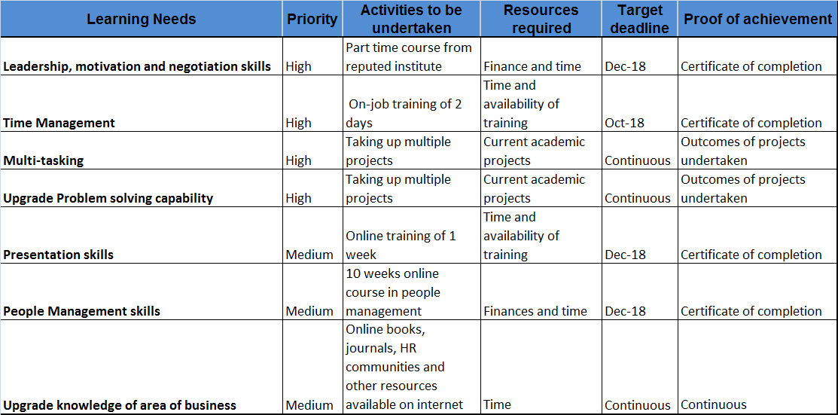
In order to make the above personal development plan (PDP) a successful event, I would need to demonstrate high dedication level as well as religiously follow all the mentioned time limits appropriately. The personal development plan can be implemented as per the below cycle;
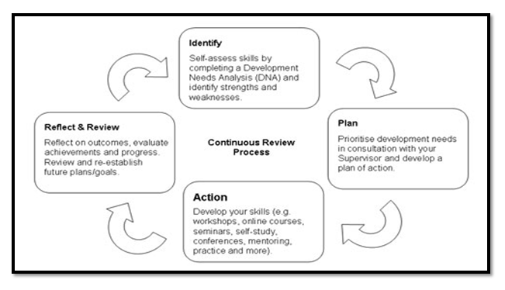
Figure 2: Source: (Thomas et al., 2018)
The above PDP cycle basically has four stages which can be explained as below;
Stage 1 (Indentify): This involves identifying the personal learning needs. I was able to identify my strengths and weaknesses with the help of the personal skills audit and the SWOT analyses done. Hence, I could identify the I need to focus majorly on time management, problem solving skills, leadership and motivation skills, as well as multi tasking skills.
Stage 2 (Plan): This involves planning activities, and goal settings which need to be undertaken within a specific time frame. I have allocated time frames for myself in and have also listed down few realistic goals and future plans that I need to undertake.
Stage 3 (Action): This involves the details about the resources that can be used to achieve the learning goals. I have selected few online and offline courses. These were selected by me after undergoing thorough enquiry about these courses with the other fellow students, my mentors as well reviewing on the internet. I am planning to enrol for the online trainings at the earliest. I have also got access to many online books, communities, journals, etc which would help me to upgrade my knowledge in the area of business management.
Stage 4 (Reflect and Review): This is the last stage of the PDP cycle, which involves reflecting on the performed actions, as well as evaluation of the progress and achievements undertaken. As I am still on my learning stage, I consider that my mentors would be the best individuals would be able to help me with proper evaluation of my progress. Their feedback and critics would help me understand if I am on the correct path of my PDP evaluation or not. In case of major problems, I would be able to make required changes to the PDP to achieve set targets efficiently.

Conclusion:
Individuals with appropriate skills and competencies are highly demanded by organisations as they facilitate business growth and development. Self assessment and skills development is very essential from the beginning stage of learning. The above self assessment done on my skills and competencies has helped me understand my strengths and weaknesses as well as the action plans required to enhance my strengths and strengthen my weakness.

References:

Beard, C. & Wilson, J., 2018. Experiential Learning: A Practical Guide for Training, Coaching and Education. 4th ed. London: Kogan Page Publishers.
Becker Professional Education, 2017. ACCA Approved - F1 Accountant in Business (September 2017 to August 2018 exams). Chicago: Becker Professional Education.
Bista, K., 2018. Journal of International Students 2018 Vol 8 Issue 3, Issue 3. North Carolina: Lulu.com.
Bolles, R., 2017. What Color Is Your Parachute? 2018: A Practical Manual for Job-Hunters and Career-Changers. revised ed. Miami: Potter/Ten Speed/Harmony/Rodale.
Heywood, J., 2018. Empowering Professional Teaching in Engineering: Sustaining the Scholarship of Teaching. California: Morgan & Claypool Publishers.
Kaplan Test Prep, 2017. MCAT Critical Analysis and Reasoning Skills Review 2018-2019: Online + Book. New York: Simon and Schuster.
Kaplan Test Prep, 2017. Praxis Prep 2017-2018: 8 Practice Tests + Proven Strategies + Online. New York: Simon and Schuster.
Kostelnik, M., Soderman, A., Whiren, A. & Rupiper, M., 2016. Guiding Children's Social Development and Learning: Theory and Skills. 9th ed. New York: Cengage Learning.
Peterson, K. & Kolb, D., 2017. How You Learn Is How You Live: Using Nine Ways of Learning to Transform Your Life. San Francisco: Berrett-Koehler Publishers.
Staley, C. & Staley, S., 2016. FOCUS on College and Career Success. 3rd ed. New York: Cengage Learning.
Thomas, R., Alfonso, E., Gabriela, G. & Pablo, V., 2018. OECD Reviews of School Resources OECD Reviews of School Resources: Colombia 2018. Paris: OECD Publishing.
Tudor, O. & Carlo, B., 2018. Periodization-6th Edition: Theory and Methodology of Training. illustrated, reprint ed. Leeds: Human Kinetics.
Vallabhaneni, S., 2018. Wiley CIAexcel Exam Review 2018, Part 1: Internal Audit Basics, Part 1. New Jersey: John Wiley & Sons.
Walsh, B., 2011. VAK Self-Audit: Visual, Auditory, and Kinesthetic Communication and Learning Styles: Exploring Patterns of How You Interact and Learn. Victoria: Walsh Seminars, Limited.
World Bank Group, 2017. World Development Report 2018: Learning to Realize Education's Promise. Washington DC: World Bank Publications.
Žarkić-Joksimović, N. & Marinković, S., 2018. Symposium proceedings - XVI International symposium Symorg 2018: “Doing Business in the Digital Age: Challenges, Approaches and Solutions”. Serbia: University of Belgrade, Faculty of Organizational Sciences.

