SOFTWARE DEVELOPMENT
ACCB4017

EXAMINATION PERIOD
CYFNOD ARHOLIADAU MAY 2020

SOFTWARE DEVELOPMENT

Julia Pietrocini 2009998

Date 10/05/2021

PART ONE ANSWER ALL QUESTIONS
1. a) What variable type would Python infer for the following values”
- 14.32 -float
- 1234 -int
- Bag -str
- -34.62 -float
- -56 -int

1 b) What errors are present in the following program to calculate the area of a triangle?

- print("Enter the base)
CORRECT IS: Print (“Enter the base”)

- base = int(input()
CORRECT IS: base= int(inputO)

- print("Enter height: ");
NO ERRORS

- height = input()
CORRECT IS: height=int(inputO)

- area=0.5*base*height
NO ERRORS

- print(" The area of the triangle is : ",area)
CORRECT IS

THE CORRECT WAY FOR 1B is:

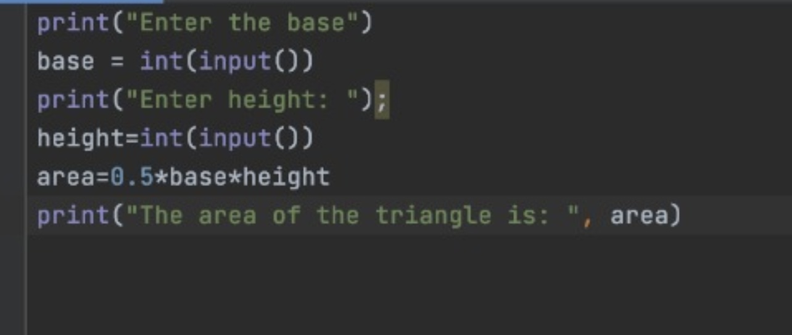

1 c) How many iterations do the following loops have?

- for i in range(24): print(i)

RESULT:
0
1
2
3
4
5
6
7
8
9
10
11
12
13
14
15
16
17
18
19
20
21
22
23

- for i in range(1,10): print(i)

1
2
3
4
5
6
7
8
9

1. d) What is the value of the integer variable total after the following code is executed?

otal=1 for x in range(8): total=total+x if(x = = 4): total=0

THE ANSWER IS: 18

1 e) Given the following program:
Temp=[23,24,25,29,40]

i) Write the code you would use to print the value stored in the third element of the array on the screen
THIRD
TEMP[2]

- Write the code you would use to add the first and last elements of the array

ANSWER

Temp append 1 : add one to the end of the array

Temp append 0,2 add two to the beginning of the array

Part TWO (Answer any two)

1. Calculating the area of a circle

The area of a circle is calculated using the formula
𝐴𝑟𝑒𝑎 = 𝜋𝑟 2

Task: Write a program to calculate the volume using the above formula. Allow the user to enter the measurement for r. You may set π as 3.142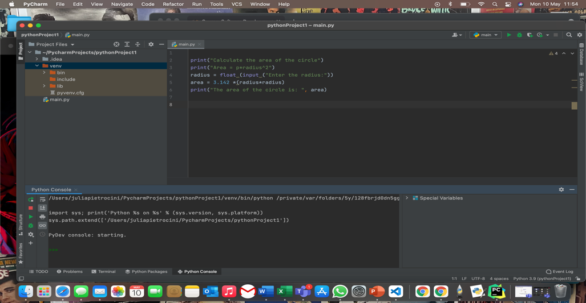

2. Using List Task:

Define a list called height and enter the following values.
height = [122,145,163,122,121,141,170,180].

Use the list functions available to do the following:

1. Display the created list
2. Append 190 to the list
3. Display total number of elements in the list
4. Sort the list in ascending order and display the modified list
5. Display the list in reverse order.



