School Synopsis
Pond Street School

Pond Street School sits within a deprived area of Pembrokeshire and serves mainly an area of predominantly local authority housing. Unemployment is above the national average and there is a high incidence of drug and alcohol abuse.

The school caters for children aged three to eleven years. There are 385 pupils on the roll, including 52 part-time pupils in the nursery. The school has identified around 52% of pupils as having additional learning needs. There are 17 children who are looked after by the local authority. Around 61% of pupils are eligible for free school meals, which is well above the national average.

A few pupils have English as an additional language and no pupils speak Welsh as a first language. Fourteen per cent of pupils are from minority ethnic backgrounds, with eleven per cent speaking English as a second or additional language.

The individual school budget per pupil is £4,498 per pupil. The maximum per pupil in the primary schools in Pembrokeshire is £20,406 and the minimum is £2,673. The school is 49th out of the 80 primary schools in Pembrokeshire in terms of its school budget per pupil.

School rationale for Nurture Group Intervention

As head of the Foundation Phase and teacher Governor on the Well-being and Curriculum committee I have been closely involved with assessing focus pupils and data and reviewing current intervention practices. We have seen an increase in the number of Looked After Children experiencing attachment issues together with a sharp rise in children experiencing problems related to trauma.

As a school we have been utilising outside agencies including Team around the family, the educational psychologist and play therapists to support these children. Measuring staff well- being has been one of our priorities for some time and since the introduction of a member of the senior management team popping in to see how staff are on a daily basis it has been recorded that many staff members are struggling to deal with some of the issues that these children were displaying in class. In conjunction with stakeholders the school development plan was drawn together to comprise the recommendations from the schools Estyn Report.

These recommendations were of no surprise to us, and in fact reinforced the need to prioritise looking ahead at new interventions that would support these children and the school as a whole. Partnership schools had already been identified to share good practice with us. With the new curriculum evolving this is the time for the school to adopt and embrace a whole school approach to not only health and well-being but to all aspects of the curriculum as a whole.
We have already met with parents and carers to explain the upcoming changes to the curriculum and we feel passionately that this intervention will bring changes that will impact the children, their families, the school and the wider community.

Personal rationale for Nurture Group Intervention

With a background in supporting impoverished families I have a passion to support them in finding positive outcomes and a way forward to meet their needs. This translates in my present role by supporting children to succeed in all that they do, providing an environment that is conducive to learning, and ensuring that they are valued and have a voice. Beneath any trauma and attachment issues are underlying issues that if left unaddressed will prevent children from thriving in school and throughout their lives, many of whom I have met as adults in my previous role.

After the conclusion of previous research on Looked After children the analysis suggested that there seemed to be a lack of teacher knowledge and understanding of the issues that these children experienced. I began reading about the impact nurture groups can have on childrens well-being and I am drawn to the ethos that underpins it, understanding the balance of the nurturing homely and educational environment that is required to establish a positive, safe and stable environment. I feel very passionately about this intervention knowing that if we as educators can provide them with a tool kit to build resilience, what huge positive implications that could have for their future development. I am naturally a caring teacher with a pastoral heart and feel that this avenue will play a significant part in my continuing professional development.

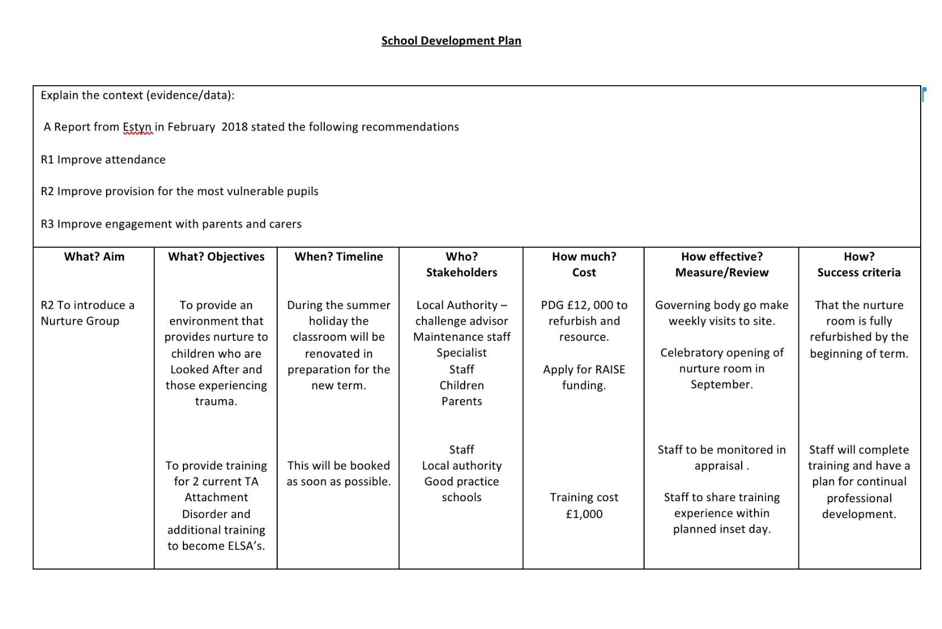
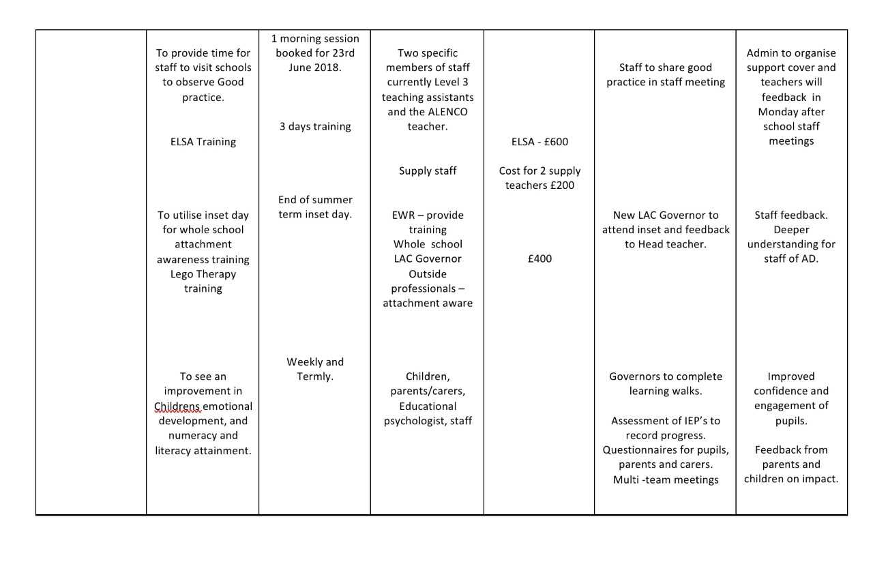





Evaluation QTS

Reflecting back on my original thoughts from my mind map, my ideas showed mis-understanding of transition at the beginning of this journey. I had presumed that a nurture group was an intervention strategy, and that transition was something different relating to changes that children face such as moving from different phases or schools. Only through lecture discussions and research that my understanding gained depth and breadth; that for children experiencing attachment disorder, every change during the school day was in fact a transition which caused some children tremendous additional stress. For them the nurture group was the intervention to help support transition in order that they could make progress and thrive. From this understanding my journey then took another path, identifying the ethos of a nurture group and how it can have impact on learners across the whole school with emotional, social and behavioural issues.

Research has identified that although nurture groups are becoming more widely used because of the impact on learners, there is still much research needed, including identifying how to measure the wellbeing of pupils. It would appear that although the Boxall Profile is a key assessment tool, that few schools use it, and are instead identifying their own means to measure progress in this field. I look forward to seeing how this will develop within the new curriculum.

With mainstream integration a key aim of the nurture group I now want to equip myself with a tool box of strategies and pedagogies that I can use specifically with children with emotional and social issues within the classroom to support children to become resilient individuals, ready to learn.

Reading and researching about how poverty impacts learners is an avenue I would like to investigate further as it ignites a sense of purpose within me, and in particular how The Welsh Government will continue to make an Impact and close the attainment gap for those experiencing poverty.

This module has opened up an avenue in education that I had not previously given much thought to in its entirety, and I feel that the two week electives next year will give me the opportunity to further develop the knowledge and skills that I already have in order to make connections and apply with new knowledge that I will undoubtably gain.
APPENDIX

An analysis of literature and research regarding mental health and well-being, inclusion, transition ,provision and progression for children with particular reference to Looked After Children and those experiencing Attachment Disorder and trauma employing a Nurture Group as an intervention strategy.

The Good Childhood Report stated that, ‘children’s well-being is now as low as it was two decades ago.’ (2018, p. 5) The National Assembly for Wales puts this into perspective arguing that, ‘With three children in an average size classroom having a mental health issue more resilience and early intervention is needed as a matter of urgency. (2018, p. 17)

The UN Convention on the Rights of the Child (UNCRC) highlight 54 articles all integrated with some however, speaking specifically about mental health and well-being in order that children can be safe. Happy and healthy. Sally Holland (2018) Childrens Commissioner for Wales blogged, ‘ I am a firm believer that taking a children’s rights approach to education will safeguard the long-term needs of children and young people and will help develop healthy and confident individuals who can learn and thrive.’ We know that in order for children to thrive they have to feel valued, loved and experienced an environment conducive to positive attachments, which The Welsh Government highlights noting that, ‘Children and young people need to experience social, emotional and physical well-being to thrive and engage successfully with their education.’ (WAG, 2015, p. 45) As they enter into this ever-changing world children will need to learn and adapt these skills to cope with change, to maintain their health and well-being but also for the well-being and success of the communities in which they live. As Organisation for Economic Cooperation and Development (OECD) argue that, ‘In fact, social and emotional skills can be equally, and in some cases even more important, than cognitive skills in determining future employment.’ (2017, p. 7) It is these skills that are highlighted in the Donaldson Report (2015) as educators prepare children for the future workforce and an attitude of life-long learning built on resilience, a key goal highlighted in The Well-being and Future and Generation Act (2014).

Resilience is the key to be, ‘able to deal with adverse events and circumstances.’ ’ (WAG, 2010, p. 12) Furthermore equipping children with the skills to be resilient within a supportive environment is a key objective of Our National Mission (2017). Goleman (1996, cited by Grigg, 2005, p. 98) believes that with our emotional intelligence rational thinking is inhibited when these adverse experiences occur, and we are unable to understand our emotions and those around us. Furthermore OECD (2018, p. 17) argue that emotional and social aspect of these skill are malleable and have, ‘ potential to intervene and effect improvements.’ Indicating the potential teachers have supporting learners to be resilient and creating environments that enhance and stimulate their interests and well-being and nurtures emotional literacy. The Allen Report (2011, p. 43) noted that children who do not develop emotional and social skills, are those from, ‘low-income households with only one permanent caregiver.’ However, Bomber (2007, p. 160) argues that ‘Traumatic experiences or loss can inhibit a child from learning the skills necessary at various stages.’ The environment, ethos and culture of the educational setting is therefore key to establishing a secure, safe and positive place which encourages children to thrive and ensures they are ready to learn effectively. To prevent adverse childhood experiences to establish, it just requites one key adult in a child’s life. The Emotional aspects of learning (SEAL) programmes implemented in schools in 2005 aimed at teaching children resilience through promoting emotional and social skills, as these are foundational to effective learning. Durlak et al (2011) argued that this programme demonstrated that teaching social and emotional skills can have a positive and changing effect on children.

Within the new Welsh Curriculum, Successful Futures (2015) one of the four distinct purposes it highlights is , ‘the health and well-being of our children and young people.’ (WAG, 2015, p. 6) with one of the areas of learning and experience being Health and Well-being. Its important to note that as Banerjee et al (2016, p. 14 ) states,‘ to date major reports on well-being at school have not substantially and solely focussed upon the primary setting.’ Therefore, the implications for the effective and successful implementation of the new curriculum is vital for the outcomes of both child, family, school and inevitably the community as a whole. It will therefore be paramount that these changes involve a holistic multi agency approach, a momentum highlighted in The Windscreen model (2015)

‘Transition is defined as the process that represents an important move from infancy to adulthood, or as a transition from one environment to another.’ (Symonds, 2015, p 149) Transition is particularly significant for children who have additional learning needs such as Looked after Children or those struggling with trauma, with effective and smooth planning for transitions being crucial as the WAG (2014, P.8) documents this suggesting that, ‘poor transition can damage progress and confidence.’

Cahill et al (2014, p. 288) argue that their research indicated, ‘how early, preventative work, consisting of key elements such as empathy, emotional containment and security can be planned and implemented before vulnerable children reach the stage when their behaviours become extremely challenging for staff to understand and support.’ Teacher knowledge and understanding is critical together with collaboratively working within a multi team approach to assess, identify and share information about these children in conjunction with parents and cares and to implement appropriate interventions. The Department for Education (2016) and The Allen Report (2011) both agree that all these elements are evidenced to support the impact of early intervention with improved attainment and employment opportunities. This therefore implies that not only the transition but the way it is introduced smoothly and in conjunction with children and parents is crucial for the progression of the child. This will inevitably involve open communication and dialogue in a multi-faceted approach with the rights of the child at the heart.

‘SEN children typically have many risk factors for poor transition outcomes. These include low achievement, low self-esteem, problem behaviour and social difficulties.’ (Symonds, 2015:130) This highlights the need for early intervention for these children as The Sutton Trust (2008, p. 1) state that, ‘on average SEL interventions have an identifiable and valuable impact on attitudes to learning and social relationships in school and overall an impact of four months additional progress on attainment.’

One Principles of an inclusive education is that, ‘all children and young people should have access to an appropriate education that affords them the opportunity to achieve their personal potential.’ (WAG, Inclusion and Pupil Support, 2014:4) This inclusivity is at the heart of the Welsh reform. (WAG, 2015) Ensuring this has impact on childrens learning is reliant on good planning and assessment, within a multi team approach including parents and children. With the Additional Learning Needs (ALN) reform the introduction of the Individual Development Plans (IDP) if used well would provide a personalised learner centred approach. ‘The emphasis of IDPs will be on making provision that delivers tangible outcomes that contribute in a meaningful way to the child’s or young person’s achievement of their full potential.’ (WAG, 2018, p. 8) This allows for clear measurable goals in progression. Gareth Evans (2018), argued that, ‘Progression as a concept is built in to Professor Graham Donaldson’s blueprint for curriculum reform and supports the understanding that children’s learning is an expedition, with stops, detours and spurts, rather than as a linear process.’

For children to progress and thrive they need to have their basic needs met (Maslow, 1943) feel safe, secure, valued, and accepted and the environment needs to be one of inclusivity, warmth, and nurture. However, if a child has experienced or been affected by trauma with a key significant adult in their lives, then, ‘ he or she will have a distorted view of themselves, others and the outside world. In particular neglect and emotional abuse have serious consequences for the emotional well-being and social capabilities of the child.’ (Bomber, 2007, p. 57)

‘Secure attachments have been found to facilitate the development of coping skills which in turn have been found to be an important protective factor for mental health in later childhood.’ (Dobbs and Arnold, 2009, cited by Cahill et al, 2014, p. 272) An important point to remember as Looked After Children are less likely to have had a stable environment. (WAG, 2010) These children are unlikely to trust others when they have experienced separation, loss, or broken relationships through trauma with supposedly key adults in their lives. Communication is therefore key.

Braveheart Education (unknown date) state that, ‘40% of children experience some kind of trauma before the age of 18.’ (Braveheart Education) Amongst these are LAC and those with attachment disorder which Children in Wales (2012) state often have additional learning needs; emotional and behavioural. Durlak et al (2011, p.1) note that, ‘Emotions can facilitate or impede childrens’ academic engagement, work ethic, commitment, and ultimate school success.’ (2011:1) Furthermore Grigg (2015, p. 373) states that these children are, ‘at significant risk of under achievement and can disrupt the learning of others.’ This will be discussed further in due course as there are implications if this is the case for both the teacher and other learners in the classroom.

It is important to highlight that children with ALN and those experiencing any kind of trauma or loss have similar needs as others for successful progression throughout their time in school, however because of their vulnerability they will have additional learning needs that need to be met. NICE (2015, p. 23) argue that for these children, ‘the challenging business of learning and coping in the classroom can be very difficult.’ Furthermore, Education Through Regional Working (ERW, 2017, p. 1) argue that these children, ‘have difficulty in developing effective executive functioning skills.’ It is these skills that allow the child to engage in learning. The implications for the classroom pedagogy are that through a social constructivism approach (Vygotsky and Dewey), collaboration and scaffolding may be challenging for children with attachment disorder. Interventions in a small group may allow for this to support learning but in a more structured and nurturing environment, which fosters warm relationships with key adults. The research indicates that challenges that face children with attachment disorder display themselves as intellectual, emotional psychological and social issues. They may be unable to concentrate, and without teacher knowledge and understanding the child’s needs may be overlooked and they may be mis - understood. Their poor behaviour may be dealt with, but the underlying issues ignored. Emotionally they may also be misunderstood by peers and labelled. Psychologically these children may suffer from anxiety, worry, low self-esteem and confidence. Socially there may be issues with friendship groups, not understanding boundaries, a loss of friends from a previous school setting of they have moved placement and a sense of insecurity.

Key for these children to thrive are relationships that are secure, warm, trusting, and empathetic. Bronfenbrenner’s Ecological Systems Theory argues that within the micro systems those closest to the child have the greatest impact, thus teachers, along with the neighbourhood can have both a positive and negative effect on the child’s experience, therefore teacher knowledge and understanding of attachment disorder and how they can manage and adapt the learning environment is crucial. Interesting as Nice (2015, p. 23) argue that, ‘it is a concern that the majority of teachers will not have covered such issues in their training.’ In addition, Zeedyk (2015, p. 5) argues that, ‘ Many childcare staff receive little or no basic training in attachment.’ A report from ERW (2015) found that throughout England and Wales there was a huge disparity between staff knowledge and understanding of attachment issues. As a result, in 2015 Carmarthenshire commissioned a LACE co-ordinator to, ‘commission interventions to improve educational outcomes for Looked after Children. (EWR, 2015, p.3)

‘Interactions with teachers differ between securely and insecurely attached children. Relative to their need for emotional support, insecurely attached children tend to see out their teachers at a higher frequency than their securely attached class peers.’ (Dobbs and Arnold, 2009, cited by Cahill et al, 2014, p. 273) A study in inner London school nurture groups may highlight the issues this could raise for the class teachers as it was argued that, ‘with the use of these groups that staff leaving to find other jobs had decreased as did the number of teachers off with work related stress, and staff morale had improved. (Boxal et al, 2000, p.43) It would therefore appear that pressure had been eliminated for these teachers with further evidence suggesting, ‘that when these children received intervention within a nurture group the mainstream class teacher can effectively offer more time and support to others within the class, whose needs had been overshadowed by children with attachment issues. (Cooper et al, 2005, p. 218) ERW also agreed in that with the nurture group intervention, there was less staff sickness. In Contrast Cooper et al (2005) highlights a potential issue for children on return to class that they may struggle to re-engage with the class teacher as they had grown so attached to their nurture group teacher. This reflects the need for open communication between teachers and a carefully planned transition period back to mainstream class that suits the individual child.

Nurture Groups
‘The Nurture group’ is an intervention strategy based in schools, introduced in 1969 by Marjorie Boxall and educational psychologist. Boxall understood children’s difficulties were the outcome of impoverished early nurturing.’ (Boxall, 2000, p.4). They make use of assessments via the Boxall Profile, ‘and strategies to build emotional well-being in small groups of targeted children through fostering positive attachment representations.’ (Banjerre et al, 2016. p. 26)

As the child’s attachment issues become a barrier to learning, the nurture group offers a safe and secure environment that structures routines thus creating an integrated approach to the child’s needs to nurture and provide for them socially, emotionally, physically, and cognitively through trusting building trusting relationships with a key adult. The environment thus creates a balance of educational and domestic experiences. It is this balance of provision within a nurture group that makes, ‘ the important link between emotional containment and cognitive learning.’ (WAG, 2010, p. 2)

Much research suggests that the group is small in number with approximately 10-12 pupils . A benefits of using smaller intervention groups argue The Welsh Government is that they allow, ‘more tailoring of approaches to specific pupils’ needs, providing teachers and TA’s with better knowledge of how to engage each pupil, closer monitoring of behaviour and attainment and increased attention and feedback to pupils.’ (WAG, 2017, p. 42) However it could be argued that small group interventions such as a nurture group remove children from their mainstream class and they miss activities with their peers.

The interventions within the nurture group will be dependent on the child’s own learning journey and progress and plans as per their IEP, however the nurture teacher’s objective is to, ‘attach the children and provide support for clearly defined and manageable expectations and goals.’ (Boxall et al, 2008, p. 36) This allows every child to succeed in learning, and implies that curriclum planning and assessment is crucial in order for them to thrive in all aspects as Boxall et al (2000, p.37) argued that, ‘As the child’s needs were reliably met, not ignored or rebuffed as they would have been in a normal class, the children developed greater trust and self-confidence, became better organised and were ready for learning.’ Knowing the child, and allowing pupil voice to lead the learning is key when planning as when the learning involves their own interests accompanied by their readiness to learn, then the child will be engaged in the learning journey (Piaget) Furthermore in 2010 The WAG (2010, p. 25) developed a statement of national purpose for schools, part of which included, ‘establishing a culture of social inclusion and personalised learning’ These are both key features of the ethos of nurture groups and the underlying principles of Our National Mission (2017) and Successful Futures (2015).

The aim of the group is to integrate the child back into the mainstream class, having provided an environment in which to develop the necessary skills and strategies to help them overcome the barriers they may face within a mainstream classroom. It is important to note that, ‘Schools scheduled interventions so that they did not impact on the timetable for core subjects, while aiming to ensure that pupils did not miss classes in non-core subjects they enjoy the most….some case study schools offered after school sessions in literacy and numeracy that could be attended by both the child and the parent.’ (WAG , 2017, p. 42) This demonstrates a whole school approach involving parents.

Teachers also found that children in nurture groups found it challenging when returning to mainstream classrooms, one reason given that these children, ‘attach themselves’ to their nurture group.’ (Cooper et al, 2005, p. 218) A factor that needs consideration when thinking through the practicalities of the nurture group interventions and curriculum content in relation to their mainstream class. Another potential issue that Ofsted highlighted in their summary report was that, ‘Almost all the nurture group pupils in the schools surveyed were working below the academic level expected for their age, because they were not taking a full part in lessons.’ (Ofsted, 2011, p. 1) Furthermore in their report they suggest that for half of the week these children would remain in the nurture group and for the remainder they would return to their midweek class for up to 2-3 terms. Cooper et al (2005, p. 217) agree that from research, ‘that the effects of a nurture group on the academic progress of learners was mixed from the view point of the mainstream staff.’

In addition, an important factor to note is that the Northern Ireland Assembly (2010, p.3) suggest, ‘ the children were not stigmatised by attending nurture group as they registered with their normal class in the morning and returned there each day for the last part of the afternoon.’ This would ensure inclusiveness within the school and support a whole school approach. In effect as Cooper et al (2005, p. 221) argue, these nurture groups are, ‘temporary transition classrooms who cannot at a given time benefit from full time experiences in mainstream classrooms.’

Ofsted reported that key to progression for these children was the careful preparation of the pupil’s transition back Into their mainstream class. ‘It was given a high priority and planned well in advance and included targeting support back in the class.’ (2011, p.5). A crucial factor yet one that has been highlighted to be problematic as time constraints between nurture staff and mainstream classes can be hard to find on top of additional work load, however, as Binnie et al suggested (2008, p. 204) with strong supportive leadership time can be set aside such one morning session per week for both teachers to liase with parents and other team members. Furthermore, Cooper et al (2005, p. 215) highlight that the nurture group teachers considered their, ‘collaborative working with their teaching assistants as crucial in achieving the effective running of the NG.’ This reiterates the need for clear communication and information sharing between colleagues in order for clear concise planning and assessment of the children within the group to be made to facilitate pupil progress.

Ofsted recorded that when this happened pupils, ‘made progress with their behaviour and academic learning at the same time.’ (Ofsted, 2011, p. 3) Their findings also indicate that, ‘where curriculum planning was not clear, gaps emerged in the pupils learning but were not always noticed.’ (Ofsted, 2011, p. 3).

However, at the same time their findings reiterated that, ‘ensuring that pupils made good progress in their academic learning often did not have as high a profile as the development of their social, emotional and behavioural skills.’ (Ofsted, 2011, p.4) This highlights the importance of understanding and having clear objectives of the outcomes of the purpose of the nurture groups. Clear directive Leadership from the outset is the key to promoting a positive ethos and a clear direction of intervention to ensure that children make progression with literacy, numeracy and other areas of learning.

Where tracking emotional, social, and academic progress, Ofsted recorded that, ‘these schools were able to demonstrate clear evidence about the progress made in each of these areas and knew where and why progress has not been made.’ (Ofsted, 2011, p.5)

To measure the impact of nurture group, it is important to know the purpose of the nurture groups and the expected outcomes for individual pupils. However, a key factor stated by The Education Endowment Foundation (undated) is that, ‘it is important to recognise the difference between monitoring pupil progress and evaluating impact of specific interventions.’
Research by both Hughes et al (2014) and Scott et al (2009) argue that evidence suggests that Nurture Groups have improved the emotional well-being of children. Furthermore, the WAG (2010, p.19) state that, ‘‘Its holistic approach has a definite impact on the child’s self-esteem and emotional health and wellbeing.

The Pupil Development Grant (2017) highlighted that, ‘Schools have actively embraced the WG directive to focus on pupils’ wider needs, and not just academic attainment: interventions cover pastoral activity, family support as well as literacy and numeracy skills for example.’ (WAG, 2017, p. 11) This fits within the new curriculum reform as The Good Childhood Report 2018 has identified the need to significantly reform the approach to wellbeing within the ethos and environment of the school.

An amendment by the ALN Bill (2018) ensured that there was also provision, ‘to ensure that a child with ALN who attends a mainstream maintained school usually engages in school activities with children who do not have ALN.’ (WAG, 2018, p. 55) Caroll et al (2017, p. 59) emphasises this by suggesting, ‘that all children in care should have a voice and be engaged in groups that allow them to express their opinions and views such as school councils.’ Pupil voice is again at the heart of the new curriculum.

In order for a holistic approach to take place to ensure progression for these children, there needs to be whole school approach. The Department for Education (2003, p. 39) state that the strongest evidence that supports early intervention approaches include and focus on, ‘the whole school environment, working with parents/carers/small group sessions, and part of a multi-system intervention.’ In agreement The WAG (2010, p. 22) state that through this approach, ‘In which all pupils have the necessary skills to thrive has implications for every aspect of school life.’

A whole school approach, ‘should serve to complement to the many items that teachers can do to support children and young people with school-based strategies, providing a holistic drive to support the prevention and deterioration of mental health and wellbeing.’ (Howard et al, 2017, p. 27) Crucial as The WAG (2010, p 15) state that, ‘around two thirds of Looked After Children are likely to have or develop mental health problems.’ In addition, The DfE (cited by NICE 2015, p. 23) state that ‘around half of all LAC were considered to be ‘cause for concern’ in relation to their emotional and behavioural health.’

Akos et al (2005, cited by Symonds, 2015, p. 206) suggest, ‘the transition coordinators all spoke about their headteacher as essential to their effectiveness in their role.’ Furthermore ERW (2017, p.2) argued the importance of, ‘engaging senior leaders in the schools involved in order to ensure a whole school approach.’ It is crucial that leadership and management are committed to changing policy.

Continual professional development is also key when developing a whole school approach to any form of intervention or strategy so there is knowledge and understanding underpinning and informing practice and pedagogy, and in turn promoting staff confidence and ownership. With regards to Attachment Awareness training ERW (2017, p.3) stated that, ‘those schools who were able to dedicate a full inset day to the training have seen a greater level of staff engagement, understanding and practice development.

Ofsted (2011, p.3) shared good practice in highlighting that through a whole school approach to Nurture Group as an intervention, that staff saw, ‘ a core purpose of the group as supporting pupils to improve their behavioural, social and emotional skills.’ Through consulting pupil bodies such as school counsellor groups and sharing circle time and focus groups understanding of nurture groups the role of the groups can be embraced, understood and embedded within the culture, ethos and overall environment of the school to have a positive impact. Employing the correct staff within a nurture group is crucial as they will be the key adult for these children. The WAG (2017, p.44) argue that, ‘ Case study schools noted the importance of matching the skills of staff to suit the roles being asked of them.’ In addition, Symonds () also argues that, ‘Those who had been in the role for several years or more felt that longevity was essential for networking and for improving the quality of relationships amongst colleagues who helped with the transition process.’ A really important factor for school leadership to consider and one in which the WAG (2015, p. 49) in Rewriting the future state, ‘Professional development activities must focus on building sustainable workforce capacity, including leadership capacity, so that investment has a long-term impact.’

The WAG (2017, p. 28) indicate that within this whole school approach that ‘School Governors also play an important role in supporting the management of PDG, predominantly through feedback on the School Development Plan.’ From personal reflection it is the role of such governors to be critical and ask questions in order to support the school in its progression of its targets and long-term progress.

The WAG (2018, p.3) set out its vision, ‘for addressing the link between poverty and underachievemt in education in the Schools Effectiveness Framework, which challenged schools to work with all partners. In ‘Rewriting the Future’ 2014 The WAG re-emphasised the importance of this work by making family and community engagement one of four central themes to the programme.’ (WAG, 2018:3) There is a great sense of community and collaboration when this happens, and this reflects in a sense of ownership and confidence for all involved when schools utilise parent’s skills and abilities. Furthermore, Public Heath England (2014, p. 25) argue that parental support. ‘can increase educational attainment.’ In addition, they argue that good communication and involvement with parents can also have a positive impact on relationships with other siblings in the household.

The Department for Education (2003, p. 24) suggest that evidence shows, ‘that of parents/carers can be supported to better manage their childrens behaviour, alongside work being carried out with the child in school, there is a much greater likelihood of success in reducing the child’s problems, and in supporting their academic and emotional development.’ There is therefore benefits to all involved, with schools needing to evaluate how effectively they reach parents. Savage (2015, p.71) argues that, ‘Integrated, co-operative and collaborative working between parents’ carers and families has always been critical to the success of inclusion.’

The WAG guidance states that the PDG, ‘is intended to overcome the additional barriers that prevent learners from disadvantaged backgrounds achieving their full potential.’ (WAG, 2017, p. 41) The Evaluation of the grant found that, ‘PDG Funds to employ TA’s in a range of roles and/or pastoral support roles for disadvantaged pupils ; gave them insights into the home lives and specific barriers faced by individual pupils.’ (WAG, 2017: 9) This communication helps to bridge gaps that may exist between parents and schools and from personal reflection, also opens up opportunities to engage in relationships to enable families to receive support from a multi-faceted team often from agencies such as Team around the family, and charities.

‘Closing the attainment gap is a long-term goal and to be successful schools will need to develop strategies to improve teaching and learning, whole schools’ systems to improve behaviour, engagement and the well-being of pupils, as well as deliver targeted support to specific pupils.’ (WAG, 201, p. 97) Through research it has been evidenced that Nurture Groups can be an effective intervention to support and equip children with skills and strategies to support their emotional development, in order that they can thrive and progress throughout their learning journey and beyond into the ever-changing wider world. Its ethos is in line with Welsh Government Initiatives to tackle poverty, and equip all children ready to learn and encounter the future workforce as confident emotionally resilient individuals

