

Design and Development of PIC Controlled Screw-Propelled Robot

by
Ryan Stapleton

Supervisor: Stephen Mosey

Project submitted as part of the requirements for the award of
BEng (Hons) Electrical and Electronics Engineering

April 2024

Contents
1.0 Introduction 1
2.0 Background Research 2
2.1 Screw Design and Geometry 3
2.1.1 Single Threaded Screw 3
2.1.2 Multi-Threaded Screw 3
2.1.3 Helical Fluted Screw 4
2.2 Drive Mechanism 4
2.2.1 DC Motors 4
2.2.2 AC Motors 5
2.2.3 Hydraulic Systems 6
2.2.4 Rotary Actuation 7
2.3 Power Source 8
2.4 Control System 8
2.5 Component Research 9
2.5.1 Microcontroller 9
2.5.2 Sensors 10
2.5.3 DC Motors 11
2.5.4 Power Source 11
3.0 Development Methodology 12
3.1 Research Methods 12
3.2 3D Modelling 12
3.3 3D Printer 13
3.4 Proteus 14
3.5 MPLAB X IDE 15
4.0 Design & Implementation 17
4.1 CAD Models 17
4.2 2D Drawing Generation 18
4.2.1 Robot Body Drawing 18
4.2.2 Robot Screw Drawing 18
4.2.3 Robot Rear Support Drawing 19
4.2.4 Robot Lid Drawing 19
4.2.5 Robot Front Support Drawing 20
4.2.6 Robot Final Assembly Drawing 20
4.3 Proteus Schematics 21
4.4 Easy PC Schematics 21
4.5 PCB Board Design 22
4.6 Implementation 22
4.7 Microcontroller Code 23
5.0 Improvements 24
6.0 Conclusion 25
7.0 Reflection 26
References 27

Figure 1- CAD Isometric View 6
Figure 2- CAD Rear View 6
Figure 3- CAD Top View 6
Figure 4- Proteus Schematic 7
Figure 5- Easy PC Schematic 7

Introduction

The development of robotic systems has undergone significant advancements in recent years, fuelled by innovations in design, materials, and propulsion technologies. Among the emerging trends in robotics, the utilization of screw propulsion systems has garnered considerable attention due to their capability to traverse challenging terrains with enhanced efficiency and manoeuvrability. This report presents a comprehensive analysis of the components essential for the successful construction and operation of a screw-propelled robot, aimed at providing insights into the design considerations, material selection, and performance optimization of such systems.
The primary objective of this report is to conduct a comprehensive examination of the key components required for the construction and operation of a screw-propelled robot. By focusing on the fundamental elements of the propulsion system, including the screw design, drive mechanism, power source, and control system, this study aims to provide valuable insights into the design principles, performance characteristics, and operational considerations of screw-propelled robots.

Background Research
Screw propulsion, also known as auger propulsion, involves the use of helical screw-like structures to generate thrust and propel a vehicle forward. This propulsion mechanism offers distinct advantages over traditional wheeled or tracked systems, particularly in environments characterized by soft or uneven terrain, such as sand, mud, or snow. Screw-propelled robots have demonstrated remarkable capabilities in various applications, including agricultural robotics, search and rescue operations, planetary exploration, and military reconnaissance.
Before starting the project, some research was needed to identify some key factors that might occur along the timescale of the project.
- Understanding the Scope and Requirements: Research helps in understanding the scope and requirements of the project. It allows you to gather information about what needs to be accomplished, the objectives of the project, and the resources required. This clarity helps in setting realistic goals and expectations.
- Identifying Potential Challenges and Risks: Research enables you to anticipate potential challenges and risks that may arise during the project. By identifying these early on, you can develop strategies to mitigate them and plan accordingly, reducing the likelihood of delays or setbacks.
- Gathering Information and Resources: Researching provides access to valuable information, data, and resources relevant to the project. This includes existing literature, case studies, best practices, methodologies, and tools that can inform your approach and decision-making process.
- Exploring Different Approaches and Solutions: Research allows you to explore different approaches and solutions to address the project requirements. By examining various methodologies, techniques, and technologies, you can make informed choices about the most suitable strategies to achieve your goals effectively and efficiently.
- Learning from Previous Projects and Experiences: Researching previous projects and experiences, whether within your organization or in the industry, helps in learning from past successes and failures. This knowledge can guide your decision-making process, enabling you to adopt proven practices and avoid repeating mistakes.
- Staying Updated with Industry Trends and Innovations: Researching keeps you updated with the latest industry trends, innovations, and advancements relevant to your project. This knowledge allows you to incorporate cutting-edge practices, technologies, and methodologies into your project, enhancing its quality and competitiveness.
- Building a Strong Foundation for Decision Making: Research provides a solid foundation for decision-making throughout the project lifecycle. Whether it's choosing the right approach, selecting the appropriate tools and technologies, or making strategic decisions, the insights gained from research enable you to make informed and evidence-based choices.
- Enhancing Creativity and Innovation: Researching exposes you to diverse perspectives, ideas, and insights, stimulating creativity and innovation. By exploring different concepts and solutions, you can generate novel approaches and ideas that add value to your project and differentiate it from others.
The scope of this research encompasses a thorough investigation of each component essential for the functionality and performance of a screw-propelled robot. This includes:
- Screw Design and Geometry: Analysis of various screw configurations, including single-threaded, multi-threaded, and helical fluted designs, to determine their suitability for different terrains and applications.
- Drive Mechanism: Examination of drive mechanisms, such as electric motors, hydraulic systems, and pneumatic actuators, to assess their efficiency, torque output, and reliability in driving the screw propulsion system.
- Power Source: Evaluation of power sources, including batteries, fuel cells, and internal combustion engines, to provide the necessary energy for propulsion and auxiliary systems.
- Control System: Investigation of control algorithms, sensors, and feedback mechanisms to ensure precise navigation, obstacle avoidance, and stability control of the screw-propelled robot.

Screw Design and Geometry
As there are various types of screw design that could be implemented into the robot, it is important to select the one most suited for the desired application of the robot.

Single Threaded Screw
Advantages

- Simplicity: Single-thread screws are straightforward in design, making them easy to manufacture and maintain.
- Lower Friction: They typically have lower friction compared to multi-thread designs due to their simpler geometry, which can be advantageous in certain applications.
- Cost-effective: Single-thread screws are generally more cost-effective to produce compared to multi-thread or helical fluted screws due to their simplicity.

Disadvantages

- Slower Speed: Single-thread screws may have slower operation speeds compared to multi-thread designs since they move less material per revolution.
- Less Efficient for Heavy Loads: They might not be as efficient for applications requiring high torque or handling heavy loads due to their single-thread design.

Multi-Threaded Screw
Advantages

- Higher Efficiency: Multi-thread screws can move more material per revolution, making them more efficient for applications requiring faster operation or handling heavier loads.
- Reduced Backlash: They can reduce backlash and axial play due to the multiple threads engaging simultaneously.
- Faster Operation: Multi-thread screws can achieve faster speeds compared to single-thread designs due to their ability to move more material per revolution.

Disadvantages

- Complexity: Multi-thread screws are more complex in design and manufacturing, which can increase production costs and maintenance requirements.
- Higher Friction: They may experience higher friction compared to single-thread designs due to increased contact surfaces between threads and the mating part.
- Potential for Jamming: The multiple threads can increase the likelihood of debris or contaminants getting trapped between the threads, potentially causing jamming or interference issues.

Helical Fluted Screw
Advantages

- High Precision: Helical fluted screws can provide high precision and accuracy in motion control applications due to their fine pitch and helical flutes.
- Self-locking: Depending on the design, helical fluted screws can exhibit self-locking properties, preventing back-driving when the load is removed.
- Smooth Operation: They can offer smooth and quiet operation due to the helical flutes guiding the motion.

Disadvantages

- Complex Manufacturing: Helical fluted screws are more complex to manufacture compared to standard single or multi-thread screws, which can increase production costs.
- Limited Load Capacity: Depending on the design and materials used, helical fluted screws may have a limited load-bearing capacity compared to some multi-thread designs.
- Potential for Wear: The helical flutes can be susceptible to wear over time, especially in high-load or high-speed applications, requiring regular maintenance and inspection.

Drive Mechanism
There are multiple options with regards to the drive mechanism of the screw of the robot. As this is an essential operation of the robot, it is vital to select the correct type motor, with the right amount of torque and RPM to allow the robot to operate as intended.

DC Motors
Advantages

- Simple Control: DC motors are relatively easy to control compared to other types of motors. By varying the voltage applied to the motor, you can control its speed efficiently.
- High Torque at Low Speeds: DC motors offer high torque at low speeds, making them suitable for applications requiring precise control over speed and torque, such as in robotics, conveyor systems, and elevators.
- Ease of Reversal: Reversing the direction of rotation in a DC motor is straightforward by simply reversing the polarity of the applied voltage, making them ideal for applications where bidirectional movement is required.
- Compact Size: DC motors tend to be compact in size relative to their power output, making them suitable for applications with limited space constraints.
- Cost-Effective: DC motors are often more cost-effective compared to other types of motors, especially for smaller-scale applications.
- Availability of Speed Control: Unlike some other types of motors, DC motors can be speed-controlled over a wide range without significant loss of efficiency.

Disadvantages

- Brush Maintenance: Most traditional DC motors use brushes and a commutator, which require periodic maintenance and replacement due to wear and tear. This maintenance can increase operating costs and downtime.
- Electromagnetic Interference (EMI): DC motors can generate electromagnetic interference, which may interfere with nearby electronic devices or sensitive equipment if not properly shielded.
- Limited Lifespan: The brushes and commutator in DC motors have a limited lifespan, which can affect the overall longevity of the motor and require regular replacement.
- Lower Efficiency at High Speeds: DC motors may experience lower efficiency at high speeds compared to other types of motors, such as AC motors.
- Limited Speed Range: While DC motors offer excellent speed control, they may have a limited speed range compared to some other types of motors, particularly at higher speeds.
- Complexity in High Power Applications: In high-power applications, such as industrial machinery or electric vehicles, DC motors may require additional components like cooling systems and more sophisticated control mechanisms, adding complexity and cost.

AC Motors
Advantages

- No Brushes: Unlike DC motors, most AC motors operate without brushes and commutators. This design feature reduces maintenance requirements and eliminates issues related to brush wear and arcing.
- High Efficiency: AC motors typically operate at high efficiency, especially when running at full load. This efficiency can result in lower energy consumption and reduced operating costs over time.
- Long Lifespan: AC motors generally have a longer lifespan compared to DC motors, primarily due to the absence of brushes and the resulting reduction in wear and tear.
- Suitable for High Power Applications: AC motors are well-suited for high-power applications, such as industrial machinery, HVAC systems, and electric vehicles, where they can provide the necessary torque and power output reliably.
- Smooth Operation: AC motors typically provide smoother operation compared to DC motors, especially at higher speeds. This smooth operation is beneficial for applications requiring consistent motion, such as pumps and fans.
- Variable Speed Control: AC motors can be easily controlled for variable speed operation using techniques such as frequency control (VFD - Variable Frequency Drive) or voltage control. This flexibility in speed control makes them versatile for a wide range of applications.

Disadvantages

- Complex Control Systems: AC motors often require more complex control systems, such as VFDs, to achieve variable speed operation. These control systems can add to the initial cost and complexity of the motor setup.
- Higher Initial Cost: Compared to DC motors, the initial cost of AC motors and associated control equipment may be higher, particularly for high-performance or specialized applications.
- Lower Torque at Low Speeds: AC motors generally provide lower torque at low speeds compared to DC motors. This limitation may affect their suitability for applications requiring high torque at low speeds, such as in certain industrial processes or robotics.
- Limited Efficiency at Low Loads: AC motors may experience reduced efficiency when operating at low loads or speeds. In such cases, energy losses due to factors like windage and friction can be relatively higher compared to when the motor is running at its rated capacity.
- Requires Synchronization: Synchronous AC motors require synchronization with the power supply frequency, which can be a limitation in some applications where precise speed control is necessary.
- More Susceptible to Overheating: AC motors can be more susceptible to overheating under certain conditions, especially if operated at low speeds for extended periods without adequate cooling.

Hydraulic Systems
Advantages

- High Torque: Hydraulic systems can provide high torque, making them suitable for driving screw-propelled systems, which require significant torque to move through challenging terrain such as mud, snow, or sand.
- Variable Speed Control: Hydraulic systems allow for precise control over the speed and direction of the screw-propelled system, enabling operators to adjust the speed according to the terrain conditions and operational requirements.
- Smooth Operation: Hydraulic systems generally provide smooth and consistent power delivery, which can result in smoother operation of the screw-propelled system, reducing wear and tear on components and enhancing overall efficiency.
- Compact Design: Hydraulic components, such as pumps, motors, and cylinders, can be compactly designed, allowing for more flexibility in the layout and integration of the screw-propelled system, particularly in constrained spaces or mobile applications.
- High Power Density: Hydraulic systems can achieve high power density, meaning they can deliver a large amount of power relative to their size and weight. This characteristic is advantageous for screw-propelled systems where power-to-weight ratio is crucial for mobility and performance.
- Adaptability: Hydraulic systems can be easily adapted to accommodate different types and sizes of screw-propelled systems, making them versatile for various applications, including agriculture, construction, military, and exploration.

Disadvantages

- Complexity: Hydraulic systems can be complex, requiring a network of hydraulic hoses, pumps, valves, and actuators. The complexity of the system increases the risk of potential leaks, failures, and maintenance requirements.
- Hydraulic Fluid Maintenance: Hydraulic systems require regular maintenance of hydraulic fluid, including monitoring fluid levels, checking for contamination, and replacing fluid as needed. Failure to maintain proper fluid levels and cleanliness can lead to system inefficiency and component damage.
- Potential for Fluid Leaks: Hydraulic systems are prone to fluid leaks, which can result in environmental contamination and pose safety hazards to operators and nearby personnel, particularly in sensitive ecosystems or hazardous work environments.
- Temperature Sensitivity: Hydraulic systems may be sensitive to temperature fluctuations, with extreme temperatures affecting the viscosity and performance of the hydraulic fluid. In cold environments, fluid viscosity may increase, leading to sluggish system response, while in hot environments, fluid viscosity may decrease, increasing the risk of fluid leakage and system overheating.
- Noise and Vibrations: Hydraulic systems can generate noise and vibrations during operation, which may be undesirable in certain applications where noise levels need to be minimized, such as stealth operations or noise-sensitive environments.
- Energy Efficiency: Hydraulic systems may have lower energy efficiency compared to other power transmission systems, such as electric or mechanical systems, particularly in situations where energy losses occur due to hydraulic fluid friction, leaks, or inefficient component design.

Rotary Actuation
Advantages

- Simplicity: Rotary actuation systems are often simpler in design compared to hydraulic or pneumatic systems, requiring fewer components such as pumps, hoses, and valves. This simplicity can lead to easier maintenance and reduced risk of system failure.
- High Torque: Rotary actuators can provide high torque output, making them suitable for driving screw-propelled systems through challenging terrain such as mud, snow, or sand.
- Ease of Control: Rotary actuation systems allow for straightforward control of the screw-propelled system's speed and direction, typically achieved through the control of electric motors or mechanical linkages. This ease of control facilitates precise manoeuvrability in various operating conditions.
- Energy Efficiency: Electric rotary actuators, in particular, can offer high energy efficiency compared to hydraulic systems, as they do not require the continuous operation of pumps and do not suffer from fluid leakage issues.
- Quiet Operation: Rotary actuation systems generally produce less noise and vibration during operation compared to hydraulic or pneumatic systems, making them suitable for applications where noise levels need to be minimized.
- Environmental Friendliness: Electric rotary actuators produce zero emissions during operation and do not rely on hydraulic fluids, reducing the risk of environmental contamination and simplifying disposal at the end of their lifecycle.

Disadvantages

- Limited Torque Range: While rotary actuators can provide high torque output, they may have limitations in torque range compared to hydraulic systems, particularly in applications requiring extremely high torque for heavy loads or extreme terrain conditions.
- Limited Speed Range: Rotary actuators may have limitations in achieving high speeds compared to hydraulic systems, which can be a disadvantage in applications where high-speed operation is critical.
- Mechanical Complexity: In some cases, rotary actuation systems can be mechanically complex, especially if they involve gearboxes, transmissions, or other mechanical components to achieve the desired torque and speed characteristics. This complexity can increase manufacturing costs and maintenance requirements.
- Space Requirements: Rotary actuators, especially those incorporating gearboxes or other mechanical components, may require more space compared to hydraulic systems, limiting their suitability for applications with tight space constraints.
- Weight: Depending on the design and materials used, rotary actuators may add significant weight to the screw-propelled system, which can affect mobility and energy efficiency, particularly in mobile or portable applications.
- Limited Environmental Adaptability: Rotary actuation systems may not be as adaptable to extreme environmental conditions as hydraulic systems, which can operate effectively in a wide range of temperatures, pressures, and terrain types.

Power Source

Control System

Component Research
Various components are required for the robot to function as required. The list of components required include items such as Microcontrollers, sensors, motors etc.

Microcontroller
The robot is to be controlled by a microcontroller. The microcontroller selected must meet a few parameters for it to be feasible for use for this project. The criteria are as follows:
- Number of I/O (digital and analogue)
- Memory size
- MCU bit size
PIC18F26K22 | PIC18F26Q10 | PIC18F44K22
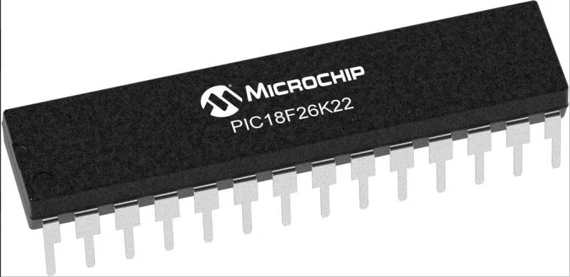 | 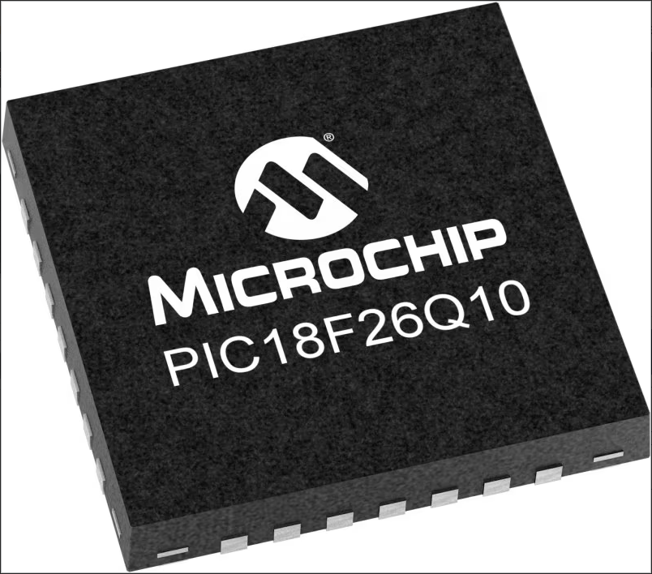 | 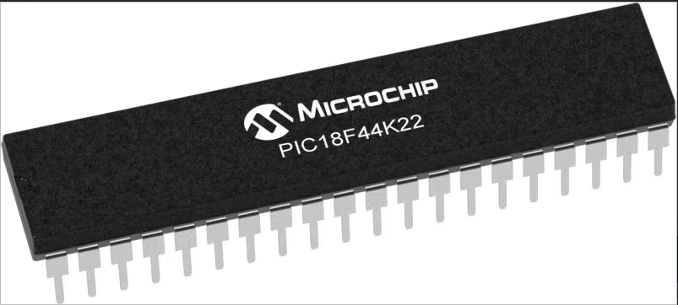
- [1]Program Memory Size (KB) - 64  - RAM - 3896  - Data EEPROM (bytes)-1024  - Pin Count-28  - Operation Voltage Max.(V)-5.5  - Operation Voltage Min.(V)-1.8  - ADC Resolution Max -10  - ADC Channels-17  - Zero Cross Detect-False  - Number of Comparators-2  - SPI-2  - I2C-2  - Standalone PWM-0  - Low Power-Yes  - Numerically Controlled Oscillator (NCO)-0  - Data Signal Modulator (DSM)-0 | - [2]Program Memory Size (KB) 64  - RAM 3615  - Data EEPROM (bytes) 1024  - Pin Count 28  - Operation Voltage Max.(V) 5.5  - Operation Voltage Min.(V) 1.8  - ADC Resolution Max 10  - ADC Channels 24  - Zero Cross Detect True  - Number of Comparators 2  - SPI 2  - I2C 2  - Standalone PWM 2  - Low Power Yes  - Numerically Controlled Oscillator (NCO) 0  - Data Signal Modulator (DSM) 1 | - [3]Program Memory Size (KB) 16  - RAM 768  - Data EEPROM (bytes) 256  - Pin Count 40  - Operation Voltage Max.(V) 5.5  - Operation Voltage Min.(V) 1.8  - ADC Resolution Max 10  - ADC Channels 28  - Zero Cross Detect False  - Number of Comparators 2  - SPI 2  - I2C 2  - Standalone PWM 0  - Low Power Yes  - Numerically Controlled Oscillator (NCO) 0  - Data Signal Modulator (DSM) 0

The microcontroller selected for the control system of the robot is the PIC18F26K22. This was selected due to its pin count, and the inputs and outputs being compatible for both digital and analogue. This microcontroller also has sufficient program memory at 64Kb, which is an ample amount required for this project.

Sensors
For the robot to operate as ‘self-aware’, sensors are required to allow the robot to ‘see’ if obstacles are blocking its path. There are various sensors that are feasible to carry out this operation.
[4]Ultrasonic Sensor | Infrared Sensor | Proximity Sensor
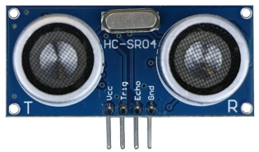 | 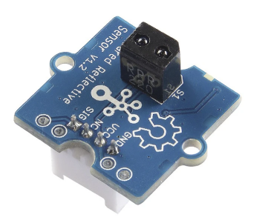 | 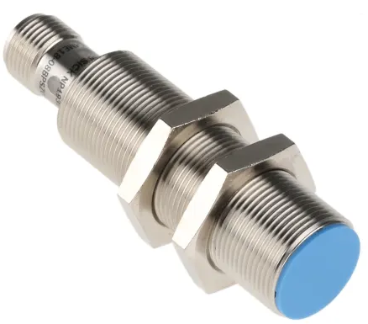
 | - [5]Panel-mounting Grove interface  - Digital output: 0 or VCC  - Built-in indicator LED  - Threshold adjustable via potentiometer  - Power supply: 3.5 – 5.5V DC  - Reflective Photo sensor: RPR-220  - Effective working distance: 4-15mm  - Minimum detectable width for monochrome lines: 10mm  - Connector: 4 pin Buckled Grove interface  - Dimension: 20mm*20mm | - [6]Extended sensing ranges: 1.5 mm to 38 mm  - Enclosure rating: IP 67  - Nickel-plated brass housing with a plastic sensing face  - High machine availability thanks to a rugged design  - High positioning accuracy thanks to precise switching behaviour

The sensor of choice for this project is the Ultrasonic Sensor. This is due to its simplistic operation and mounting capabilities. This sensor is easily compatible with the microcontroller of choice, and relatively easy to program. This sensor was also the cheapest out of the 3 choices, and more readily available.

DC Motors
To provide motion to the screws on the robot, two DC motors will be used (one supplied to each lead screw). These motors have to provide enough torque to allow the robot to move through difficult terrain, such as sand or mud, whilst having a low enough supply voltage to not overpower the circuitry controlling it. A comparison table is shown below:

[7]RS PRO Brushed Geared DC Geared Motor | [8]Mellor Electric Brushed DC Motor | [9]DOGA Geared DC Geared Motor
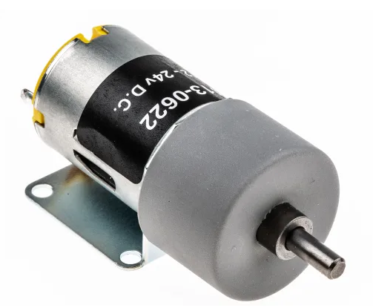 | 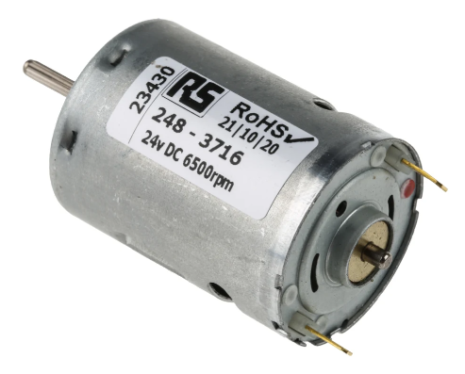 | 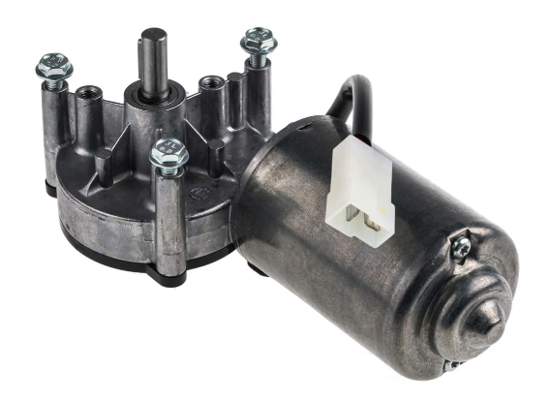
- Supply Voltage – 12-24V  - Shaft Diameter – 4mm  - RPM – 82-164  - Torque – 10Ncm  - Power Output – 1.31W | - Supply Voltage – 24V  - Shaft Diameter – 2.3mm  - RPM – 6500  - Torque – 3.5Ncm  - Power Output – 4.5W | - Supply Voltage – 12V DC  - Shaft Diameter – 9.3mm  - RPM – 40  - Torque – 5Nm  - Power Output – 20W

The motor of choice for this project is the RS Pro brushed geared motor. This motor was selected due to it having the correct supply voltage range, whilst providing an ample amount of torque. Price was also a factor, with this motor being the cheapest from the table, and they are readily available.
The motor will be controlled by a motor drive circuit, control by a L298N motor driver. Controlled by the microcontroller, this will send the desired commands to the motors for them to respond accordingly.

Power Source
The robot will require a power source to operate. As most of the components are TTL logic and require a maximum of 5V, the power source shouldn’t exceed 24V. Voltage regulators will be used to prevent a power surge from damaging the TTL logic components.
2x 12V batteries will be used to provide the power source to the robot. The motors used have a supply voltage range of 12V-24V. Using two 12V batteries will allow the motors to operate at their highest capacity, whilst voltage regulators will prevent anything more than 5V entering the TTL logic components.

Development Methodology
This section of the report will outline the various techniques and applications to be used to develop the robot such software, machinery and research techniques.

Research Methods
Firstly, research was required on the various aspects of completing this project. This includes researching components required. This was done by using current items on the market as a reference to lay the foundations of how this device will work.
Once this was understood, research into components was completed, by looking at datasheets and comparing against similar products to find which ones suits the application the best.

3D Modelling
To model the prototype robot, [10]Catia V5 was used. Catia V5 is 3D modelling package used within SAFRAN Seats GB. The robot was modelled in individual parts and then later brought into an assembly as the final product. The robot underwent numerous revisions until the final product was fit for purpose. The models of the individual parts were also used for the 3D printing of this.

Advantages

- Comprehensive Design Capabilities: CATIA V5 offers a wide range of design tools and features, allowing users to create complex 3D models with precision. It supports parametric modelling, surface modelling, assembly design, and drafting, among other functionalities.
- Industry Standard: CATIA V5 is an industry-standard CAD software used by many companies, particularly in aerospace, automotive, and manufacturing sectors. Learning CATIA V5 can enhance job prospects and collaboration opportunities within these industries.
- Integration with PLM Systems: CATIA V5 seamlessly integrates with product lifecycle management (PLM) systems, allowing for efficient management of design data, revisions, and collaboration among team members throughout the product development lifecycle.
- Customization and Automation: CATIA V5 provides extensive customization options through its scripting language (CAT Script) and Application Programming Interface (API). Users can automate repetitive tasks, create custom features, and tailor the software to suit specific workflow requirements.
- Large User Community and Support: Due to its widespread adoption, CATIA V5 has a large user community and extensive online resources, including forums, tutorials, and user groups. This makes it easier for users to find help, share knowledge, and troubleshoot issues.

Disadvantages

- Steep Learning Curve: CATIA V5 has a reputation for having a steep learning curve, especially for beginners or users transitioning from other CAD software. Mastering its extensive toolset and complex workflows may require significant time and effort.
- Resource Intensive: CATIA V5 is a resource-intensive software, requiring powerful hardware specifications to run smoothly, especially when working with large assemblies or complex models. This can be a limitation for users with limited computing resources.
- License Cost: CATIA V5 is a proprietary software developed by Dassault Systèmes, and obtaining licenses can be expensive, particularly for individual users or small businesses. The cost of licenses and maintenance fees may deter some potential users.
- Limited Compatibility: While CATIA V5 supports various file formats for importing and exporting, seamless compatibility with other CAD software may be limited. This can pose challenges when collaborating with partners or clients who use different CAD tools.
- Updates and Compatibility Issues: Upgrading to newer versions of CATIA V5 or transitioning between versions can sometimes lead to compatibility issues with existing designs or third-party plugins. This may require additional time and effort to resolve.

3D Printer
The manufacturing of the robot is to be done using a 3D printer. The printer in question is a [11]BCN3D Sigma D25 printer. This printer is relatively inexpensive, and is mainly targeted for prototyping parts. This is due to the material used being PLA, which is a biodegradable plastic.
This printer uses a 0.4mm hot end extruder. This means that each layer of material extruded from the hot end will be 0.4mm in diameter.

Advantages

- Independent Dual Extruder (IDEX) System: One of the main advantages of the BCN3D Sigma d25 is its Independent Dual Extruder system. This allows for multi-material and multi-colour printing without the risk of cross-contamination between materials. It also enables printing of support structures with soluble materials, making post-processing easier for complex prints.
- Large Build Volume: The Sigma d25 offers a relatively large build volume for a desktop 3D printer, allowing users to print larger parts or multiple smaller parts simultaneously.
- High-Quality Prints: With a sturdy frame and precise motion system, the Sigma d25 is capable of producing high-quality prints with fine details and smooth surfaces.
- Wide Range of Compatible Filaments: This printer can handle a variety of filaments, including PLA, ABS, PETG, TPU, and more, giving user’s flexibility in material choices for their prints.
- Open Source: BCN3D provides open-source software and firmware for the Sigma d25, allowing users to customize and modify their printing experience according to their needs.

Disadvantages

- Price: The BCN3D Sigma d25 is relatively expensive compared to some other desktop 3D printers, which may put it out of reach for some hobbyists or small businesses.
- Complexity: While the IDEX system offers versatility, it also adds complexity to the printer, which may require more knowledge and experience to operate effectively. Users may need to spend more time calibrating and troubleshooting compared to simpler single-extruder systems.
- Large Footprint: Although it has a large build volume, the Sigma d25 also has a correspondingly large physical footprint. This may be a drawback for users with limited workspace.
- Software Limitations: While BCN3D provides open-source software, some users may find the provided slicing software lacking in features compared to other slicers available on the market.
- Maintenance: Like any 3D printer, the Sigma d25 requires regular maintenance to keep it running smoothly. The dual extrusion system may require additional maintenance compared to single-extruder printers, such as purging and cleaning to prevent clogs and jams.

Proteus
Proteus is a popular software suite used for electronic design automation (EDA), particularly for simulating and designing electronic circuits. Here are some advantages and disadvantages of using Proteus:

Advantages

- Simulation Capabilities: Proteus offers powerful simulation features that allow designers to simulate and test their electronic circuits before prototyping them physically. This helps in identifying and resolving issues early in the design process, saving time and resources.
- Mixed-Signal Simulation: Proteus supports mixed-signal simulation, enabling designers to simulate both analogue and digital circuits in the same environment. This is beneficial for designing systems that contain both analogue and digital components, such as microcontroller-based systems.
- Large Component Library: Proteus comes with an extensive library of electronic components, including microcontrollers, sensors, actuators, and other discrete components. This vast component library makes it easy for designers to quickly prototype and simulate various types of circuits without the need to create custom components.
- Ease of Use: Proteus has a user-friendly interface that is relatively easy to navigate, making it suitable for both beginners and experienced designers. The software provides various tools and features that streamline the design process and make circuit simulation and debugging more efficient.
- PCB Design Integration: Proteus seamlessly integrates circuit simulation with PCB layout design. Designers can transition from circuit simulation to PCB layout design within the same software environment, allowing for a more cohesive design workflow.
- Interactive Debugging: Proteus provides interactive debugging features that allow designers to monitor circuit behaviour in real-time during simulation. This helps in identifying and troubleshooting issues quickly, leading to faster design iterations and improvements.

Disadvantages

- Limited Accuracy: While Proteus offers powerful simulation capabilities, the accuracy of simulations may sometimes be limited, especially for complex circuits or high-frequency designs. Designers should validate critical circuit parameters with physical prototypes or more advanced simulation tools for high-precision designs.
- Limited Flexibility: Although Proteus has a large component library, it may not always include the specific components or models required for certain designs. Designers may need to create custom models or components, which can be time-consuming and require additional expertise.
- Cost: Proteus is a commercial software suite, and obtaining a license may incur costs, especially for professional or commercial use. While Proteus offers a free trial version with limited features, access to the full suite of capabilities requires purchasing a license, which may be a barrier for some users.
- Learning Curve: While Proteus has an intuitive interface, mastering its advanced features and capabilities may require some learning curve, especially for beginners or users transitioning from other EDA tools. Adequate training and resources may be necessary to fully utilize Proteus' potential.
- Limited Collaboration Features: Proteus may lack robust collaboration features compared to some other EDA tools. Collaborative design workflows, such as real-time collaboration and version control, may be limited or require additional third-party tools.

MPLAB X IDE

MPLAB X IDE is an Integrated Development Environment (IDE) specifically designed for programming and debugging Microchip's PIC microcontrollers and dsPIC digital signal controllers. Here are some advantages and disadvantages of using MPLAB X IDE:

Advantages

- Comprehensive Development Environment: MPLAB X IDE provides a comprehensive environment for developing embedded firmware for Microchip microcontrollers. It integrates various tools such as editors, compilers, assemblers, and debuggers, streamlining the development process.
- Wide Support for Microchip Devices: MPLAB X IDE supports a wide range of Microchip microcontrollers and digital signal controllers, including PIC, dsPIC, and AVR devices. This broad support makes it suitable for a variety of embedded applications across different industries.
- Feature-Rich Editor: MPLAB X IDE includes a feature-rich code editor with syntax highlighting, code completion, and code navigation features, making it easier for developers to write and maintain code efficiently.
- Integrated Debugger: MPLAB X IDE integrates powerful debugging tools, including a simulator and in-circuit debugger (ICD), allowing developers to debug their code interactively. This helps in identifying and resolving issues quickly during the development phase.
- Plugin Support: MPLAB X IDE supports plugins, allowing developers to extend its functionality and customize their development environment according to their requirements. Plugins can add additional features, tools, or support for third-party devices and peripherals.
- Version Control Integration: MPLAB X IDE seamlessly integrates with version control systems such as Git, enabling developers to manage their code repositories directly within the IDE. This facilitates collaborative development and version control management.

Disadvantages

- Steep Learning Curve: MPLAB X IDE can have a steep learning curve, especially for beginners or developers who are new to embedded programming or Microchip devices. Understanding its various features and tools may require some time and effort.
- Resource Intensive: MPLAB X IDE can be resource-intensive, especially when working with large projects or debugging complex code. Developers may experience slowdowns or performance issues, particularly on less powerful hardware configurations.
- Limited Cross-Platform Support: While MPLAB X IDE is available for multiple operating systems including Windows, macOS, and Linux, the user experience and feature parity may vary across platforms. Some features or tools may be better supported on certain platforms than others.
- Documentation and Community Support: While Microchip provides extensive documentation and resources for MPLAB X IDE, including tutorials and user guides, the availability of community support and resources may vary compared to other IDEs with larger user bases.
- Integration with Third-Party Tools: While MPLAB X IDE integrates well with Microchip's ecosystem of tools and devices, integration with third-party tools or hardware may not always be straightforward and may require additional configuration or setup.
- Updates and Stability: Some users have reported issues with stability and occasional bugs in certain versions of MPLAB X IDE. While Microchip regularly releases updates and bug fixes, users may encounter issues that require troubleshooting or workaround solutions.

Design & Implementation

CAD Models
Below showcases the 3D models of the Robot. This was modelled using Catia V5 3D modelling software.
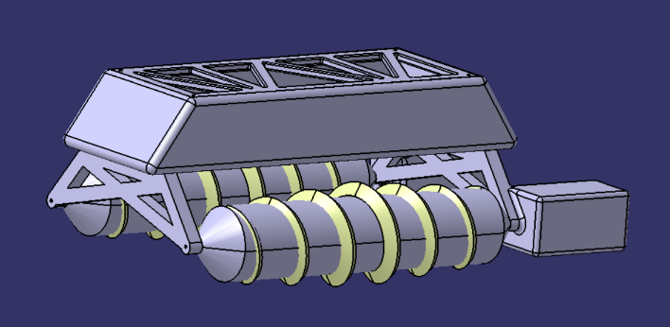
Figure 1- CAD Isometric View

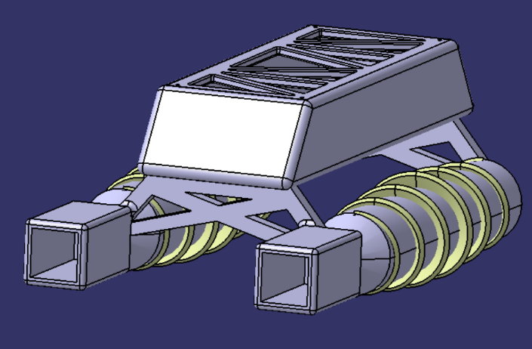
Figure 2- CAD Rear View

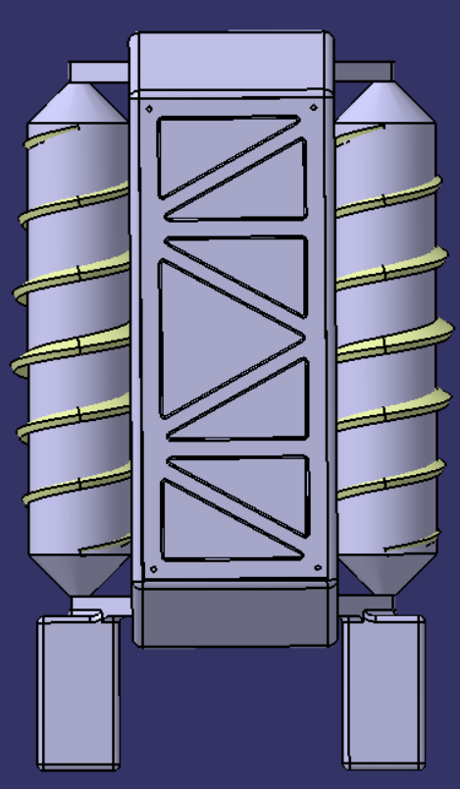
Figure 3- CAD Top View

2D Drawing Generation

Robot Body Drawing

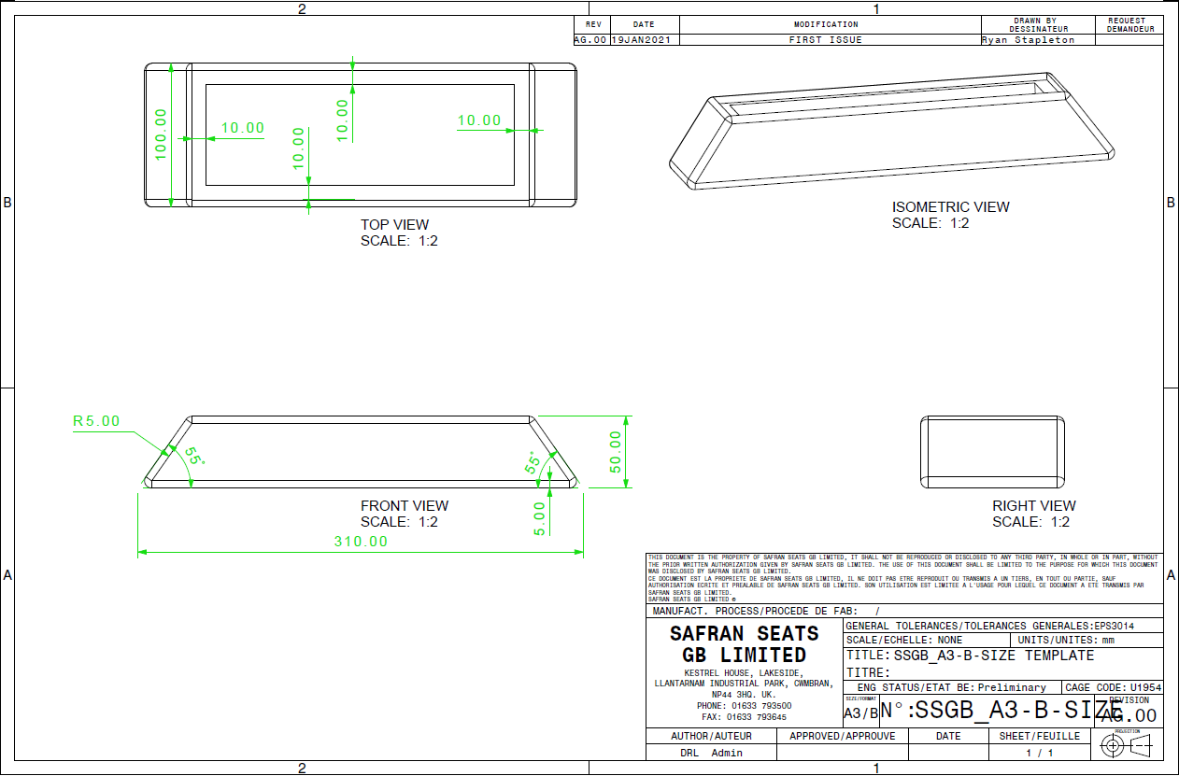

Robot Screw Drawing
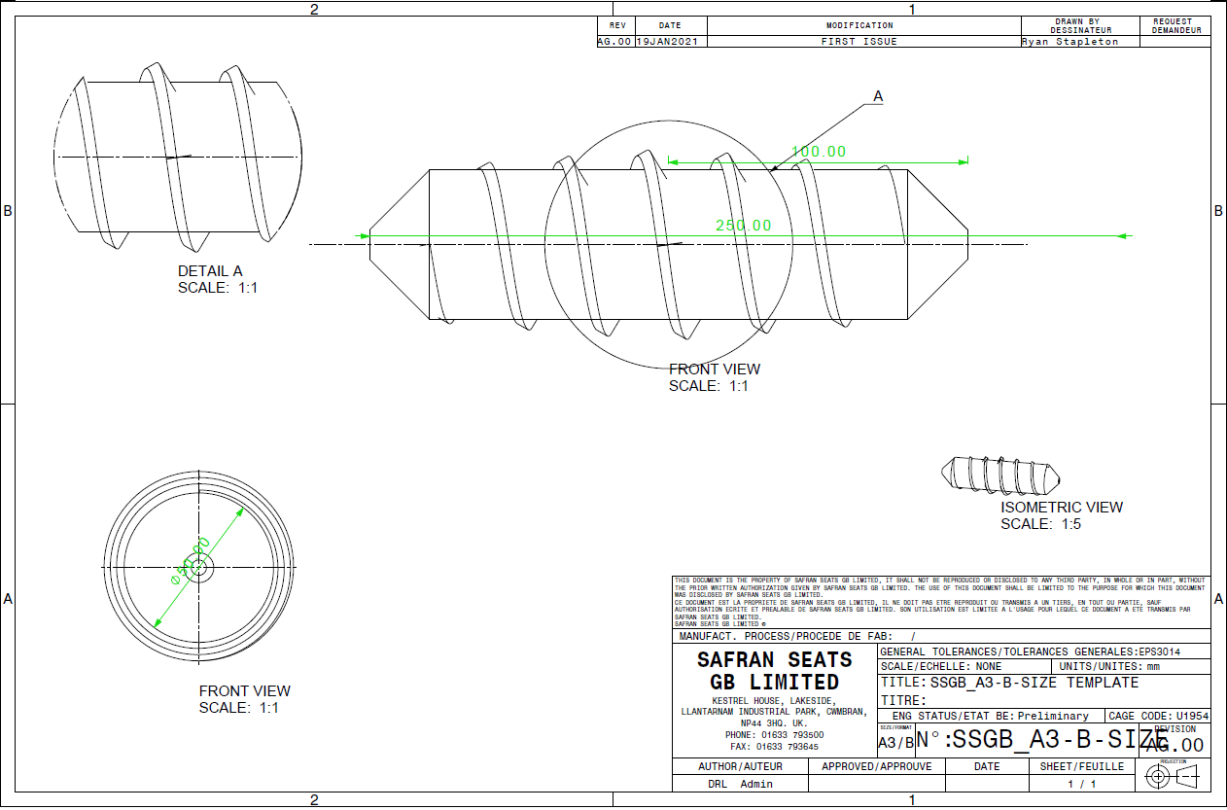

Robot Rear Support Drawing
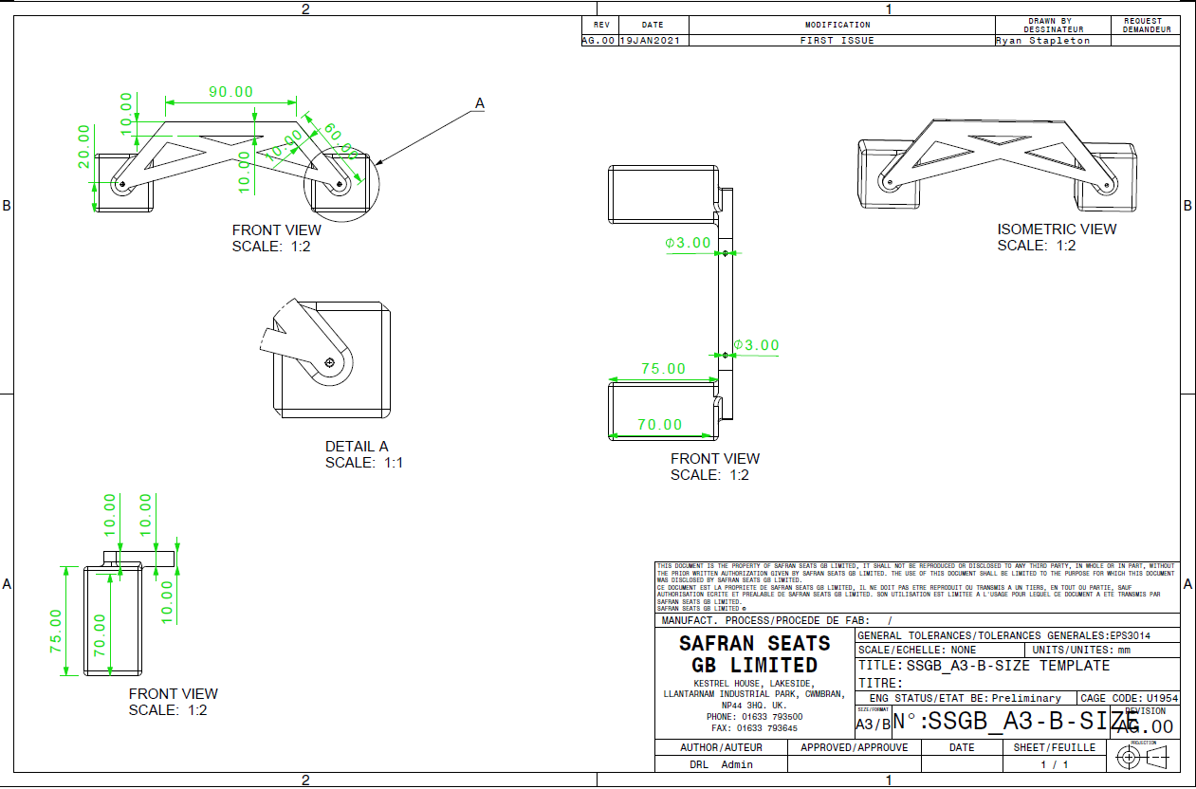

Robot Lid Drawing
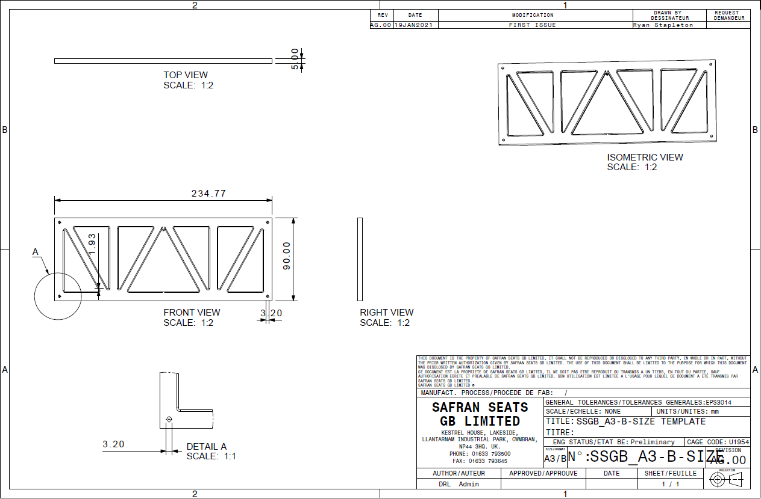

Robot Front Support Drawing
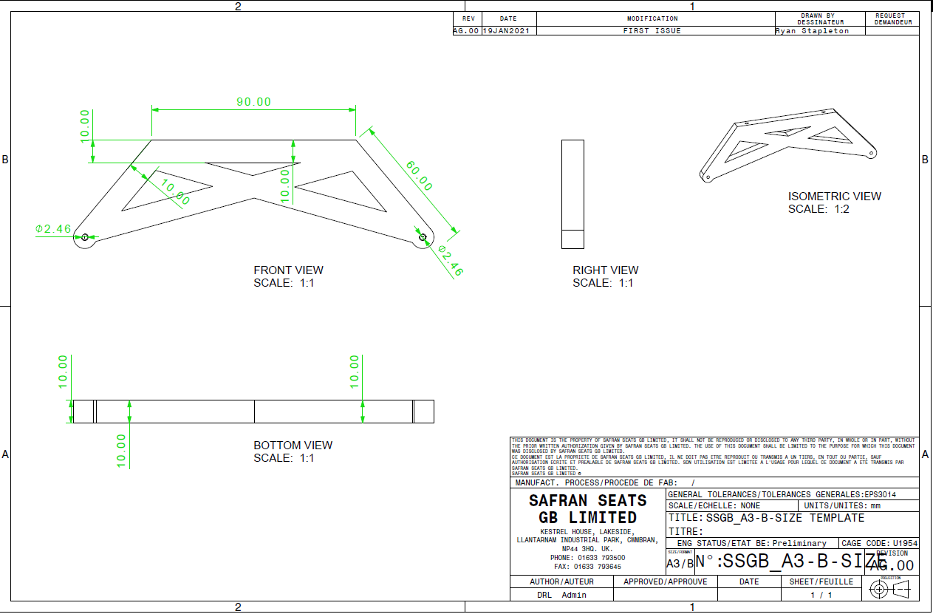

Robot Final Assembly Drawing
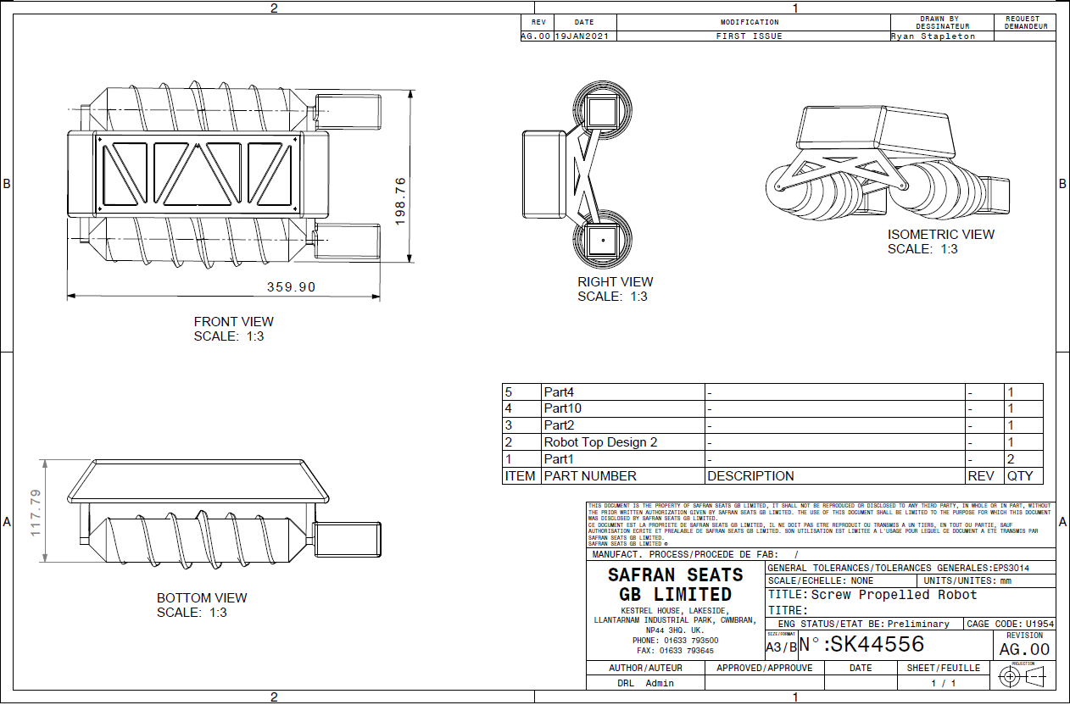

Proteus Schematics
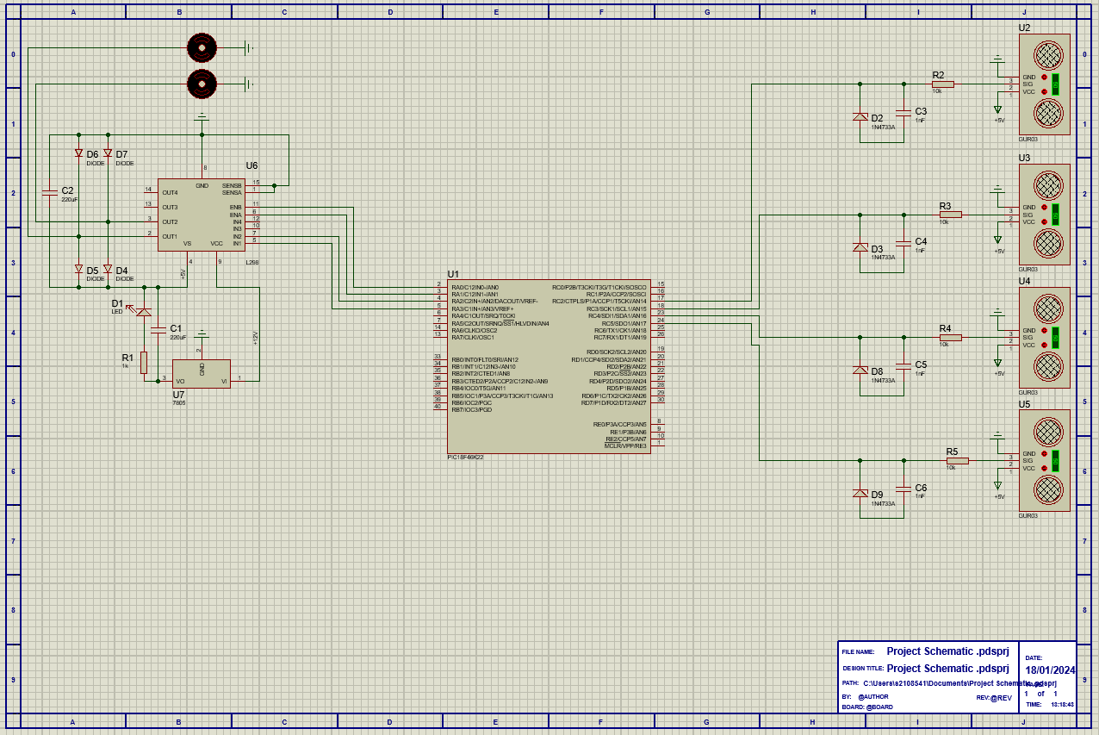
Figure 4- Proteus Schematic

Easy PC Schematics
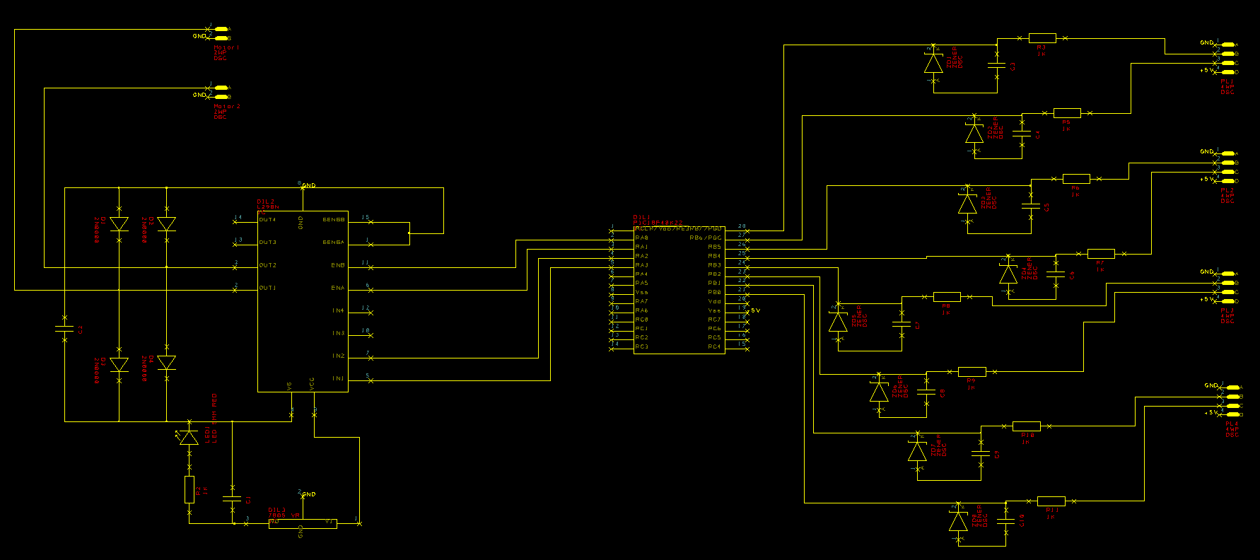
Figure 5- Easy PC Schematic

PCB Board Design
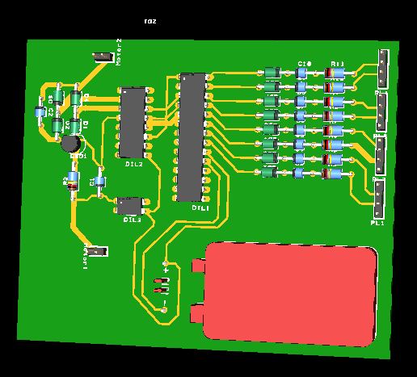
Figure 6- Easy PC PCB Board Design

Implementation

Microcontroller Code

Improvements
Upon reflection on the completion of the robot, it is evident that numerous improvements could be made to the robot to better aid functionality and aesthetics.

Firstly, weatherproofing the robot would be a major improvement to aid both functionality and aesthetics of the robot. The robot is designed to mimic that of an all-terrain vehicle, capable of withstanding harsh environments. However, this prototype design has exposed vents for the electronics, preventing this robot from being used in harsh conditions such as sand and mud for example. To achieve a more realistic resemblance to the machinery being mimicked, weatherproofing is an essential upgrade.

Secondly, another essential upgrade to aid functionality would be the motors used. Although the current motors do provide enough torque to make the robot manoeuvrable, the motors struggle even when being supplied with the maximum amount of input voltage. For this design to be feasible for use in all terrain, the motors would require more torque to be used in rocky environments.

Another improvement to the design would be the housing of the ultrasonic sensors. The initial idea for this prototype was to use a hole saw to cut out the area required to house the sensors in place. This was a mistake, as drilling through an angle piece of material was quite a challenge and an unnecessary one at that. To improve this, the housing for the sensors would be integrated into the model of the robot, allowing the sensors to placed and bonded into position. This in turn would improve the aesthetics and assembly of the final product.

To better aid functionality, there are a few hardware upgrades that are needed to allow the robot to be functional in accordance with the design brief. The current revision of the robot doesn’t function, which is largely down to the failure of programming the microcontroller used. To prevent this from happening again, there a few areas in both the design and personal improvements that can be made.

Instead of ordering all components and manually soldering to a PCB board, more effort should have been made using the PCB board design software, and getting the PCB board manufactured. This would have resulted in a professional board that was clean, and reduce the chance of microcontroller functioning incorrectly. By soldering components manually, there is an increased risk and damaging components, having poor joints resulting in poor conductivity and makes the board ‘untidy’ making it more difficult to house the PCB board inside the robot. This would also minimise the chance of the inability of programming the PIC, which was one issue faced when developing the project.

As a personal improvement when undertaking a task like this again, more time and care should be taken when reading the specifications of the microcontroller selected. The PIC18F26K22 selected has two VSS pins on either side of the PIC. Rather than reading the specifications of the internals of the PIC, assumptions were made that this was to accommodate accessibility rather than aid functionality of the PIC. In reality, both VSS pins are required to supply power to both sides of the PIC. This is the reason that the PIC could not be programmed, as the pins required for programming are accessed on either side of the PIC.

Conclusion

Reflection

References

[1] | “Microchip,” [Online]. Available: https://www.microchip.com/en-us/product/PIC18F26K22. [Accessed 19 March 2024].
[2] | “Microchip,” [Online]. Available: https://www.microchip.com/en-us/product/pic18f26q10. [Accessed 19 March 2024].
[3] | “Microchip,” [Online]. Available: https://www.microchip.com/en-us/product/PIC18F44K22. [Accessed 19 March 2024].
[4] | R. Pro, “RS Components,” [Online]. Available: https://uk.rs-online.com/web/p/bbc-micro-bit-add-ons/2153181?gb=s. [Accessed 19 March 2024].
[5] | “RS Components,” [Online]. Available: https://uk.rs-online.com/web/p/sensor-development-tools/1845081?gb=s. [Accessed 19 March 2024].
[6] | “RS Components,” [Online]. Available: https://uk.rs-online.com/web/p/proximity-sensors/7033739?gb=s. [Accessed 19 March 2024].
[7] | “RS Pro,” [Online]. Available: https://docs.rs-online.com/5f97/A700000007670016.pdf. [Accessed 19 March 2024].
[8] | Mellor, “RS Pro,” [Online]. Available: https://docs.rs-online.com/0826/0900766b81650237.pdf. [Accessed 19 March 2024].
[9] | Doga, “RS Pro,” [Online]. Available: https://docs.rs-online.com/a7d9/0900766b800932a5.pdf. [Accessed 19 March 2024].
[10] | D. Systemes, “3DS,” [Online]. Available: https://www.3ds.com/products/catia/catia-v5. [Accessed 19 March 2024].
[11] | “BCN3D,” [Online]. Available: https://www.bcn3d.com/wp-content/uploads/2022/01/BCN3D-Datasheet-Sigma-D25-EN-v1.8.pdf. [Accessed 19 March 2024].
[12] | S. Electronics, “Shopify,” [Online]. Available: https://cdn.shopify.com/s/files/1/0176/3274/files/L298_DS.pdf?v=1590528634. [Accessed 19 March 2024].

