

Student Name: Eleonora Mariana Filip
Student Number: 1807163
Module Name: Human Resource Management
Module Code: LCMB7000
Lecturer Name: Dr Gladius Kulothungan
Assignment Title: Human Resource Management (2)
Company Name: Dell Inc.
Executive Summary
In this report, the main discussion is being made on the different practices of human resource management of an organisation. Furthermore, in this report, a section has been dedicated to the discussion of the 5Ps model and its effectiveness in the strategic management of an organisation. Three effective areas of human resource practices as has been identified and discussed that include compensation, employee retention and change management. Concerning the compensation that is being provided to employees, scientific management theory is being assessed in this report. Furthermore, the theory of Maslow's Hierarchy of Needs has been developed to support the implementation of change management by the Iof an organisation.

Table of Contents
Introduction 4
Company Background 4
The 5Ps Model 6
Compensation 9
Scientific Management Theory and its Relevance in HR Practices and Policy 9
Change Management and its Relevance in HR Practices and Policy 11
Motivational Theory 13
Retention 14
Vision and Mission 14
Recommendation 14
Conclusion 16
Reference List 17

Introduction
The effective acts of recruiting, selecting and hiring candidates within an organisation to ensure that all the desired activities can be achieved efficiently are known to be human resource management (Stone et al., 2020). It falls under the role and responsibility of the human resource manager to develop different procedures and policies to enhance the competitive edge of an organisation. In this report, the focus is going to be shared on the different human resource strategies that can be initiated by an organisation and make effective usage in three different areas of the same. The three major areas of human resource management that would be discussed in this report are retention, change management and compensation. Furthermore, a demonstration will be initiated, highlighting the chosen and its benefits in valuing team members, appreciating them and creating a sense of belongingness. All the discussions that will be done in this report will be backed by different theories of human resource management.

Company Background
Dell has been the chosen organisation by which the analysis of the human resource management will be done concerning the three different areas that include retention, compensation and change management. The headquarters of Dell is present in Round Rock, Texas, United States and have been operating inner about 180 countries with more than 680 Dell stores. Currently, it is determined that the total number of employees that are working under Dell globally is counted to be 1330000 which shows a significant fall from the previous year (Statista, 2022). The total revenue that is being generated by Dell is noted to be 101.2 billion dollars in the fiscal year 2022 (Statista, 2022).
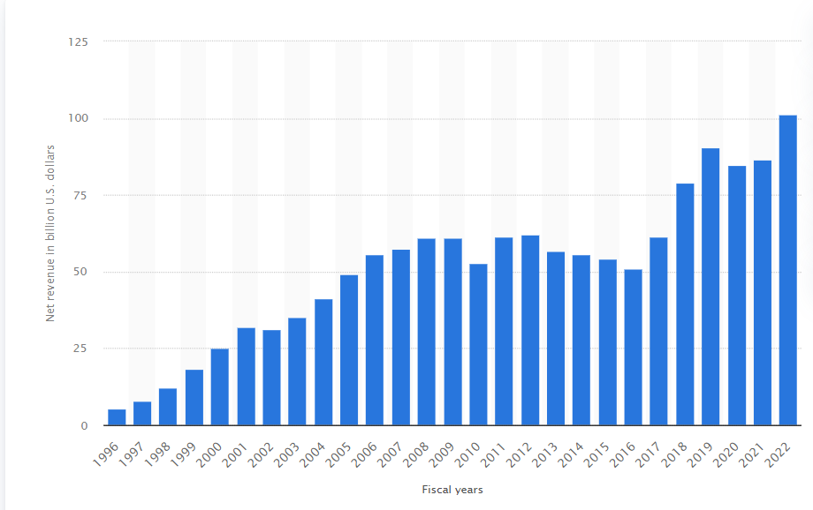
Figure 1: Total Revenue Generated by Dell
(Source: Statista, 2022)

The 5Ps Model
One of the most effective strategic models that can be used by an organisation to enhance the quality of their performance along with employees is the 5Ps model. With the help of the 5Ps model, an organisation can effectively determine the five key elements that they can initiate to improve the operations of their organisation (St Hill, 2018).
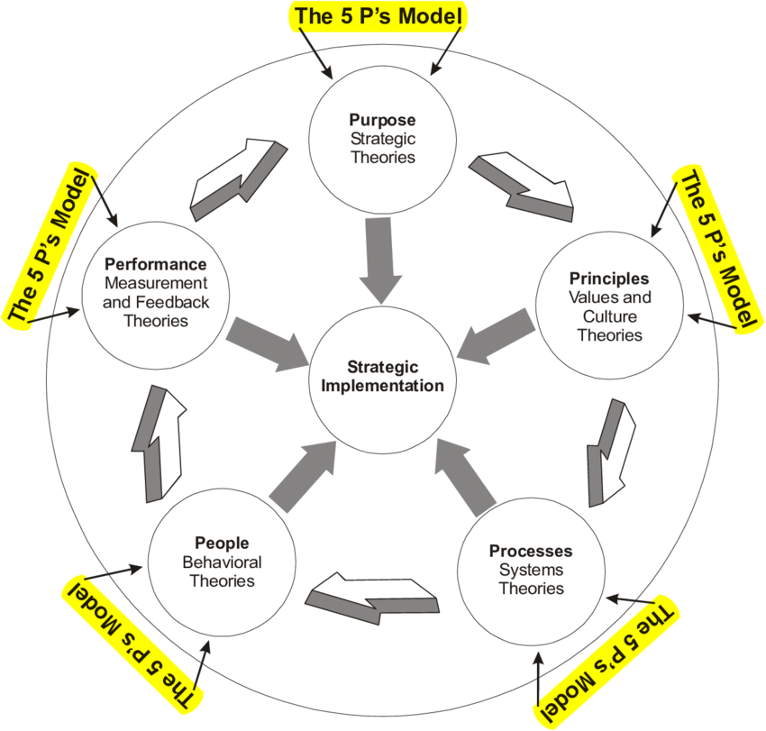
Figure 2: 5Ps Model of Strategic Management
(Source: St Hill, 2018)
Purpose
In this step of the model, the organisation needs to develop strategies that are highly related to its mission and vision of the same. In order to establish an effective purpose that highlights the interest and scope of an organisation, I need to determine its strengths and weaknesses along with the opportunities and threats that they have. This can be achieved by the organisation by conducting an organisational SWOT analysis. For instance, the vision of Dell, UK is to emerge into digital technologies that would serve all the different sectors in the world (Dell, 2022). With an effective and transparent aim, it becomes easy to make employee understand their goal and develop a sense of belongingness.
Principles
The principles in this model are regarded to be the process by which an organisation establishes different strategies to fulfil its purposes. Furthermore, I believe that the principles will act as guidance by which the organisation can create effective culture and ethics which would help employees to feel appreciated and valued. In order to achieve this, the strategies are being developed based on the values and cultures that they are willing to maintain within the organisation where employees can feel the sense of belongingness. For instance, the core value of Dell is to create and develop technologies that are innovative, high integrated and pose higher value, which is being envisioned by customers and organisations (mission-statement, 2022).
Processes
In the process section of this model, the focus is being made on the systems and other methods that are significant for the operation of the organisation. In this, the focus is being made on the rules and regulations that are being followed by the organisation along with their structure and other procedures. In order to implement the same, I will be required to create flux grams and process maps and determine the responsibilities that employees are required to perform to have value and appreciation. For instance, the structure that is being maintained by Dell is regarded to be functional where different departments are created with employees that have skills related to the same.
People
In this step of the model, the focus is being made on the different strategies that are being established by the human resource manager of an organisation to manage and evaluate the performance of employees. This is being done so that the organisation can achieve their desired goals and objectives by analysing and evaluating the performance level of employees. I can be achieved by providing training to employees by assessing their strengths and weaknesses. For instance, Dell provides their employees with both formal and informal training processes so that they can have significant development, contribute to its goals of the same, and feel valued along with appreciated (Harrison, 2016).
Performance
Performance indicates the overall outcome that is being achieved by the organisation with the help of all the appropriate standards. Their metrics, insights and the number of consumers they have been able to serve can measure the performance level of an organisation. In order to achieve this, I can use a tool called key performance indicator to determine its metrics and make employee feel valued and a sense of belongingness as well. For instance, Dell uses the process of RAID to determine their performances within the marketplace (Dell, 2022).

Compensation
The systematic approach that is being considered by an organisation to provide monetary value to employees for producing a higher quality of work is known to be compensation (Okeke and Ikechukwu, 2019). In terms of analysing the performance of employees, I believe that their job satisfaction with the recruitment process, compensation is regarded to be the best tool for an organisation to make use of. Furthermore, I also believe that most organisations can utilise the tool of compensation to enhance their competitive edge within the marketplace and make effective utilisation of the resources that is available to them. Some of the major components of compensation that I feel will be beneficial for the organisation to provide to their employees can include:
- Job Description: Here, most of the organisation shares the roles and responsibilities that employees are required to perform along with the different aspects of the job. This will help be valued by undermining the role that they have to perform.
- Job Analysis: In this, the focus is being made on the interview process and the observation of the candidates that are being made from the same. I believe this will be beneficial for my team members because they can provide best of their performance and receive appreciation.
- Pay structure: One of the most important components of compensation that I fell is the pay structure that is being provided to employees. Based on the performance level being shared by employees of an organisation, pay structure and incentives should be provided to increase their sense of belongingness within the same.
Some of the types of compensation that I believe most organisations provide to their employees include commissions, bonuses, merit pay, housing allowances, pension and many more. For instance, Dell provides their employees with compensation that includes discounts on the Dell products that they purchase which is regarded to be up to 10% and other benefits, likely, as mortgages, holidays, payments for hotels and many more (Dell, 2022).

Scientific Management Theory
Understanding the concept of compensation that is being initiated by an organisation I believe can be done effectively with the help of scientific management theory in human resources. Scientific management theory is being established by Federick W. Taylor has initiated different scientific methods to determine the production process of an organisation (Ferreira et al., 2018).

Relevance and Application in HR Practices and Policy
The key principles of scientific management theory that the organisation can use to evaluate and provide compensation are:
Selection of Methods
An organisation needs to determine an effective method of working that would help employees to perform their tasks extensively and efficiently. This will create a sense of belongingness and appreciation for employees working within the said organisation. However, it falls under my responsibility to determine one single method that would help them to conduct the job that is being assigned to them. For instance, after the cause of the pandemic, Dell has been using a remote and hybrid working pattern to initiate higher innovation and creativity levels (Wood, 2020).
Assigning Jobs
The organisation needs to assign a task to their employees based on their talents and skills to attain the same (Prasad, 2020). Furthermore, if I lack to have talented employees to perform the task, I can provide extensive training facilities where they can determine the task that they have to perform along with the goals and objectives.
Monitoring the Performance
After assigning the task to employees, the organisational leaders need to have a key sense of monitoring and evaluating the performance shared by employees (Wren and Bedeian, 2020). Furthermore, after the evaluation is being conducted effectively, I will need to provide necessary feedback so that they can perform with perfection and gain the opportunity to attain compensation and receive appreciation and a sense of belongingness.

Change Management
The systematic approach that is being adopted and applied by an organisation concerning their tools, resources and knowledge is known to be as change management (Jayatilleke and Lai, 2018). Within the process of change management, it is determined that the organisation undergoes major changes that also alter the performance level that is being shared by employees. In this process, the organisation is required to enact the changes, implement new processes, develop strategies and analyses the negative outcomes. I have the role in implementing the change management to determine the different strategies that would be beneficial for achieving the desired outcome. Furthermore, it falls under my responsibility to determine the changes that are about to take place, the cause for the same, determine the areas that may get affected and how the effect is going to be mitigated. For instance, when dell took an initiative to implement innovative products, they had to undergo severe changes where the inclusion of employees is also being done (Bajarin, 2019).

Relevance and Application in HR Practices and Policy
Some of the steps that I can use to implement effective changes are the following:
Sense of Urgency
HR managers of the organisation need to create a sense of urgency for employees to determine that they are about to undergo certain changes where their contribution is highly required (Cameron and Green, 2019). Furthermore, in this step, I can enable employees to gain knowledge about the change along with the cause for the same.
Building of Coalition
After sharing the urgency for change, it falls under the responsibility to build a team that would be highly dedicated to developing strategies and other methods to embrace the change (Rosenbaum et al., 2018). This should be done with the view of the talents and skills that are being posed by employees.
Strategic Visions
After the creation of an effective team, I will need to provide vision to employees so that they can feel motivated and encouraged to perform the task that is being assigned to them.
Volunteering Workforce
Building of effective communication channel and other means by which the team who have the vision to reach the goals that is being desired by the organisation can attain effectively. This would help the organisation to build the confidence in their employees and share information regards the same.
Actions to Eliminate Barriers
Furthermore, the role is to identify the skills that are lacking by an employee and develop strategies to help the same to achieve them (Stouten et al., 2018). I can achieve this with the help of a training and mentorship program that would be initiated by the organisation and aligning the same to achieve its goals and objectives.
Celebrating Short-term Wins
Motivating employees who are highly contributing to the change that is taking place within an organisation is important. However, this can be achieved by providing employees with rewards and tokens of achievements as wins so that they can determine the improvement that is required to achieve.
Acceleration
Modification of the organisational culture should be done in such a manner that it would be directly linked with the change that they are willing to implicate within the same. I as an HR manager would also identify the challenges and develop strategies related to the same to make employees feel appreciated and valued within the organisation.
Implementation of Change
Whenever possible, I as an HR manager would implement the change that I am willing to attain within my organisation and link with the newly developed culture and values. This will help employee to receive the sense of belongingness within my organisation.

Motivational Theory
Effective implementation of change management can be done with the adaptation of the different motivational theories that can be used to encourage employees towards the same. The most efficient motivational theory that can be adopted by an organisation is Maslow’s Hierarchy of Needs where encouragement is provided to employees based on their needs. Within the theory of Maslow’s Hierarchy of Needs, Dell can implement change by determining five basic needs of employees that include physiological, safety, belongingness, esteem and self-actualisation (Hopper, 2020). I can effectively provide my employees with opportunity to fulfil their needs that would make them consider staying loyal to fulfil the same and contribute towards the work that is desired by the organisation.

Retention
Retention within the process of HRM can be defined as the ability of an organisation to reduce the amount of employee turnover and influence people to remain in their job. Within the operational process of an organisation, it is determined the key element is to retain the employees and develop strategies regards the same. If I can retain my employees effectively, there are certain benefits that they can receive which include an efficient flow of work along with training, a higher level of output, increased morale, better consumer experiences and many more. This will also provide them with the sense of belongingness, appreciated and valued. In order to retain employees of an organisation, I need to measure and monitor the work that is being shared by them, include different software and conduct employee survey to determine their needs and issues faced. For instance, the Dell has been using machine learning and artificial intelligence to retain their employees by decreasing their workload (Walden, 2020).

Vision and Mission
I have the vision that all employees of Dell will be able to emerge into innovative and creative ideas to establish different technologies that would benefit them along with the organisation. Dell has been using different technologies, likely, machine learning and artificial learning to combat the next level of job-hopping that is being undertaken by employees and offer the same with flexible working hours and conditions. I prefer to ensure that retention of the employees is being done based on their talents and knowledge that they have gained while working within the same. Furthermore, Dell has also looked for opportunities that have helped them to enhance their reward structure that would help them to mitigate the turnover rate of employees (Walden, 2020). Furthermore, I have the vision of developing different strategies that would help my employees and receive different idea of helping them as being HR of the organisation. Finally, I will also try to develop strategies that would enable me to provide required appreciation, value and a sense of belongingness to my employees.

Recommendation
- The HR manager of Dell can increase the motivation level of employees by creating a skilled workforce and this has created intensified activities that are required for employees to perform.
- Incorporation of other theories that would the HR manager of Dell to identify the competencies that are being shared by employees should also be done with higher strategic plans.
- Evaluation of the training and mentorship programs that are being provided to employees of Dell should also be redesigned based on the changes that are being desired and implemented.

Conclusion
With the discussion that has been made in this report, it can be stated that the development of strategic human resource plans can help to achieve organisational goals and objectives. With the help of the 5Ps of the model, an organisation can determine the effectiveness of the flow of work along with evaluation of the performance within the competitive market. In the 5Ps of strategic management, the elements include purpose, principles, processes, people and performance. Furthermore, three main areas of HRM are being discussed in the report that includes compensation, change management and retention of employees. The relevance of compensation that is being provided by HR to employees is backed by the scientific management theory. Furthermore, concerning change management, the effective usage of motivational theory can be done by the organisation.

Reference List
Bajarin, T., 2019. Looking Back, Looking Forward: Dell’s Transformational Decade [Online] Available at: https://www.forbes.com/sites/timbajarin/2019/12/09/looking-back-looking-forward-dells-transformational-decade/?sh=79effbea6062 [Accessed 18 April 2022]
Cameron, E. and Green, M., 2019. Making sense of change management: A complete guide to the models, tools and techniques of organizational change. Kogan Page Publishers.
Dell, 2022. Delivering a better tomorrow [Online] Available at: https://www.dell.com/en-uk/dt/corporate/about-us/who-we-are.htm#:~:text=OUR%20VISION&text=From%20healthcare%20to%20education%20to,help%20solve%20complex%20societal%20challenges. [Accessed 18 April 2022]
Dell, 2022. Dell Benefits [Online] Available at: https://www.dell.com/html/emea/openday_en/dellbenefits.html#:~:text=You%20will%20be%20entitled%20to,weeks%20additional%20unpaid%20maternity%20leave.&text=Wedding%20Leave%3B%20Study%20Leave%3B%20Paternity%20Leave.&text=Dell%20employees%20can%20make%20full,choices%20for%20breakfast%20and%20lunch. [Accessed 18 April 2022]
Dell, 2022. Performance issues: How to measure. [Online] Available at: https://www.dell.com/support/kbdoc/en-us/000121365/performance-issues-how-to-measure [Accessed 18 April 2022]
Ferreira, J., Mueller, J. and Papa, A., 2018. Strategic knowledge management: theory, practice and future challenges. Journal of knowledge management.
Harrison, M., 2016. How Dell Develops Training for Career Growth of New Leaders [Online] Available at: https://www.dell.com/en-us/blog/how-dell-develops-training-for-career-growth-of-new-leaders/ [Accessed 18 April 2022]
Hopper, E., 2020. Maslow's hierarchy of needs explained. ThoughtCo, ThoughtCo, 24.
Jayatilleke, S. and Lai, R., 2018. A systematic review of requirements change management. Information and Software Technology, 93, pp.163-185.
mission-statement, 2022. Dell Mission and Vision Statement Analysis [Online] Available at: https://mission-statement.com/dell/ [Accessed 18 April 2022]
Okeke, M.N. and Ikechukwu, I.A., 2019. Compensation management and employee performance in Nigeria. International Journal of Academic Research in Business and Social Sciences, 9(2).
Prasad, L.M., 2020. Principles and practice of management. Sultan Chand & Sons.
Rosenbaum, D., More, E. and Steane, P., 2018. Planned organisational change management: Forward to the past? An exploratory literature review. Journal of Organizational Change Management.
St Hill, R., 2018. The 5P model of missional business: Background and description. In Reimagining Christian Education (pp. 295-326). Springer, Singapore.
Statista, 2022. Dell Technologies net revenue worldwide from 1996 to 2022 [Online] Available at: https://www.statista.com/statistics/264911/dells-net-revenue-since-1996/ [Accessed 18 April 2022]
Statista, 2022. Dell Technologies number of employees worldwide from 1996 to 2022 [Online] Available at: https://www.statista.com/statistics/264917/number-of-employees-at-dell-since-1996/ [Accessed 18 April 2022]
Stone, R.J., Cox, A. and Gavin, M., 2020. Human resource management. John Wiley & Sons.
Stouten, J., Rousseau, D.M. and De Cremer, D., 2018. Successful organizational change: Integrating the management practice and scholarly literatures. Academy of Management Annals, 12(2), pp.752-788.
Walden, S., 2020. How HR Teams Use Data Management to Boost Retention [Online] Available at: https://www.dell.com/en-us/perspectives/how-hr-teams-leverage-people-analytics-to-boost-retention/ [Accessed 18 April 2022]
Wood, J., 2020. Hybrid Work and The Future Workplace [Online] Available at: https://www.dell.com/en-us/perspectives/the-future-of-work-is-hybrid/ [Accessed 18 April 2022]
Wren, D.A. and Bedeian, A.G., 2020. The evolution of management thought. John Wiley & Sons.

