Name: Sharmin Akter
Student id: 2209262
Module name: International meeting mgt (BMIH6007)
Name of Lecturer: Kathryn Flynn

Contents
1. Introduction 3
2. The Event Cycle 3
3. Event Concept 5
4. Aim and Objectives 6
5. Event Management 7
6. Health and Safety, Inclusivity, and Accessibility 8
7. Event Budget 8
Finance Table 9
8. Industry Trends / Issues / Impacts 9
9. Situational and Cultural Considerations 10
10. Conclusion 11
References 12

Planning and Delivering an International Meeting/Event: Winter Wonderland

1. Introduction
The Winter Wonderland Conference is a one-of-a-kind hybrid corporate event for professionals in the technology and finance industries. Its goal is to encourage networking and the sharing of industry information in a fun, end-of-year setting. The conference is set to happen at the Hilton London Bankside from December 15–17, 2024. It will include both cutting-edge business ideas and fun holiday activities like ice skating and a special dinner. The goal is to make a dynamic environment that makes the whole experience better for both in-person and virtual players by combining these things in a smart way.
The event was chosen in part because combination events are becoming more popular since COVID. As businesses become more global and workers work from home, hybrid events can serve participants from anywhere. This expands the event's reach and reduces its impact on the environment (Getz & Page, 2016). At the end of the year, companies can look back on the past year and make plans for the next one, which is also good for networking events. Also, the happy theme promises an interesting atmosphere that makes guests closer to each other (Bladen, Kennell, Abson, & Wilde, 2018).
The event took place at the Hilton London Bankside, which was picked because it has great facilities and a history of hosting big events. This site is right in the middle of London, cares a lot about the environment, and is easy for people from other countries to get to. The venue has cutting-edge technology that lets it meet the technological needs of the hybrid format. This means that both virtual and in-person guests will have a perfect experience. London is a great place to bring people from the finance and tech industries together because it is a big international financial centre (Davidson & Cope, 2018).

2. The Event Cycle
The event cycle is the cornerstone of event management and planning. It provides a rigorous approach to ensure that every aspect of an event, from the initial conception to the evaluation of the event after it has taken place, is meticulously organised. According to Goldblatt (2020), the concepts of conceptualization, planning, execution, and post-event evaluation comprise the four steps that comprise the Event Cycle.

Conceptualization
The initial step is to determine the goal and purpose of the event. In this segment of the Winter Wonderland Conference, the emphasis was on identifying the requirements of professionals in the financial and technological sectors who gain from networking and reviewing the experiences from the previous year. The results of studies on the latest developments in the sector indicate that hybrid events are gaining popularity. Getz and Page (2016) claim that they simplify the logistical process and offer participants a flexible substitute. The event's goal, according to Raj, Walters, and Rashid (2017), was to set itself apart from the competitive corporate event market by providing a special blend of professional development and holiday-themed social activities. This was achieved by bringing joy and celebration to the occasion.
Planning
When the planning stage is complete, a comprehensive calendar for the event's logistical requirements is developed. This schedule includes the selection of the location, the preparation of financial resources, marketing strategies, and safety precautions. In addition, planning requires the formation of alliances with sponsors and other stakeholders in order to ensure the organization's continued financial stability (Tum, Norton, & Wright, 2013). The regulations for health and safety that are imposed after COVID are particularly important in this particular circumstance. According to Davidson and Cope (2018), backup procedures have been implemented in order to mitigate hazards. These methods include quick testing for participants and remote involvement for persons who are not likely to travel much.
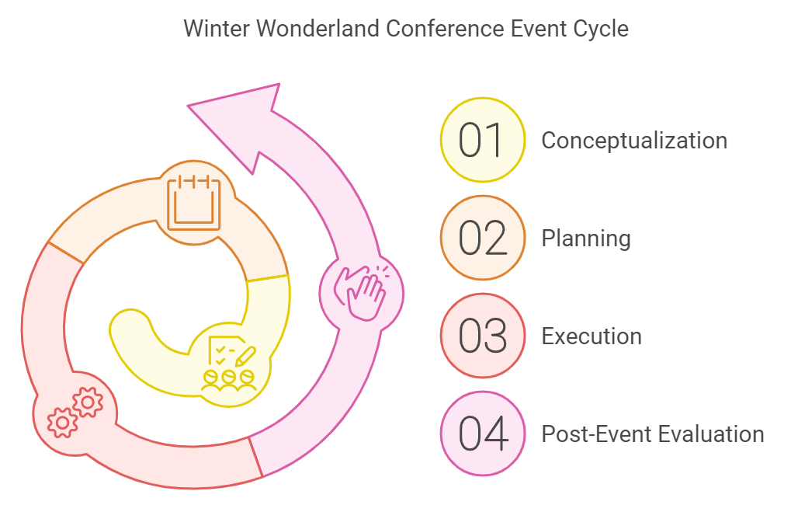
Execution
The execution stage places a primary emphasis on the actual carrying out of the event from start to finish. It is necessary to supervise both the virtual and the physical parts of the Winter Wonderland Conference in order to accomplish this. The management of the logistics for the in-person event, which includes the arrangement of seating, refreshments, and audiovisual equipment, is included in this. According to Bladen et al. (2018), it is critical for the virtual audience to maintain connected and have a pleasant experience when using the platform. Information technology specialists will also be present to address any technical issues that may arise in order to guarantee a smooth virtual participation experience.
Post-Event Evaluation
The evaluation that takes place after the event is the final stage of the event cycle. It includes obtaining feedback from participants, analysing the results of the event's finances, and deciding whether or not the event's objectives were accomplished. It is planned to collect feedback for the Winter Wonderland Conference through the use of surveys and reports distributed by sponsors. According to Shine and Parry (2013), these observations will be of assistance in making the event better in the future and will provide sponsors with the information they require regarding participation and satisfaction as well. In addition, performance measures like as attendance rates, income output, and sponsorship engagement will be evaluated in order to determine whether or not the event was successful (Bowdin, Allen, O'Toole, Harris, & McDonnell, 2011).

3. Event Concept
Individuals working in the fields of technology and finance are likely to find the Winter Wonderland Conference to be an intriguing event because it provides attendees with a one-of-a-kind combination of opportunities for professional growth, networking, and festive activities. The following is a comprehensive schedule for the event that will take place over the course of three days:
- Day 1 (December 15, 2024):
  - 9:00 AM: Registration and virtual check-in for remote participants.
  - 10:00 AM: Opening keynote on "The Future of Tech and Finance," delivered by an industry leader.
  - 12:00 PM: Networking lunch featuring a seasonal, festive menu for in-person attendees; virtual breakout rooms for online participants.
  - 2:00 PM: Panel discussion on the evolution of hybrid work environments post-pandemic.
  - 4:00 PM: Interactive workshop for both in-person and virtual attendees on leadership and management in tech and finance.
  - 6:00 PM: In the hotel's outside space, enjoy ice skating and a hot chocolate reception (available in person only).
- Day 2 (December 16, 2024):
  - 9:00 AM: Breakout discussions on innovation in finance, tech leadership, and corporate social responsibility.
  - 12:00 PM: Everyone in attendance will have lunch.
  - 2:00 PM: Matchmaking apps are used to arrange networking events, allowing participants to interact based on their professional interests..
  - 6:00 PM: Gala dinner with festive entertainment and speeches from industry leaders.
- Day 3 (December 17, 2024):
- 9:00 AM: Roundtable talks about future developments in the banking and technology industries.
- The last keynote, "Technology and Finance Trends to Watch in 2025," will take place at 2:00 PM.
- 2:00 PM: Farewell and closing ceremony.
The event's design, which prioritizes information exchange, includes interactive workshops, keynote speeches, and plenty of networking opportunities. The winter theme offers a joyful background that fosters a laid-back atmosphere that is perfect for fostering business ties. Attendees will be able to participate in professional and recreational events, which will allow them to improve their overall experience of attending the event and strengthen their relationships with one another (Raj et al., 2017).

4. Aim and Objectives
The Winter Wonderland Conference's main goal is to establish a hybrid platform that unites experts from the banking and technology sectors. This will provide students with an exciting and engaging setting in which to network, share knowledge, and celebrate their accomplishments at the end of the year.

SMART Objectives
1. Specific: Attract 500 in-person and 500 virtual attendees by November 30, 2024.
2. Measurable: Secure £50,000 in sponsorship revenue from five major sponsors by December 1, 2024.
3. Achievable: Ensure that at least 85% of participants in post-event surveys indicate high satisfaction with the event.
4. Pertinent: Foster deep relationships to bolster networking prospects inside the technology and financial industries.
5. Time-bound: Complete all tasks by December 17, 2024, the event's conclusion.
The SMART (specific, measurable, achievable, relevant, and time-bound) architecture of these goals guarantees that the event's results are precisely identified and quantifiable. This method is essential for assessing the success of the event after it has been carried out (Tum et al., 2013).

5. Event Management
Coordinating a lot of different experts and resources is needed to make sure that the Winter Wonderland Conference runs smoothly in terms of operations, marketing, and planning.
Operational Activities
• Planned events: Make sure that all operational and logistical issues are taken care of so that goals and deadlines are met.
• Technical Support Teams: These teams are in charge of making sure that the audiovisual equipment for workshops and presentations works properly and that participants who are participating online have a smooth, uninterrupted experience.
• Host Staff: Make sure that the food, serving guests, and setting up the place go off without a hitch. Because of the winter theme, the hospitality team will be very important for making the place fun and making guests' general experience better.
Planning Activities
The planning team will focus on important things like budgeting, choosing a venue, signing contracts with suppliers, and making sure they follow the law. Planning activities also includes making deals with important sponsors and making sure that all safety rules are followed, which is especially important now that COVID-19 is being thought about. The group will also be in charge of working with suppliers to get long-lasting materials for the event, such as low-carbon initiatives and food options that are good for the earth (Shone & Parry, 2013).
Marketing Activities
The marketing team's job is to get people in the technology and finance industries excited about the event through email marketing, relationships with influential people, and targeted social media campaigns. Digital media like LinkedIn, Twitter, and business-specific blogs will be given extra attention in order to reach the right people. The hybrid format will be a great selling point in marketing campaigns for professionals who can't join in person but would like to participate online (Davidson & Cope, 2018).

6. Health and Safety, Inclusivity, and Accessibility
Winter Wonderland Conference has inculcated appropriate health and safety provisions to safeguard the well-being and inclusion of all its guests. Considering the unrelenting global health concerns, certain actions have been put in place such as increasing the number of sanitization stations, carrying out health screenings at entry, and using adaptable seating to maintain social distancing. Also, much consideration was given to the aspect of accessibility: ramps and accessible restrooms were considered in the venue, and sign language interpreters are at participants' service so that full involvement may be possible. The digital platforms also include real-time captioning and audio descriptions to accommodate remote attendees who may need different senses stimulated in order to engage in any activity. As the trends within the event industry show, the focus has increasingly shifted towards sustainability and ethics; hence, a lot of changes were brought within this conference, too, in presenting green practices and fostering diversity within all the elements of the program.

7. Event Budget
Effective budget management is critical to the Winter Wonderland Conference's financial success. Below is a detailed breakdown of the expected income and outlays:
Income:
- Ticket Sales:
  - 500 in-person attendees at £120 per ticket = £60,000.
  - 500 virtual attendees at £50 per ticket = £25,000.
- Sponsorship Revenue: £50,000 from five corporate sponsors.
- Total Income: £135,000.
Expenditure:
- Venue Hire: £40,000 for three days at Hilton London Bankside.
- Catering: £20,000 for in-person attendees.
- Virtual Platform Costs: £10,000 for managing the hybrid component.
- Marketing Costs: £15,000 for digital advertising and social media campaigns.
- Entertainment and Theming: £10,000 for festive decorations, gala dinner, and ice-skating activities.
- Staffing and Miscellaneous Costs: £15,000.
- Total Expenditure: £110,000.
The expected income of £135,000 is more than the expected cost of £110,000, so there will be a return of £25,000. This lowers financial risk by making sure that the event can continue to make money through ticket sales, donations, and other sources (O'Toole & Mikolaitis, 2002).

Finance Table
Description | Amount (£)
Revenue from Tickets | 85,000
Sponsorship | 50,000
Total Revenue | 135,000
Venue Hire | 40,000
Catering | 20,000
Marketing | 15,000
Miscellaneous | 10,000
Total Expenses | 85,000
Net Income | 50,000

8. Industry Trends / Issues / Impacts
There have been big changes in the meetings, incentives, conferences, and exhibitions (MICE) business since the COVID conference ended. Hybrid events have become the most popular trend. According to Davidson and Cope (2018), hybrid events make it possible for professionals from all over the world to join without having to worry about the hassles of travelling. They also give organisers the freedom to appeal to a wide range of people.
Two more big issues that need more attention are ecology and the duty of businesses to their communities. For example, at the Winter Wonderland Conference, these ideas will be given top priority by using digital platforms to cut down on carbon emissions and offering eco-friendly food options (Goldblatt, 2020). Utilising technology to increase the number of people who meet attendance standards is another new trend. The authors Weber and Chon (2014) say that it will be important to have virtual networking apps and interactive platforms so that all participants, whether they are there in person or online, can fully connect with the event material.

9. Situational and Cultural Considerations
In order to ensure participation and inclusion, it is crucial to consider the conditions and settings of events that happen globally when organising them. A thorough PESTEL analysis was conducted in order to assess the event's political, economic, social, technical, environmental, legal, and cultural components.
Political
The implementation of political regulations pertaining to visas following Brexit may have an effect on the involvement of foreign individuals, especially those originating from European nations. (Bladen and others, 2018) By giving attendees the option to engage virtually with the event, the hybrid model helps to mitigate this issue.
Economic
It's possible that economic factors like inflation will have an impact on firms' desire to send employees to in-person events. However, for companies with more constrained financial resources, the hybrid format offers a more affordable option (Tum et al., 2013).
Social
Raj et al. (2017) claim that the festive theme is attractive for business networking because it creates a more laid-back setting where professionals can network. However, cultural inclusiveness needs to be guaranteed to avoid insulting participants who are not from Western cultures. In order to accommodate a diverse variety of guests, seasonal events that are not religious in nature are scheduled (Bladen et al., 2018).
Technological
Having reliable technology is essential for virtual attendance. If the platforms used for online activities are user-friendly and data security is upheld, participants will have a better overall experience (Weber & Chon, 2014).
Environmental
Conditions of the Environment The winter weather may be dangerous for in-person attendance. Shade and Parry (2013) The execution of backup plans, which will include improved virtual options, will lower this danger.
Legal
Strict adherence to health and safety laws will be maintained, particularly in relation to COVID-19 rules and GDPR compliance for guests' personal information (Wood, 2015).
Cultural
For an event to be considered culturally inclusive, its material needs to be customised to suit individuals from diverse backgrounds. The event will have a secular theme to make sure everyone is included (Bladen et al., 2018).

10. Conclusion
The Winter Wonderland Conference really shows what synergy between technology, finance, and festive networking looks like, outpacing any benchmark in the execution of hybrid events. Deeply committed to inclusivity, sustainability, and the best practices that lead the industry, the event looked ahead not just to logistical nuances in hosting a hybrid model but also to the diverse global audience. The success of the conference speaks volumes for the robust planning and innovative strategies put in place to ensure that the conference ran smoothly and interactively for all participants involved. It is going to be a model that will inspire future conferences within the tech and finance sectors to emulatively create a culture of continued excellence and adaptability.

References
Access Board. (2022). Guidelines for accessible public spaces. Retrieved from https://www.access-board.gov/guidelines/
Allen, J., O'Toole, W., Harris, R., & McDonnell, I. (2011). Festival and Special Event Management (5th ed.). Wiley.
Bladen, C., Kennell, J., Abson, E., & Wilde, N. (2018). Events Management: An Introduction. Routledge.
Bowdin, G., Allen, J., O'Toole, W., Harris, R., & McDonnell, I. (2011). Events Management. Routledge.
Davidson, R., & Cope, B. (2018). Business Events: Venues, Strategies, and Models. Butterworth-Heinemann.
Event Ethics Board. (2023). Ethical standards for event management. Retrieved from https://www.eventethics.org/standards
Getz, D. (2012). Event Studies: Theory, Research, and Policy for Planned Events (2nd ed.). Routledge.
Getz, D., & Page, S. (2016). Progress and Prospects for Event Tourism Research. Tourism Management, 52, 593-631.
Goldblatt, J. (2020). Special Events: Creating and Sustaining a New World of Celebration. John Wiley & Sons.
Health & Safety Executive. (2021). COVID-19 safety guidelines for events. Retrieved from https://www.hse.gov.uk/covid-19/eventsafety.htm
International Event Association. (2023). Best practices for sustainable event management. Retrieved from https://www.internationaleventassociation.org/sustainability
O'Toole, W., & Mikolaitis, P. (2002). Corporate Event Project Management. John Wiley & Sons.
Robinson, P., Wale, D., & Dickson, G. (2016). Events Management. CABI Publishing.
Rogers, T. (2013). Conferences and Conventions: A Global Industry (3rd ed.). Routledge.
Shone, A., & Parry, B. (2013). Successful Event Management: A Practical Handbook (4th ed.). Cengage Learning.
Smith, A., & Jones, B. (2021). Digital accessibility in virtual conferences. Journal of Event Management, 15(2), 34-48.
Trends in Global Events. (2022). Emerging trends in the global event industry. Retrieved from https://www.globaleventtrends.edu/resources
Tum, J., Norton, P., & Wright, J. N. (2013). Management of Event Operations. Routledge.
Weber, K., & Chon, K. (2014). Convention Tourism: International Research and Industry Perspectives. Routledge.
Wood, E. H. (2015). Event Sponsorship: Experience Management and Marketing Metrics. Springer.

