DS 1 assessment
JULIO CESAR VARGAS LOPEZ.
ID: 2431056.

My digital life.

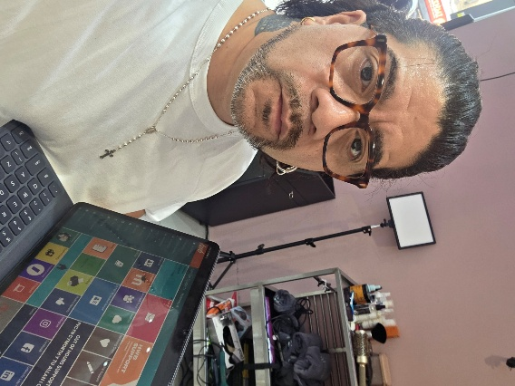
In this picture I show that digital tools are part of my school life and at work


Normally, I use social media to promote my work and give myself visibility, credibility, and with this, gain more clients and make my business grow.

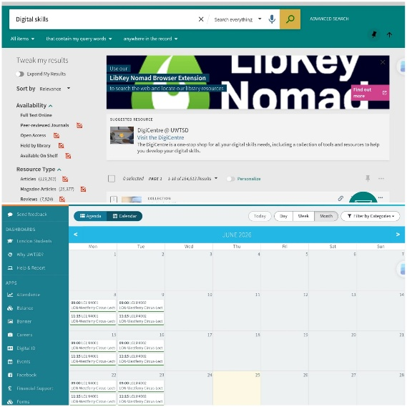
Using tools like calendars and the university library gives me more confidence to work on my university assessment.

[Insert Photo/Screenshot below]
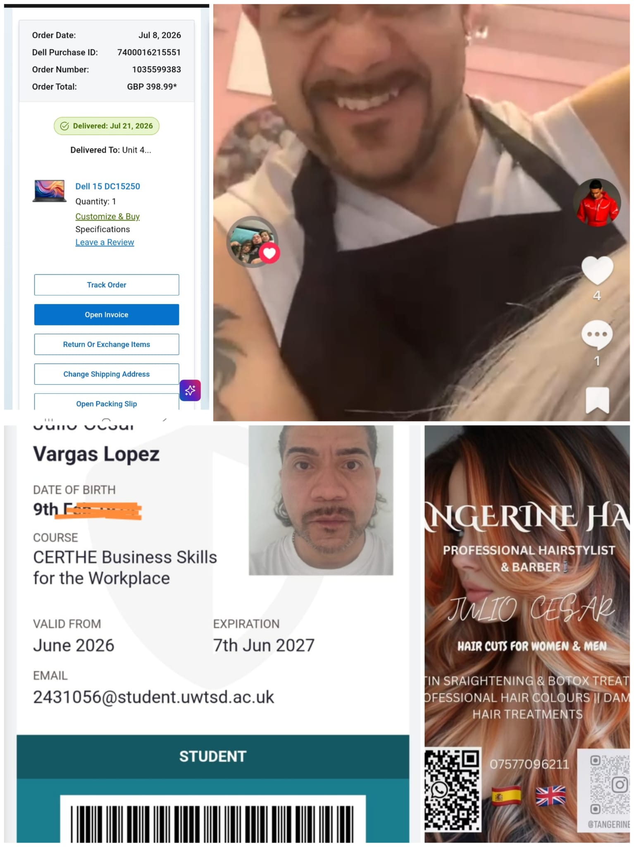
In conclusion, right now I feel more confident with social media and digital tools, and being able to make the most out of them.

