Joshua Thomas Douglass
1701538
Photography in the Arts
Creative Research
Paul Duerinckx

“It is useless and tedious to represent what exists, because nothing that exists satisfies me…. I prefer the monsters of my fantasy to what is positively trivial.”
Baudelaire, Salon Review 1859
Is Baudelaire’s position defensible in light of the case lens-based art-forms make to ‘represent what exists’? Or, from a contemporary perspective, do the ‘monsters of fantasy’ still allow artists to engage with ‘what exists’ creatively?

Word count: 1821

Charles Baudelaire’s connection to his fantasy, what exists creatively, is stronger than that of his connection to what exists literally. In relation, I’m interested in the fantasy of my mind and the capability it has creatively. In response to this I will explore my creative ideas and opinions as well as ideas of others in order to conclude, in my opinion, whether ‘Baudelaire’s position is defensible in light of the case lens-based art-forms make to ‘represent what exists’? Or, from a contemporary perspective, do the ‘monsters of fantasy’ still allow artists to engage with ‘what exists’ creatively’.
Progressively, the work of Cindy Sherman projects a contemporary perspective of what her ‘monsters of fantasy’ are. The body of work I have engage with is called ‘Clowns’ (2004) which Sherman created between 2003 and 2004. During an interview with Betsy Berne, (Tate, 2003) on her work ‘Clowns’ (2004) she explains that:
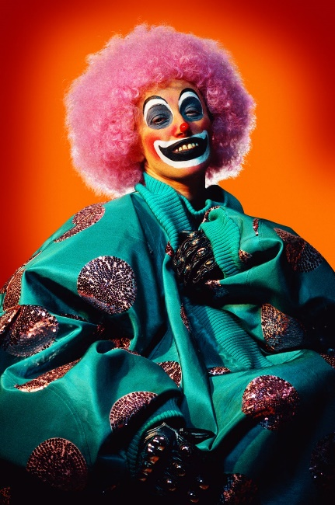
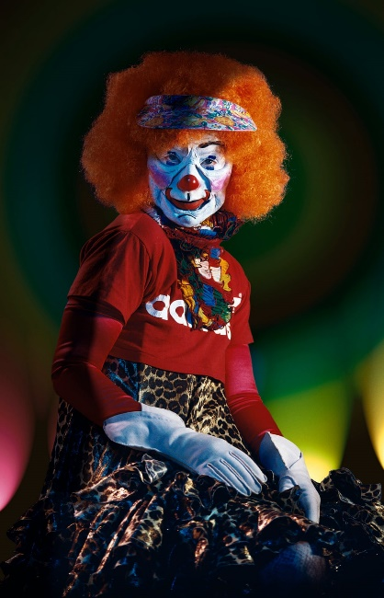
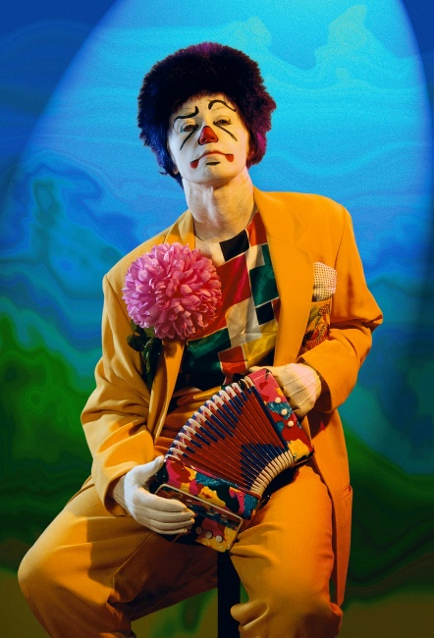
‘I still wanted the work to be the same kind of mixture – intense, with a nasty side or an ugly side, but also with a real pathos about the characters – and [clowns] have an underlying sense of sadness while they’re trying to cheer people up. Clowns are sad, but they’re also psychotically, hysterically happy, that you could be painted to look like you’re happy and still look like you’re sad underneath, or the opposite too. The more research I did the more levels I saw. There are a lot of creepy, sad, different emotions that I really like’.

Images from Sherman. C, ‘Clowns’ (2004).
In response to this I would firmly agree with the fact that Sherman is portraying her ‘monsters of fantasy’ creatively through this body of work. The idea of subconscious feelings and emotions she is using through visual augmentation counters Baudelaire’s position as Sherman is connecting to her creativity more than a representing what exists. In my opinion, Sherman is addressing a spike of interest of hers in a new light through connecting with her emotions and thoughts and producing work that allows her to contemporise her creativity and stray away from existential realism. In addition to this, Sherman states in the same interview that, ‘pyjamas turned into a clown outfit; it’s ugly and funky, but I liked it for that and it just helped everything come together,’ (Tate, 2003). Moreover, her initial idea and starting point for this body of work is pyjamas, turned into a clown outfit. The spark that Sherman had was creative, however this can be countered with the fact that clowns are what exists, but her thoughts of them are what differs from the ordinary, this then becomes creative existence in my opinion, therefore Sherman is in conflict with the representation of literal existence within her work. Sherman is taking something that already exists and shaping it to her creative ideas. Sherman depicts clowns through femininity, this is important as usually males are seen to take on this role.
In my opinion empowerment towards females is being displayed as Sherman is allowing for no gender separation with who is enabled to play the role of clowns. Sherman would technically utilise punchy, vivid colours to exaggerate the alter ego of the characters she was creating adding more depth in terms of creative manipulation, allowing the viewers to engage on more than just a visual level. From my perspective Sherman challenged the ‘monsters of her fantasy’ through delivering subconscious feeling and personas through the makeup she used. Therefore, presenting each image or clown differently and in doing this she allowed for the viewers to feeling different emotions based on the visuals of each image allowing for Sherman to creatively challenge what exists literally and through fantasy. Complimentary to this, Robinson. A (2011) writes:
‘Bakhtin believes that the grotesque is counterposed to the classical aesthetic of ready-made, completed being. The carnivalesque body in contrast expressed ideas of simultaneous death and rebirth. It is counterposed to the classicist idea of art as the pursuit of the sublime.’

In response to this, the idea of grotesque aesthetics of clowns to represent happiness or comedic pleasure within circus or carnival context allows for a wider creative view of normality. Ultimately, portraying what exists literally and creatively to come together to make something unnaturally comic.
Moving towards a different way of perceiving lens-based art forms is how it exists and to what extent is the representation we see genuine and real. The production of the everyday multiplies with lens-based image making through the loss of exclusivity. In addition, how the reproduction of singular art pieces loses the exclusivity and uniqueness that they hold through lens-based reproduction. In support of this John Berger writes:
‘The uniqueness of every painting was once part of the uniqueness of the place where it resided. Sometimes the painting was transportable. But it could never be seen in two places at the same time. When the camera reproduces a painting, it destroys the uniqueness of its image. As a result, its meaning changes’.
(Berger, 1972, p.19)
Berger raises a valuable point, he emphasises the destruction of uniqueness and originality lens-based image making has on what exists creatively and exclusively, as far as reproduction of the same piece. Berger also stated that,’ the painting now travels to the spectator rather than spectator to the painting. In its travels, its meaning is diversified.’ (Berger, 1972, p.20.) In response to this, diversification and location plays a key component to how anything is consumed creatively. Within my own work this is a factor for me as the images I produce I wish to be interpreted differently depending on the creativity of the viewer, obviously my images are based on the ‘monsters of my fantasy’, however I wish for all of my work to be interpreted both from my perspective so the viewer knows my intentions as well as being open for additional creative exploration.
In conjunction to this, Ralph Eugene Meatyard strived upon the monsters of his fantasy in my opinion. As his main profession lay as an optician Meatyard used his strange and sinister approach to image making in the 1950’s of large facial masks and dolls. Seen as unnatural and absurd during this time, Meatyard stretched the boundaries of normalised image making as he used his minds fantasies to create some of the most renowned surreal images to date. Meatyard’s, ‘The Family Album of LucyBelle Crater’, (1972) depicts his surreal ideas and thoughts he had when creating lens-based images. In my opinion, Meatyard defends Baudelaire’s position as Meatyard’s work has more engagement in what isn’t existential to what is, he explores the ‘monsters of his fantasies’ as a means to what exists in reality and what exists within his fantasies allowing him to explore further than ordinary reality.
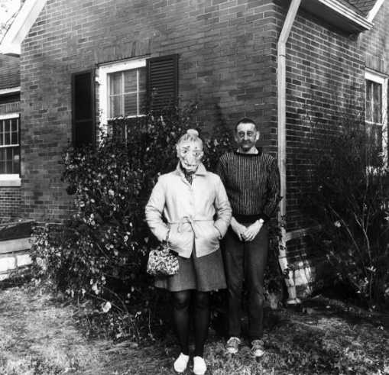
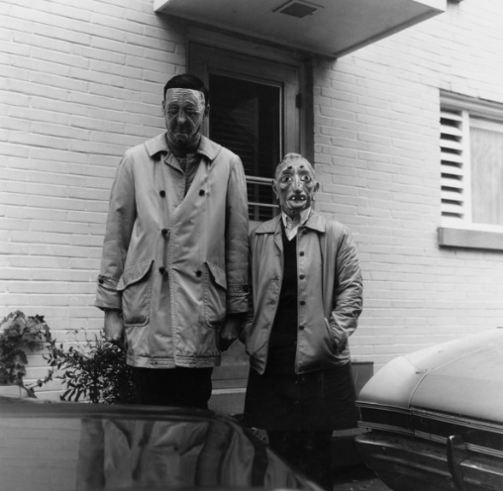
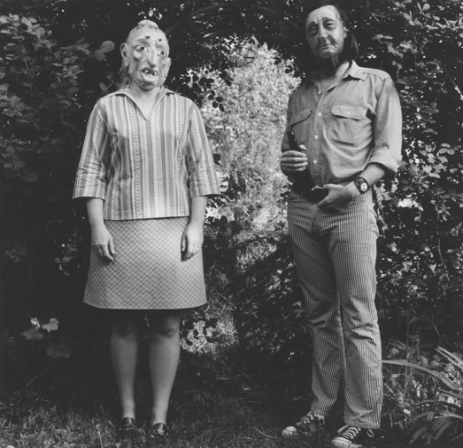
Images from Meatyard. E. R, ‘The Family Album of LucyBelle Crater’ (1972).
Meatyard used large rubber masks that covered the face of his family. During the time Meatyard created work, this form of surreal image making was unheard of and argued against normality and what an image should be compared to that of the images he did in fact create. His creative ability is clear through his work and preferred the ‘monsters of fantasy’ more than reality. Evidently, when looking and engaging with these images, the viewer can correlate with the emotional angles that they give, shot in black and white gives additional focus on the sharpness of the images allowing the viewer to engage fully in the deeper meanings and feelings of these images. Moreover, an article by (Edwards. S, 2017) states that:
‘In the last two years before his death, of cancer, in 1972, Meatyard began to employ the masks in a more structured way, staging a sixty-four-image series that he called “The Family Album of Lucybelle Crater.” Each of these pictures, which form the bulk of “Ralph Eugene Meatyard: American Mystic,” an upcoming exhibit at the Fraenkel Gallery, in San Francisco, features two characters, both masked and both named Lucybelle Crater. The images, each with a scrawled caption underneath, create the convincing illusion of a family album belonging to a clan of suburban, oafish monsters. There’s something tender about these monsters as they sprawl across grassy lawns, Keds akimbo, earnest and exposed in their joint grotesque identity.’
Its interesting to me that somethings so ordinary, such as a shop bought mask, can allow for such a sinister and dark image. Within ‘The Family Album of Lucybelle Crater’ (1972), the same position and stance is taken for the majority of the images, this adds significance as to why Meatyard wanted this specifically. Linking back to Baudelaire’s position, the creation of Meatyard’s imagination allowed him to defend Baudelaire through the ‘monsters of his fantasy’.
Following this, an essay by Chris Barker titled ‘Mechanical Reproduction in an Age of High Art’ addresses the reproduction of art works through the age of lens-based image making commenting on abstraction not being ‘compositional wholes’. As Barker (2014) writes:
‘Parisian photographer Eugène Atget began to kill the aura by dismembering photographed scenes to focus on details. This was a way of seeing that led to surrealism and also to “arty” abstractions of parts that did not make compositional wholes.’
I found it intriguing that abstraction was described as not being ‘compositional wholes’, in terms of Baudelaire’s stand point, I would agree that to a certain extent abstraction is not a ‘compositional whole.’ Abstraction to me is capability of imaginative improvisation and allowing thoughts, feelings and emotions to forge visual aesthetical images. Through abstraction allowing the creator to display the ‘monsters of their fantasy’ and represent what does not exist literally. Though, lens-based image making has certain limitations connected to what can actually be represented there is technically nothing that cannot be created that exists.
In summary of Sherman and Meatyard’s work, I would ultimately agree that in light of lens-based image making these two artists would defend Baudelaire’s position as both Sherman and Meatyard use creative visualisation to represent their work of what creatively exists and not existentially exists using real world objects to experiment and represent what exists within their own minds as the ‘monsters of their fantasy’. Sherman with, ‘Clowns’ (2004) and Meatyard with, ‘The Family Album of LucyBelle Crater’ (1972). In conclusion to this I firmly believe that from a contemporary perspective, artists are still able to engage with their own personal ‘monsters of fantasy’ through lens-based image making. Though, lens-based image making does have some limitations in the respect that anything the mind is capable of creating is not always possible to create through a lens. However, creating using other mediums could lead to being photographed though a lens, such as the masks Meatyard uses throughout his work. In correlation to this, enabling anything that truly exists to be represented how the artist chooses, manipulation allows for images to appear fantasised and unreal, something that doesn’t truly exist. However, what exists is adjusted in order to represent a ‘monster of fantasy.’

Bibliography

Berger. J (1972), Ways of Seeing, (London, Penguin)
Berne. B (2003), interview with Sherman. C, Available at:
https://www.tate.org.uk/context-comment/articles/studio-cindy-sherman (Access date: 10th December 2018)
Barker. C (2014), Available at:
https://contempaesthetics.org/newvolume/pages/article.php?articleID=708 (Accessed on: 11th December 1018)
Edwards. S (2017), Available at:
https://www.newyorker.com/culture/photo-booth/ralph-eugene-meatyards-sweetly-southern-gothic-family-album (Accessed on: 11th December 2018)
Robinson. A (2011), Available at:
https://ceasefiremagazine.co.uk/in-theory-bakhtin-2/ (Accessed on: 11th December 2018)

Illustrations List

Sherman. C, ‘Clowns’, (2004) Available at: https://www.theguardian.com/artanddesign/gallery/2016/may/30/cindy-sherman-clowning-around-and-socialite-selfies-in-pictures (Accessed on: 11th December 2018)
Meatyard. E. R, ‘The Family Album of Lucy belle Crater’, (1972) Available at:
http://www.dcmooregallery.com/exhibitions/ralph-eugene-meatyard-the-family-album-of-lucybelle-crater?view=slider#20 (Accessed on: 11th December 2018)

