Task 1: Locating Sources
Identify and locate three different sources (a report, a journal article, and a website) related to the question
“What employability skills do university graduates need to succeed in the workplace?”
Show how you used keywords, search terms, and Boolean operators to find them, and explain how you know which type of source each one is and why it is appropriate for the research question.

Source Type & Why It Is Appropriate | URL/DOI | What search engine did you use? Google/Online Library/Library AI Assistant | Keywords/Boolean Operators Used
Journal Article. | https://librarysearch.uwtsd.ac.uk/permalink/44WHELF_UWTSD/1bmis16/cdi_proquest_journals_2785473199 | UWTSD Online Library. | "employability skills" AND "graduates".

Task 2: Evaluating Information (CRAAP Test)
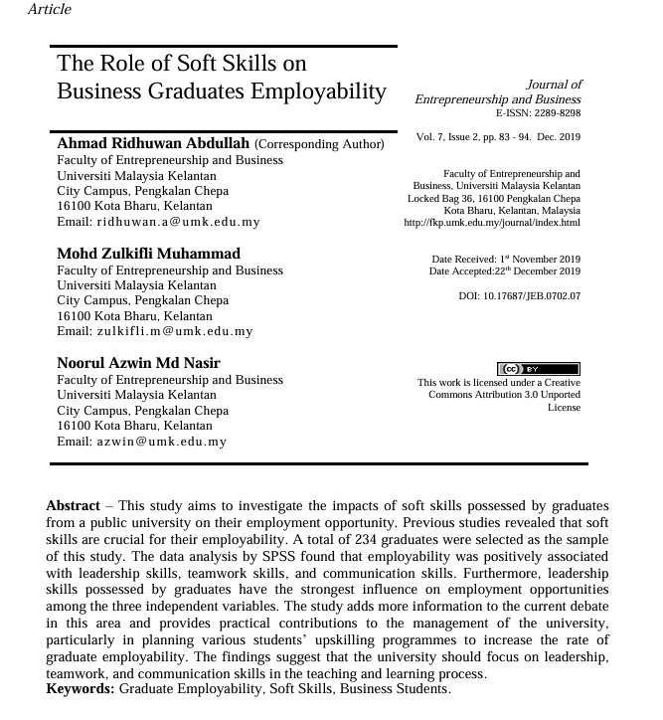
Your colleague has forwarded you a source from a peer reviewed journal, and they are not sure whether it is appropriate to use and has asked for your help. Your task is to evaluate the source by using the CRAAP Test to assess its appropriateness for the following question “What employability skills do business university graduates need to succeed in the workplace?”

CRAAP Test
Currency | The journal article was published in the December of 2019. I would consider it to be relatively current due to the article fitting within the 10-year recommended timeline.
Relevance | I would consider this source to be very relevant the overarching question due to the information found within the abstract. The abstract itself recommends three skills in particular which correlate to positive associations within employment. Key words relevant to the question itself are also found within the abstract, e.g., ‘employability’, ‘graduate’, and ‘soft skills’.
Authority | The authors of this journal article appear to have an expertise within the world of business and entrepreneurship, which naturally goes hand in hand with employability and workforce. All three are a part of the faculty of their respective university, which exhibits that they are educated in the matter.
Accuracy | It would be safe to assume that this journal article would be accurate to the best of the authors’ knowledge as articles need to undergo the peer-review process from fellow experts within the field of study. If not accurate, it would be unlikely featured in the journal.
Purpose | From reading the abstract, it is my interpretation that the authors of this article’s main purpose are to present which employability skills are most desirable for the success within future careers. They appear to want to arm newly graduates with appropriate skills provided by their university and therefore, exhibit skills for the universities to focus on providing.
Task 3: Source Analysis
Your manager has provided you with a short extract from a source and has asked you to analyse the source by Identifying one strength, one weakness, and providing a brief explanation of the strength and weakness identified.
If you want to read the article online, please click the following link: https://www.universitiesuk.ac.uk/latest/news/strong-demand-graduates-employers

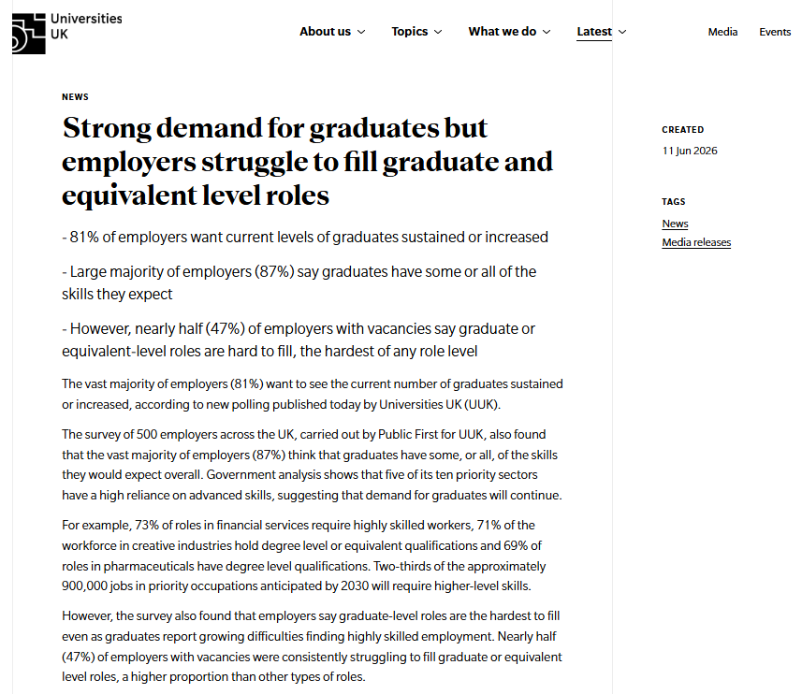
.

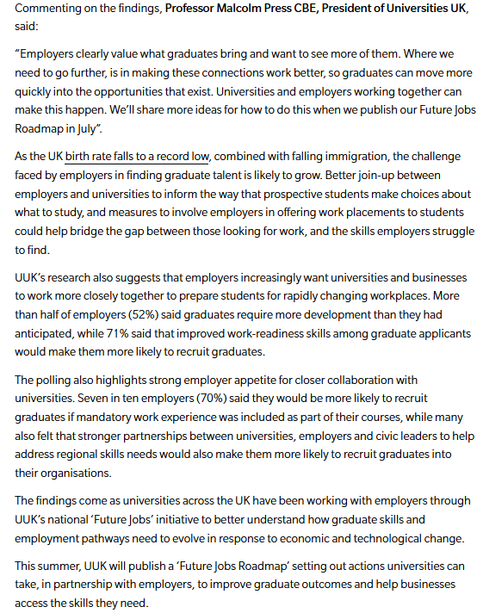

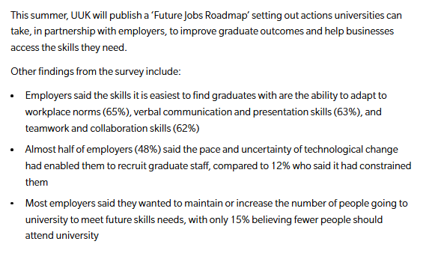

Strength of the Source:
One strength of the source would include the currency of the news article. The source itself is very up to date and easily accessible to students studying at university, but not necessarily relevant for the general public.

Weakness of the Source:
One weakness of the source would be its accuracy. A news article will not undergo a thorough peer-review process from experts within the desired field of study. Therefore, bias, the spread of disinformation or misinformation may be present within the contents of the article.

