Questions and Guidelines for Assessment Component 1


Changemakers: Creativity and Value Creation
Professions (BMHP5014)

Component 1: Online portfolio of set exercises

Student name: Eric Lerouge ANGWE NZE
Student number: 2417255
Lecturer’s name: Dr Brian MASHUMBA

Table of contents
Introduction 2
Task 1- Defining Key Concepts in Practice 2
Task 2 - Mind Map 4
Task 3 - Self-Reflection of Group Activity 5
Task 4 – Case Study Analysis of a UK Innovation 5
Task 5 - Research Task 6
Task 6 - Exploring Digital Innovation in Health and Social Care 6
Task 7 - Understanding the NHS Leadership Framework 7
Task 8 – Self-Reflection Journal Entry 8
Reference 9
Appendix 10

Assessment Component 1

Introduction
This portfolio demonstrates evidence of learning and reflection on the key concepts of creativity, innovation, value creation, leadership and technology in health and social care. It illustrates the application of these concepts to the aim of service quality improvement, patient outcome enhancement, and contemporary challenges facing healthcare organisations. The portfolio applies relevant theories and academic research to apply to practice, emphasising the need to be creative and continually evaluating practice for person-centred care. The portfolio demonstrates and reflects the knowledge and skills that support innovation and positive change in professional practice through critical reflection and practical examples. Overall, the portfolio is evidence of engagement with the module content and application of learning to ensure effective and sustainable improvements are made within health and social care services.

Task 1- Defining Key Concepts in Practice
Innovation
Innovation is the implementation of new ideas, services or processes that enhance the quality, efficiency or effectiveness of care. In health and social care, innovation is crucial as it enables organisations to adapt to the growing demands of their patients, the lack of staff and advances in technology, and to enhance the quality of their services (West and Farr, 1990). The adoption of EHRs has also led to improved communication among healthcare providers, minimised medication mistakes and boosted patient safety, for instance. Rogers' Diffusion of Innovation Theory states that the diffusion of innovation takes time, and that individuals and organisations adopt it over time based on how it is perceived and accepted (Rogers, 2003).
Creativity
Creativity involves producing original and useful ideas that are useful to solve a problem or to make something better. Creativity in health and social care contributes to the ability of the professionals working in this field to create person-centred approaches, to enhance the experience for the people they care for and to address complex service challenges. For instance, an occupational therapist can create individual rehabilitation activities to suit the person's physical capabilities and interests, which can increase participation in rehabilitation. According to Amabile's Componential Theory of Creativity, creativity is a result of the interplay of knowledge, creative-thinking skills, and intrinsic motivation (Amabile, 1996).
Value Creation
Value creation is defined as creating improved patient outcomes with the best use of available resources (Porter, 2010). In health and social care, value is a key consideration as organisations need to ensure that they provide care of an acceptable quality, in the face of limited resources and increasing demand. One example is the implementation of preventive health care programs like diabetes education and screening that help people care for their diabetes and lead to fewer hospitalizations. According to Porter's Value-Based Healthcare model, value is added in healthcare organisations when the outcomes for patients are better than the costs of the care (Porter, 2010).
Change
Change is the process of altering, modifying or changing our existing practices, behaviours or systems to enhance organisational performance and patient care. Health and social care need to change as services need to be continuously adapted to reflect new evidence, policies, technologies and expectations of patients. During the COVID-19 pandemic, for instance, many health care systems implemented telehealth consultations, expanding access to care while minimizing the need to have unnecessary in-person visits. Lewin's Change Management Model suggests that change is successful when people abandon the old way of doing things, adopt the new way and reinforce the change to make it the new norm (Burnes, 2017).

Task 2 - Mind Map
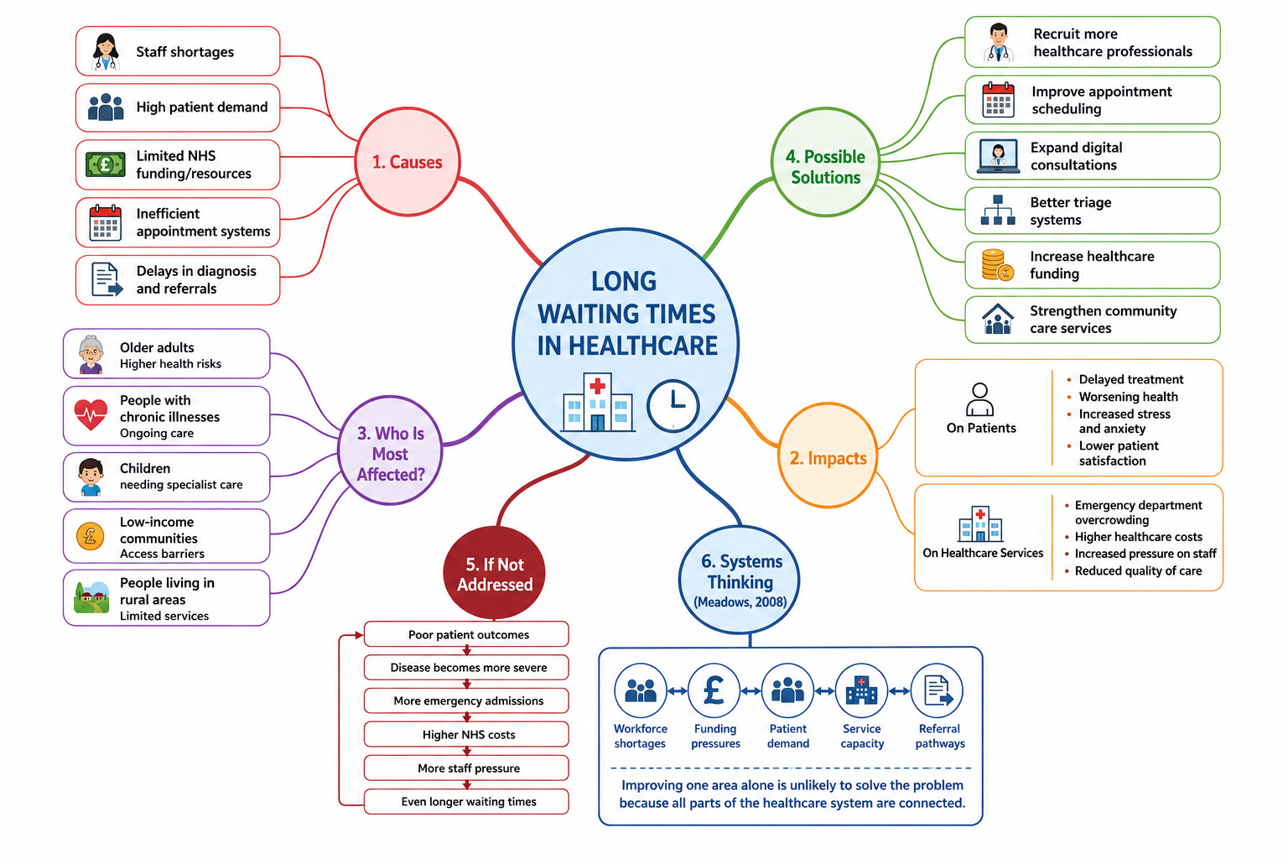

Figure 1. Mind Map: Long Waiting Times in Health and Social Care
The mind map is centred on the problem of long waiting times in health and social care which is a major concern of patients and health and social care workers. The reasons for long waiting periods are often due to staff shortages, rising patient numbers, inadequate funding and poor appointment systems. The interrelated factors can contribute to a delayed diagnosis and treatment, cause patient anxiety and add to the stress on healthcare providers. Without addressing the problem, patient outcomes could deteriorate, hospitalizations may rise and the efficiency of care may decrease. The mind map also outlines potential solutions, such as hiring more health care providers, enhancing appointment processes, promoting virtual health care and increasing community health care support. According to a Systems Thinking Approach, long waiting times are not the fault of a single factor; instead, coordinated improvements throughout the healthcare system are required to create sustainable and effective improvement (Meadows, 2008).

Task 3 - Self-Reflection of Group Activity
This reflection is based on Kolb's Experiential Learning Cycle (Kolb, 1984). For the class activity where I was asked to do convergent and divergent thinking, I facilitated the discussion of the group and made suggestions to help them solve the problem. The divergent thinking was the process of coming up with many ideas to solve the problem, and the convergent thinking was the process of analysing the ideas and deciding on the best solution. I found divergent thinking easier because I liked to add my own ideas in before the group came up with their own ideas. In retrospect, I found that by asking all participants to present their ideas, it led to a more collaborative discussion and better decision making. If the group had a few options, I suggested discussing the pros and cons of each option to help us come to a decision. This experience had been a great support in developing my communication, leadership and teamwork skills and has taught me the importance of being creative and critical. Kolb (1984) says that learning takes place when we reflect on experience and then transfer what we have learned to future experiences. In the future, I would suggest that quieter group members speak up sooner in the discussion so that everyone's opinion is heard before a final decision is made.

Task 4 – Case Study Analysis of a UK Innovation
One of the innovations in the NHS is Virtual Ward, where patients receive hospital-level care at home by being monitored remotely and being supported regularly by healthcare professionals. This innovation was developed to meet the growing demand in hospitals, long waiting time and the lack of beds, and to ensure that patients continue to be treated safely and effectively. The use of digital technology, clinical expertise and person-centred care to provide care outside of the hospital was achieved through the creativity that was applied. Virtual wards provide value by enhancing patient experiences, preventing unnecessary hospital admissions and facilitating earlier discharge without compromising care quality. They also support health care workers to manage hospital capacity more effectively as well as increase the efficiency of NHS services (NHS England, 2023). Reported benefits are decreased pressure on hospital beds, increased patient satisfaction and better utilization of healthcare resources. Rogers' Diffusion of Innovation theory suggests that innovations in healthcare will gain acceptance if they offer tangible advantages, can be easily used and enhances current practice (Rogers, 2003). The effectiveness of virtual wards indicates that other digital models could be rolled out throughout other areas of health and social care to enhance access, efficiency and patient outcomes.

Task 5 - Research Task
One of the health and social care issues currently being addressed is staff stress and burnout of employees, which has a detrimental impact on employee wellbeing and care provided to patients. The two main causes of burnout that Maslach and Leiter (2016) cite are too much work and not enough organizational support, along with the emotional demands. Their work, which is based on the Maslach Burnout Theory, shows that stress in the workplace can cause emotional exhaustion, depersonalisation and diminished professional achievement. This is why healthcare professionals under constant stress might have reduced job satisfaction and performance.
Similarly, West et al. (2018) found that administrative demands, excessive work hours and poor work-life balance are significant factors in healthcare workers' burnout. The authors highlight those organisational interventions – for example, staffing and staff wellbeing – are more effective than individual resilience. Both studies concur that workplace factors are the primary contributors to burnout, with West et al. (2018) focusing more on the organisational responsibility to alleviate stress. In practice, staff burnout can lead to staff fatigue, poor quality of care and staff turnover. These articles give a better sense of what causes burnout and the need to have a healthy work environment that positively impacts employee wellbeing and patient care.

Task 6 - Exploring Digital Innovation in Health and Social Care
- Benefit of Wearable Health Technologies
Wearable health technologies, like smartwatches and fitness trackers, enable people to monitor their health indicators, including heart rate, physical activity and sleep patterns. With continuous health data they provide, these devices can help manage chronic conditions and alert patients to potential issues early on, allowing them to take an active role in their health management. For instance, someone with cardiovascular disease can use a smartwatch to track their heart rate and get alerts if there are irregular patterns, so that they can seek medical advice on time. The Technology Acceptance Model suggests that the adoption of wearable technologies is more likely to occur when users find the technologies useful and easy to use. Wearable devices therefore can help to enhance self-management, improve patient engagement and decrease non-necessary hospital admissions by intervening at the right time.

(ii) Electronic Health Records (EHRs)
By providing a unified digital system to share patient information, Electronic Health Records (EHRs) facilitate communication and collaboration among authorised healthcare professionals, ensuring that patient information is accurate and up to date. This helps to avoid unnecessary testing, reduce documentation inaccuracies and enable effective decision making in various healthcare environments. For instance, if a GP refers a patient to a hospital specialist, both doctors will have access to the same medical details, prescriptions and test results, providing continuity of care. The Technology Acceptance Model proposes that healthcare practitioners are more apt to utilize electronic systems if they are more effective and simpler to use. Key benefits of effective EHR use include better patient safety, improved multidisciplinary collaboration and better quality, person-centred care.

(iii) Digital Technology for Preventative Care and Health Promotion
Digital technology is central to preventative care, allowing people to track their health, get accurate information and make positive changes to their lifestyles well before they fall ill. Reminders, personalised advice and progress tracking from mobile health apps, wearable devices and online health platforms can help encourage healthy lifestyle decisions. For instance, a diabetes prevention application can remind the user to do regular exercise, provide tips for nutrition, and remind the user to get their blood glucose checked, which can help lower the likelihood of developing complications (Davis, 1989). Individuals are more likely to adopt these technologies if they believe that they will be of benefit to them and easy to use, as the Technology Acceptance Model states. Digital technologies enhance the delivery of early intervention and health education, which leads to healthier lifestyles and lower rates of preventable disease and better public health.
Task 7 - Understanding the NHS Leadership Framework
Part A – NHS Leadership Framework Summary
The NHS Healthcare Leadership Model describes the behaviours that are expected of good leaders at every level in health and social care. The framework has nine dimensions: inspiring, shared purpose, leading with care, evaluating information, connecting services, sharing the vision, engaging the team, holding to account, developing capability and influencing for results (NHS Leadership Academy, 2013). The framework is not just about management responsibilities, it's about the behaviours of the leader that enhance team working, communication and person-centred care. It is important because good leadership helps to deliver high-quality health care, promotes continuous improvement and helps organisations adapt to the evolving needs of patients. The framework also encourages a positive culture in the workplace, supporting staff to feel supported, valued and motivated to deliver safe and effective care. Transformational Leadership Theory states that leaders who inspire and empower others will be more likely to promote innovation and organisational performance improvement (Bass and Avolio, 1994).
Part B – Leadership Behaviour
Leading with Care is one of the important leadership behaviours. Leaders, who are empathetic, respectful and supportive, foster a positive working culture in which staff are confident to try new ideas and enhance practice. For instance, if the ward manager is regularly listening to staff concerns and encouraging suggestions for improving patient care, this can lead to greater staff engagement and motivation. This supportive approach can result in innovative solutions such as better communication, or better discharge planning. Transformational Leadership Theory suggests that leaders who encourage and support their teams are more successful in promoting innovation and achieving better patient outcomes (Bass and Avolio, 1994).
Part C – Reflective Journal Entry
My knowledge of creativity and value creation in health and social care has grown significantly during this module. At first, I thought that creativity was primarily about coming up with new ideas, but I now know that it is also about making improvements to existing services that will have an impact on the outcomes for patients. The mind map, case study analysis and group reflection illustrated the creative, leadership and digital innovation solutions to real health care challenges. I have also gained an understanding of the value of team working evidence-based practice and reflective learning. I plan to use these principles in my future professional practice to promote continuous improvement and provide safe person-centred care and to be open to new ideas that will support service users and healthcare organisations.

Task 8 – Self-Reflection Journal Entry
This reflection uses Gibbs' Reflective Cycle (Gibbs, 1988). During this module I have enhanced my knowledge of creativity, innovation and value creation in health and social care. Initially, I thought of innovation primarily in terms of the introduction of new technology. But the examples of innovation, such as the case study on NHS 'virtual wards' and the group exercise on convergent and divergent thinking demonstrated that innovation can also be about enhancing services that already exist, through collaborative practice, problem-solving and person-centred approaches. The learning experiences shifted my thinking, because they showed me how to add up a little bit to get a lot of value for patients, employees and healthcare organisations. This learning has helped me to appreciate the need to embrace new ideas and to apply evidence-based methods to address challenges. I will use creative thinking, team working and reflective work to promote continual improvement and provide quality and person-centred care in future placements and roles.

Reference
Amabile, T.M. (1996) Creativity in Context. Boulder, CO: Westview Press.
Bass, B.M. and Avolio, B.J. (1994) Improving Organizational Effectiveness Through Transformational Leadership. Thousand Oaks, CA: Sage Publications.
Burnes, B. (2017) 'Kurt Lewin and the Harwood Studies: The foundations of OD', The Journal of Applied Behavioral Science, 53(3), pp. 255–281.
Davis, F.D. (1989) 'Perceived usefulness, perceived ease of use, and user acceptance of information technology', MIS Quarterly, 13(3), pp. 319–340.
Gibbs, G. (1988) Learning by Doing: A Guide to Teaching and Learning Methods. Oxford: Oxford Polytechnic.
Kolb, D.A. (1984) Experiential Learning: Experience as the Source of Learning and Development. Englewood Cliffs, NJ: Prentice Hall.
Maslach, C. and Leiter, M.P. (2016) 'Understanding the burnout experience: Recent research and its implications for psychiatry', World Psychiatry, 15(2), pp. 103–111.
Meadows, D.H. (2008) Thinking in Systems: A Primer. White River Junction, VT: Chelsea Green Publishing.
NHS England (2023) Virtual Wards Including Hospital at Home. Available at: https://www.england.nhs.uk/long-read/virtual-wards-including-hospital-at-home/ (Accessed: 31 July 2026).
NHS Leadership Academy (2013) Healthcare Leadership Model. Leeds: NHS Leadership Academy.
Porter, M.E. (2010) 'What is value in health care?', New England Journal of Medicine, 363(26), pp. 2477–2481.
Rogers, E.M. (2003) Diffusion of Innovations. 5th edn. New York: Free Press.
West, C.P., Dyrbye, L.N. and Shanafelt, T.D. (2018) 'Physician burnout: Contributors, consequences and solutions', Journal of Internal Medicine, 283(6), pp. 516–529.
West, M.A. and Farr, J.L. (1990) Innovation and Creativity at Work: Psychological and Organizational Strategies. Chichester: John Wiley & Sons.
World Health Organization (2021) Global Strategy on Digital Health 2020–2025. Geneva: World Health Organization.

Appendix


