

Academic Skills
Reflective Report Using Gibbs’ Reflective Cycle

Student Name: Mariana Nogueira
Student ID: 2439864
Module Code: LCLM4001_LON
Module: Academic Skills
Lecturer: Lizeta

Table of Contents

Introduction ......................................................... 3

Description ......................................................... 5

Feelings ............................................................. 6

Evaluation .......................................................... 7

Analysis ............................................................. 8

Conclusion .......................................................... 9

Action Plan ......................................................... 10

References .......................................................... 11

Introduction

Academic writing is an important skill for university students because it allows them to communicate ideas clearly and in an organised manner. At university, students are expected not only to express their opinions but also to explain their ideas and support them with evidence from academic sources. This distinguishes scholarly writing from everyday writing, which is generally more informal and personal. According to Academic Writing: A Handbook for International Students Bailey (2018), academic writing focuses on clarity, structure, and the use of evidence to support arguments. These elements are essential for producing high-quality academic work.
Many students find academic writing challenging when they first start university. This was also evident in my own experience. At first, I felt very nervous when I practised writing in class. I thought I would not be able to do it, but with consistent practice, I gradually adapted and became more interested in this topic. In Brazil, studying another language can be expensive, and for this reason many people only begin learning a second language when they are older and have their first job. This also happened to me, which made my academic writing journey more challenging.
The difficulty arises mainly because students need to learn new rules, such as how to structure essays correctly, use formal language, and reference sources accurately. Writing at University Creme and Lea (2008) explain that academic writing involves not only language skills but also learning how to think critically and in an organised way. Moreover, writing assignments can create pressure, especially when students aim for perfection. One common problem is writer’s block, which occurs when students struggle to start writing or develop their ideas further. How to Write a Thesis Murray (2012) suggests that this often happens when students feel stressed or uncertain about their abilities.
This reflective report uses Gibbs’ Reflective Cycle to analyse my experience with academic writing during the Academic Skills module. Learning by Doing: A Guide to Teaching and Learning Methods Gibbs (1988) explains that reflection helps learners understand their experiences and improve their performance over time.
The aim of this report is to reflect on my experience of learning academic writing. I will describe my experience, explain my feelings, evaluate my progress, analyse the strategies that helped me, and present an action plan for future improvement.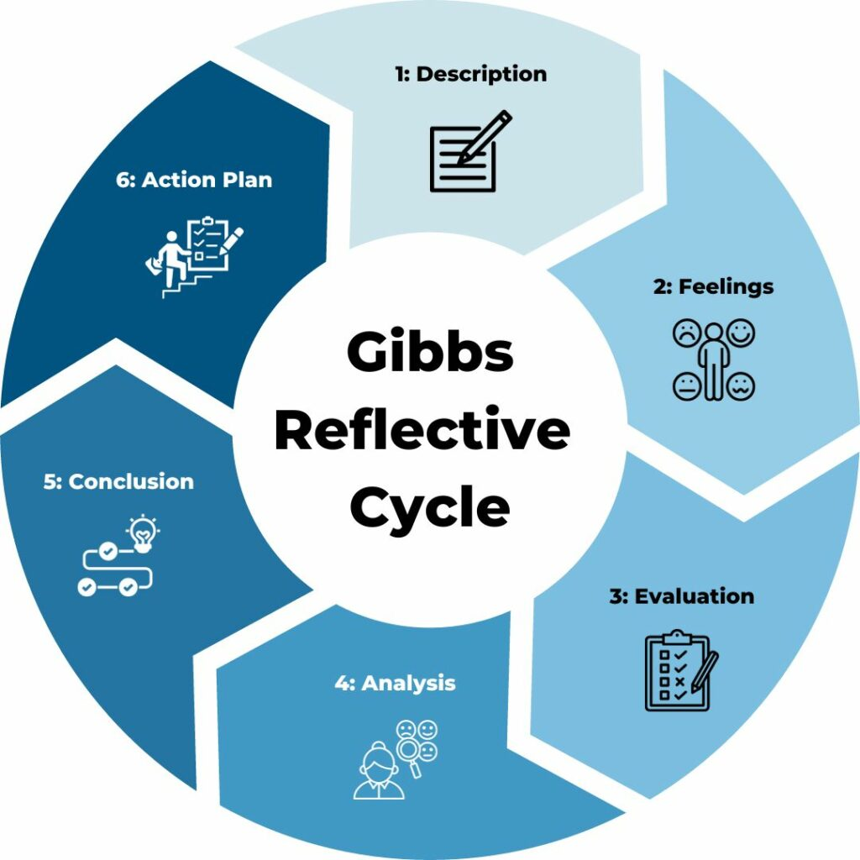
The Gibbs Reflective Cycle - Free Template Download & Guide

Description

When I started my university studies, I quickly realised that academic writing was very different from the writing I had done before. Previously, my writing was more informal, and I did not need to follow a clear structure. I could simply express my ideas in a straightforward way. However, at university, writing must be more formal, well-organised, and supported by evidence.
During the Academic Skills module, I learned that scholarly writing follows a clear structure. This structure usually includes an introduction, body paragraphs, and a conclusion. Each part serves a specific purpose. The introduction presents the topic and main argument, the body paragraphs develop ideas and include evidence, and the conclusion summarises the key points. The Complete Guide to Referencing and Avoiding Plagiarism Neville (2010) explains that a clear structure helps students organise ideas effectively.
Another crucial aspect of academic writing is referencing. Students are expected to use sources such as books and journal articles to support their arguments. Referencing not only shows where information comes from but also helps to avoid plagiarism. Academic Writing for Graduate Students Swales and Feak (2012) explain that referencing allows students to connect their ideas with existing academic knowledge.
Even though I understood these concepts, I found it difficult to apply them in practice. I often struggled to organise my ideas into coherent paragraphs and was sometimes unsure how to start my assignments. My biggest difficulty in academic writing is choosing the correct words, writing accurately, and maintaining a formal style instead of an informal one.
Moreover, I am planning to work in Human Resources in the future. I know that strong writing skills will be essential for tasks such as preparing reports, conducting interviews, and communicating professionally. Therefore, improving my academic writing is not only important for my studies but also for my future career in Human Resource Management Human Resources.

Feelings

At the beginning of the Academic Skills module, I felt nervous and uncertain about my writing ability. English is not my first language, and writing academic texts in another language can be challenging. I was worried about making grammar mistakes and using the wrong vocabulary.
The Academic Skills classes also created what I consider a positive discomfort. They made me realise that I need to deepen my knowledge more and more, especially in academic writing. This discomfort was important because it showed me that improvement requires effort and continuous learning.
Sometimes I also felt frustrated because I had ideas in my mind but did not know how to express them clearly in writing. This situation often contributed to writer’s block, which made it difficult to start my assignments. Second Language Writing Hyland (2019) explains that academic writing can create anxiety because students are expected to meet high standards and use unfamiliar academic language.
However, my feelings began to change as I learned more about academic writing strategies. The more I practised writing and received feedback, the more confident I became. I started to understand that writing is a process that takes time and effort, and that improvement happens gradually.

Evaluation

Looking back on my experience, I can see both positive and negative aspects.
One positive aspect was learning about the structure of academic writing. Understanding how to organise my work helped me present my ideas more clearly and made my writing easier to follow.
Another positive aspect was learning how to use academic sources. Incorporating references made my work more reliable and supported my arguments better.
However, there were also challenges. The biggest difficulty I faced was writer’s block. Sometimes I did not know how to start writing, and I spent too much time trying to write perfect sentences instead of beginning the task.
Another limitation was that even when brainstorming helped me begin, I still needed extra time to organise my ideas into clear and connected paragraphs.
Despite these difficulties, I can say that the module helped me improve my writing skills and increased my confidence over time.

Analysis

After reflecting on my experience, I realised that several strategies helped me improve my academic writing.
One useful strategy was brainstorming. This involves writing down ideas before starting an assignment. The Study Skills Handbook Cottrell (2017) explains that brainstorming helps students organise their thoughts and prepare for writing.
Another helpful strategy was free writing. This means writing for a short period without focusing too much on grammar or structure. Writing Without Teachers Elbow (1998) suggests that free writing helps students express ideas more freely and reduces fear.
Breaking assignments into smaller parts was also effective. Instead of writing everything at once, I focused on one section at a time, which made the process more manageable.
Reading academic texts also helped me improve. By reading, I could see how ideas were organised and how references were used.
Reflection was another important strategy. A Handbook of Reflective and Experiential Learning Moon (2004) suggests that reflection helps learners understand their experiences and improve their skills.
Overall, I learned that academic writing is a skill that develops over time. It requires continuous practice, feedback, and patience.

Conclusion

In conclusion, this reflective report helped me understand my experience of learning academic writing during the Academic Skills module.
At the beginning, I faced several challenges, including writer’s block, low confidence, and difficulty organising my ideas clearly. These challenges made academic writing feel stressful and sometimes difficult, especially because English is not my first language and I was still learning how to express my ideas in a formal academic way.
However, over time I improved my skills by using different strategies and practising regularly. Brainstorming, free writing, and reading academic texts helped me develop my ideas more clearly and write more effectively. These strategies also reduced some of the pressure I felt when starting assignments.
Using Learning by Doing: A Guide to Teaching and Learning Methods Gibbs’ Reflective Cycle also helped me understand my learning process better. Reflection allowed me to recognise my progress, identify my difficulties, and understand that improvement happens gradually through practice and feedback.
Academic writing is an important skill that will support both my studies and my future professional development. As I plan to work in Human Resource Management Human Resources, I understand that writing clearly, formally, and professionally will be essential in many situations, such as preparing reports, communicating with colleagues, and documenting information accurately.
Overall, this experience showed me that academic writing is not only a university requirement, but also a long-term skill that I will continue developing with confidence and persistence.

Action Plan

In the future, I plan to continue improving my academic writing skills by applying the strategies that I have learned during this module. This is especially important because I want to work in Human Resources, and strong writing skills will be essential for preparing reports, conducting interviews, and communicating effectively in my future career.
First, I will continue using brainstorming before starting any assignment. This strategy helps me organise my ideas and create a clear writing plan before developing paragraphs.
Second, I will read more academic articles and books related to my subject. Reading academic texts helps me expand my vocabulary, understand sentence structure, and observe how formal arguments are presented.
Third, I will ask for feedback from my lecturers and classmates whenever possible. Feedback is important because it helps me identify mistakes and understand how I can improve future work.
I will also practise writing more regularly, even when I do not have assignments to submit. Short writing exercises can help me become more confident and improve my ability to choose appropriate words.
Another important goal is to continue improving my formal writing style. My biggest difficulty is choosing the correct words, writing accurately, and avoiding informal language. For this reason, I will pay more attention to academic vocabulary and sentence construction.
Finally, I will continue using reflection after each assignment. By thinking critically about what worked well and what still needs improvement, I can monitor my progress more effectively.
By following these steps, I hope to become a more confident and effective academic writer, prepared for a successful academic journey and a professional future in Human Resources.

References

Bailey, S. (2018) Academic Writing: A Handbook for International Students. London: Routledge.
Cottrell, S. (2017) The Study Skills Handbook. London: Palgrave Macmillan.
Creme, P. and Lea, M. (2008) Writing at University. Maidenhead: Open University Press.
Elbow, P. (1998) Writing Without Teachers. Oxford: Oxford University Press.
Gibbs, G. (1988) Learning by Doing: A Guide to Teaching and Learning Methods. Oxford: Oxford Polytechnic.
Hyland, K. (2019) Second Language Writing. Cambridge: Cambridge University Press.
Moon, J. (2004) A Handbook of Reflective and Experiential Learning. London: Routledge.
Murray, R. (2012) How to Write a Thesis. Maidenhead: Open University Press.
Neville, C. (2010) The Complete Guide to Referencing and Avoiding Plagiarism. Maidenhead: Open University Press.
Swales, J. and Feak, C. (2012) Academic Writing for Graduate Students. Michigan: University of Michigan Press.

