

LOCATION: Coleg SIR GAR | LLEOLIAD: COLEG SIR GAR
LEVEL 6 | LEFEL 6
EXAMINATION PERIOD | CYFNOD ARHOLIADAU
May 2024 | mai 2024

MODULE CODE: SGEE6001

Power Electronics and Drives
EXAMINATION

SOLUTIONS

Solutions
Question 1
a) Waveforms identifying key parameters:
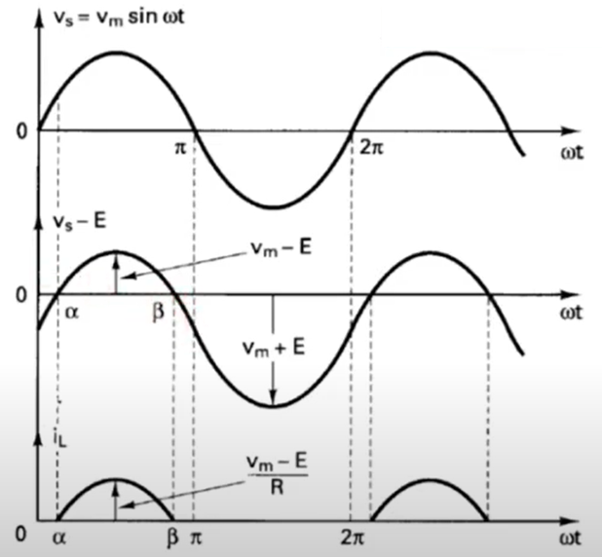
Vs = E
E
wt = θ
wt = θ
wt = θ
[Vm sin(θ) – E] / R
Conduction angle

Note: Vm- Vmax
Diode D1 conducts when $Vs≥ E$ which is the point where the condition $θ≥ α$as indicated in the diagram.
From the waveforms, the value of alpha α can be found when Vs = E and therefore:
Vm sin(α) = E and from this α = sin⁻¹ (E / Vm)
Diode D1 will block when Vs < E during the condition θ = β and starts conducting again at
2π + α
From the waveform diagram β = π – α
The charging current i_{L} can be deduced from the volts drop across R using Ohms Law.
Vs – E = i_{L} R then i_{L} = Vs – E / R
9
Therefore: i_{L} = [Vm sin(θ) – E] / R with condition α < θ < β where wt = θ

b)
(i) Conduction angle of the diode:

Vp = 120V, E = 24V
Vs = 120 / 2 = 60V rms
Vm = $√2$ x 60 = 84.85V
α = sin⁻¹ [24 / 84.85] from [Vm sin(α) = E]
= 0.279 rad or 16⁰

Therefore: β = π – α
6
= π – 0.279
= 2.862 rad
Conduction angle = β – α
= 2.862 – 0.279 = 2.583 rad or 148⁰

(ii) In order to find current limiting value of R, i_{L} average with respect to wt must first be found in order to apply Ohms Law.

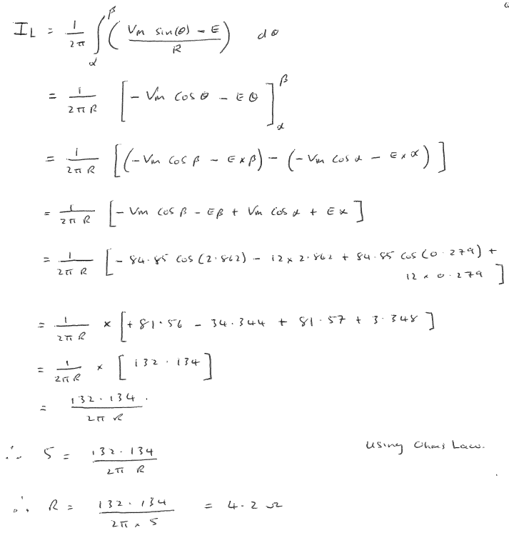
8

(iii) Peak Inverse Voltage (PIV) of the diode:
2
PIV = Vm + E
= 84.85 + 24 = 108.85V

Total = 25 marks

Solutions
Question 2
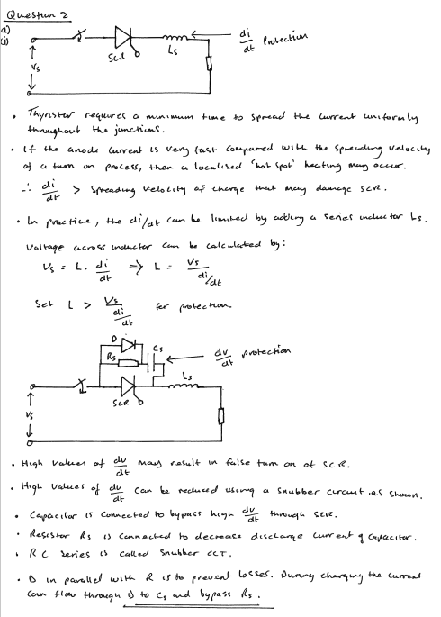
7
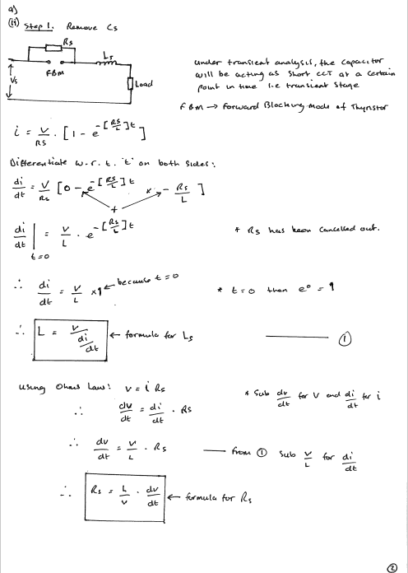
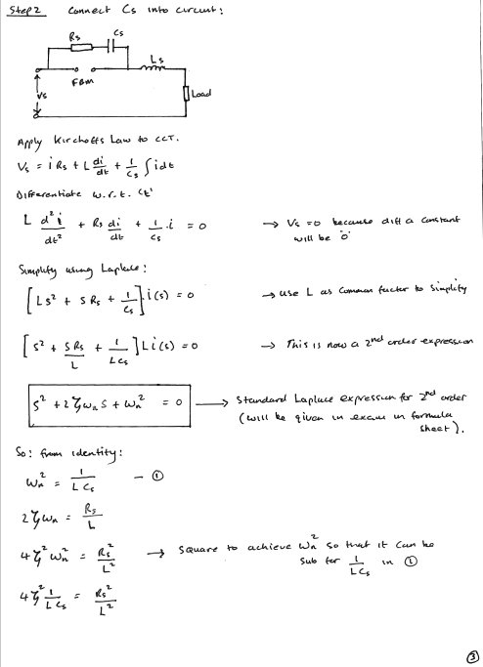
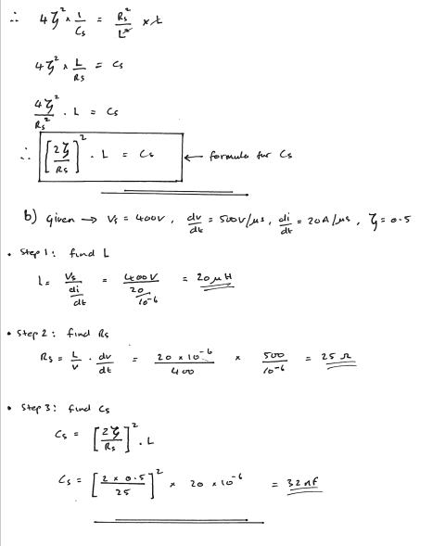
6
12
Total = 25 marks

Solutions
Question 3
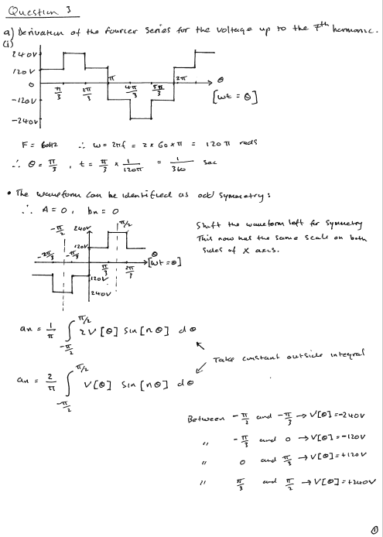
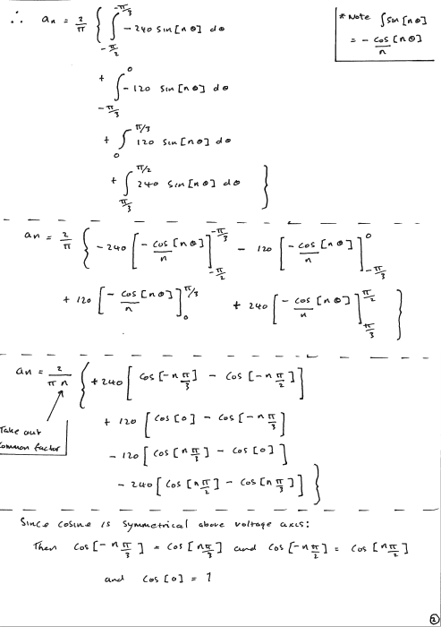
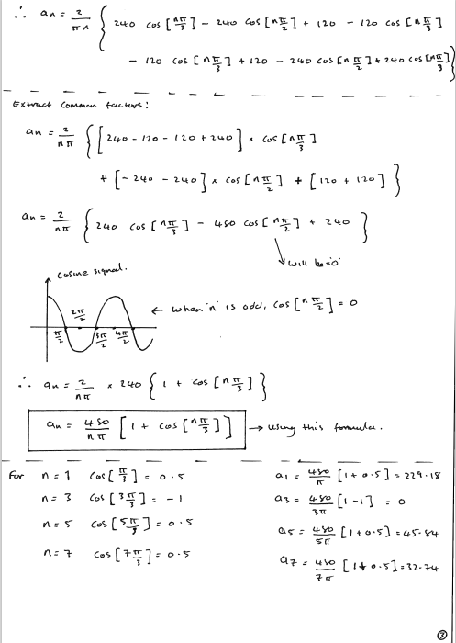
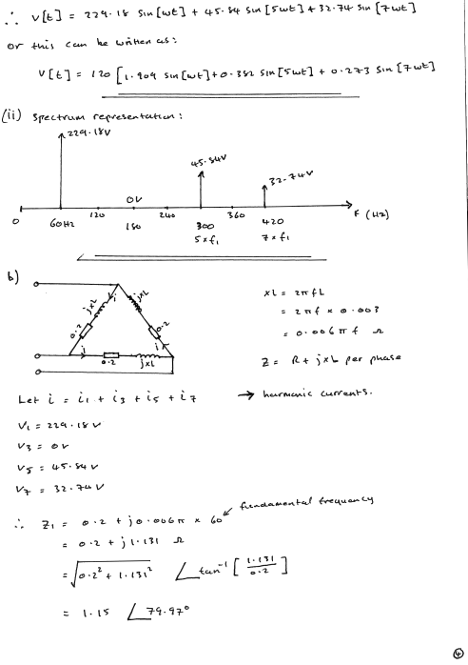
3
15
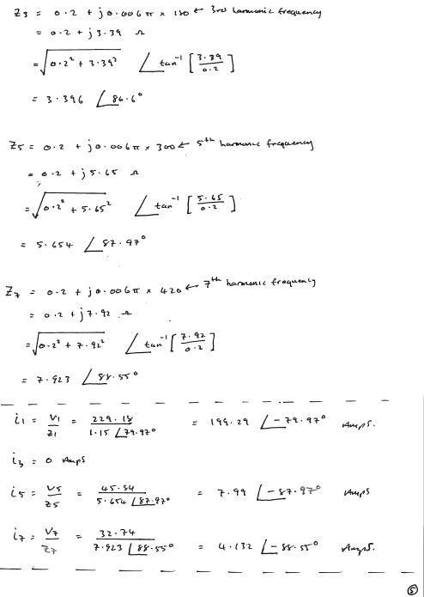
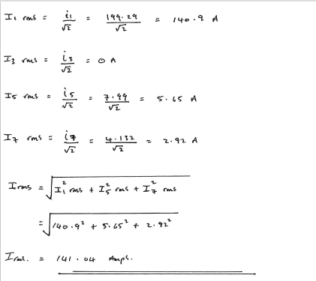
7
Total = 25 marks

Solutions
Question 4
a)
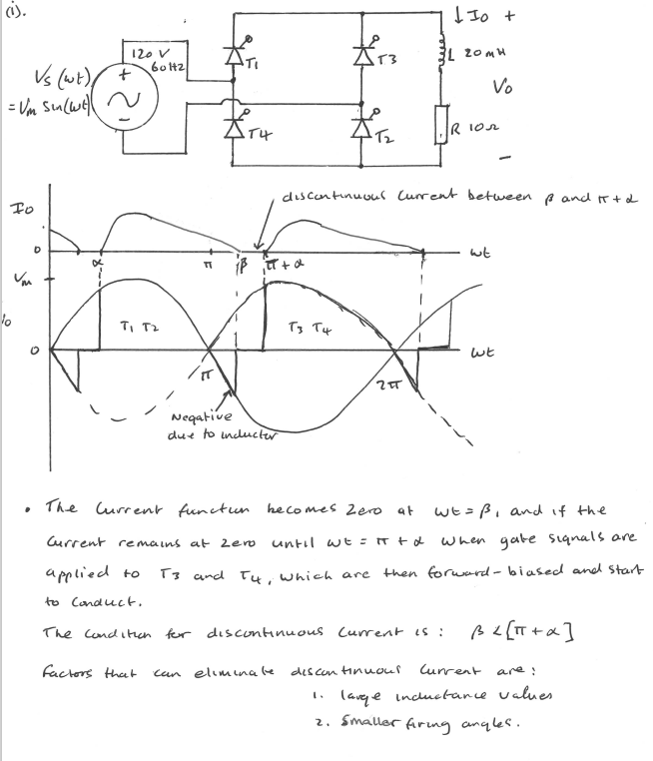
7
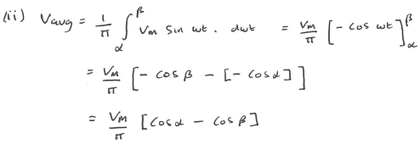
4
b)

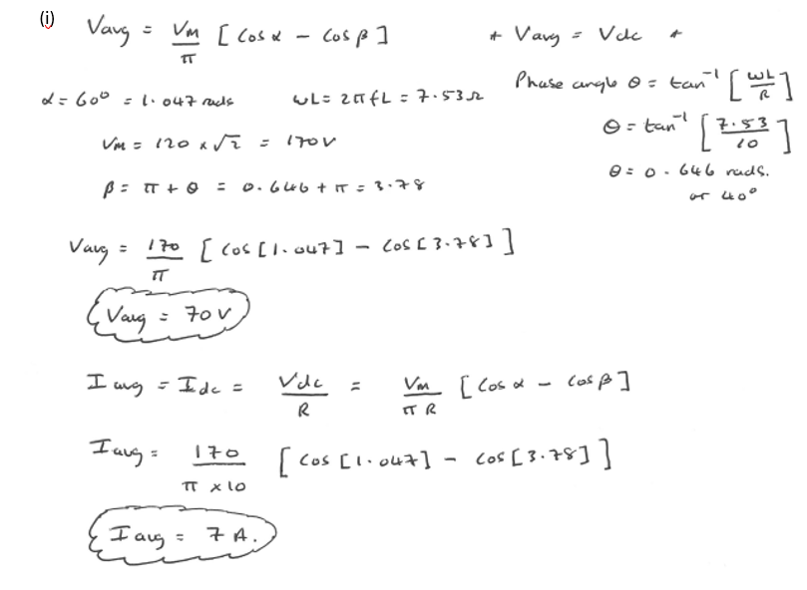
7

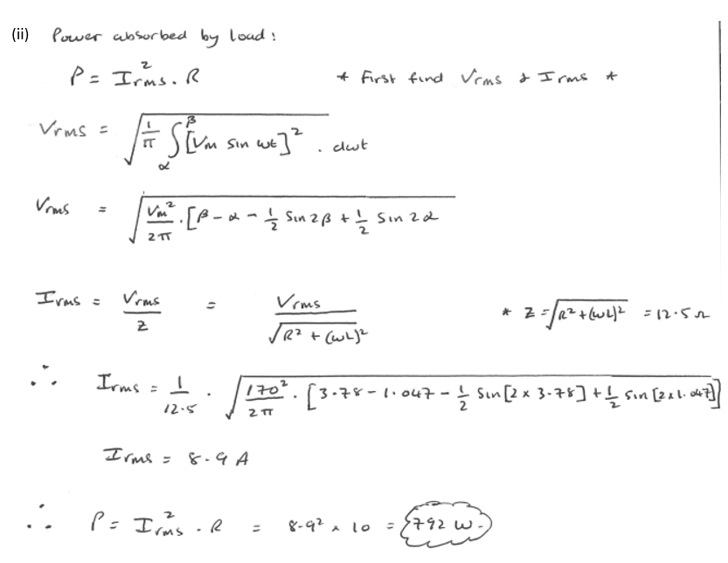
7

Total = 25 marks

Solution
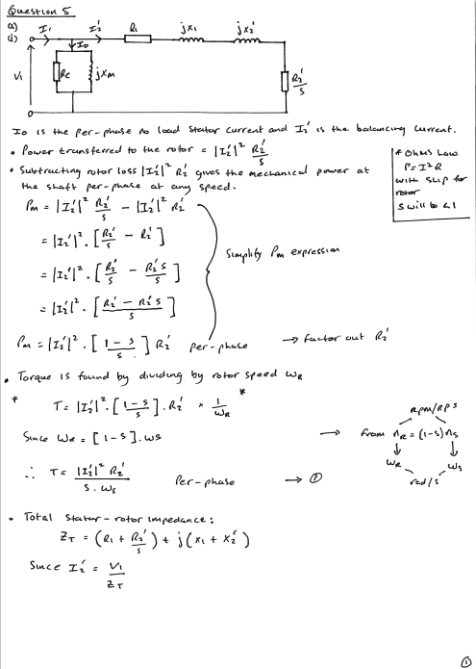
(ii)
4

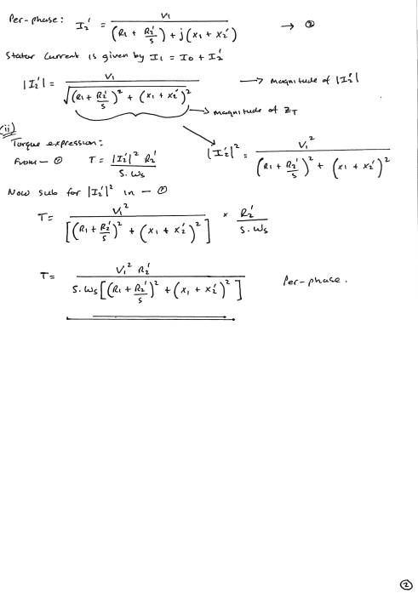
(iii)
4
4
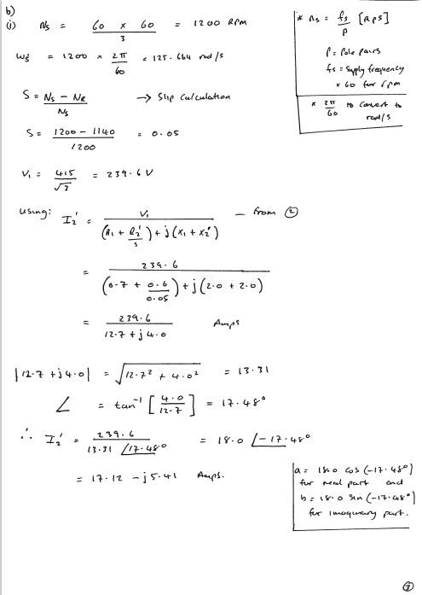

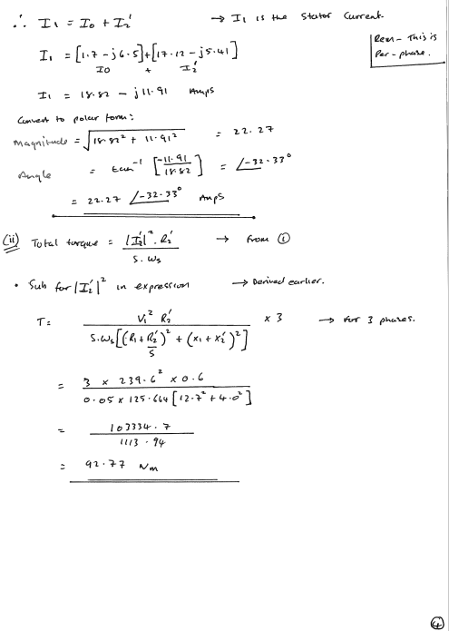
Total = 25 marks
5
8

