

Assessment 1 – Reading Task Template
PART 1: Upload your photo of your A3 in-class notes here:
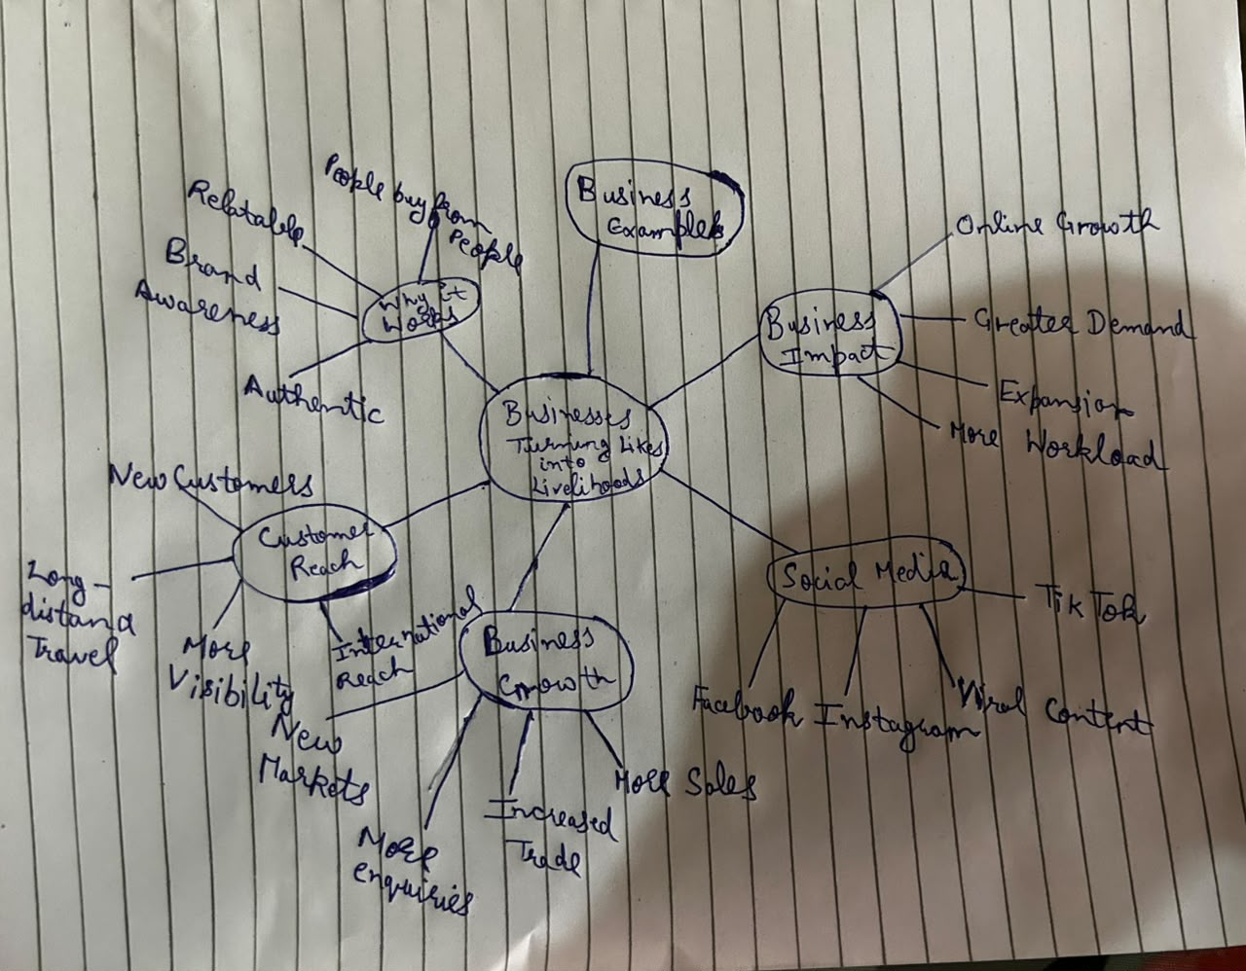

PART 2:
- Answer every question below in 1-3 full sentences.
- Use your own words. Do not use generative AI to answer these questions.
- Include a specific detail from the text when asked.
REMINDER
- The main idea is the overall message of the whole text.
- A key point helps to explain the main idea.
- A specific detail or example from the text shows that the key point is true.

- What is the main idea of the whole text?
The point is that, with the help of social media platforms like TikTok, Instagram, and Facebook, small businesses can be popularised and discover new clients (Qalati et al., 2022). Authentic, engaging and viral content can help businesses gain visibility, capture customers in different locations and generate business and sales opportunities.

- What is one key point that supports the main idea, and which specific example from the text shows this?
The first one is that social media has the possibility of drawing customers who are way beyond the locality of the business when the content goes viral. Following this, customers used to travel as far as three hours to visit Honywood Sandwich Shop after reading social-media content about its chicken burger, as an indication that online awareness can translate to actual customer visits.

- What is a different key point that supports the main idea, and which specific example from the text shows this?
Another important aspect is that social media can assist companies to increase their visibility and transition to online business instead of the traditional form of selling (Marolt, Zimmermann and Pucihar, 2022). To illustrate, the case of Lindy Loo Boutique switched exclusively to the Internet after Linda Hunter started writing posts on social media and now sends clothes to customers throughout the UK and even to Australia.

- Which part of the text do you think is most important, and why?
I believe that the explanation is that people react to social-media content that is engaging and familiar instead of being reacted to in the form of being advertised. This is relevant since it informs why businesses are able to establish better relationships with their customers and convert social-media attention into interest in their products or services.

Reflection:
- What did you find difficult in this task (including in-class components), and why was it difficult?
I struggled to pinpoint the central focus since the paper contained a variety of businesses, examples and statistics of the effects of social media. The main points were also difficult to isolate when specific examples were involved to highlight a point, since most of the examples seemed to be highlighting the same point (Liu and Zheng, 2024).

- What helped you with this difficulty, and how did it help you?
The development of the A3 mind map assisted me in arranging the businesses, examples, statistics and impacts of social media in various groups. It was easier once I reread the text and arranged similar information, as it helped me to see the big picture and choose the most significant pieces of information in my answers.

References
Liu, X. and Zheng, X. (2024) ‘The persuasive power of social media influencers in brand credibility and purchase intention,’ Humanities and Social Sciences Communications, 11(1), pp. 1-12. https://www.nature.com/articles/s41599-023-02512-1
Marolt, M., Zimmermann, H.D. and Pucihar, A. (2022) ‘Social media use and business performance in SMEs: The mediating roles of relational social commerce capability and competitive advantage,’ Sustainability, 14(22), pp. 1-26. https://www.mdpi.com/2071-1050/14/22/15029
Qalati, S.A., Ostic, D., Sulaiman, M.A.B.A., Gopang, A.A. and Khan, A. (2022) ‘Social media and SMEs’ performance in developing countries: Effects of technological-organizational-environmental factors on the adoption of social media,’ Sage Open, 12(2), pp. 1-13. https://journals.sagepub.com/doi/abs/10.1177/21582440221094594

