

LOCATION: Swansea | LLEOLIAD: abertawe
LEVEL 5 | LEFEL 5
EXAMINATION PERIOD | CYFNOD ARHOLIADAU
5th March (MOCK) | 5th March (MOCK)

MODULE CODE: ACDB5002
Electronics I

TIME: 2 HOURS
ANSWER ALL QUESTIONS

Each Question Carries 25 Marks
Total Marks : 100

This exam does not allow the use of reference materials, scraps of paper, online resources, or observing any practice sessions.

- Equipment or materials required – PC running CAD software or Pencil/Ruler/Paper
- Open MS Word Document to capture the simulation screen dumps .
- Save the name of the file in this pattern ‘Exam_studentname_studentid’ and upload the file in Moodle.

QUESTION 1
Design a circuit using the PIC16F877A microcontroller, where LEDs are connected to pins RC0 through RC7, each with a 100Ω current-limiting resistor. The LEDs should turn ON simultaneously, with a delay of half a second when a switch is pressed.
The project should include the following :
  - Design the circuit using simulation software. [10 Marks]
  - Write a C program to accomplish the specified task. [10 Marks]
  - Execute the simulation to verify the operation of the circuit and program. [5 Marks]
QUESTION 2
Demonstrate a down counter using 7- Segment Display each with a 100Ω current-limiting resistor by considering the following conditions. Consider Common Anode 7- Segment display using the hex values given below.
0 | 1 | 2 | 3 | 4 | 5 | 6 | 7 | 8 | 9
0XC0 | 0XF9 | 0XA4 | 0XB0 | 0X99 | 0X92 | 0X82 | 0XF8 | 0X80 | 0X90
- When a push button is connected to port pin RC7 is pressed once, the 7 segments should count down from 9 to 1 within a delay of 100ms.
- The counter should stop counting when the button is released.
The project should include the following components:
- Design the circuit using simulation software. [10 Marks]
- Write a C program to accomplish the specified counting task. [10 Marks]
- Execute the simulation to verify the operation of the circuit and program. [5 Marks]
QUESTION 3
- For the circuit given below, Answer the following questions.
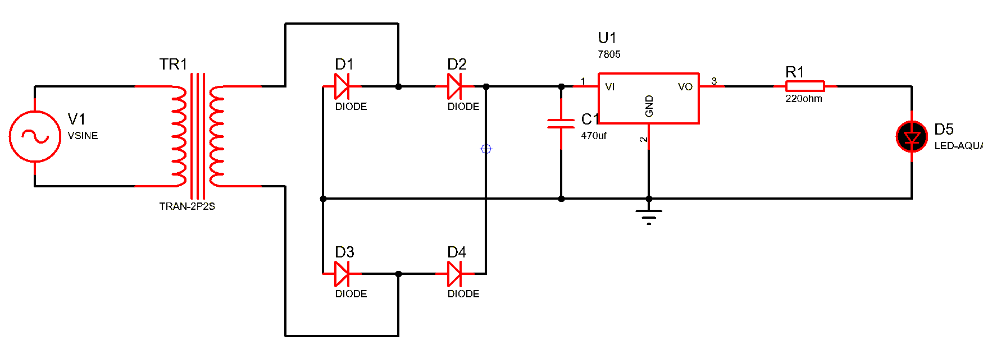
- Identify the above circuit and briefly explain the purpose of it. [3 Marks]
- Explain the working principle of this circuit. [8 Marks]
- Design and simulate the above circuit diagram using Simulation Software. [14 Marks]
QUESTION 4
      - Explain the working principle of LM393 Amplifier with a neat diagram. [10 Marks]
      - Design and simulate the Humidity sensor circuit using appropriate simulation software, such as Proteus. [14 Marks]

Diwedd/End

