UNIVERSITY OF WALES
TRINITY SAINT DAVID

Topic: Assignment Part 2
United Kingdom
Economic theories, analysis of the macroeconomic performance for the most recent 5-year period
Ivilina Atanasova Atanasova

Course: Business Management, 2028391
Management Economics (LCBB5003)

Dr David Jenkins

22/03/23
Table of content

1. Introduction………………………………………………………………………….. | 3
2. Main body…………………………………………………….……………………………… | 4
2.1. A Brief history of the country………………………………………………………………... | 4
2.2. Type of government…………………………………………………………………………. | 4
2.3. Population in the United Kingdom………………………………………………………… | 4
2.4. Ethnicity in the United Kingdom …………………………………………………………… | 5
2.5. Religions in the United Kingdom…………………………………………………………… | 5
2.6. Production profile on the United Kingdom 2018-2022…………………………………… | 6
2.7. Imports in the United Kingdom 2018-2022………………………………………………... | 7
2.8. Export in the United Kingdom 2018-2022………………………………………………… | 8
2.9. Major trading partners in the United Kingdom……………………………………… | 9
2.9.1. Major trading partners 2018……………………………………………………………… | 9
2.9.2. Major trading partners 2019……………………………………………………………… | 10
2.9.3. Major trading partners 2020……………………………………………………………… | 11
2.9.4. Major trading partners 2021……………………………………………………………… | 11
2.9.5. Major trading partners 2022……………………………………………………………… | 12
2.10. Import and Export 2018 – 2022 in the United Kingdom…………………………….. | 12
2.11. Main macroeconomic indicators of economic growth in the United Kingdom… | 13
2.11.1. Gross Domestic Product (GDP) 2018-2022…………………………………………... | 13
2.11.2. Unemployment 2018 – 2022 in the UK………………………………………………… | 13
2.11.3. Inflation 2018 – 2022 in the UK…………………………………………………………. | 14
2.11.4. Balance of payments 2018 – 2022 in the UK………………………………………….. | 14
2.11.5. Interest rates 2018 – 2022 in the UK…………………………………………………… | 14
2.11.6. British pound……………………………………………………………………………... | 15
3. Conclusion………………………………………………………………..………….. | 16
References………………………………………………………………………………………... | 17

- Introduction

The research displayed here analyses the performance of the United Kingdom’s economy over the most recent five years, from 2018 to 2022. This research looks at the population of the United Kingdom from 2018 through 2022 and includes information on its racial and cultural composition as well as its religious and political leanings.
A comprehensive look has been taken at the production profile, which includes an analysis of the most important imports, exports, and trading partners. Excel contains various tables and spreadsheets with data on imports and exports, with the data being broken down by year and showing the most importers and exports according to the product. It lists the top five countries in terms of both imports and exports. For the years 2018–2022, Excel tables containing the numbers for exports and imports have been generated.
The Gross Domestic Product (GDP), the Unemployment Rate (Unemployment Rate), the Inflation Rate (Inflation Rate), the Balance of Payments (Balance of Payments), and the Interest Rate (Interest Rate) are (Bank of England). The modifications that were requested between 2018 and 202 can be seen displayed in the Excel spreadsheets and Word tables below.
The findings and interpretations that are presented in the section titled "Conclusion" are the result of an economic study that was conducted in the United Kingdom over the preceding five years.

2. Main body
2.1. A Brief history of the country
Stone tools and traces at Hapsburg in Norfolk indicate 800,000-year-old English occupation.
In 1604, James I became Great Britain's first king. James I "rebranded" the Sovereign as the Unite, showing his goal and cementing what would become England's borders in the 10th century. West Saxon kings unified southern Britain. On January 1, 1801, all 558 members of the old Parliament of Great Britain and 100 of the House of Commons of Ireland formed the first Parliament of the United Kingdom.
The UK is a European island. England, Wales, Scotland, and Northern Ireland comprise the UK. London is a major fiscal, political, and artistic centre. Belfast, Londonderry, Edinburgh, Glasgow, Swansea, Cardiff, Birmingham, Liverpool, and Manchester are among the world's most populous cities. (Jenkins, 2018).
2.2. Type of government - Constitutional monarchy. The queen is the head of state, and the prime minister leads the government and the House of Lords' biggest party. Most government is legislative, executive, and law. King must be other bey chief and cabinet.
Council laws need Commons consent. Post-WWI cabinet staff implemented council decisions. It guides the council, reports, and advises government agencies.
Charles became King of the UK and 14 Commonwealth states on September 8, 2022, following Elizabeth II's death. The UK is a constitutional monarchy and sovereign democracy with liberty. Rishi Sunak is the prime minister, and Charles III is the king. (Wilson & Game, C., 2006).
2.3. Population in the United Kingdom - The population increased 0.34 per cent to 67,736,802 in 2023. In 2022, the UK's population was 67,508,936, up 0.34 per cent. The UK population rose 0.33 per cent to 67,281,039 in 202 1. The UK population rose 0.42% to 67,059,474 in 2020.
Our economic forecasts show that the UK population will top 68.71 million in 2025, up from 68.29 million in 2024– figure 1 (Trindade, 2019).

Figure 1. Population in the United Kingdom 2019-2025 (Trindade, 2019).
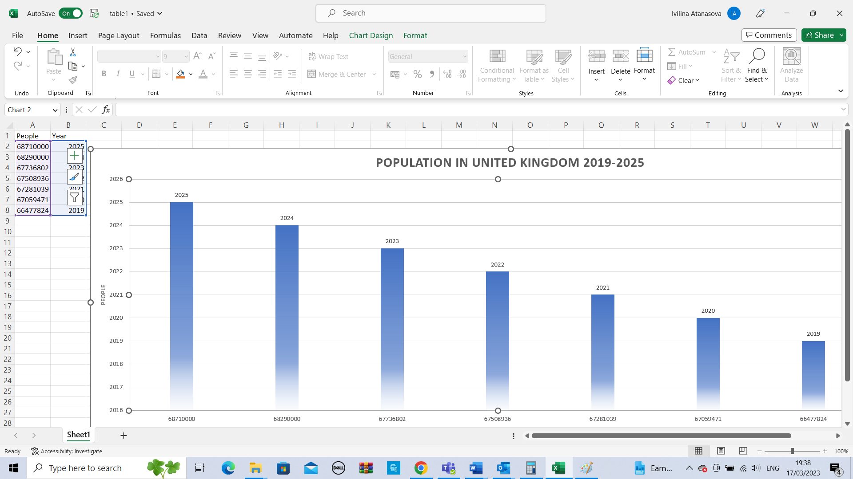

2.4. Ethnicity in the United Kingdom – figure 2.
The 2022 Census reported 81.7% white, 9.3% Asian, 4.0% black, 2.9% mixed, and 2.1% other ethnicities. The majority (74.4%) of the 19 races are white British, followed by white "other" (6.2%) and Indian (3.1%) ethnicities. White "other" rose from 4.4% to 6.2%, from 333,100 to 923,800 (Payne & Harrison; E., 2020).

Figure 2. Ethnicity in the United Kingdom 2022 (Payne & Harrison; E., 2020).
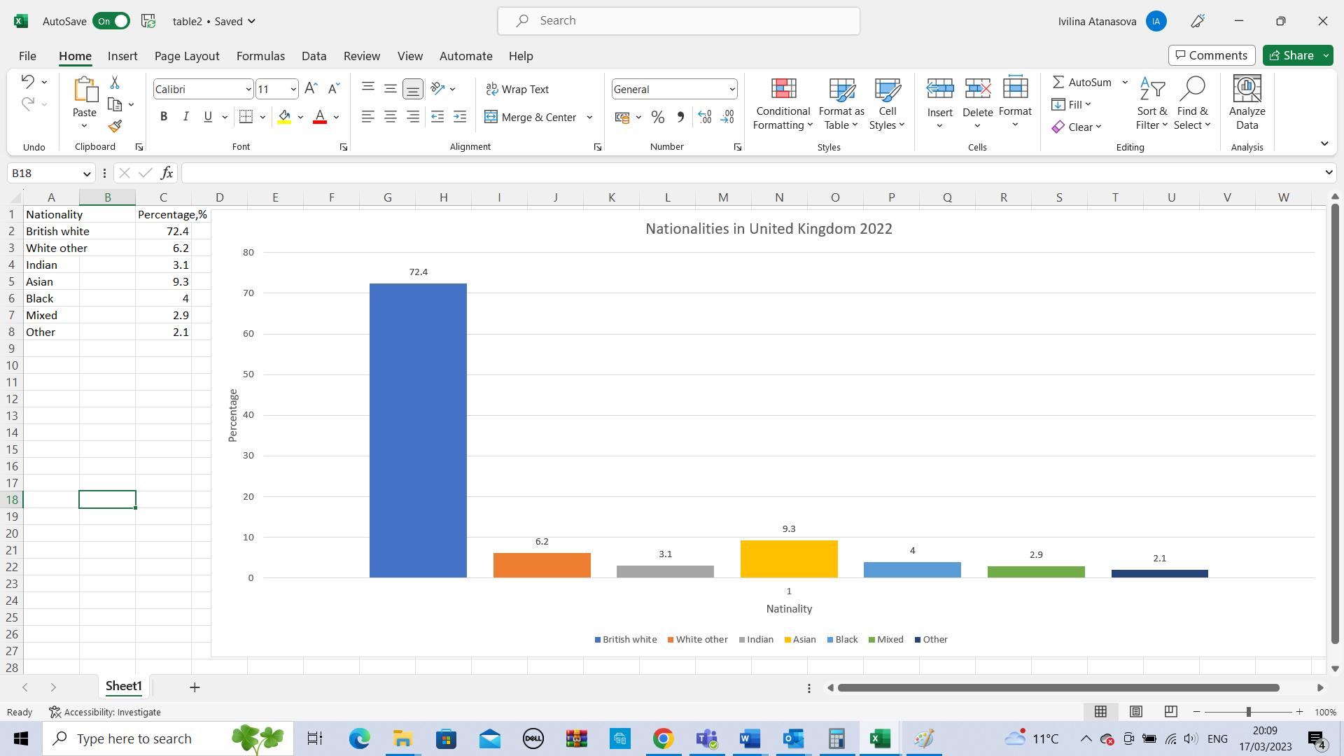

2.5. Religions in the United Kingdom
England, with the largest population, has the Church of England as its prominent church. The Church of England is neither Protestant nor Catholic. Christians dropped 5.5 million (17%), and Muslims rose 1.2 million (43%), reaching 3.9 million. Christians dropped 13.1,% and Muslims gained 1.7% (Bonney, 2013).
2.6. Production profile on the United Kingdom 2018-2022
The G7—the world's seven most affluent nations—meet informally. Figure 3: UK industry ranks 9ninthoverall.
Figure 3. Top 10 manufacturing countries in the world (Nelson, 2019)
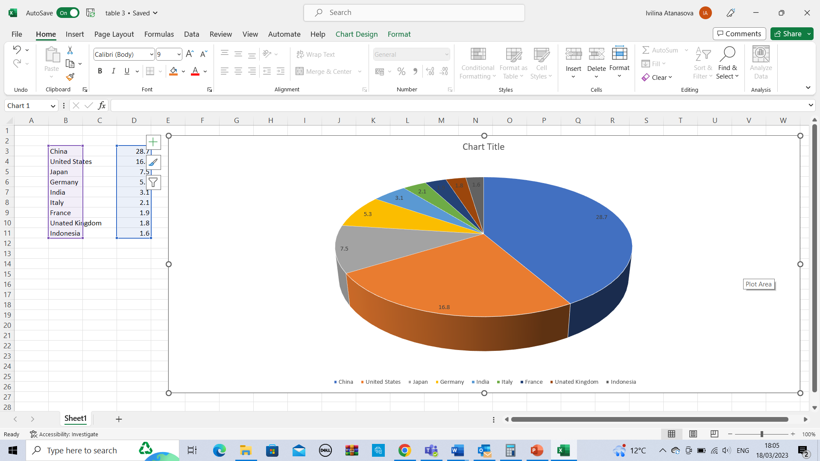

UK industrial production gauges industrial firm output. 87% manufactures. Industrial output includes transport equipment (9%), essential metals (8%), other production and repair (6%), medical goods and preparations (6%), rubber, plastic, and non-metallic mineral products (6%), and food, drink, and smoke (11%). Oil & gas (10%), dirt (12%). Water, waste, and trash account for 8% and electricity, gas, steam, and air conditioner for 11%. Service jobs added 19%. Shopping, leisure, expert services, company management, and money (figure 4). Figure 5 shows UK makers' 2018–2022 item sales. (Nelson, 2019).

Figure 4. UK industrial production, % (Nelson, 2019).
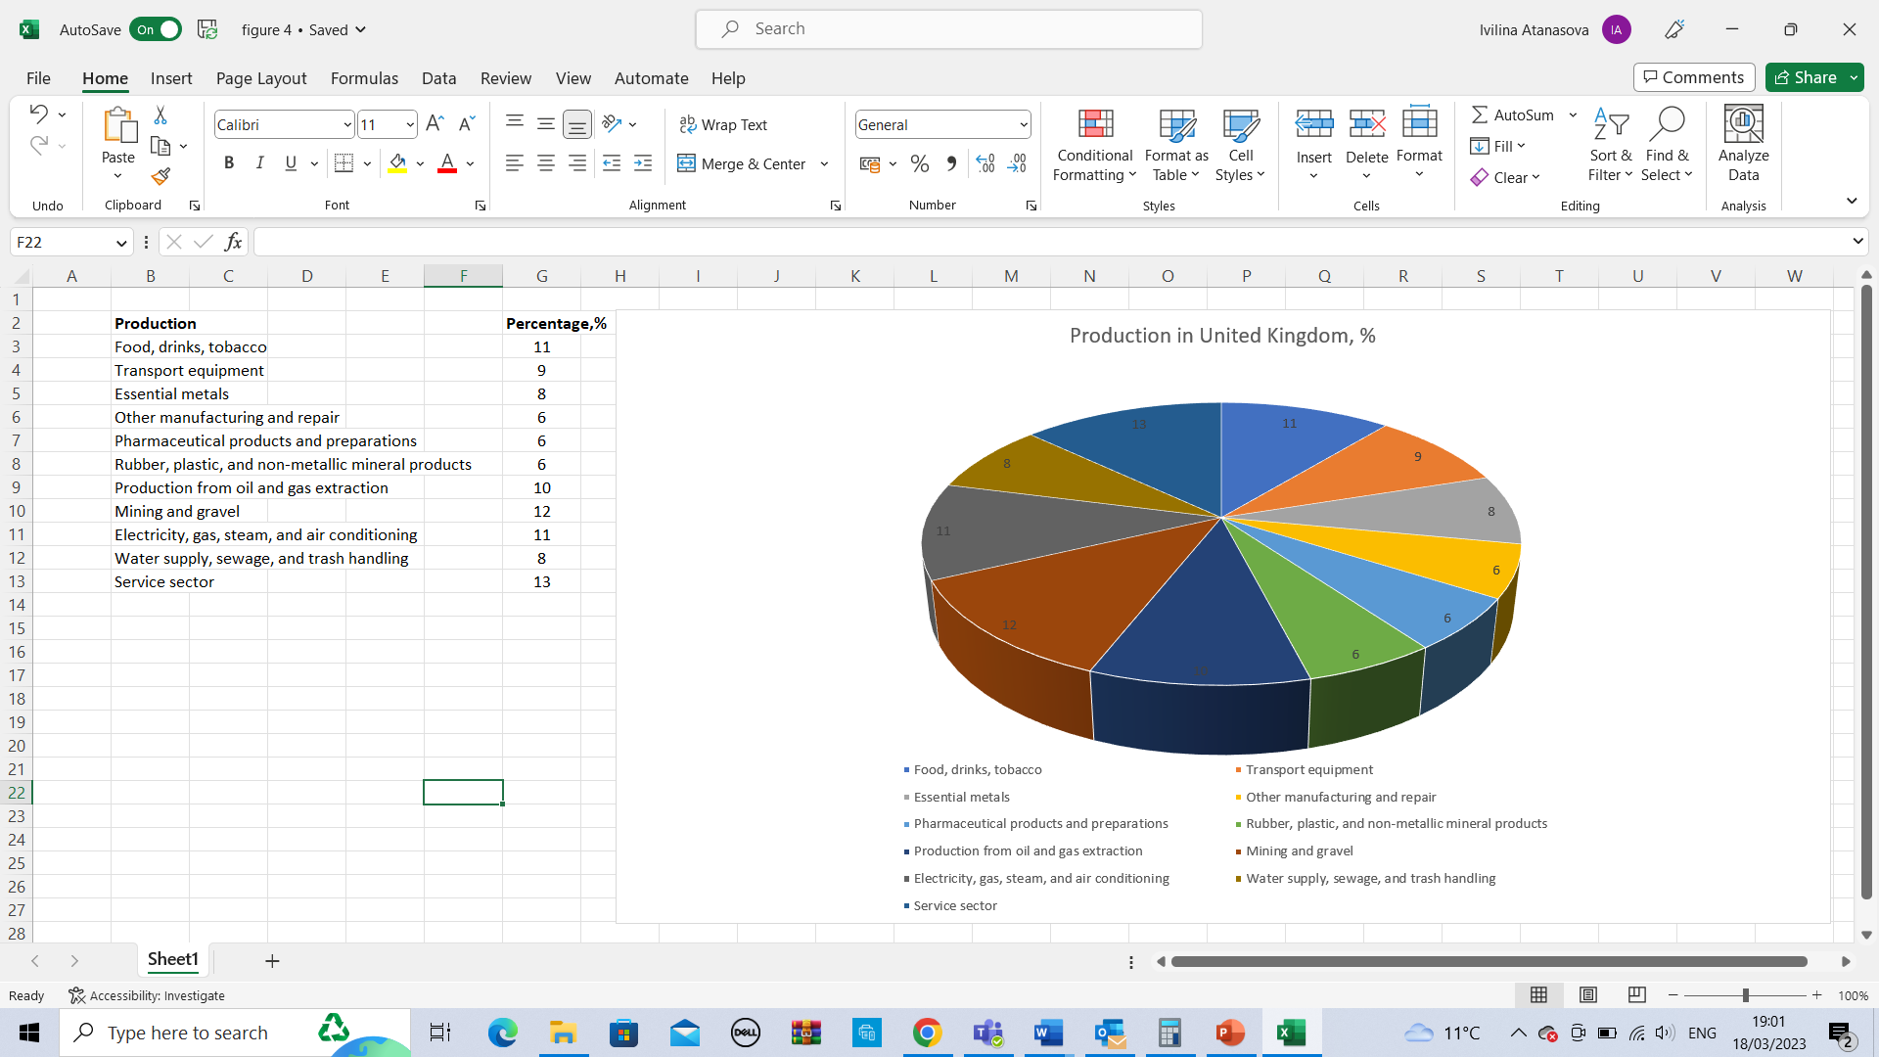
Figure 5. UK manufacturers' product sales in 2018-2022 (Stan Yorke, 2022)
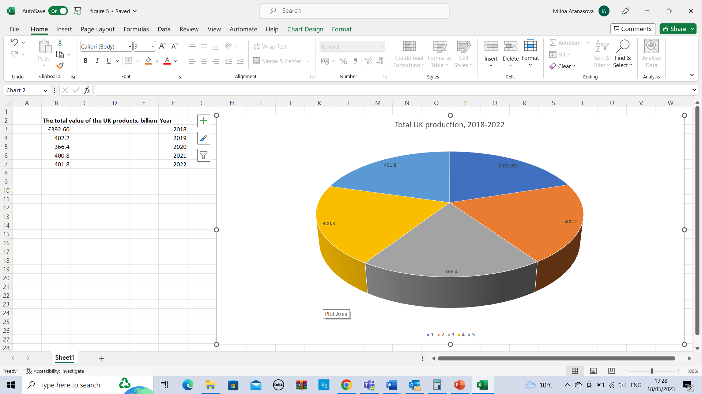

The overall amount of sales by UK makers was £392.6 billion in 2018, up 0.8% from 2017; £384.3 billion in 2019, down 2.1% from 2018; £366.4 billion in 2020, down 17.9% from 2019; £400.8 billion in 2021, up £34.5 billion (9%); £402.8 billion in 2022, up 2 billion (2%) (Stan Yorke, 2022).
2.7. Imports in the United Kingdom 2018-2022
Britain exported in 2018. 2018 UK trade gap was £38 billion. Automobiles made goods, and chemicals increased 2018 goods imports, while unnamed goods and energy decreased.
Two thousand nineteen goods cost £542 billion. The commodities trade gap grein £35.5 billion from 2018. In 2019, precious metals outsold vegetables in the UK.
2020 imported £493 billion. £52.3 billion (9.6%) less than in 2020. In 2020, the COVID-19 epidemic cut retail trade, impacting our top-selling partners and product groups. Precious metals (£84.3B), technical items, motor cars, electronic devices, and natural fuels to ed 2020 imports.
2021 imported £505 billion. £8.6 billion (1.7%) more than in 2020. Due to COVID-19 restrictions, EU Leave (including the previously disclosed schedules of the UK departing the EU and the ensuing adjustment thematic analysis), the global economic downturn, and supply chain issues, trade statistics have been more volatile the past three years. The UK acquired mothe st valuable metals (£59.9B) in 2021, followed by mechanical tools, natural fuels, cars, and computers.
2022 imported £889.2 billion. Machines, trip gear, and fuels ruled 2022 imports. Figure 6 shows UK imports from 2018-2022; Table 1 shows the most purchased items yearly. (Muhammad, 2022).

Figure 6. Imports in the United Kingdom 2018-2022 (Muhammad, 2022)
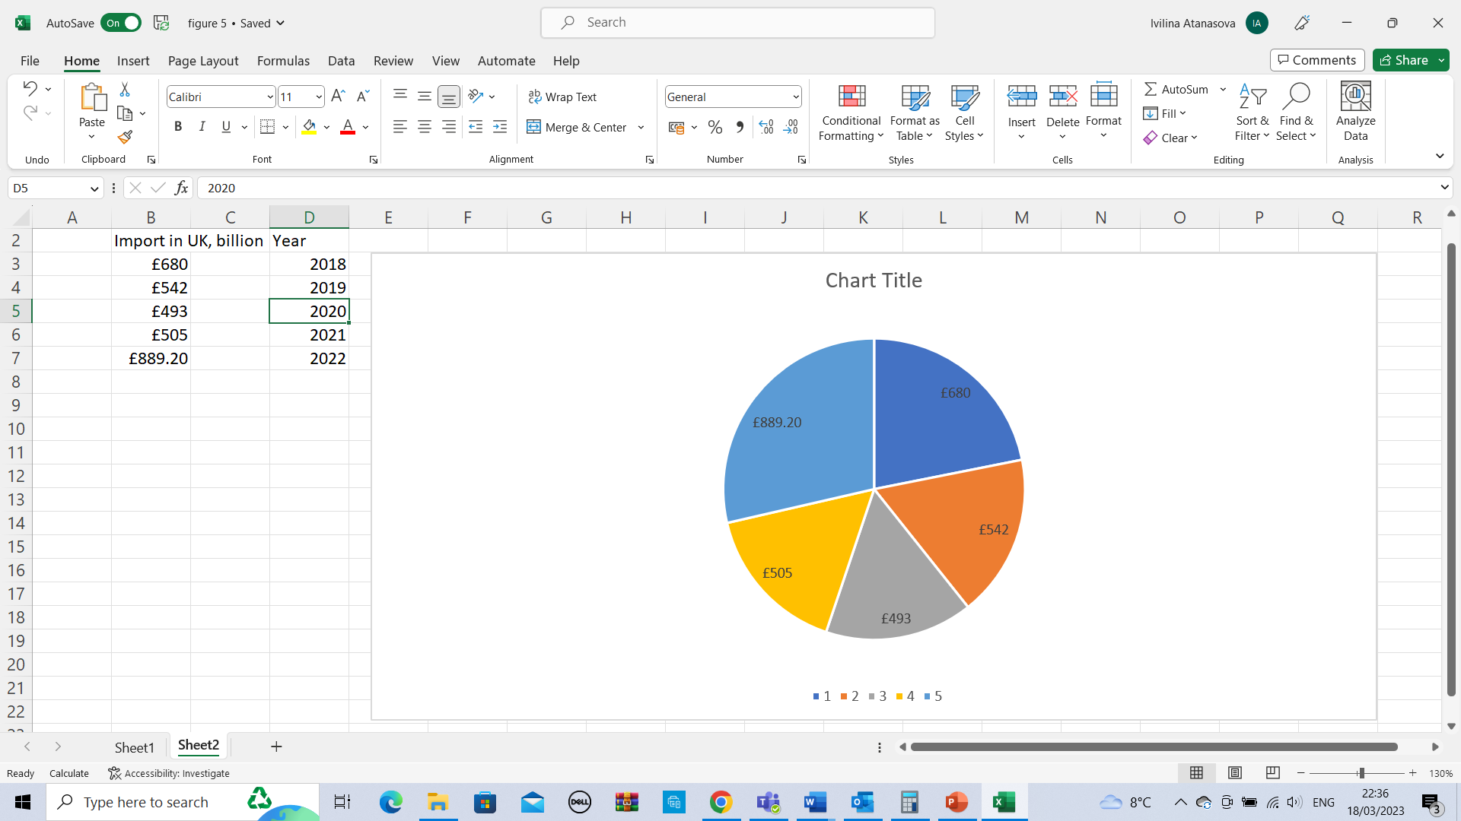

Table 1. The most frequently purchased suitable by year (Muhammad, 2022).
Most extensive Import goods in the UK | Year
Automobiles | 2018
Precious metals | 2019
Precious metals | 2020
Precious metals | 2021
Magoodses, transit equipment, and fuels | 2022

2.8. Export in the United Kingdom 2018-2022
Exports of £345 billion caused a -£142 billion trade deficit in 2018. Four thousand four hundred eighty-five goods were shipped to 231 nations, a rise of -6.7% of GDP from 2017. In 2018, the UK exported precious metals, aircraft parts, motor cars, pharmaceuticals, and refined gasoline.
2019 totalled £367 billion. It rose £2.4 billion (0.7%) from 2018. The UK's top exports were cars, intermediary mechanical power sources, pharmaceuticals, crude oil, and unspecified items s.
In 2020, England, Wales, Scotland, and Northern Ireland had a £262,5 B export excess. London's £145.9 billion service exports comprised most of England's £9.8 billion trade deficit in 2020. Mechanical items were the UK's largest export in 2020 despite a 17% dip. US exports fell £2.1 billion (21%), while UAE exports fell £0.9 billion (39%).
In 2021, product exports totalled £312.4 billion, up £14.5 billion (4.9%) from 2020 but down 10.5% from 2018. The UK shipped 119 billion pounds of machines and transit apparatus in 2021. Chemical exports were worth 54 billion pounds,s and other industries 38.9 billion pounds.
The UK exported £813 billion in 2022. British exports to the EU reached 42% in 2021. The UK's top five exports were gold ($7.68B), automobiles ($2.66B), gas turbines ($2.19B), crude petroleum ($1.69B), and other specified commodities ($1.66B). Figure 7 shows UK exports from 2018-2022; Table 2 shows the most bought items yearly. (Harris, & Li, Q. C. (2022).

Figure 7. Shows the Exports in the United Kingdom 2018-2022 (Harris, & Li, Q. C. (2022)
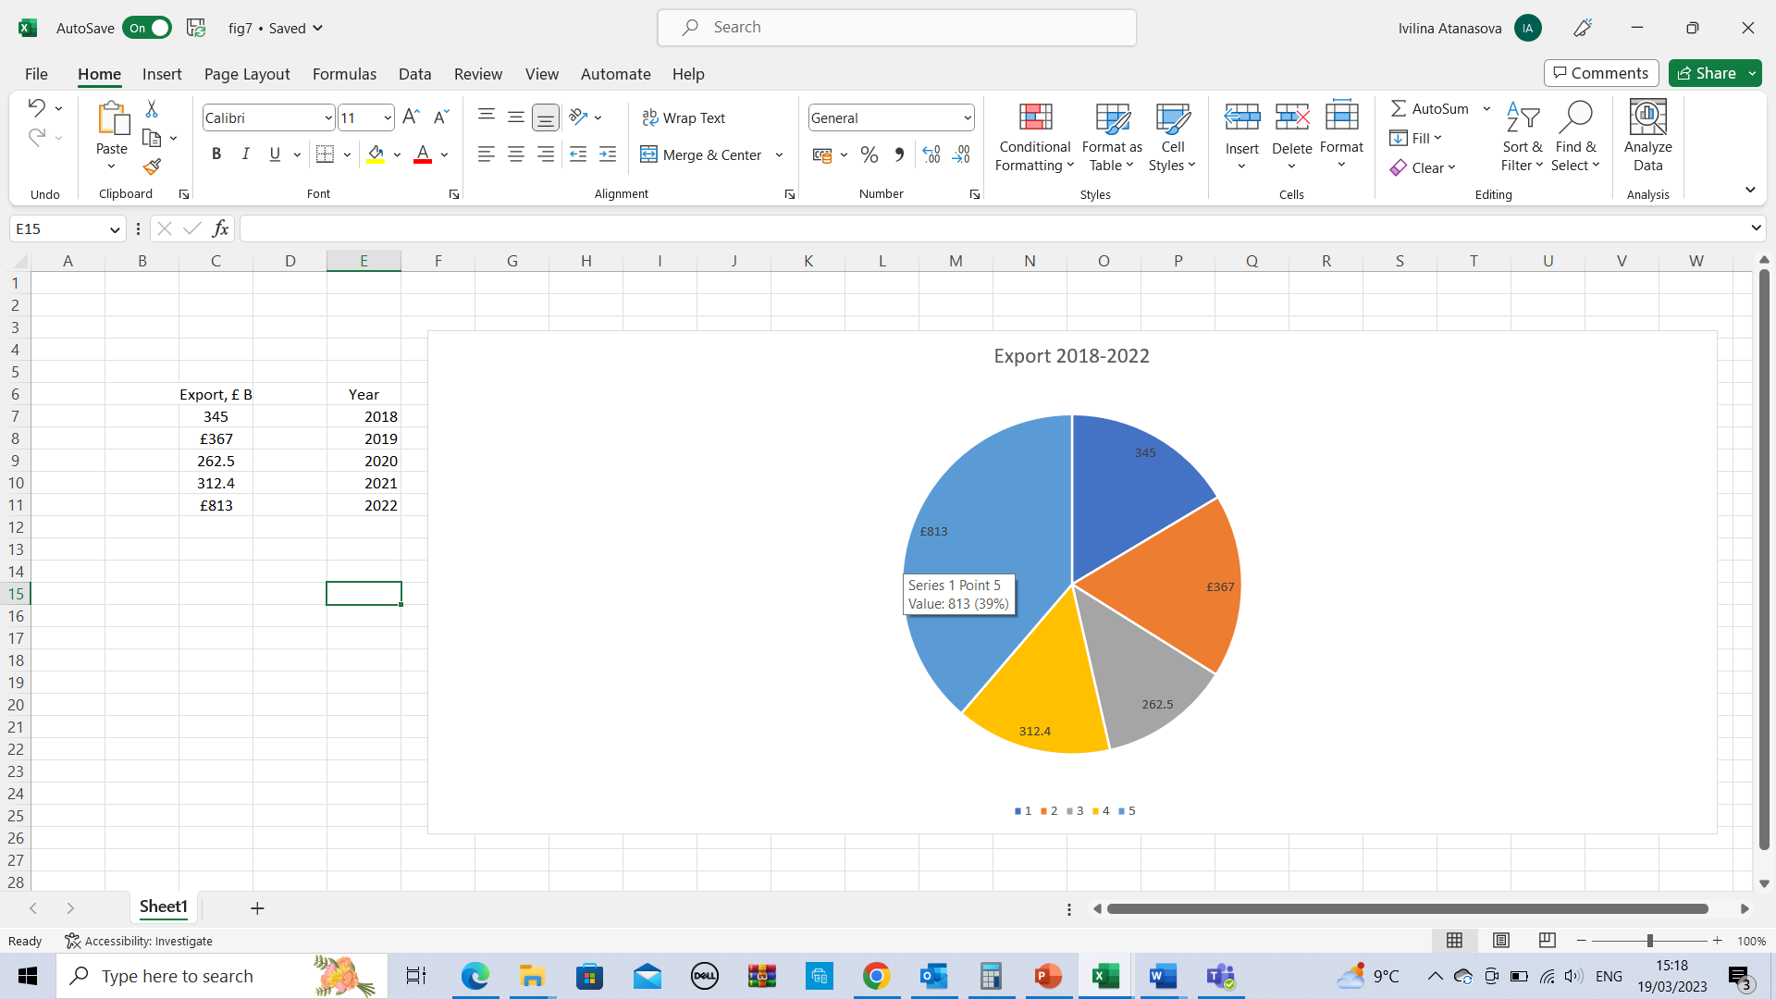

Table 2. Export in the United Kingdom by year (Harris, & Li, Q. C. (2022)
Most extensive Export goods in the UK | Year
Precious metals | 2018
Cars | 2019
Mechanical goods | 2020
Machinery and transportation equipment | 2021
Gold | 2022

2.9. Major trading partners in the United Kingdom
2.9.1. Major trading partners 2018
The United States (£72.4 billion), Germany (£77.3 billion), the Republic of the Netherlands (£49.1 billion), China (£45.4 billion), and France (£42.8 billion) were the top five countries from which the United Kingdom received goods in 2018.
UK's main export markets in 2018 were the U.S. (£118.2 billion), Germany (£55.4 billion), the Netherlands (£44.0 billion), France (£42.1 billion), and Ireland (£38.3 billion) – figure 8 (Jim Sherlock & Jonathan Reuvid, 2022).

Figure 8. Major trading partners 2018 (Jim Sherlock & Jonathan Reuvid, 2022)
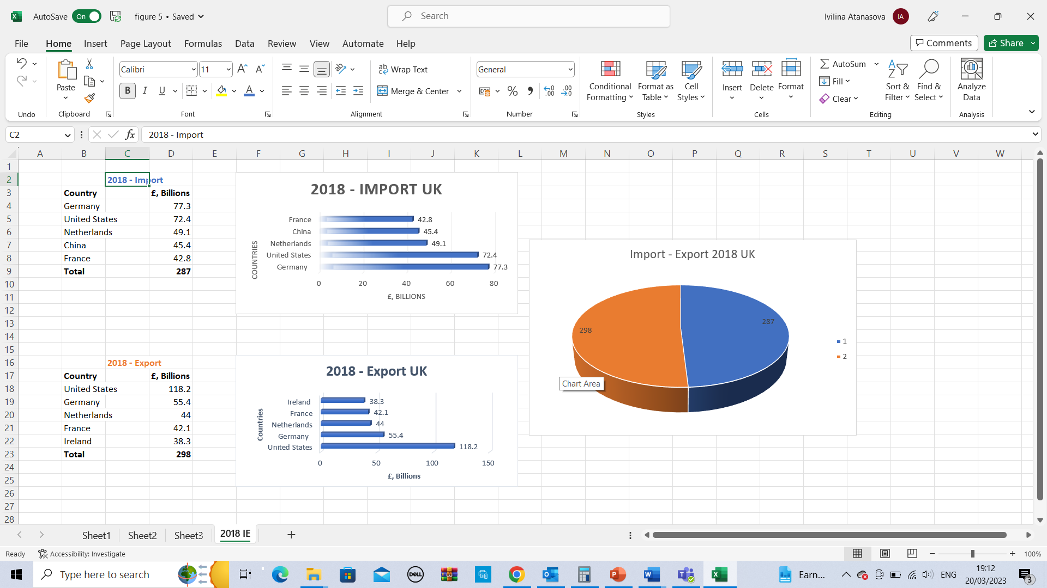

2.9.2. Major trading partners 2019
Despite a decline in the worth of £2.7 billion (3.9 per cent, Germany remained the United Kingdom's biggest trade partner in 2019 (66.0 B), followed by the United States (51.1 B), China (46.4 B), the Netherlands (42.1 B), and France (29.5 B).
The United States was still the United Kingdom's biggest export market in 2019, but the rise in value from 2018 to 2019 was £8.2 billion (17 per cent). The United States (57.4), Germany (36.5), France (24.7), the Netherlands (23.7), and China (23.6) all followed – figure 9 (Jim Sherlock & Jonathan Reuvid, 2022).

Figure 9. Major trading partners 2019 (Jim Sherlock & Jonathan Reuvid, 2022)
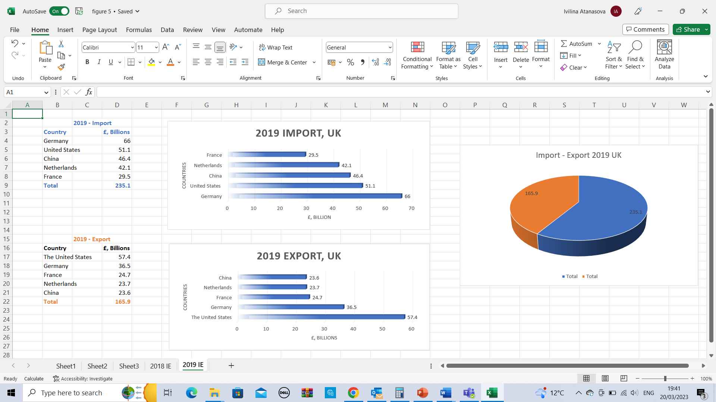

2.9.3. Major trading partners 2020
The Major trading partners in 2020 for import and export were the e: United States 126B-Export and 74.8B-Import, followed by Germany Export - 49B and 66.1B – Import; China – 25.9B Export and 56.9B-Import; Netherlands Export – 35.5B and Import – 42.1B; France – 31.1B; Export and Import – 35.2B – figure 10 (Jim Sherlock & Jonathan Reuvid, 2022).

Figure 10. Major trading partners 2020 (Jim Sherlock & Jonathan Reuvid, 2022)
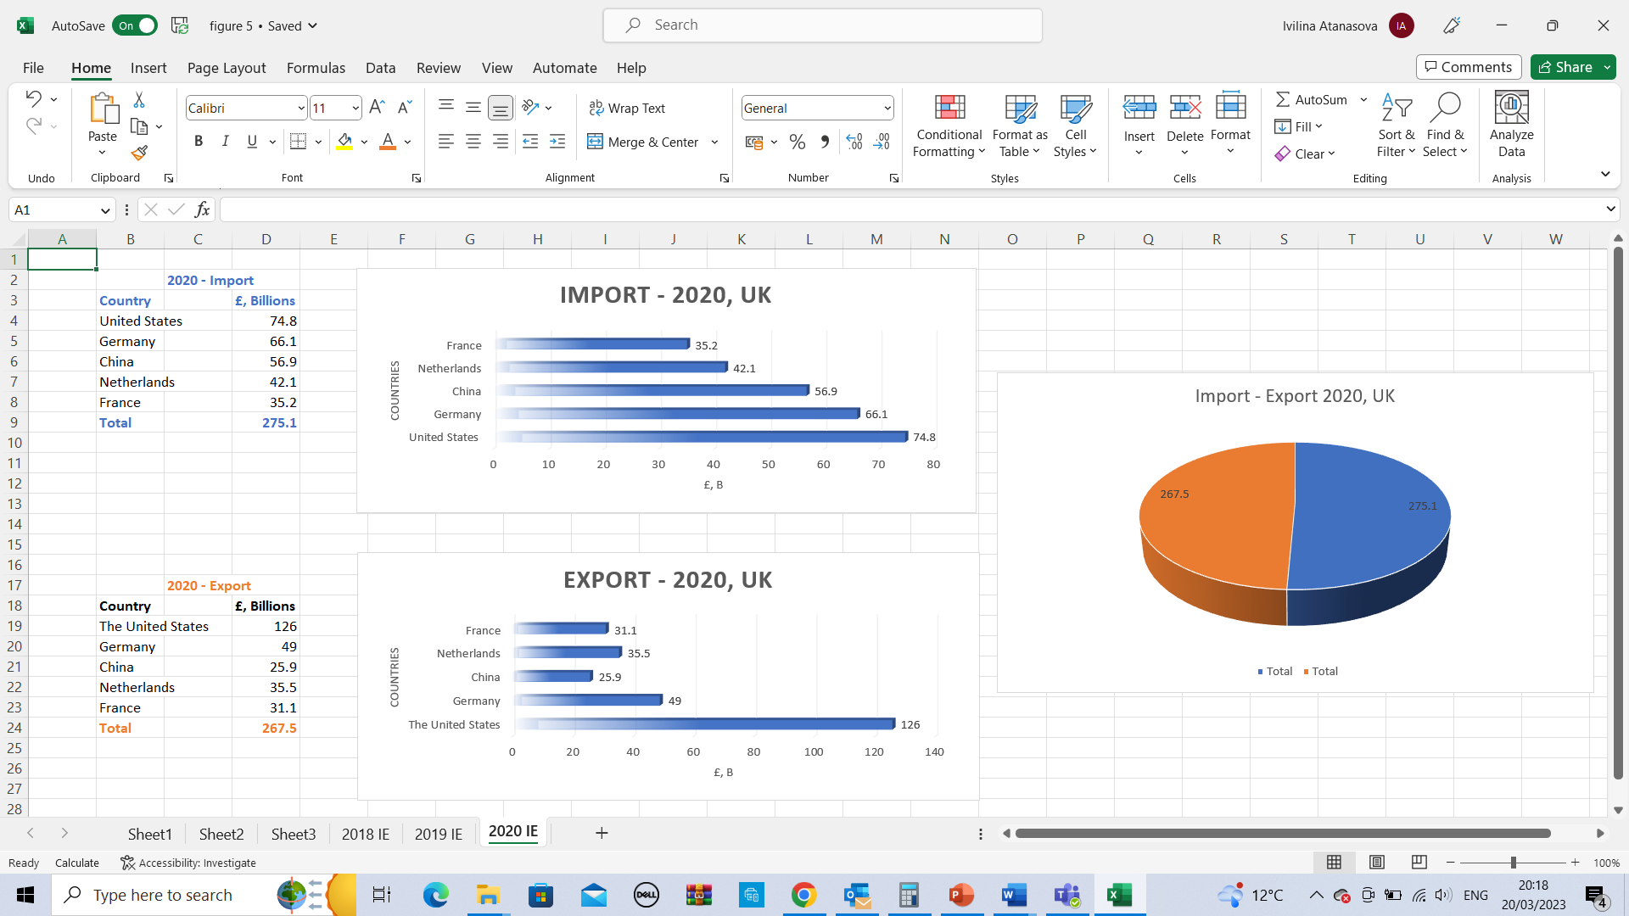

2.9.4. Major trading partners 2021
UK Exports partners: The top 5 trading partners are: USA - 33.7B; Germany - 22.8B; Netherlands - 21.1B; France - 19.7B; the Republic of Ireland -16.6 B.
UK Import’s top 5 trading partners are China - 44.5B; Germany - 42.4B;t the USA - 31. the 7B; Netherlands - 26.3B; Belgium - 19.7B – figure 11 (Jim Sherlock & Jonathan Reuvid, 2022)

Figure 11. Major trading partners 2021 (Jim Sherlock & Jonathan Reuvid, 2022)
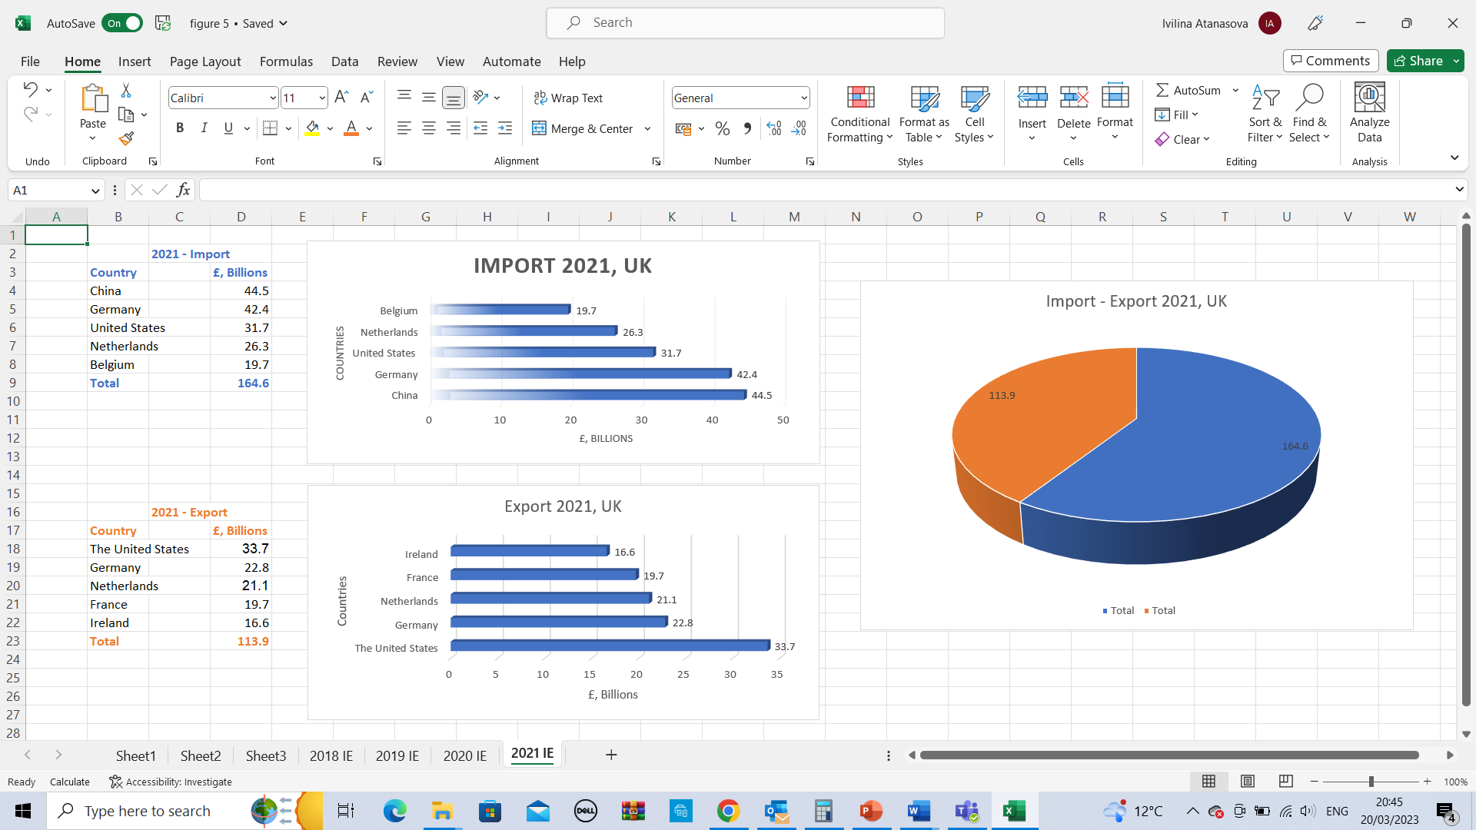
2.9.5. Major trading partners 2022
UK Exports top 5 partners: USA - 54,0 B; Netherlands - 43,2B; Germany - 32,69B; Ireland - 26,68B; France - 24,35B;
UK Import’s top 5 partners: Germany - 51,69B; Netherlands - 43,71B; USA - 40,35B; China - 40,28B; Norway - 37,92B – figure 12 (Jim Sherlock & Jonathan Reuvid, 2022).

Figure 12. Major trading partners 2022 (Jim Sherlock & Jonathan Reuvid, 2022)
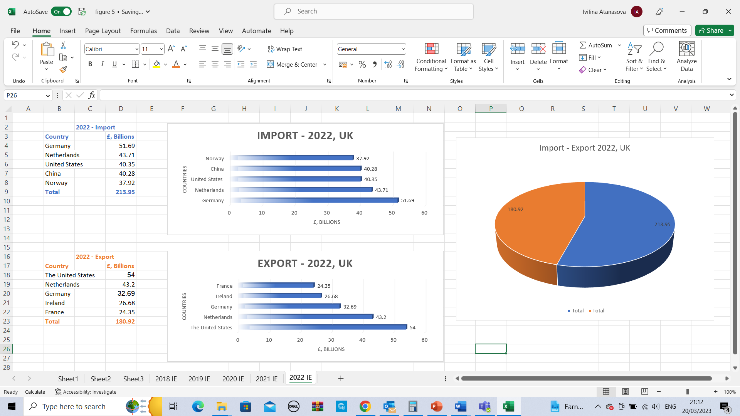

2.10. Import and Export 2018 – 2022 in the United Kingdom – figure 13.

Figure 13. Import and Export 2018 – 2022 (Jim Sherlock & Jonathan Reuvid, 2022)
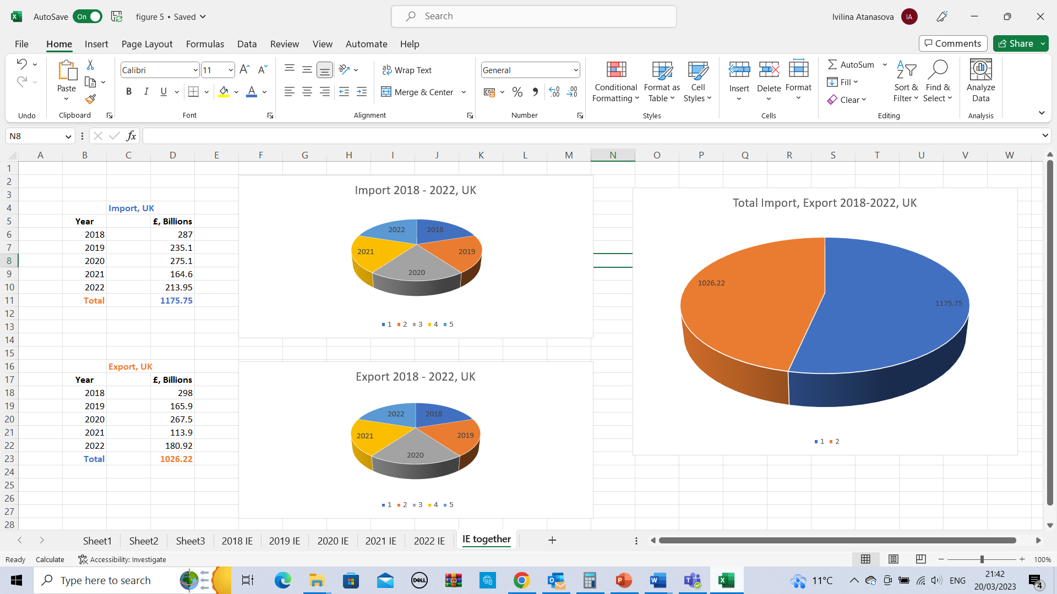

2.11. Main macroeconomic indicators of economic growth in the United Kingdom
2.11.1. Gross Domestic Product (GDP) 2018-2022 - Estimates of the worth of products and services generated in the United Kingdom over a particular time – figure 14. U.K. GDP for 2022 was $2,231.36B, a 9.68% decline from 2022; U.K. GDP for 2021 was $3,131.38B, a 15.78% increase from 2020; U.K. GDP for 2020 was $2,704.61B, a 5.34% decline from 2019; U.K. GDP for 2019 was $2,857.06B, a 0.73% decline from 2018; U.K. GDP for 2018 was $2,878.15B, a 7.26% increase from 2017 (Meo, Al Masri & etc., 2022).

Figure 14. Gross Domestic Product (GDP) 2018-2022 (Meo, Al Masri & etc., 2022)
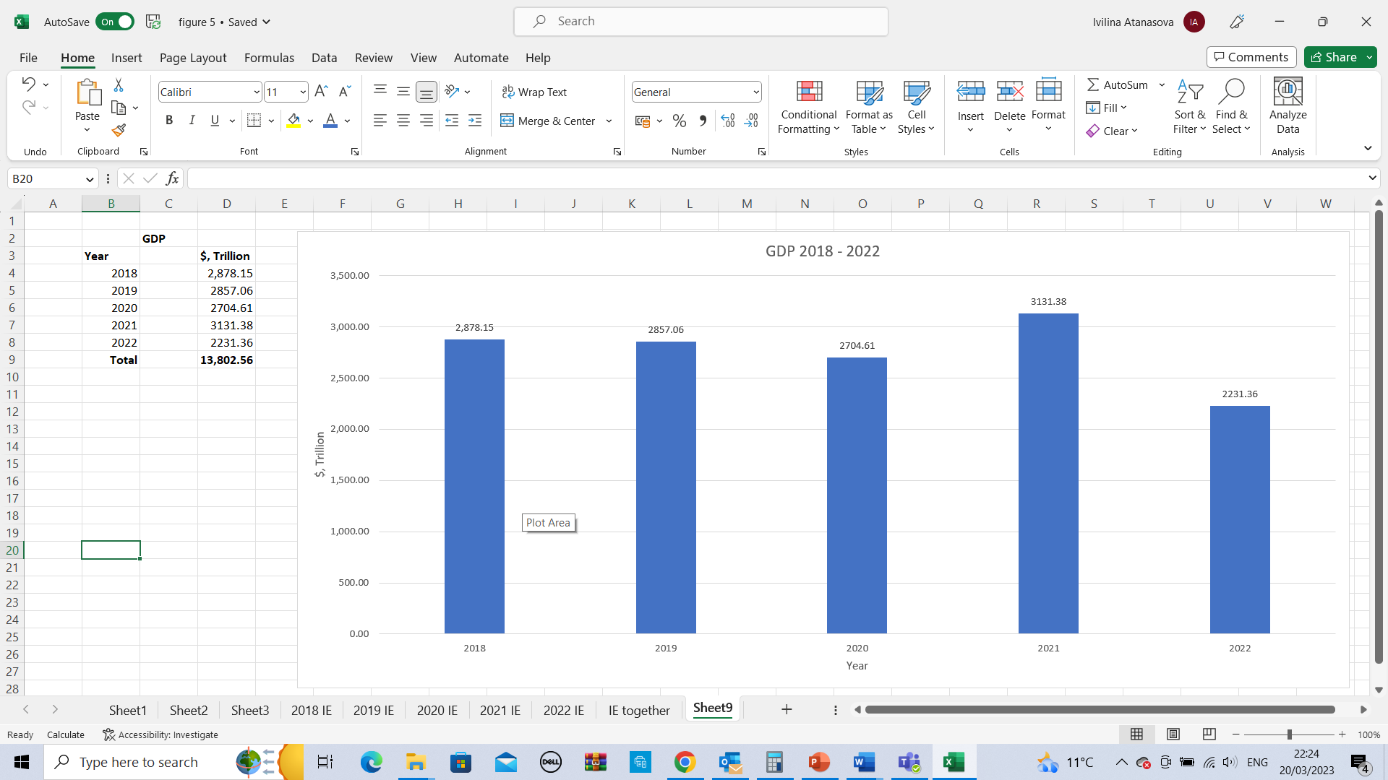

2.11.2. Unemployment 2018 – 2022 in the UK – Unemployed people constantly seek jobs but cannot obtain them. The unemployment rate is widelconsideredas a proxy for the economy's overall condition. The unemployment percentage is the most common statistic to describe the jobless situation – table 3 (Ibrahim, 2022).
In 2018, the U.K. unemployment rate was 4.00%, 0.33% less than in 2017; in 2019, it was 3.67%, 0.23% less than in 2018; in 2020, it was 8.05%, 4.38% more than in 2019; in 2021, it was 5.46%, 2.59% less than in 2020; and in 2022, it was 3.7%, 1.76% less than in 2021.

Table 3. Unemployment 2018 – 2022 in the UK (Ibrahim, 2022)
2018 | 4.00%
2019 | 3.67%
2020 | 8.05%
2021 | 5.46%
2022 | 3.7%

2.11.3. Inflation 2018 – 2022 in the UK
"Inflation" refers to the average annual percentage rate of price inflation. The general rise in costs or the general theme of life living a nation are examples of inflation's broad scope – table 4 (Ibrahim, 2022).

Table 4. Inflation 2018 – 2022 in the UK (Ibrahim, 2022)
2018 | 2.29%
2019 | 1.791%
2020 | 0.851%
2021 | 2.588%
2022 | 9.067%

2.11.4. Balance of payments 2018 – 2022 in the UK

The balance of payments (BOP), also referred to as the sum of all of the global payments, is a record of all financial dealings between domestic and foreign parties over a specified time frame, typically a quarter or year. It is a comprehensive record of all business and political dealings between residents of one nation and those of another (Ibrahim, 2022).
The deficit in the fourth quarter of 2018 (Oct.–Dec.) was the biggest since the third quarter of 2016 (July–Sept.), increasing from £0.7 billion to £23.7 billion, or 4.4% of GDP.
The UK's current account imbalance shrank significantly from £19.9 billion in Q3 (July-September) 2019 to £5.6 billion in Q4 (October-December 2019), or 1.0% of GDP. (GDP).
Quarter 1 (Jan-Mar) 2020 saw a rise in the UK current account deficit to £21.1 billion, or 3.8% of GDP, while the underlying deficit, which strips out not financial gold and other precious metals, shrank slightly by £1.3 billion to £19.9 billion, or 3.6% of GDP.
In 2021, the United Kingdom ran a £43 billion trade imbalance with the European Union and a £15 billion advantage with all other nations.
As the product deficit grew to £64.4 billion and the services balance grew to £40.5 billion in Q3 2022, the overall trade deficit shrank to £23.9 billion, excluding rare metals. With a shortfall of £3.6 billion in Q3 2022, the primary revenue column accounted for 0.6% of GDP (Ibrahim, 2022).
2.11.5. Interest rates 2018 – 2022 in the UK
Borrowers pay interest to lenders, while savers earn interest from financial institutions. Interest is expressed as a yearly proportion of the principal balance of a loan or savings account– table 5.
Average borrowing rates dropped from 4.54% in 2018 to 3.94% in 2019.
The average interest rate on a new home loan has remained steady at 2.10%. There was an effective rate on new individual time accounts of up to 1.41%. The effective rate on consumer new other loans fell to 6.20%in 2019.
For 2020 New mortgage interest rates hit a record high of 2.68%. All new unprotected personal loans now have an effective interest rate of 7.03%. The interest rate on new personal term accounts can now be as high as 1.05%.
As 2021 came to a close, the average interest rate increased from 2.96% to 5.34% in the following year – 2022 (Ibrahim, 2022).

Table 5. Bank of England Mortgage Interest rates 2018 – 2022 in the UK (Ibrahim, 2022)
2018 | 3.94%
2019 | 2.10%
2020 | 2.68%
2021 | 2.96%
2022 | 5.34%

2.11.6. British pound
The British pound sterling (GBP) is the money of the United Kingdom and its dependent countries. The Great British Pound is the world's most extended continuously issued money. The British pound, represented by the symbol £, is a primary international currency.
The dollar’s dominance is primarily to blame for the pound’s decline this year, as it was in 1985. In 2022, the pound’s value will have dropped by around 20% against the dollar, which is only slightly more than the 15% drop experienced by the euro and is on par with the 30% drop experienced by the Japanese yen.

3. Conclusion

According to a study, the UK population increased by 1258978 from 66477824 (2019) to 67736802 (2023). 72.4% of Brits are white, 25% are foreign-born, and Christianity is the official religion. The UK ranks 9th in industrial output at 1.8%, behind China at 28.7%.
Mining, gravel, food, drinks, and tobacco have the most companies. The COVID-19 epidemic reduced UK output to £366.4b in 2020 and £402.8b in 2022. Gold was shipped most in 2019–2021. 2022 (£813B) and 2020 (£262,5B) are the most significant and lowest exports.
Germany imports £77.3B; the US exports £118.2B in 2018. Germany imports £66B; the US exports £57.4B in 2019. The USA eexported£126B and imported £74.8B in 2020. China imports £4,4.5B, and the US exports £33.7B in 2021. The US exports £54B, and Germany imports £51.69B in 2022.
According to the statistics, Germany, the United States, and China are the United Kingdom's three most important business allies.
From 2018 to 2022, the United Kingdom will bring in £1175.75 billion, while it will send out £1026.22 billion.
GDP varied from £3131.38B in 2021 to £2231.36B in 2022. The COVID-19 epidemic will increase joblessness in 2020 and decrease it in 2022. After bottoming in 2020, inflation will rise to 9.067% in 2021 and keep above 11% through 2023. The fourth-quarter deficit was 4.4% of GDP. Mortgage rates rose during the COVID-19 epidemic.34 Thirty-four percent followed.
Figure 15 shows the big rise in unemployment from 2020, Rising inflation and interest rates.

Figure 15. Rise in unemployment from 2020, Rising inflation and interest rates (Ibrahim, 2022)
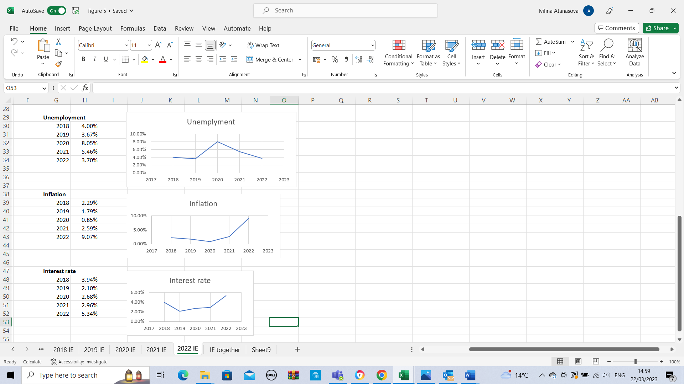

References
Bonney (2013). Monarchy, religion and the state : civil religion in the United Kingdom, Canada, Australia and the Commonwealth. Manchester University Press;
Carl Nelson (2019). Import/Export: How to Take Your Business Across Borders;
Harris & Li, Q. C. (2022). EXPORT-MARKET DYNAMICS AND THE PROBABILITY OF FIRM CLOSURE: EVIDENCE FOR THE UNITED KINGDOM. Scottish Journal of Political Economy, 57(2), 145–168. https://doi.org/10.1111/j.1467-9485.2010.0051;
Jim Sherlock & Jonathan Reuvid (2022). The Handbook of International Trade - A Guide to the Principles and Practice of Export;
Meo, Al Masri, A. A., Usmani, A. M., Memon, A. N., & Zaidi, S. Z. (2022). Impact of GDP, spending on R&D, number of universities and scientific journals on research publications among Asian countries. PloS One, 8(6), e66449–e66449. https://doi.org/10.1371/journal.pone.0066449;
Muhammad (2022). Estimating import demand in the presence of seasonal trade and unobserved prices. Applied Economics Letters, 20(5), 446–451. https://doi.org/10.1080/13504851.2012.709595;
Musa Jega Ibrahim (2022). Macroeconomic Analysis for Economic Growth;
Payne & Harrison, E. (2020). Social divisions : inequality and diversity in Britain (Payne & E. Harrison, Eds.; Fourth edition.). Policy Press;
Simon Jenkins (2018). A Short History of England;
Stan Yorke (2022). The Industrial Revolution Explained: Steam, Sparks & Massive Wheels - An Illustrated Guide to the Technology that Changed Britain Forever: Steam, ... Britain Forever;
Trindade Maia, Maia, R. T., & Araújo, M. C. de. (2019). Integrated View of Population Genetics (Maia & M. C. de Araújo, Eds.). IntechOpen;
Wilson, & Game, C. (2006). Local government in the United Kingdom (4th ed.). Palgrave Macmillan;

