Taylor Dawn Hodges
2008862
HND Computing (Software Engineering)
5th May 2021
Introduction to Web and Database Concepts (ACCA4023)
Database Analysis and Design

Diagrams

Figures

Contents

Diagrams

Context
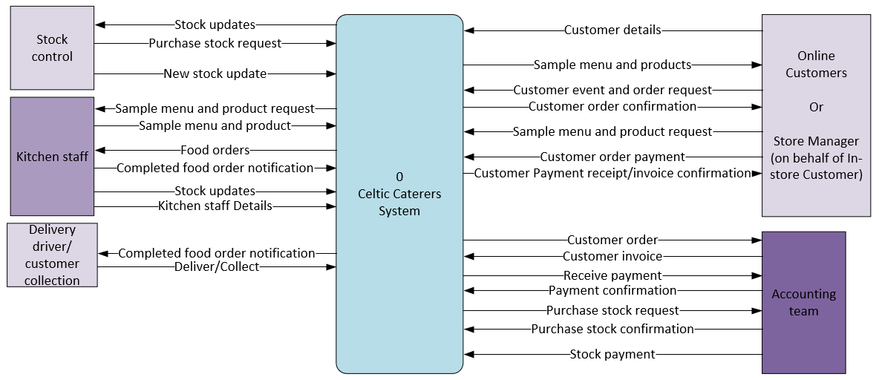
Diagram 1: Context.

Level 0
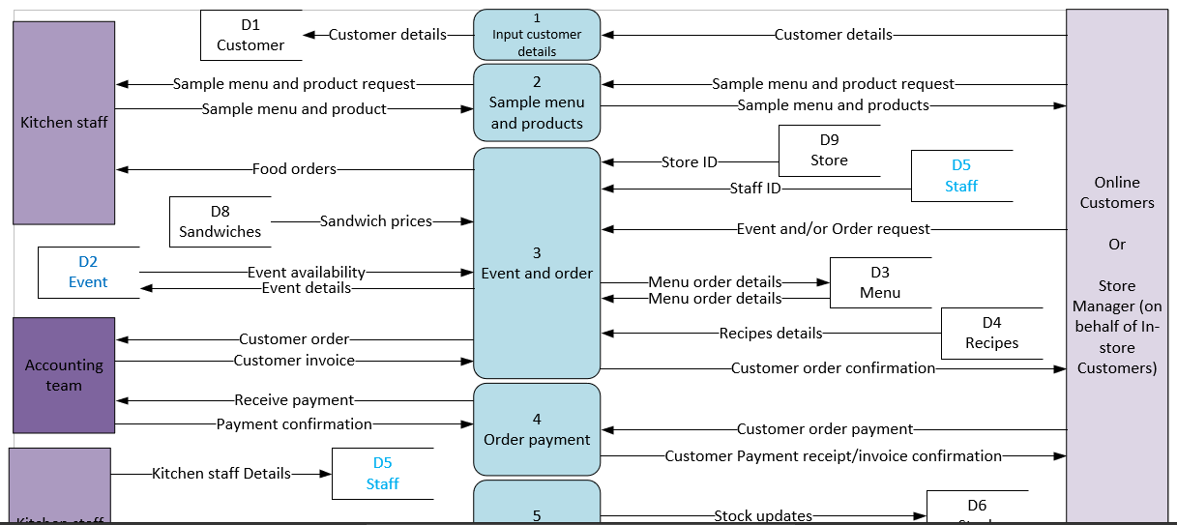
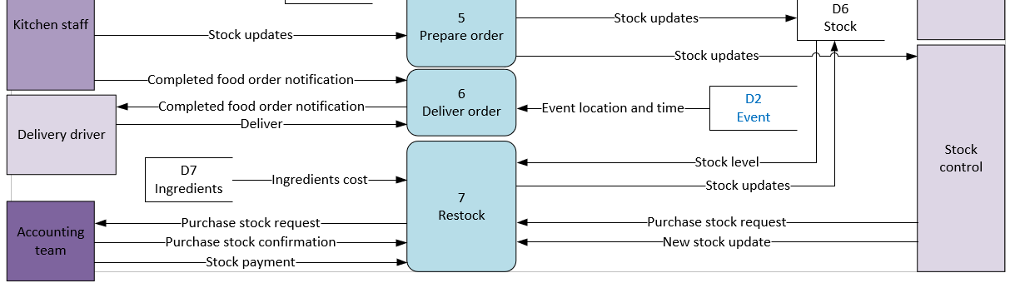
Diagram 2: Level 0.

ERD
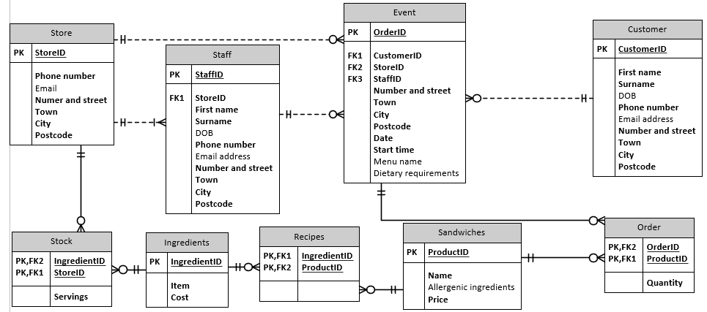
Diagram 3: ERD.

Access

Form

Main menu
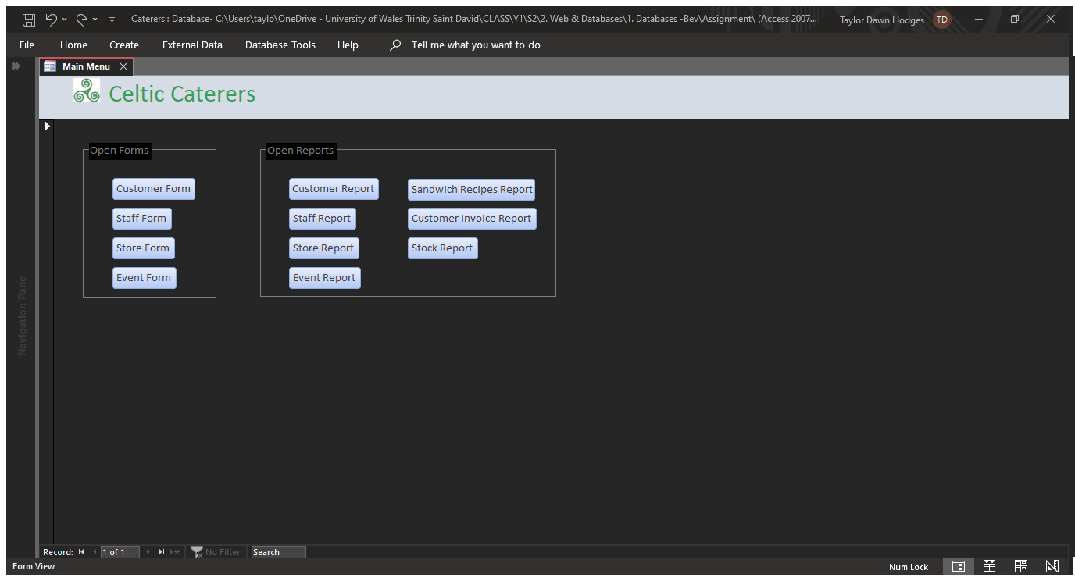
Screenshot 1: Main menu, displayed immediately after the database is opened using an AutoExect. Buttons navigate user to various forms and reports.

Customer
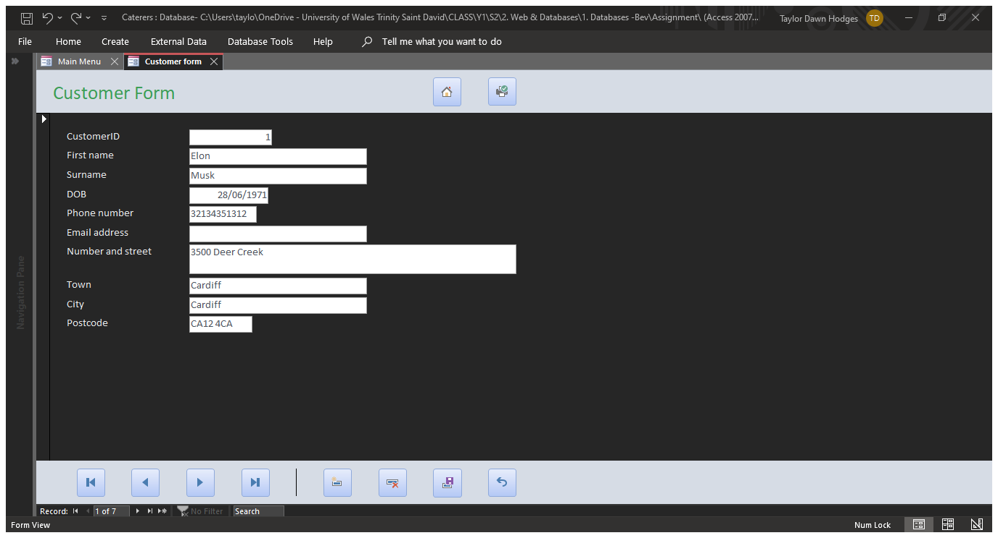
Screenshot 2: Customer form, complete with home, print, first record, previous record, next record, last record, new record, delete record, save record, and undo buttons.

Staff
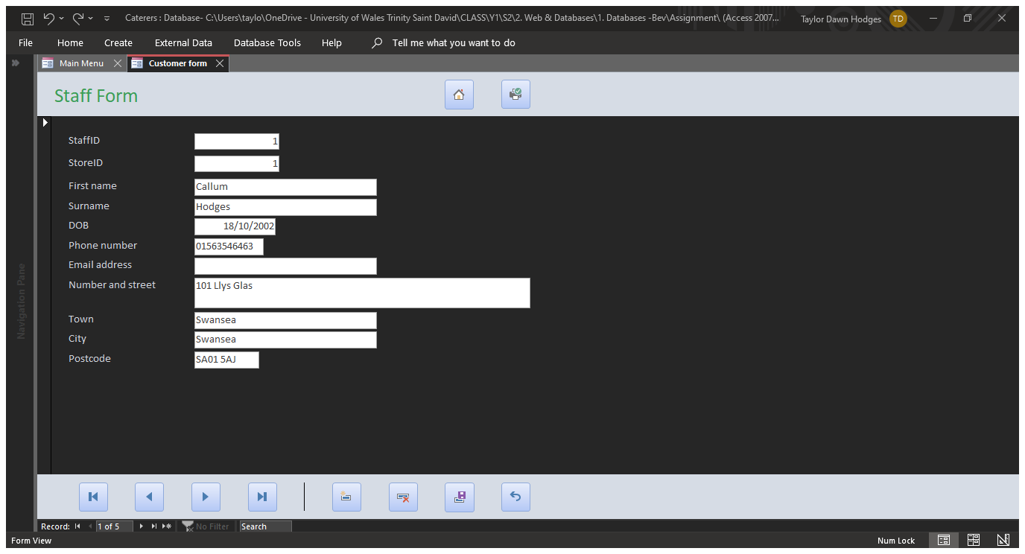
Screenshot 3: Staff form, with all buttons listed previously.

Store
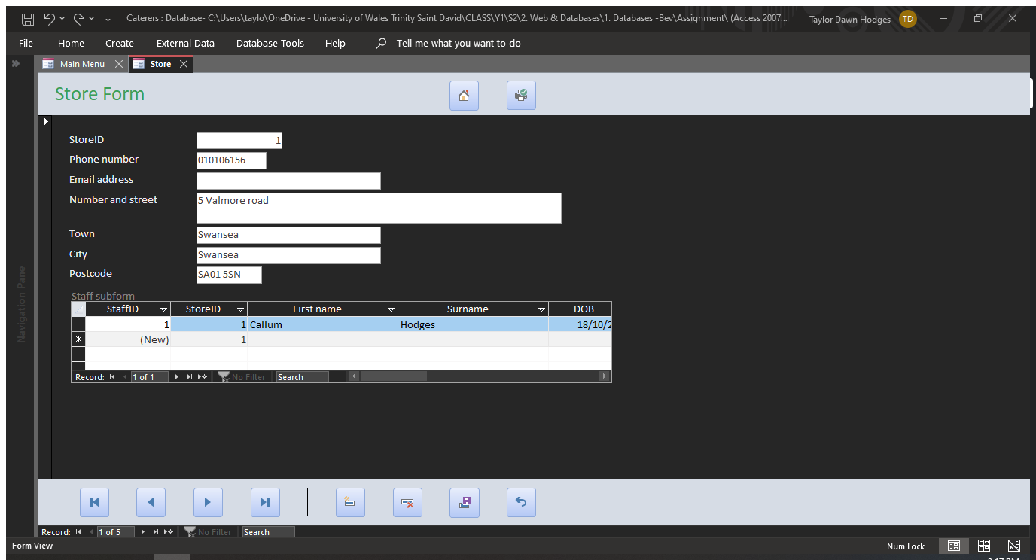
Screenshot 4: Store form, featuring staff sub-form, with all buttons listed previously.

Event
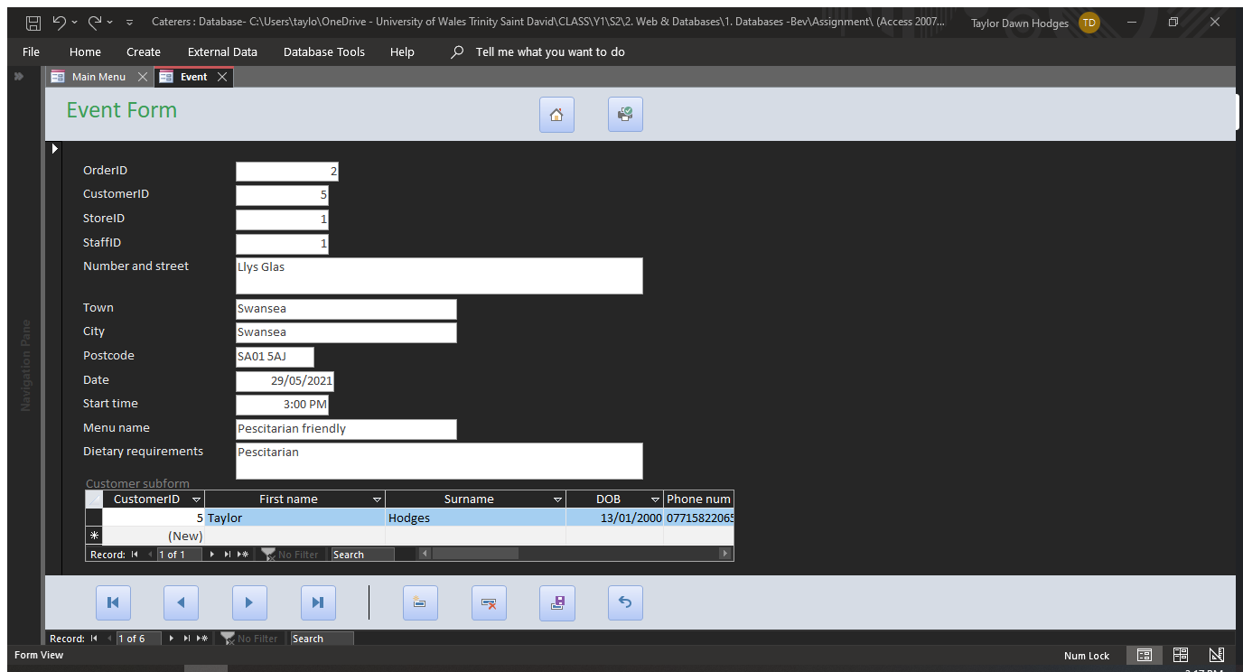
Screenshot 5: Event form, featuring customer sub-form, with all buttons listed previously.

Reports

Customer
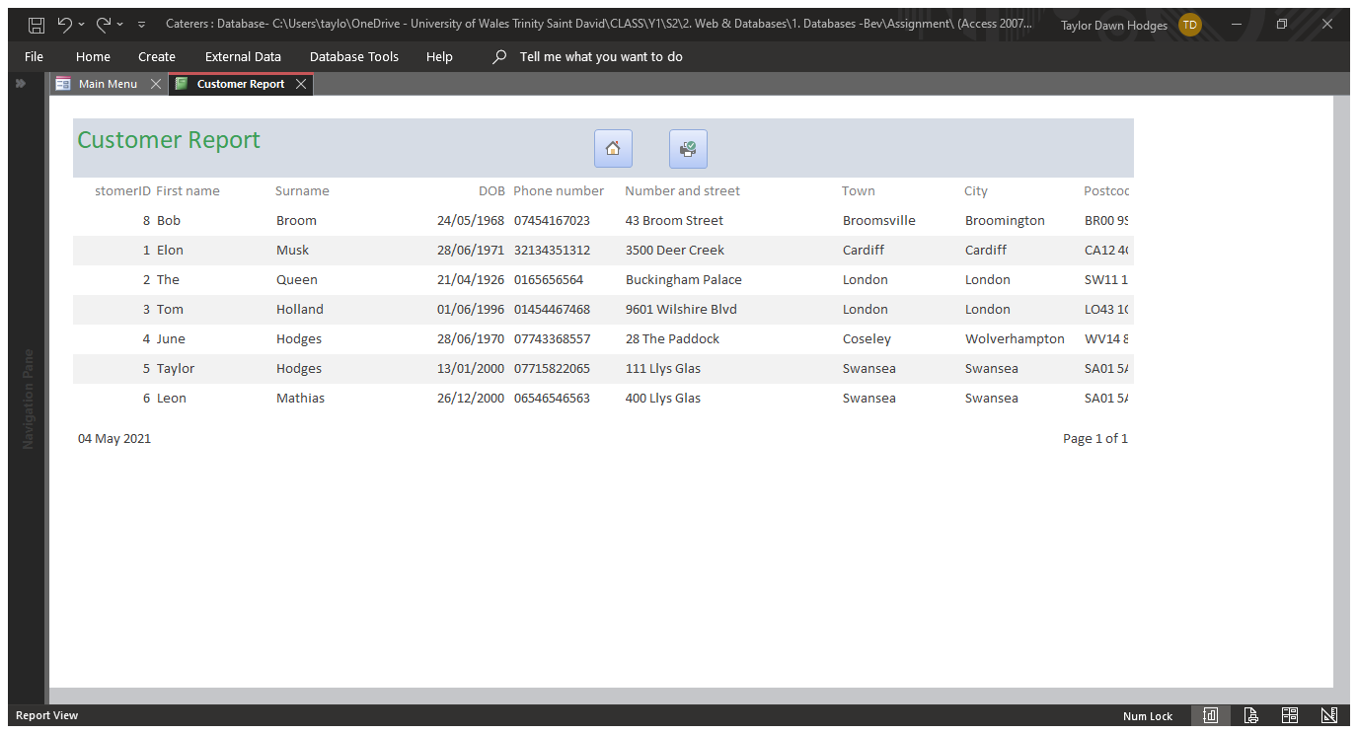
Screenshot 6: Customer report, with home and print buttons.

Staff
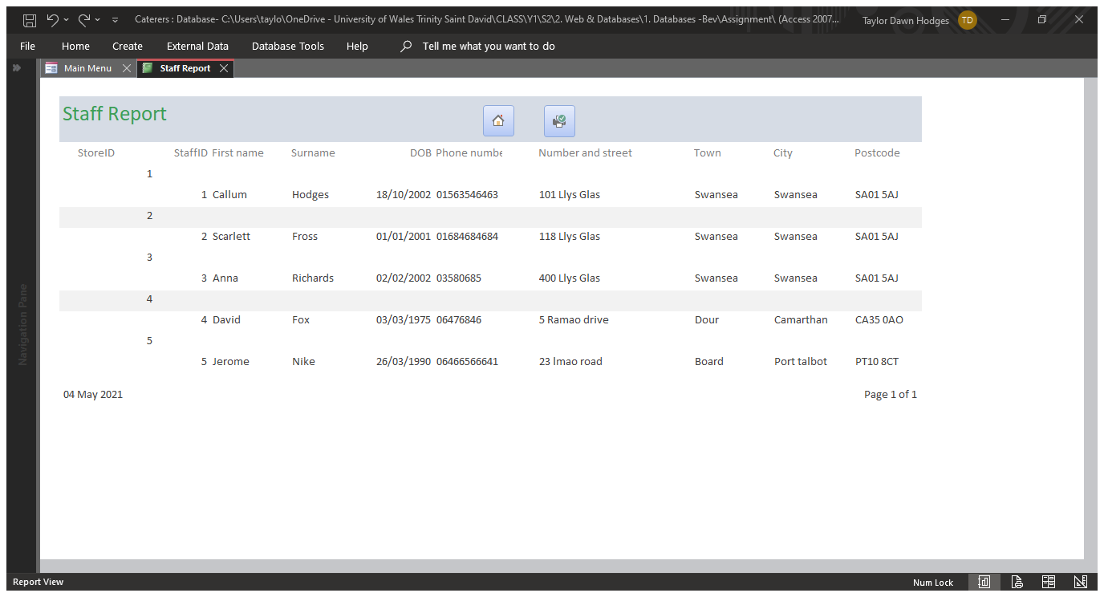
Screenshot 7: Staff report, with all buttons listed previously.

Store
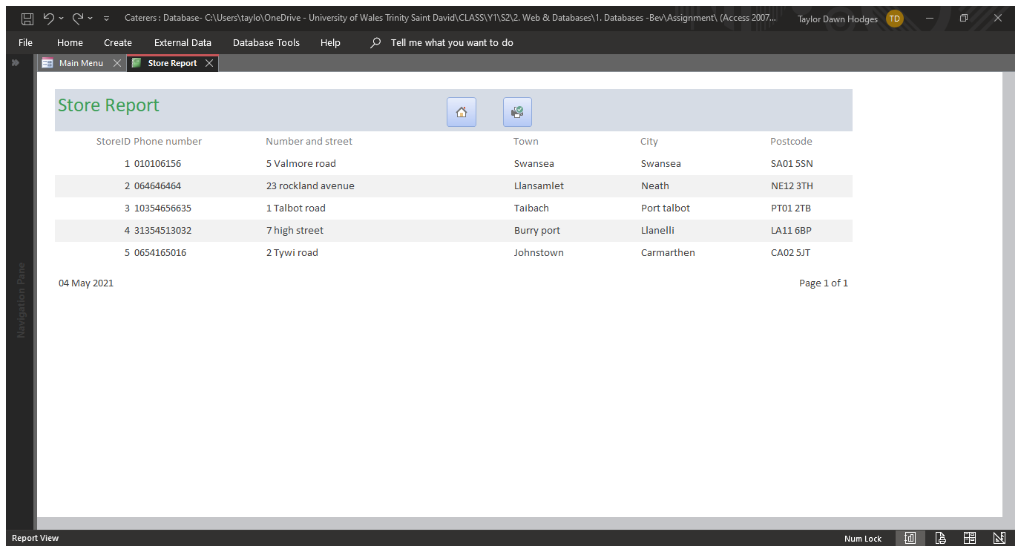
Screenshot 8: Store report, with all buttons listed previously.

Event
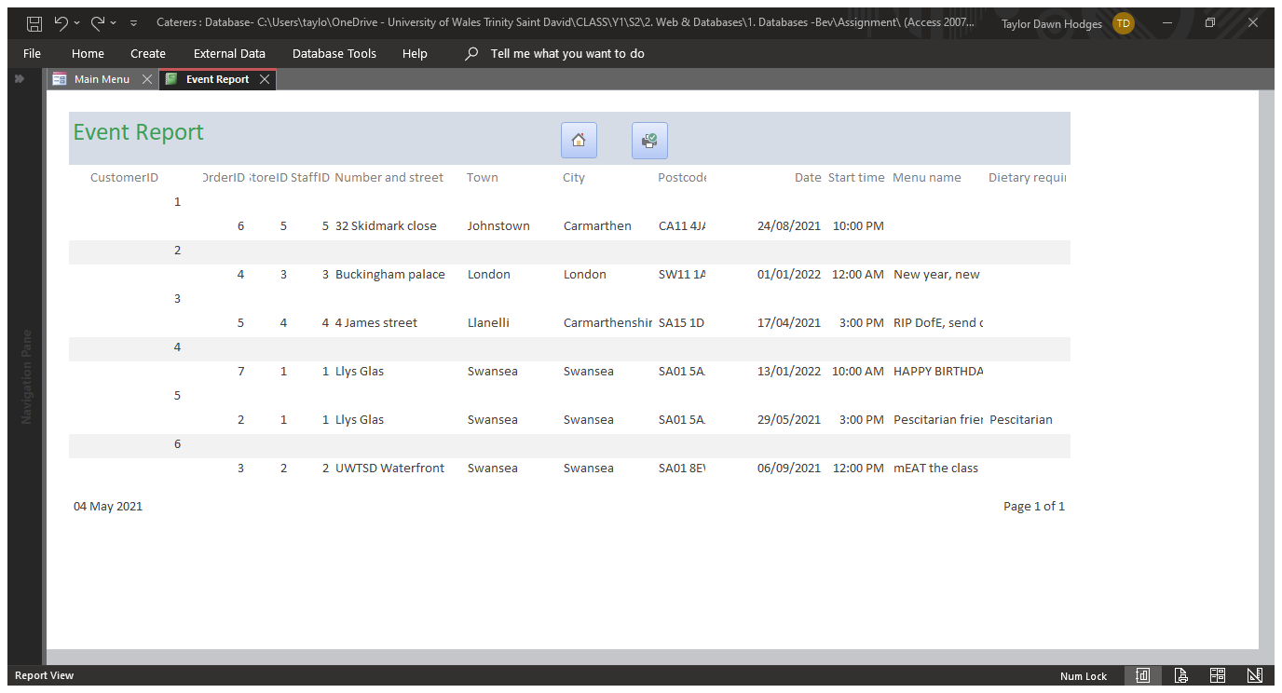
Screenshot 9: Event report, with all buttons listed previously.

Recipes
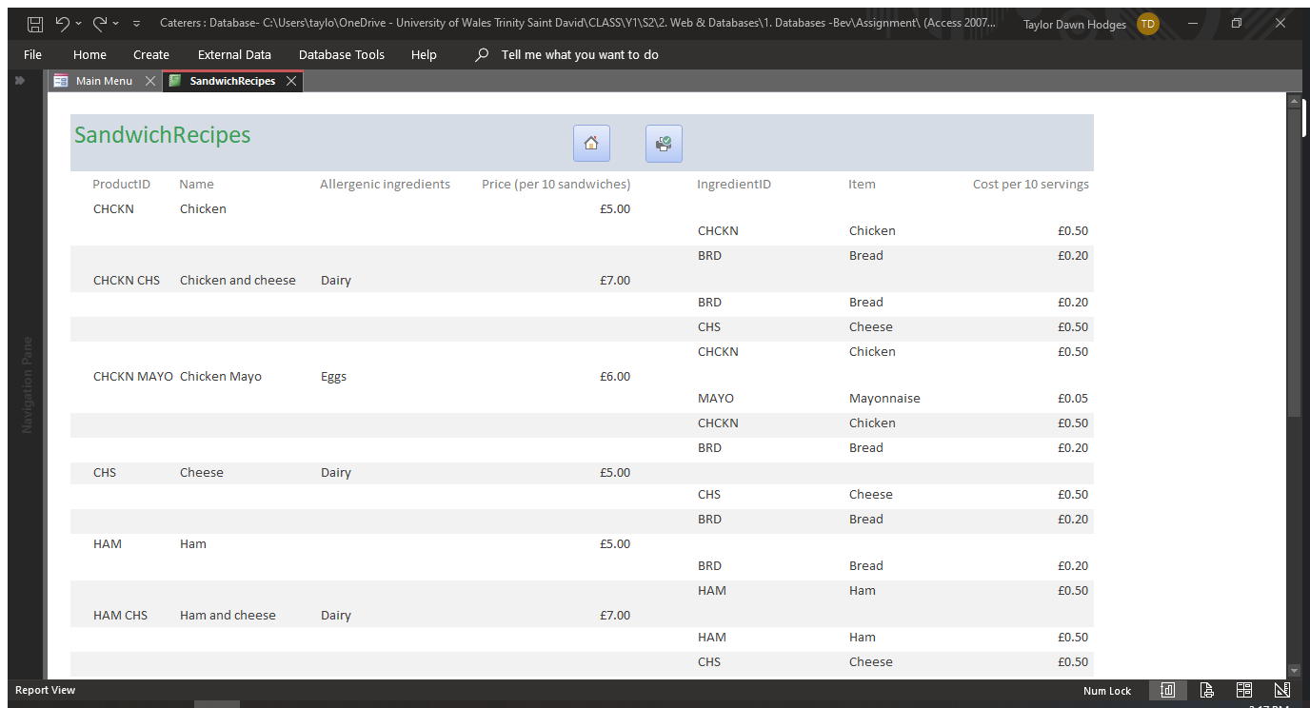
Screenshot 10: Sandwich recipes report, with all buttons listed previously.

Stock
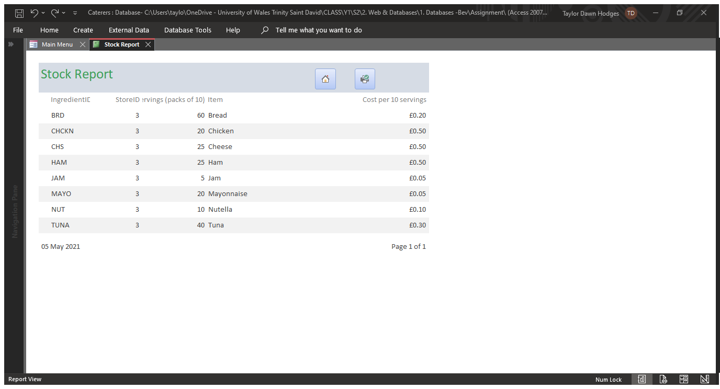
Screenshot 11: Stock report, with all buttons listed previously.

Invoice
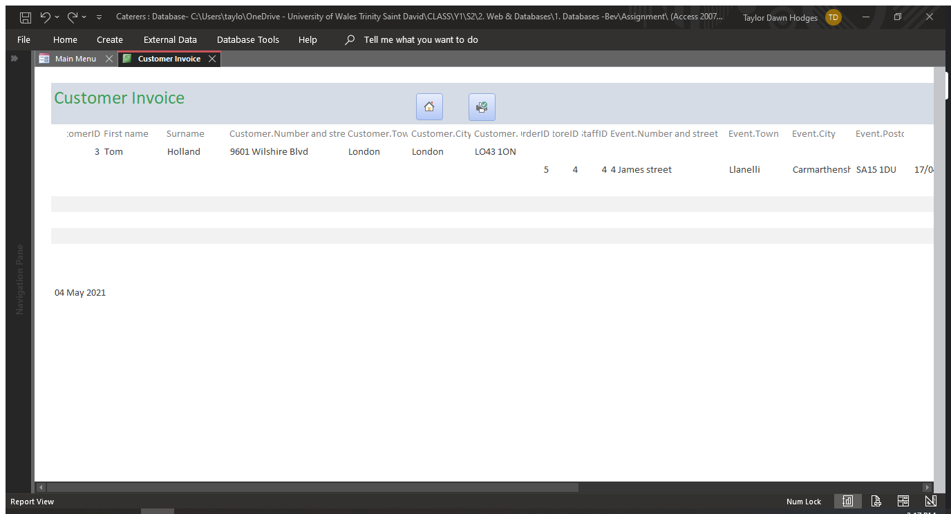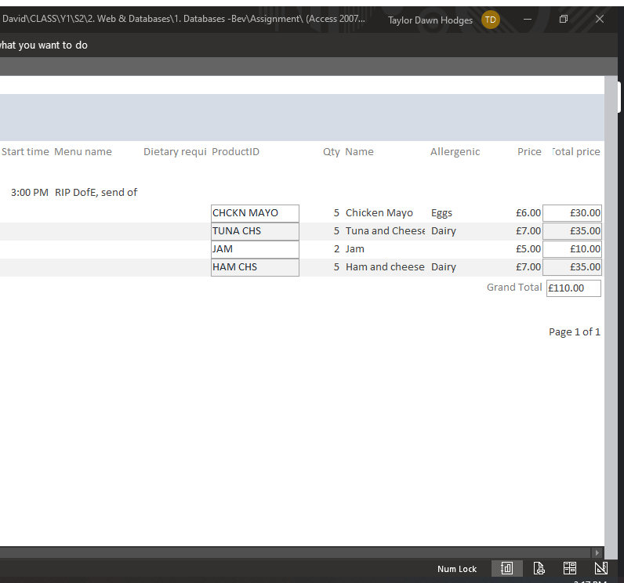
Screenshot 12: Customer invoice report, with all buttons listed previously. Report calculates customer’s purchases.

User Guide
When the user opens the database, they will be presented with the main menu form using an AutoExect.
The buttons on the main menu take the user to the respective reports and forms:

- Customer form
- Staff form
- Store form
- Event form
- Customer report
- Staff report
- Store report
- Event report
- Sandwich recipes report
- Stock report
- Customer invoice report

Screenshot 13: Main menu, displayed immediately after the database is opened using an AutoExect. Buttons navigate user to various forms and reports.

From there, the user can click through the navigation buttons in the footer to navigate through forms, create new, delete, save, and undo forms, complete with appropriate icons.
Screenshot 14: Form footer with navigation, new, delete, save, and undo record buttons.

All forms and reports have a button in the header to print, created using a macro, as well as a home button to return to the main menu, complete with appropriate icons.
Screenshot 15: Home and print buttons on all forms and reports.

Walkthrough
How to create a new customer record.
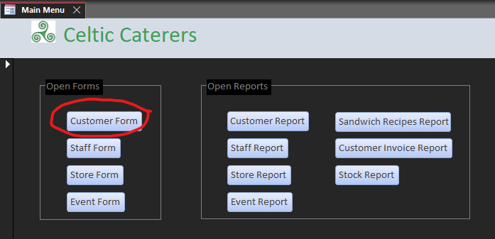
Screenshot 16: To add a new customer, begin by clicking the “customer form” button.
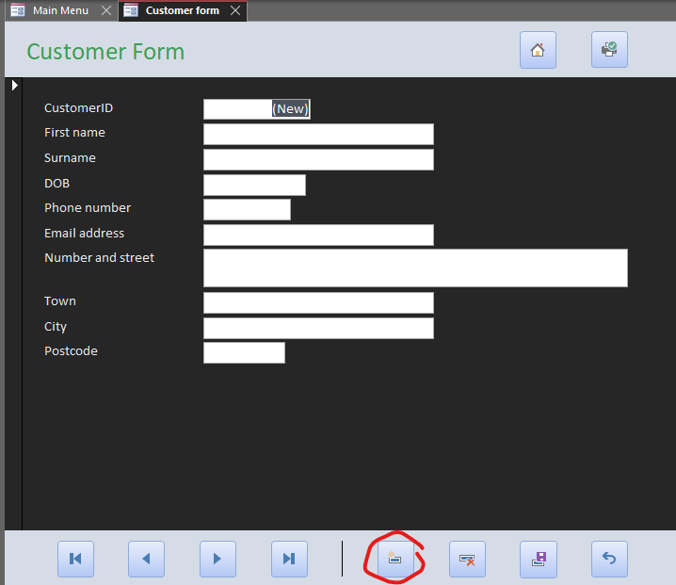
Screenshot 17: Click the “new record” button to open a new record.
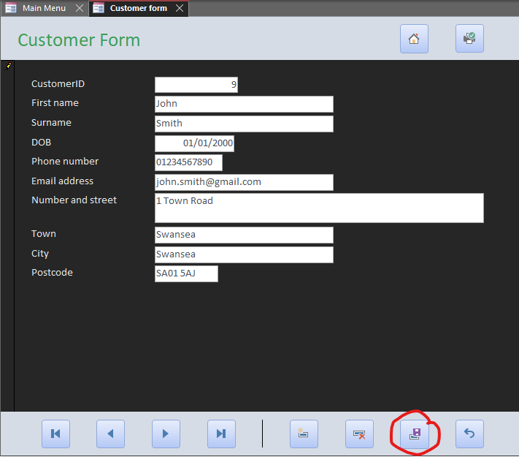
Screenshot 18: Enter customer details and click on the “save” button to save the new record.
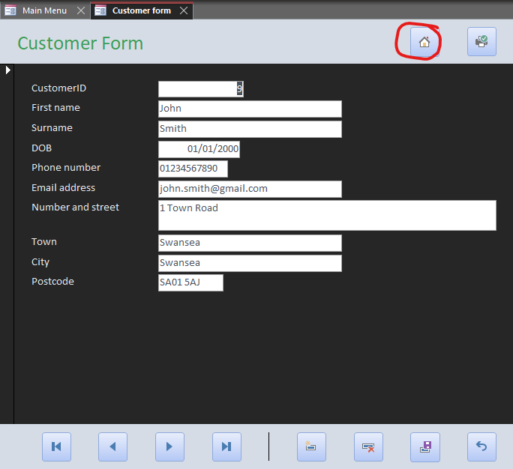
Screenshot 19: Click the “home” button to return to the main menu.

Bibliography

[1] | Leon Marsden, “Creating Forms and Sub-Forms in Access,” YouTube, 24 April 2016. [Online]. Available: https://www.youtube.com/watch?v=dWNeBJD7fH8. [Accessed 4 May 2021].
[2] | Andy Dolinski, “Calculate totals in reports Microsoft Access,” YouTube, 12 March 2014. [Online]. Available: https://www.youtube.com/watch?v=H-mtENX4v6k. [Accessed 4 May 2021].
[3] | Mythologian, “Celtic Symbols and Their Meanings - Mythologian,” Mythologian, [Online]. Available: https://mythologian.net/celtic-symbols-meanings/. [Accessed 4 May 2021].

