
Entrepreneurship Assessment 2
A Fitness Center and Salon in London

Name: - Vikaskumar H Desai
Student id: - 1706369
Subject: - Entrepreneurship
Subject code: - SBMA7111_ENT_A2 report
Tutor name: - Richard small

Table of Contents
Introduction to the Business 2
Management 2
Business Funding and Start UP Capital 3
Analysis of the Industry 3
Analysis of Macro Environment 4
Analysis of Micro Environment 6
Marketing and Promotional Strategy 7
Primary Research for Business prospects 10
Financial Projection and Estimations 12
References 15

Introduction to the Business
The start-up business will be named as Fitness and Salon Club and it will operate within the context of UK market. The business idea is to offer the diverse services of gym, swimming pool and salon services under one roof for the UK customers. The overall business will thereby comprise of three sections, one unisex gym, one unisex salon and one swimming pool which can help to cater or respond to the health, fitness and grooming needs of the UK population. In addition to the offering of the fitness facilities of swimming pool and gym the organization of Fitness and Salon Club will also offer advanced salon facilities and services to their customers (McKeever, 2016). This will effectively include the spa services, facial, hair dressing and de tanning services along with pedicure, manicure and bridal make ups. In addition both natural and cosmetic services will also be delivered.
Mission and Vision
The mission of Fitness and Salon Club is to achieve a high market through introduction of the unique services of gym, swimming and salon services together under one roof so that the health, lifestyle and fitness needs of customers can be fulfilled.
In consideration of vision, the organization of Fitness and Salon Club, will focus upon catering to the changing demands and needs of the UK population, through introduction of their wider range of products and services so that the gym, swimming and salon facilities can be availed by the customers more conveniently and effectively.

Management
The business founder will play the role of CEO. In addition, the overall structure of the management will comprise of one human resource (HR) manager, one operations manager and one sales and marketing manager. This hierarchy of the management structure is expected to highly benefit the start-up business of Fitness and Salon Club to achieve higher market performance and productivity which can effectively cater to their desired market growth, sustainability and development.

Fig: Management Structure for Fitness and Salon Club

Business Funding and Start UP Capital
Obtaining of proper funding is deemed for be necessary for the start-up business of Fitness and Salon Club. In this regards, the overall estimated costs for the business start-up is nearly 9,000000 GBP. Out of this overall value nearly 25 percent will be obtained from the venture capitalists or the investors and 25 percent will be self-funded by the owner of the business. The remaining 50 percent of the capital value will be acquired through the bank loans (Cosenz, 2017).

Analysis of the Industry
The grooming industry in UK is seen to be growing at a high pace. The statistics and observations highlights that UK customers have spent more than 2 billion of GBP in hair and salon services in the last quarter of 2017. This statistics showcases high market opportunity for the organization of Fitness and Salon Club.
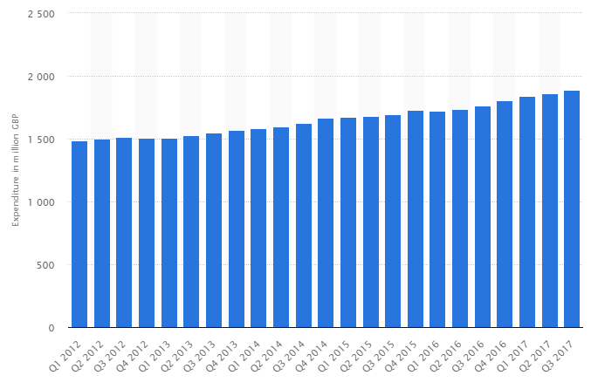
Fig: Statistics of customer spending in the hair and salon services in UK (source: statistica.com)
When considering the perspective of fitness and well industry, the overall market is estimated to reach a value of 22 billion GBP by the year of 2020. This offers better growth and development opportunities for Fitness and Salon Club (Raven, 2018).

Analysis of Macro Environment
The identification of the macro environment for Fitness and Salon Club in United Kingdom (UK), can be done by implementation of the PEST framework. This will help in identification of external factors impacting the business activities in the targeted market. Such external factors as identified from PEST analysis have been discussed as below;
Political factors:
UK has a stable political system, which offers Fitness and Salon Club with proper environment to conduct their business in the UK market. The relaxed business regulations and polices makes it beneficial for Fitness and Salon Club to carry out their business activities or operations in the targeted market. However, the different government rules and standards must be maintained.
Economic factors:
The stable economic growth of UK can be considered to a boon for Fitness and Salon Club. The increase in the GDP rate ensures higher spending power of the customers in UK that can help the organization in fostering of desired revenues or sales in the UK market.
Socio Cultural factors:
Considering the demographic profile of UK, Fitness and Salon Club has the opportunity of targeting wider range of customers by their services and products. In addition the high awareness regarding grooming and fitness among the UK population can also help Fitness and Salon Club, in development of higher presence in the targeted market (Konishi, 2017).
Technological factors:
The availability of the technological resources in UK, offer Fitness and Salon Club with high opportunities in respect to sustaining of their business operations and growth effectively. The availability of high technology helps Fitness and Salon Club to ensure proper customer services in addition to the availability of high quality of equipment and technology for the gym and salons services.
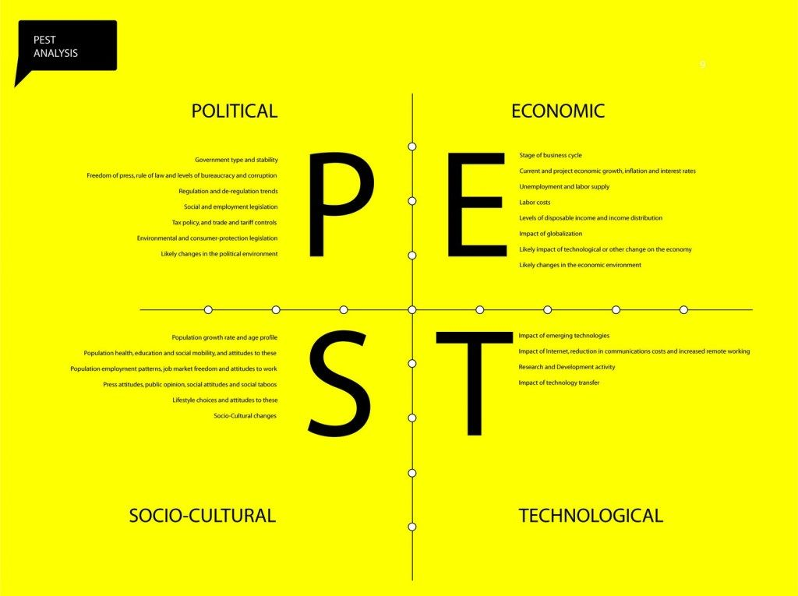
Fig: PEST Analysis

Analysis of Micro Environment
The overall micro environment in relation to the start up business of Fitness and Salon Club, can be explained by implementation of SWOT analysis as discussed below;
Strengths:
The key strengths of Fitness and Salon Club lies in their wide offering of products and services under one roof and convenient location. In this context the delivery of gym, swimming pool and the salon services is expected to cater to the diverse health and grooming or lifestyle needs of the UK population in a streamlined and convenient manner. In addition the services offered by the organization will also be of high quality which can prove advantageous in obtaining of competitive advantage in the market by fulfilment of the diverse needs of the United Kingdom (UK), population. This can also help in establishment of higher brand value and appeal in the respective market.
Weaknesses:
Considering the low market experience and expertise, the organization can face a high difficulty in management of their business activities and operations in a sustainable manner. In addition the organization also lacks the presence of proper marketing channels, supplier networks which can limit their overall business performance in the market. The unavailability of a competent workforce and manpower can also be considered to be among the key weaknesses of the start-up business of Fitness and Salon Club (Hill, 2014).
Opportunities:
Considering the rising demand for fitness and grooming services in the UK market, the introduction of the wide product range and variety will help the Fitness and Salon Club in fulfilling the demands and expectations of the UK customers. In addition the unique service of offering gym, swimming pool and the salon services under one roof can prove to be of high competitive advantages for Fitness and Salon Club in the market of United Kingdom (UK).
Threats:
The changes in the demands, choices or needs of the customers is one of the key disadvantages or threats for Fitness and Salon Club. In addition the market is also prone to high variations and fluctuations. The organization also faces a stiff competition from other fitness and grooming and salon services offered by other organizations in the market of United Kingdom (UK).

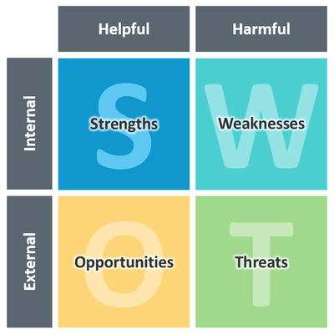
Fig: SWOT Analysis

Marketing and Promotional Strategy
For the purpose of sustaining in the highly competitive landscape in United Kingdom (UK), there is a need for Fitness and Salon Club, to implement highly innovative marketing strategy so as to create a better brand awareness and appeal to the customers in UK.
Thus Fitness and Salon Club must effectively segment the targeted market so that potential customers or clients can be identified and marketing strategies can be developed for appealing to the identified customer segments. Some of the factors that need to be considered for segmentation of the market, have been discussed below;
Demographic factors: For segmentation of the market some of demographic parameters such as income level, educational status, social status and others must be considered (Hollensen, 2015).
Psychographic factors: In respect to psychographic factors, the overall attitudes as well as lifestyle of the customers towards grooming and fitness must be considered.
Behavioural factors: The specific behavioural factors which must be incorporated by the organization of Fitness and Salon Club for proper segmentation of the market includes the usage rates and status of customers, the perception of the customers towards health, grooming and fitness in addition to the brand appeal.
Geographic factors: Some of factors which must be considered for segmentation of the market is the location of the potential customers across different metropolitan and urban areas.
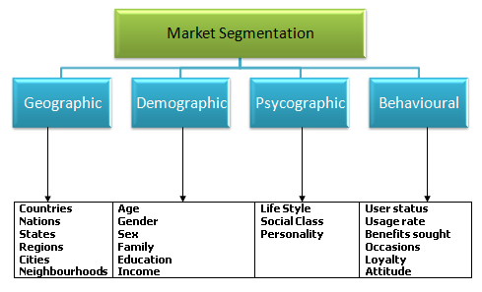
Fig: Market Segmentation

The targeted customer group of Fitness and Salon Club will be the UK citizens between the age group of 20 to 50 years. The customers will belong to the upper and middle income groups or classes of the society having a higher preferences towards fitness, grooming and lifestyle products and services.
In relation to the overall segments of customers targeted by the business of Fitness and Salon Club, an innovative and appropriate marketing strategy needs to be developed. In this context the use of different promotional channels must be utilized so that the overall brand message is properly conveyed to the targeted customer groups or segments in the UK market. The use and implementation of different promotional media or channels have been discussed as below;
Broadcast and Print Media: Advertisements must be propagated among the customer segments, through printing and publishing of ads in newspapers, fitness and health magazines and others. In addition pamphlets and leaflets can also be distributed among the targeted customers or audiences in the market. The use of different television channels can also be incorporated so that the products and services delivered by the organization can be effectively communicated to the customers thereby targeted (Hatten, 2015).
Display Media: Advertisements can also be displayed by the use of billboards, posters and hoardings across prominent locations in the metropolitan or urban areas of United Kingdom (UK).
Digital Media: The digital media can be used by Fitness and Salon Club, so that the products and services can be marketed or promoted across the customer segments through the innovative platforms offered by digital media. In addition by proper utilization of digital media, a better geographic focus can be achieved in relation to the marketing and promotions at much reduced costs and operations. This can be achieved by proper utilization of different social media platforms or channels. It can also help Fitness and Salon Club in development of effective customer communication and relations that is necessary for the purpose of generating a high brand appeal to the targeted customer segments or groups in the UK market. Some of the social media platforms or channels utilized for this purpose include the following as mentioned;
- You Tube
- Twitter
- Facebook
- Instagram

Fig: Use of the different marketing channels for product and service promotion

Primary Research for Business prospects
The future prospects of the concerned business have been identified and analysed by conducting a specific market survey. This survey was initiated among the core targeted customer groups of Fitness and Salon Club, within the age range of 20 to 50 years. The analysis have been showcased as below;

The results of the market survey as depicted above effectively indicate that the business of Fitness and Salon Club have high growth prospects in the UK market. As per the analysis, it is evident that the uniqueness and variety of the services and products delivered by Fitness and Salon Club under one roof will help in catering to the diverse needs of the UK population. This can help the organization to have a high appeal to the targeted UK customers in addition to enjoying a high competitive edge or advantage in the respective market. However, the organization has a threat from other organizations must the wide product and service range under one roof can prove to a competitive advantage for the organization leading to high business sustainability in the UK market.

Financial Projection and Estimations
The overall detailed financial estimation of the start-up business of Fitness and Salon Club, has been discussed below;
Now considering the different sectored services offered by the start up business, expectations are such that nearly 10 GBP of revenue’s will be achieved from customer visiting the gym, 25GBP of revenues will be realized from the customers visiting the salon and nearly 12 GBP of revenues is expected from each of the customers visiting the swimming pool services offered.
The overall estimated customers and clients for the Fitness and Salon Club for the first 3 years of the business operations have been discussed below;
It is estimated that on a daily basis Fitness and Salon Club, will have nearly 100 customers for the gym, 90 customers for the salon services and another 100 customers for the swimming pool services. Therefore the overall figure of customers on yearly basis is derived as per the operations in the first year. In the second and third year it is expected that the customer influx will increase by nearly 10 percent for the combined services delivered by Fitness and Salon Club.
 | Yearly Customer |  |  | Total
 | Gym | Salon | Swimming Pool | Total
Year 1 | 34500 | 32400 | 35000 | 101900
Year 2 | 37950 | 35640 | 38500 | 112090
Year 3 | 45000 | 39204 | 42000 | 126204

Estimation of Sales
Now based upon the estimation of yearly customer influx and revenues obtained per client or customer for Fitness and Salon Club the estimation of sales for 3 years of business operations have been discussed below;
 | Gym | Revenues from Gym | Salon | Revenues from Salon | Swimming Pool | Revenues from Swimming Pool | Total revenue (GBP)
1st year | 34500 | 414000 | 32400 | 810000 | 35000 | 420000 | 1644000
2nd year | 37950 | 455400 | 35640 | 891000 | 38500 | 462000 | 1808400
3rd year | 45000 | 540000 | 39204 | 980100 | 42000 | 504000 | 20204100

References
Cosenz, F., 2017. Supporting start-up business model design through system dynamics modelling. Management Decision, 55(1), pp.57-80.
Hatten, T.S., 2015. Small business management: Entrepreneurship and beyond. Nelson Education.
Hill, C.W., Jones, G.R. and Schilling, M.A., 2014. Strategic management: theory: an integrated approach. Cengage Learning.
Hollensen, S., 2015. Marketing management: A relationship approach. Pearson Education.
Konishi, Y., 2017. On the Role of Skill, Quality, and Environmental Factors on Customer Behavior of the Beauty Industry. Research Institute of Economy, Trade and Industry (RIETI).
Mariotti, S. and Glackin, C., 2014. Entrepreneurship and small business management. Pearson Higher Ed.
McKeever, M., 2016. How to write a business plan. Nolo.
Perry, A.S., Rahim, E. and Davis, B., 2018, March. Startup Success Trends in Small Business beyond Five-Years: A Qualitative Research Study. In 6th International Conference on Innovation and Entrepreneurship: ICIE 2018 (p. 341). Academic Conferences and publishing limited.
Polyakova, O. and Mirza, M.T., 2016. Service quality models in the context of the fitness industry. Sport, Business and Management: An International Journal, 6(3), pp.360-382.
Raven, S., 2018. Mind the gap: Sport management education and employability auto-ethnographical analysis of sport management education and the sports fitness industry. Education+ Training.
Schaper, M.T., Volery, T., Weber, P.C. and Gibson, B., 2014. Entrepreneurship and small business.
Yeh, F.T., 2017. A Study of Innovative Business Model for the Hair Salon Industry: A Case of Company A.

