Centrifugal Clutches

A centrifugal clutch is a mechanical device which is used to transmit the torque from the driver shaft to the driven equipment giving a soft start to the machinery with no load engagement. The clutch allows the speed to be controlled between the drive and driven equipment, this will allow the operator to run the engine safely at a designated idling speed without driving the equipment. By having this clutch, it will allow the engine to reach its optimal torque before engaging and experiencing any load applied. Only when the RPM of the engine is increased will the clutch fully engage, this results in a smooth engagement and prevents the engine from stalling.
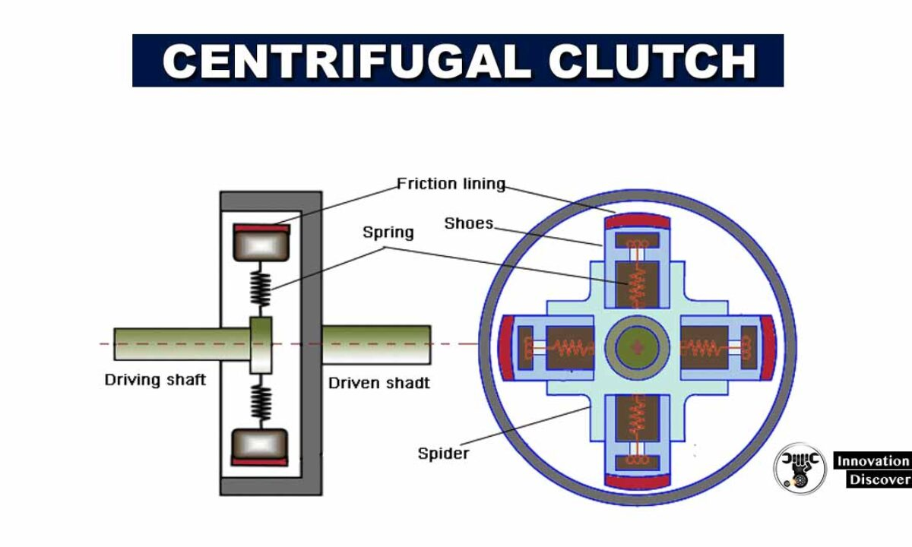

The clutch can also be used as a sort of protection for the engines as it ensures that high levels of torque are not transmitted back through the flywheel to the engine, this is crucial as extreme levels of torque transmitted back into the engine can cause irreparable damage. This can be very costly and sometimes economically unfeasible to repair, the clutch will take this potential failure and cost out of the equation, clutches themselves are not cheap but compared to the cost of an engine rebuild they are considerably cheaper.

(Centrifugal Clutch Explained – An Engineer’s Guide to a Centrifugal Clutch, n.d.)

Clutch development has accelerated this century, due to the pursuit of trying to create a clutch that is light weight, increased refinement and to maximise the torque produced even at low speeds. Vehicles have started to come away from centrifugal clutches and start to use dual mass flywheels, these were first introduced in diesels but have not been adopted for all vehicles.

Looking at the material and designs of today’s centrifugal clutches you can see there has been considerable developments in the last 100 years. Karl Benz came to the realisation that some degree of friction in the clutch would ensure a gradual and smooth take off, this provided the answer which troubled many manufactures for years. Benz developed a clutch system that used leather belts; after a small number of tests, he realised that the materials available to him would not tolerate the resultant friction and heat; due to the limited materials available to him this dampened his ambitions.

Over the years the clutch was then further developed as more friction materials became available, for years after clutches were manufactured using asbestos friction materials. While the asbestos materials were incredibly effective, scientists discovered that asbestos could cause cancer and lung disease. This then forced the national institute of health to regulate the material. Since then, synthetic aramid fibres have been developed for the use of clutches and other high friction required components, ceramics are also highly popular now within sports car.

The constant evolution of the industry and its applications has influenced friction material manufactured to keep their compositions and advancement a secret. This is done to set themselves apart from competitors and give them the edge, the introduction of ceramics allows companies to alter the structure of the ceramics which will help increase the materials efficiency and durability. The reduction of noise and increase performance have become major demands for clutch products, this is the driving force for constant development in friction resistance materials.

Centrifugal clutches are used in engine driven equipment which have a high starting inertia, they are commonly found in mobile equipment with rotating parts some of these may include:

- Vibratory plate compactors and rollers
- Go-karts
- Chainsaws
- Woodchippers/stump grinders

(Friction materials, n.d.)

There are numerous advantages of having a centrifugal clutch as part of drive systems, this first one being that they are automatic, centrifugal clutches rely on RPM and the laws of physics to automatically engage and disengage. This allows the operator to just increase of decrease the rpm and the clutch will automatically engage the drive shaft.
Centrifugal clutches are relatively in expensive compared to other types of clutch; this is due to fewer parts being involved with no need for addition of a battery or other additional parts required on some clutches.
With there being few components and the components that are present being rather cheap and easy to replace it means that the clutch has low maintenance requirements. As long as the initial design and construction of the clutch is good, there is very little chance the system will break or wear away.
When engaging with the engine heavy loads and abrupt starts put a lot of stress and torque on the engine and can cause a lot of damage, the centrifugal allows for a smooth and shockless acceleration.
Progressive engagement with the load is a lot safer and helps prolong the life of the engine and more energy is saved during the start up making it more efficient compared to other clutches.

(Advantages and Disadvantages of Centrifugal Clutches, n.d.)

Electromagnetic clutches are made up of a few main components, coil shell, an armature, rotor and a hub. The clutch works by the rotor portion getting magnetized, once the magnetic field exceeds the air gap between the rotor and armature, they engage. Then like any other clutch the frictional force generated at the contact of surface transfers the torque of the driving shaft to the driven one causing it to rotate. Once the voltage is removed from the coil it loses its magnetic field and the contact is broken. The time taken to engage comes down to a few factors, the strength of the magnetic field, inertia and the air gap in the clutch.

(Electromagnetic Clutch Applications - Pros and Cons, n.d.)

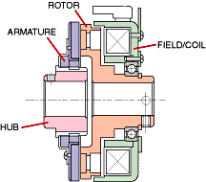

Electromagnetic clutches can be used for remote application as they do not require linkage to actuate the clutch, they are heavily used throughout automation manufacturing because of this reason, allowing operators to push a button for the clutch to engage when they are not near the machinery. These clutches are typically used in printing machinery, conveyor drives, copier machines and other factory automation.

(Mecholic: Electromagnetic Clutch Working, Applications, Advantages and Disadvantages, n.d.)

Bibliography
Advantages and Disadvantages of Centrifugal Clutches. (n.d.). Retrieved from BLM Automatic Clutch: https://www.blm-cm.com/blog/advantages-disadvantages-centrifugal-clutches/
Centrifugal Clutch Explained – An Engineer’s Guide to a Centrifugal Clutch. (n.d.). Retrieved from Lancereal: https://www.lancereal.com/centrifugal-clutch-explained/
Electromagnetic Clutch Applications - Pros and Cons. (n.d.). Retrieved from Auto Pro Tips: https://www.autoprotips.com/electromagnetic-clutch-applications/
Friction materials. (n.d.). Retrieved from https://www.frictionmaterials.com/tag/centrifugal-clutch/
Mecholic: Electromagnetic Clutch Working, Applications, Advantages and Disadvantages. (n.d.). Retrieved from Mecholic: https://www.mecholic.com/2016/01/electromagnetic-clutch-working-application-advantages.html

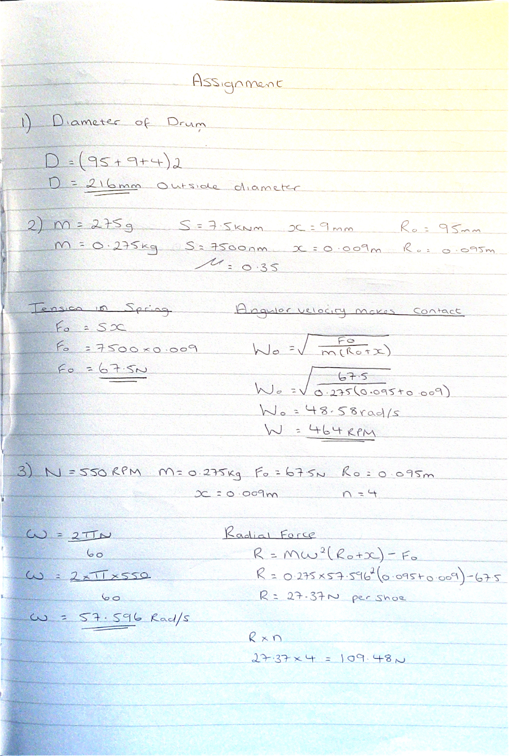

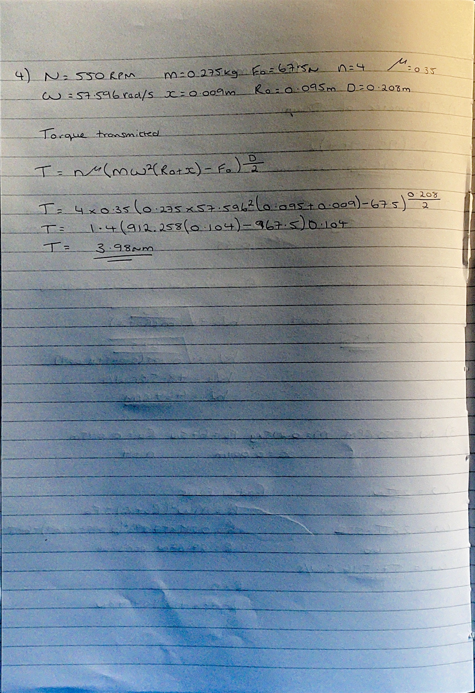

6) Changing the coefficient of the shoe material had a drastic change on the materials performance and the torque which was able to be produced. The high the coefficient of the material the greater the torque to speed driven ratio is, this is due to there being more friction and reducing the amount of slippage between the shoes and the inside of the drum. As the coefficient gets less, there is less friction and an increase in slippage that’s why the torque being produced is less than the other two.



