Please delete the box below and replace it with an “appropriate” passport style photograph that clearly shows your face. Your photo should be roughly the same size as the box:

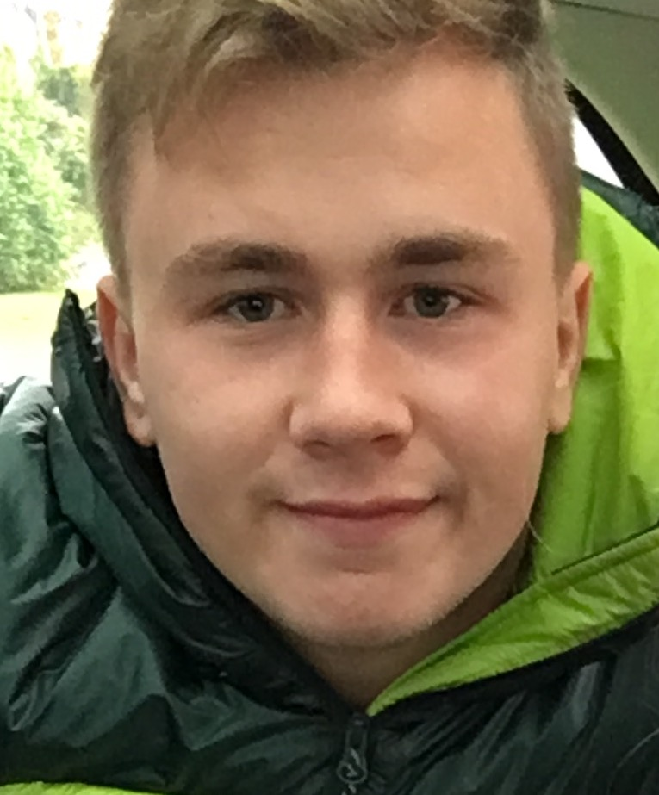

Name: Rhydian Jones

Student number: 1701731

Student email address: 1701731@student.uwtsd.ac.uk

Contact number: 07908882934

Please use the remaining space to give a brief outline of why you have chosen your course of study and any relevant special interests or experiences:

I have chosen my course because I have always had an interest in physical education and want to pursue it as a career, I also find the subject interesting as there is more than just the physical part to it for example the theory, learning about the psychological, social and physiological aspects of it. All my interests and hobbies involve some sort of sport such as football and rugby.

