

Certificate of Higher Education in
Employability Skills LEVEL 4
Module Name – BMSW4011 – Managing Enterprise
Student Name: Dorina Whittingham
Student No:2421723

Task 2: Individual presentation

Slide: Company concept
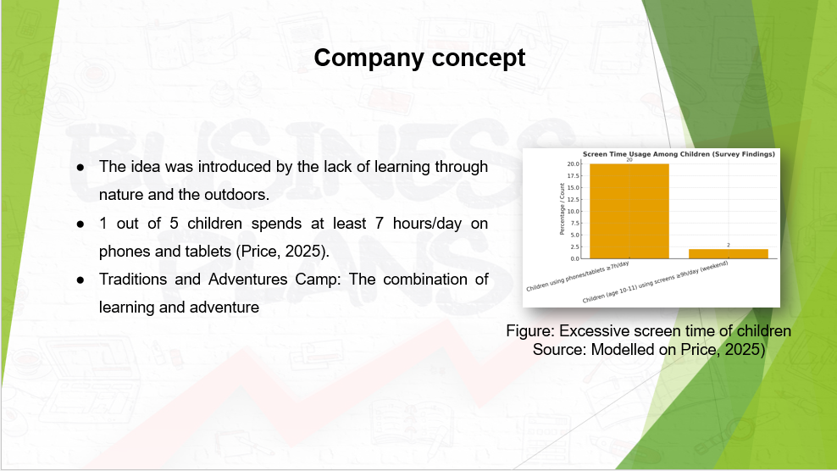
The lack of learning through the outdoors caused the idea’s formation. 20% of children spend hours utilising electronic devices (Price, 2025). The camp will provide them with a chance to consider learning in the real world. Traditions and Adventures Camp will link education with activities.

Slide: Business Overview
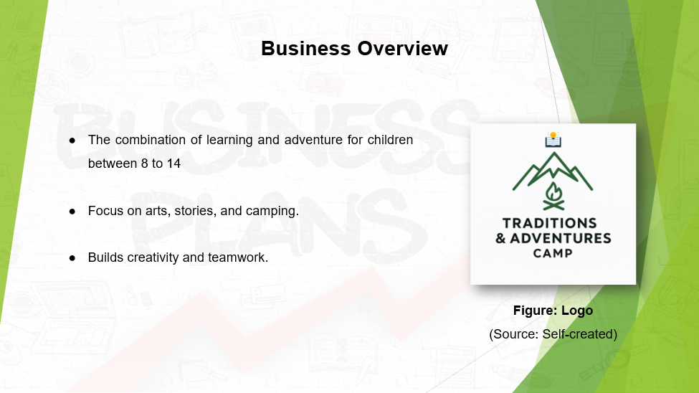
Traditions and Adventures Camp offers learning and adventure for children in the age range of 8 to 14. It considers a combination of art, storytelling, and camping. The aim is to build creativity and teamwork through nature. The mission is to link education with experiences at an outdoor level. This is required to help children to grow at a social level and at an intellectual level.

Slide: Mission, Aim, and Legal Structure
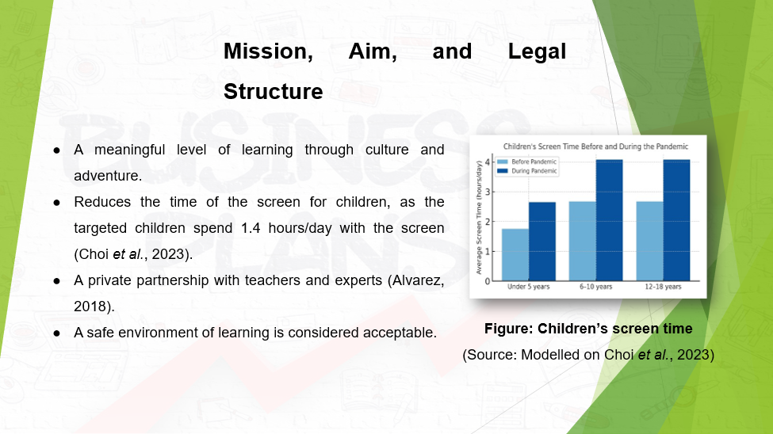
The mission is to create meaningful forms of experiences related to learning through culture and adventures in an outdoor environment for children. Children aged 6 to 10 years highlighted the largest enhancement in screen time, with 1.4 hours a day (Choi et al., 2023). The camp will operate as a private partnership between teachers and experts. The goal is to consider learning through culture and adventure in a safe environment.

Slide: Objectives and USP
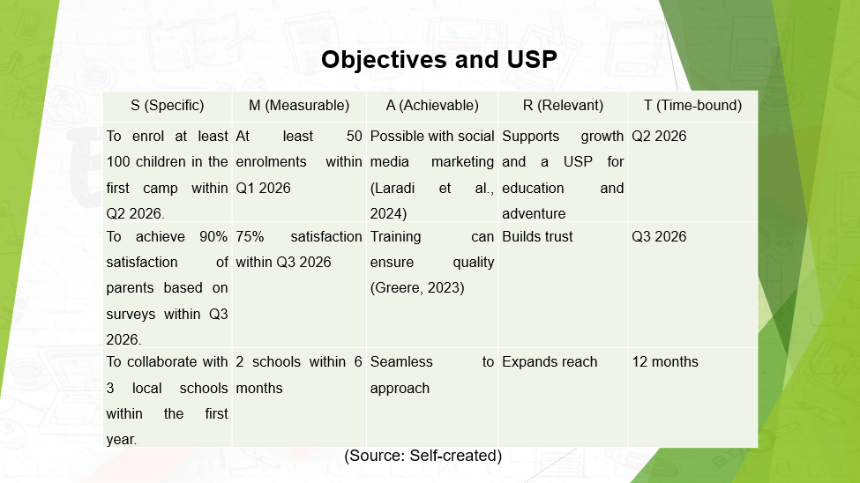
The camp targets to enroll one hundred children by Q2 2026, along with achieving 90% satisfaction of parents. The USP is considered a combination of education and adventure. Collaboration with 3 schools at the local level can enhance awareness and trust. Such a combination can create an environment for learning at an outdoor level.

Slide: Legal Identity
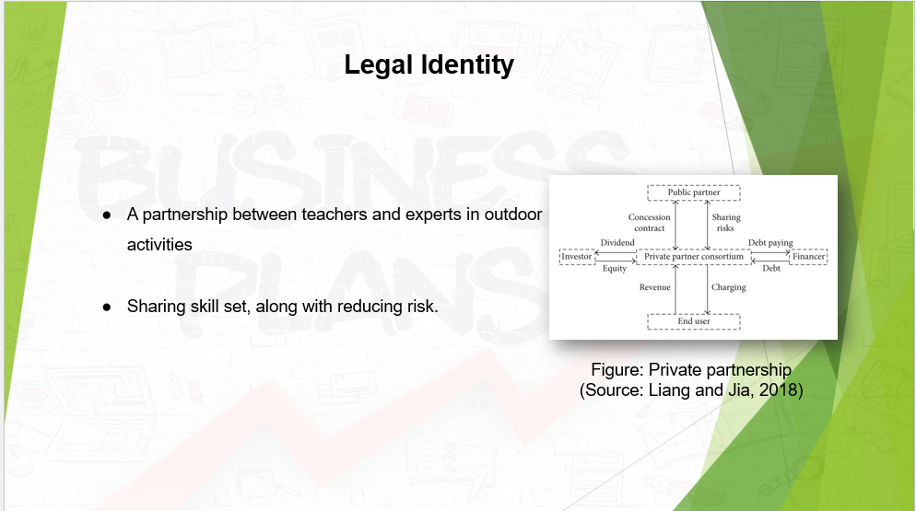
The camp will consider a partnership between teachers and experts in outdoor activities. The rationale is that it will share skill sets, along with reducing risk. The costs of running the business entity can be shared among the partners.

Slide: Target market
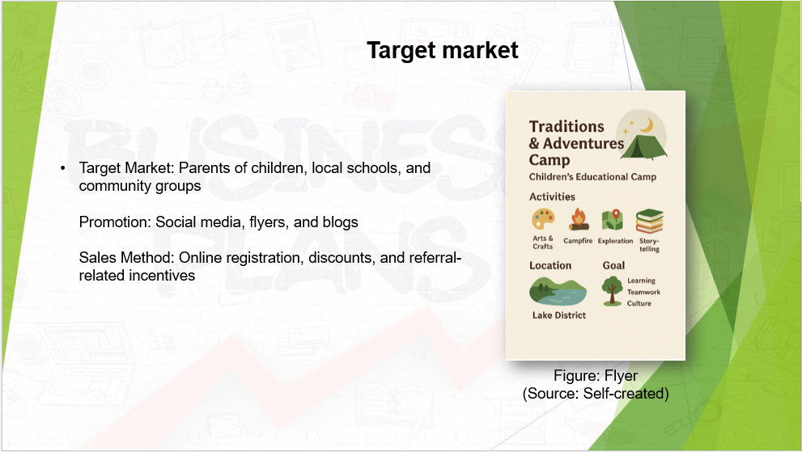
The target market is the group of parents of children aged between 8 to 14, local schools, and community-related groups. Promotion will be through posts on social media platforms such as Instagram, flyers, partnerships in schools, and engaging content. The sales method is bookings online, discounts, and incentives for referrals (Whittington et al., 2023). Word-of-mouth will be focused on for further growth.

Slide: 12-month Marketing Strategy and Branding
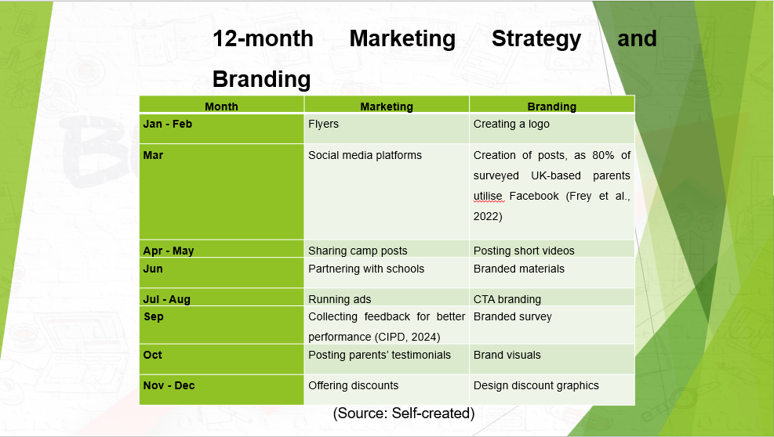
Marketing will consider social media, ads, and partnerships with several schools. Facebook was used by more than 80% of surveyed parents in the UK (Frey et al., 2022). Flyers can enhance the awareness of the brand. Branding-based activities include the creation of a logo, posts for social media, videos in a short form, and CTA-based branding. Sharing visuals of the brand and designing a discount-based graphic can be done.

Slide: Marketing Examples
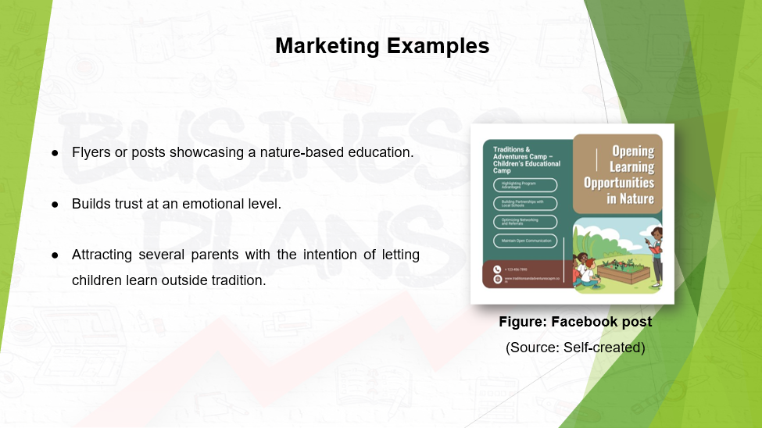
The marketing-related approach can include a flyer in a colorful form, a Facebook post for displaying an activity related to the camp and education. These instances can be considered for trust and connection in an emotional form. Such can be for attracting parents with a search for education and activities for children outdoors.

Slide: Elevator Pitch – Idea
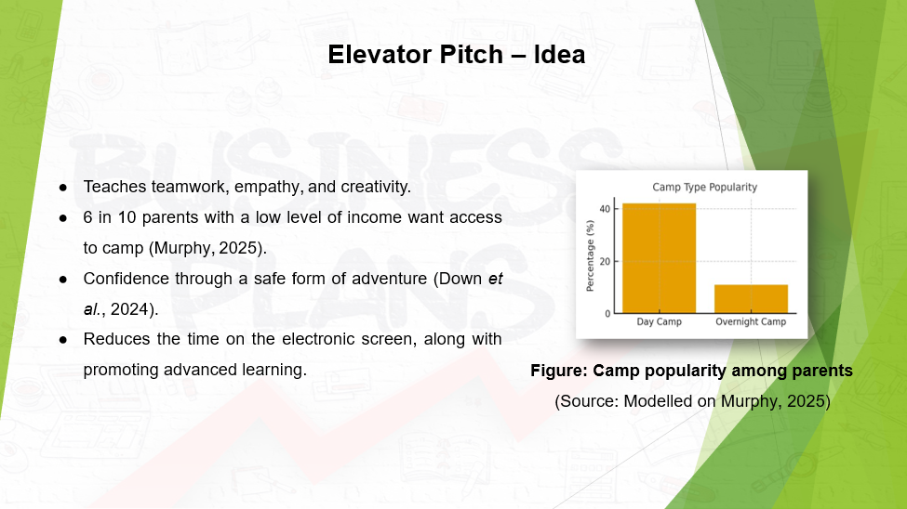
Traditions and Adventures Camp endeavors to provide education at the local level. It will teach teamwork, empathy, and creativity in a major way. More than 6 out of 10 parents with a low level of income surveyed in 2024 wanted their children to have an experience related to camp (Murphy, 2025). The camp will foster the confidence of children through adventure. It is considered a major solution to cope with the challenges related to screen time.

Slide: Elevator Pitch – Investment Appeal
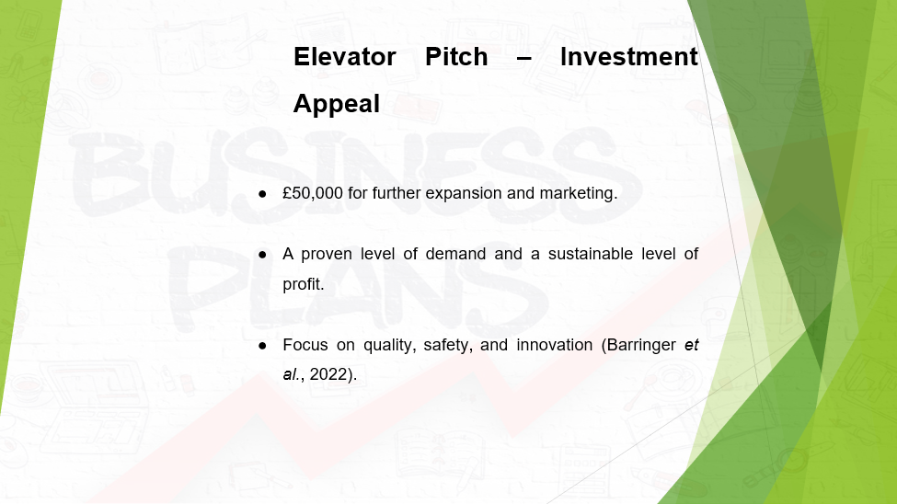
An investment of 50,000 pounds will expand facilities, marketing, and equipment. The business has showcased demand and a sustainable level of profit. I am committed to quality, safety, and innovation. Supporting this camp indicates the promotion of growth at the social level, the value of education, and care for the environment.

Slide: Physical location
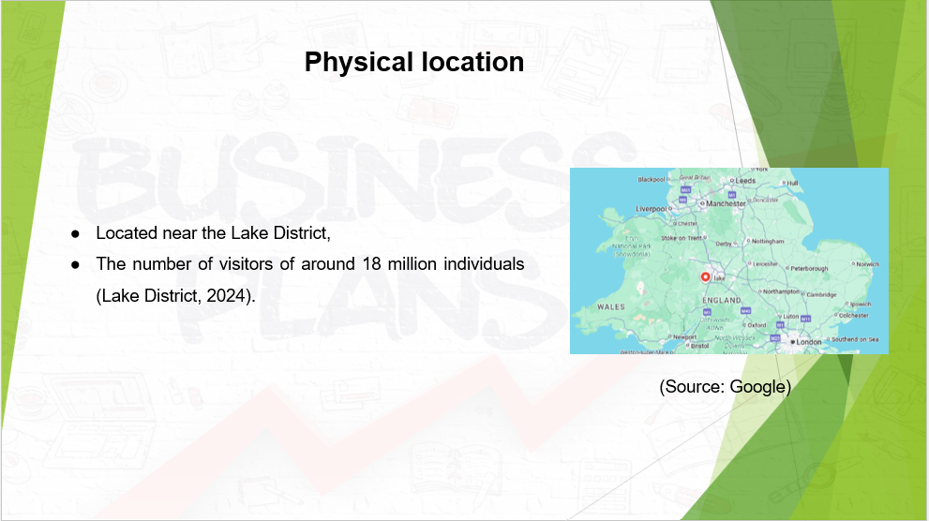
The camp will be considered near the Lake District in the UK. The area attracts around millions of visitors each year (Lake District, 2024). The camp will have tents,
classrooms, and areas for tasks and learning related to both groups and cultures.

Slide: Human resources strategy
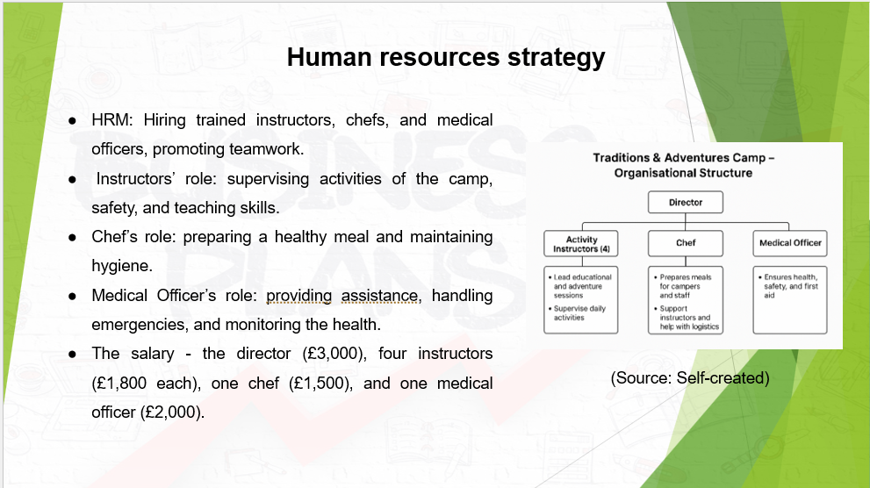
The camp will have one director, four instructors of activity, one chef, and one medical officer. A trained set of instructors will guide a set of activities, considering safety. The chef will prepare a set of healthy meals, along with maintaining hygiene. The medical officer will provide first aid, tackle emergencies, and monitor the health of each individual. Staff will be hired through a job board. Safety will be a priority (Whittington et al., 2020). Salaries will be as per position and responsibilities.

Slide: Sources of Finance
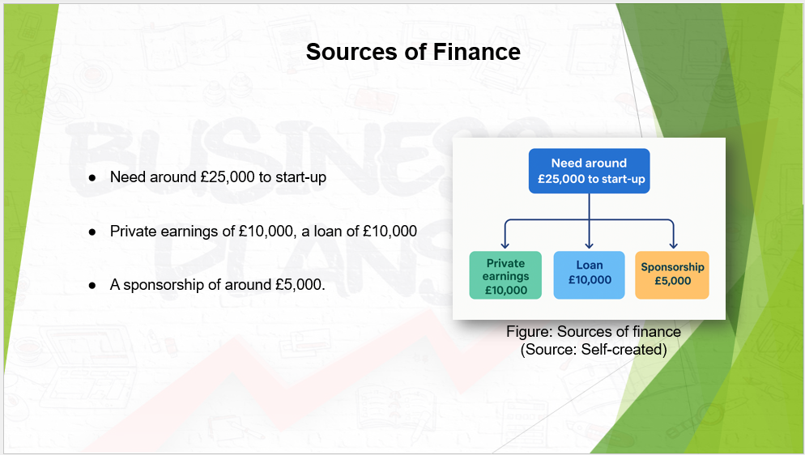
A total of £25,000 will be required as funds. The business will consider private earnings of £10,000, a loan of £10,000, and a sponsorship of around £5,000. Local sponsorships will be considered. Scalability will be considered as per raising funds in the future.

Slide: Cash flow forecast
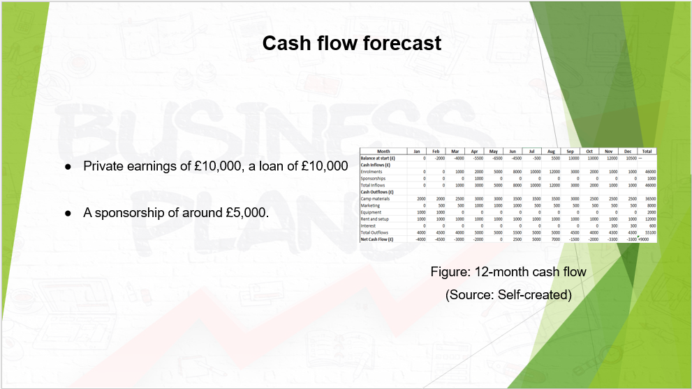
The financial forecast is realistic and feasible. It has displayed the growth of enrolment, a controllable cost, and a positive balance of cash flow, £9,000. This can cause financial stability and growth in a sustainable way.

Slide: SWOT analysis
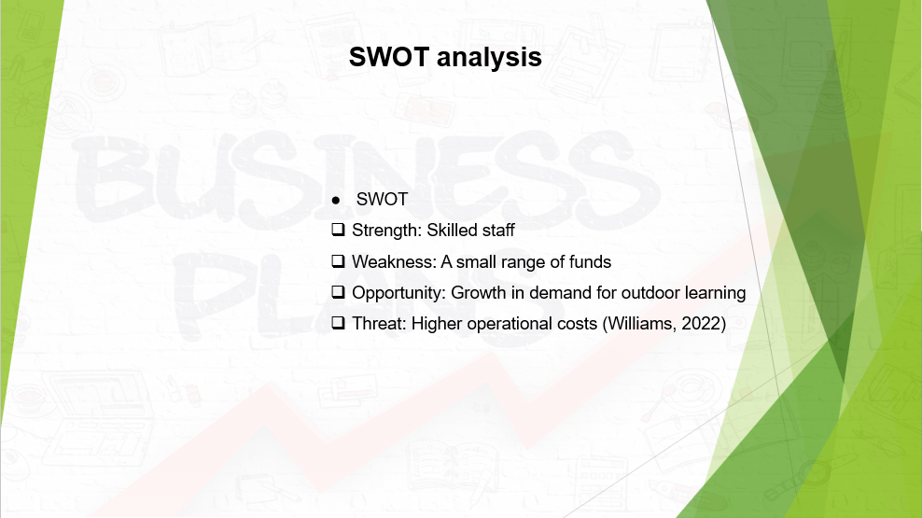
The SWOT analysis displays a skilled set of staff as a core strength. However, a small range of funds is considered a weakness. The growth of demand for outdoor learning can be an opportunity. On the other hand, a high level of operational costs is considered a threat.

References
- Alvarez, S.A., 2018. What Entrepreneurs Need to Know Before They Start [Video]. London: Henry Stewart Talks Ltd. Duration: 30 min 05 sec.
- Barringer, B.R. and Ireland, R.D., 2022. Entrepreneurship: Successfully Launching New Ventures. Updated 6th ed., Global ed. Harlow: Pearson.
- Choi, E.J., King, G.K. and Duerden, E.G., 2023. Screen time in children and youth during the pandemic: a systematic review and meta-analysis. Global Pediatrics, 6, p.100080.
- Choi, E.J., King, G.K. and Duerden, E.G., 2023. Screen time in children and youth during the pandemic: a systematic review and meta-analysis. Global Pediatrics, 6, p.100080.
- CIPD, 2024. Improving feedback to improve performance. Available at: https://www.cipd.org/en/knowledge/bitesize-research/improving-feedback/ (Accessed: 30 October 2025).
- Down, M.J., Picknoll, D., Edwards, T., Farringdon, F., Hoyne, G., Piggott, B. and Murphy, M.C., 2024. Outdoor adventure education for adolescent social and emotional wellbeing: A systematic review and meta-analysis. Journal of Adventure Education and Outdoor Learning, pp.1-30.
- Frey, E., Bonfiglioli, C., Brunner, M. and Frawley, J., 2022. Parents’ use of social media as a health information source for their children: a scoping review. Academic Pediatrics, 22(4), pp.526-539.
- Greere, A., 2023. Training for quality assurance in higher education: practical insights for effective design and successful delivery. Quality in Higher Education, 29(2), pp.165-191.
- Lake District, 2024. Lake District facts and figures. Available at: https://www.lakedistrict.gov.uk/learning/factsandfigures (Accessed: 29 October 2025).
- Laradi, S., Elfekair, A., Alrawad, M., Hashim, M. and Derouez, F., 2024. Leveraging capabilities of social media marketing for business success. Computers in Human Behavior Reports, 16, p.100524.
- Liang, Y. and Jia, H., 2018. Key success indicators for PPP projects: evidence from Hong Kong. Advances in Civil Engineering, 2018(1), p.9576496.
- Murphy, S., 2025. Summer camp scramble: US families need it, but it can cost as much as a month’s rent. The Guardian, 16 July. Available at: https://www.theguardian.com/us-news/2025/jul/16/summer-camp-childcare-cost (Accessed: 31 October 2025).
- Price, B., 2025. Children in Wales using screens for more than seven hours a day, BBC News. BBC. Available at: https://www.bbc.com/news/articles/cx2gljvdgp3o (Accessed: 29 October 2025).
- Whittington, R., Regnér, P., Angwin, D., Johnson, G. and Scholes, K., 2020. Exploring Strategy: Text and Cases. 12th ed. Harlow: Pearson.
- Whittington, R., Regnér, P., Angwin, D., Johnson, G. and Scholes, K., 2023. Exploring Strategy: Text and Cases. 13th ed. Harlow: Pearson.
- Williams, S., 2022. The Financial Times Guide to Business Start Up 2021/2023: The Most Comprehensive Guide for Entrepreneurs. 32nd ed. Harlow: Pearson.

