The Home of 2030- Reflective Report

Back in January of this year we took a trip to Bay campus to meet Joanna Clarke, head of design for the Active Building Centre, who gave us a tour of the award winning Active Classroom. The tour included: showing us the living wall on the outside of the classroom, the solar wall, the charging stations for the electric cars on campus, and a few other things. One of these was the active office where live tv screens displayed the electricity usage within the building. Joanna introduced us to the ‘Home of 2030’ young persons design challenge, which is a competition that invites people to design a green home fitting the needs of the future. Following this we were given a brief, design guide and a booklet with information on the active classroom to aid us throughout the project.
Once we decided our groups we made sure to read through the material that we had been given to fully understand what we had to do. Similarly to the last project, I made sure to do my own research to make sure I could be as helpful as possible to the process. A resource that I found particularly useful was the design guide, as it highlighted 6 key principles when designing an active building. Each chapter has a plethora of information from energy storage to specialised materials. The sub section on biodiversity was a great read for me as it highlighted the importance of the use of green spaces. I originally wanted to focus the design for the house around this idea, but when consulting with the group we decided to centralise our design around something to combat flood risks. With the countless storms hitting the country causing devastation and forcing many people out of their homes, we thought it was vital to design a house that could withstand such circumstances.
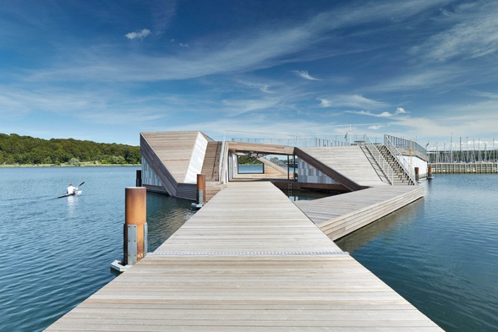
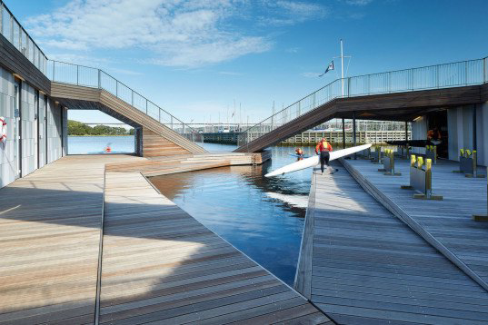
Once we decided on the main concept we did some research on pre-existing floating buildings for inspiration. We found a floating kayak club by Force4architects (Force4, n.d).
Force4 Architects Kayak club ( S.Aagaard, 2015)
Not only does the design allow optimal use for the club as it is right on the water, but it also shows that even a building that is floating in water can be artistic and elegant. Following this inspiration we knew we wanted to do the same with ours, making it functional and practical but also aesthetically pleasing.
We each had designs for the house but couldn’t come to an agreement on which was the most appropriate. One session Joanna came around talking to everyone and noticed Steffan’s design for the studio project and said that it would be a good idea for the competition. Joanna likened it to an existing project, the HiveHaus (HiveHaus.co.uk n.d), which is a modular pod design with interchangeable surfaces creating a compact but comfortable structure.
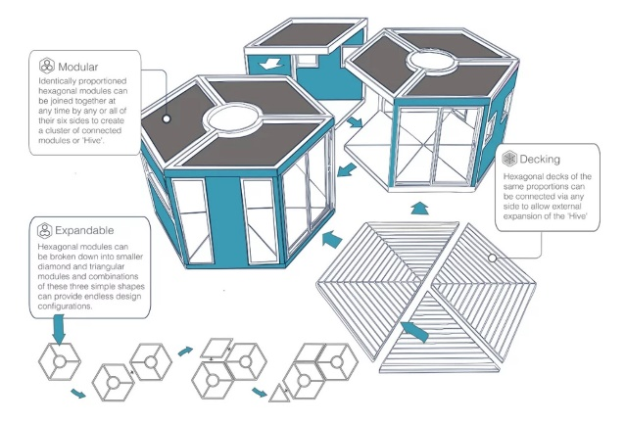

Diagram of the HiveHaus (HiveHaus.co.uk, n.d)

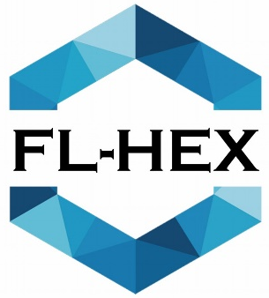
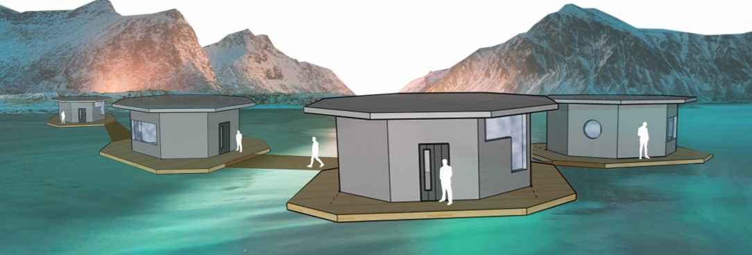
From Joanna’s advice we began to form our design, with Steffan’s base idea. We adapted it so that it could form communities with linking walkways. The idea of forming a neighbourhood was important, people don’t want to be isolated, a loan house floating on water doesn’t have as much appeal as a community of houses would.

Our community design and logo (2020)
After talking to Joanna and Ian further about the project; the name Fl-Hex was created based on the designs of flexible living spaces and the hexagon shape. We later realised that the shape was not a hexagon but was in fact an octagon, but we kept the name despite the hilarious oversight.
Now that we had the design nailed down we had to figure out how it would float and how it would combat floods. The house would be anchored to mooring posts to prevent the house from floating away, and would have a hollow concrete frame so that it acts as a ship’s hull, making it float. Along with the interchangeable living arrangements we decided to add the option to make the house two storeys to accommodate larger families. This design idea was key as the population is growing and the need for more housing is rapid. For the sustainable elements of the house we decided it would have a solar panelled roof and it would feature both water and wind turbines, making use of the surrounding environment.
We finally had all of our ideas together so all that was left to do was put it into presentation format. I worked on some 3D sketches of the house and then we used photoshop to create the boards. This part was easy with Aneurin’s photoshop skills and his key eye for design aesthetic. The finished product looked professional and realistic, we were all pleased with the result and proud of our work. After submitting and meeting the deadline for the competition the final step was to present our boards to Joanna. I personally didn’t say anything during the presentation as the boys knows that I get flustered and stumble on my words, despite this the boys gave a confident and professional presentation. We even had a picture together which I thought was a nice final touch to the project.
Overall I feel that I have learnt a lot throughout this project. In my previous reflective essay I mentioned that group work isn’t my forte. However, from working on another project with my course mates I have learnt a lot more about teamwork and I think I am becoming more accustomed to working with others. I have also learnt more about active buildings, I knew of them before but nothing in depth. Joanna’s design guide gave me so much important information that I am planning to take forward to future projects. While doing projects like this you complain about the workload and wonder why you need to do it, but in the end you realise that everything you have learnt in the process is building up your knowledge and skills set that you can transfer into new challenges.

Bibliography-

Aagaard, S., 2015. The Floating Kayak Club. [image] Available at: <https://www.archdaily.com/777503/the-floating-kayak-club-force4-architects> [Accessed 12 March 2020].

Force4. 2015. Force4. [online] Available at: <http://force4.dk/> [Accessed 12 March 2020].

Hivehaus.co.uk 2018. Diagram Of Hivehaus. [image] Available at: <https://www.hivehaus.co.uk/> [Accessed 12 March 2020].

Hivehaus.co.uk. 2018. [online] Available at: <https://www.hivehaus.co.uk/> [Accessed 12 March 2020].

