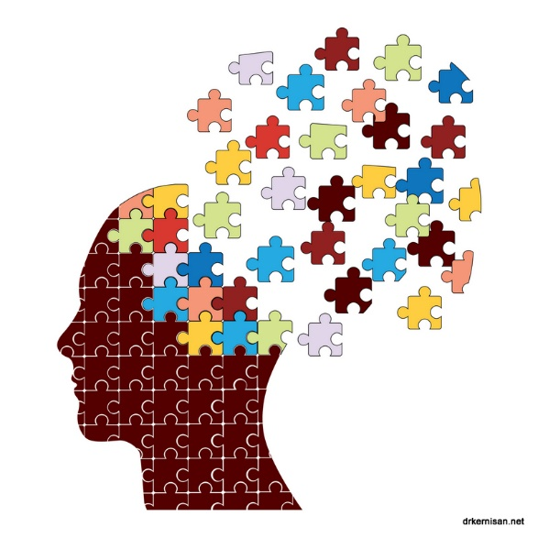
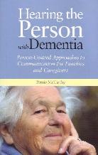
Specialised Care:
Working with Dementia.
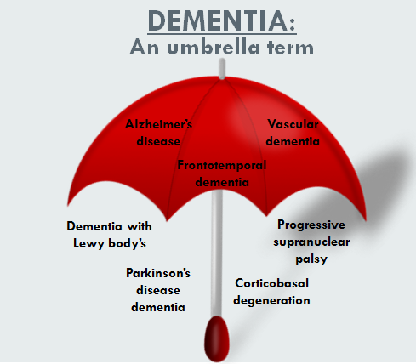
Assignment Two.
Tracy Howells – 1703054.
DipHE Nursing Studies Carmarthen April 2019.
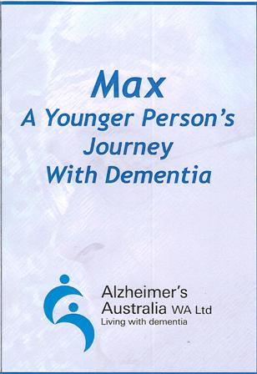
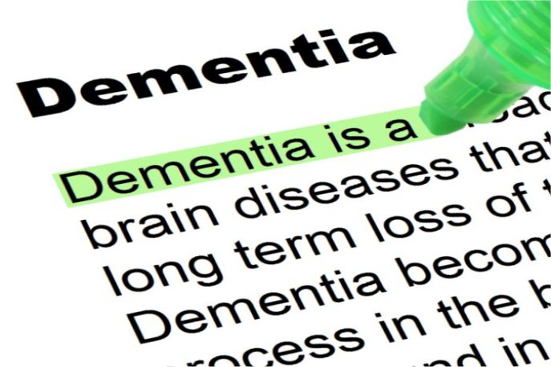

2. Contents List.

- Title Page.
- Contents List.
- Abstract.
- Introduction.
- Discussion.
5(a) Analysis and comparison of peer support and admiral nurses.
5(b) analysis of the Impact of peer support and admiral nurses on those coping with dementia.
- Conclusion.
- Recommendations.
- Reference List.
- Appendix.
Appendix A – Brain map.
Appendix B – Table of Resources.
Appendix C - WEB LINKS.

3. ABSTRACT.
With people living longer, the likelihood of the older population requiring dementia care is inevitable. Whilst dementia is not just an older person’s disease, a higher percentage of the population within the United Kingdom who have been diagnosed with dementia are aged over 70 years old. With the probability of a rise in future diagnosis, the government accepts that there will be a rise in the cost of providing dementia care, which is a major economic concern. The aim of this report is to evaluate the most popular available support and resources and to assess which has not only been the most cost effective but the most enriching to the lives of those coping with dementia. Whilst many resources seem to be web based, the two subjects currently referred to in journals and the media; are Admiral Nurses and Peer Support. From research it is evident that both have their important roles to play in the diagnosis and treatment of dementia however, the most cost effective and enriching is peer support. This report therefore concludes that peer support requires more investigation, investment and sign posting as the way forward for the future of dementia care. A mutually beneficial scheme for the individual, the economy and the community at large.
4. INTRODUCTION.
One of the main challenges facing the National Health Service (NHS) in the United Kingdom (UK) over the next 20 years will be to ensure the provision of a highly skilled workforce in all aspects of dementia care. The UK has a population that is living longer and therefore it is anticipated that the number of older people requiring dementia care will rise exponentially. Alzheimer’s Society (2007) acknowledge that the financial implications of caring with an ageing population with dementia is a political issue, however, can provide evidence that standards of dementia care must be improved, standardised and monitored. The National Dementia Strategy (2009) was brought in by the Department of Health to do just that, not only to provide strategies for training staff but for educating everyone. Alzheimer’s Disease International (2012) state that although there is greater public awareness of the word dementia many people do not know anything regarding its epidemiology or aetiology, in a poll 85% did not realise that the disease affected the brain. Appendix A provides further information on the types of dementia, the areas of the brain they affect and likely symptoms that follow. Alzheimer’s Disease International (2012) further states that this lack of clarity and understanding allows for inaccurate assumptions about the disease and its effects to continue; thus, perpetuating negative images of the condition, social exclusion and maintains societies inability to accept those who are coping with dementia. Holden and Woods (1995) supports this view and goes further to state that therapists and nurses working in the field of dementia need a positive approach to dementia care thus to promote a better understanding to the public.
5. DISCUSSION.
A diagnosis of dementia can be daunting and raises many questions about the future. Asking for help can feel particularly difficult for an individual especially if they have always been independent however it can be useful to know that a wide range of information and support is available to help them live well and stay independent for as long as possible. Appendix B shows a table of the organisations, resources and support available, albeit the list may vary depending on the covering health board. It is clear from the list that most of the support available comes from Charities. Other tangible resources include Peer Support and Admiral Nurses. This report will focus on two sources of support namely informal care through peer support and formal care via Admiral Nurses.
5(a). ANALYSIS AND COMPARISON OF PEER SUPPORT AND ADMIRAL NURSES.
PEER SUPPORT. Firstly; the term peer needs clarification as to the meaning applied to it in this report. Peer support is given by individuals who have had the same or similar diagnosis or coped with someone who has and is rooted in a commonality of experience. These individuals could be neighbours, friends, volunteers or charity workers. Keyes et. al. (2014) supports this view and goes further to acknowledge that this type of support is an excellent way of providing practical, social and emotional support to those coping with dementia. The HM Government (2012) shares this view and refers to it as a conscious shift from “advice on high to support next door” naturally seeing it as the way forward to reduce the financial burden on the government purse strings as the cost of caring for someone with dementia rises. Having alluded to this it is fair to say that peer support has its place whether paid for or given by volunteers, friends or neighbours. Usher et. al. (2006), Chien and Normal (2009) and Fisher et. al. (2012) all provide evidence of peer support helping those diagnosed with cancer, mental health and diabetes. Keyes et. al. (2014) alludes to peer support as having positive impacts on social inclusion as those who cope with dementia feel isolated and marginalised. A view shared by MacKean and Abbott-Chapman (2012) who adds that peer support can quickly identify and prevent an individuals potential crisis and sign post them to avenues for help earlier on; for example; for counselling, other support groups and reconnecting with health care professionals for medication and care package reviews. They further report that peer support assists with feelings of loneliness, isolation, loss and struggle; providing those who cope with dementia a sense of belonging, friendship and understanding as well as practical help with attending appointments, support group access, going on days out, shopping; all the things that contribute to a normal life, as well as respite for carers who need time for themselves to recharge.
ADMIRAL NURSES. When things get challenging or difficult for people with dementia and their families, Admiral Nurses work alongside them giving one to one support, expert guidance and practical solutions. Those coping with dementia from time to time need the unique dementia expertise and experience of NHS Professionals; who extend a lifeline helping everyone in the family to live more positively with dementia in the present with more confidence and less fear. Dementia UK (2018) and The Royal British Legion (2018) promote the use of Admiral Nurses, whilst the NHS seem to be a little behind the times when appointing trust employed Admiral Nurses; a view shared by the Nursing Times (2017). NHS Wales (2018) describe the role of a trust appointed Admiral Nurse as improving communication between the patient, family and clinical staff in acute hospital settings. They further state that these nurses anticipate the additional complications dementia can present for a patient and work with other clinical staff to offer the best care for that individual and their family. They also provide support for clinical staff and nurses who provide care to those with dementia in hospital. The Royal British Legion describes Admiral Nurses as being able to provide skilled assessments to determine the needs of family, carers and the person with dementia, provide information and practical advice on supporting those with dementia, able to provide emotional and psychological support throughout the caring journey, advise on how to care for someone with dementia, help to develop people’s skills to encourage positive approaches to living with dementia and work with other professionals and organisations to provide additional support where needed.
THE COMPARISON. To compare the two sources of support available to those coping with dementia, the services provided by the health board are limited in time, money and availability. They tend to influence the stay and treatment in hospital of those with dementia; often facilitating in communication, care package development and expedite discharge; a view purported by NHS Wales (2018). The Royal British Legon (2018) state that charitable lead Admiral Nurses see those coping with dementia in their own homes and easier to contact for advice out of hours. They further state that there are more nurses employed by charities than the NHS, thus can be accessed more readily.
In relation to peer support, Keyes et. al. (2014) stated that the supportive atmosphere within the groups had a positive impact on reducing isolation, sharing of information and advice leading to increased support in maintaining and improving memory. Clare, Rowlands and Quinn (2008) supports peer lead treatment and states that the service provided intensive one-to-one therapy in an environment that best suits the individual, it is not time bound and easily accessible, compared to health board run schemes. They go onto add that through the sharing of coping strategies allowed those with dementia to gain control, find new and valued roles within the family and create new communities; shifting from passive patients to active patients.
5(b). ANALYSIS OF THE Impact of peer support and admiral nurses on those coping with DEMENTIA.
Zimmerman et. al. (2005) acknowledge that caring for and supporting someone with dementia can be stressful and at times upsetting. This is a view shared by Garand et. al. (2005) who go onto state that it is important that care givers look after their own health and well-being and turn to others for support when need. The further suggest that how people care for the person diagnosed with dementia will always come naturally, often loved ones know the individual best so professionals should not underestimate the value they bring to their care package; it is important to continue to see the person and not just their dementia. Keyes et. al. (2014) adds that the disease will at some point affect a person’s ability to communicate and in most types of dementia people will struggle to find the right words or follow a conversation. This can be upsetting and frustrating for both the carer and the person with dementia. They may also start to behave differently from how they used to; and some behaviours can be particularly unusual or challenging. Whether you are a health care professional or informal carer such as family, friend, neighbour or charity support worker help is there to support and guide them also. NHS Wales (2018) suggest that Admiral Nurses can facilitate diagnosis, assist with care packages, provide information regarding the type of disease and its effects giving those coping with dementia all the necessary information to empower them to reach informed decisions about their care. NHS Wales (2018) provide the medical support and information regarding the dementia diagnosis, however at some point the individuals go home. This is where Keyes et. al. (2014) first advocated peer support and provides evidence of how this type of support impacts on the lives of those left to cope with the disease. The evidence put forward is supported by the Healthbridge Study (2010). Keyes et. al. (2014), using six headings detail the positive impact that peer support had on those coping with dementia namely:-
Commonality of experience – patients and carers reported about the support that emerged from being able to identify with others who were in the same or similar situation. It made participants feel included, valued and wished to interact.
Reciprocity – participants recounted the feelings of isolation and loneliness shifting to knowing that they were not alone in their diagnosis or experience and feelings of community inclusion. Individuals felt they could exchange information to better everyone thus finding a new valued role in life.
Social and emotional impacts – individuals referred to the positive impact and quality of the relationships made within the peer group. The space to be themselves, the understanding of their individual experience of the disease without fear of ridicule had an immense impact. Many maintained their sense of humour and independence as they were encouraged to do the things they still enjoyed and focused on the tasks they could do feeling a rise in self-esteem and self-worth.
Direct Experience – the pooling of resources helped people to develop their own coping strategies.
Enabling – participants and their families reported gaining in confidence and willing to interact socially, talk to strangers on the bus, go out and about, walk their dogs, things they would not have thought about doing before.
Quality of peer relationships – those coping with dementia eluded to the difference between the relationships they had with Health Care professionals and the group. The peer group came out on top. The reasons given for this are that whilst the professionals many individuals encountered were nice, had everything at their fingertips and came up with ideas to help cope with dementia, they did not appear to be very empathic as they were not in the same position as the patients found themselves in. Participants went onto say that the peer group were down to earth, real people from all walks of life, who were described as having been there and that they were more likely to listen to a peer group member and follow their advice than that of a professional who had probably repeated the same advice to every single person they saw in the clinic that day.
Keyes et. al. (2014) deduced that peer support had the most impact on peoples living with dementia, and everybody who engaged saw an improvement in their day to day lives. The Department of Health (2010) supports this finding and acknowledged that NHS professionals whilst having all the necessary knowledge at their fingertips, may not be in the same position as those they advise and therefore may not come across as understanding or empathic. This is a view strenuously supported by Clarke et. al. (2013) who furthers that peer support should form a large part in the governments dementia strategy for 2015 and beyond. Hartley (2002) suggested that working together with peer support to help those coping with dementia was the way forward and foretold the potential positive benefits that could be attained, eight years before the Healthbridge Study in 2010. Fung and Chien (2002) supports Hartley (2002) and suggests that peer support is not a new idea and that not everyone needs a degree to help someone but the common sense they were born with and their life experiences.
6. CONCLUSION.
Whilst it is important that individuals have input from a qualified health care professional in relation to diagnosing dementia, so that the right treatment plan can be discussed, and information given as to the type; thereafter any support required can come from other sources. Medical intervention has its place for when the condition progresses towards end of life care, drug intervention or nursing care. In the interim those coping with dementia should not be defined or become the disease, those involved can still have an assemblance of a normal life albeit in ways that are different from those envisaged prior to diagnosis.
Peer support was appreciated by people with dementia who took part in the Healthbridge Study (2010). Participants described it as a meaningful and enriching form of support and would recommend it to others. Peer support enables those coping with dementia to find fulfilment in daily tasks, feel empowered to join in, in the community in which they live, be confident in who they are and accept the diagnosis without becoming the disease.
Peer support is the way forward for the future care of those diagnosed with dementia, reducing cost to the NHS and providing education to the public at large and irradiating stereotypical views of the disease.
Appendix C provides a list of web inks should the reader wish to research the subject further.
7. RECOMMENDATIONS.
i) Promotion of peer group support across the county.
ii) Education programmes for schools regarding dementia.
iii) Bring all dementia related services under one roof within community hubs.
iv) Improve training for Health Care Professionals including formal and informal carers, whether in acute hospital settings, nursing homes, community, general practice or in volunteer services. The training for staff is not detailed enough.
v) Introduce peer support earlier on in the diagnosis of dementia to help individuals live well for longer.
vi) Encourage the shift from passive patient to active patient.
vii) Local governments to encourage businesses not only to provide disabled access but make properties more dementia friendly where possible.
viii) Improve wider public knowledge on dementia.
Viiii) Improve supply and access to support mechanisms for those who work with or look after those with dementia. Increase number of Admiral Nurses both within hospital and community settings.
x) Engage with those coping with dementia when developing or reviewing strategies and policies. Get it right first time.
8. REFERENCE LIST.
Alzheimer’s Disease International (2012) World Alzheimer Report 2012: Overcoming the stigma of dementia. London: Alzheimer’s Disease International 2012.
Alzheimer’s Society (2007) Dementia UK: The Full Report. London: Alzheimer’s Society 2007.
Chien, W. and Norman, I. (2009) Review: The effectiveness and active ingredients of mutual support groups or family care givers of people with psychotic disorders. International Journal of Nursing Studies, 46, 1604-1623.
Clare L., Rowlands, J., and Quinn, R., (2008) Collective strength: the impact of developing a shared social identity in early-stage dementia. Dementia, 7: 9-30.
Clarke, C. L., Keyes, S. E., Wilkinson, H., Alexjuk, J., Wilcockson, J., Robinson, L., and Cattan, M., (2013) Healthbridge: The National Evaluation of Peer Support Networks and Dementia Advisors in implementation of the National Dementia Strategy for England. A Department of Health Policy Research Programme Project Ref:025/058. London: Department of Health 2013.
Dementia UK (2018) How can an Admiral Nurse help? Available at: https://www.dementiauk.org/get-support/admiral-nursing. [Accessed 1 April 2019].
Department of Health (2009) Living well with dementia: A National Dementia Strategy. London Department of Health 2009.
Department of Health (2010) Putting people first: Planning together – peer support and self-directed support. London Department of Health 2010.
Fisher, E. B., Boothroyd, R. I., Coufal, M., Baumann, L. C., Mbanya, J., Rotheram-Borus, M., and Tansgugarn, C., (2012) Peer support for self-management of diabetes improved outcomes in international settings. Health Affairs: 31, 130-139.
Fung, W., and Chien, W. (2002) The effectiveness of a mutual support group for family caregivers of a relative with dementia. Archives of Psychiatric Nursing: 16, 134-144.
Garand, L., Dew, M. A., Eazor, L. R., Dekosky, S. T., and Reynolds III, C. F., (2005) Caregiving burden and psychiatric morbidity in spouses of persons with mild cognitive impairment. International Journal of geriatric Psychiatry, 20(6): 512-522.
Hartley, B. E., (2002) Stepping Forward: Working together through peer support. London: National Children’s Bureau Enterprises Ltd.
Healthbridge Study (2010) The National Evaluation of Peer Support Networks and Dementia Advisers in implementation of the National Dementia Strategy for England. Department of Health Policy Research Programme [Ref: 025/0058]
HM Government (2012) Caring for our future: vision for 2015. London: TSO.
Holden, U. and Woods, R. T. (1995) Positive Approaches to Dementia. Edinburgh: Churchill Livingston, 1995.
Keyes, S., Clarke, C., Wilkinson, H., Alexjuk, E., Wilcockson, J., Robinson, L., Reynolds, J., McClellands, S., Corner, L., Cotton, M. (2014) “We’re all thrown in the same boat”: A qualitative analysis of peer support in dementia care. Dementia Journal Vol. 15(4) 560-577. London: SAGE Publications 2014.
MacKean, R., and Abbott-Chapman, J., (2012) Older people’s perceived health and wellbeing: the contribution of peer-run community -based organisations. Health Sociology review, 21, 47-57.
NHS Wales (2018) Dementia Care. Available at: https://www.nhs.uk/conditions/dementia/social-services-and-the-nhs. [Accessed 12 April 2019).
Nursing Times (2017). First Admiral Specialist Nurse for Essex. Available at: https://www.nursingtimes.net/news/hospital/first-admiral-specialist-dementia-nurse-appointed-for-essex. [Accessed 12 April 2019].
The Royal British Legion (2018) Admiral Nurses. Available at: https://www.britishlegion.org.uk/get-support/care/admiral-nurses. [Accessed 10 April 2019].
Ussher, J., Kirsten, L., Butlow, P., and Sandoval, M., (2006) What do cancer support groups provide which other supportive relationships do not? The experience of peer support groups for people with cancer. Social Science and Medicine, 62, 2565-2576.
Zimmerman, S., Williams, C. S., Reed, P. S., Boustani, M., Preisser, J. S., and Heck, E., (2005) Attitudes, stress and satisfaction of staff who care for residents with dementia. The Gerontologist, 45(1): 96-105.

Lewy Body and Parkinson’s affects the functions of the motor cortex and cerebellum
Vascular Dementia affects blood supply around the brain.
Alzheimer’s affects functions in the
Frontal lobe
Temporal lobe
Brain Stem
Hypocampus
Parietal lobe
TOUCH AND PRESSURE
TASTE

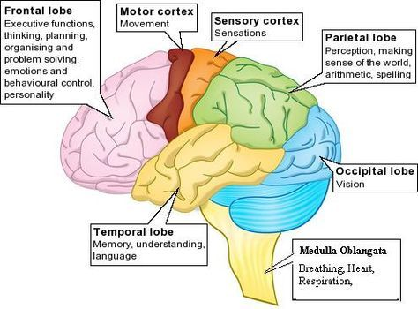
APPENDIX A –
BRAIN MAP
Pons
Huntington’s affects functions in the
Motor cortex
Temporal lobe.
Frontotemporal dementia effects Frontal Lobe functions
Spinal Cord
SMELL
HEARING
FACIAL RECOGNITION
SPEECH AREA
Cerebellum
Controls muscle co-ordination and balance.

Alcoholic dementia affects all brain functions, depletion of vitamin B means the brain cannot function properly and leads to memory loss
Boxers/Concussion dementia affects frontal and temporal lobe functions changing behaviour and causing memory loss.

Appendix B – Table of Resources.

Below is a table showing the resources and support available for those diagnosed with or coping with dementia. They include:-

Resource. | Support available.
NHS/GP | Diagnosis. Care Planning. Exploration of care options. Admiral Nurses.  Medication requirements. Day Centres. Dementia Help books on prescription. Community Nurses. Dieticians. Occupational therapists. Hospital admissions.
Social Services/Local Government | Care Needs Assessment. Housing options. Personal budgeting. Respite Care. Reduction in Council tax. Housing benefit. Transport. Care package for Domiciliary Care. Safeguarding.
UK Government | Personal Independent Payments. Attendance Allowance. Carers allowance.  Benefit calculator.
Charities:-  Age UK.  Alzheimer’s UK.  Marie Curie.  Dementia UK. | Memory Cafe’s. Creative workshops. Cognitive stimulation. Fact sheets. Fidget toys. Befriending services. Support Groups. Advocacy. Singing for the brain. Outings. Transport. Telephone helplines. Peer Group Support.
Non-Profit Organisations:-  Carers UK.  The Carers Trust. | Dementia care workers. Domiciliary carers. Practical help with the fundamentals of care, washing, dressing, feeding, toileting. End of life care.
Social Media. | Internet. Facebook. Online support groups. e-mail. Access to global information and research.

Appendix C –Web Links.

https://www.pembrokeshire.gov.uk/community-services/dementia-cafes
https://www.nhs.uk/conditions/dementia/help-and-support
http://www.housingcare.org/service/list/s-136-dementia-support/l-358-pembrokeshire.aspx
http://www.housingcare.org/service/list/s-130-support-for-dementia-carers/l-358-pembrokeshire.aspx
https://www.dementiauk.org/sources-of-support-for-families
https://www.alzheimers.org.uk/get-support/help-dementia-care
https://www.ageuk.org.uk/information-advice/health-wellbeing/conditions-illnesses/dementia/getting-care-and-support
https://www.dementiauk.org/get-support/admiral-nursing
https://www.britishlegion.org.uk/get-support/care/admiral-nurses.
https://www.nursingtimes.net/news/hospital/first-admiral-specialist-dementia-nurse-appointed-for-essex.
https://www.nhs.uk/conditions/dementia/social-services-and-the-nhs
https://www.dementiauk.org/get-support/admiral-nursing
https://www.ageuk.org.uk/information-advice/health-wellbeing/conditions-illnesses/dementia/understanding-dementia
https://www.youngdementiauk.org/young-onset-dementia-facts-figures
http://alzheimers.emedtv.com/dementia/childhood-dementia.html
https://carers.org
https://www.dementiacarematters.com/dementiacaremattersdvdshop.html
https://www.training2care.co.uk/virtual-dementia-tour.htm

